**LAB EXPERIMENTS** DAY-1

AIM:-To implement UML diagrams for passport management system..

DESIGN:-

1.USE CASE:

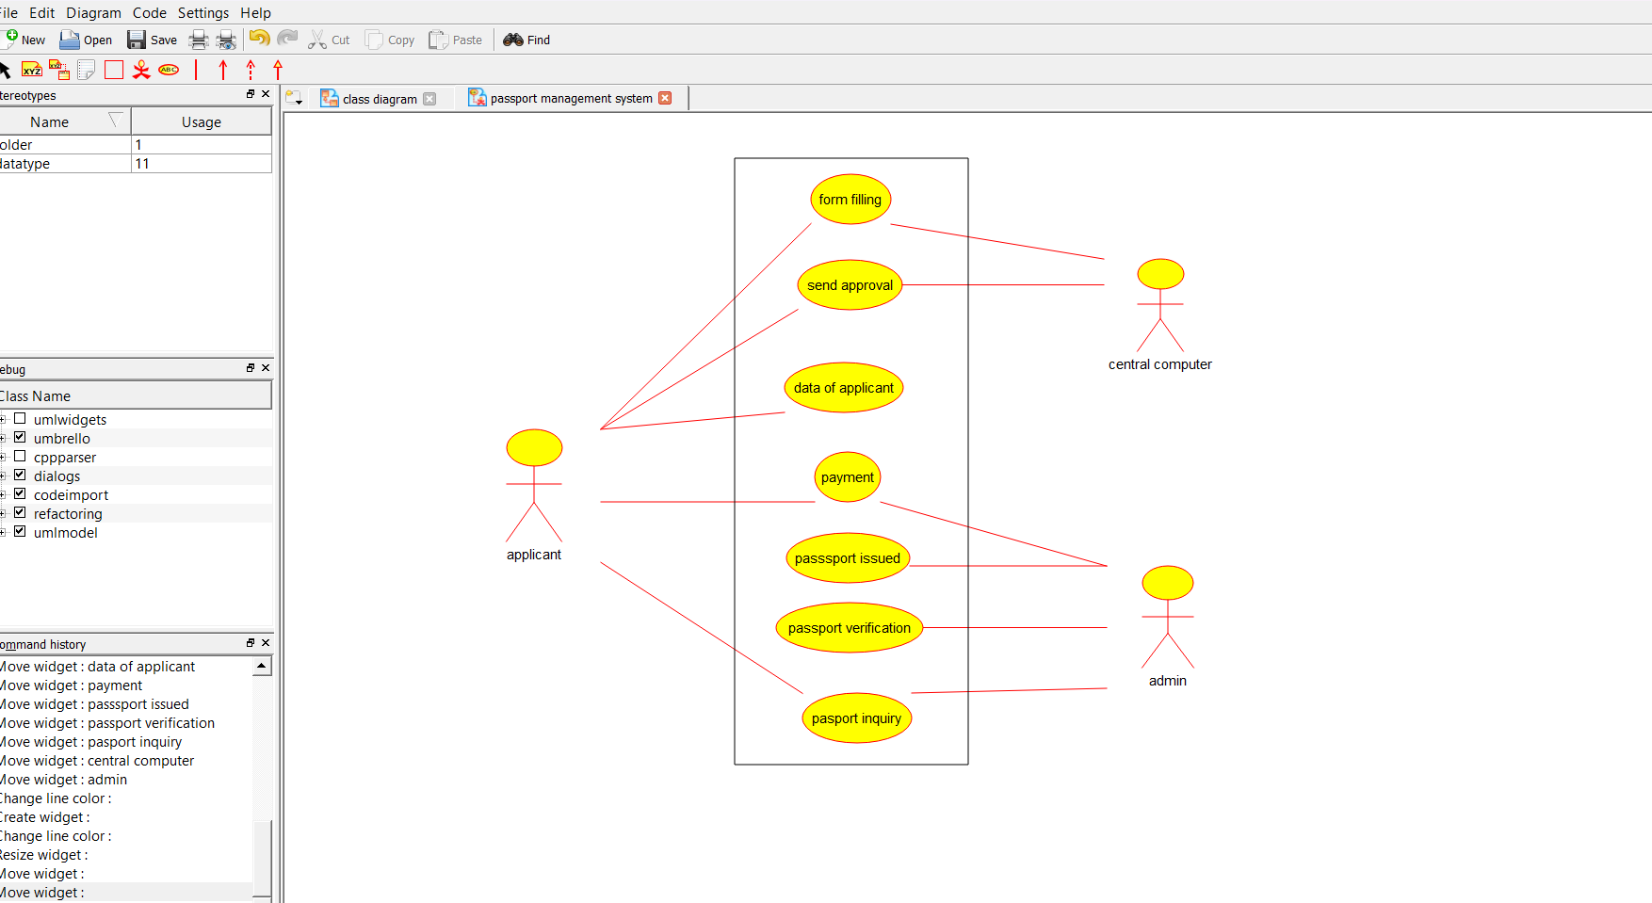

2.CLASS DIAGRAM:-

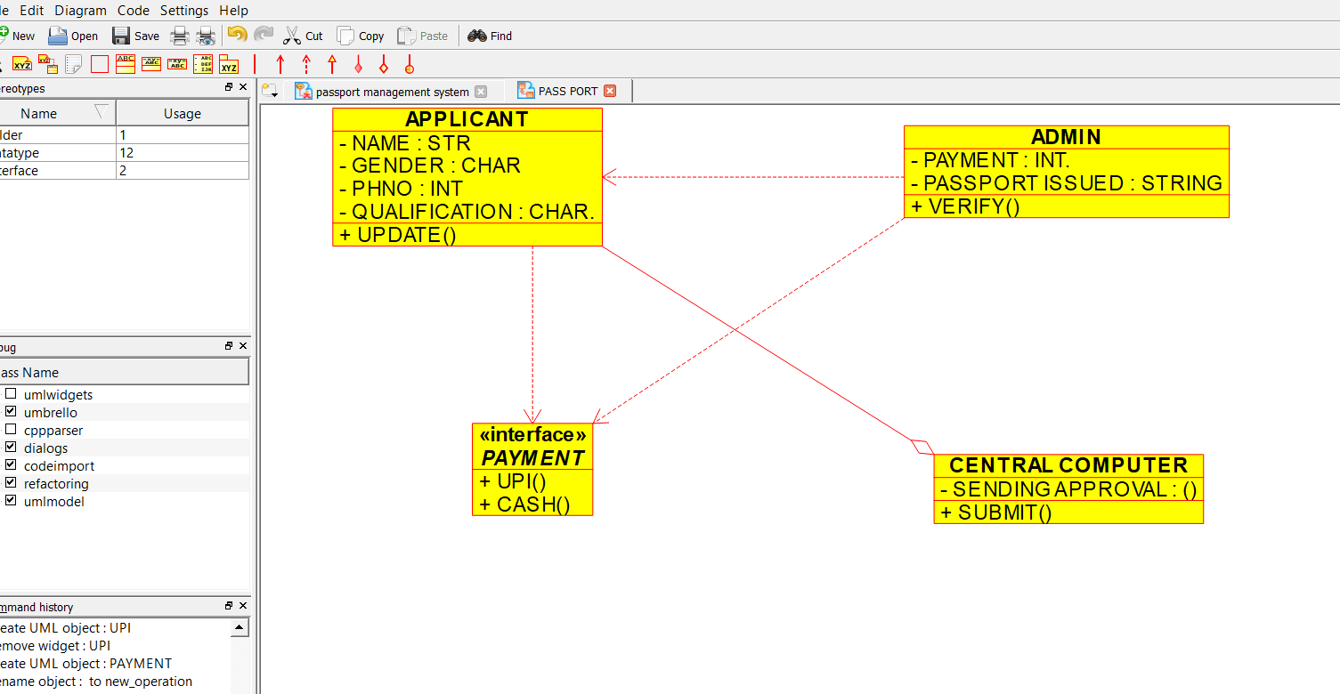

SEQUENCE DIAGRAM:-

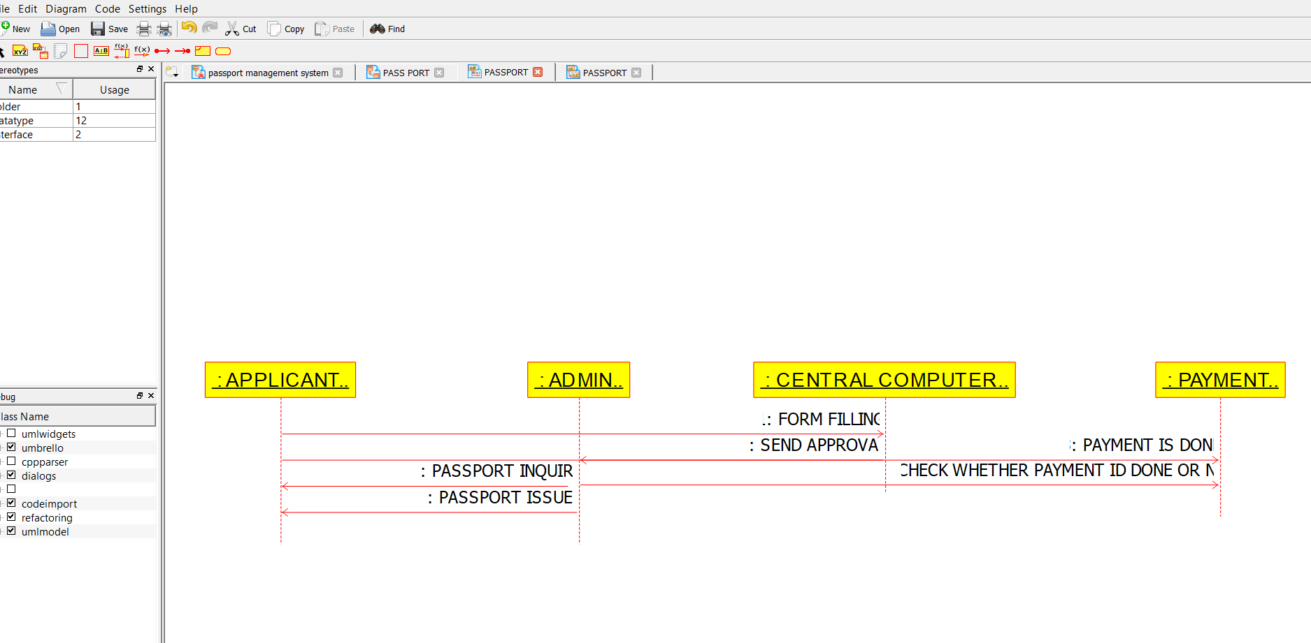

PACKAGE DIAGRAM:-

