Q1. Point the camera to a chessboard pattern or any known set of reference points that lie on the same plane. Capture a series of 10 images by changing the orientation of the camera in each iteration. Select any 1 image, and using the image formation pipeline equation, set up the linear equations in matrix form and solve for intrinsic and extrinsic parameters (extrinsic for that particular orientation). You will need to make measurements of the actual 3D world points, and mark pixel coordinates.

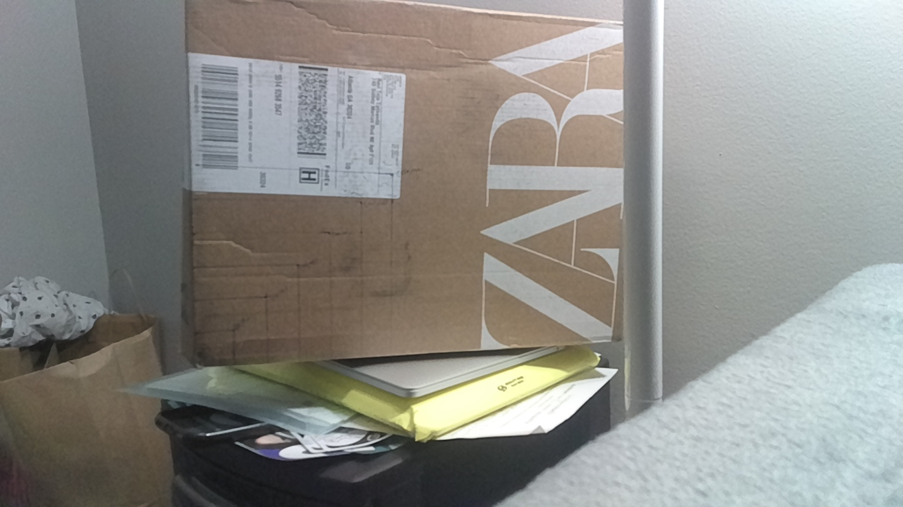
The above picture shows the object I have used to mark 6 world co-ordinates.
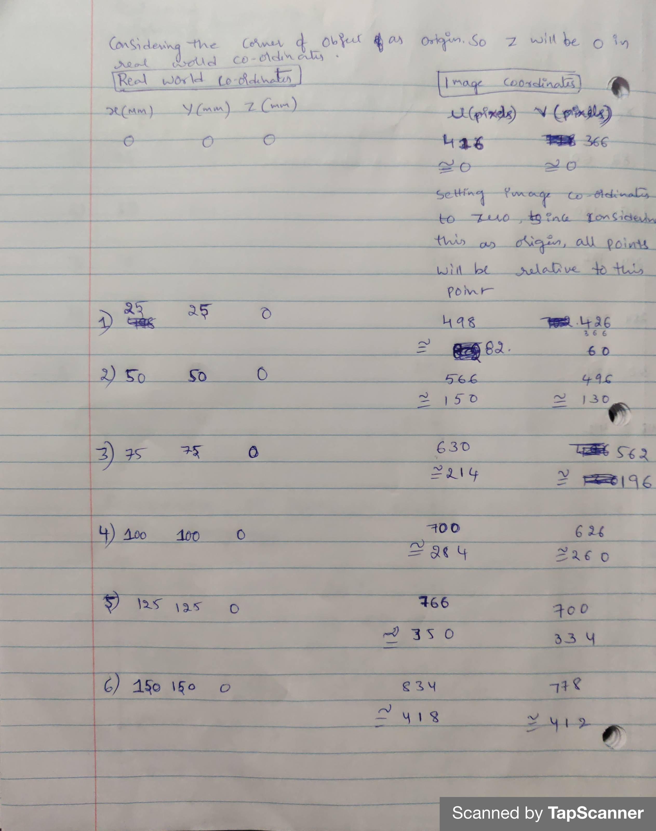
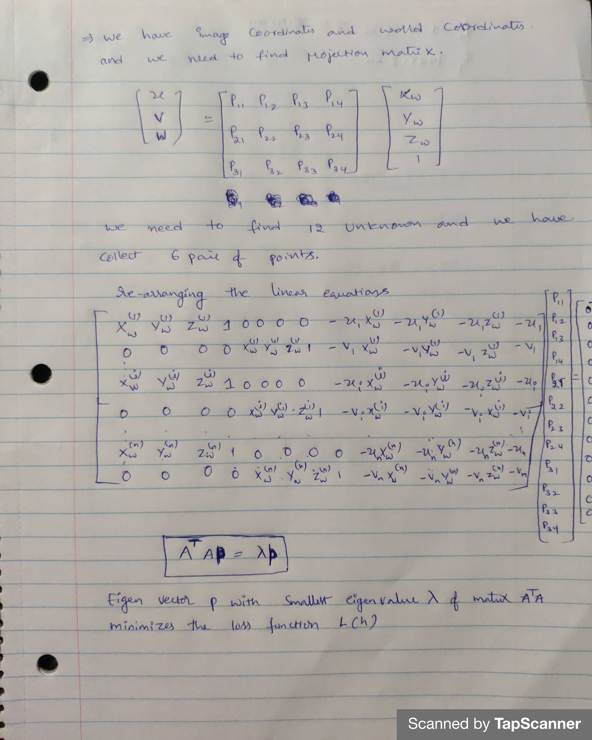
Taking the help of matlab to solve the above matrices.
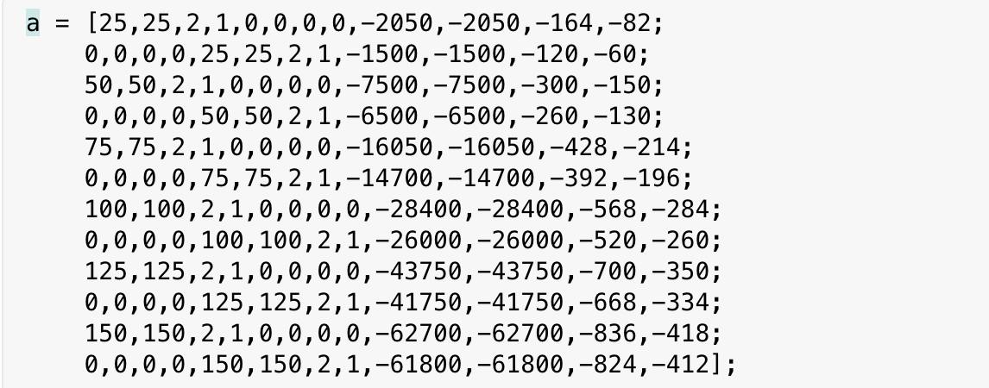
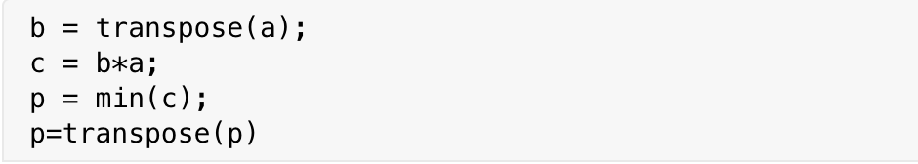
Projection matrix p :
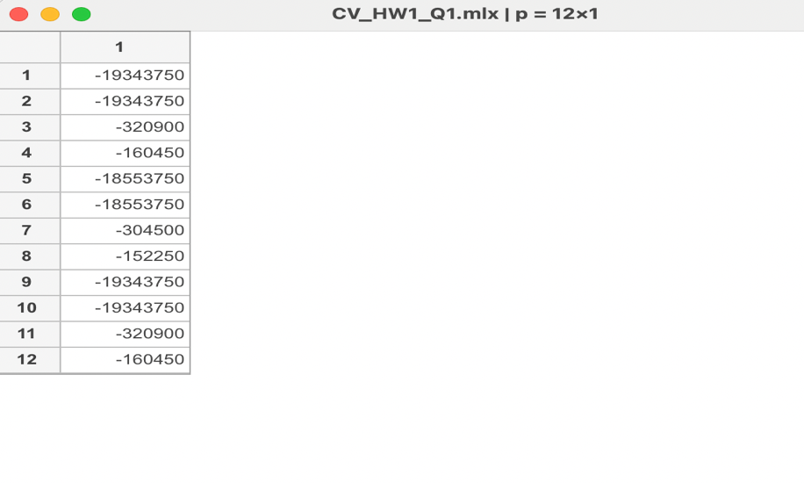
We can now run QR factorization to get calibration matrix K and rotation matrix R
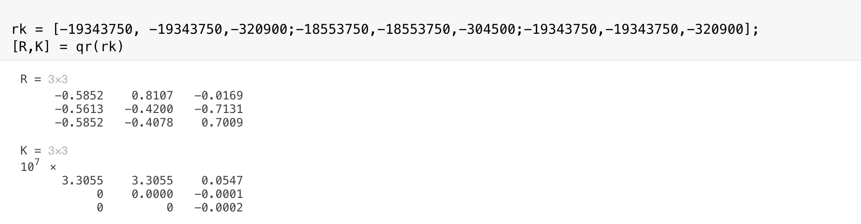

Calculating translation matrix using following equation
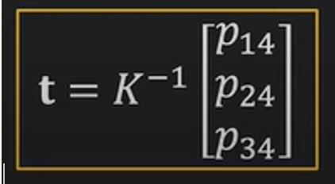

Here pr is column vector with values from last column of projection matrix
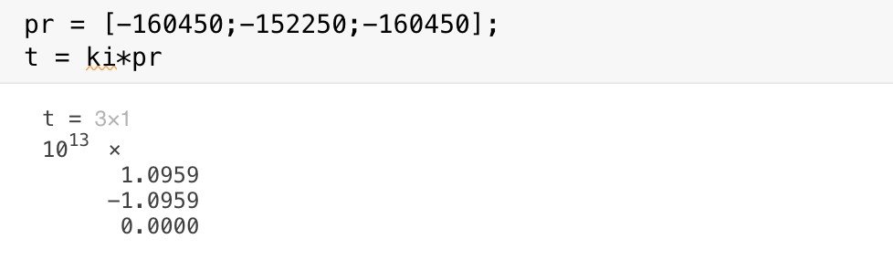
T is the translation vector.

Q2. Select any pair of images from the set-in problem 1 above. Compute the homography between those two images.
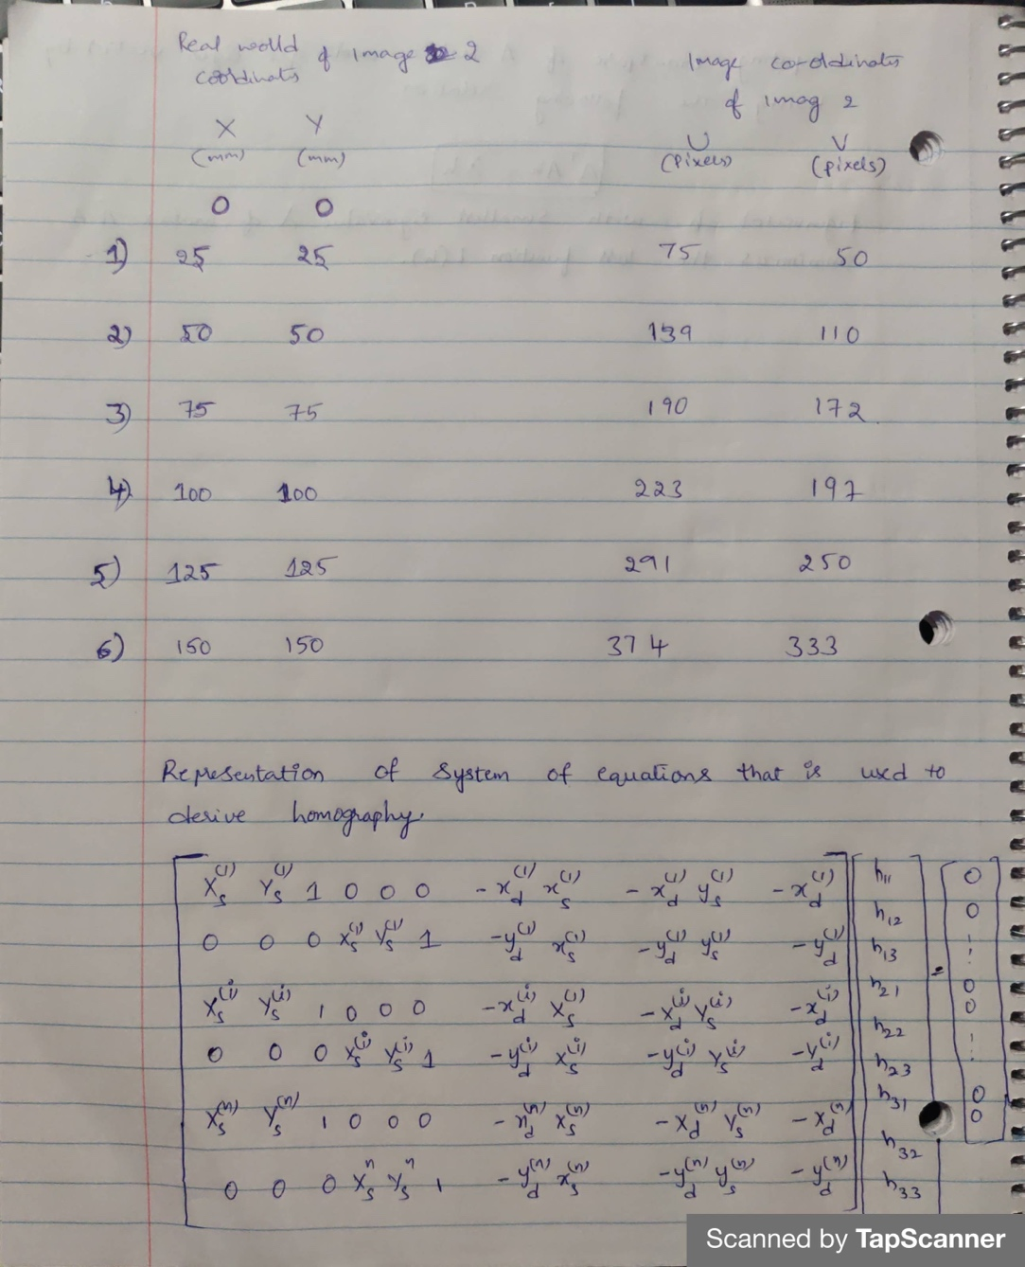
I have used 2 images . image 1 co-ordinates are same as the one used in question 1. The above picture has co-ordinates of second image.
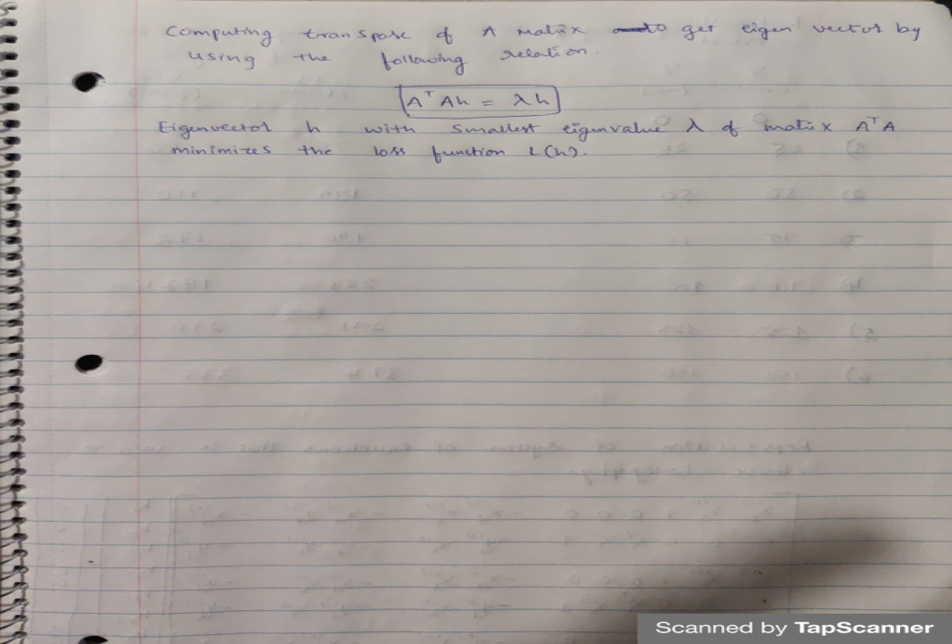
Using matlab for the calculation.
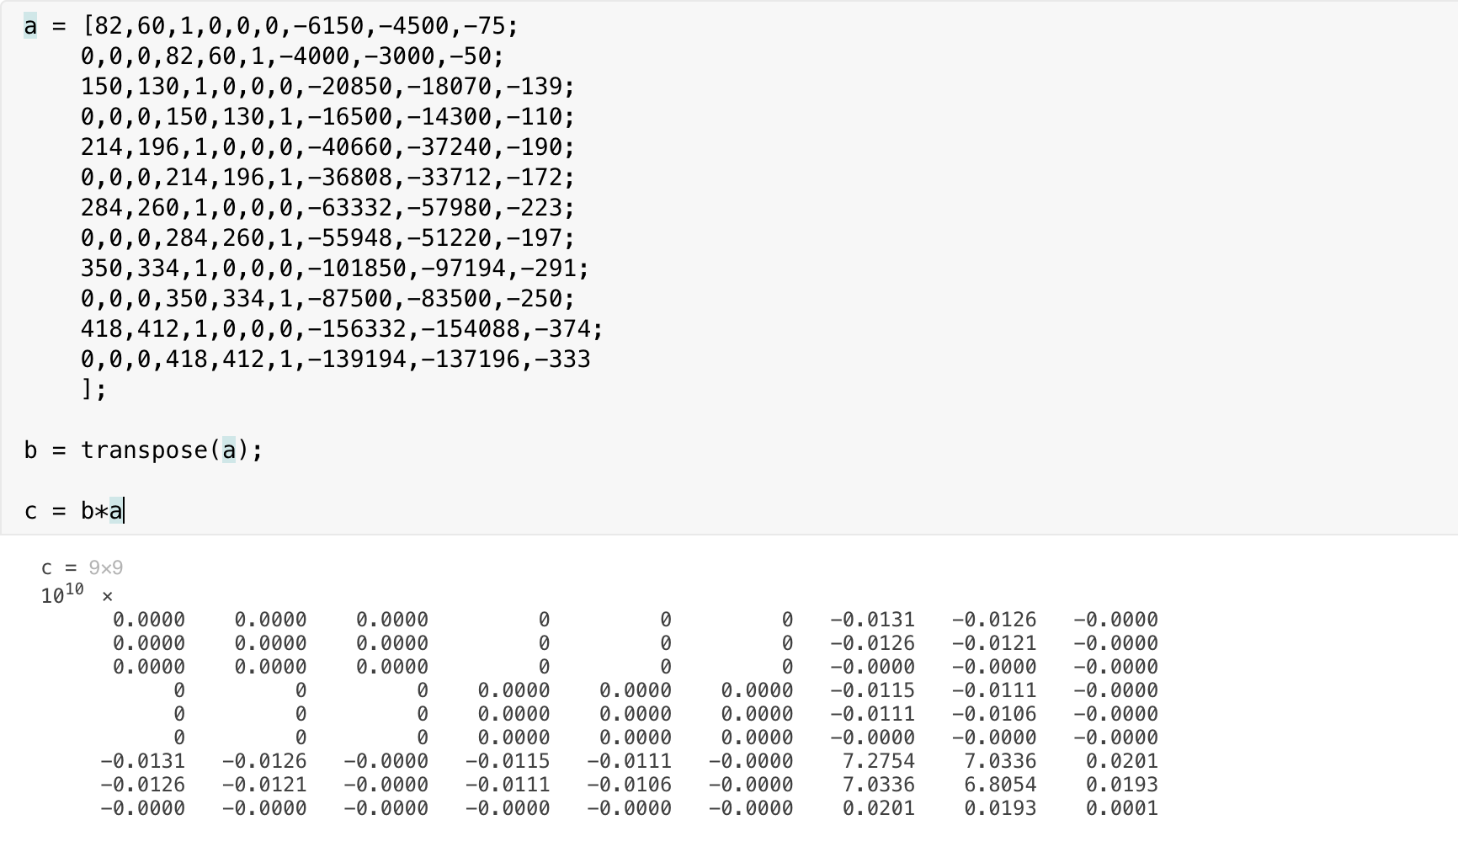We get homogenous matrix by fetching minimum from each column

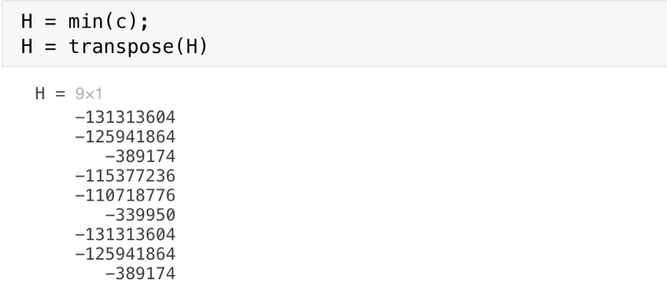

3. Write a MATLAB script to find the real world dimensions (e.g. diameter of a ball, side length of
a cube) of an object using perspective projection equations. Validate using an experiment where
you image an object using your camera from a specific distance (choose any distance but
ensure you are able to measure it accurately) between the object and camera.

I am calculating the area of a rectangular box.
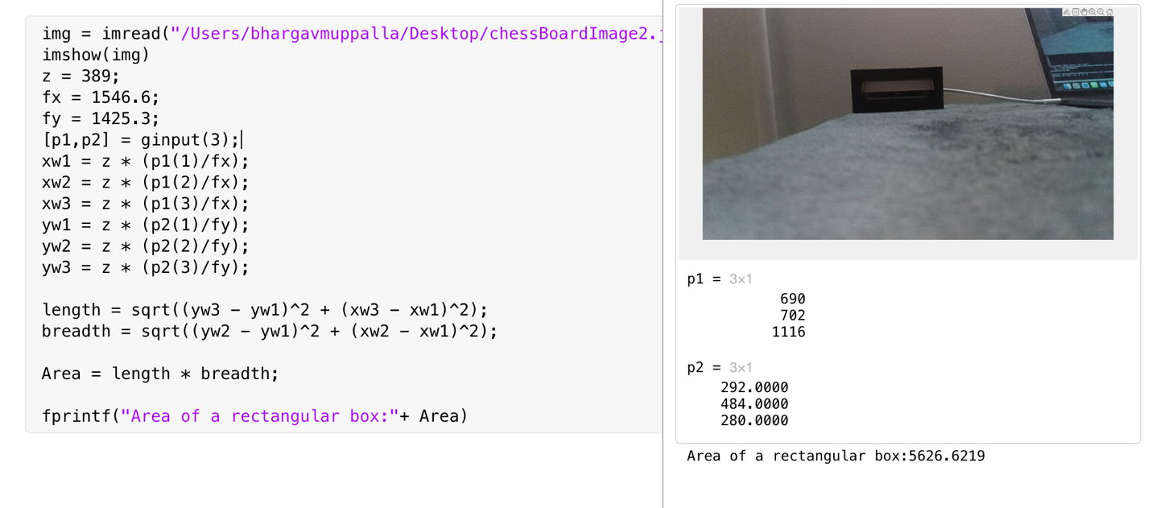

5. Setup your application to show a RGB stream from the mono camera and a depth map
stream from the stereo camera simultaneously. Is it feasible? What is the maximum frame rate
and resolution achievable?

It is feasible to run RGB stream from mono camera and a depth map stream from stereo camera.
Maximum framerate is 60fps. And resolution is 1920 X 1080.
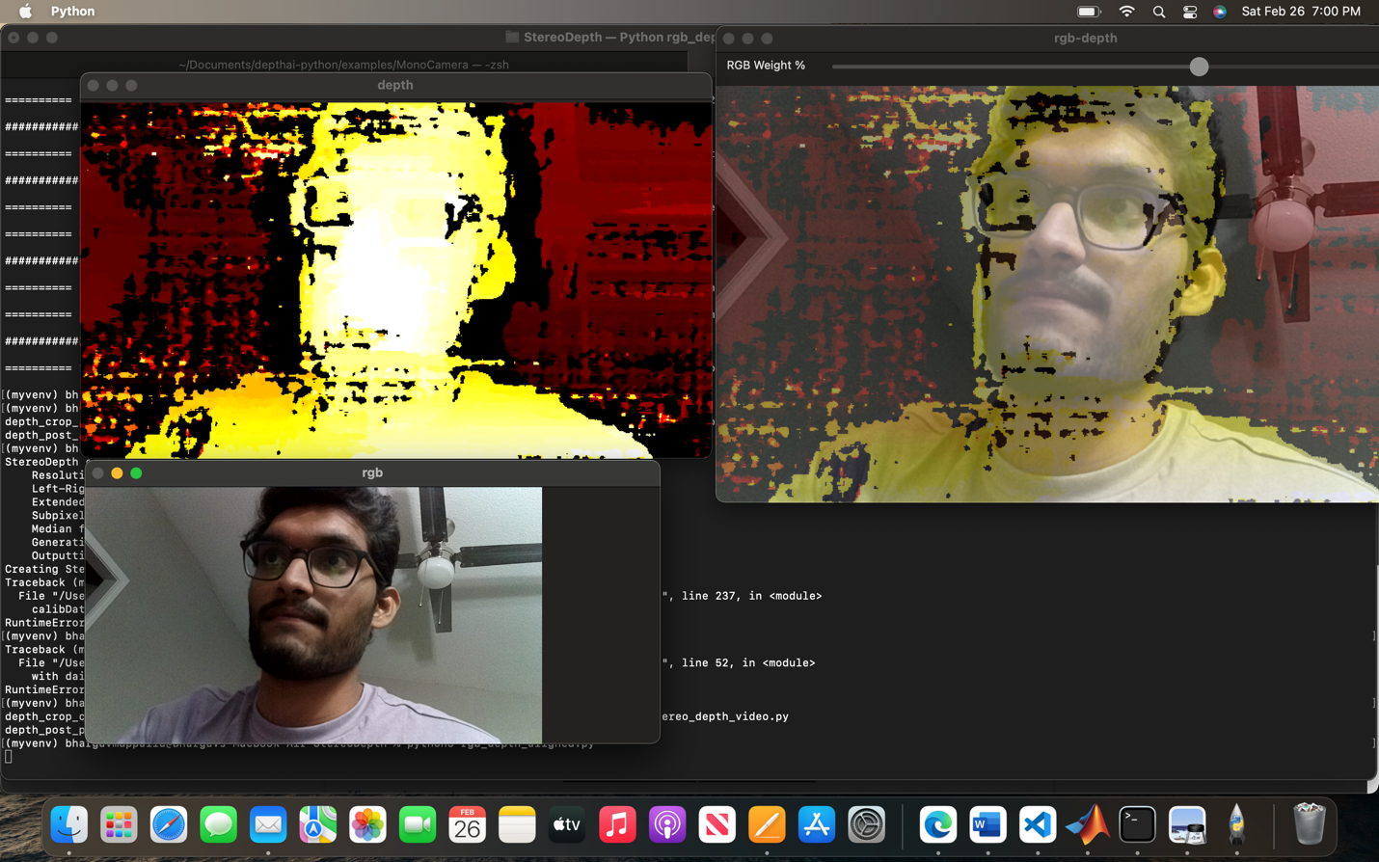

6. Run the camera calibration tutorial. Compare the output with answers from Part A and Matlab
calibration exercise.
bhargavmuppalla/CV: Assignment files of computer vision (github.com)

uploaded all MatLab scripts in the above link.

