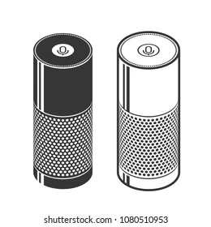

**SHALOMINC_SMARTBEATS_Deliverable_3**

**Team Name: SHALOM INC**

**Project Name: SMARTBEATS**

**Team Members:**

**Bhargav Patel (N01373029),**

**Ripal Patel (N01354619),**

**Vidhi Kanhye (N01354573) &**

**Nicholas Mohan (N01361663)**

# **Table of Contents**

**Table of Contents** **1**

**Brief Description:** **2**

**Members Info and Participation** **2**

**GitHub Link and Proof of Invitation** **3**

**Sprints (Stories, Theme and Epics):** **4**

**Sprints (Stories, Theme and Epics):** **5**

**Daily Standups Outcome** **6**

**Gantt Chart:** **7**

**C4 Diagram Model** **8**

**Level 1:** **8**

**C4 Diagram Model** **9**

**Level 2:** **9**

**C4 Diagram Model** **10**

**Level 3:** **10**

**C4 Diagram Model** **11**

**Level 4:** **11**

**C4 Diagram Model** **12**

**Level 4:** **12**

**Sprint Retrospective** **13**

**Two Design Principles** **14**

**Two Design Patterns** **14**

**Progress since deliverable 2** **14**

**Runtime Permissions Used:** **14**

**EXTRAS** **14**

# **Brief Description:**

The application itself is a controller for a smart home speaker. It will allow the user to control the music supplied to the speaker and accent lighting. Access to a song database will also be incorporated into this app for the online database functionality aspect.

# **Members Info and Participation**

| **Name** | **ID** | **Signature** | **Effort** |
| --- | --- | --- | --- |
| **Nicholas Mohan** | **N01361663** |  | **100%** |
| **Bhargav Patel** | **N01373029** |  | **100%** |
| **Ripal Patel** | **N01354619** |  | **100%** |
| **Vidhi Kanhye** | **N01354573** |  | **100%** |

# 

# **GitHub Link and Proof of Invitation**

**GitHub Link:** [**https://github.com/bhargavpatel3029/SMARTBEATS**](https://github.com/bhargavpatel3029/SMARTBEATS)

**Screenshot of Github Invitation:**

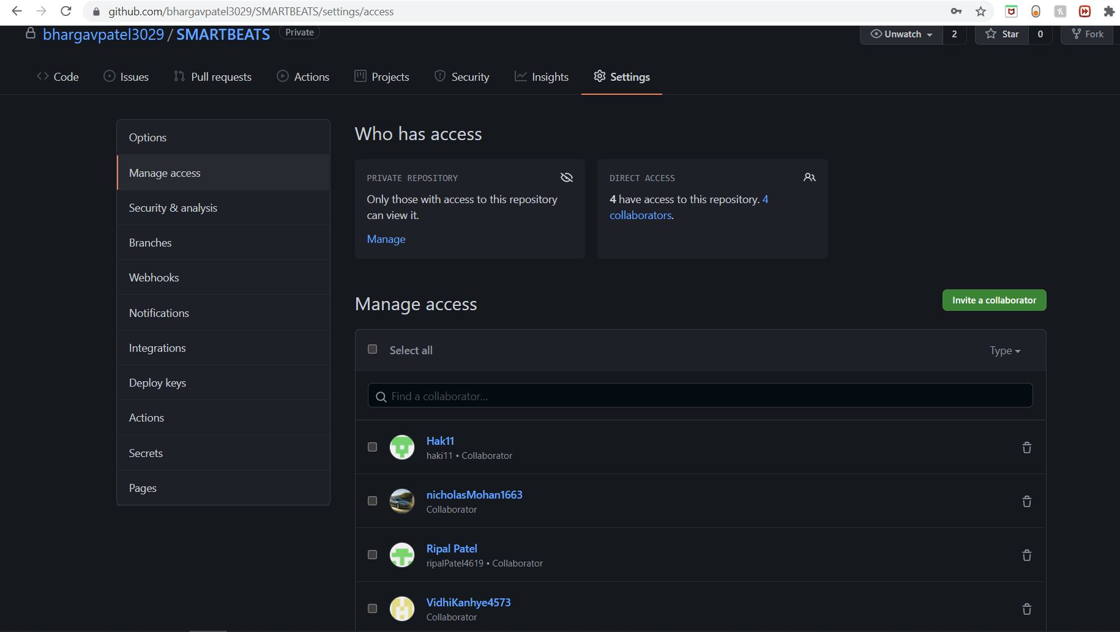

# 

# 

# **Sprints (Stories, Theme and Epics):**

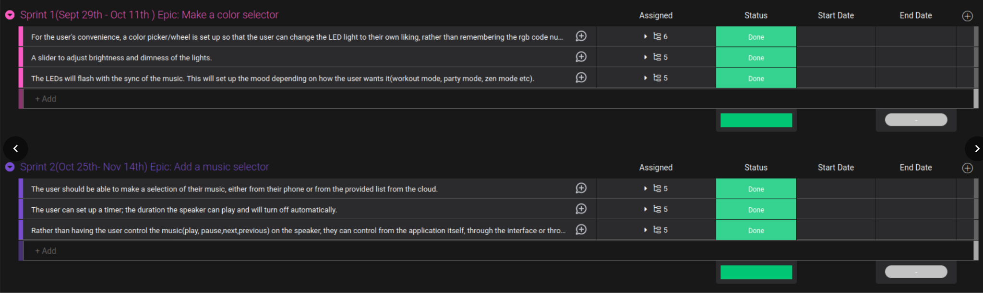

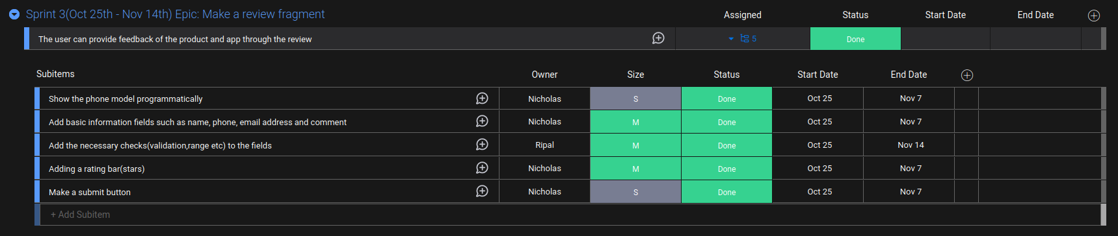

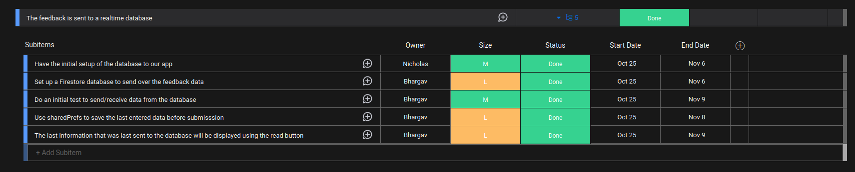

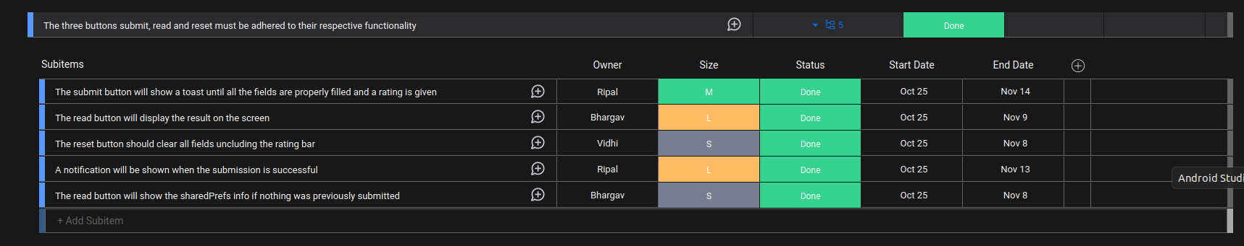

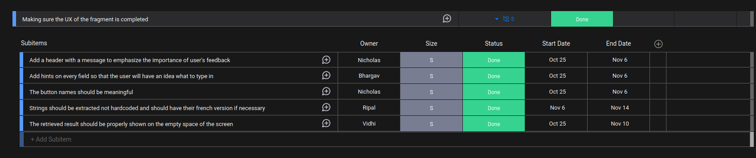

# **Sprints (Stories, Theme and Epics):**

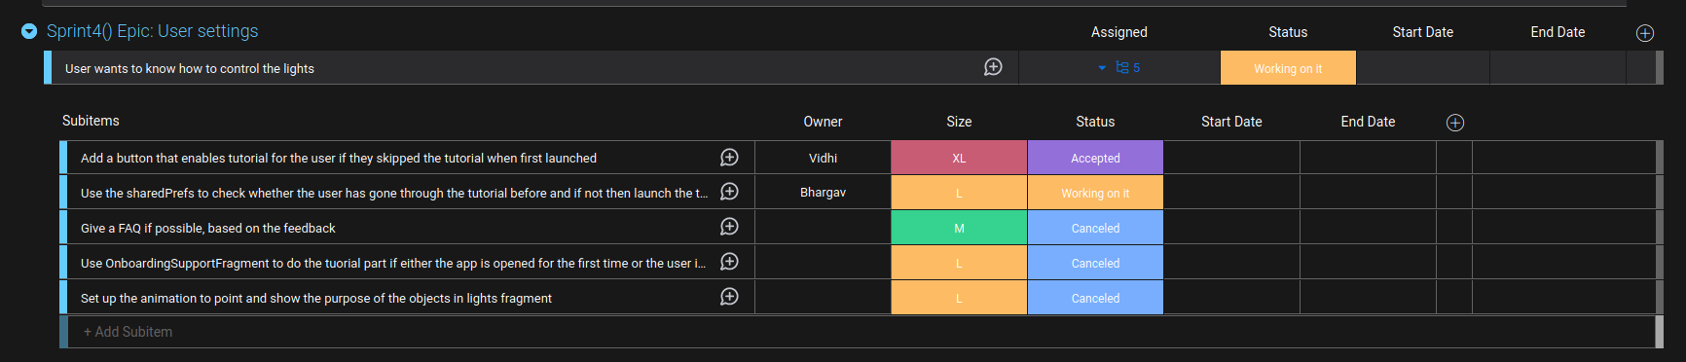

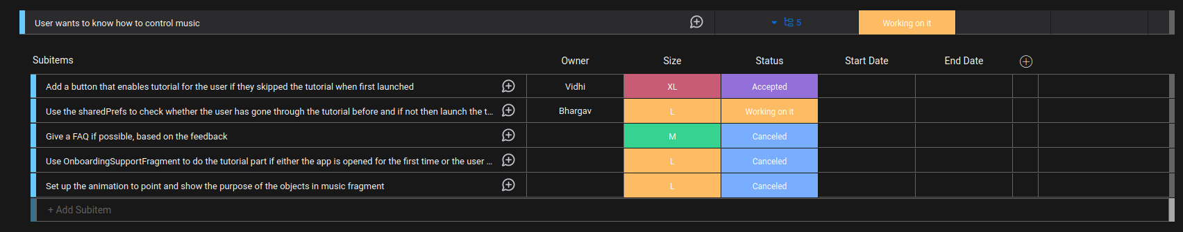

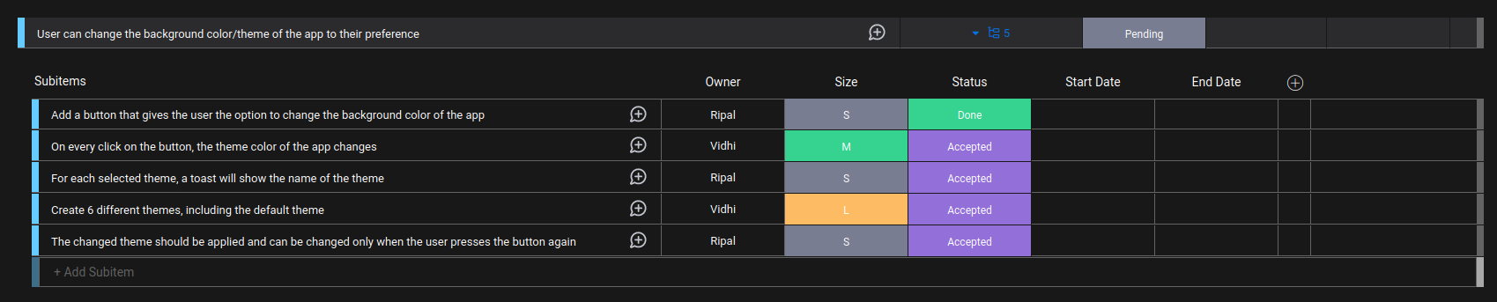

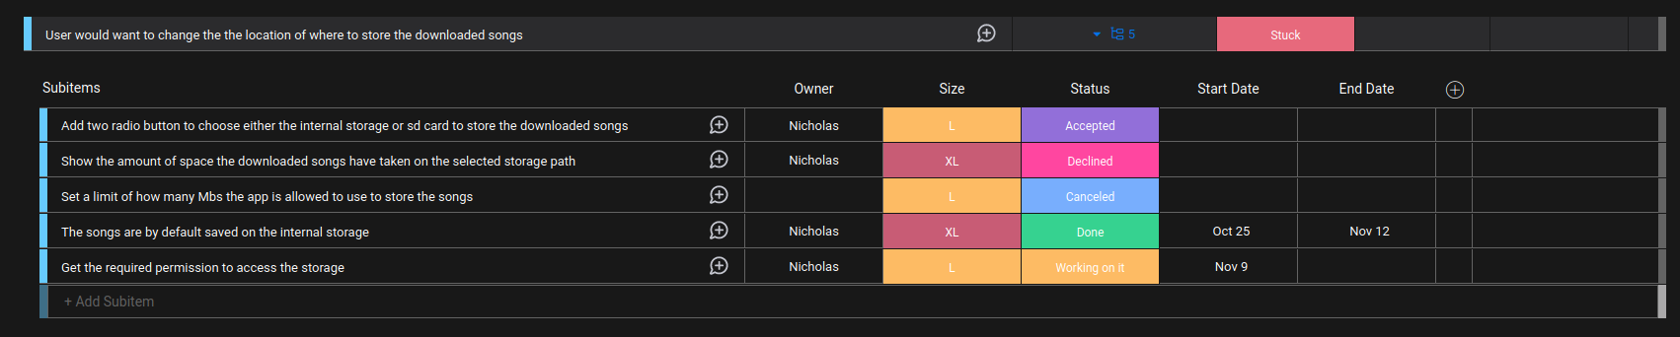

# 

# **Daily Standups Outcome**

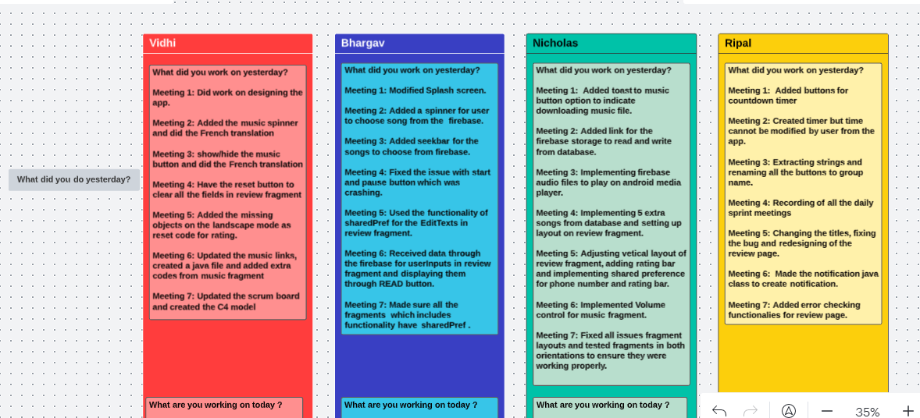

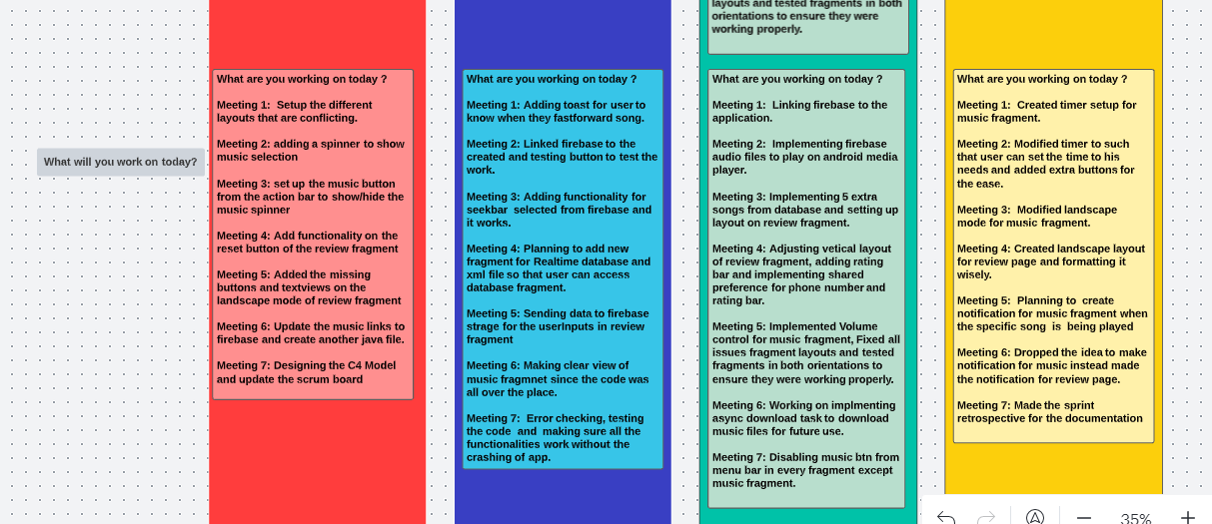

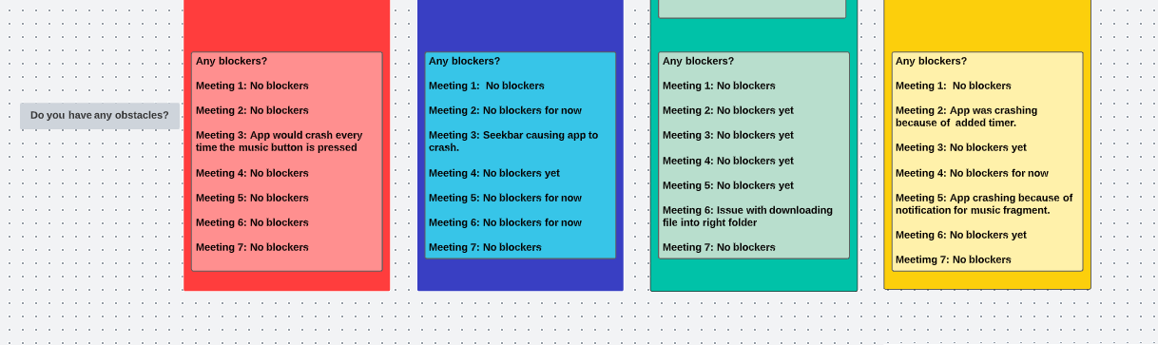

# **Gantt Chart:**

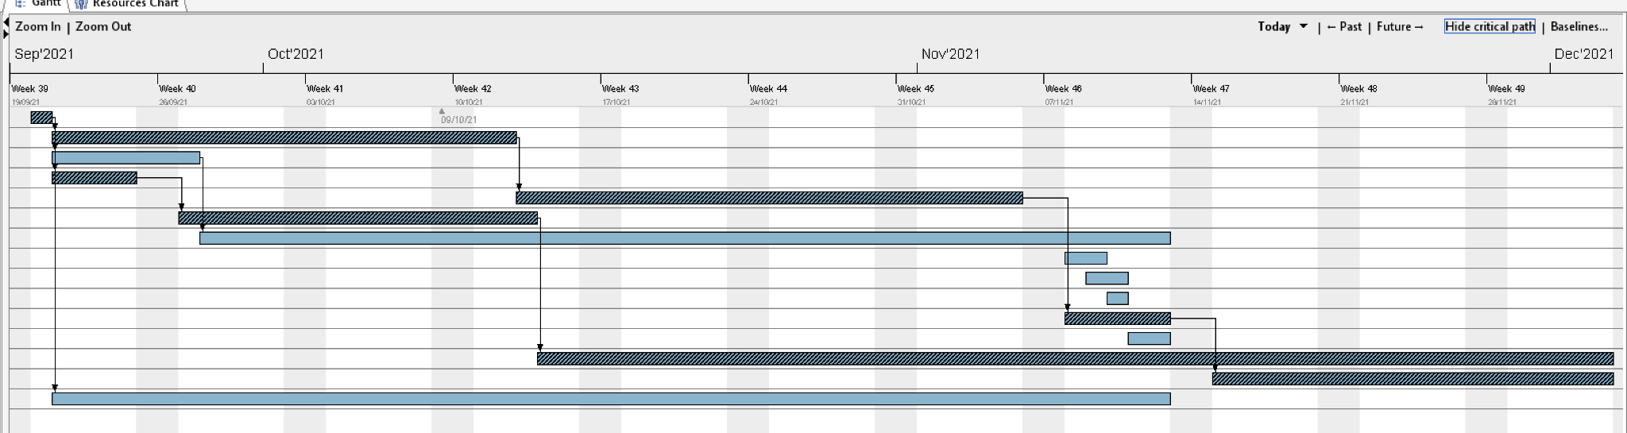

# 

# 

# 

# 

# 

# 

# **C4 Diagram Model**

# **Level 1:**

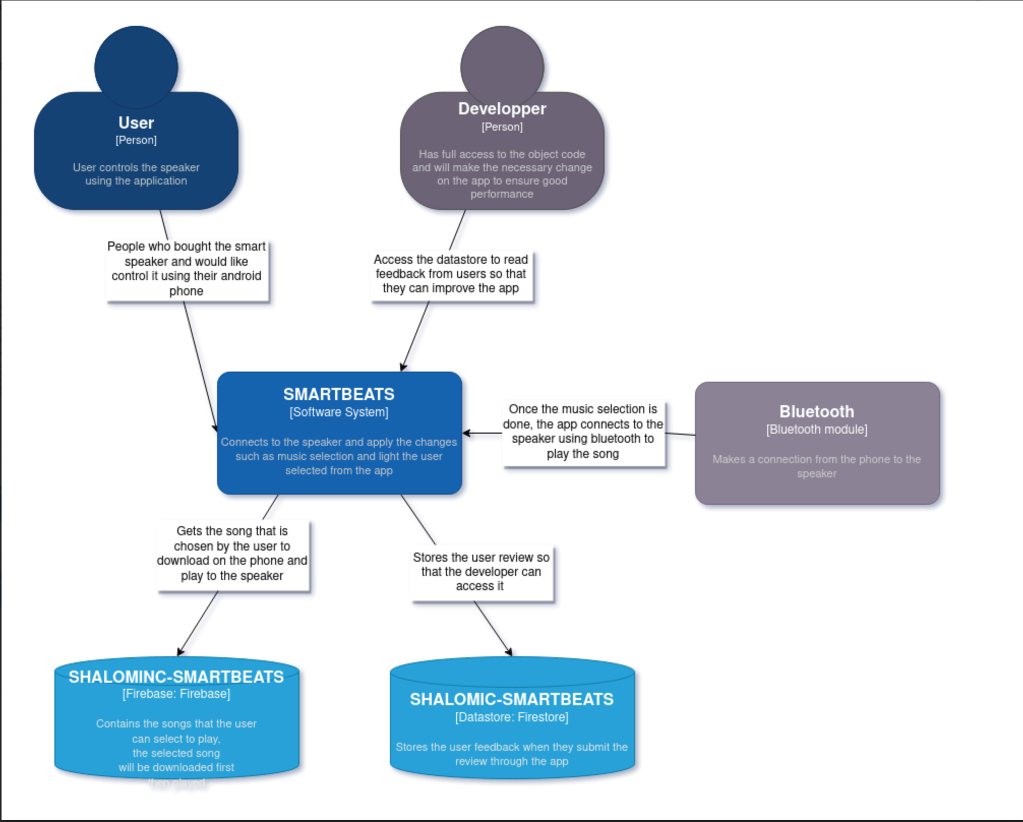

# **C4 Diagram Model**

# **Level 2:**

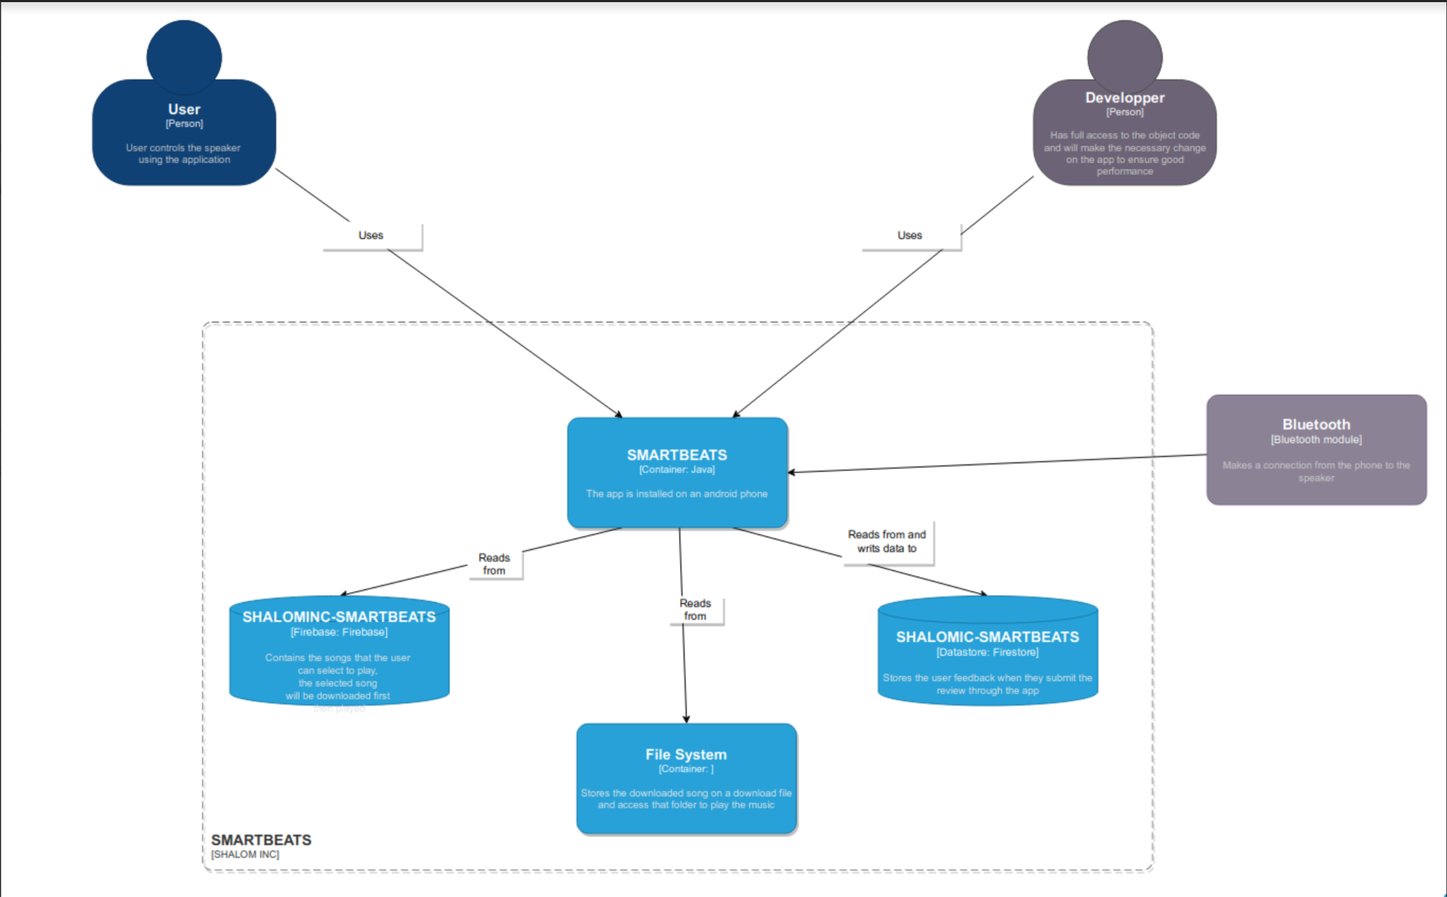

# 

# 

# 

# 

# 

# **C4 Diagram Model**

# **Level 3:**

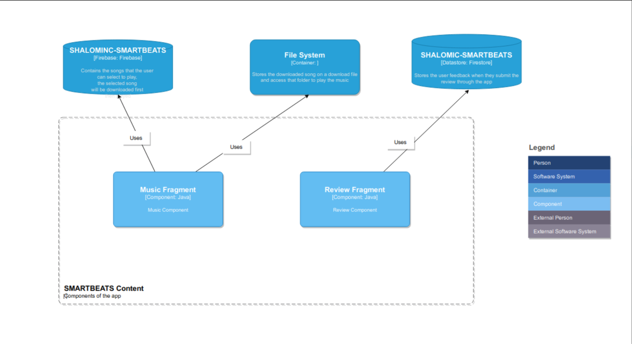

# **C4 Diagram Model**

# **Level 4:**

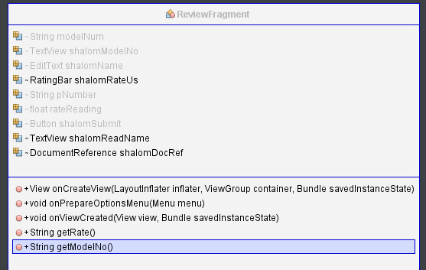

# 

# 

# **C4 Diagram Model**

# **Level 4:**

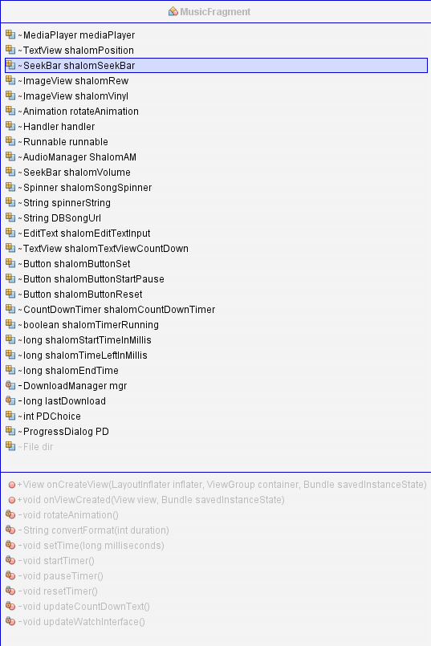

# 

# 

# 

# 

# **Sprint Retrospective**

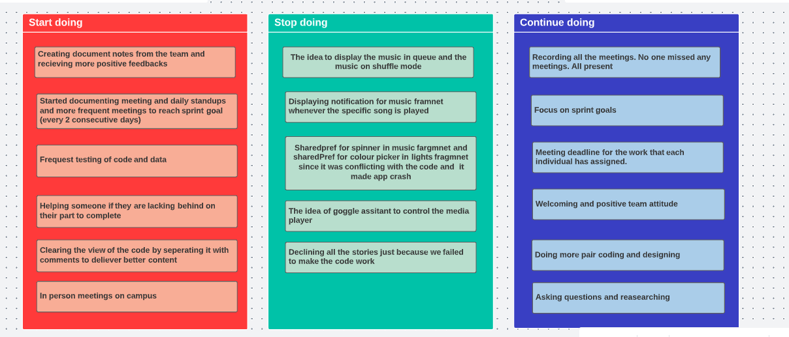

# **Two Design Principles**

Keep It Simple and Stupid Principle (KISS): There was splitting of methods and creation of smaller functions to make the code simpler and easier to read and since even after that it was complicated there were comments added on so even if a person reads it first time, they would have a clear view of our code.

The Interface Segregation Principle (ISP) : Creation of a function which does a specific functionality and can be called whenever the coder needs it.

# **Two Design Patterns**

Structural Patterns: A reasonable reason to add the button or other objects.

Behavioural Patterns: such as onClickListeners for the buttons.

# **Progress since deliverable 2**

Since deliverable 2 there have been many changes to this application. Some of the major features/functionality that were added in this app are Firebase Storage and Firestore Database. In Addition, Sending and receiving data to the firebase was the major functionality. In order to do Async we had to download the songs from our Firebase Storage so the user can play songs from their download folder. Minor changes like adding a decrement timer, volume seekbar for controlling the volume of the song, Sharedpreferences for the TextViews, EditText and Spinners. Addition of a rating bar for users to give us a review out of five stars, retrieving the model number of the user's device. In the end, the functionality of most of these features are working and there is still more to be added and tested upon in the future.

# **Runtime Permissions Used:**

<uses-permission android:name="android.permission.INTERNET" />

<uses-permission android:name="android.permission.READ_EXTERNAL_STORAGE" />

<uses-permission android:name="android.permission.WRITE_EXTERNAL_STORAGE" />

<uses-permission android:name="android.permission.BLUETOOTH"/>

<uses-permission android:name="android.permission.BLUETOOTH_ADMIN" />

<uses-permission android:name="android.permission.BLUETOOTH_CONNECT" />

# **EXTRAS**

PDF Included in Deliverable3 Folder