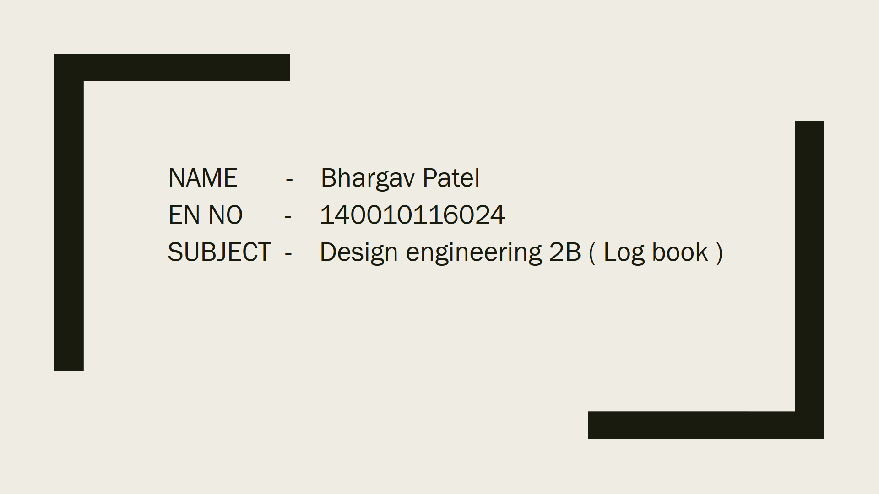

**A.D PATEL INSTITUTE OF TECHNOLOGY**

|  |  |  |
| --- | --- | --- |
| **DEPARTMENT OF INFORMATION TECHNOLOGY** | | |
| **Week 1: Plan of Action Based on Revalidation & Feedback** | | |
| Semester: 6th | Subject: Design Engineering II [B] 2160001 | Team Id: 11 |

|  |  |  |
| --- | --- | --- |
| No. | Feedback of 5th Semester Examiner | Modification Based on Feedbacks |
| 1. | Make sure your app follows responsive web standards. | - Decided to use bootstrap framework into web application. |
| 2. | Authentication process must divide into roles wise access. | - Decided to add roles of Admin and Faculty.  - In faculty role decided to add modification so that department Constraint should be added. Constraint in the sense different department faculty can’t modify other department student information. |
| 3. | Put student overall rank and semester wise rank into student information page based on their departments. | - Decided to Add student ranks into student information page. |
| 4. | Provide csv file feature to upload student information instead  of to provide registration form into faculty page | - Decided to Add that change into faculty page. |

**Date:** 24 **/** 12 **/** 2016

**Sign: ________________**

**A.D PATEL INSTITUTE OF TECHNOLOGY**

|  |  |  |
| --- | --- | --- |
| **DEPARTMENT OF INFORMATION TECHNOLOGY** | | |
| **Week 2: Detail Design** | | |
| Semester: 6th | Subject: Design Engineering II [B] 2160001 | Team Id: 11 |

|  |  |  |
| --- | --- | --- |
| No. | Title | Description |
| 1 | Aspects of Products  Ex: http://qatestlab.com/knowledge-center/qa-testing-materials/5-main-functional-aspects-of-web-software-products/ | - ASP.NET or java Hibernet framework based authentication system.  - result Analysis of students.  - Faculty Panel and only one faculty have rights to change other credentials.  - student result information management. |
| 2 | Material: Require Row Material to Develop your product (H/W Require, S/W Require) | - eclipse or Visual studio 2015.  - ASP.NET or MVC architecture in ASP.net or Hibernet  - Excel  - Web browser. |
| 3 | Process: Which Process you follow to design your product. Ex. Development Model Water flow etc.. | - Water fall model or agile development process. |
| 4 | Resources: Resources Req. To Deploy Your Product Hosting Server, Database Server, | - tomcat version 8.0.2 or IIS Express.  - oracle or MS Access. |
| 5 | Standards: To Design with standards you follow Ex. Framework (Benefit of the framework for your project). Image Size so that it can be loaded easily | - responsive web standards e. g, bootstrap  - ASP.NET or MVC in hibernet |

**Date:** 07 **/** 01 **/** 2017

**Sign: ________________**

**A.D PATEL INSTITUTE OF TECHNOLOGY**

|  |  |  |
| --- | --- | --- |
| **DEPARTMENT OF INFORMATION TECHNOLOGY** | | |
| **Week 3: Detail Design** | | |
| Semester: 6th | Subject: Design Engineering II [B] 2160001 | Team Id: 11 |

|  |  |  |
| --- | --- | --- |
| No. | Title | Description |
| 1 | Aspects of Products  Ex: http://qatestlab.com/knowledge-center/qa-testing-materials/5-main-functional-aspects-of-web-software-products/ | - MVC authentication of user to provide more reliable data manipulation.  - Access to particular account based on Faculty or Admin Role.  - Provide privilege department wise to Faculty.  - To provide student information based on student enrollment request. |
| 2 | Material: Require Row Material to Develop your product (H/W Require, S/W Require) | - Visual studio 2015  - Excel  - Web browser  - Database of oracle or mysql or MSAcess etc. |
| 3 | Process: Which Process you follow to design your product. Ex. Development Model Water flow etc.. | - Agile development process |
| 4 | Resources: Resources Req. To Deploy Your Product Hosting Server, Database Server, | - IIS 10.0 Express or Higher version of IIS.  - MySql or MsAcess. |
| 5 | Standards: To Design with standards you follow Ex. Framework (Benefit of the framework for your project). Image Size so that it can be loaded easily | - responsive web standards e. g, bootstrap  - .NET MVC. |

**Date:** 28 **/** 01 **/** 2017

**Sign: ________________**

**A.D PATEL INSTITUTE OF TECHNOLOGY**

|  |  |  |
| --- | --- | --- |
| **DEPARTMENT OF INFORMATION TECHNOLOGY** | | |
| **Week 4: Detail Design** | | |
| Semester: 6th | Subject: Design Engineering II [B] 2160001 | Team Id: 11 |

|  |  |  |
| --- | --- | --- |
| No. | Title | Description |
| 1 | Aspects of Products  Ex: http://qatestlab.com/knowledge-center/qa-testing-materials/5-main-functional-aspects-of-web-software-products/ | - MVC authentication of user to provide more reliable data manipulation.  - Access to particular account based on Faculty or Admin Role.  - Provide privilege department wise to Faculty.  - Auto generation of result analysis based on student data inserted.  - To provide student information based on student enrollment request. |
| 2 | Material: Require Row Material to Develop your product (H/W Require, S/W Require) | - Visual studio 2015  - Excel  - Web browser  - Database MSAcess. |
| 3 | Process: Which Process you follow to design your product. Ex. Development Model Water flow etc.. | - Agile development process. |
| 4 | Resources: Resources Req. To Deploy Your Product Hosting Server, Database Server, | - IIS 10.0 Express or Higher version of IIS.  - Database MsAcess. |
| 5 | Standards: To Design with standards you follow Ex. Framework (Benefit of the framework for your project). Image Size so that it can be loaded easily | - .NET 4.5 framework MVC 5.0  - ER entity relational model  - Responsive Web standards. |

**Date:** 11 **/** 02 **/** 2017

**Sign: ________________**

**A.D PATEL INSTITUTE OF TECHNOLOGY**

|  |  |  |
| --- | --- | --- |
| **DEPARTMENT OF INFORMATION TECHNOLOGY** | | |
| **Week 5: Modelling & Analysis** | | |
| Semester: 6th | Subject: Design Engineering II [B] 2160001 | Team Id: 11 |

**Development Models:**

**1. Use-Case model**



**2. Activity models:**

**-** View Analysis activity



- Student Information Entry Activity



**-** Result entry activity



**-** Faculty account registration activity 

Add/Remove subject activity



- Faculty data management Activity



**Analysis:**

- here, Use case model indicates functionality of web application and that functionality’s activity flow described in activity diagrams.

**-** functionality that have been included:

* Result view to student

* Any user can request enrollment number as query and based on that data will be provided.

* Faculty registration through admin

* Admin can enroll faculty and can provides role to particular faculty.

* View analysis of semester result by any user

* By selecting department and semester option user can view particular semester analysis department wise.

* Analysis for particular semester

* Auto generation mechanism of semester from database is specified.

* Manipulate student info

* Faculty or Admin can manipulate any student information. Faculty have privilege that it can only manipulate their department student information.

* Subject data manipulation by admin

* If subject offered by university is changed by the time then admin can add or remove subject.

* Faculty data management

* If faculty wanted to change their login credential then they can.

**Date:** 25 **/** 02 **/** 2017

**Sign: ________________**

**A.D PATEL INSTITUTE OF TECHNOLOGY**

|  |  |  |
| --- | --- | --- |
| **DEPARTMENT OF INFORMATION TECHNOLOGY** | | |
| **Week 6: Modelling & Analysis** | | |
| Semester: 6th | Subject: Design Engineering II [B] 2160001 | Team Id: 11 |

**Development Models: 1. Class model:**



**2. Sequence Model:**



**Analysis:**

**-** To achieve object oriented architecture Its mandatory to know how classes well structured.

- Here, class diagram constructed based on requirement specified in aspect section of week 4 log.

**-** class diagram contains two packages:

1. ARAFinal.Controllers

* This package is responsible to maintain state of the incoming requests from users.

2. ARAFinal.Models

* This package is responsible to establish connection with database.

* This models are actually Entity Relational models which are basically interface between

Database and controller.

- In order to know how classes will actually interacts with each other or how sequence should maintain when interaction with in classes is going on; for that Sequence diagram models is essential factor.

- In sequence diagram user is divided into two categories 1st Authorized (faculty / Admin) and 2nd is Unauthorized (Anonymous)

- If user is authorized then process related to update and insert data into database will enabled. That means views which related to database operation will be available to the user.

- If user is unauthorized then student can see views which provides student information and current semester analysis.

**Date:** 11 **/** 03 **/** 2017

**Sign: ________________**

**A.D PATEL INSTITUTE OF TECHNOLOGY**

|  |  |  |
| --- | --- | --- |
| **DEPARTMENT OF INFORMATION TECHNOLOGY** | | |
| **Week 7: Modelling & Analysis** | | |
| Semester: 6th | Subject: Design Engineering II [B] 2160001 | Team Id: 11 |

**Development Model: 1. Data flow model:**



**2. State model:**



**Analysis:**

**-** To know process being done on data which is provided to web application. Data flow model is essential term.

- This model is basically describing each and every data flows of web application and that data flow has particular states, So the data flow and state models are highly dependent on each other but they can be distinguished based on their states behavioral activities. E. g, Data flows from one Controller to another controller. But the controller can share data if reliable state is established between them.

- In this application data flow diagram shows that when any user is requests, at that time it also shares information related to state with application (if state was established before). If application identifies user is already authorize then it will render user based on role that is assigned to him.

- For authorized user (faculty / admin), he can perform database manipulation tasks. When user submits requests data to update or insert, at that time request will come to controller, it checks whether user has right to manipulate database i.e. IT faculty updates CP student data base. So if user have rights then data updating task will perform and data will flow into particular states.

- state model specifies how data will pass through particular states.

**Date:** 18 **/** 03 **/** 2017

**Sign: ________________**

**A.D PATEL INSTITUTE OF TECHNOLOGY**

|  |  |  |
| --- | --- | --- |
| **DEPARTMENT OF INFORMATION TECHNOLOGY** | | |
| **Week 8: Implementation Phase** | | |
| Semester: 6th | Subject: Design Engineering II [B] 2160001 | Team Id: 11 |

**Design of Views & Controllers:**

In this period of time task was performed:

* Team overviewed web application various structures and studied Internal structure of .NET MVC5 patterns.
* One theme page is selected as master page which is specified below:

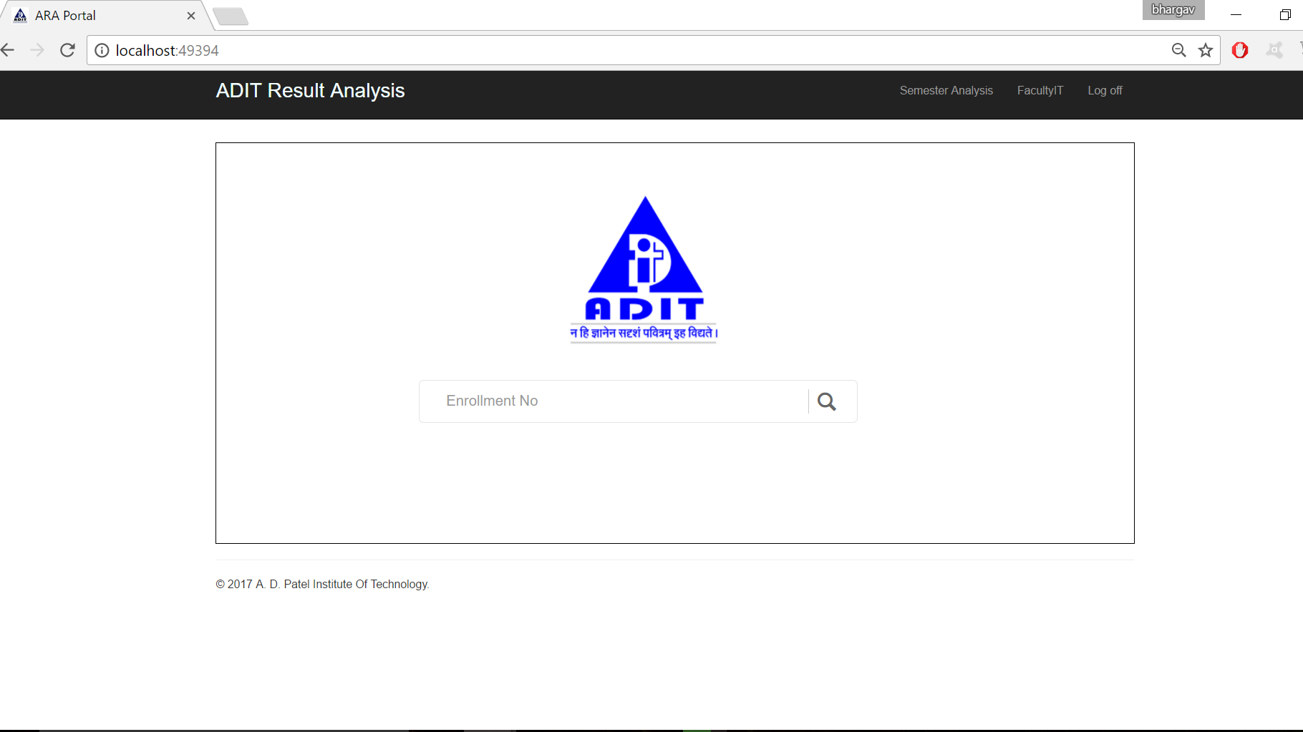

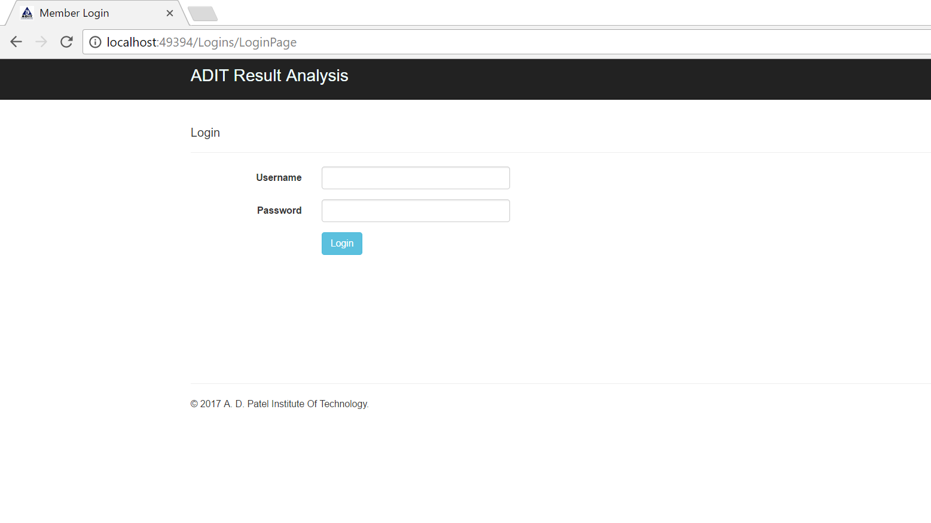

**-** master page follows principles of responsive web design is divided into three parts Header , Body & Footer

**-** Header generates dynamic tabs which could full fill overall mapping of application perfectly.

**-** In Body section processing tasks and contents related to data was specified.

**-** Footer contains copyrights and year information.

**-** Header & Footer pages (common pages) were specified into shared folder and Body (actual view) was specified into particular <named> folders.

- total views & controllers were generated in this time period was,

* Departments (only controller to handle models data)

* Home (view with controller)

* Logins (controller authentication through model Owin.Security)

* Logins1 (view with controller)

- Internal behavioral structure was handled by controllers which were stated same name as View folders.

**Date:** 15 **/** 04 **/** 2017

**Sign: ________________**

**A.D PATEL INSTITUTE OF TECHNOLOGY**

|  |  |  |
| --- | --- | --- |
| **DEPARTMENT OF INFORMATION TECHNOLOGY** | | |
| **Week 9: Implementation Phase** | | |
| Semester: 6th | Subject: Design Engineering II [B] 2160001 | Team Id: 11 |

**Design of Views & Controllers:**

* Other views and controllers were designed in this time duration, list of views and controllers were specified below:

* Result (View and controller to handle model of result table)

* SemesterAnalysis (View and Controller to autogenerate analysis as per tables data)

* StudentInfo (View and Controller to generate view based on students result)

* Semesters (View and Controller to handle model of semesters table)

- All over design was ready into these time period but server side interaction handling was remained to implement.

- Design screenshots were specified below,

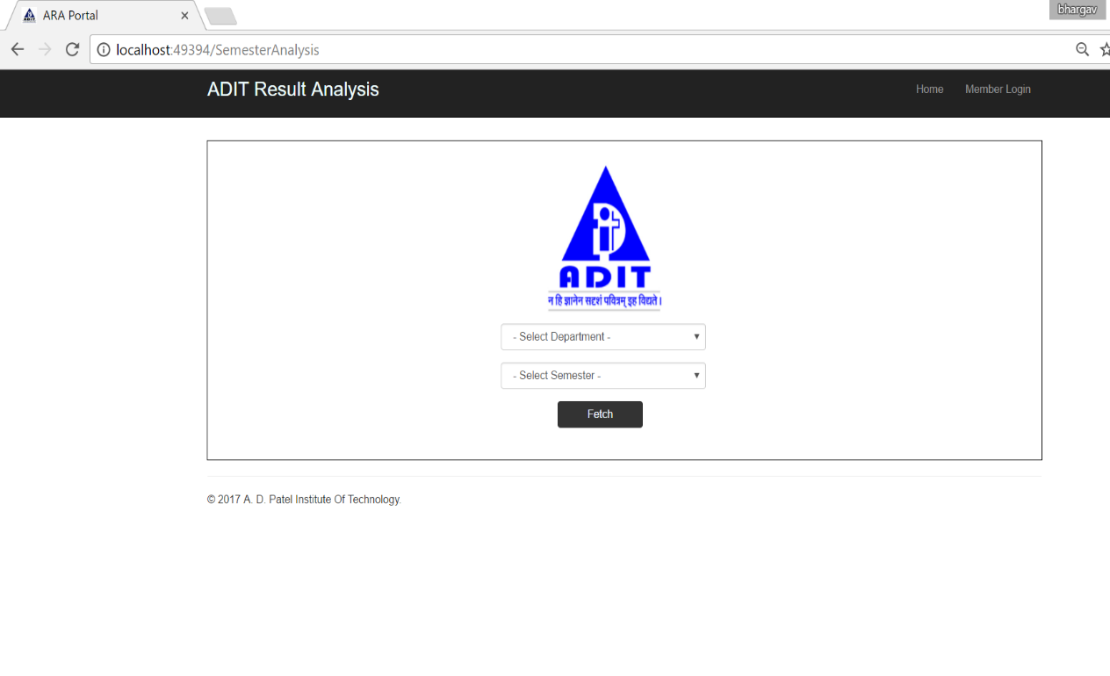

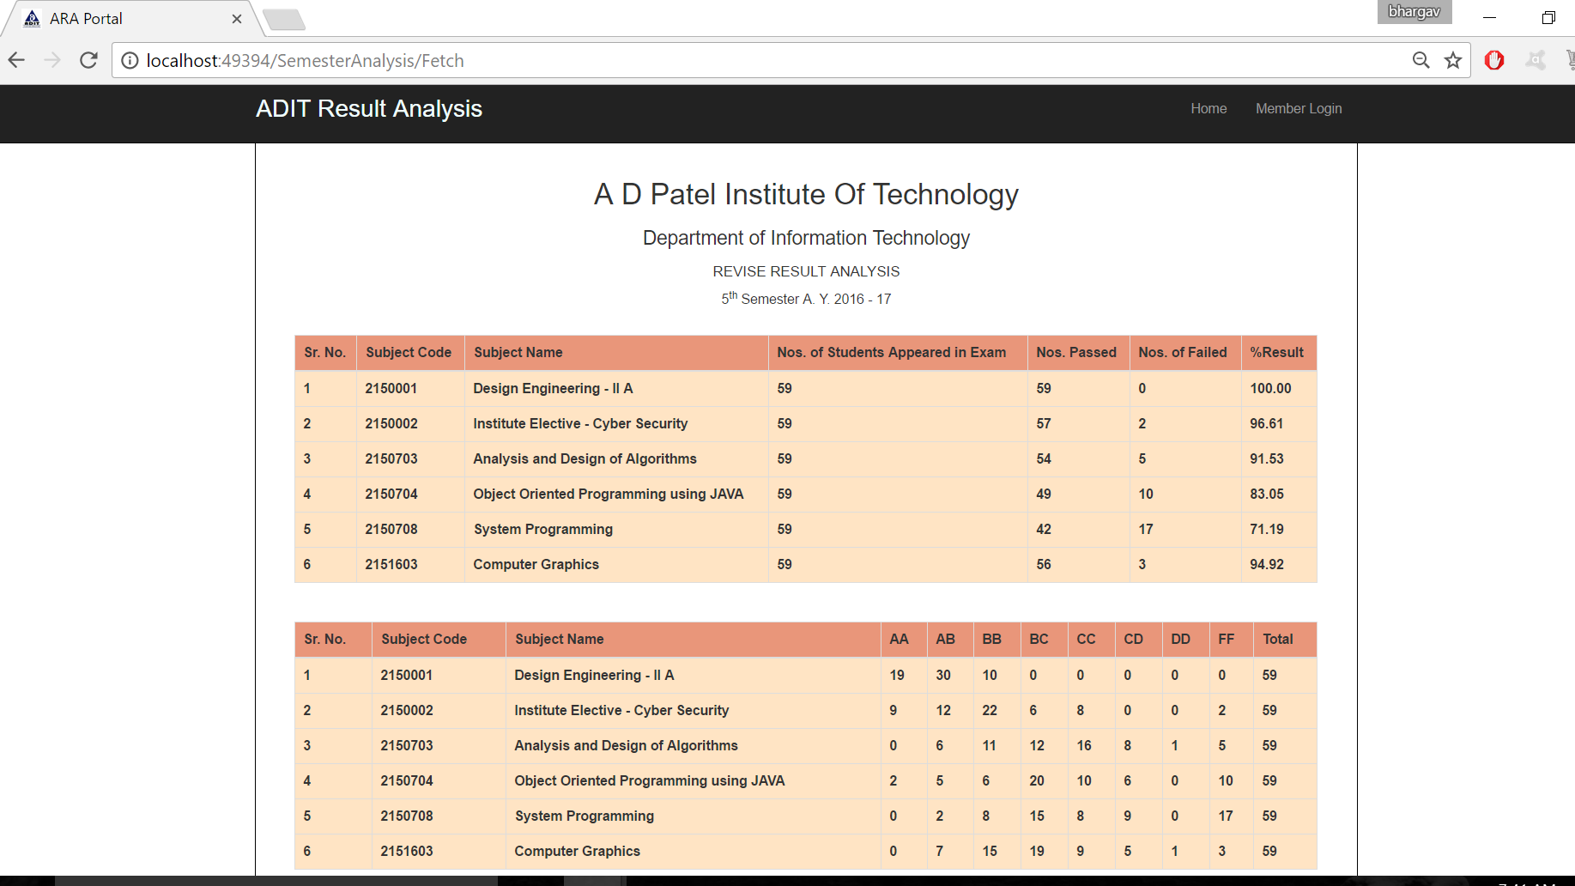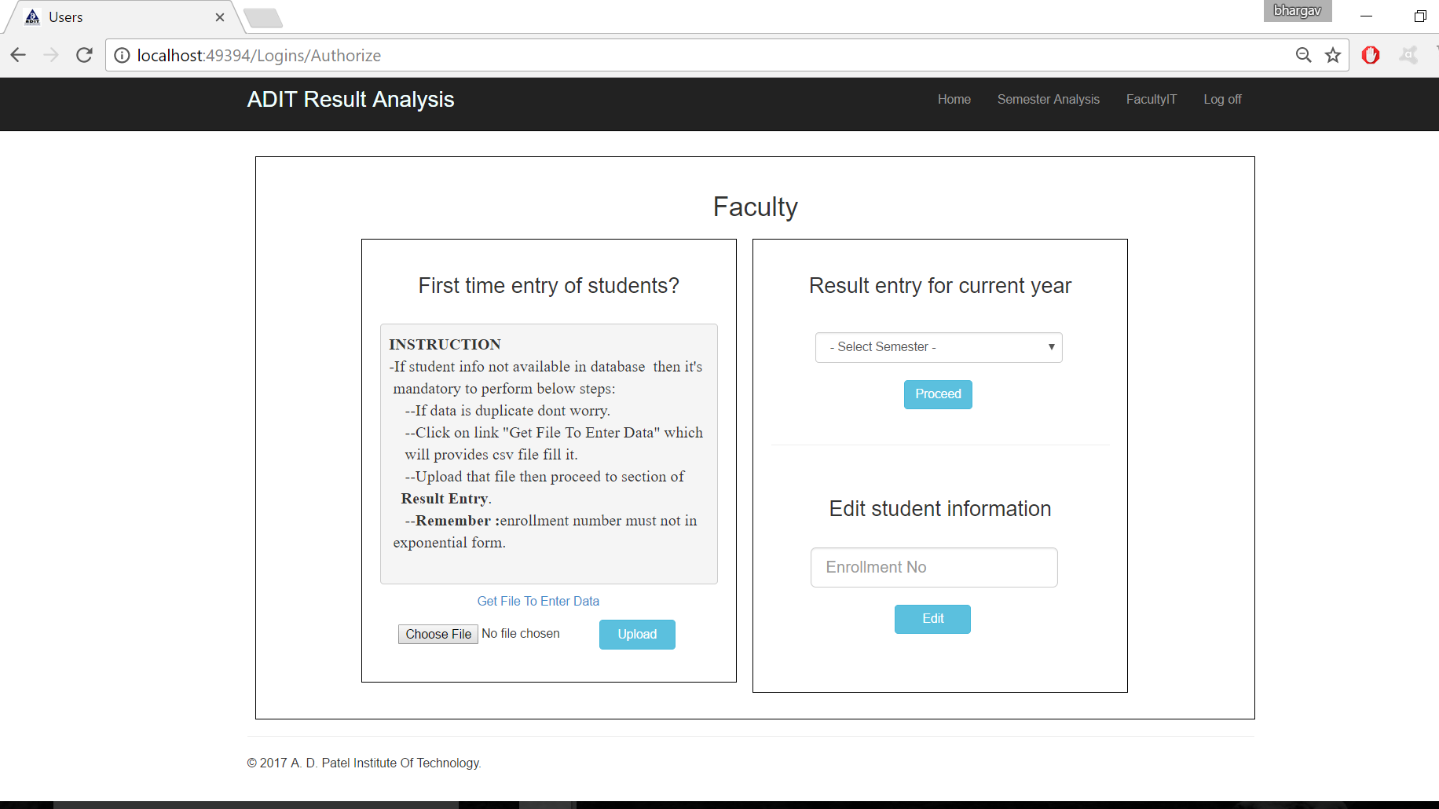

**Date:** 22 **/** 04 **/** 2017

**Sign: ________________**

**A.D PATEL INSTITUTE OF TECHNOLOGY**

|  |  |  |
| --- | --- | --- |
| **DEPARTMENT OF INFORMATION TECHNOLOGY** | | |
| **Week 10: Implementation Phase** | | |
| Semester: 6th | Subject: Design Engineering II [B] 2160001 | Team Id: 11 |

- Models were generated based on Table structures specified in data base. ER diagram of models:

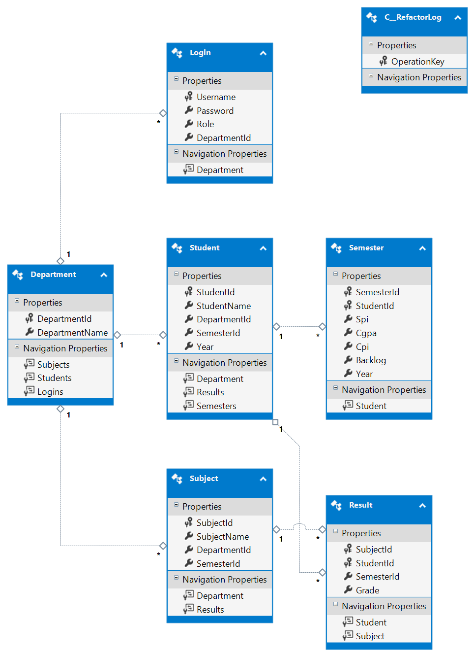

* Http request handling and session management task was done in this time period (Authorize method).

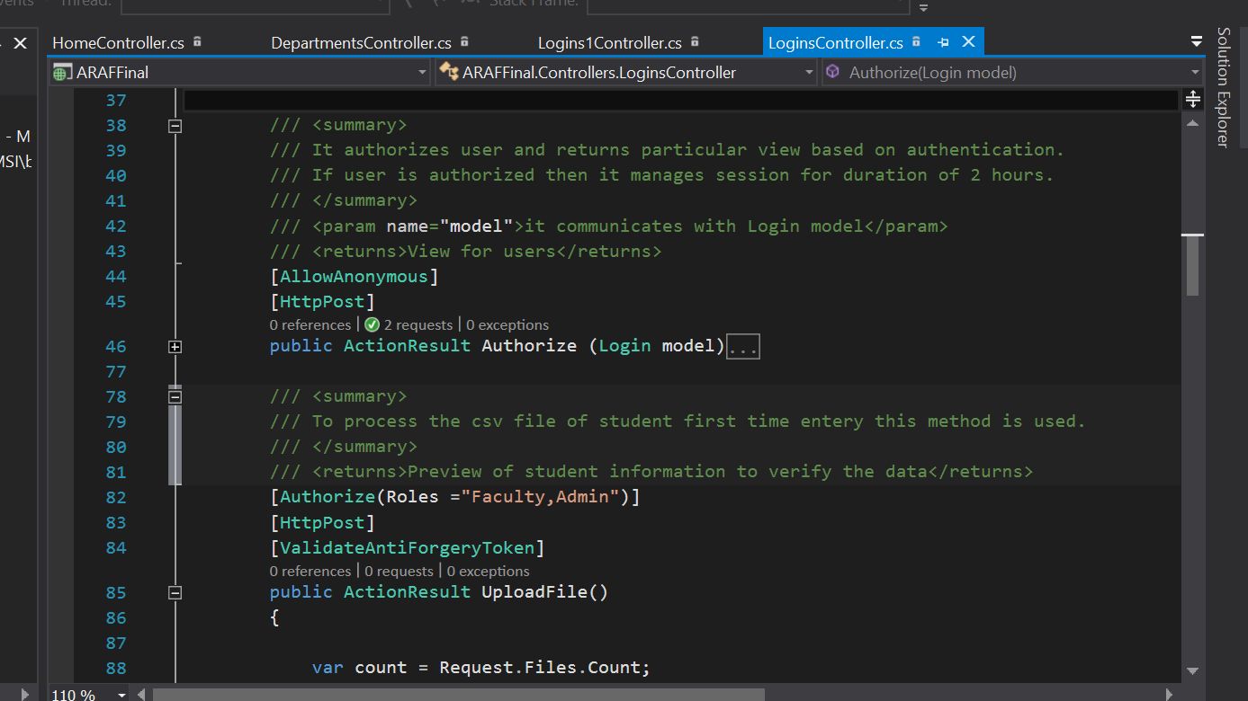

* File handling (CSV handling) was done based on some constraint (UploadFile method).

**Date:** 29 **/** 04 **/** 2017

**Sign: _______________**

**A.D PATEL INSTITUTE OF TECHNOLOGY**

|  |  |  |
| --- | --- | --- |
| **DEPARTMENT OF INFORMATION TECHNOLOGY** | | |
| **Week 11: Testing Phase** | | |
| Semester: 6th | Subject: Design Engineering II [B] 2160001 | Team Id: 11 |

* Testing task was done in this time period. Task were specified below:
* Security check (SQL injection, vulnerable login task)

For example,

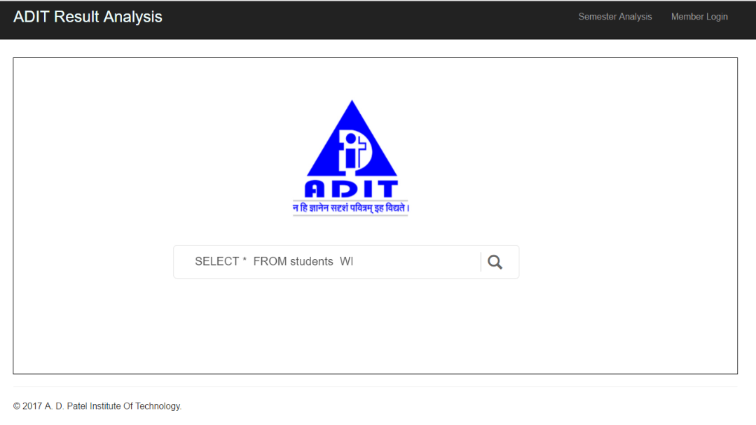

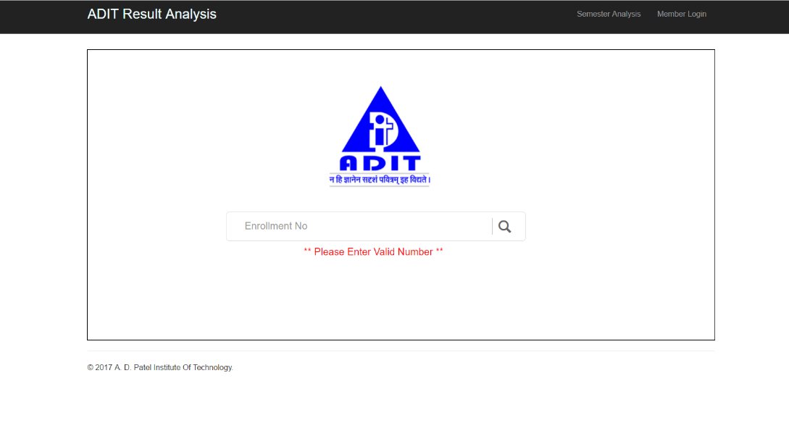

* User operability (random user was invited to use that application and took feedback)
* Team was continuously checking any further development is necessary or not.
* Because of Agile development method is followed continuous implementation phase was actually going on parallelly with testing phase.

**Date:** 04 **/** 05 **/** 2017

**Sign: ________________**

**A.D PATEL INSTITUTE OF TECHNOLOGY**

|  |  |  |
| --- | --- | --- |
| **DEPARTMENT OF INFORMATION TECHNOLOGY** | | |
| **Week 12: Testing Phase** | | |
| Semester: 6th | Subject: Design Engineering II [B] 2160001 | Team Id: 11 |

* Testing task was done in this time period is specified below:

**Black Box testing:**

In this period of time team was trying to approach standard way of testing which was learned into Software engineering subject

Black box testing is generally used to testing functionality of system so that team tried to use web application various ways and prepared functionality list which is specified below.

* Enrollment wise search for result
* Authorized user login
* CSV file manipulation
* Department wise semesters analysis
* Admin access to all database tables

**Date:** 06 **/** 05 **/** 2017

**Sign: ________________**

**A.D PATEL INSTITUTE OF TECHNOLOGY**

|  |  |  |
| --- | --- | --- |
| **DEPARTMENT OF INFORMATION TECHNOLOGY** | | |
| **Week 13: Testing Phase** | | |
| Semester: 6th | Subject: Design Engineering II [B] 2160001 | Team Id: 11 |
|  |  |  |

* Testing task was done in this time period is specified below:

**White Box Testing:**

White box testing is generally used for optimization of program that means internal structure of program can change but it will not affect user interface of the program.

List of method which is optimized

|  |  |
| --- | --- |
| **Controller** | **Method** |
| LoginsController | ResultEntry() |
| LoginsController | Update() |
| LoginsController | ResultUpdate() |
| SemesterAnalysisController | Fetch() |

**Date:** 13 **/** 05 **/** 2017

**Sign: ________________**

**A.D PATEL INSTITUTE OF TECHNOLOGY**

|  |  |  |
| --- | --- | --- |
| **DEPARTMENT OF INFORMATION TECHNOLOGY** | | |
| **Week 14: Re-Implementation & Testing** | | |
| Semester: 6th | Subject: Design Engineering II [B] 2160001 | Team Id: 11 |

In testing phases some issues was noted that some functionality doesn’t work perfectly. So that team decided to re-implement some methods which is listed below with description

|  |  |  |
| --- | --- | --- |
| **Controller** | **Method** | **Changes** |
| StudentInfoController | SearchByEnrollment() | Ranks calculation mechanism was not optimized so created some new methods GetCurrentRank() and GetOverallRank() and used into  This method |
| HomeController | Search() | Method was contained 7 LINQ queries which is optimized and reduced to 3 queries. |
| LoginsController | Authorize() | Method was using Authorization cookie time duration about 30 minutes which was reset to 2 hours. |
| SemesterAnalysisController | Index() | Content of the page was not returned perfectly by this method so, some changes in variables were done. |

After reimplementation of these methods black box & white box testing was carried out and worked perfectly.

**Date:** 20 **/** 05 **/** 2017

**Sign: ________________**