Benchmarking Multi-Objective Routing Policies for Multilingual Helpdesk Queries
Research Paper 2: Evaluation Methodology
- BHARGAVA RAMA SASTRY | Reg. No.2520030303 | Department of CSE, KLH
Guide: ASIF SHAIK | 2026
Abstract—Routing studies usually report cost savings on English benchmarks, which does not show whether a router is fair across languages, keeps sensitive data local, or meets latency targets. This paper defines a benchmark protocol for multi-objective routing in a multilingual helpdesk setting. The protocol specifies a labeled multilingual dataset with privacy and acceptability annotations, six evaluation metrics, five systems under test, a held-out experimental protocol with normal and degraded network conditions, and ablations that test each component of the proposed router. We also state falsifiable hypotheses and threats to validity. The protocol is designed so that a router cannot appear strong by performing well on one language or by sending sensitive data to the cloud. It is applied to the router described in the companion paper; results will be reported when the experiments are complete.
Index Terms—LLM routing, benchmarking, multilingual evaluation, privacy, latency, cost-aware inference, fairness.

I. INTRODUCTION
Routing studies such as RouteLLM [1] and Hybrid LLM [2] report cost savings mainly on English benchmarks. Privacy-aware cloud–edge systems, such as PRISM [3], report privacy and latency results without a multilingual evaluation. Helpdesk operators, however, need evidence on all of these dimensions at once. They must know whether a router serves users in each language fairly, keeps personal data local when required, and meets latency targets under realistic network conditions.
This paper defines such a benchmark. Fig. 1 gives an overview of the protocol. The contributions are (i) a dataset design with privacy and acceptability labels in multiple languages, (ii) a metric suite that covers cost, latency, privacy, quality, and fairness, (iii) a set of baselines and ablations that isolate each design choice, and (iv) explicit hypotheses and threats to validity.
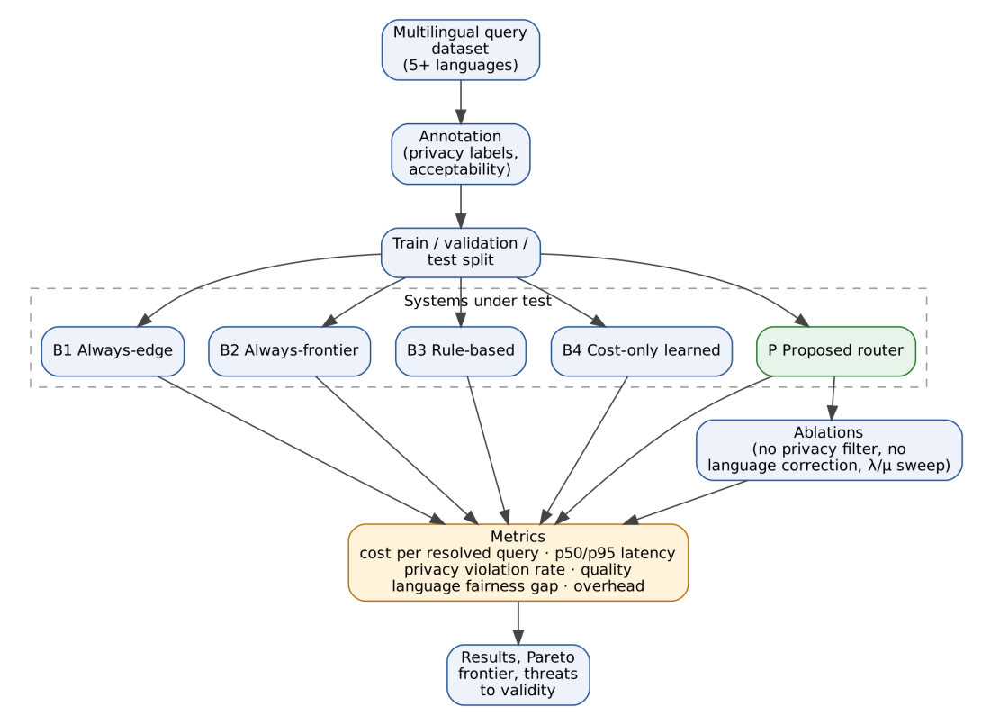
Fig. 1. Evaluation pipeline. A labeled multilingual dataset is split and passed to five systems. All systems are scored on the same metrics, and ablations test the components of the proposed router.

II. DATASET CONSTRUCTION
Language differences affect both cost and quality [4], [5], so the dataset must cover several languages and must label them consistently. Reasoning accuracy also drops for lower-resource languages [6]. Reasoning accuracy also drops for lower-resource languages [6]. Table I gives the design.
TABLE I. DATASET DESIGN
Element | Specification
Languages | At least five: English and Spanish (high-resource), Hindi (medium-resource), and Telugu and Tamil (lower-resource). The final choice should reflect the operator’s user base.
Queries per language | Approximately [N]
Categories | Billing, account access, technical troubleshooting, product information, complaints
Privacy labels | Low, moderate, or critical. Two annotators label each query; a third resolves disagreements.
Acceptability judgments | Reference answer or rubric per query. Judged by native-speaker annotators.
Agreement reporting | Inter-annotator agreement reported for privacy labels and acceptability judgments
Splits | Training, validation, and test splits by query template and category, so that no near-duplicates cross splits
Queries will be generated for each category, translated, and checked by native speakers. Translated queries will be marked as such, and the test set will include natural queries where they can be obtained.

III. METRICS
Table II lists the six metrics. All are reported per system and per language.
TABLE II. EVALUATION METRICS
No. | Metric | Definition | Direction
M1 | Cost per resolved query | Total API and compute cost divided by the number of acceptable answers | Lower is better
M2 | Latency | p50 and p95 end-to-end response time, including routing overhead | Lower is better
M3 | Privacy violation rate | Fraction of critical queries that reached a cloud tier | Target 0%
M4 | Quality | Fraction of answers judged acceptable | Higher is better
M5 | Language fairness gap | Difference in acceptable-answer rate between the highest- and lowest-resource languages | Lower is better
M6 | Routing overhead | Time and cost added by the router itself | Lower is better

IV. SYSTEMS UNDER TEST
Five systems are compared. Table III states the differences between them. The proposed router (P) is the design described in the companion paper. The cost-only learned router (B4) is modeled on RouteLLM [1], which is open source and uses preference data.
TABLE III. SYSTEMS UNDER TEST
Code | System | Routing behavior | Privacy filter | Latency term | Language correction
B1 | Always-edge | Smallest local model for all queries | Not applicable | Not applicable | Not applicable
B2 | Always-frontier | Strongest cloud model for all queries | Not applicable | Not applicable | Not applicable
B3 | Rule-based | Routes by language and keyword rules only | No | No | No
B4 | Cost-only learned | RouteLLM-style router trained on the same data | No | No | No
P | Proposed router | Policy from the companion paper | Yes (hard) | Yes | Yes

V. EXPERIMENTAL PROTOCOL
Each system is run on the same held-out test set. The quality predictor is trained on a separate split with no overlap in queries or templates. Latency is measured under two conditions, shown in Table IV. Each configuration is run [k] times, and results are reported as means with 95% confidence intervals computed by bootstrap resampling over queries.
TABLE IV. EXPERIMENTAL CONDITIONS
Condition | Description | Purpose
Normal network | Typical cloud latency for each provider | Baseline latency comparison
Simulated cloud slowdown | Added delay on cloud tiers | Tests whether the router avoids slow tiers under stress
Held-out test set | No overlap with training or calibration queries | Unbiased estimate of quality and fairness

VI. ABLATIONS
Three ablations isolate the components of the proposed router. Table V gives the design.
TABLE V. ABLATION DESIGN
Ablation | Component removed or varied | Expected effect | Metric checked
A1 | Privacy filter | Nonzero privacy violations | M3
A2 | Language correction | Larger language fairness gap | M5
A3 | Sweep of cost weight λ and latency weight μ | Trade-off curve between cost and quality | Cost versus quality Pareto frontier

VII. HYPOTHESES
The following hypotheses will be tested against the results.
- H1. The proposed router has a smaller language fairness gap (M5) than B4, because B4 does not model language-specific quality.
- H2. For queries routed to the edge, the proposed router has a lower p95 latency (M2) than B2.
- H3. Removing the privacy filter (A1) produces a nonzero privacy violation rate (M3), which shows that the filter is necessary rather than cosmetic.
These hypotheses could be refuted, and the paper will report the outcome in either case.

VIII. RESULTS
Results will be reported when the experiments are complete. Table VI gives the template that will be filled in.
TABLE VI. RESULTS TEMPLATE (TO BE COMPLETED)
System | Quality (M4) | Cost (M1) | p50 latency (M2) | p95 latency (M2) | Privacy violations (M3) | Fairness gap (M5)
B1 Always-edge | [ ] | [ ] | [ ] | [ ] | [ ] | [ ]
B2 Always-frontier | [ ] | [ ] | [ ] | [ ] | [ ] | [ ]
B3 Rule-based | [ ] | [ ] | [ ] | [ ] | [ ] | [ ]
B4 Cost-only learned | [ ] | [ ] | [ ] | [ ] | [ ] | [ ]
P Proposed router | [ ] | [ ] | [ ] | [ ] | 0 (target) | [ ]

IX. THREATS TO VALIDITY
TABLE VII. THREATS TO VALIDITY AND MITIGATIONS
Threat | Description | Mitigation
Annotation bias | Annotators may disagree on acceptability, especially for complaints | Two annotators plus adjudication; report agreement
Model drift | Cloud models change over time | Report model versions and access dates
Price volatility | Cost figures depend on current pricing | Report pricing dates; recompute costs from logged tokens
Dataset representativeness | Generated or translated queries may not match real helpdesk language | Include natural queries where possible; report the proportion
Translation artifacts | Translated queries may read unnaturally | Native-speaker review of every translated query

X. FEASIBILITY OF THE EVALUATION
The evaluation requires three resources: API access to one on-device model and two cloud models, annotation time from native speakers, and compute for the quality predictor. API costs are controlled by logging token counts and capping query numbers during development. Annotation effort scales with the number of languages, so the protocol allows a reduced set of languages if annotators are limited. The protocol is designed so that each system can be run independently, which allows the experiments to be completed in stages.

XI. CONCLUSION
This paper defined a benchmark protocol for multi-objective routing in a multilingual helpdesk setting. The protocol measures cost, latency, privacy, quality, and fairness together, and it isolates each design choice through baselines and ablations. Applying the protocol will show whether the proposed router meets its objectives, or where it does not.

REFERENCES
[1] I. Ong et al., “RouteLLM: Learning to route LLMs with preference data,” in Proc. Int. Conf. Learn. Represent. (ICLR), 2025. arXiv:2406.18665.
[2] D. Ding et al., “Hybrid LLM: Cost-efficient and quality-aware query routing,” in Proc. Int. Conf. Learn. Represent. (ICLR), 2024. arXiv:2404.14618.
[3] J. Zhan, H. Shen, Z. Lin, and T. He, “PRISM: Privacy-aware routing for adaptive cloud–edge LLM inference via semantic sketch collaboration,” in Proc. AAAI Conf. Artif. Intell., 2026. arXiv:2511.22788.
[4] O. Ahia, S. Kumar, H. Gonen, J. Kasai, D. R. Mortensen, N. A. Smith, and Y. Tsvetkov, “Do all languages cost the same? Tokenization in the era of commercial language models,” in Proc. Conf. Empirical Methods Natural Lang. Process. (EMNLP), 2023. arXiv:2305.13707.
[5] A. Petrov, E. La Malfa, P. H. S. Torr, and A. Bibi, “Language model tokenizers introduce unfairness between languages,” in Proc. Adv. Neural Inf. Process. Syst. (NeurIPS), 2023. arXiv:2305.15425.
[6] F. Shi et al., “Language models are multilingual chain-of-thought reasoners,” in Proc. Int. Conf. Learn. Represent. (ICLR), 2023. arXiv:2210.03057.

