
Department of CSE

B.Tech. CSE Trimester -5

Roll No:- 2520030303
Name:- P.Bhargava Rama Sastry

Cloud Infrastructure and Services
25CS2206E

LAB RECORD
2026

Experiment -2

AIM: To create an AWS New Zero Budget.

Description:
Creating an AWS New Zero Budget environment involves setting up and configuring an Amazon Web Services account to use cloud computing resources while minimizing costs. It focuses on utilizing AWS Free Tier benefits, available credits, and eligible services to deploy and manage cloud resources without exceeding the allocated budget. This process includes configuring billing alerts, setting up AWS Budgets, monitoring resource usage, and applying cost-control measures to prevent unexpected charges.
Steps:

- Login to the AWS Management Console.
- In the top search bar, type Billing and open Billing and Cost Management.
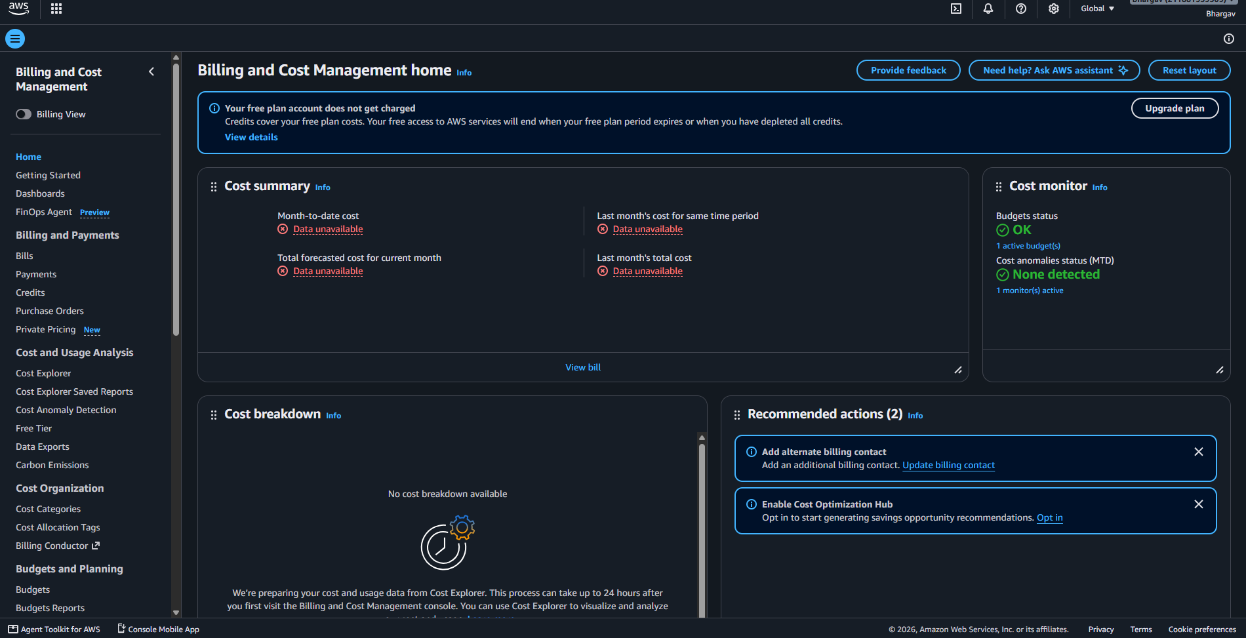
- From the left navigation pane, click Budgets.

- Click Create budget.
- 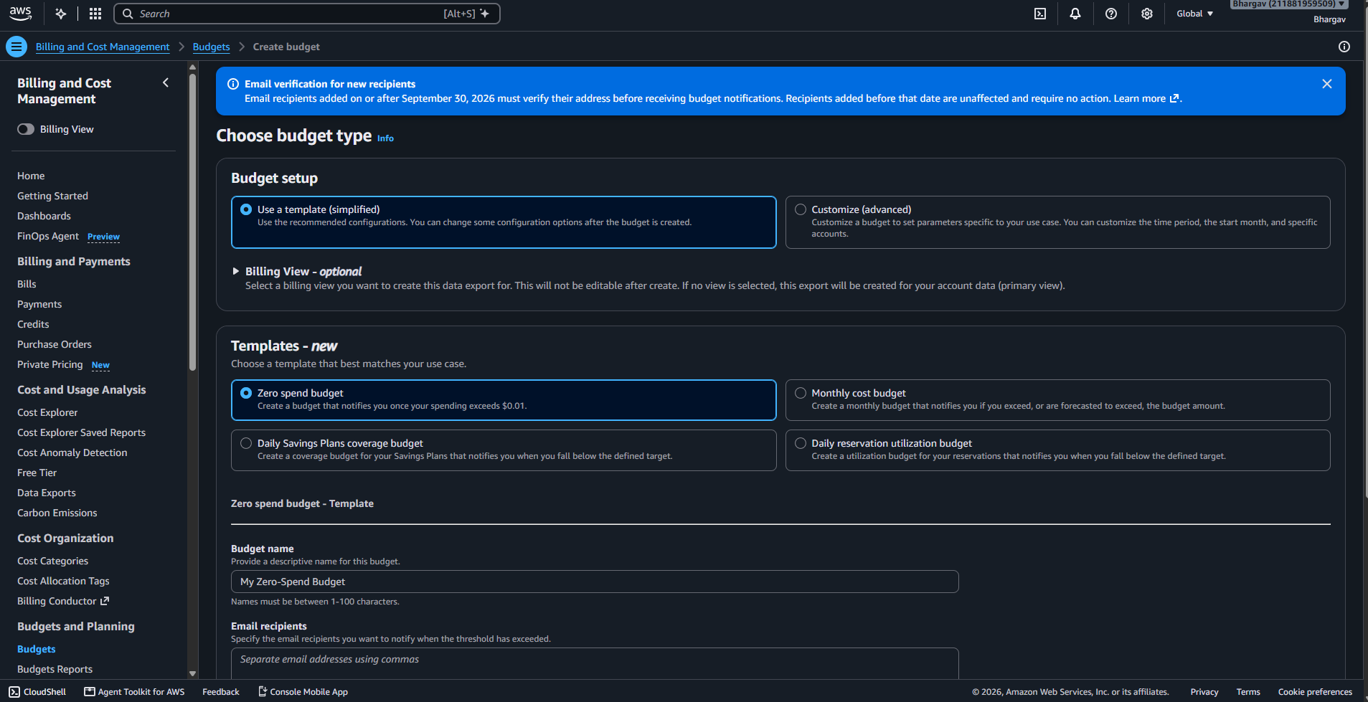
- Select Cost budget → Click Next.
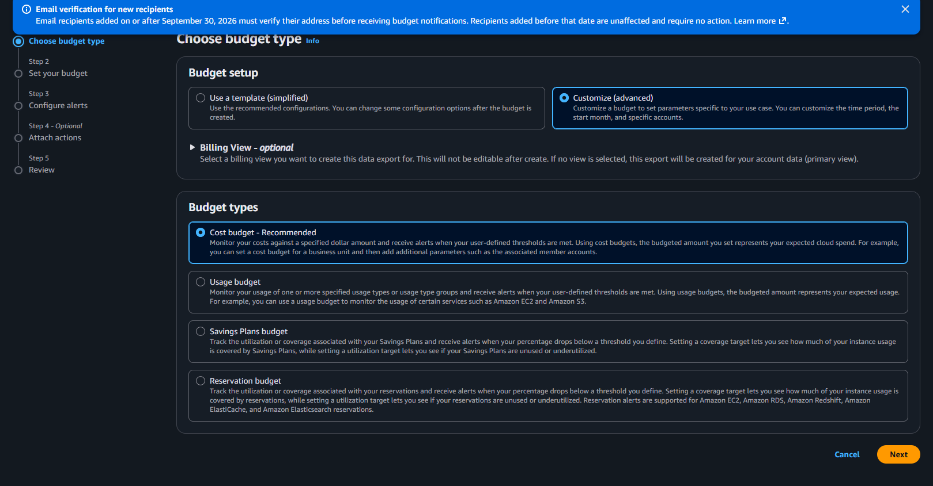
Budget Configuration
- Enter Budget name: Zero-Budget-FreeTier.
- Set Period: Monthly.
- Set Budget effective dates:
  - Start date: Current month
  - End date: Leave empty (ongoing)
- Under Budget amount, enter:
  - Amount: 0
  - Currency: USD (default)
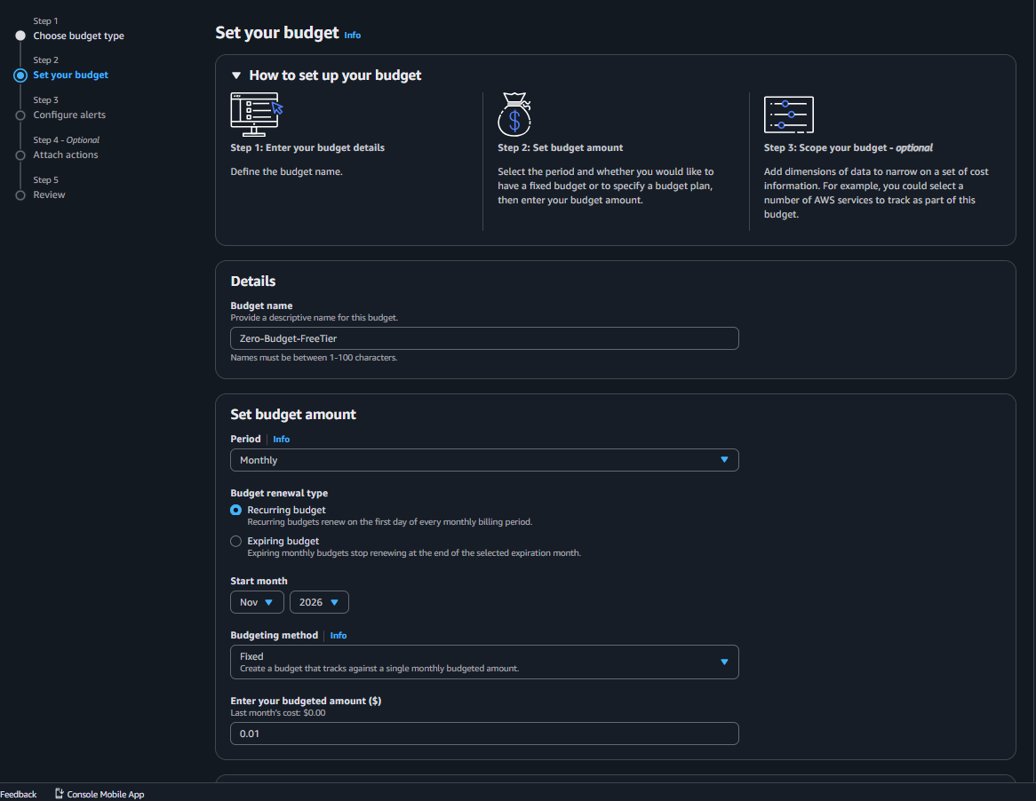
Scope (Optional but Recommended)
- Keep default settings (applies to entire AWS account).
Alerts Configuration
- Click Add alert threshold.
- Configure alert:
  - Threshold type: Actual costs
  - Alert condition: Greater than
  - Amount: 0 USD
- Notification:
  - Email recipients: Your registered email ID
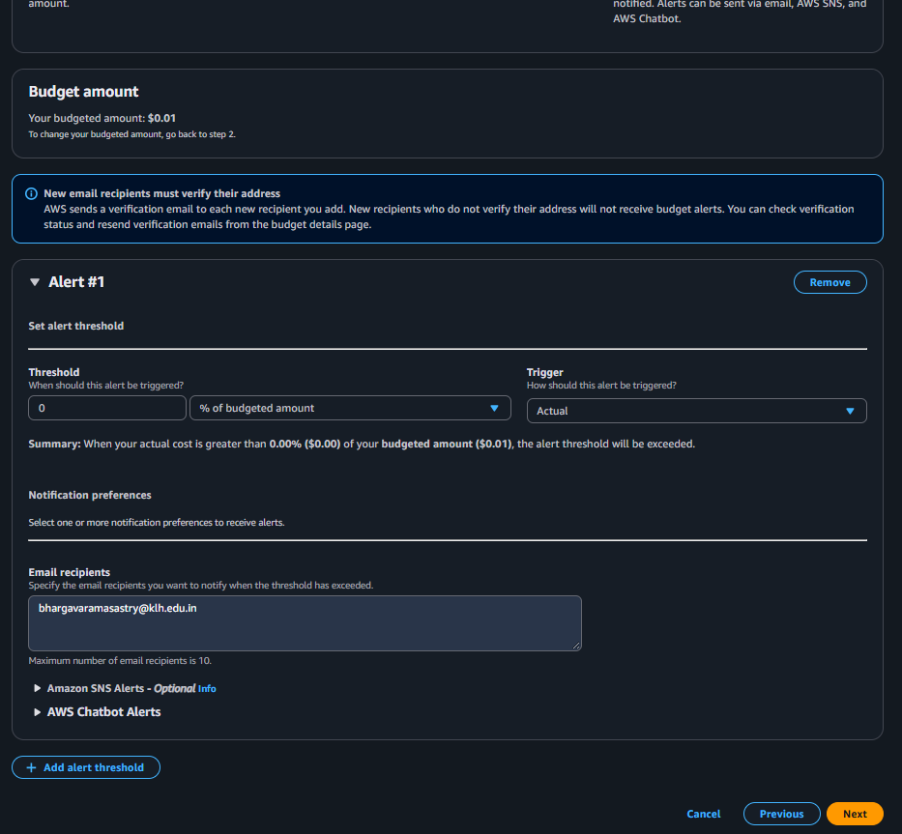
- Click Next.
Review and Create
- Review all settings.
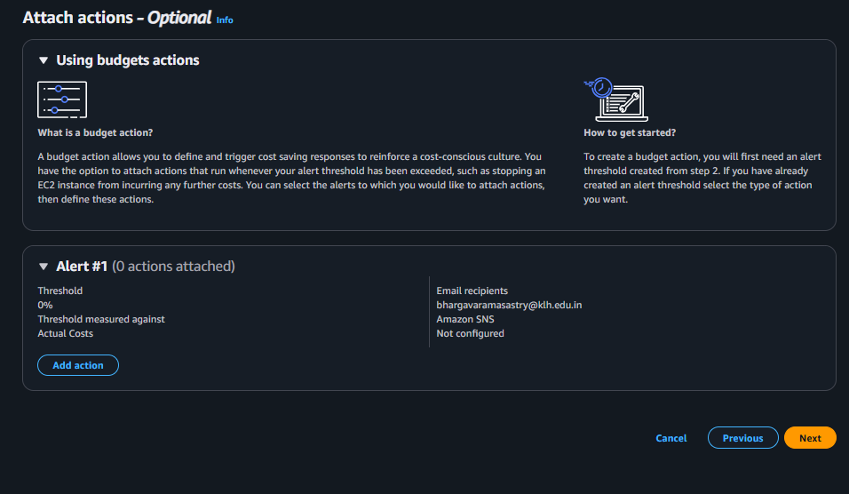
- Click Create budget.
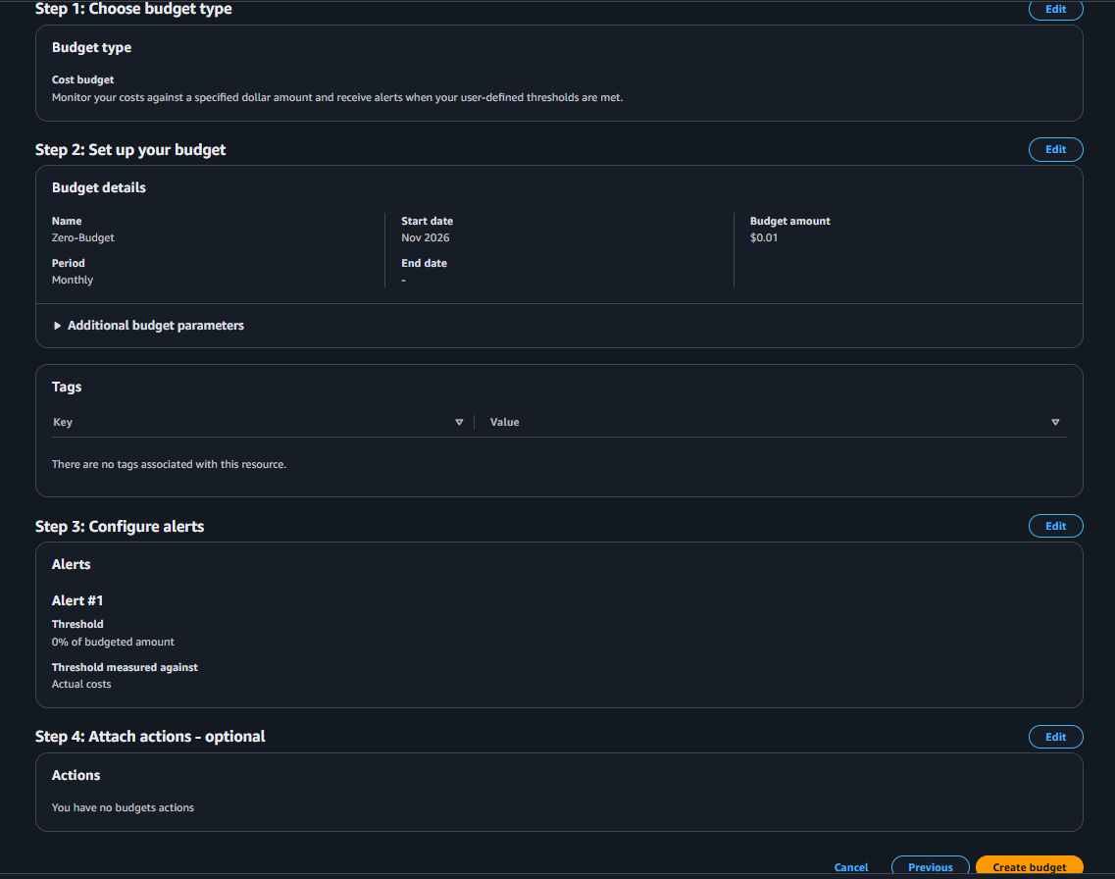
Verification
- Budget Zero-Budget-FreeTier appears in the Budgets list.
When any cost is incurred (> $0), an email alert will be sent immediately.
Output:


