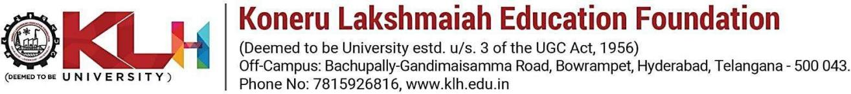

Mohd. Razia
Podila Bhargava Rama Sastry
2520030303
CSE
CO-4

Case Study Topic: Shortest Path Optimization for Document Routing using Dijkstra’s Algorithm in DocuTrack

DocuTrack is a Digital Document Management and Retrieval System used to store and transfer digital documents across multiple departments. Documents often travel through different processing stages such as verification, approval, review, and archival.
To optimize document transfer and reduce processing time, Dijkstra’s Shortest Path Algorithm was implemented. The system models departments as graph nodes and transfer paths as weighted edges representing transfer time.
The implementation demonstrates how the shortest routing path can be identified efficiently for faster document movement inside the organization.
Problem Statement
In the DocuTrack system, documents pass through multiple departments before final approval. Different routes may take different processing times.
The challenge is to:
- Find the shortest processing path.
- Reduce document transfer delay.
- Optimize routing efficiency.
- Improve overall workflow performance.

Proposed Solution

Dijkstra’s Algorithm is used to calculate the shortest path between departments.
Why Dijkstra’s Algorithm?
- Efficient shortest path calculation.
- Works well for weighted graphs.
- Reduces document routing time.
- Improves workflow optimization.
- Suitable for network routing systems.

Implementation Details:

Operations Performed

Create weighted graph.

Define departments and transfer costs.

Apply Dijkstra’s Algorithm.

Calculate shortest routing path.

Display optimized document route.
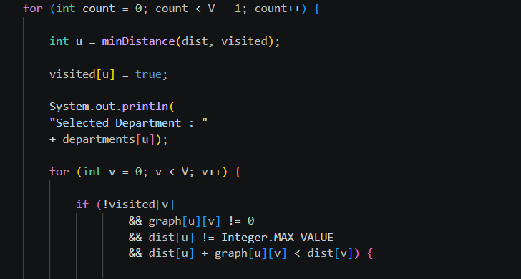

Result: Screenshots/Output

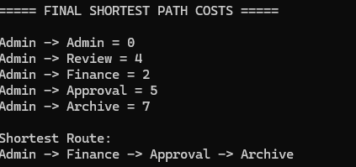

- Shortest routing path identified successfully.
- Transfer cost minimized.
- Workflow efficiency improved.
- Faster document movement achieved.

GitHub Link:

https://github.com/bhargavram-hub/DoctTrack--Digital-Document-Management-Retrieval-System-.

