

Mohd. Razia
Podila Bhargava Rama Sastry
2520030303
CSE
CO-5

Case Study Topic: Efficient Document Sorting using Merge Sort and Quick Sort in DocuTrack

DocuTrack stores large collections of documents such as reports, invoices, research papers, and meeting records. Efficient document sorting is necessary for quick retrieval and organized storage.
In this case study, Merge Sort and Quick Sort algorithms were implemented to sort documents based on Document IDs. The performance and efficiency of both sorting techniques were analyzed and compared.
The implementation demonstrates how advanced sorting algorithms improve document organization and retrieval operations.
Problem Statement
As document repositories grow, sorting documents manually or using inefficient methods becomes difficult.
The challenge is to:
- Sort large document collections efficiently.
- Reduce sorting time.
- Improve retrieval speed.
- Compare sorting algorithm performance.

Proposed Solution

Merge Sort and Quick Sort algorithms are implemented for document sorting.

Why Merge Sort?
- Stable sorting algorithm.
- Efficient for large datasets.
- Time Complexity: O(n log n)

Why Quick Sort?
- Faster average-case performance.
- Efficient memory utilization.
- Widely used in practical systems.

Implementation Details:

Operations Performed

Create unsorted document dataset.

Apply Merge Sort.

Apply Quick Sort.

Compare sorted outputs.

Analyze sorting efficiency.

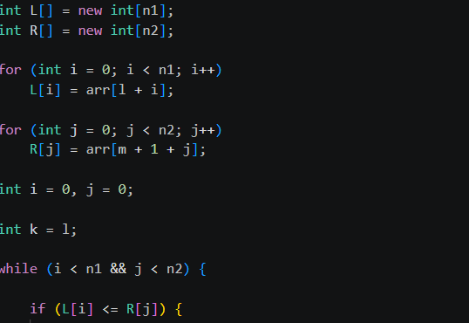

Result: Screenshots/Output

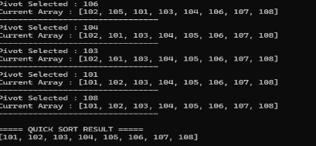

1) Documents sorted successfully.
2) Merge Sort maintained stable ordering.
3) Quick Sort showed faster execution.
4) Sorting improved retrieval efficiency.

GitHub Link:

https://github.com/bhargavram-hub/DoctTrack--Digital-Document-Management-Retrieval-System-.

