

Mohd. Razia
Podila Bhargava Rama Sastry
2520030303
CSE
CO-1

Case Study Topic: Document Metadata Indexing using AVL Tree in DocuTrack

The DocuTrack system stores a large number of digital documents. Efficient document retrieval is essential for quick access to records. To solve this problem, an AVL Tree was implemented to store document metadata using Document IDs as keys.
The AVL Tree automatically balances itself after every insertion and deletion operation. This ensures that document search operations remain efficient even when the number of stored documents increases. The implementation demonstrates how self-balancing binary search trees can be used in document management systems to achieve faster indexing and retrieval.
This case study is directly related to the DocuTrack project because document repositories require fast searching and organized storage of metadata.
Problem Statement

DocuTrack is a Digital Document Management and Retrieval System that stores a large number of documents. Each document
is assigned a unique Document ID for identification and retrieval.
As new documents are uploaded continuously, the document IDs are often generated in sequential order. If a normal Binary Search Tree (BST) is used for indexing, sequential insertions can create a skewed tree structure, increasing search time and reducing retrieval efficiency.
The challenge is to design an indexing mechanism that:
- Maintains a balanced structure.
- Supports fast document search.
- Handles continuous document insertions efficiently.
- Improves retrieval performance for large repositories.

Proposed Solution

To overcome the limitations of a normal BST, an AVL Tree is used for document indexing.

Why AVL Tree?
An AVL Tree is a self-balancing Binary Search Tree that automatically maintains balance after every insertion and deletion operation.

Implementation Details:

Operations Performed
- Insert document records into AVL Tree.
- Search document records using Document ID.
- Perform tree balancing using rotations.
- Display document records using Inorder Traversal.

Steps Followed
- Created AVL Tree node structure.
- Inserted document IDs into the tree.
- Calculated node heights after insertion.
- Applied rotations whenever imbalance occurred.
- Performed search operation for document retrieval.
- Displayed indexed document records.
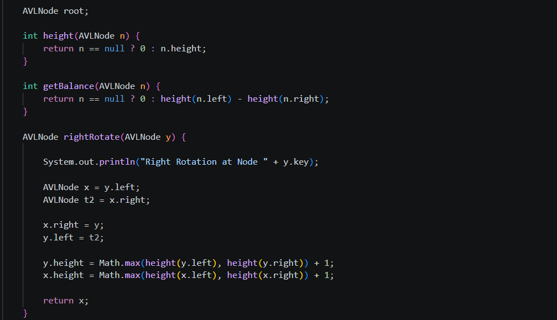

Result: Screenshots/Output

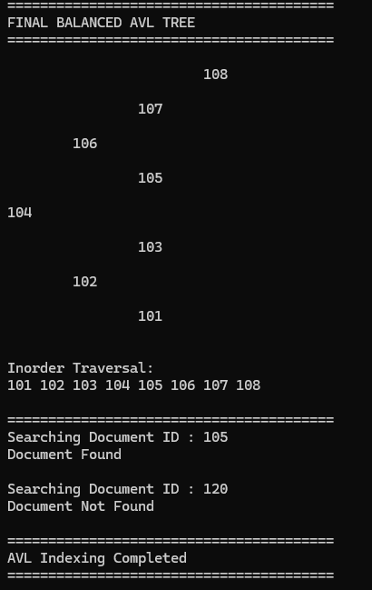

• AVL Tree maintained balanced structure.
• Search operations remained efficient.
• Document retrieval performance improved significantly.
• Suitable for document indexing applications.

GitHub Link:

https://github.com/bhargavram-hub/DoctTrack--Digital-Document-Management-Retrieval-System-.

