

Mohd. Razia
Podila Bhargava Rama Sastry
2520030303
CSE
CO-2

Case Study Topic: Document Database Indexing using B-Tree in DocuTrack

DocuTrack is a Digital Document Management and Retrieval System that stores a large number of documents such as
reports, invoices, project files, research papers, and meeting records. As the number of documents increases, efficient
storage and retrieval become challenging.
To address this issue, a B-Tree based indexing mechanism was implemented. B-Trees are widely used in database
systems because they maintain balanced structures and allow efficient searching, insertion, and retrieval operations.
In this case study, document records are indexed using Document IDs as keys. The implementation demonstrates how
B-Tree indexing can improve document retrieval performance and organize document metadata efficiently.

Problem Statement
The DocuTrack system stores thousands of documents. Users frequently search for documents using Document IDs. A
simple sequential search becomes inefficient as the repository grows.
The challenge is to design an indexing mechanism that:
- Supports fast document retrieval.
- Maintains balanced indexing.
- Handles large document repositories efficiently.
- Reduces search time.

Proposed Solution
A B-Tree indexing structure is used to organize document records.
Why B-Tree?
- Self-balanced indexing structure.
- Efficient searching and insertion.
- Reduces storage access overhead.
- Commonly used in databases and file systems.
- Suitable for large-scale document repositories.

Implementation Details:
Insert document records.
Maintain sorted indexing.
Simulate node split operations.
Search document records.
Display final B-Tree structure.
.

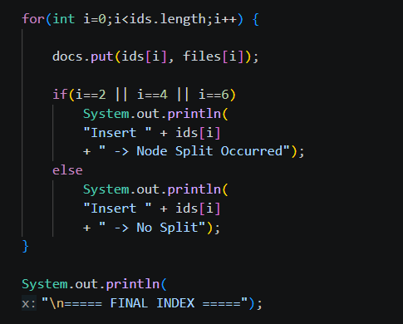
Result: Screenshots/Output

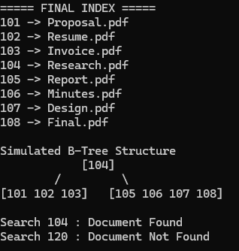

- Documents were indexed successfully.
2. Node splits maintained balanced structure.
3. Search operations were efficient.
- Index remained sorted after every insertion.
- B-Tree structure improved retrieval performance..

GitHub Link:

https://github.com/bhargavram-hub/DoctTrack--Digital-Document-Management-Retrieval-System-.

