

Mohd. Razia
Podila Bhargava Rama Sastry
2520030303
CSE
CO-3

Case Study Topic: Folder Hierarchy Traversal using BFS and DFS in DocuTrack

DocuTrack is a Digital Document Management and Retrieval System that organizes documents into folders and subfolders.
As the number of folders increases, efficient navigation becomes essential for quick document access.
To solve this problem, Breadth First Search (BFS) and Depth First Search (DFS) traversal algorithms were implemented.
These algorithms help users navigate folder structures efficiently and locate documents stored within different directories.
In this case study, a folder hierarchy is represented as a graph structure, and BFS and DFS algorithms are used to traverse
and display folder paths systematically.

Problem Statement

The DocuTrack system stores documents inside multiple folders and subfolders. Users often need to browse the folder
hierarchy to locate documents quickly.
The challenge is to:
- Navigate folder structures efficiently.
- Visit every folder without repetition.
- Display traversal paths clearly.
- Improve document discovery. .

Proposed Solution

Two graph traversal algorithms are implemented:
Breadth First Search (BFS)
BFS explores folders level by level.
Depth First Search (DFS)
DFS explores one branch completely before moving to another.
Why BFS and DFS?
- Efficient folder navigation.
- Complete traversal of folder hierarchy.
- Useful for document discovery.
- Supports retrieval operations.
- Widely used in file systems.

Implementation Details:
Folder Structure Used
Root
├── HR
├── Finance
└── Projects
├── Reports
└── Designs

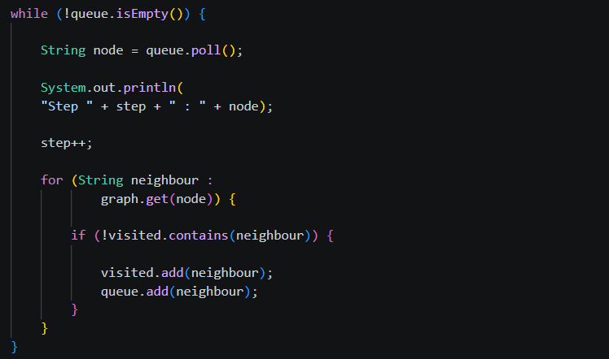

Result: Screenshots/Output

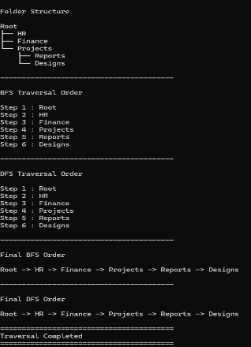

- Folder hierarchy was created successfully.
- BFS traversed folders level by level.
- DFS traversed folders depth-wise.
- All folders were visited exactly once.
- Traversal algorithms improved folder navigation efficiency.
GitHub Link:

https://github.com/bhargavram-hub/DoctTrack--Digital-Document-Management-Retrieval-System-.

