“Course Recommendation System”
Project Report submitted for the partial fulfilment of grade for the course
Data Structures and Algorithms -3 (25CS2103E)
in
DEPARTMENT OF COMPUTER SCIENCE ENGINEERING
by
M. DIJENDRA | :2520030164
CH. NRIPENDRA | :2520030280
P. BHARGAVA | :2520030303
Team Number: 7
Section: 6
Under the Guidance of
Dr. V. Sireesha
Professor
Department of Computer Science and Engineering


2026-27

DEPARTMENT OF COMPUTER SCIENCE ENGINEERING
Declaration
The Project Report entitled “Course Recommendation System” is a record of Bonafide work of M. DIJENDRA – 2520030164, CH. NRIPENDRA – 2520030280, P. BHARGAVA – 2520030303 submitted in partial fulfillment for the award of B. Tech in Computer Science and Engineering. The results embodied in this report have not been copied from any other departments/University/Institute.

M. DIJENDRA – 2520030164
CH. NRIPENDRA – 2520030280
P. BHARGAVA – 2520030303

DEPARTMENT OF COMPUTER SCIENCE ENGINEERING
CERTIFICATE
This is to certify that the mini project based report entitled “Course Recommendation System” is a bonafide work done and submitted by M. DIJENDRA – 2520030164, CH. NRIPENDRA – 2520030280, P. BHARGAVA – 2520030303 in partial fulfillment of the requirements for the award of the degree of BACHELOR OF TECHNOLOGY in Department of Computer Science Engineering, during the academic year 2026-27.

Signature of the Guide  (Dr. V. Sireesha) | Signature of the HOD  (Dr. P. Venkateshwara Rao)

Signature of the External Examiner

ACKNOWLEDGEMENT
We express our sincere gratitude to our project guide, Dr. V. Sireesha, Professor, Department of Computer Science and Engineering, for her constant guidance, encouragement and valuable suggestions throughout the development of this project. Her feedback in the review sessions helped us to improve both the design and the implementation of the Course Recommendation System.
We are thankful to Dr. P. Venkateshwara Rao, Associate Professor and Head of the Department of Computer Science and Engineering, for providing the facilities and the academic environment needed to complete this work. We also thank all the faculty members of the department who taught us the concepts of Data Structures and Algorithms that form the basis of this project.
Finally, we thank Koneru Lakshmaiah Education Foundation for the opportunity to carry out this project, and our friends and families for their support and motivation.

M. DIJENDRA – 2520030164
CH. NRIPENDRA – 2520030280
P. BHARGAVA – 2520030303

Abstract
Choosing the right courses from a large catalogue is a difficult decision for a student. Interests, career goals, completed courses, prerequisite chains and credit limits all have to be considered together, while most course portals offer only a static list that can be searched by exact name. This project presents CourseMatch, a Course Recommendation System that treats course discovery and planning as a set of algorithmic problems drawn from Data Structures and Algorithms-III (25CS2103E).
The system is a web application with a Node.js and Express backend that exposes a REST API, and an HTML, CSS and JavaScript frontend. Courses are searched by title, identifier, tag and description with the string-matching algorithms KMP, Z-Function and Rabin-Karp. When a query contains spelling mistakes, Wagner-Fischer edit distance with token similarity recovers the intended course. Prerequisites are modelled as a directed graph and traversed with depth-first search to decide eligibility and to list exactly which courses are still missing. A recommendation score based on the career goal, interests, level and prerequisite depth is combined with 0/1 Knapsack dynamic programming to choose the best set of eligible courses within a credit limit. Bipartite matching and Edmonds-Karp maximum flow model student-course allocation under limited seats, and a greedy approximation covers desired skills within a credit budget.
The project also includes an Algorithm Lab that makes the algorithms of course outcomes CO1 to CO6 executable from the browser, including sequence alignment, branch-and-bound scheduling, suffix structures, advanced dynamic programming, NP-completeness reduction, approximation, and randomized and parallel algorithms. Tests on a catalogue of 28 courses show that exact queries are ranked by relevance, misspelled queries are recovered, prerequisite chains are returned in the correct order and recommendations never exceed the credit limit. The result is a complete, explainable and extensible system that links the theory of the course with a practical academic tool.

Table of Contents
 |  |  | Page No.
 | Acknowledgement |  | iv
 | Abstract |  | v
 | Table of Contents |  | vi
 | List of Figures |  | vii
1 | Introduction | 1.1 Overview  1.2 Problem statement  1.3 Scope of the project  1.4 Objectives | 1-3
2 | System Requirements | 2.1 Functional Requirements  2.2 Non-Functional Requirements  2.3 Hardware and Software Requirements | 4-5
3 | System Design | 3.1 High-level Architecture Diagram  3.2 Description of each layer  3.3 Data design and graph models | 6-9
4 | Implementation | 4.1 Module-wise implementation  4.2 Front-end logic (UI rendering, state management)  4.3 API integration  4.4 Data persistence  4.5 Complexity summary  4.6 Setup and execution | 10-16
5 | Results | 5.1 Experimental setup  5.2 Course search  5.3 Prerequisite checking  5.4 Recommendation within a credit limit  5.5 Matching, flow and approximation  5.6 Algorithm Lab results  5.7 Discussion | 17-23
6 | Challenges & Limitations | 6.1 Issues faced during development  6.2 Solutions applied  6.3 Limitations of the System | 24-25
7 | Conclusion & Future Work | 7.1 Conclusion  7.2 Future Work  7.3 Skills learned during development | 26
 | References | - Books, research papers, tutorials and documentation sites used | 27

List of Figures
1.1 | Overview of the CourseMatch system: inputs, algorithm engine and outputs | 1
3.1 | Layered architecture of CourseMatch | 6
3.2 | Application workflow from query to learning path | 7
3.3 | Prerequisite graph of the 28-course catalogue | 9
3.4 | Flow network used for course allocation (example with three students) | 9
4.1 | Composition of the course catalogue by domain and level | 15
4.2 | Mapping of credit-limited course selection to 0/1 Knapsack | 11
4.3 | Home screen of CourseMatch | 13
4.4 | Project Map tab summarising the pipeline and CO coverage | 14
5.1 | Pattern-matching search for “machine learning” | 17
5.2 | Fuzzy search for the misspelled query “machne lerning” | 18
5.3 | Prerequisite path shown for Natural Language Processing | 18
5.4 | Learning path generated for the AI/ML goal with a 12-credit limit | 19
5.5 | CO1 module: sequence alignment and branch-and-bound scheduling | 21
5.6 | CO2 module: string matching and suffix structures | 21
5.7 | CO4 module: bipartite matching and maximum flow | 22
5.8 | CO5 module: 3-SAT to Vertex Cover reduction and 2-approximation | 22
5.9 | CO6 module: randomized and parallel algorithms | 23

1. INTRODUCTION

1.1 Overview
Every semester a student has to choose from a large catalogue of courses. The right choice depends on many things at once: personal interests, a career goal, the courses already completed, the prerequisites of each new course, and the number of credits that can be taken. A plain list of courses on a portal answers none of these questions, and a small spelling mistake in a search box usually returns nothing at all.
CourseMatch is the Course Recommendation System developed in this project for the course Data Structures and Algorithms-III (25CS2103E). It treats course discovery and planning as a set of algorithmic problems and solves each one with the technique that fits it best. Course titles, identifiers, tags and descriptions are searched with the string-matching algorithms KMP, Z-Function and Rabin-Karp. Misspelled queries are recovered with Wagner-Fischer edit distance. Prerequisites are stored as a directed graph that is traversed with depth-first search (DFS). The best set of courses that fits inside a credit limit is chosen with 0/1 Knapsack dynamic programming. Student-to-course allocation under limited seats is modelled with bipartite matching and the Edmonds-Karp maximum-flow algorithm, and a greedy approximation covers the skills a student wants to acquire.
The system follows the client-server model shown in Fig. 1.1. A student enters a query, interests, a career goal, completed courses and a credit limit in a browser. The Node.js and Express backend runs the relevant algorithms over a JSON course catalogue of 28 courses spread across five domains (Software Engineering, Web Development, Data Science, AI/ML and Cybersecurity), and returns ranked courses, prerequisite paths and an optimized learning path. In addition, an interactive Algorithm Lab makes the algorithms of course outcomes CO1 to CO6 executable from the browser, so that every concept of the syllabus can be demonstrated on live input.
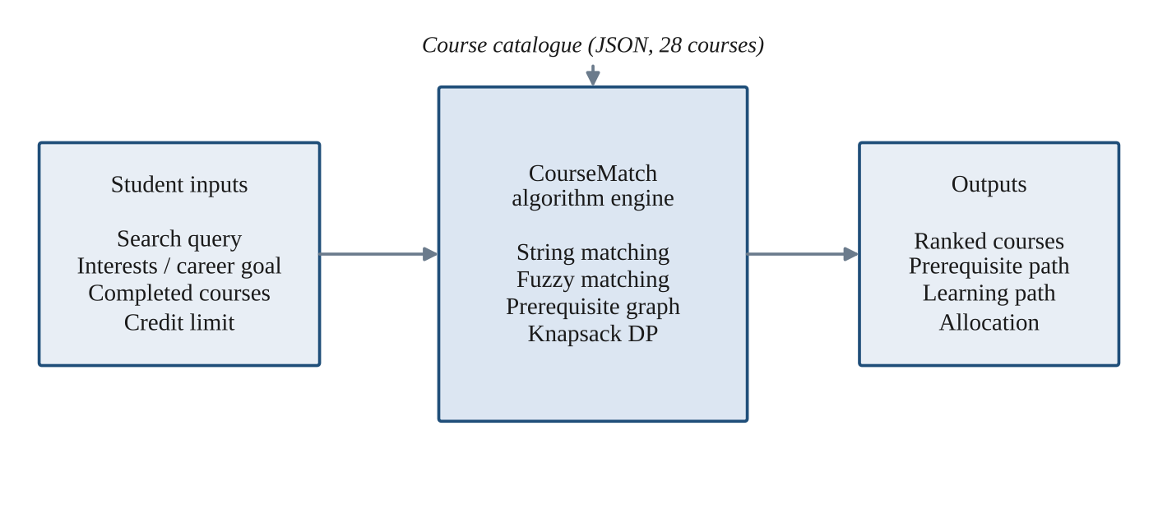
Fig. 1.1 Overview of the CourseMatch system: inputs, algorithm engine and outputs
Related approaches. Course-search tools usually rely on simple keyword matching, which is fast but fails on partial or misspelled queries. Pattern-matching algorithms such as KMP and Rabin-Karp [1], [2] find a pattern in linear expected time, and edit-distance methods [3] tolerate typing errors. Recommender systems in general combine content-based and collaborative information [11]; CourseMatch follows the content-based line, scoring a course by how well its tags, level and prerequisite depth match the student’s goal, and then uses an exact optimization step (knapsack) instead of a simple top-k cut-off, so that the credit budget is respected.

1.2 Problem Statement
Students have to select courses from a growing catalogue while considering several factors together. Doing this by hand has four recurring difficulties:
- Fragmented discovery. Courses are found by exact name only. A typo or an unfamiliar term returns nothing useful.
- Invisible prerequisites. Chains of prerequisites that span several semesters are rarely checked automatically, so students register for courses they are not yet eligible for.
- No measure of fit. A portal cannot say how closely a course matches the student’s stated interests, career goal and completed courses.
- Credit-constrained planning. Choosing the most valuable combination of courses within a fixed credit budget is a combinatorial optimization problem and cannot be solved by a simple filter.
The problem addressed by this project is therefore to design and implement an algorithm-driven system that searches, filters, checks eligibility for, ranks and recommends courses, and that can also demonstrate the underlying DSA-3 algorithms on real input.

1.3 Scope of the Project
The scope of the project covers the following:
- A web application with four views: Explore (search and browse), Learning Path (personalized planner), CO Algorithm Lab (CO1 to CO6 demonstrations) and Project Map (a summary of the pipeline for review and viva).
- A REST API implemented in Node.js and Express, with the algorithms written from first principles in separate JavaScript modules.
- A catalogue of 28 courses with identifiers, descriptions, credits, levels, tags and prerequisites, stored as JSON, together with student profile and search-log files.
- Search by exact pattern (KMP, Z-Function, Rabin-Karp) with automatic fall-back to fuzzy matching (edit distance and token similarity).
- Prerequisite checking and missing-prerequisite chains, credit-limited recommendation by 0/1 Knapsack, student-course matching and capacity allocation, and a greedy skill-coverage approximation.
The following are outside the scope of this version: user authentication, a relational database, real university course data and timetable clash detection. Some of these are discussed as future work in Chapter 7.

1.4 Objectives
- Provide fast course searching by title, identifier, tag and description using KMP, Z-Function and Rabin-Karp.
- Handle spelling mistakes and approximate queries with Wagner-Fischer edit distance and token similarity.
- Check prerequisites automatically with DFS and report the exact chain of courses still required.
- Recommend courses according to interests, career goal, level and completed courses.
- Select the best set of courses within a credit limit using 0/1 Knapsack dynamic programming.
- Demonstrate bipartite matching, maximum flow and approximation algorithms on the student-course allocation problem.
- Provide an Algorithm Lab that covers course outcomes CO1 to CO6 with runnable demonstrations.
- Deliver a simple, responsive and interactive web interface on top of a clean REST API.

2. SYSTEM REQUIREMENTS

2.1 Functional Requirements
The functional requirements of CourseMatch, together with the module or API route that satisfies each one, are listed in Table 2.1.
Table 2.1 Functional requirements and the modules that implement them
ID | Requirement | Implemented by
FR1 | Browse the complete course catalogue and filter it by domain. | GET /api/courses, /api/categories; app.js
FR2 | Search courses by title, identifier, tag or description using exact pattern matching. | GET /api/search; stringSearch.js
FR3 | Return approximate matches for misspelled queries. | GET /api/search (fuzzy branch); editDistance.js
FR4 | Show whether each course is completed, eligible or locked for the student. | app.js card rendering; prerequisites.js
FR5 | Show the ordered list of missing prerequisites needed to unlock a course. | GET /api/prerequisites/:id; prerequisites.js
FR6 | Accept completed courses, a career goal and a credit limit, and recommend the best set of eligible courses. | POST /api/recommend; knapsack.js
FR7 | Match students to eligible courses and respect per-course capacity. | POST /api/matching; bipartite.js, maxFlow.js
FR8 | Select courses that cover the desired skills within a credit limit using an approximation. | POST /api/approximate; approximation.js
FR9 | Store and retrieve student profiles. | POST /api/students, GET /api/students/:id; fileStore.js
FR10 | Log every search query with its mode, result count and time. | GET /api/search; search_log.json
FR11 | Run the CO1 to CO6 demonstrations on user-supplied or default input. | POST /api/co1, /string-suite, /dp-suite, /co5, /co6, /parallel
FR12 | Expose catalogue statistics (domains, levels, average credits). | GET /api/analytics

2.2 Non-Functional Requirements
- Performance. Search, prerequisite checks and recommendations must respond immediately for a catalogue of a few dozen courses. The search box is debounced by 220 ms so that the server is not called on every keystroke.
- Usability. The interface must be responsive, keyboard friendly (Ctrl+K focuses the search box) and must state which algorithm produced a result.
- Correctness. Prerequisite eligibility and credit limits are hard constraints: a recommendation must never contain a course whose prerequisites are incomplete or exceed the credit budget.
- Explainability. Every response names the algorithm used and, where relevant, its complexity, so that the behaviour can be explained in a review or viva.
- Portability. The system must run on Windows, Linux and macOS with only Node.js and a modern browser.
- Maintainability. Each algorithm lives in its own module with a small exported interface, so that it can be tested and replaced independently.
- Security. All text rendered in the browser is escaped to avoid HTML injection, and the API validates required fields such as the student identifier.

2.3 Hardware and Software Requirements
Table 2.2 Hardware and software requirements
Category | Requirement
Hardware | Laptop or desktop computer, 4 GB RAM or above, modern processor, sufficient storage.
Operating system | Windows, Linux or macOS.
Runtime | Node.js (LTS) and npm.
Backend | Node.js with Express 4 and CORS middleware (package.json dependencies).
Frontend | HTML5, CSS3 and JavaScript running in a modern web browser.
Data | JSON files for courses, students and search logs.
Tools | Visual Studio Code, Git and GitHub for version control; Python 3 optionally to serve the frontend separately.

3. SYSTEM DESIGN

3.1 High-level Architecture Diagram
CourseMatch is organized as four layers, shown in Fig. 3.1. The browser talks to the Express service layer over HTTP using JSON. The service layer calls pure functions in the algorithm layer, which read course data through a small file-store utility.
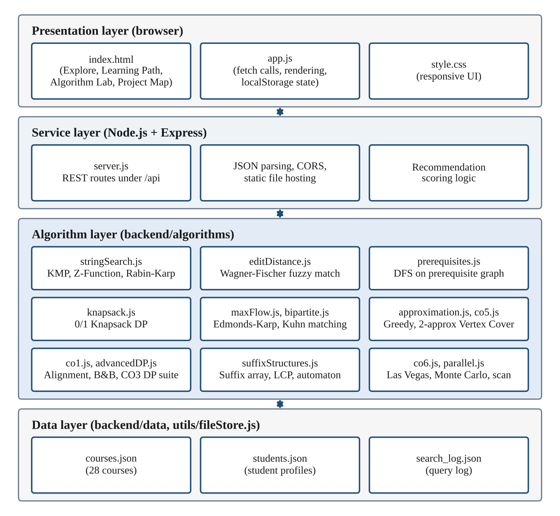
Fig. 3.1 Layered architecture of CourseMatch
The end-to-end behaviour is summarised by the workflow in Fig. 3.2. A query is first answered by exact pattern matching. If no result is found, or the best relevance score is below 35, the system falls back to fuzzy matching. Each course is then labelled as completed, eligible or locked from the prerequisite graph, and the planner finally selects the best eligible set under the credit limit with 0/1 Knapsack.
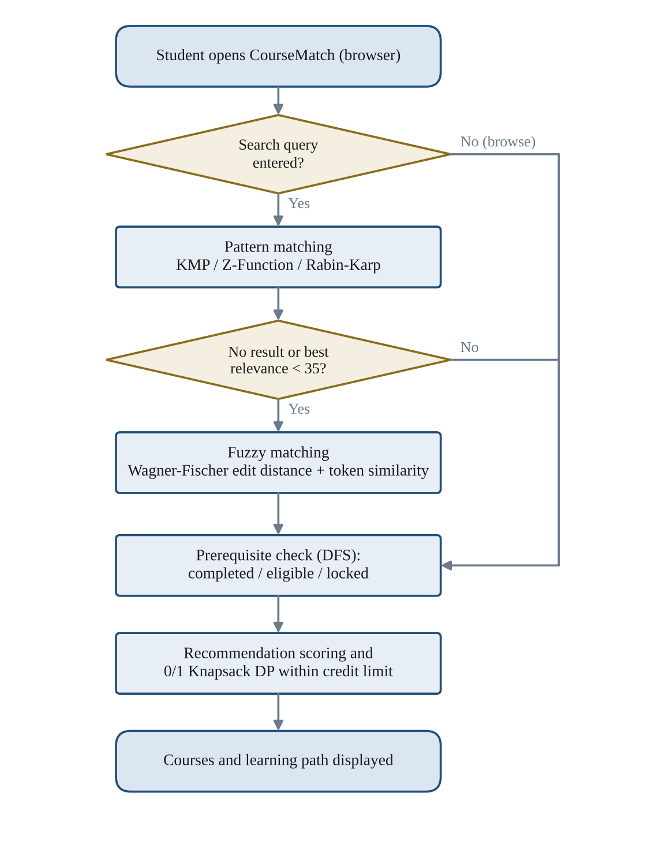
Fig. 3.2 Application workflow from query to learning path

3.2 Description of Each Layer

3.2.1 Presentation layer
The presentation layer consists of index.html, app.js and style.css. The page has four tabs. Explore shows a live search box, domain chips and course cards. Learning Path collects completed courses, a career goal and a credit limit. CO Algorithm Lab contains one card for each of CO1 to CO6 with editable inputs and a result box. Project Map summarises the pipeline and the coverage of each course outcome. The layer holds no business logic: it only calls the API with fetch and renders the JSON that comes back. The only state kept in the browser is the list of completed courses and the selected career goal, saved in localStorage so that they survive a page reload.

3.2.2 Service layer
server.js creates the Express application, enables CORS and JSON body parsing, serves the frontend folder as static files and registers the REST routes (Table 4.3). The recommendation endpoint also lives here: it filters eligible and locked courses, computes the recommendation score of every eligible course and passes the scored list to the knapsack module. Every search is appended to search_log.json.

3.2.3 Algorithm layer
The algorithm layer holds fourteen small modules, each exporting plain functions with no dependency on Express. They are grouped by purpose: string algorithms (stringSearch.js, editDistance.js, suffixStructures.js), graph algorithms (prerequisites.js, bipartite.js, maxFlow.js), optimization (knapsack.js, advancedDP.js, approximation.js, co1.js, co5.js) and randomized or parallel algorithms (co6.js, parallel.js, parallelWorker.js). Keeping the modules free of web code makes each of them easy to test and to explain separately.

3.2.4 Data layer
Data is stored in three JSON files read and written through utils/fileStore.js, which offers readJSON, writeJSON and appendJSON. A missing or empty file is treated as an empty list, so the system starts cleanly on a fresh installation.

3.3 Data Design and Graph Models
Each course record has the fields shown in Table 3.1. The prerequisites field turns the catalogue into a directed acyclic graph in which an edge goes from a prerequisite to the course that depends on it. Fig. 3.3 shows the graph of all 28 courses arranged by depth: courses with no prerequisites are at level 0 and the deepest chain, ending at Natural Language Processing (CS431) and Computer Vision (CS432), reaches level 6.
Table 3.1 Fields of a course record in courses.json
Field | Type | Description
id | string | Unique course code, for example CS330.
title | string | Course title searched by KMP, Z-Function and edit distance.
description | string | Short description searched by Rabin-Karp and token matching.
credits | integer | Credit value; used as the weight in the knapsack.
prerequisites | array of ids | Courses that must be completed first; edges of the prerequisite graph.
tags | array of strings | Domains such as AI/ML or Cybersecurity; matched with interests and career goals.
level | string | Beginner, Intermediate or Advanced; contributes to the recommendation score.

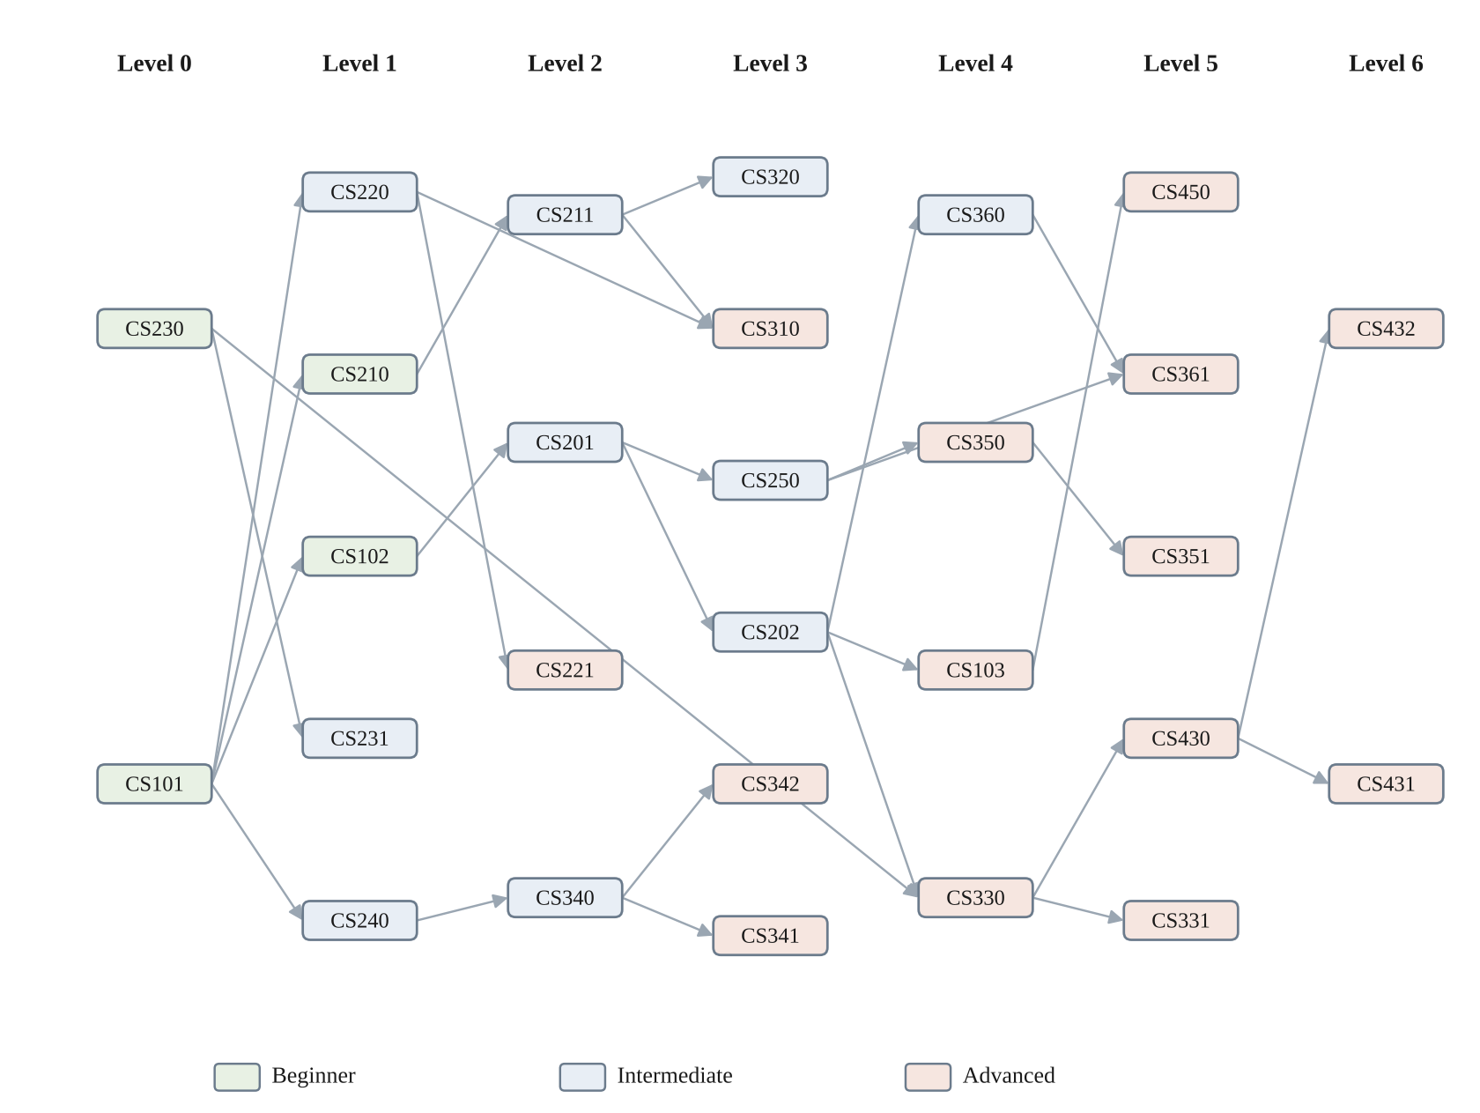
Fig. 3.3 Prerequisite graph of the 28-course catalogue
For allocation, the same eligibility information is turned into a flow network (Fig. 3.4). A super-source is connected to every student with capacity 1, each student is connected with capacity 1 to every course the student is eligible for and interested in, and each course is connected to a super-sink with capacity equal to its available seats. The value of the maximum flow is the largest number of students that can be placed simultaneously without exceeding any course capacity.
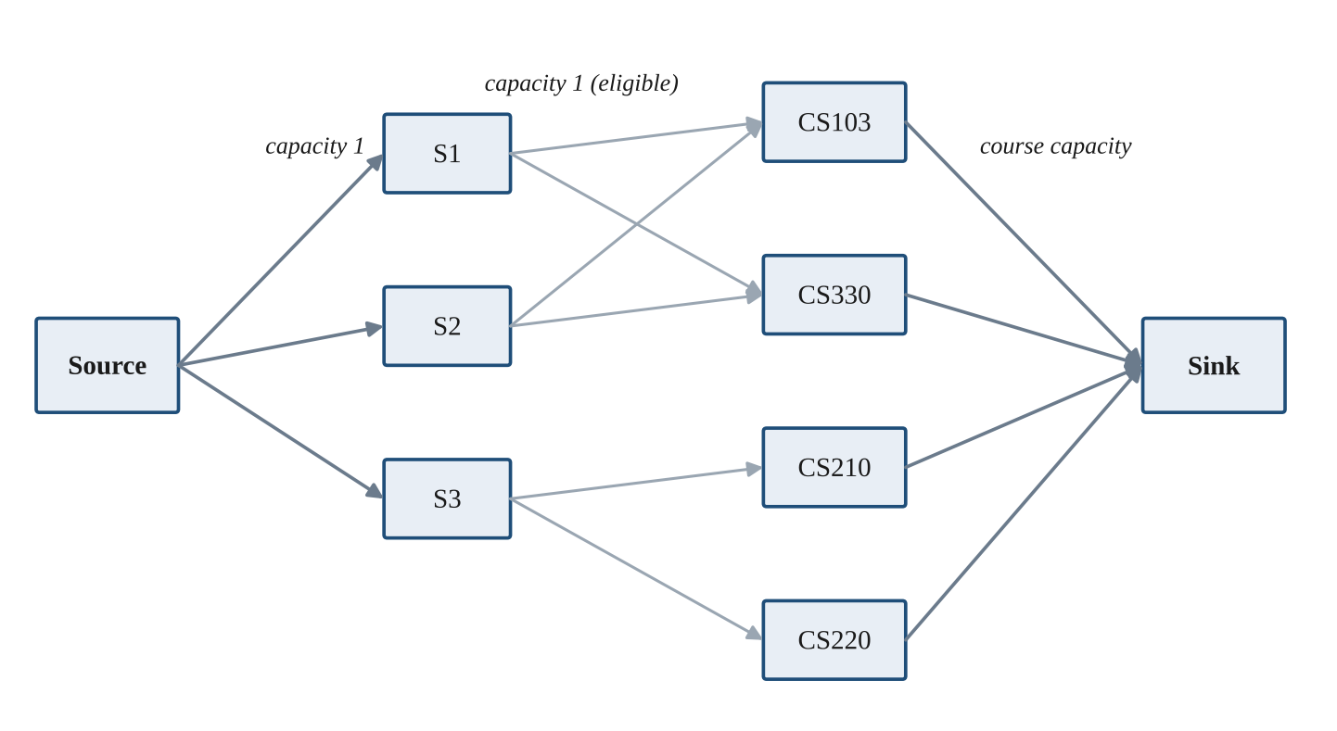
Fig. 3.4 Flow network used for course allocation (example with three students)

4. IMPLEMENTATION

4.1 Module-wise Implementation

4.1.1 String matching: KMP, Z-Function and Rabin-Karp
All three matchers in stringSearch.js first normalise text to lower case and return the index of the first occurrence of the pattern, or -1. KMP builds the longest-prefix-suffix (LPS) array of the pattern so that after a mismatch the search resumes without re-reading text characters, giving O(n + m) time. Z-Function concatenates the pattern, a separator character and the text, computes the Z-array in linear time and reports a position where the Z-value equals the pattern length. Rabin-Karp compares a rolling hash (base 257, modulus 1,000,000,007) of the pattern with the hash of each text window and confirms a hash hit by comparing the strings, giving expected O(n + m) time.
function buildFailureFunction(pattern) {
const lps = new Array(pattern.length).fill(0);
let len = 0;
for (let i = 1; i < pattern.length;) {
if (pattern[i] === pattern[len]) lps[i++] = ++len;
else if (len) len = lps[len - 1];
else lps[i++] = 0;
}
return lps;
}
searchCourses combines the three algorithms into a relevance score for every course. A KMP hit in the title adds 100 (otherwise a Z-Function hit adds 95), a hit in the course identifier adds 80, a tag hit adds 55, a Rabin-Karp hit in the description adds 35, and each query word found in the title, tags or description adds 18. Courses with a score above zero are sorted by relevance, so a title match always outranks a description match.

4.1.2 Fuzzy matching with edit distance
When exact matching returns nothing, or the best relevance is below 35, fuzzySearchCourses is used. It computes the Wagner-Fischer edit distance (insertions, deletions and substitutions) with a two-row table, which needs O(nm) time and only one extra row of storage, O(max(n, m)) space, instead of the full table. The distance is converted into a similarity between 0 and 1 as 1 - distance / max length. The final fuzzy score of a course is a weighted sum:
score = 0.55 × title similarity + 0.25 × best token similarity with title words + 0.12 × token similarity with tags + 0.08 × token similarity with description words.
Only courses with a score of at least 0.56 are kept, and at most twelve results are returned, best first. Word-level similarity is what lets the query “machne lerning” match “Machine Learning Foundations” even though the whole-string edit distance is large.

4.1.3 Prerequisite graph and DFS
isEligible returns true only when every prerequisite of a course is in the set of completed courses. getMissingPrerequisiteChain performs a depth-first traversal from the prerequisites of the target course. A course is added to the chain after all of its own prerequisites have been visited, so the returned list is already in the order in which the courses must be taken. Visited and completed courses are skipped, which keeps the traversal linear in the number of courses and edges, O(V + E).

4.1.4 Recommendation scoring and 0/1 Knapsack
For each eligible course that is not yet completed the server computes a score from the student’s interests and career goal:
score = 4 + 8 × (number of tags matching the goal or interests) + level bonus + min(number of prerequisites, 2),
where the level bonus is 1 for Beginner, 2 for Intermediate and 3 for Advanced courses. The scored courses are then passed to recommendWithinCreditLimit, which solves the 0/1 Knapsack problem with credits as weights, scores as values and the credit limit as capacity (Fig. 4.2). The table dp[i][w] stores the best total score using the first i courses within w credits, and the chosen courses are recovered by walking back through the table. The running time and space are both O(n · C).
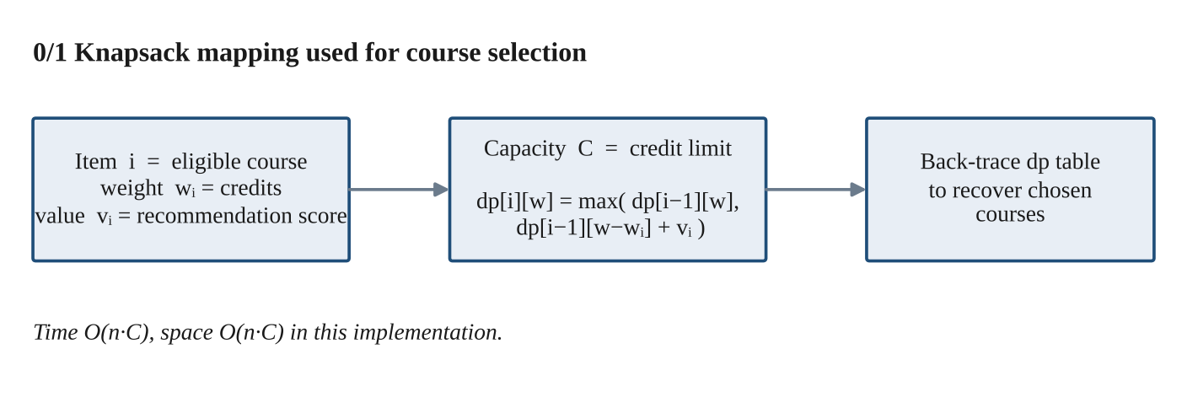
Fig. 4.2 Mapping of credit-limited course selection to 0/1 Knapsack
for (let i = 1; i <= n; i++) {
const c = scoredCourses[i - 1];
for (let w = 0; w <= cap; w++) {
dp[i][w] = dp[i - 1][w];
if (c.credits <= w)
dp[i][w] = Math.max(dp[i][w], dp[i - 1][w - c.credits] + c.score);
}
}

4.1.5 Bipartite matching and maximum flow
/api/matching builds, for every student, the list of courses that are not yet completed, share a tag with the student’s interests and are eligible. This is a bipartite graph with students on one side and courses on the other. maximumBipartiteMatching applies Kuhn’s augmenting-path algorithm: for each student a DFS tries to find a free course, or a course whose current student can be moved elsewhere. The running time is O(V · E).
buildCourseAllocation then creates the flow network of Fig. 3.4 and runs Edmonds-Karp, the Ford-Fulkerson method with breadth-first search for the shortest augmenting path, in O(V · E²) time. Course capacity comes from the request (courseCapacity) and defaults to one seat. Both algorithms are reported by the endpoint so that their results can be compared.

4.1.6 Greedy approximation
greedyCoverage addresses the problem of covering a set of desired skills with a few courses within a credit budget, which is a budgeted maximum-coverage problem and NP-hard. The greedy rule repeatedly picks the eligible course that adds the most new target skills per credit, and stops when the budget is used up or all target skills are covered. The result reports the selected courses, the credits used, the covered skills and the percentage of target skills covered.

4.1.7 CO Algorithm Lab
The Algorithm Lab implements one or more algorithms for each course outcome. Table 4.1 lists them with their time complexity.
Table 4.1 Algorithms of the CO Algorithm Lab
CO | Algorithms implemented | Module | Time complexity
CO1 | Needleman-Wunsch sequence alignment; branch-and-bound course scheduling (NP-hard); substring search; network flow | co1.js | O(nm); O(2ⁿ) worst case with pruning
CO2 | KMP, Z-Function, Rabin-Karp rolling hash, suffix array, LCP array (Kasai), suffix automaton | stringSearch.js, suffixStructures.js | O(n+m); suffix array O(n log²n); LCP and automaton O(n)
CO3 | Interval DP, bitmask DP (assignment), DP on trees (independent set), DP on subsets (set cover), Held-Karp TSP | advancedDP.js | O(n³); O(n·2ⁿ); O(n); O(2ᵁ·S); O(n²·2ⁿ)
CO4 | Edmonds-Karp maximum flow, Kuhn bipartite matching, capacity allocation | maxFlow.js, bipartite.js | O(VE²); O(VE)
CO5 | 3-SAT to Vertex Cover reduction; 2-approximation for Vertex Cover | co5.js | Polynomial reduction; O(E)
CO6 | Randomized quicksort (Las Vegas), Miller-Rabin primality test (Monte Carlo), parallel reduce, parallel prefix scan | co6.js, parallel.js | O(n log n) expected; O(k log³n); work O(n), span O(n/p + log p)

Some of these modules deserve a short explanation. The 3-SAT to Vertex Cover reduction creates two nodes for every variable (true and false) joined by an edge, a triangle of three nodes for every clause, and an edge from each clause node to the variable node that would falsify it. A formula with n variables and m clauses is satisfiable exactly when the graph has a vertex cover of size k = n + 2m. The Vertex Cover 2-approximation takes both endpoints of every edge of a maximal matching; because any cover must contain at least one endpoint of each matching edge, the cover found is at most twice the optimum. The parallel reduce and parallel prefix demonstrations split the input into chunks processed by Node.js worker threads (worker_threads), then combine the partial sums, which illustrates the work-span model.

4.2 Front-end Logic (UI Rendering, State Management)
The frontend is plain HTML, CSS and JavaScript with no build step; the Express server serves the folder directly. Its main behaviours are:
- Initial load. init() fetches the course list and domain tags, builds the filter chips and the career-goal buttons, and runs an empty search to show the whole catalogue.
- Live search. Each keystroke restarts a 220 ms timer. When it fires, search() calls /api/search, shows the algorithm badge returned by the server (pattern or fuzzy) and renders one card per result with its match percentage.
- Course cards. A card is marked COMPLETED, ELIGIBLE or LOCKED by comparing its prerequisites with the completed list. The button on an eligible card marks the course as completed; on a locked card it opens a modal with the prerequisite path from /api/prerequisites/:id.
- State. The completed courses and the chosen career goal are saved to localStorage after every change and restored on the next visit. All other state is rebuilt from the server.
- Planner. The Learning Path tab posts the completed courses, goal and credit slider value to /api/recommend and renders the returned set together with the eligible count and the credits used.
- Algorithm Lab. Each “Run” button posts its inputs to the matching CO endpoint and prints the formatted result in the card.
- Safety. Every string coming from the server is passed through an esc() helper before being inserted into the page, so course text cannot inject HTML.

Fig. 4.3 Home screen of CourseMatch

Fig. 4.4 Project Map tab summarising the pipeline and CO coverage

4.3 API Integration
The frontend and the algorithms communicate only through the REST API in Table 4.3. All responses are JSON and every response names the algorithm that produced it.
Table 4.3 REST API of the backend
Method | Route | Purpose
GET | /api/health | Health check of the service.
GET | /api/courses | Complete course catalogue.
GET | /api/categories | Sorted list of domain tags.
GET | /api/search?q=&category= | Pattern search with fuzzy fall-back; logs the query.
GET | /api/prerequisites/:id?completed= | Ordered chain of missing prerequisites for a course.
POST | /api/recommend | Eligible courses, scores and the knapsack-optimal set for a credit limit.
POST | /api/matching | Bipartite matching and max-flow allocation for a list of students.
POST | /api/approximate | Greedy skill-coverage approximation within a credit limit.
GET | /api/analytics | Course count, domain counts, level counts and average credits.
POST / GET | /api/students, /api/students/:id | Create or update and read a student profile.
POST | /api/co1, /api/string-suite, /api/dp-suite, /api/co5, /api/co6, /api/parallel | Algorithm Lab demonstrations for CO1 to CO6.

As an example, the planner sends the following request to /api/recommend:
POST /api/recommend
{ "completedCourses": ["CS101","CS102","CS201","CS202","CS230"],
"careerGoal": "AI/ML", "creditLimit": 12 }
and receives the number of eligible and locked courses, the credits used, the name of the algorithm and the list recommended in which each course carries its score.

4.4 Data Persistence
The catalogue is a JSON array of 28 courses with a total of 97 credits and an average of 3.46 credits per course. Fig. 4.1 summarises its composition: Software Engineering is the largest domain with 15 courses, followed by AI/ML (12), Data Science (11), Web Development (8) and Cybersecurity (7), and 14 of the 28 courses are of Advanced level. A course can carry several tags, so the domain counts add up to more than 28.
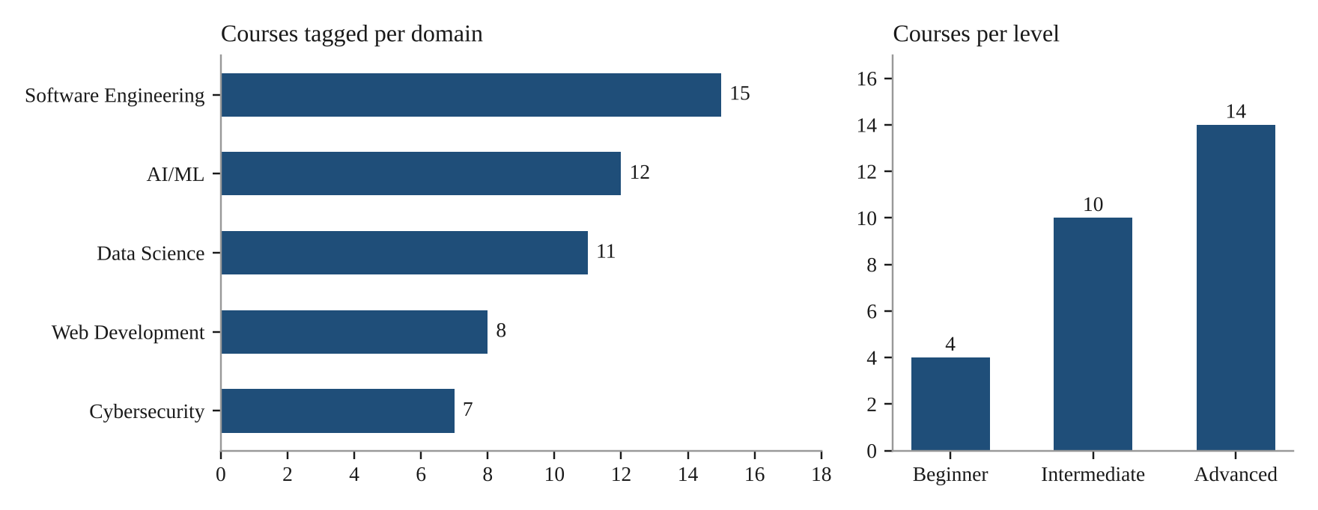
Fig. 4.1 Composition of the course catalogue by domain and level
Student profiles are written to students.json by POST /api/students, which replaces an existing record with the same identifier or appends a new one and stamps it with the update time. Every search appends a record with the query, the selected category, the mode (pattern or fuzzy), the number of results and an ISO timestamp to search_log.json.

4.5 Complexity Summary
Table 4.2 Complexity of the main algorithms
Algorithm | Time | Space | Used for
KMP | O(n + m) | O(m) | Title, tag and description search
Z-Function | O(n + m) | O(n + m) | Title search
Rabin-Karp | Expected O(n + m); worst O(nm) | O(1) | Description search
Wagner-Fischer edit distance | O(nm) | O(max(n, m)) | Fuzzy search
DFS on prerequisite graph | O(V + E) | O(V) | Eligibility and missing chain
0/1 Knapsack DP | O(n · C) | O(n · C) | Credit-limited recommendation
Kuhn bipartite matching | O(V · E) | O(V) | Student-course matching
Edmonds-Karp | O(V · E²) | O(V²) in this implementation | Capacity allocation
Greedy coverage | O(k · n) for k picks | O(n) | Skill-coverage approximation

4.6 Setup and Execution
- Install Node.js (LTS) and npm.
- Open a terminal in the backend folder and run npm install to install Express and CORS.
- Run npm start. The server starts on port 5000 (or the PORT environment variable).
- Open http://localhost:5000 in a browser. The backend serves the frontend folder, so no separate frontend server is needed.

5. RESULTS

5.1 Experimental Setup
The system was run locally with Node.js and tested in a desktop browser on the 28-course catalogue of Fig. 4.1. All outputs in this chapter were produced by the project’s own code. The search, planner and prerequisite tests were repeated with different inputs to check that the results follow from the algorithms described in Chapter 4.

5.2 Course Search
Table 5.1 shows four search experiments. The exact matchers answer “machine learning” and “database” directly, and rank a title match far above a match found only through words in the description. The misspelled query “machne lerning” finds no exact match, so the server switches to the Wagner-Fischer fuzzy matcher and still returns Machine Learning Foundations.
Table 5.1 Search experiments and results
Query | Mode | Results | Top results (score)
machine learning | Pattern (KMP, Z, Rabin-Karp) | 3 | CS330 Machine Learning Foundations (136); CS331 and CS430 (18, one query word matched)
database | Pattern | 2 | CS220 Database Management Systems (153); CS221 NoSQL and Distributed Databases (153)
machne lerning | Fuzzy (edit distance + tokens) | 1 | CS330 Machine Learning Foundations (similarity 0.567)
cyber security | Pattern (word matches) | 7 | All seven courses tagged Cybersecurity (each scores 36): CS101, CS240, CS250, CS340, CS341, CS342, CS450

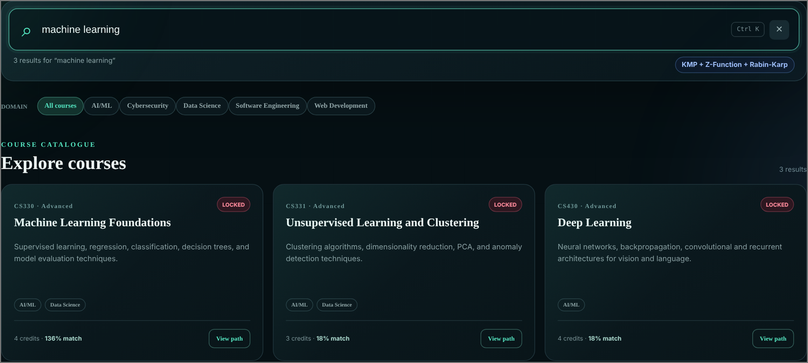
Fig. 5.1 Pattern-matching search for “machine learning”

Fig. 5.2 Fuzzy search for the misspelled query “machne lerning”

5.3 Prerequisite Checking
Prerequisite chains are computed by DFS from the prerequisite graph. Table 5.2 lists three cases. For a student who has completed CS101, CS102, CS201, CS202 and CS230, Machine Learning Foundations (CS330) is already unlocked. A student with only CS101 still needs four courses, and a student with nothing completed needs seven courses, in the correct order, before Natural Language Processing (CS431) can be taken. Fig. 5.3 shows the last case in the interface.
Table 5.2 Prerequisite chains returned by the DFS module
Target course | Completed courses | Missing prerequisites (in order)
CS330 Machine Learning Foundations | CS101, CS102, CS201, CS202, CS230 | None; the course is unlocked
CS330 Machine Learning Foundations | CS101 | CS102, CS201, CS202, CS230
CS431 Natural Language Processing | None | CS101, CS102, CS201, CS202, CS230, CS330, CS430


Fig. 5.3 Prerequisite path shown for Natural Language Processing

5.4 Recommendation within a Credit Limit
Two planner scenarios are summarised in Table 5.3. In the first, the student has completed five foundation courses, selects AI/ML as the career goal and allows 12 credits. Of the 28 courses, 8 are eligible and 15 are still locked (the remaining 5 are completed). The knapsack chooses Data Structures and Algorithms 3, Machine Learning Foundations and Database Management Systems, for 11 of the 12 credits. The two AI/ML courses carry the highest scores (16 and 17), while the third course is a three-credit course whose score of 7 ties with several other eligible courses; no better combination fits in the remaining credits. In the second scenario the student has completed nothing and wants Web Development with 9 credits. Only two courses have no prerequisites, so only they can be recommended.
Table 5.3 Planner scenarios and the sets selected by the knapsack
Scenario | Eligible / locked | Recommended courses (credits, score) | Credits used
Completed: CS101, CS102, CS201, CS202, CS230  Goal: AI/ML, limit 12 | 8 / 15 | CS103 Data Structures and Algorithms 3 (4, 16)  CS330 Machine Learning Foundations (4, 17)  CS220 Database Management Systems (3, 7) | 11 of 12
Completed: none  Goal: Web Development, limit 9 | 2 / 26 | CS101 Introduction to Programming (3, 13)  CS230 Probability and Statistics (3, 5) | 6 of 9


Fig. 5.4 Learning path generated for the AI/ML goal with a 12-credit limit

5.5 Matching, Flow and Approximation
For three students (two interested in AI/ML with the same completed courses, one interested in Web Development with only CS101 completed) and a capacity of one seat for CS330, the bipartite matching assigns all three students and the maximum flow is also 3. The two algorithms may choose different but equally large assignments: matching gave S1 → CS330, S2 → CS103, S3 → CS210, while the flow network gave S1 → CS103, S2 → CS330, S3 → CS210. The greedy coverage approximation with target skills Data Science and AI/ML and an 8-credit limit selects only Data Structures and Algorithms 3 (4 credits), which already covers both skills (100 percent coverage) and leaves the remaining credits unused.

5.6 Algorithm Lab Results
The Algorithm Lab was run with its default inputs. The main results for each course outcome are given in Table 5.4 and the corresponding screens are shown in Fig. 5.5 to Fig. 5.9.
Table 5.4 Results of the Algorithm Lab with default inputs
CO | Input | Result
CO1 | Sequences COURSE and SOURCE; 12-credit scheduling | Alignment score 6 with no gaps (4 matches, 2 mismatches); branch-and-bound found the best schedule of value 80 using 11 credits (CS101, CS201, CS202) after visiting 84 search nodes
CO2 | Text BANANA, pattern ANA | KMP, Z-Function and Rabin-Karp all report index 1; suffix array [5, 3, 1, 0, 4, 2]; LCP array [0, 1, 3, 0, 0, 2]; suffix automaton with 10 states
CO3 | Default matrices, tree and sets | Matrix-chain order ((A1×A2)×(A3×A4)); assignment minimum cost 9; tree independent set maximum 13; set cover needs 2 sets; Held-Karp tour cost 80 along 0→2→3→1→0
CO4 | Student A, interest AI/ML, five completed foundation courses | 2 eligible course nodes; maximum matching 1 and maximum flow 1; the student is assigned Data Structures and Algorithms 3
CO5 | 3 variables, 2 clauses; 5-edge graph | Reduction graph with 12 nodes and 15 edges and target cover size k = 7; the 2-approximation returns the cover {A, B, C, D} from matching edges (A,B) and (C,D)
CO6 | Values 1 to 9 shuffled; number 7919; 12 values on 4 workers | Randomized quicksort returns the sorted array; Miller-Rabin declares 7919 probably prime after 8 rounds; parallel reduce returns the sum with partial sums per worker; the prefix scan returns the running totals


Fig. 5.5 CO1 module: sequence alignment and branch-and-bound scheduling
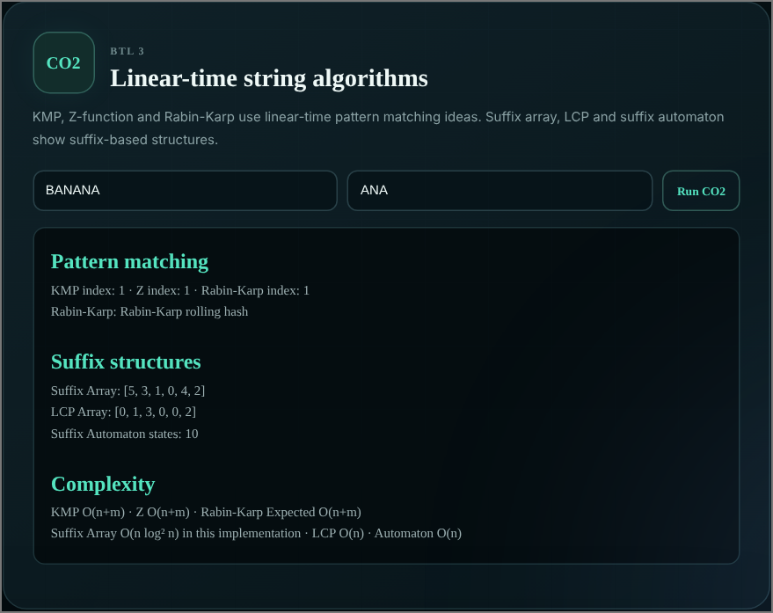
Fig. 5.6 CO2 module: string matching and suffix structures

Fig. 5.7 CO4 module: bipartite matching and maximum flow

Fig. 5.8 CO5 module: 3-SAT to Vertex Cover reduction and 2-approximation
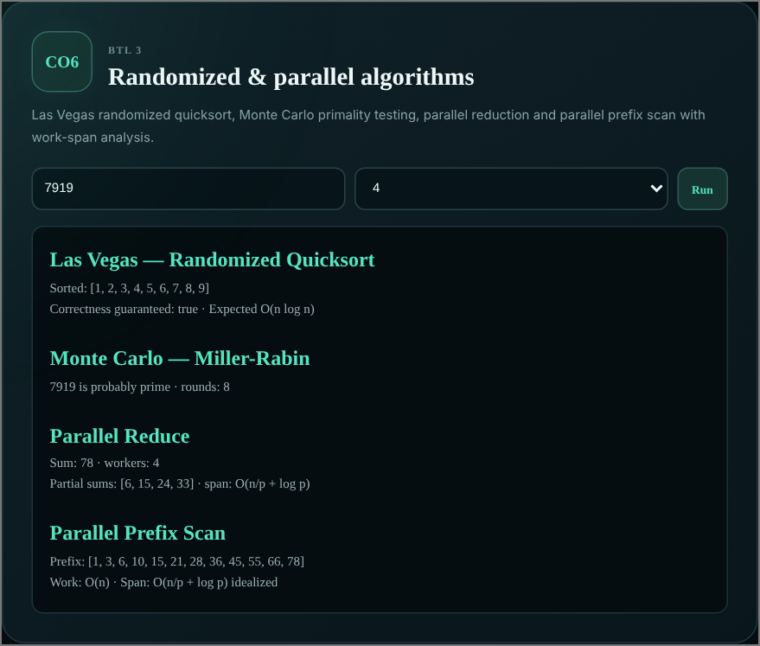
Fig. 5.9 CO6 module: randomized and parallel algorithms

5.7 Discussion
The results show that each algorithm contributes a distinct capability. String matching gives precise, ranked results for correct queries, and edit distance recovers from typing errors, so a search does not end with an empty page. DFS on the prerequisite graph removes the need to inspect prerequisites manually and explains exactly what is missing. The knapsack step turns a list of eligible courses into a plan that respects the credit limit, and the matching and flow modules show how the same eligibility data supports seat allocation. Because every response names its algorithm, the behaviour of the system can be traced back to the theory of the course.

6. CHALLENGES & LIMITATIONS

6.1 Issues Faced during Development
- Choosing the technology. The initial proposal described a Java core with a Swing or lightweight web interface. For a web demonstration with many live algorithm modules, the team moved to Node.js and Express, so that the algorithms, the API and the interface could share one language and one JSON data format.
- Deciding when a query is a typo. Fuzzy matching on every query would return noisy results, while exact matching alone fails on misspellings. A rule was needed to decide when to fall back.
- Ranking exact matches. A course whose title, tag and description all match must outrank a course that matches only one word of a long query.
- Respecting hard constraints. Recommendations had to obey prerequisites and the credit limit, while still preferring courses that match the student’s goal.
- Covering the whole syllabus. Six course outcomes with more than a dozen algorithms had to be integrated into one application with a consistent API and a readable output for each.
- Parallel algorithms in JavaScript. Parallel reduce and prefix scan needed real concurrency, while JavaScript runs on a single thread by default.

6.2 Solutions Applied
- Moved the whole project to Node.js and Express with the algorithms in separate modules, and used the same JSON structures in the backend and the browser.
- Used exact matching first and switched to fuzzy matching only when no result exists or the best relevance is below 35. Fuzzy results are also filtered by a minimum score of 0.56 and limited to twelve.
- Designed the relevance score with decreasing weights for title (100 or 95), identifier (80), tag (55) and description (35) matches, plus a small bonus per matched word.
- Made eligibility a hard filter applied before scoring, and made the credit limit the capacity of the knapsack, so the constraints cannot be violated by construction.
- Implemented each algorithm as an independent function with a small return object, and exposed one endpoint per course outcome.
- Used Node.js worker_threads so that chunks of the input are reduced or scanned in separate workers and then combined.

6.3 Limitations of the System
- The catalogue is small (28 courses) and written by hand; it is not connected to real university data.
- Data is kept in JSON files that are rewritten completely on each update. This is simple but does not support concurrent writers, and search_log.json grows without bound.
- There is no login or access control; student profiles are identified only by an identifier sent by the client.
- The recommendation score is a fixed hand-tuned formula; it does not learn from student feedback or past enrolments.
- Course capacity defaults to one seat unless it is supplied in the request, and the allocation does not consider timetable clashes or semester boundaries.
- Search relevance thresholds (35 for fall-back, 0.56 for fuzzy results) are fixed values chosen for this catalogue and may need tuning for a larger one.
- The parallel demonstrations use worker threads on one machine, so they illustrate the work-span model but not distributed execution.

7. CONCLUSION & FUTURE WORK

7.1 Conclusion
This project applied advanced data structures and algorithms to a practical academic problem. CourseMatch lets a student search a catalogue with KMP, Z-Function and Rabin-Karp, recover from spelling mistakes through edit distance, see exactly which prerequisites are missing through DFS, and obtain a learning path that respects a credit limit through 0/1 Knapsack dynamic programming. Bipartite matching, Edmonds-Karp maximum flow and greedy approximation extend the same data to allocation and coverage problems. The Algorithm Lab makes the algorithms of course outcomes CO1 to CO6 executable, so the system serves both as a working recommendation tool and as a demonstration of the DSA-3 syllabus.
The tests in Chapter 5 show that the implemented modules behave as the theory predicts: exact queries are ranked by relevance, misspelled queries are recovered, prerequisite chains are returned in the correct order, and recommendations never exceed the credit limit.

7.2 Future Work
- Connect the system to a larger, real course database and replace the JSON files with a relational or document database.
- Add student login, profiles and a persistent history of completed courses and past recommendations.
- Use course capacity data and Network Flow for real student-course allocation, with semester-wise planning and timetable clash detection.
- Improve recommendations with advanced similarity measures and with feedback from students, for example collaborative filtering on top of the current content-based score.
- Visualise the prerequisite graph interactively, add an analytics dashboard for administrators and deploy the application as a cloud service.
- Add automated unit tests for every algorithm module and for the API.

7.3 Skills Learned during Development
- Designing and analysing algorithms: string matching, dynamic programming, graph traversal, network flow, approximation and randomized algorithms.
- Translating a theoretical algorithm into clean, modular JavaScript, modelling a real problem as a graph, a knapsack or a flow network, and reasoning about time and space complexity.
- Building a REST API with Node.js and Express, and consuming it from a plain HTML, CSS and JavaScript frontend.
- Working as a team with Git and GitHub, writing documentation and presenting results in project reviews.

REFERENCES
[1] D. E. Knuth, J. H. Morris Jr. and V. R. Pratt, “Fast pattern matching in strings,” SIAM Journal on Computing, vol. 6, no. 2, pp. 323–350, 1977.
[2] R. M. Karp and M. O. Rabin, “Efficient randomized pattern-matching algorithms,” IBM Journal of Research and Development, vol. 31, no. 2, pp. 249–260, 1987.
[3] R. A. Wagner and M. J. Fischer, “The string-to-string correction problem,” Journal of the ACM, vol. 21, no. 1, pp. 168–173, 1974.
[4] J. Edmonds and R. M. Karp, “Theoretical improvements in algorithmic efficiency for network flow problems,” Journal of the ACM, vol. 19, no. 2, pp. 248–264, 1972.
[5] T. H. Cormen, C. E. Leiserson, R. L. Rivest and C. Stein, Introduction to Algorithms, 4th ed. Cambridge, MA, USA: MIT Press, 2022.
[6] D. Gusfield, Algorithms on Strings, Trees, and Sequences. Cambridge, U.K.: Cambridge University Press, 1997.
[7] J. Kleinberg and É. Tardos, Algorithm Design. Boston, MA, USA: Pearson Addison-Wesley, 2006.
[8] V. V. Vazirani, Approximation Algorithms. Berlin, Germany: Springer, 2001.
[9] S. B. Needleman and C. D. Wunsch, “A general method applicable to the search for similarities in the amino acid sequence of two proteins,” Journal of Molecular Biology, vol. 48, no. 3, pp. 443–453, 1970.
[10] M. Held and R. M. Karp, “A dynamic programming approach to sequencing problems,” Journal of the Society for Industrial and Applied Mathematics, vol. 10, no. 1, pp. 196–210, 1962.
[11] G. Adomavicius and A. Tuzhilin, “Toward the next generation of recommender systems: A survey of the state-of-the-art and possible extensions,” IEEE Transactions on Knowledge and Data Engineering, vol. 17, no. 6, pp. 734–749, 2005.
[12] M. O. Rabin, “Probabilistic algorithm for testing primality,” Journal of Number Theory, vol. 12, no. 1, pp. 128–138, 1980.
[13] T. Kasai, G. Lee, H. Arimura, S. Arikawa and K. Park, “Linear-time longest-common-prefix computation in suffix arrays and its applications,” in Proc. 12th Annual Symposium on Combinatorial Pattern Matching (CPM), LNCS 2089, 2001, pp. 181–192.
[14] Node.js Foundation, “Node.js documentation.” [Online]. Available: https://nodejs.org/docs/latest/api/
[15] OpenJS Foundation, “Express: Fast, unopinionated, minimalist web framework for Node.js.” [Online]. Available: https://expressjs.com/
[16] Mozilla Developer Network, “Web APIs: Fetch API and Web Storage API.” [Online]. Available: https://developer.mozilla.org/

