UNIT1
Lists, Links and Images
1a. Write a HTML program, to explain the working of lists. Note: It should have an ordered list, unordered list, nested lists and ordered list in an unordered list and definition lists.
Aim: Write a HTML program, to explain the working of lists. Note: It should have an ordered list, unordered list, nested lists and ordered list in an unordered list and definition lists.
Description:
1. Ordered List (<ol>)
An ordered list is used when the sequence of items matters. For example, instructions or steps in a process. The list items are automatically numbered by the browser (1, 2, 3, ...).
HTML tag: <ol> (ordered list), with items wrapped in <li> (list item).
Example use case: "Steps to bake a cake"
2. Unordered List (<ul>)
An unordered list is used when the order of items does not matter. Items are typically marked with bullet points.
HTML tag: <ul> (unordered list), with items in <li>.
Example use case: "Shopping list" or "List of features"
3. Nested Lists
A nested list is a list inside another list. This allows you to create hierarchical structures, such as categories and subcategories.
You can nest <ul> inside another <ul>, or <ol> inside <ol>.
Example: Under a list item "Fruits", you might nest another list with "Apple", "Mango", etc.
4. Ordered List inside an Unordered List
You can combine list types by placing an ordered list inside an unordered list (or vice versa). This is useful when you want to provide details or steps within a category.
Example: A bullet point "How to make tea" followed by a numbered list of steps inside it.
5. Definition List (<dl>)
A definition list is used for terms and their explanations or definitions. It consists of:
<dl>: Definition list container
<dt>: Definition term
<dd>: Definition description
Example use case: Glossary of terms like "HTML", "CSS", "JavaScript" with explanations.
Code:
<!DOCTYPE html>
<html lang="en">
<head>
<meta charset="UTF-8">
<title>HTML Lists Example</title>
</head>
<body bgcolor="lavender">
<h1>Demonstration of HTML Lists</h1>
<h2>1. Ordered List</h2>
<ol>
<li>First item</li>
<li>Second item</li>
<li>Third item</li>
</ol>
<h2>2. Unordered List</h2>
<ul>
<li>Apple</li>
<li>Banana</li>
<li>Mango</li>
</ul>
<h2>3. Nested List (Unordered inside Ordered)</h2>
<ol>
<li>Fruits
<ul>
<li>Mango</li>
<li>Grapes</li>
</ul>
</li>
<li>Vegetables
<ul>
<li>Carrot</li>
<li>Broccoli</li>
</ul>
</li>
</ol>
<h2>4. Ordered List inside Unordered List</h2>
<ul>
<li>Steps to Prepare Tea:
<ol>
<li>Boil Water</li>
<li>Add Tea Leaves</li>
<li>Strain and Serve</li>
</ol>
</li>
</ul>
<h2>5. Definition List</h2>
<dl>
<dt>CSS</dt>
<dd>Cascading Style Sheets, used to style HTML elements.</dd>
<dt>JavaScript</dt>
<dd>A scripting language used to add interactivity.</dd>
</dl>
</body>
Output:
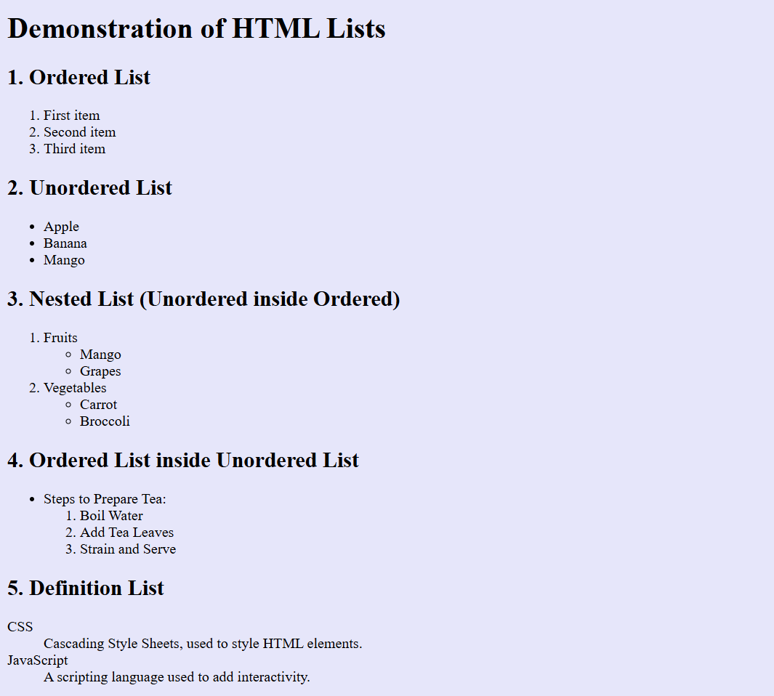

RESULT:

1b. Write a HTML program, to explain the working of hyperlinks using tag and href, target Attributes. Note: Use text to link https://www.aec.edu.in/ Use image to link https://www.aec.edu.in/?p=Gallery.
Aim: . Write a HTML program, to explain the working of hyperlinks using tag and href, target Attributes. Note: Use text to link https://www.aec.edu.in/ Use image to link https://www.aec.edu.in/?p=Gallery.
Description: This HTML program demonstrates the use of the <a> tag to create hyperlinks. The important attributes used are:
🔹 href (Hypertext REFerence):
Specifies the destination URL of the link.
Example: href="https://www.aec.edu.in/"
🔹 target:
Defines how the link will be opened.
target="_blank" opens the link in a new browser tab or window.
If you omit target, the link opens in the same tab by default.
Code:
<!DOCTYPE html>
<html lang="en">
<head>
<meta charset="UTF-8">
<title>Hyperlink Example</title>
</head>
<Body>
<h1>Demonstrating Hyperlinks in HTML</h1>
<!-- Text Hyperlink-->
<h2>1. Text Link using &lt;a&gt;, href, and target="_blank"</h2>
<p>
Visit <a href="https://www.ace.edu.in/"
target="_blank">Aditya Engineering College Website</a>.
</p>
<!--Image Hyperlink-->
<h2>2.Image Link using &lt;a&gt; and href</h2>
<p>
Click the image below to visit the <strong>Gallery page</strong>:
</p>
<a href="https://www.ace.edu.in">
</body>
</html>
Output:
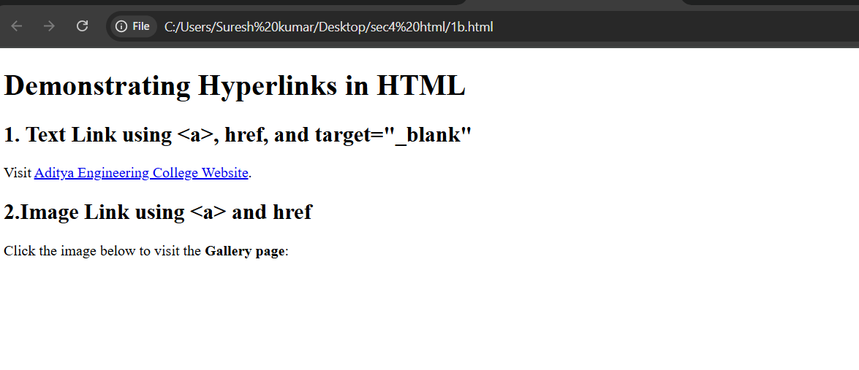
RESULT:

1c. Create a html document that has your image and your friends image with a specific height and width .also when clicked on the images it should navigate to their respective profiles.
Aim: Create a html document that has your image and your friends image with a specific height and width .also when clicked on the images it should navigate to their respective profiles.
Description: Images as Links:
Each image is wrapped in an <a> tag. When you click on an image, it navigates to the respective profile page URL.
Specific Size:
Both images have a fixed height and width of 200px using the CSS height and width properties.
Styling:
Images have a border and a hover effect that slightly zooms in when the mouse hovers.
The layout uses inline-block styling to display images side by side with spacing.
Responsive Behavior:
The target="_blank" attribute makes sure the profiles open in new browser tabs without leaving the current page.

Code:
<!DOCTYPE html>
<html>
<head>
<title>
Image with link
</title>
</head>
<body>
<h1>From image to a link</h1>
<a href="https://www.linkedin.com/in/bhargav-ram-gaddangi-897a22323?utm_source=share&utm_campaign=share_via&utm_content=profile&utm_medium=android_app"
target="_blank"> <img src="bhargav.jpg" width="300px" height="300px" />
</a>
<a href="https://www.linkedin.com/in/sharathchandra-panga-59212936a?utm_source=share&utm_campaign=share_via&utm_content=profile&utm_medium=android_app"
target="_blank">
<img src="sarath.jpg" width="300px" height="300px"/>
</a>
</body>
</html>
Output:

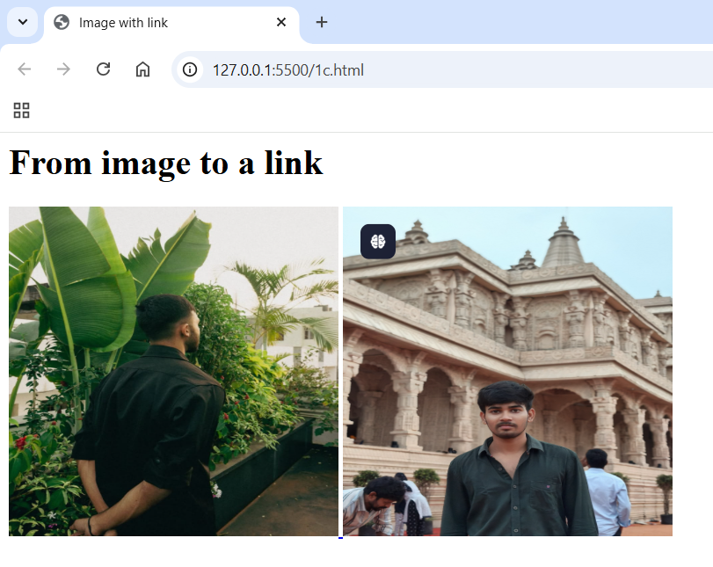
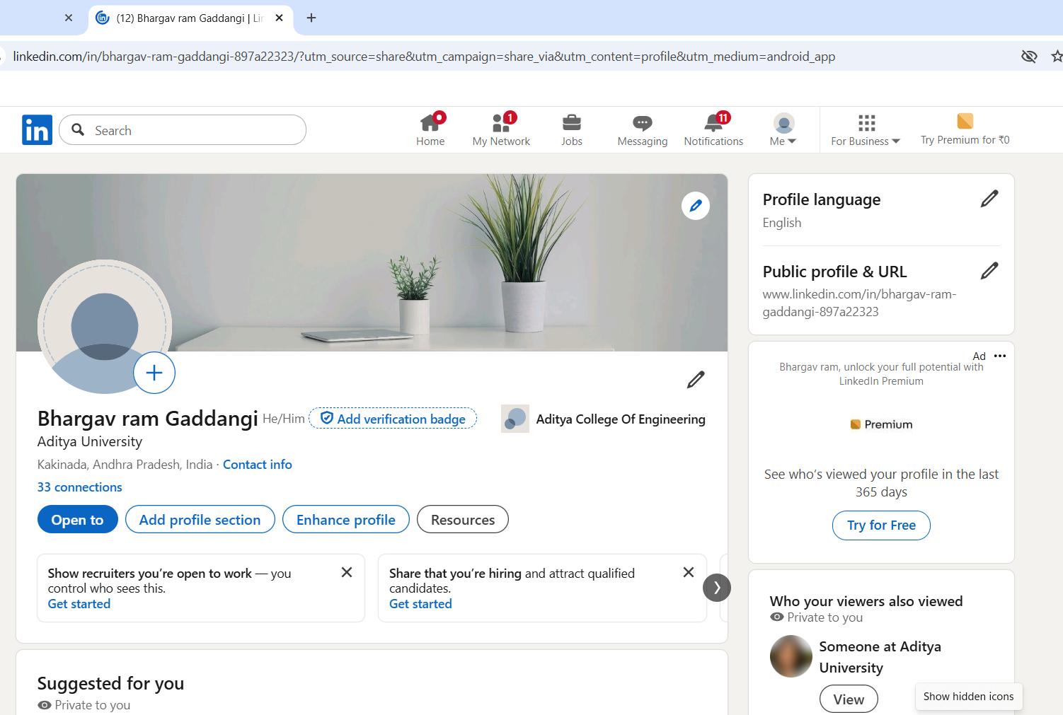

RESULT:

1d. Write a HTML program, in such a way that, rather than placing large images on a page, the preferred technique is to use thumbnails by setting the height and width parameters to something like to 100*100 pixels. Each thumbnail image is also a link to a full sized version of the image. Create an image gallery using this technique.
Aim: Write a HTML program, in such a way that, rather than placing large images on a page, the preferred technique is to use thumbnails by setting the height and width parameters to something like to 100*100 pixels. Each thumbnail image is also a link to a full sized version of the image. Create an image gallery using this technique.
Description:
This HTML document demonstrates how to build a simple image gallery using thumbnail images. Thumbnails are small preview versions of larger images and help pages load faster while still giving users access to high-quality images on click.
🔹 How it works:
Thumbnail Images:
Each image is displayed in a small size: 100x100 pixels.
The thumbnail size is set using the height and width attributes in CSS (img { height: 100px; width: 100px; }).
Links to Full Images:
Each thumbnail is wrapped in an <a> tag.
The href in the anchor tag points to the full-sized image (e.g., 600px wide).
The target="_blank" attribute makes the full-size image open in a new tab, keeping the gallery page open.
Styling:
Flexbox is used to lay out the gallery neatly in rows.
A hover effect zooms in the thumbnail slightly for a clean interactive feel.
Code:
<!DOCTYPE html>
<html >
<head>
<meta >
<title>Thumbnail Image Gallery</title>
<style>
body {
font-family: Arial, sans-serif;
text-align: center;
}
.gallery {
display: flex;
flex-wrap: wrap;
justify-content: center;
gap: 15px;
margin-top: 20px;
}
.gallery_a_img {
width: 100px;
height: 100px;
object-fit: cover;
border: 2px solid #ccc;
border-radius: 8px;
transition: transform 0.3s;
}
</style>
</head>
<body>
<h1>My Image Gallery</h1>
<p>Click on a thumbnail to view the full-Sized image</p>

<div class="gallery">
<a href="bhargav.jpg" target="_blank">
<img src="bhargav.jpg" class="gallery_a_img" alt="Image 1">
</a>
<a href="manish.jpg" target="_blank">
<img src="manish.jpg" class="gallery_a_img" alt="Image 2">
</a>
<a href="sarath.jpg" target="_blank">
<img src="sarath.jpg" class="gallery_a_img" alt="Image 3">
</a>
</div>
</body>
</html>
</html>

Output:

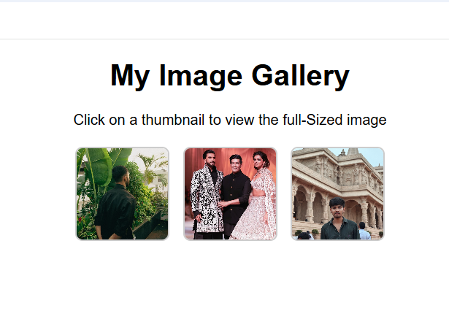

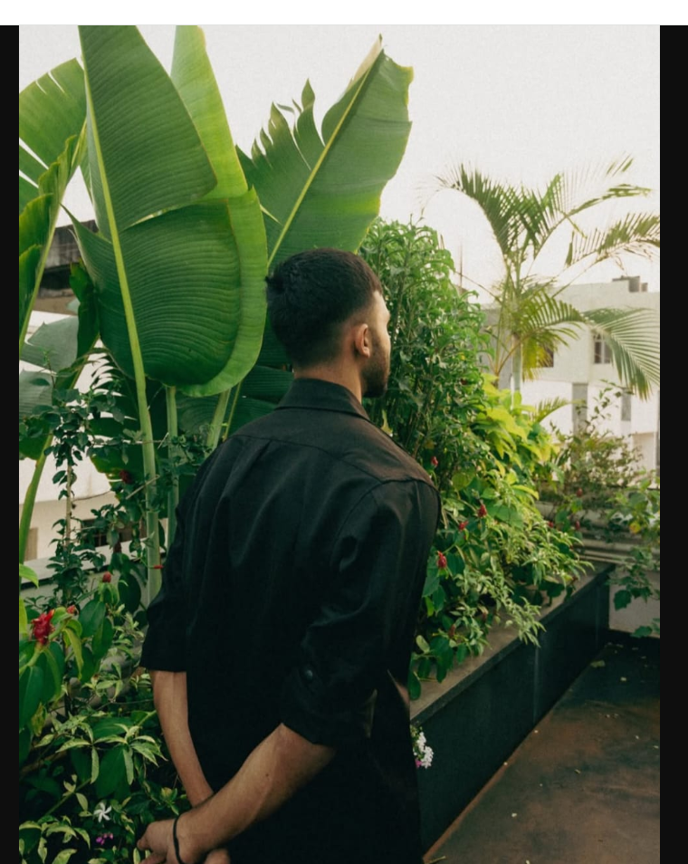
RESULT:

UNIT2:
2a.Write a HTML program, to explain the working of tables. (use tags: <table>, <tr>, <th>, <td> and attributes: border, rowspan, colspan).
Aim: Write a HTML program, to explain the working of tables. (use tags: <table>, <tr>, <th>, <td> and attributes: border, rowspan, colspan).
Description: This program illustrates how to create a table using HTML tags like <table>, <tr>, <th>, and <td>, along with attributes like border, rowspan, and colspan. The <tr> tag defines rows, <th> is used for table headers, and <td> for normal data cells. The rowspan attribute allows a single cell to extend across multiple rows, while colspan allows a cell to span multiple columns.
Code:
<html>
<body>
<h1>HTML TABLE</h1>
<table border="3px" bordercolor="pink" background="" width="100px" height="100px">
<tr>
<th>S.no</th>
<th>Student name</th>
<th>Roll no</th>
</tr>
<tr>
<td>1</td>
<td>Bhargav Ram</td>
<td>24B11CS121</td>
</tr>
<tr>
<td>2</td>
<td>Subramanyam</td>
<td>24B11CS209</td>
</tr>
<tr>
<td>3</td>
<td>Aravind sai</td>
<td>24B11CS446</td>
</tr>
<tr>
<td>4</td>
<td>Koushik</td>
<td>24B11CS502</td>
</tr>
</table>
</body>
</html>
Output:

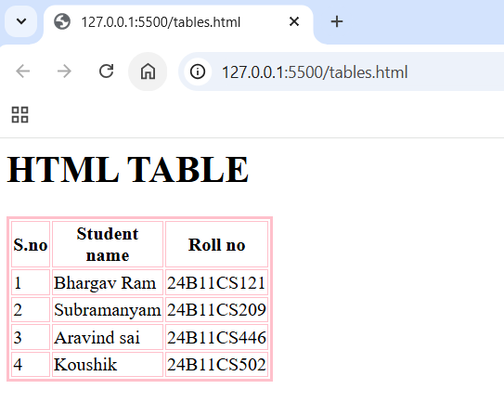

RESULT:

2b. Write a HTML program, to explain the working of tables by preparing a timetable. (Note: Use tag to set the caption to the table & also use cell spacing, cell padding, border, rowspan, colspan etc.)
Aim: Write a HTML program, to explain the working of tables by preparing a timetable. (Note: Use tag to set the caption to the table & also use cell spacing, cell padding, border, rowspan, colspan etc.).
Description: The given HTML program demonstrates the use of tables to create a weekly class timetable. It showcases various important table properties and tags in HTML. The <table> tag is used to create the table structure, and a <caption> is added at the top using the <caption> tag to give the table a meaningful title, "Weekly Class Timetable." The table uses attributes such as border, cellspacing, and cellpadding to define the outer border, the space between cells, and the padding inside each cell respectively. Inside the table, the <tr> tag is used for table rows, and <th> and <td> are used to define header and data cells. The rowspan attribute is applied to the "Break" and "Lunch" columns to merge cells vertically across multiple days, as these activities occur at the same time each day. The colspan attribute is used in the "Wednesday" row to merge two periods into one for project work, illustrating how to merge cells horizontally.
Code:
<!DOCTYPE html>
<html>
<head>
<title>College Timetable</title>
</head>
<body>
<h2 align="center">Weekly Class Timetable </h2>
<table border="2" cellspacing="5" cellpadding="10" align="center" bordercolor="green" background="blue">
<caption><strong>Class Timetable - CSE Department</strong></caption>
<tr>
<th>DAY</th>
<th>9:00 - 10:00</th>
<th>10:00 - 11:00</th>
<th>11:00 - 12:00</th>
<th>12:00 - 1:00</th>
<th>01:00 - 2:00</th>
<th>02:00 - 03:00</th>
<th>03:00 - 04:00</th>
</tr>
<tr>
<td>Monday</td>
<td>Maths</td>
<td>Physics</td>
<td>Chemistry</td>
<td rowspan="6" style="text-align:center">Lunch Break</td>
<td colspan="2">Computer Lab</td>
<td>English</td>
</tr>
<tr>
<td>Tuesday</td>
<td>English</td>
<td>Maths</td>
<td>Physics</td>
<td>Chemistry</td>
<td>Work shop</td>
<td>Sports</td>
</tr>
<tr>
<td>Wednesday</td>
<td>English</td>
<td>Maths</td>
<td>Physics</td>
<td>Chemistry</td>
<td>Work shop</td>
<td>Sports</td>
</tr>
<tr>
<td>Thursday</td>
<td>English</td>
<td>Maths</td>
<td>Physics</td>
<td>Chemistry</td>
<td>Work shop</td>
<td>Sports</td>
</tr>
<tr>
<td>Friday</td>
<td>English</td>
<td>Maths</td>
<td>Physics</td>
<td>Chemistry</td>
<td>Work shop</td>
<td>Sports</td>
</tr>
<tr>
<td>Saturday</td>
<td>English</td>
<td>Maths</td>
<td>Physics</td>
<td>Chemistry</td>
<td>Work shop</td>
<td>Sports</td>
</tr>
</table>
</body>
</html>
Output:
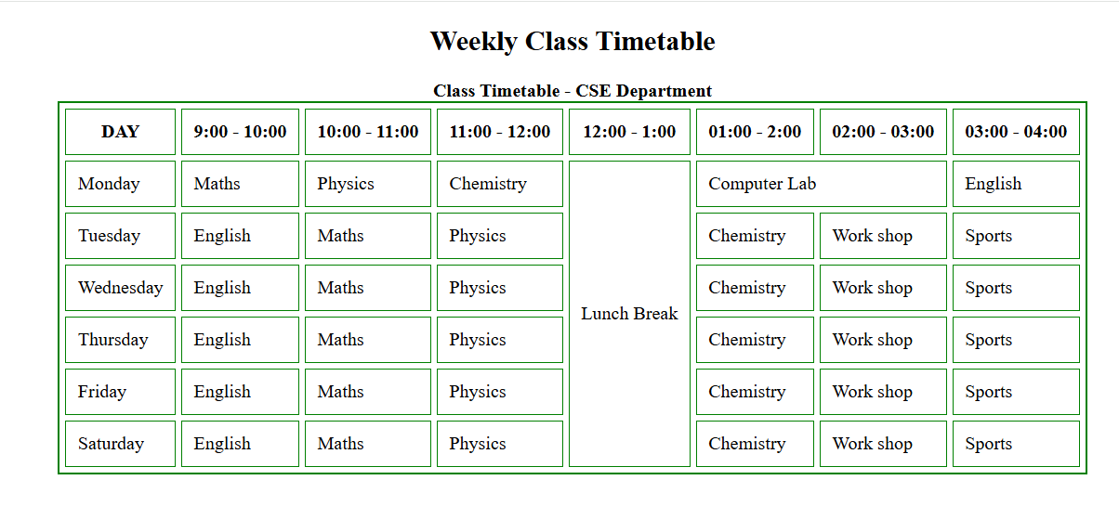
RESULT:

2c.Write a HTML program, to explain the working of forms by designing Registration form. (Note: Include text field, password field, number field, date of birth field, checkboxes, radio buttons, list boxes using & tags, and two buttons ie: submit and reset. Use tables to provide a better view).
Aim: Write a HTML program, to explain the working of forms by designing Registration form. (Note: Include text field, password field, number field, date of birth field, checkboxes, radio buttons, list boxes using & tags, and two buttons ie: submit and reset. Use tables to provide a better view).
Description: The given HTML program demonstrates the working of HTML forms by creating a student registration form. It utilizes the <form> tag along with various input types to collect user information in a structured and user-friendly way. A table is used to neatly organize the form fields, aligning labels and input boxes for better readability. The form includes a text field for the full name, a password field for account security, a number field for age, and a date picker for selecting the date of birth. It also uses radio buttons for gender selection, ensuring the user can choose only one option, and checkboxes for selecting multiple known languages. Additionally, a drop-down list is included using the <select> and <option> tags to allow users to choose their country from predefined options.
Code:
<!DOCTYPE html>
<html>
<head>
<title>Registration Form</title>
</head>
<body bgcolor="orange">
<h2 align="center">Student Registration Form</h2>
<form action="#" method="post">
<table border="1" align="center" cellpadding="10" cellspacing="0">
<tr>
<td><label for="fname">First Name:</label></td>
<td><input type="text" id="fname" name="fname" required></td>
</tr>
<tr>
<td><label for="lname">Last Name:</label></td>
<td><input type="text" id="lname" name="lname" required></td>
</tr>
<tr>
<td><label for="password">Password:</label></td>
<td><input type="password" id="password" name="password" required></td>
</tr>
<tr>
<td><label for="age">Age:</label></td>
<td><input type="number" id="age" name="age" min="0" max="100"></td>
</tr>
<tr>
<td><label for="dob">D.O.B:</label></td>
<td><input type="date" id="dob" name="dob"></td>
</tr>
<tr>
<td>Gender:</td>
<td>
<input type="radio" id="male" name="gender" value="Male">
<label for="male"> Male</label>
<input type="radio" id="female" name="gender" value="Female">
<label for="female">Female</label>
</td>
</tr>
<tr>
<td>Languages Known:</td>
<td>
<input type="checkbox" id="english" name="language" value="English">
<label for="english"> English</label>
<input type="checkbox" id="telugu" name="language" value="Telugu">
<label for="telugu"> Telugu</label>
<input type="checkbox" id="hindhi" name="language" value="Hindhi">
<label for="hindhi"> Hindhi</label>
</td>
</tr>
<tr>
<td><label for="course">Course:</label></td>
<td>
<select id="course" name="course">
<option value="">--Select--</option>
<option value="B.Tech">B.Tech</option>
<option value="M.Tech">M.Tech</option>
<option value="MCA">MCA</option>
<option value="MBA">MBA</option>
</select>
</td>
</tr>
<tr>
<td><label for="address">Address:</label></td>
<td><textarea id="address" name="address" rows="4" cols="30"></textarea></td>
</tr>
<tr>
<td colspan="2" align="center">
<input type="submit" value="Submit">
<input type="reset" value="Reset"
</td>
</tr>
</table>
</form>
</body>
</html>
Output:
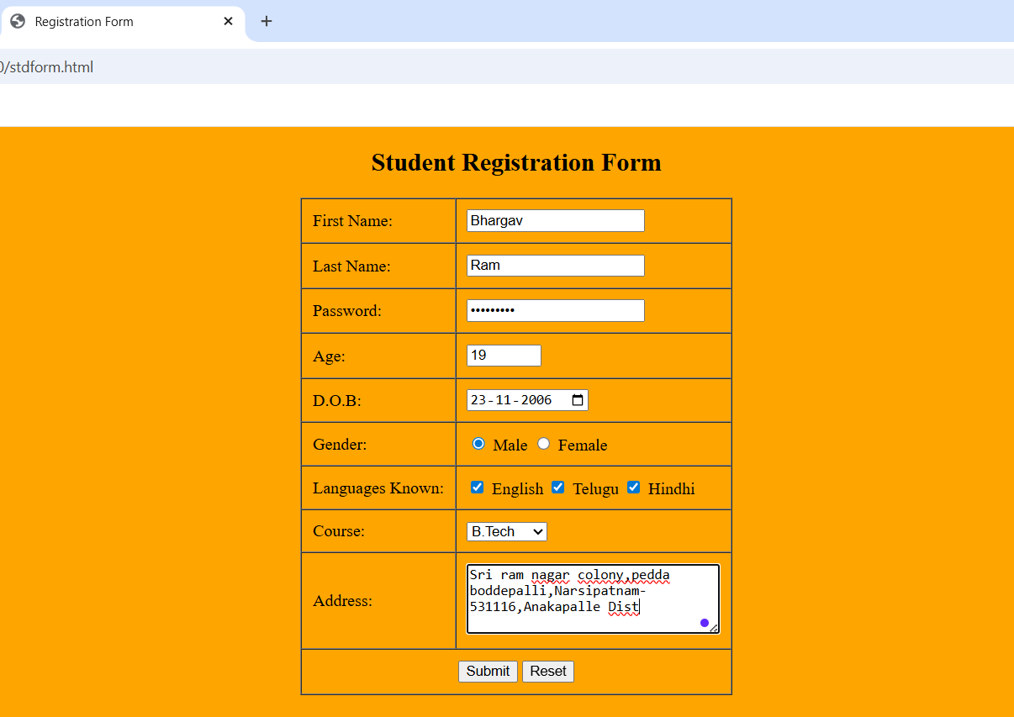
RESULT:

2d. Write a HTML program, to explain the working of frames, such that page is to be divided into 3 parts on either direction. (Note: first frame image, second frame frame paragraph, third fixed).
Aim: Write a HTML program, to explain the working of frames, such that page is to be divided into 3 parts on either direction. (Note: first frame image, second frame frame paragraph, third fixed).
Description: This HTML program demonstrates the concept of frames by dividing the web page into three horizontal sections using the <frameset> tag. The main file (index.html) uses the rows attribute to split the page into three parts: 30%, 40%, and 30% of the screen height respectively. Each section loads a separate HTML file using the <frame> tag. The first frame (image.html) displays an image, the second frame (paragraph.html) contains a paragraph of text, and the third frame (fixed.html) shows a fixed message, such as a footer or copyright note.
Code:
<!DOCTYPE html>
<html>
<head>
<title>Frames Example -Vertical Split</title>
</head>
<frameset cols="33%,33%,34%">
<frame src="sss.jpg" name="imageFrame">
<frame src="para.html" name="paraFrame">
<frame src="registration2.html" name="linkFrame">
<noframes>
<body>
<p>Your browser doesnot support frames.Please update your browser.</p>
</body>
</noframes>
</frameset></html>
OUTPUT:

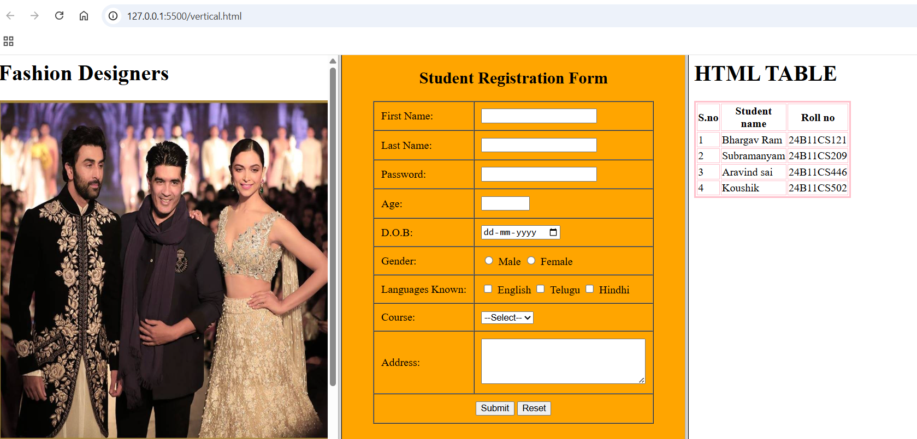
RESULT:

Unit 3:
3a)HTML5 Semantic Elements
Aim: To design a webpage using HTML5 semantic tags such as <article>, <aside>, <figure>, <figcaption>, <footer>, <header>, <main>, <nav>, <section>, <div>, and <span> to demonstrate the structure and meaning of each element.
Description:
This program creates a travel blog webpage that uses HTML5 semantic tags for better structure and readability. The <header> tag defines the page heading, while the <nav> tag contains the navigation menu for moving to different sections. The <main> tag holds the central content, and inside it, <article> is used to represent a self-contained story. The <section> tag groups related content inside the article, and <figure> with <figcaption> is used to insert an image along with a descriptive caption. The <aside> tag contains tips related to the main topic, and <footer> displays copyright details. The <div> tag is a generic container, while <span> is used for inline styling or grouping text inside other elements.
Code:
<!DOCTYPE html>
<html lang="en">
<head>
<meta charset="UTF-8">
<title>HTML5 Semantic Elements Demo</title>
<style>
body {
font-family: Arial,sans-serif;
margin: 0;
}
header,nav,footer {
background-color: #333;
color:white;
padding: 1em;
}
nav a {
color:white;
margin: 0 10px;
text-decoration: none;
}
main{
display:flex;
padding:20px;
}
article {
flex: 3;
padding:20px;
background-color: #f9f9f9;
}
aside {
flex:1;
padding:20px;
background-color: #e0e0e0;
}
figure {
margin: 0;
text-align:center;
}
figcaption {
font-style:italic;
font-size: 0.9em;
}
footer {
text-align:center;
}
</style>
</head>
<body>
<header>
<h1>My Blog Website </h1>
</header>
<nav>
<a href="home.html">Home</a>
<a href="">Articles</a>
<a href="#">Gallery</a>
<a href="#">Contact</a>
</nav>
<main>
<article>
<h2>Understanding HTML5 Semantic Tags</h2>
<p><span style="font-weight: bold;">HTML5</span>introduced Semantic elements that make your code more readable and accessible.</p>
<figure>
<img src="sarath.jpg" height=”300px” width=”300px” alt="HTML5 Illustration">
<figcaption>Figure: Illustration of HTML5 layout</figcaption>
</figure>
<section>
<h3>Why Use Semantic Tags?</h3>
<p>Semantic tags help search engines and screen readers understand the structure of your webpage.</p>
</section>
</article>
<aside>
<h3>Related Posts</h3>
<ul>
<li><a href="#">Introduction to HTML</a></li>
<li><a href="#">CSS Basics</a></li>
<li><a href="#">JavaScript for Beginners</a></li>
</ul>
</aside>
</main>
<footer>
<p>&copy; 2025 My Blog, All rights reserved.</p>
</footer>
</body>
</html>

Output:
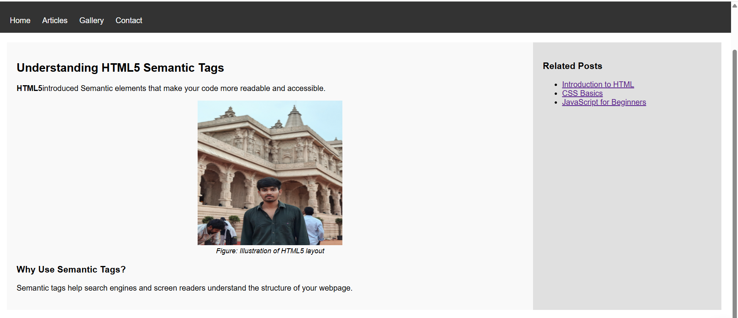
RESULT:

3B) Embedding Audio and Video
Aim:
To create an HTML5 webpage that embeds audio and video files using <audio> and <video> tags.
Description:
This program demonstrates multimedia embedding in HTML5. The <audio> tag is used to insert an audio file (nature.mp3) with controls that allow the user to play, pause, and adjust the volume. The <video> tag is used to embed a video file (nature.mp4) with similar controls and specified width and height. The <source> element inside both tags specifies the file path and format, making it possible for the browser to choose the correct media file. Alternative text is provided for browsers that do not support these tags.
Code:
<html>
<body>
<h2>Audio File</h2>
<audio controls autoplay loop>
<source src="tone.mp3" type="audio/mpeg">
Your browser does not support the audio element.
</audio>
<h2>Video File</h2>
<video height="300" width="300" controls>
<source src="aagadu.mp4" type="video/mp4">
Your browser does not support the video tag.
</video>
</body>
</html>

Output:
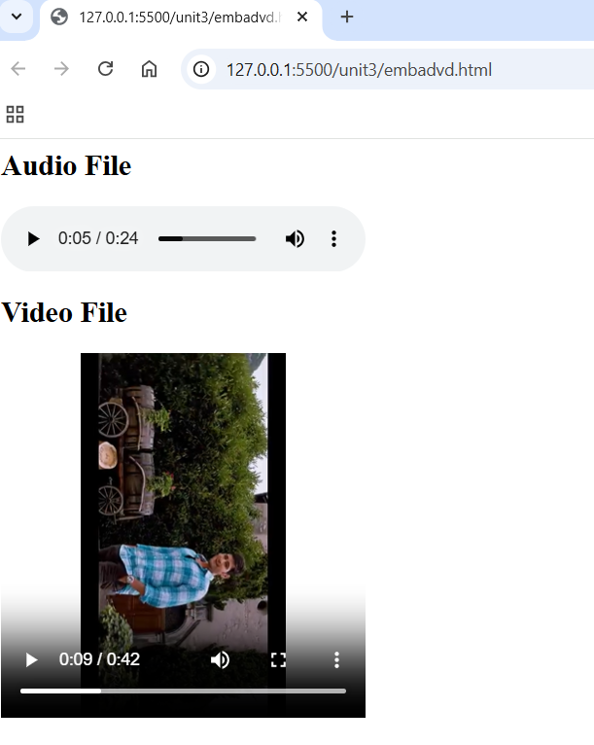

3c) Types of CSS – Inline, Internal, External
Aim:
To apply CSS styles to HTML elements using different types of style specifications: inline, internal, and external CSS.
Description:
The program uses three CSS styling methods:
External CSS – A separate styles.css file contains rules for headings (h1) to make the text dark blue and center-aligned. It is linked to the HTML file using the <link> tag.
Internal CSS – CSS rules are placed inside the <style> tag within the HTML head section to set paragraph text color to green and define a class .highlight that gives text a yellow background.
Inline CSS – The style attribute is used inside an HTML tag to directly apply styles such as red text color and bold font to a specific paragraph.
Code:
External css:
<!DOCTYPE html>
<html>
<head>
<link rel="stylesheet" type="text/css" href="mystyle.css">
</head>
<body>
<h1>This is heading</h1>
<p>This is paragraph</p>
</body>
</html>
Internal css:
<html>
<head>
<style>
body{
background-color:blue;
}
h1{
background-color:pink;
}
p{
background-color:green;
}
</style>
</head>
<body>
<h1>This is a heading</h1>
<p>This is a pragraph.</p>
</body>
</html>
Iniline css:
<html>
<body>
<h1 style="color:green;text-align:center;">This is a heading</h1>
<p style="color:orange;">This is a paragraph.</p>
</body>
</html>
Output:
External css:
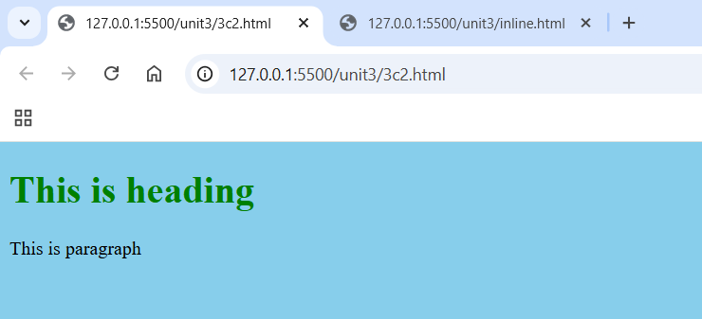

Internal css:
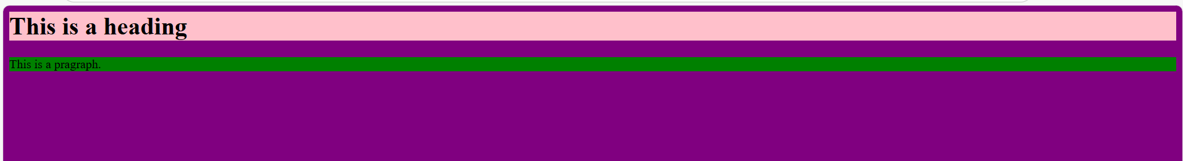
Iniline css:
