EXPERIMENT-1.1
AIM: Write a C++ Program to find the roots of a quadratic equation.
PROGRAM:
#include <iostream>
#include <cmath>
using namespace std;
int main() {
double a, b, c, discriminant, root1, root2;
cout << "Enter coefficients a, b and c: ";
cin >> a >> b >> c;
discriminant = b * b - 4 * a * c;
if (discriminant > 0) {
root1 = (-b + sqrt(discriminant)) / (2 * a);
root2 = (-b - sqrt(discriminant)) / (2 * a);
cout << "Roots are real and distinct: " << root1 << " and " << root2 << endl;
}
else if (discriminant == 0) {
root1 = -b / (2 * a);
cout << "Roots are real and equal: " << root1 << endl;
}
else {
double realPart = -b / (2 * a);
double imaginaryPart = sqrt(-discriminant) / (2 * a);
cout << "Roots are complex and imaginary: ";
cout << realPart << " + " << imaginaryPart << "i and ";
cout << realPart << " - " << imaginaryPart << "i" << endl;
}
cout<<"24B11CS121";
return 0;
}
OUTPUT: 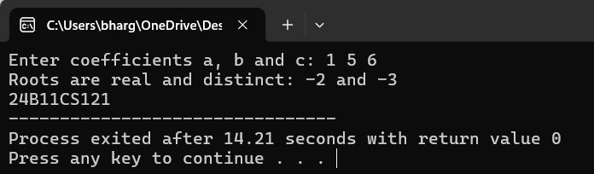

EXPERIMENT-1.2
AIM: Write a C++ Program to find factorial of a given number using recursion
PROGRAM:
#include <iostream>
using namespace std;
int factorial(int n) {
if (n == 0 || n == 1)
return 1;
else
return n * factorial(n - 1);
}
int main() {
int num;
cout << "Enter a number: ";
cin >> num;
if (num < 0)
cout << "Factorial is not defined for negative numbers." << endl;
else
cout << "Factorial of " << num << " is " << factorial(num) << endl;
cout<<"24B11CS121";
return 0;
}
OUTPUT:

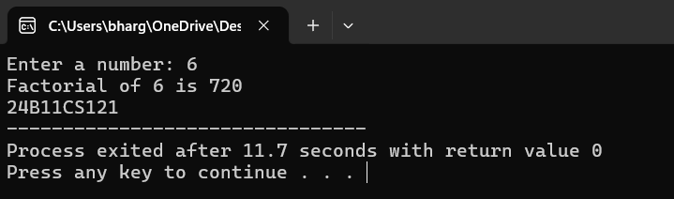

EXPERIMENT-1.3
AIM: Write a C++ Program to Implement scope resolution and namespaces.
PROGRAM:
#include <iostream>
using namespace std;
int num = 50;
namespace Example {
int num = 100;
void display() {
cout << "Inside namespace Example: num = " << num << endl;
}
}
int main() {
int num = 10;
cout << "Local num: " << num << endl;
cout << "Global num: " << ::num << endl;
cout << "Namespace num: " << Example::num << endl;
Example::display();
cout<<"24B11CS121";
return 0;
}
OUTPUT: 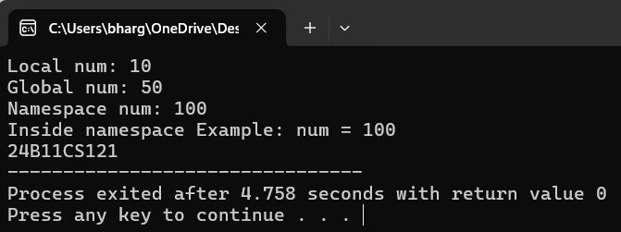

EXPERIMENT-1.4
AIM: Write a C++ Program to Illustrate the use of default arguments and access specifiers.
PROGRAM:
#include <iostream>
using namespace std;
class Adder {
private:
int result;
public:
void add(int a, int b = 0) {
result = a + b;
cout << "Sum: " << result << endl;
}
};
int main() {
Adder obj;
obj.add(5);
obj.add(5, 10);
cout<<"24B11CS121";
return 0;
}
OUTPUT:
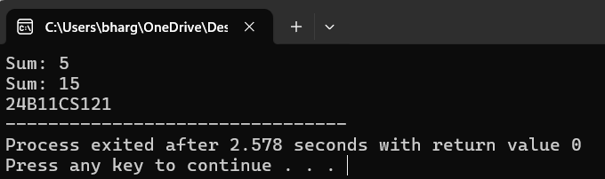

EXPERIMENT-2.1
AIM: Write a C++ Program to illustrate inline functions and function overloading.
PROGRAM:
#include <iostream>
using namespace std;
inline int square(int x){
return x*x;
}
int add(int a,int b)
{
return a+b;
}
double add(double a,double b)
{
return a+b;
}
int main(){
cout<<square(5)<<" "<<add(3,4)<<" "<<add(2.5,3.5)<<endl;
cout<<"24B11CS121";
}
OUTPUT:
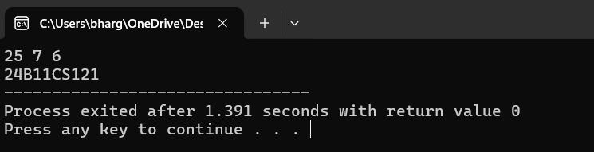

EXPERIMENT-2.2
AIM: Write a C++ Program to illustrate friend function
PROGRAM:
#include<iostream>
using namespace std;
class demo
{
private:
int x;
void get()
{
x=45;
}
friend void sum();
};
void sum()
{
int y;
y=50;
demo d;
d.get();
cout<<"Sum="<<d.x+y<<endl;
cout<<"24B11CS121";
}
int main()
{
sum();
}

OUTPUT:
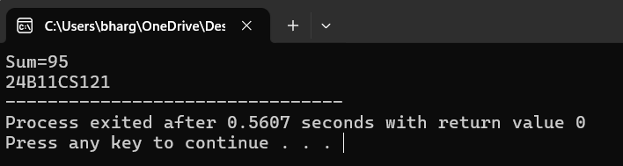

EXPERIMENT-2.3
AIM: Write a C++ Program to illustrate the use of Constructors and Destructors.
PROGRAM:
#include <iostream>
using namespace std;
class Demo {
private:
string name;
public:
Demo(string n) {
name = n;
cout << "Constructor called for " << name << endl;
}
~Demo() {
cout << "Destructor called for " << name << endl;
}};
int main() {
Demo obj1("Object1");
Demo obj2("Object2");
cout << "Inside main function" << endl;
cout<<”24B11CS121”<<endl;
return 0;
}
OUTPUT: 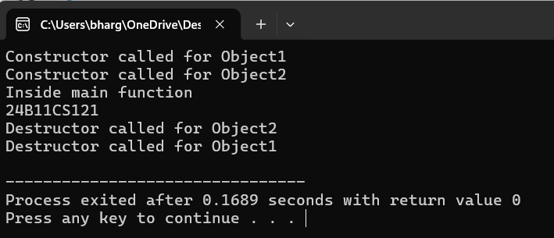

EXPERIMENT-2.4
AIM: Write a C++ Program to illustrating Constructor overloading.
PROGRAM:
#include<iostream>
using namespace std;
class rectangle
{
private:
int length,breadth;
public:
rectangle()
{
length=23;
breadth=10;
}
rectangle(int l,int b)
{
length=l;
breadth=b;
}
rectangle(int x)
{
length=x;
breadth=x;
}
void area()
{
cout<<"Area of rectangle="<<length*breadth<<endl;
}
};
int main()
{
rectangle r1;
rectangle r2(4);
rectangle r3(13,3);
r1.area();
r2.area();
r3.area();
cout<<"24B11CS121";
return 0;
}
OUTPUT: 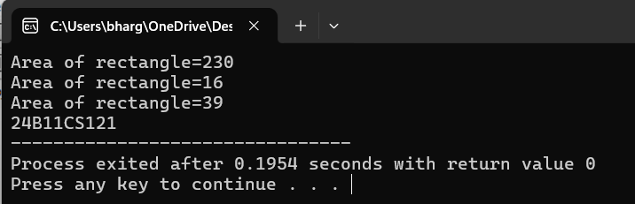

EXPERIMENT-2.5
AIM: Write a C++ Program to illustrating Copy Constructor.
PROGRAM:
#include <iostream>
using namespace std;
class Sample {
int x;
public:
Sample(int a) {
x = a;
}
Sample(const Sample &s) {
x = s.x;
}
void display()
{
cout << "Value: " << x << endl;
}
};
int main() {
Sample obj1(10);
Sample obj2 = obj1;
obj1.display();
obj2.display();
cout<<"24B11CS121";
return 0;
}
OUTPUT:
