USN NUMBER: 1RUB25CSE0004
NAME:Bhargav R Rao

Ex No: 1  Date: 16-09-2026 | Inherently Interpretable Models

Objective
To implement and evaluate inherently interpretable machine learning models for breast cancer classification, and to understand how their internal parameters, decision rules, nearest examples, likelihood contributions, and feature-wise shape functions can be used to explain predictions. The lab also aims to compare the accuracy and interpretability of different models.
Description
In this laboratory, the Breast Cancer Wisconsin (Diagnostic) dataset is used as a binary classification problem to distinguish between malignant and benign cases. Six clinically meaningful features—mean radius, mean texture, mean perimeter, mean smoothness, mean concavity, and worst area—are selected to make the models easier to interpret. The data is divided into training and testing sets, and feature standardization is applied where required.
The following inherently interpretable models are implemented:
1. Logistic Regression – interprets predictions using feature coefficients and odds ratios.
2. Decision Tree – explains predictions through decision paths and IF–THEN rules.
3. Explicit Rule List – extracts root-to-leaf paths from the decision tree as human-readable rules.
4. k-Nearest Neighbors (k-NN) – explains predictions using the most similar training patients.
5. Gaussian Naive Bayes – explains predictions using per-feature likelihood contributions.
6. Generalized Additive Model (GAM) – explains predictions using a separate smooth shape function per feature.

Model
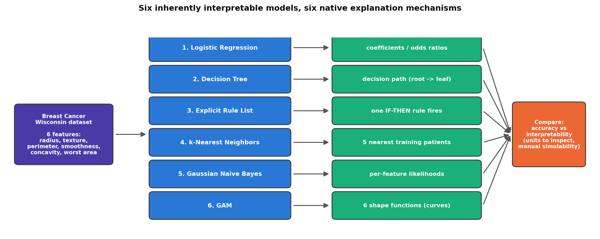
All six models are trained on the same six standardised features; each is paired with its own native explanation mechanism (coefficients, a decision path, an IF-THEN rule, nearest neighbours, per-feature likelihoods, or shape functions), and the models are then compared on accuracy and on how much work each explanation takes to inspect.
Algorithm
Algorithm: Comparison of Inherently Interpretable Models
- Start.
- Import the required Python libraries and machine learning algorithms.
- Load the Breast Cancer Wisconsin (Diagnostic) dataset.
- Select six clinically meaningful features: mean radius, mean texture, mean perimeter, mean smoothness, mean concavity, worst area.
- Separate the input features X and target variable y.
- Split the dataset into training and testing sets using stratified sampling.
- Standardize the selected features using StandardScaler.
- Train a Logistic Regression model.
- Obtain its coefficients and calculate odds ratios to interpret feature contributions.
- Train a Decision Tree with restricted depth and interpret its decision paths.
- Extract the tree's root-to-leaf paths as explicit IF–THEN rules.
- Train a k-NN classifier with k = 5.
- Identify the five nearest training examples for a test patient and use their majority class as the explanation.
- Train a Gaussian Naive Bayes classifier.
- Examine class-wise feature means and interpret the contribution of individual features using likelihoods.
- Train a Generalized Additive Model (GAM) using separate smooth functions for the six features.
- Evaluate all models using test accuracy.
- Compare the models based on: prediction accuracy, interpretability unit, number of units to inspect, manual simulability.
- Plot the accuracy comparison of all models.
- Analyze the accuracy–interpretability trade-off.
- Stop.

GitHub Link
https://github.com/bhargavrrao-web/XAI_LABS-/blob/main/Inherently_Interpretable_Models.ipynb

