**Dbpass** Vitcc$3499  
**Section 1 : Course Introduction**

What are Databases?  
Databases are systems that allow users to store and organize data

Why use Databases?

They are useful when dealing with large amounts of data

**From Spreadsheets to Databases**

|  |  |
| --- | --- |
| **Spreadsheets** | **Databases** |
| One time analysis | Data Integrity |
| Quickly need to chart something out | Can handle massive amounts of data |
| Reasonable data set size | Quickly combine different datasets |
| Ability for untrained people to work with data | Automate steps for re-use |
|  | Can support data for websites and applications |

Tabs = Tables

Rows = Rows

Columns = Columns

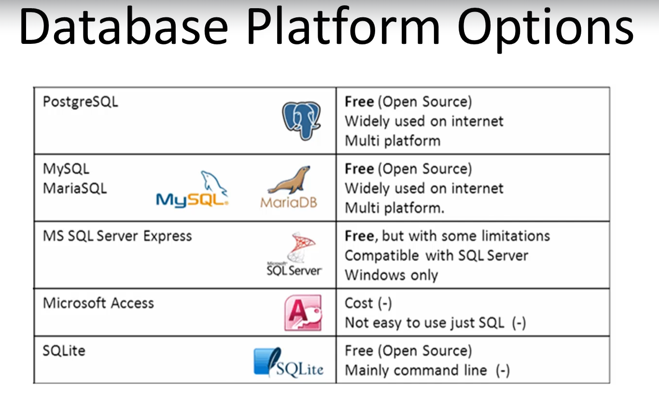

SQL is the programming language used to communicate with our Database

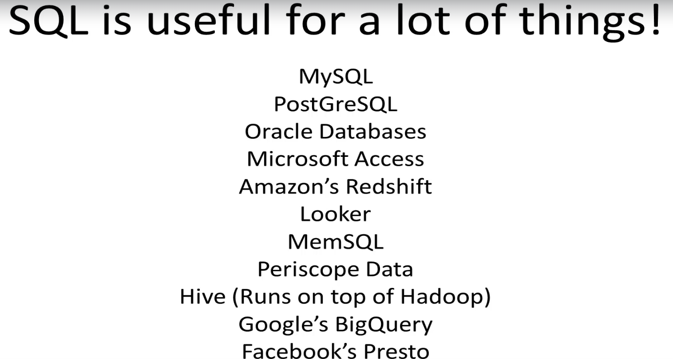

**PostgreSQL** - SQL Engine that stores data and read queries and returns information

**PgAdmin** - Graphical User Interface for connecting with PostgreSQL