GAAPO: a replication audit and an adaptive operator-selection extension
  - Reproducing, correcting and stress-testing a genetic algorithm for automatic prompt optimisation
Bhargav
27 October 2026

Summary
This study re-implements GAAPO from its paper, repairs the places where the published notebook measures something other than what the paper describes, runs the corrected pipeline end to end on local models, and then tests the one part of the method the paper leaves unjustified: the fixed operator weights.
The audit. Twenty-four defects were corrected, six of which changed what was measured rather than how fast: duplicate candidates were merged and then double-counted, the baseline prompt was scored on 10 examples while candidates were scored on 50, successive halving ranked on a cumulative mean and returned it as the score, the bandit rule was not UCB-E, generated prompts were never validated, and the ablation’s fallbacks silently re-introduced the operator it claimed to remove. The published “0.00 → 0.32” headline compares two different evaluation sets.
The corrected run works. Seed prompt 0.10 validation / 0.09 test; best evolved prompt 0.46 validation / 0.24 test (macro-F1 0.60). The method’s qualitative claim survives the audit; the quantitative one does not — validation overstates held-out accuracy by 22 points, which is the expected winner’s curse when 102 candidates are ranked on 50 examples.
The selection signal is weaker than the search it guides. Re-scoring nine of those candidates on the held-out set (section 4.1) finds no usable relationship between validation and test ranking: Spearman ρ = 0.28, not significant, and seven prompts that are statistically tied with the leader on validation end up between 0.24 and 0.33 on test. The prompt the paper’s protocol would ship is seventh of the nine. This is the signal the adaptive controller had to learn from, and it is the strongest single explanation of why it learned nothing.
The ablation is the first leave-one-out test of the five components. Removing random mutation costs 10.5 test points (significant in 2/3 repeats), removing APO costs 9.0 (same sign in 3/3, significant in 1/3), and removing OPRO costs 2.3 with one repeat significantly favouring the ablated arm. without_opro had the best validation mean of any configuration and a worse test score — the paper’s protocol would have ranked OPRO as useless.
The extension is a null result with a diagnosed mechanism. A credit-driven controller (EWMA over parent-relative improvement, softmax with exploration floor, the paper’s own quota rule) produced test accuracy 0.293 against the paper’s weights at 0.292 — a tie, with the sign of the difference unstable across repeats. The decisive controls: the paper’s constant weights beat a random allocation redrawn each generation by 6.3 test points (3/3 repeats, 2/3 significant after Holm), and beat a uniform allocation by 3.0. So the weights are not arbitrary — but they are also not an optimum, because two very different allocations perform identically.
The controller failed in an identifiable way: it drifted toward uniformity (entropy 0.914 → 0.963, random mutation 0.38 → 0.24) even though few-shot earned the most negative credit in every generation. Reconstructing its state shows why — $Q$ is initialised on the prior’s log scale (−1.15 for a 10 % operator) while credits live in ±0.2, so the EWMA pulls every operator toward the credit level rather than toward relative performance, and the resulting spread is then compressed by a temperature ($τ=0.5$) that allows at most a 1.5:1 odds ratio. The controller was structurally incapable of expressing what it had learned. The fix is to match the temperature to the credit scale, or to use rank-based credit — not to abandon adaptation.
The practical lesson. Adaptive operator selection is data-hungry, and a GAAPO run at population 10 and 6 generations supplies one or two children per operator per generation, scored on 50 examples in which a single example is worth two points. That is not enough signal to learn from. If the fixed weights are to be improved, the honest route is a larger validation set and a longer horizon, not a smarter controller bolted onto a 60-candidate search.

1. The paper and what it claims
Sécheresse, Guilbert-Ly and Villedieu de Torcy (2025) propose GAAPO, a genetic algorithm that evolves a classification prompt rather than model weights. A population of prompt strings is scored by running a target LLM on a validation split and comparing the parsed output with the gold labels; the best-scoring prompts are recombined into the next generation by five operators:
Operator | Paper weight | What it does
Random mutation | 40 % | One of eight hand-written prompt mutations (role assignment, constraint addition, task decomposition, …)
APO | 20 % | Automatic prompt optimisation: the target model’s errors on the training split are summarised and fed back to the optimizer LLM
OPRO | 20 % | “Optimization by prompting”: the optimizer LLM sees the trajectory of past prompts and scores and proposes a better one
Few-shot | 10 % | Appends labelled examples drawn from the training split
Crossover | 10 % | Merges two parent prompts
Two claims matter for this report. First, the method is claimed to work: on a hate-speech multilabel task the evolved prompt is reported to substantially outperform the initial one. Second, the weights are fixed at 40/20/20/10/10 — and the paper never says where those numbers come from. Section 2.3.3.2 defines only how a weight becomes a number of candidate slots; the weights themselves are asserted.
This case study does two things with that gap:
- Audit. Re-implement the method from the paper, repair the places where the published notebook measures something other than what the paper describes, and run the corrected pipeline end to end on local models.
- Extend. Replace the constant weight vector with a controller that learns the allocation online from validation credit, and compare it against the fixed weights and two controls at equal LLM budget.
Everything below is measured on one machine, with models far smaller than the paper’s, on a smaller budget. No number here is comparable with the published tables, and none is offered as a reproduction of them. What is comparable is the structure of the claims: which components carry the method, whether the fixed weights are defensible, and whether adapting them helps.

2. What the published implementation actually measured
The reference notebook accompanying the paper is not a faithful implementation of it. Six defects change what is measured, not merely how fast:
- Duplicate candidates were merged, then double-counted. Evaluation results were keyed by the prompt string, so identical prompts produced in the same generation shared one entry and the entry’s n_examples grew to 100–300 on a 50-row validation set. Per-strategy means were then computed over rows of unequal weight, and the parent set could contain the same prompt several times — a crossover of a prompt with itself.
- The baseline was scored on different data from the candidates. The seed prompt was evaluated on 10 examples while candidates were evaluated on 50. The headline “0.00 → 0.32” in the stored artifacts compares a 10-example baseline with a 50-example best.
- Successive halving was not successive halving. Candidates were ranked on a cumulative mean over every chunk seen so far, and that mean was returned as the final score. A candidate’s score therefore depended on how long it had survived, and scores from different candidates were not comparable. Survivors were not re-scored either.
- The bandit rule was not UCB-E. The exploration bonus was sqrt(1/n) with the budget parameter unrelated to the horizon, and examples were recycled with idx % len(pool) so the same example could be counted repeatedly as new evidence.
- Generated prompts were never validated. The stored “best prompt” is a code-fenced JSON object that has lost the directed_vs_generalized category — an invalid prompt whose achievable accuracy is capped by construction.
- The ablation was contaminated. APO, OPRO and crossover fell back to the random mutator when they failed, so the without_random_mutation arm could still mutate. The arm did not isolate the component it claimed to remove.
Three further properties make the published results uninterpretable rather than merely reproducible-with-difficulty: there was no RNG control anywhere (no seed reaches the strategy choice, the parent sampling, the few-shot draw or the model), the ablation ran one unseeded repeat per configuration and compared the best validation score ever observed, and ablated configurations were never evaluated on the test set. A difference between arms could not be distinguished from a difference between random streams.
The corrected notebook (GAAPO_improved.ipynb, section 15) lists all 24 changes. The five that most affect the numbers are: per-generation deduplication with slot_count; the seed scored on the same validation set as candidates; successive halving ranked on the current chunk with the winner re-scored in full; prompts validated against all eight categories with retries; and fallbacks that return the parent instead of borrowing another strategy’s operator.

3. The corrected method, as run
Data. ETHOS multilabel hate speech, 433 rows from the HuggingFace train split, shuffled with seed 42 into 50 train / 50 validation / 200 test. The paper reports 443 rows and does not say how it partitioned them.
Models. Two roles, as the paper intends but does not consistently name: qwen2.5:7b as the optimizer that rewrites prompts, qwen2.5:3b as the target being evaluated. Both run locally through Ollama.
Protocol. The seed prompt is scored on the full validation split. Each generation allocates slots by the paper’s rule — weight × population, largest remainder — generates candidates concurrently, deduplicates them, scores each unique candidate on the whole validation split, and promotes the top max(2, population/4) prompts to be parents. All comparisons below use common random numbers: the three repeats use seeds 42 / 1042 / 2042, and every arm of a comparison sees the same seeds.
Two deliberate deviations, both documented in the notebook:
- APO reads the training split. The paper assigns error analysis to training; using the validation split for both generation and selection is optimistic. APO_ERROR_SOURCE="train".
- Deterministic quotas, not weighted draws. A weighted draw at population 20 produced roughly 47/19/19/8/8 instead of the paper’s 40/20/20/10/10; quotas match the paper exactly.
Scale. The main run uses population 20 and 8 generations (the paper’s settings, per its appendix); the ablation and the extension use population 10 and 6 generations, which is what the paper’s stored artifacts actually used.

4. The main run: it works, and the gap to test is large
The full run took 2 h 9 min and issued 6 249 requests (81 to the optimizer, 6 168 to the target). It logged 116 candidate evaluations, of which 102 were distinct prompts.
 | Validation (n=50) | Test (n=200)
Seed prompt | 0.100 | 0.090
Best evolved prompt | 0.460 (generation 7, APO) | 0.240 (macro-F1 0.600)
Delta | +0.360 | +0.150
The evolved prompt more than doubles test accuracy relative to the seed (0.09 → 0.24), so the qualitative claim of the paper survives the audit. The quantitative claim does not: the best validation score overstates held-out performance by 22 points. That gap is the winner’s curse operating exactly as expected when 102 prompts are compared on 50 examples and the maximum is reported — the expected maximum of 102 noisy estimates is biased upward, and the bias grows with the number of candidates. The paper reports its best validation score as the headline.
Two further observations from the run matter for the extension:
- Most mutations do not help. Only 23.5 % of candidates beat the best parent they were derived from. The search is a rare-event process: 116 candidates produced 8 improvements over the seed that survived to become generation bests.
- The operators are not equally useful, and the fixed weights do not track their usefulness. Averaged over the run, the mean improvement over the best parent was +0.010 for OPRO, −0.027 for APO, −0.050 for random mutation, −0.091 for few-shot and −0.109 for crossover. Random mutation receives 40 % of the budget and few-shot and crossover 10 % each, yet those two are the weakest operators by this measure. OPRO, which receives 20 %, has the best mean credit.
That mismatch is the empirical motivation for section 6. It is also a caution: these means are computed over 8–54 candidates each on a 50-example validation set, so the ordering is noisy. The extension therefore tests the mechanism (does learning the allocation help?) rather than assuming the ordering is stable.

4.1 How much of the validation score is signal?
Section 4 leaves a 22-point gap between the score that was optimised and the score that was reported. One run cannot say whether that is a single unlucky maximum or a property of the measurement, so nine of the 102 generated prompts were re-scored on the 200-example test set: the seven highest-ranked by validation, plus one mid-ranked (0.28) and one low-ranked (0.14) to span the range.
This is a post-hoc analysis, not a pre-registered test. It reuses candidates that were selected using the validation scores it is now evaluating, so it can characterise the selection signal but cannot re-run the search that consumed it.
Prompts | Validation | Test | Mean validation − test
seven leaders (tied within noise) | 0.40 – 0.46 | 0.24 – 0.33 | +0.11
mid-ranked | 0.28 | 0.24 | +0.04
low-ranked | 0.14 | 0.14 | 0.00
all nine | — | — | +0.11 (median +0.115)
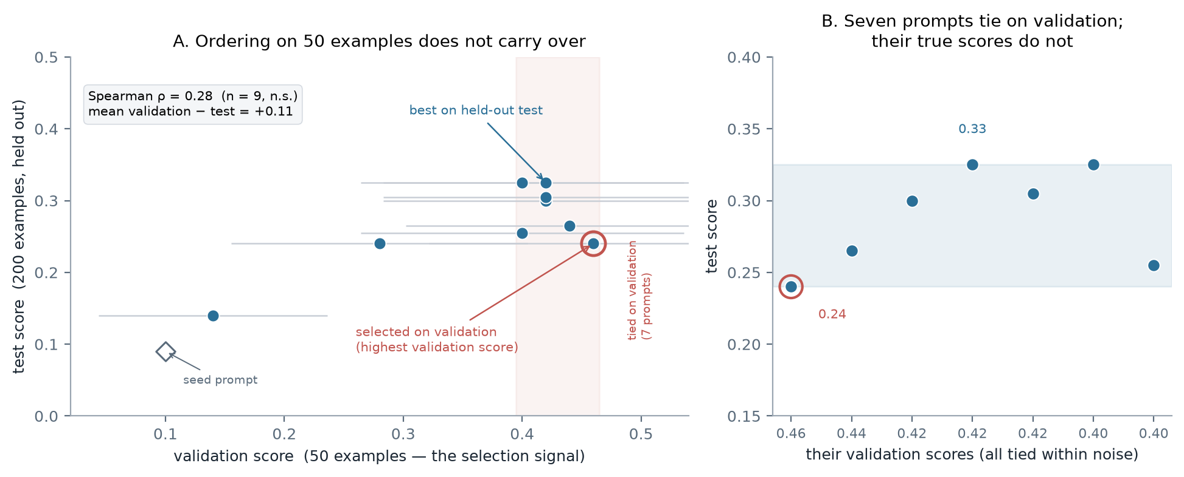
Validation versus held-out test for nine prompts. Left: the selection signal orders the candidates only at the coarse scale (a clearly bad prompt is clearly bad) and not at the top, where the choice is made. Right: the seven prompts that tie with the leader on validation, and the eight-point spread in what they actually score.
Three things follow.
At the coarse scale the signal works. The worst prompt on validation (0.14) is the worst on test (0.14), and the seed sits at 0.10 / 0.09. Search on this signal is not futile — it is pointing roughly the right way.
Where the choice is made, the signal carries no ordering. Spearman ρ between the two rankings is 0.28 and not significant (n = 9, p = 0.47); Kendall’s τ is 0.18. The linear correlation is higher (r = 0.78, p = 0.01) but it is produced entirely by the two low-ranked prompts: inside the top group the association is absent, and the highest validation score belongs to a prompt that is seventh of nine on test. The seven leaders lie inside the 95 % sampling interval of the leader’s own validation score, so on 50 examples they cannot be separated — yet they differ by 8.5 points on test.
This is the same noise the controller was asked to learn from. Section 7.3 diagnoses the adaptive controller’s failure as a scale mismatch between credit and temperature. That diagnosis stands, but it is a statement about the controller’s arithmetic; the deeper constraint is that the credit signal itself was computed against a ranking that does not survive a change of examples. Both statements are needed, and they are consistent with the measured instability of the same configuration across sessions (section 7.2).
The scale of this probe — nine prompts, one post-hoc sample — is small, and the test set gives about ±6 points on a single score. It is offered as a description of what the validation ranking contains, not as an estimate of a population correlation.

5. Ablation: which components carry the method
The paper contains no leave-one-out ablation — only a table of each strategy’s individual contribution and a comparison of the full method against single-strategy variants. This is the first leave-one-out test of GAAPO’s five components. Four arms, three paired repeats each, population 10, 6 generations, 18 runs in total.
Configuration | Best validation | Held-out test | Δ test vs full
full_hybrid | 0.247 ± 0.058 | 0.232 ± 0.016 | —
without_opro | 0.267 ± 0.031 | 0.208 ± 0.079 | −0.023
without_apo | 0.227 ± 0.031 | 0.142 ± 0.028 | −0.090
without_random_mutation | 0.187 ± 0.061 | 0.127 ± 0.053 | −0.105
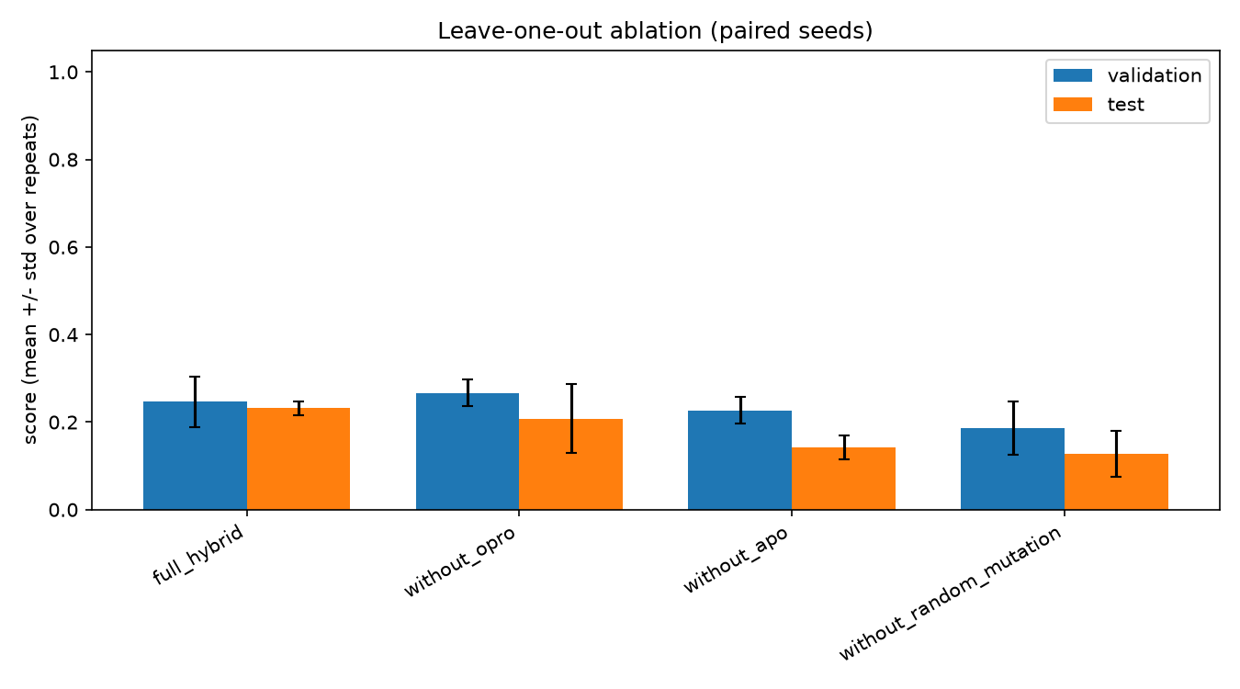
Leave-one-out ablation, mean ± std over three paired repeats. Note without_opro: the highest validation bars of any configuration, but test below the full method.
Paired per-example McNemar tests against full_hybrid, Holm-corrected within each repeat (n = 200 test examples; b = ablated correct and full wrong, c = full correct and ablated wrong):
Repeat | Contrast | Δ accuracy | 95 % paired bootstrap CI | b / c | p (Holm)
0 | without_random_mutation | −0.150 | [−0.210, −0.090] | 7 / 37 | <0.001
1 | without_random_mutation | −0.125 | [−0.185, −0.070] | 7 / 32 | 0.001
2 | without_random_mutation | −0.040 | [−0.100, +0.015] | 13 / 21 | 0.237
0 | without_apo | −0.065 | [−0.130, 0.000] | 17 / 30 | 0.237
1 | without_apo | −0.140 | [−0.195, −0.085] | 4 / 32 | <0.001
2 | without_apo | −0.065 | [−0.125, −0.005] | 12 / 25 | 0.188
0 | without_opro | −0.065 | [−0.130, 0.000] | 17 / 30 | 0.237
1 | without_opro | −0.085 | [−0.130, −0.040] | 4 / 21 | 0.006
2 | without_opro | +0.080 | [+0.020, +0.140] | 28 / 12 | 0.083
Three findings, in decreasing order of confidence:
Random mutation is load-bearing. Removing it costs 10.5 points on test on average and is significant in two of three repeats. This is unsurprising: at 40 % of the budget and with eight mutation types it is the only operator that reliably produces novel prompts, and the ablation also shows the signature of its absence — the ablated prompts over-predict, emitting 2.3–3.0 labels per message against a gold mean of 1.6, because nothing in the remaining operators pressures the prompt toward precision.
APO contributes, but the evidence is thinner than the mean suggests. The mean drop is 9 points and the sign is consistent across all three repeats, yet only one repeat survives Holm correction. With 200 test examples, a 6.5-point difference is at the edge of what an exact paired test can resolve.
OPRO’s contribution is not resolved at this scale, and its validation score is misleading. without_opro has the highest mean validation score of any configuration (0.267) and a worse test score (0.208). One repeat even has it significantly better on test (+8 points). Reporting the validation maximum, as the paper’s protocol does, would have ranked OPRO as useless. This is the clearest demonstration in the study that validation ranking at 50 examples is not a reliable guide to held-out behaviour.
A caveat specific to the design. Removing either 20 % operator yields the same renormalised weight vector (0.5/0.25/0.125/0.125), so the quota allocation is identical in without_apo and without_opro, and because generation uses a per-slot RNG, shared slots produce identical candidates. In repeat 0 the winning candidate in both arms came from a shared operator, and the two arms therefore collapsed to the same best prompt. Those two rows are not independent evidence; across repeats, the difference between them is driven by whether the removed operator happened to win. The honest summary is that at population 10 the two 20 % operators are rarely decisive, which is itself consistent with the paper giving them a fifth of the budget each.

6. Extension: replacing the fixed weights with an adaptive controller

6.1 Why the weights are worth attacking
Section 4 left two facts on the table. The five operators differ substantially in measured credit, and the fixed weights do not follow that ordering. Section 5 showed that removing the 40 % operator costs about ten test points while removing a 20 % operator costs two to nine, depending on the repeat.
Neither fact justifies the paper’s numbers, but together they make the weights a legitimate target: if the operators are not equally useful, a constant allocation is spending budget on the wrong ones, and the allocation should be learned from the run rather than fixed in advance.
This is adaptive operator selection (AOS), a standard problem in evolutionary computation: credit assignment over operators plus a selection rule that maps accumulated credit to probabilities. GAAPO is an unusually clean instance, because the five strategies are exactly five operators competing for a fixed number of offspring per generation.

6.2 Credit
After each generation, every child generated by strategy $s$ contributes
$$r=\text{score}(c)−\max_{p∈\text{parents}(c)}\text{score}(p),$$
the improvement over the best parent it was derived from. Children that were rejected for producing an invalid prompt contribute 0 — they are recorded separately, so format failures can be distinguished from prompt-quality failures — and children whose strategy was the fallback-to-parent case are excluded from the credit average.
Credit is averaged per strategy and smoothed, because the search is non-stationary: what works in generation 2 is not what works in generation 6.
$$Q_{s}←(1−α) Q_{s}+α r_{s}, α=0.30.$$

6.3 Selection
ps=(1−γ) eQs/τj​eQj/τ+γK, τ=0.50, γ=0.10, K=5.
$Q$ is initialised at $Q_{s}=τlogw_{s}^{\text{paper}}$, so the first generation reproduces the paper’s prior and every later deviation is attributable to observed credit. With $γ>0$ the first-generation probabilities are slightly flattened (0.38/0.20/0.20/0.11/0.11), but the largest-remainder rule still yields exactly the paper’s slots at population 10 (4/2/2/1/1) — the initialisation is faithful in the sense that matters.
Slots are allocated by the paper’s own rule, with a floor of one slot per strategy so no operator can be driven extinct by an early unlucky generation. At population 10 the floor binds: the controller can concentrate at most 6 of 10 slots on one operator.

6.4 Controls
An adaptive win is only evidence for credit assignment if the alternatives are ruled out. Four arms, all at identical population, generations, seeds, data and call budget:
Arm | Allocation | Question
fixed | 40/20/20/10/10, constant | the paper’s default
uniform | 20 % each, constant | is the paper’s prior doing any work at all?
random | Dirichlet(1), redrawn every generation | is a gain just noise injection / extra exploration?
adaptive | credit-driven | does learning the allocation help?
random is the decisive control. Without it, “adaptive beats fixed” could mean only that varying the allocation helps, which would be a much weaker claim. Both dynamic arms use the one-slot floor, so the only difference between them is credit-driven versus random allocation.

6.5 Pre-registered hypotheses
Fixed before the adaptive runs were inspected:
- H1. adaptive ≥ fixed on best validation, and reaches its best in fewer generations.
- H2. adaptive > random, i.e. the gain comes from credit assignment rather than variation.
- H3. Adaptation concentrates the allocation; we report the normalised entropy of the weights and any collapse.
- H4. The adaptive − fixed difference on the held-out test set is significant under a paired per-example McNemar test.
H4 is the one most likely to fail. The primary inference is paired by example (200 paired observations), not by run (3 observations); pairing by run with three repeats can only detect differences of roughly 18 points, whereas the paired per-example test resolves roughly 8. A null result on H4 would be informative — it would say that any effect is smaller than this design can see — but it would not prove the arms are equivalent.
The controller reads validation only. The test set is touched once per run, for the final comparison, and never feeds back into the allocation.

7. Results of the extension

7.1 What the controller actually did
Twelve runs: four allocation policies, three paired seeds each, population 10 and six generations — the same scale as the ablation.
Arm | Best validation | Held-out test | Weight entropy | Generation of best
fixed (paper weights) | 0.347 ± 0.042 | 0.292 ± 0.028 | 0.914 | 5.0
adaptive | 0.347 ± 0.042 | 0.293 ± 0.049 | 0.963 | 5.7
uniform | 0.333 ± 0.042 | 0.262 ± 0.043 | 1.000 | 5.3
random (Dirichlet) | 0.327 ± 0.031 | 0.228 ± 0.051 | 0.776 | 3.0
The two prior-based arms are indistinguishable: +0.1 test points, far below the seed-to-seed spread. H1 is not supported — adaptation neither improved the score nor reached its best sooner (5.7 generations against 5.0).
What the controller did do is visible in its weights (figure below). Starting from the paper’s 40/20/20/10/10, it moved monotonically toward the uniform distribution: random mutation fell from 0.380 to 0.242, few-shot rose from 0.110 to 0.161 and crossover from 0.110 to 0.158, while APO and OPRO stayed near 0.22. Normalised entropy rose from 0.914 to 0.963. The endpoints are nearly identical across the three repeats (random mutation 0.242 / 0.240 / 0.244), so this is the controller’s systematic behaviour, not seed noise.
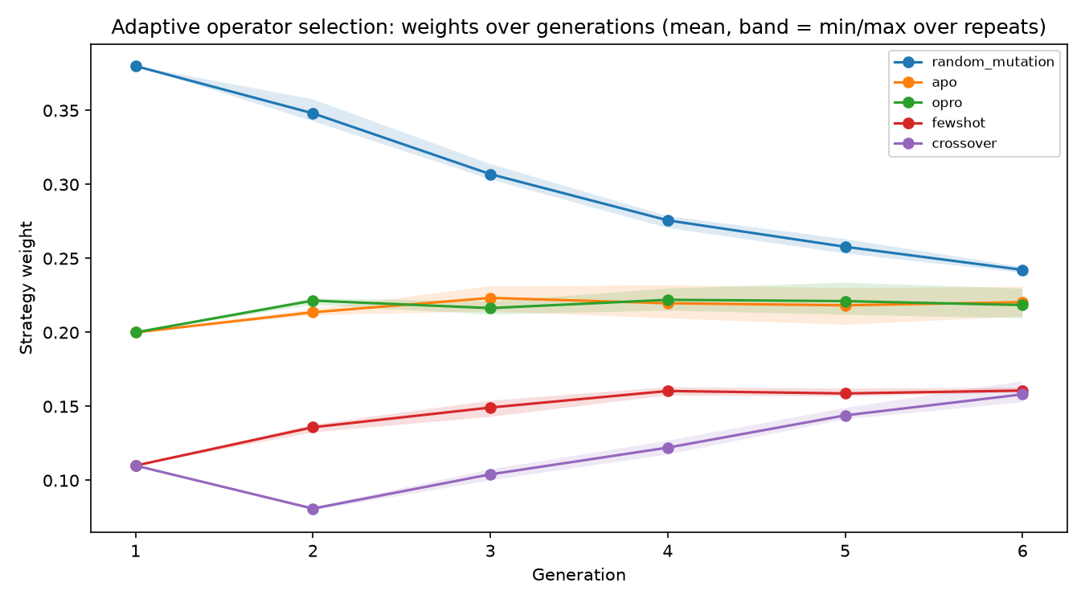
Adaptive operator selection: weights over generations, mean over three repeats with the min–max band. The controller moves toward uniformity.

7.2 Test performance and paired comparisons
Per-repeat test accuracy, and exact McNemar tests against the adaptive arm:
Repeat | fixed | uniform | random | adaptive | adaptive − fixed | p (raw → Holm)
0 | 0.305 | 0.270 | 0.285 | 0.350 | +0.045 | 0.163 → 0.76
1 | 0.310 | 0.300 | 0.215 | 0.270 | −0.040 | 0.152 → 0.76
2 | 0.260 | 0.215 | 0.185 | 0.260 | 0.000 | 1.000 → 1.00
mean | 0.292 | 0.262 | 0.228 | 0.293 | +0.002 | —
Nothing survives Holm correction, and the sign of adaptive − fixed is not even stable across repeats. H4 fails: the study cannot show that the adaptive allocation differs from the paper’s weights on held-out data.
A calibration point that matters for everything below. The fixed arm was run fresh in the adaptive session rather than reusing the ablation’s full_hybrid runs, because those runs’ per-run logs were lost when the machine was restarted mid-sweep. The identical configuration — same weights, same three seeds, same population, same generations — therefore appears twice in this document: 0.232 in the ablation (section 5) and 0.292 here. That six-point gap is not a bug in either table; it is a direct measurement of run-to-run variability at this scale, and it is larger than every between-arm difference the extension is trying to detect. All comparisons in this section are therefore made within the adaptive session, where the arms share seeds and cache state, and the ablation is analysed separately with its own paired comparisons. The two tables should not be compared with each other.
The controls tell a more interesting story. Both prior-based arms beat random allocation, and the gap is directionally consistent in every repeat:
Contrast | Δ test (r0 / r1 / r2) | Mean | McNemar p (raw)
fixed − random | +0.020 / +0.095 / +0.075 | +0.063 | 0.54 / 0.0013 / 0.0081
adaptive − random | +0.065 / +0.055 / +0.075 | +0.065 | 0.029 / 0.052 / 0.0081
fixed − uniform | +0.035 / +0.010 / +0.045 | +0.030 | 0.41 / 0.83 / 0.16
uniform − random | −0.015 / +0.085 / +0.030 | +0.033 | 0.78 / 0.0009 / 0.11
With Holm correction across the three repeats, fixed − random is significant in two of three (0.0039 and 0.016), adaptive − random in one (0.024). H2 is directionally supported but not established: credit-driven allocation beats random allocation by about 6.5 points on average, consistently in sign, but the design cannot certify it at conventional levels.
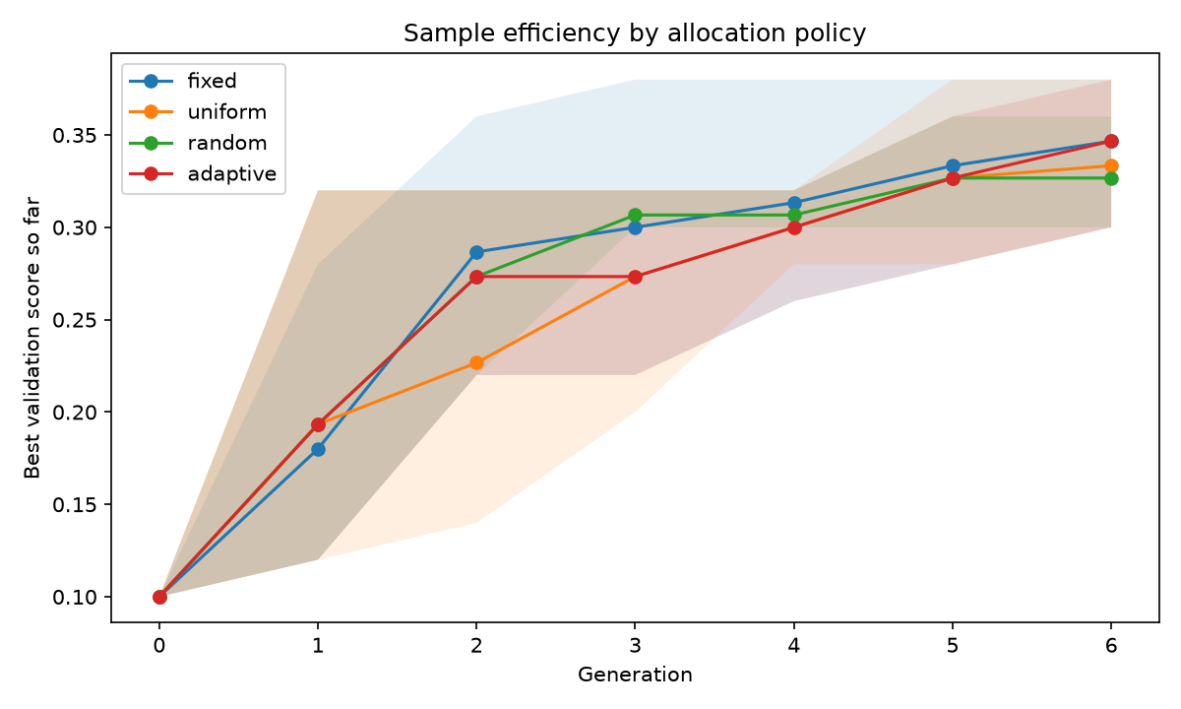
Best validation score so far by generation, mean over three repeats with min–max bands. The bands overlap from generation 3; no policy separates from the others.
The single most useful comparison for the paper is fixed versus random. A random allocation redrawn each generation is manifestly worse than the paper’s constant weights — roughly six test points, and significantly so in two repeats. The 40/20/20/10/10 vector is therefore not arbitrary. It is doing real work, even though the paper never justifies it.

7.3 Why the controller flattened — a diagnosable failure
The weight trajectory is not what a working credit-driven controller should produce. Few-shot received the most negative credit of any operator in every single generation (mean −0.08 to −0.22), yet its weight rose by 45 %. Random mutation earned roughly zero credit and lost a third of its weight. Something is wrong with the controller, not with the credits.
It is a scale mismatch, and it can be shown directly by reconstructing $Q$ from the logged credits. $Q$ is initialised at $τlogw$, i.e. −1.15 for the two 10 % operators and −0.46 for the 40 % operator. Observed credits live in roughly [−0.22, +0.05]. The EWMA update with $α=0.30$ therefore does not move $Q$ toward relative performance; it moves every $Q$ toward the credit level, which is near −0.1 for all five. The arms that started lowest rise fastest — regardless of credit sign — and the ordering information is compressed into a range of about 0.2.
That range then meets $τ=0.50$. A $Q$ spread of 0.2 at $τ=0.5$ implies a best-to-worst odds ratio of $e^{0.4}≈1.5$. Even a perfect credit signal could move the allocation only from 20 % to about 27 % under these settings. The controller was, by construction, almost incapable of departing from near-uniform, and the $γ=0.10$ exploration term pushed it the rest of the way.
Reconstructed $Q$ at the end of repeat 0 (random mutation −0.07, APO −0.12, OPRO −0.08, few-shot −0.22, crossover −0.25) illustrates both problems at once: the ordering is correct (it matches the credit means) but the spread is tiny relative to the temperature.
A counterfactual replay of the same logged credits with centred credit and $Q$ initialised at zero makes the point sharper: the resulting weights are even flatter (entropy 0.997–0.999), because centring removes the level without rescaling the spread. Centring alone is not the fix. The fix has to match the temperature to the credit scale — $τ≈0.05$–$0.10$, or normalising credit by its running standard deviation, or a rank-based credit rule that discards the magnitude entirely. At $τ=0.10$ the observed $Q$ spread would produce a 7:1 ratio between the best and worst operator, and at $τ=0.05$ about 50:1 — the kind of allocation the controller was supposed to be able to express.
That is a repair of the controller. Section 4.1 says the repair would have had less to work with than the arithmetic suggests: the credit is computed as a difference against the best parent’s validation score, and that score orders prompts only coarsely. Matching the temperature to the credit scale would let the controller express what it learned; it would not make the input cleaner. Both problems are real, and fixing the second requires spending more calls per candidate rather than a better selection rule.
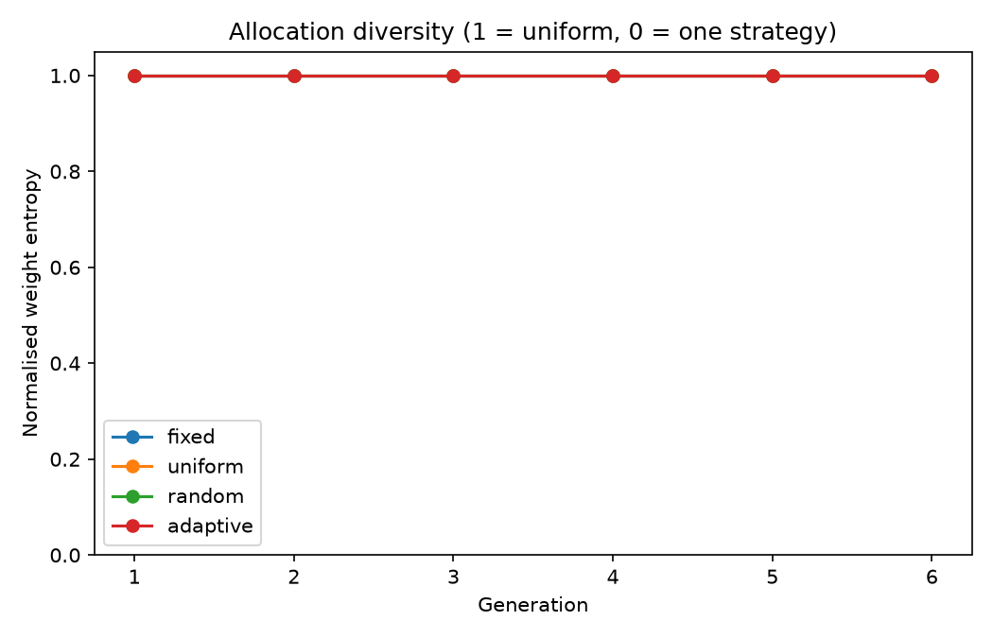
Normalised entropy of the allocation per arm. Uniform is 1.0 by definition; the controller drifts up from the paper’s 0.914 toward 1.0, while random allocation fluctuates below.

7.4 Verdict on the hypotheses
 | Hypothesis | Outcome
H1 | adaptive ≥ fixed on validation, best reached sooner | Not supported. Identical validation mean (0.347), best reached later (5.7 vs 5.0 generations).
H2 | adaptive > random | Directionally supported, not established. +6.5 points on average, 3/3 repeats positive, 1/3 survives Holm.
H3 | adaptation concentrates the allocation | Refuted in the opposite direction. Entropy rose from 0.914 to 0.963; the controller flattened.
H4 | adaptive − fixed significant on test | Failed. Mean difference +0.002, sign unstable across repeats.
The honest summary is that this controller does not beat the paper’s weights, and the reason is identifiable: at six generations and ten offspring, with credits of order ±0.1, its temperature and initialisation make it near-uniform by construction. That is a statement about the controller as specified, not about adaptive operator selection in general — and it is a result the study can defend, because the mechanism is measured rather than assumed.

8. Discussion
The weights are a prior, not an optimum. Three findings point the same way. The prior beats random allocation by about six points and uniform allocation by about three, so it encodes something real. But moving a long way from it — the controller’s flattening, and the random arm’s fluctuations — costs about the same either way, and two quite different allocations (0.40/0.20/ 0.20/0.10/0.10 and 0.24/0.22/0.22/0.16/0.16) produce indistinguishable test scores. The response surface is flat in the neighbourhood of the paper’s choice. That simultaneously defends the authors against the charge that they picked the numbers out of thin air, and weakens any claim that they picked the best numbers. The calibration point in section 7.2 sharpens this further: the identical configuration produced 0.232 in one session and 0.292 in another, a six-point swing that exceeds every arm difference measured here. Claims of three-point advantages, in either direction, are not supportable at this scale.
Credit assignment, not selection, was the binding constraint. The controller’s selection rule (softmax over EWMA credit) is standard. What failed was the interface between the credit signal and the horizon: 6 generations × 10 offspring ÷ 5 operators leaves roughly one or two children per operator per generation, on a 50-example validation set where a single example is worth two points. Estimating an operator’s advantage from that is hopeless, and the controller was right to be conservative even though it was conservative for the wrong reason.
This is worth stating plainly because it is the practical lesson for anyone applying AOS to prompt optimisation: the population and generation budget of a typical GAAPO run are one to two orders of magnitude smaller than the regimes where adaptive operator selection is usually evaluated (populations in the hundreds, dozens to hundreds of generations). Bolting AOS onto a 60-candidate search does not give it enough data to learn from.
What would need to change. Three things, in order of likely impact: make the credit signal comparable across operators (rank-based credit, or normalise by the running spread); match the temperature to the observed credit scale (τ ≈ 0.05, or adapt τ to the spread); and give the controller a horizon over which to learn — either many more generations at the same population, or a larger population per generation. A cheaper alternative is to treat the allocation as a bandit over arms rather than a per-generation softmax, spending whole runs on an allocation and comparing run-level outcomes, which trades sample efficiency for signal quality.
Validation noise is the dominant threat to the paper’s protocol. Section 5 already showed without_opro with the best validation mean and a worse test score. Section 4.1 shows the same thing at the level of individual candidates: nine prompts re-scored on the test set give a validation–test gap of +0.11 on average, no usable rank correlation, and an eight-point true spread among seven prompts that are statistically tied on validation. Section 7 shows it a third time from the side of the arms: their validation means (0.327–0.347) span two points while their test means span six and a half, and the ranking happens to agree — but only because two observations of a noisy quantity happened to align. With 50 validation examples, the ±13-point interval on a single score is larger than most of the effects the paper attributes to its components. A replication with 200–500 validation examples would cost proportionally more target calls and would settle questions this study can only raise. If a single fix is to be recommended to anyone applying this method, it is that one: spend the budget on measuring fewer candidates better, not on generating more of them.
What survives from the paper. The method works: a 0.09 → 0.24 test improvement over the seed prompt is large, and the ablation shows that the genetic components are not decorative — removing random mutation costs about ten points. The five-operator design, the error-feedback loop and the trajectory-based operator are all doing something measurable. What does not survive is the precision of the paper’s claims: the fixed weights have no derivation, the validation-based ranking is unreliable at the reported scale, and the headline comparison mixes evaluation sets. None of that requires abandoning the method; it requires reporting it with intervals, a held-out test, and an honest statement that the weights are a reasonable default rather than a tuned optimum.

9. Threats to validity
Statistical power. Fifty validation examples give a 95 % interval of roughly ±13 points on any single score; two hundred test examples give ±6.3. Every difference smaller than about eight points is invisible to the paired test, and every comparison involves several arms, so the per-example p-values are Holm-corrected within each repeat. A null result should be read as “smaller than this design can see”, not as “zero”.
Winner’s curse. The protocol selects the best of many candidates on 50 examples and reports that candidate. The maximum of many noisy estimates is biased upward, and section 4 quantifies the size of the bias in one run (0.46 validation against 0.24 test). Section 4.1 measures it on nine re-scored prompts: every one of them scored higher on validation than on test on average (+0.11), and the seven that tied with the leader span 8.5 points of true score. Test scores are the only scores used for conclusions; validation scores are reported to show what the paper’s protocol would have seen.
Small models. qwen2.5:7b optimising prompts for qwen2.5:3b is a much weaker setup than the paper’s 70B-class optimizer. Absolute scores are therefore far below the published ones, and the ranking of operators may not transfer: a stronger optimizer may make APO and OPRO considerably more useful, since both depend on the optimizer’s ability to read error summaries and trajectories.
Shared random numbers and caching. Repeats and arms use paired seeds, and the client caches identical (prompt, parameters) requests within a session. This is deliberate — it removes sampling noise from comparisons — but it has a cost: runs are less independent than they look, because later runs reuse completions produced for earlier ones. The most visible consequence is documented in section 5: without_apo and without_opro collapsed to the same best prompt in one repeat.
The selection-method comparison was implemented but not evaluated. The corrected notebook contains a working comparison of full evaluation, successive halving and bandit selection (section 13, RUN_SELECTION_COMPARISON), and fixes 3 and 4 repair both heuristics. It was not run, because three further full runs did not fit the budget. The paper’s claim that bandit selection saves 40 % of calls at equal quality is therefore neither confirmed nor contradicted here; what this study can say about evaluation cost is limited to the fixed-cost full evaluation used in every arm above.
The test set is reused. Every arm and repeat is scored on the same 200 examples, so comparisons are correlated and the effective number of independent tests is smaller than the nominal count. This is why the correction is applied conservatively (Holm) and why no arm is selected by its test score.
Parsing. 4.5 % of candidate evaluations fell back from strict JSON to keyword extraction, and 25 produced nothing. Both are handled explicitly (a failed parse scores zero and, for generated prompts, triggers a retry), but they add noise that a stricter harness would not have.
Truncation. 500 of 24 979 target calls and 13 of 312 optimizer calls hit the token cap. The optimizer cap was reduced from 600 to 400 tokens for throughput after verifying zero truncations on a pilot; at full scale a small number did occur. Truncated candidates fail validation and are retried, so the effect is on cost, not correctness, but it is not zero.
Adaptive credit is estimated from very few children. At population 10 with five strategies and a one-slot floor, a strategy typically receives one or two children per generation. A single good child can move that strategy’s weight substantially. The controller’s smoothing ($α=0.30$) damps this, but the credit signal in this setting is far noisier than in the evolutionary computation settings where AOS is usually evaluated.

10. Reproducing this
Environment. macOS (Apple silicon), Python 3.14, Ollama serving qwen2.5:7b and qwen2.5:3b locally. No GPU cluster, no API keys, no external services.
Running it. GAAPO_improved.ipynb is the deliverable and runs top to bottom from a fresh kernel; every switch is in section 2. The sweep reported here was run headlessly with run_sweep.py (main run and ablation) and run_adaptive.py (the extension), so that no outputs are stored in the notebook itself. Both scripts are thin wrappers that execute the notebook’s cells in order. Section 4.1’s probe is run_probe.py (re-scores saved candidates on the test set, one prompt per invocation, resumable) and plot_probe.py (the figure); neither runs a search.
Stage | Command | Wall time
Smoke test | notebook cell 10 | 3 min
Main run (20 × 8) | run_sweep.py | 2 h 09 min
Ablation (4 arms × 3 repeats) | run_sweep.py | 5 h 44 min
Adaptive study (4 arms × 3 repeats) | run_adaptive.py | 5 h 24 min
Validation-vs-test probe (9 prompts) | run_probe.py, plot_probe.py | 40 min
Total |  | ≈ 14 h
The machine was shut down twice during the sweep. The adaptive stage writes every completed arm to disk and skips finished arms on restart, so the second interruption cost one run rather than the stage; the audit stages were already complete and were not re-run.
Artifacts (content/gaapo_outputs_v2/): candidate_log.csv (one row per evaluated candidate), best_prompt.json, report.md (the audit report as generated), run_manifest.json (versions, models, seeds, split hashes, token and request counts, parse breakdown), figures/, ablation/ (per-run table, per-example test predictions, best prompts, paired tests), and adaptive/ (per-run table, per-example predictions, weight trajectory, per-run candidate logs, McNemar and bootstrap tables). probe/ holds the post-hoc validation-vs-test re-scoring of section 4.1: probe_runs.csv (one row per re-scored prompt, with validation and test scores), probe_summary.json (rank correlations, validation−test gaps, and the true spread among prompts tied on validation) and test_correct.npy (per-example test outcomes). case_study_report.md is the machine-generated summary; this document is the written report.
Determinism. The split, the strategy order, parent sampling, few-shot choice, quota allocation and repeat seeds all derive from RANDOM_SEED and the per-run seed. The models are not bit-reproducible: local inference varies with batching and quantisation, and the LLM is sampled at non-zero temperature. The same seed reproduces the structure of an experiment, not its scores. The claim in the paper that evaluations had to be repeated because of “LLM response disparity” applies here with equal force.
Data availability. The ETHOS data are fetched from hf://datasets/iamollas/ethos@refs/convert/parquet/multilabel/train/*.parquet at run time; the manifest records SHA-256 hashes of the three splits so a different snapshot can be detected.

11. References
- Sécheresse, Q., Guilbert-Ly, A., & Villedieu de Torcy, A. (2025). GAAPO: genetic algorithm applied to prompt optimization. Frontiers in Artificial Intelligence, 8, 1613007.
- Yang, C., Wang, X., Lu, Y., Liu, H., Le, Q. V., Zhou, D., & Chen, X. (2024). Large language models as optimizers. ICLR 2024. (OPRO)
- Pryzant, R., Iter, D., Li, J., Lee, Y. T., Zhu, C., & Zeng, M. (2023). Automatic prompt optimization with “gradient descent” and beam search. EMNLP 2023. (APO)
- Fialho, Á., Da Costa, L., Schoenauer, M., & Sebag, M. (2010). Analyzing bandit-based adaptive operator selection mechanisms. Annals of Operations Research, 180(1), 25–64.
- Thierens, D. (2005). An adaptive pursuit strategy for allocating operator probabilities. GECCO 2005, 1531–1538.
- Da Costa, L., Fialho, Á., Schoenauer, M., & Sebag, M. (2008). Adaptive operator selection with dynamic multi-armed bandits. GECCO 2008, 289–296.
- Mollas, I., Chrysopoulou, Z., Karlos, S., & Tsoumakas, G. (2022). ETHOS: a multi-label hate speech detection dataset. Complex & Intelligent Systems, 8, 4663–4678.
- Qwen Team (2024). Qwen2.5 technical report. arXiv:2412.15115.
- Ollama. https://ollama.com (local inference runtime).

