### Ex:No:14

Date:

**TRIGGER**

##### Aim:

To implement trigger in MySQL.

A trigger or database trigger is a stored program executed automatically to respond to a specific event e.g., insert, update or delete occurred in a table.

##### Create trigger syntax

CREATE TRIGGER trigger_nametrigger_timetrigger_event ON table_name

FOR EACH ROW BEGIN

... END;

##### Program 1 :

Create a trigger in MySQL to log the changes of the EMPLOYEES table with fields ID, Name and Email. Also create a new table named EMPLOYEES_AUDIT to keep the changes of the employee table. Create a BEFORE UPDATE trigger that is invoked before a change is made to the employees table.

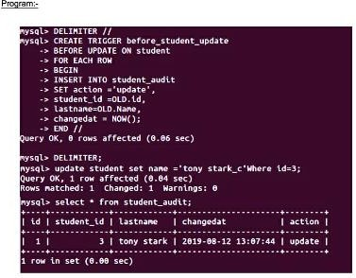

**RESULT:** Thus the trigger is executed successfully.

{echo ”operations failed failed”,mysqli_error($conn);

}

mysqli_close($conn);

**?>**

##### OUTPUT:

After creation of database and emp table



After insertion:

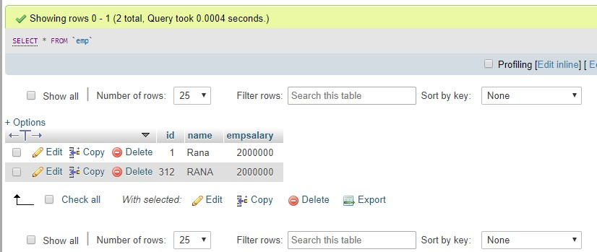

After deletion:

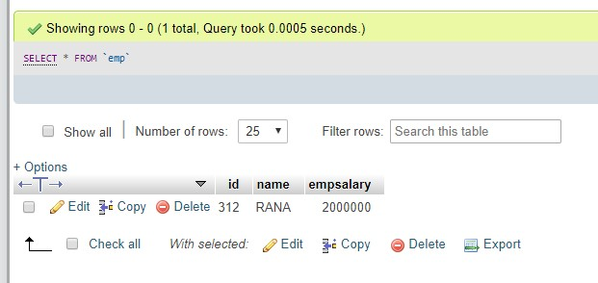

After updation:

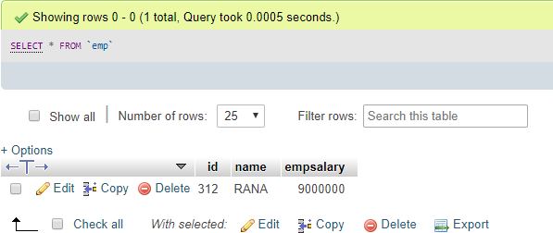

**RESULT:**ThustheMysqlconnectedusingPHP and MYSQLandexecutedtheCREATE,INSERT,SELECTcommandinMySQL.