### Ex. No.: 8

Date:

**VIEW, INDEX, SEQUENCE**

##### AIM:

To create view, index and sequence on the given relation.

##### DESCRIPTION:

**VIEW**

MySQL has supported database views since version 5+. In MySQL, almost features of views conform to the SQL: 2003 standard. MySQL processes query against the views in two ways:

1.In a first way, MySQL creates a temporary table based on the view definition 2.statement and executes the incoming query on this temporary table.

3.In a second way, MySQL combines the incoming query with the query defined the view into one query and executes the combined query.

##### INDEX:

A database index, or just index, helps speed up the retrieval of data from tables. When you query data from a table, first MySQL checks if the indexes exist, then MySQL uses the indexes to select exact physical corresponding rows of the table instead of scanning the whole table..

##### SEQUENCE:

In MySQL, a sequence is a list of integers generated in the ascending order i.e., 1,2,3… Many applications need sequences to generate unique numbers mainly for identification e.g., customer ID in CRM, employee numbers in HR, equipment numbers in services management system, etc.

To create a sequence in MySQL automatically, you set the AUTO_INCREMENT attribute to a column, which typically is a primary key column.

##### SYNTAX:

**VIEW:**

CREATE

[ALGORITHM = {MERGE | TEMPTABLE | UNDEFINED}] VIEW

[database_name].[view_name] AS [SELECT statement]

##### INDEX:

CREATE [UNIQUE|FULLTEXT|SPATIAL] INDEX index_name USING [BTREE | HASH | RTREE]

ON table_name (column_name [(length)] [ASC | DESC],...)

##### SEQUENCE:

CREATE TABLE table_name(

col_name1 AUTO_INCREMENT PRIMARY KEY, col_name2,

col_name3, ….);

###### Questions:

Create a view with name ‘std_view’ using STUDENT table which holds the value of register number, name and DOB of student.

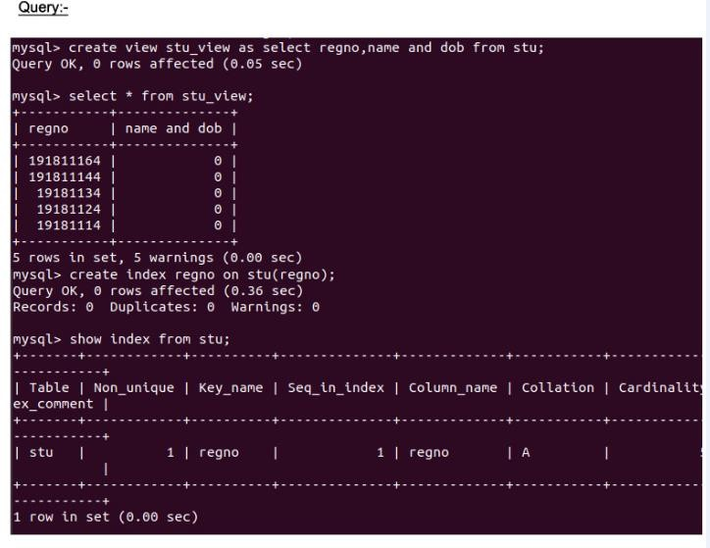

RESULT:

The records from the tables are displayed using JOIN using EquiJoin,InnerJoin, OuterJoin.