Task 1:
- Create a Highly Available Web App Using ALB + EC2 Auto Scaling with architect diagram and explanation.
- Goal: Deploy a simple web application that can scale and stay available.
Steps:
- Launch 2 EC2 instances in different AZs with a simple Apache/Nginx page.
- Create a Target Group and register instances.
- Create an Application Load Balancer (ALB).
- Set up Auto Scaling Group with:
  - Min: 1
  - Max: 3
  - CPU > 60% → scale out
  - CPU < 20% → scale in
- Test failover by stopping one instance—web app should still load.

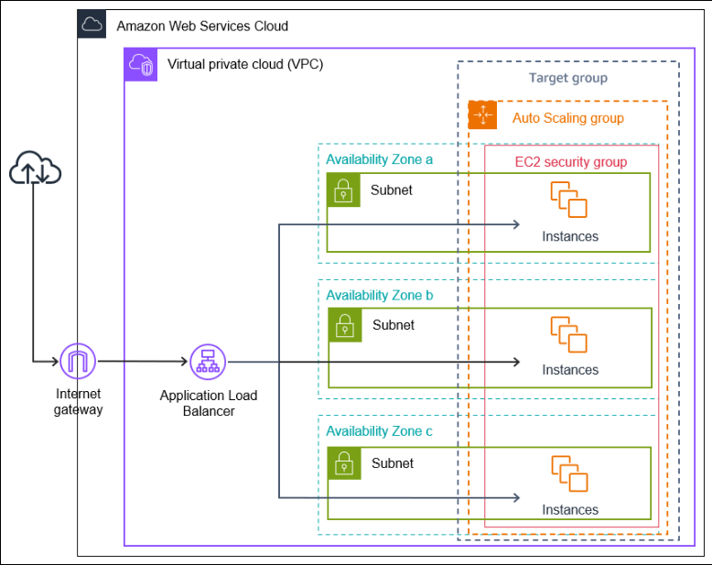

Solution:

- I have used my personal AWS account for these tasks.
- Below is the step-by-step flow which I have implemented for this task using terraform on my local machine.

Components used:
- Installed terraform on local machine first
- Default VPC with existing 2 subnets (different AZs)
- EC2 instances running Nginx
- Application Load Balancer (ALB)
- Target Group
- Auto Scaling Group (ASG)
- CloudWatch alarms for scaling
High availability is achieved by:
- Instances spread across multiple AZs
- ALB routing traffic only to healthy instances
- ASG replacing failed instances automatically

End-to-end request flow:
- User opens the ALB DNS name in a browser.
- ALB receives the request on Listener (HTTP :80).
- ALB forwards the request to the Target Group.
- Target Group selects a healthy EC2 instance.
- Nginx on the instance returns the web page (index.html).
- If an instance becomes unhealthy, ALB stops sending it traffic and ASG replaces it if needed.

Steps for creating this architecture:
- Configured access and secret keys of my AWS account in main.tf file:
  - 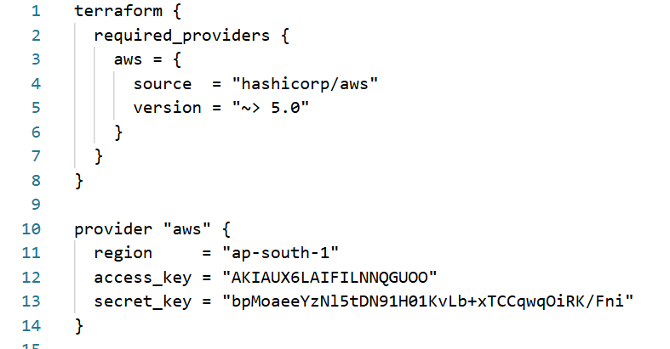
- Added a block for VPC:
  - 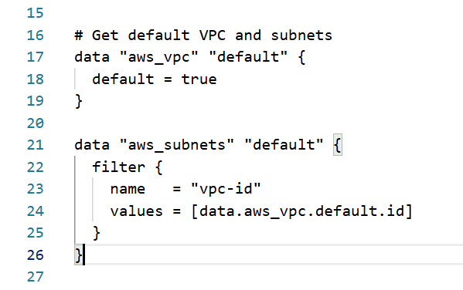
  - 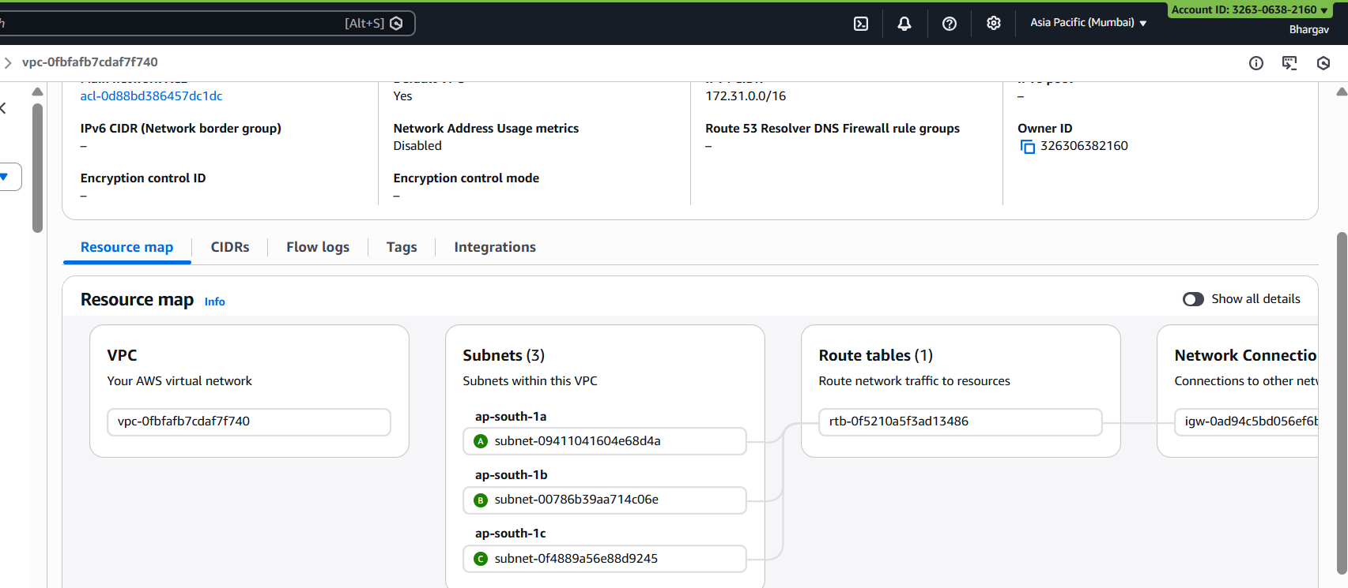

- Used below block for AMI for launching web servers in ASG:
  - 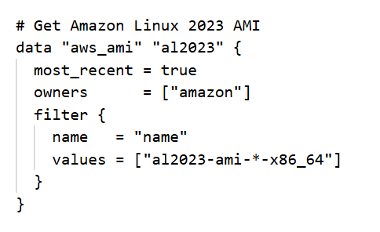
- Security Group for ALB:
  - 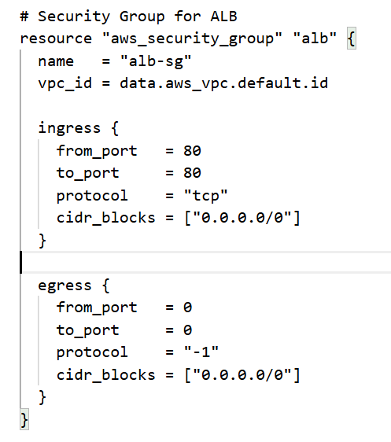
  - 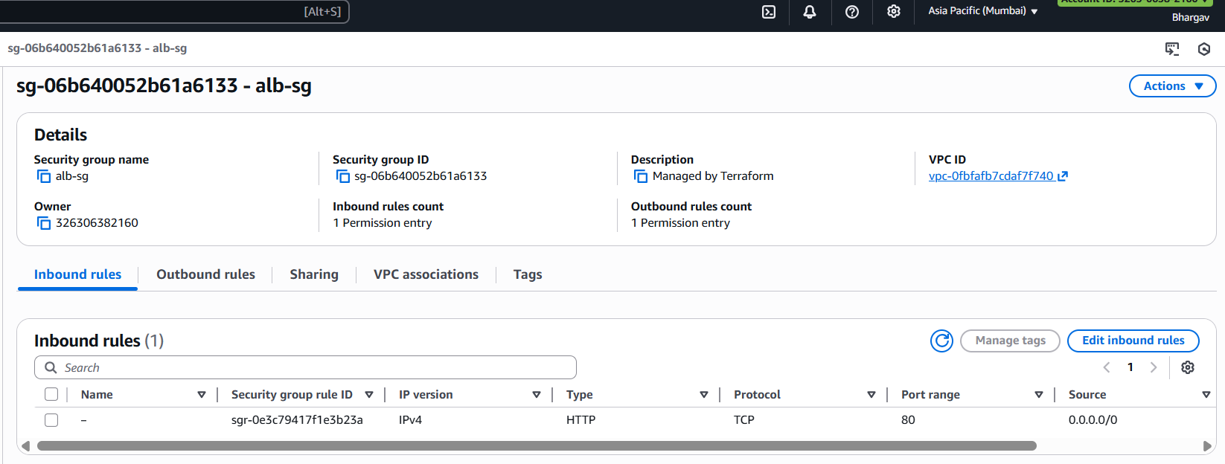

- Security Group for EC2:
  - 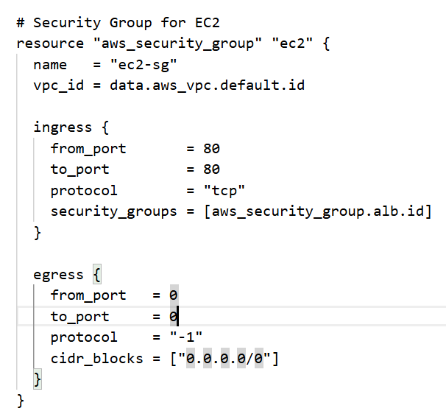
  - 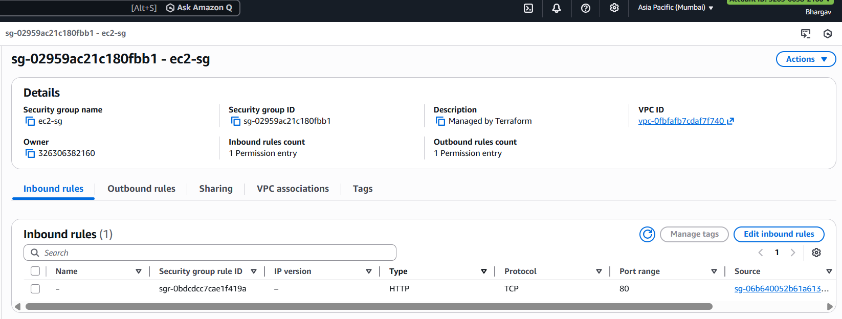

- Launch template configuration:
  - 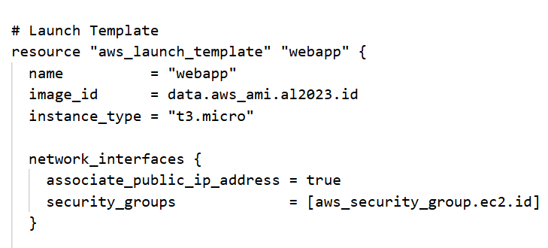
- Userdata of the LT:
  - 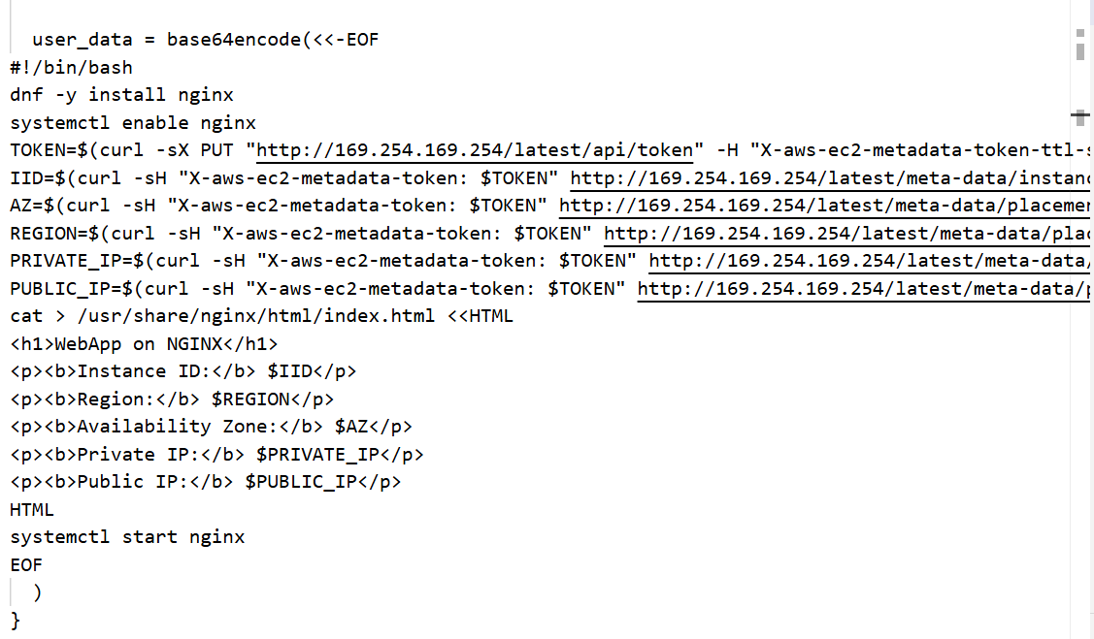
  - 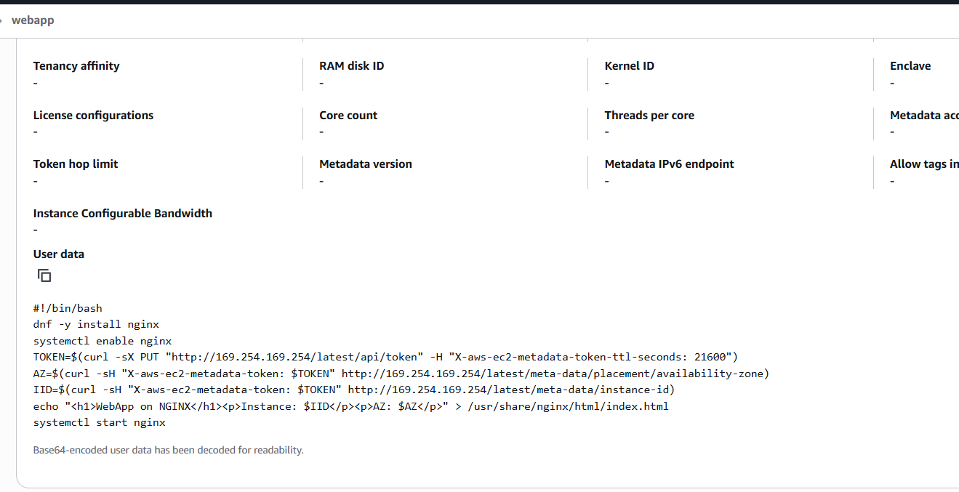

- Target group:
  - 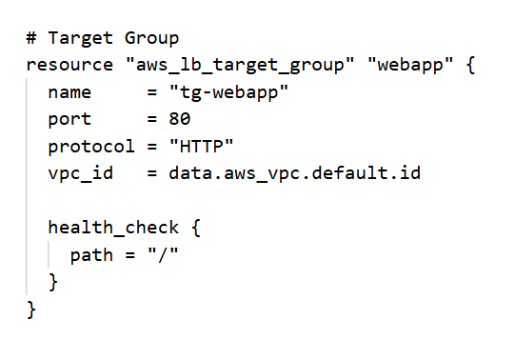
  - 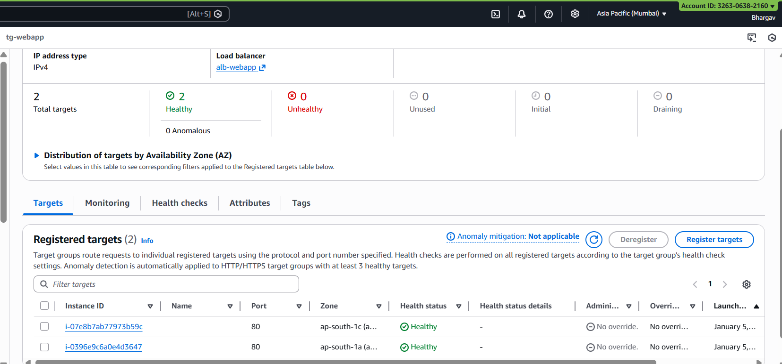
- ALB and Listener configurations:
  - 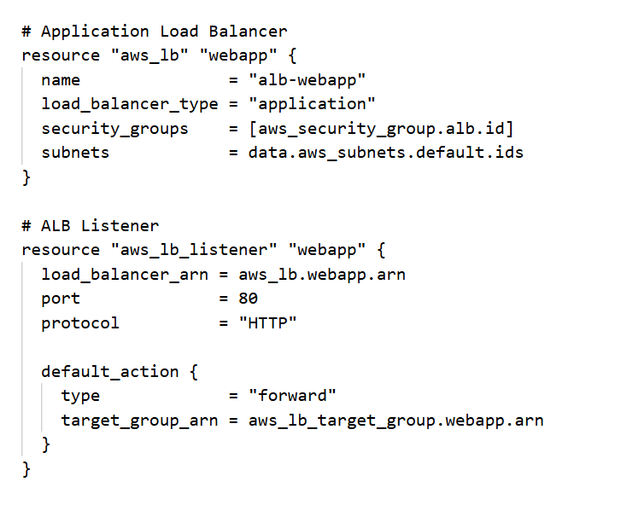
  - 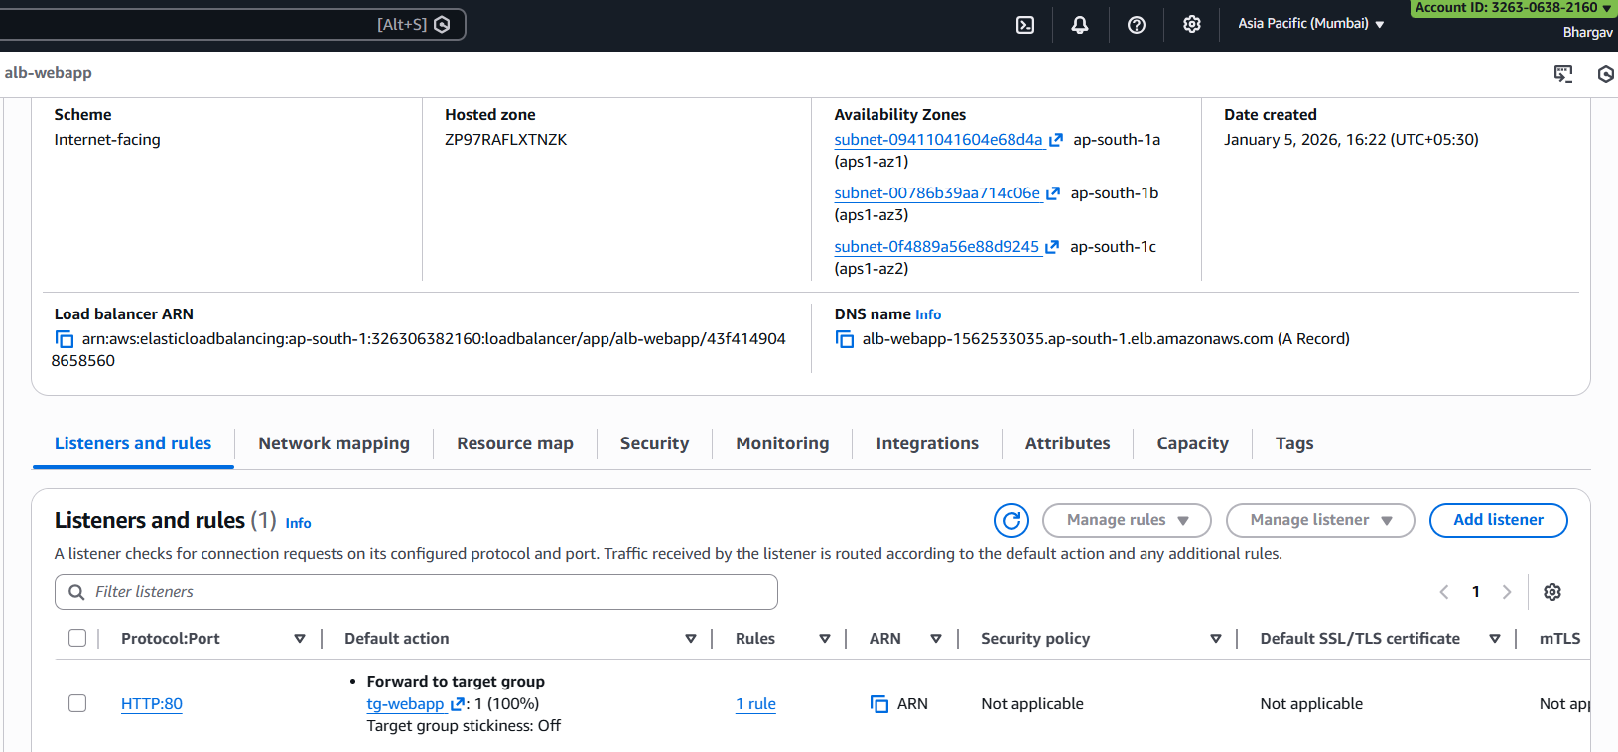
- ASG:
  - 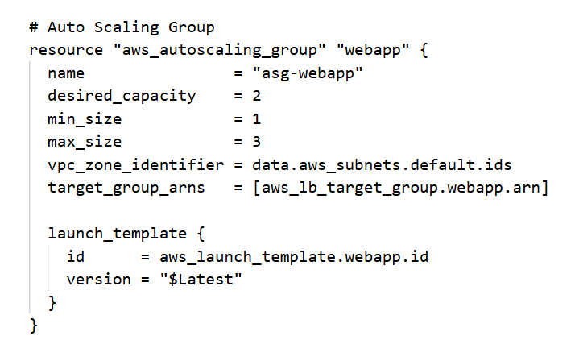
  - 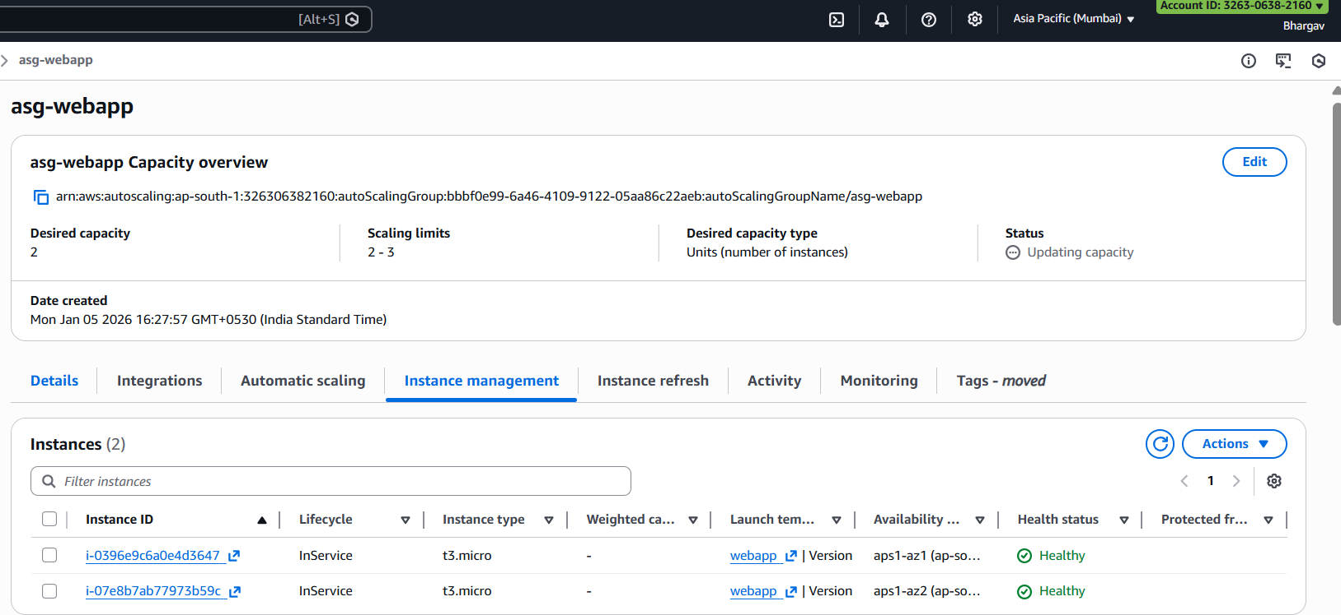
- Scaling policies:
  - 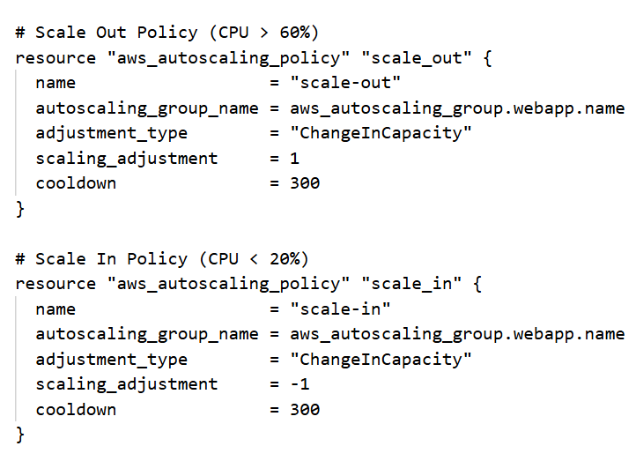
  - 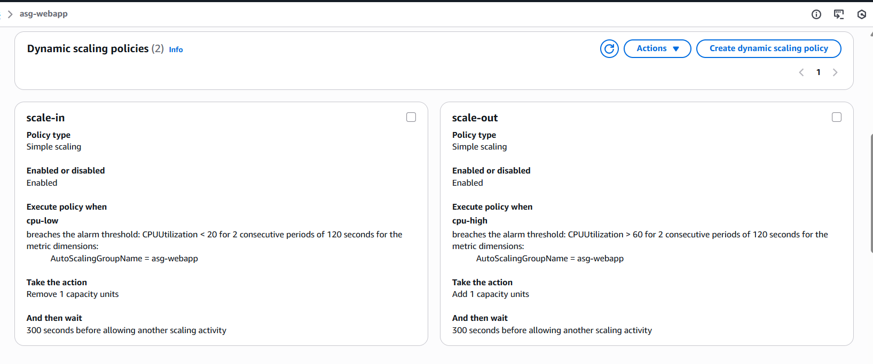
- Cloudwatch alarms:
  - 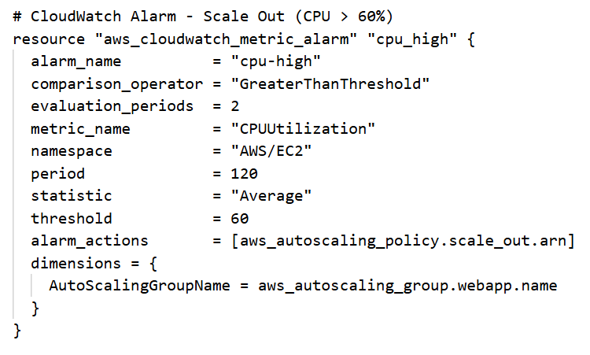
  - 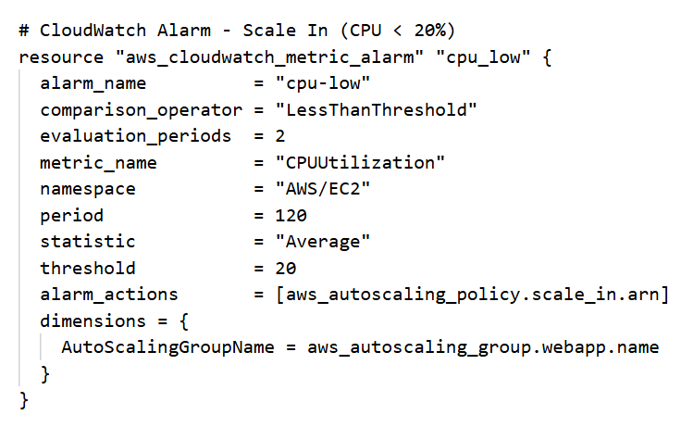
  - 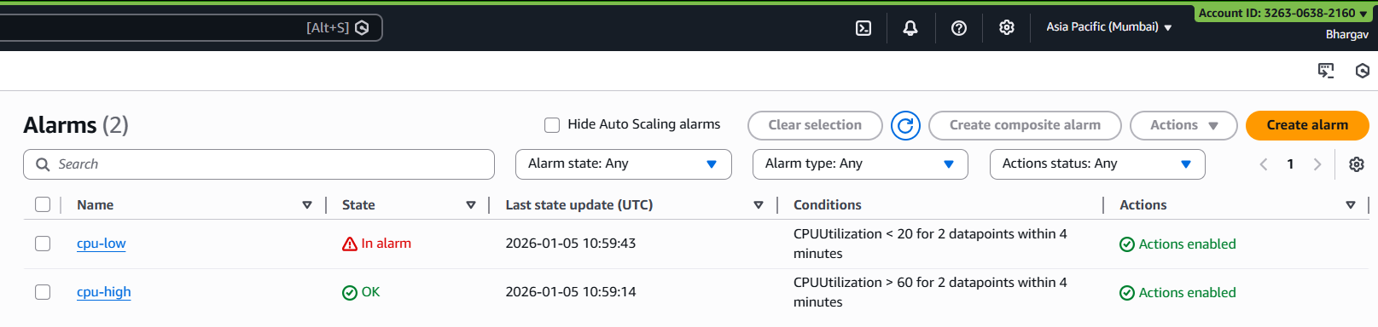
- Code block for the output of DNS resolution of ALB:
  - 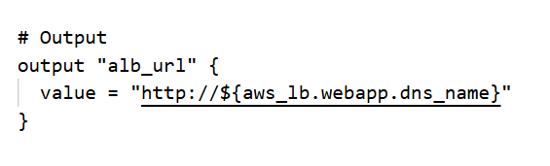

Notes:
- main.tf file > contains all my TF infrastructure code
- terraform.tfstate > contains the state of deployed resources with all the information of all the created resources in detail
- terraform.tfstate.backup > Backup of state file

Output:
- While hitting the ALB DNS http://alb-webapp-1562533035.ap-south-1.elb.amazonaws.com/ in browser, it shows the details of the instance on which the current hit is made:
  - 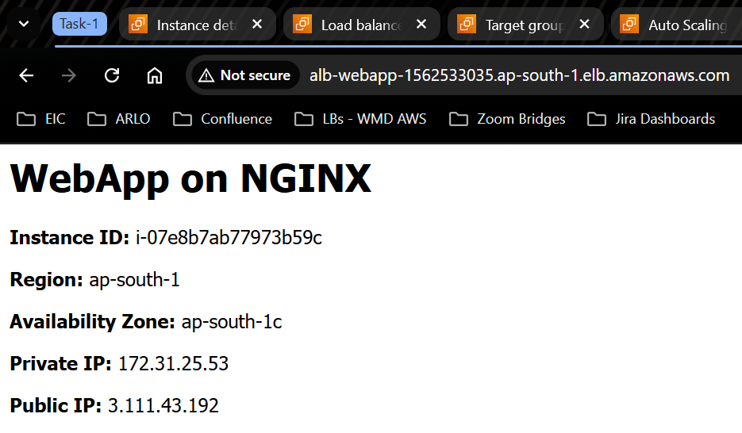
- If I click on refresh tab, it will change the instance and AZ to another machine behind the ALB:
  - 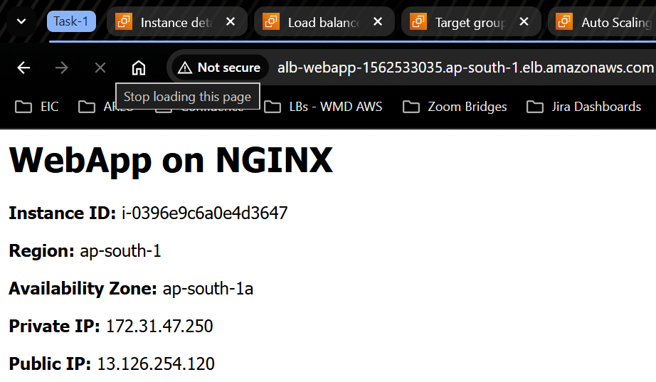
  - This shows that the traffic is divided between machines behind ASG and ALB with 2 different AZs
- Even if an instance is detached/terminated behind the ALB and ASG, the other machine will continue to serve the traffix:
  - 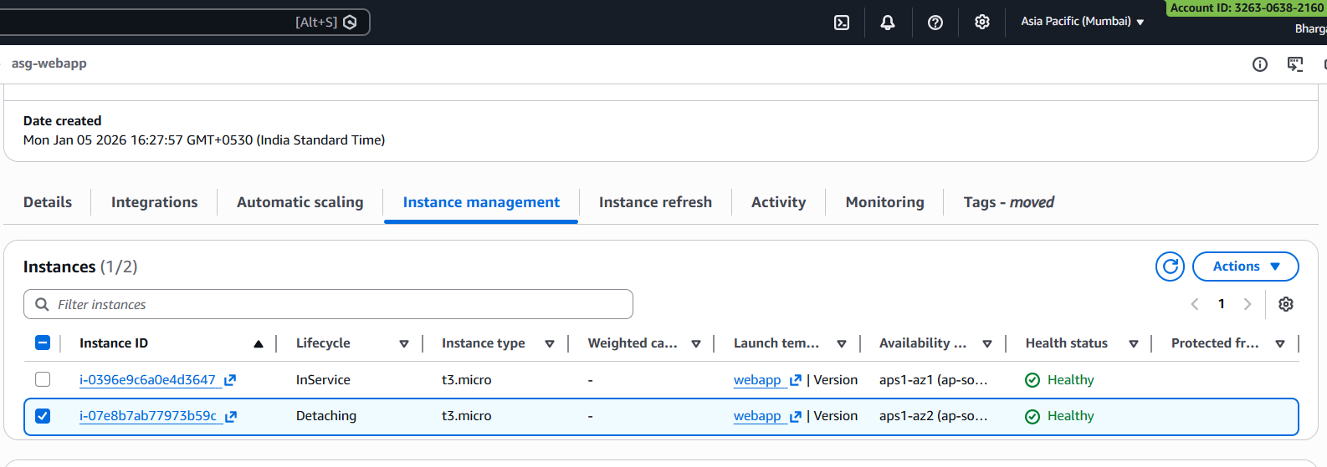
  - 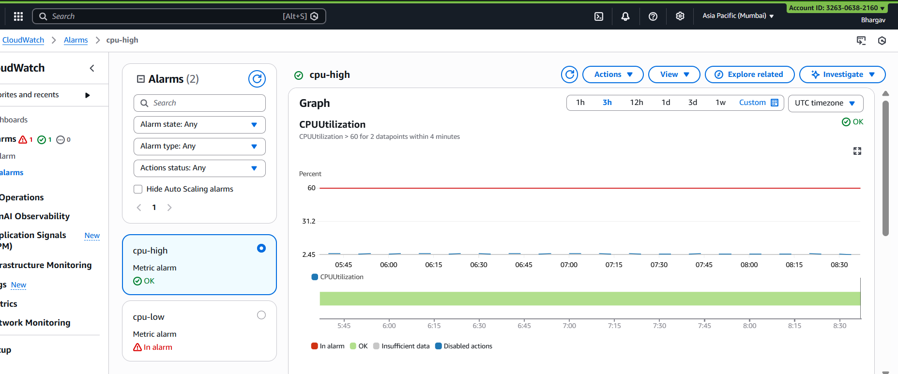
  - 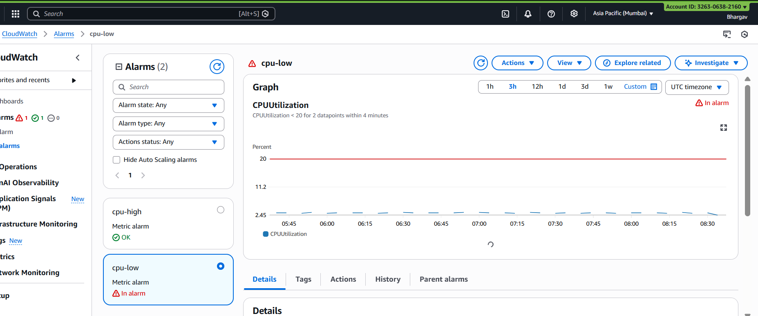
  - 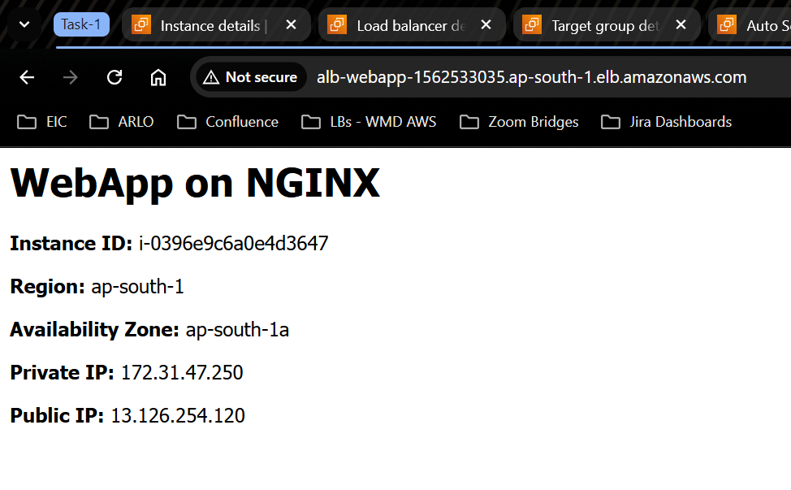
- To test the autoscaling policies attached, I tested it out by creating stress on 1 machine and as expected, the machine went into alarm mode and was taken out by ALB and was recycled, during the whole incident there was no downtime and the traffic continued to flow to the other machine.
- Similarly, for other scenario, when the cpu was utilization was low than 20%, 1 machine auto-deregistered from the ASG.

The terraform code for this task is uploaded at https://github.com/bhargavsurti-arlo/Training-and-Upskilling/tree/main/Tasks

