Task-6
Task 6: Build a Simple AI-Powered Inventory Automation System (use any AI Tools)
Use your mind to select the fields and infrastructure considering various scenarios of FinOps OR EOS / EOL etc…

Solution:
- Created the Portal using Cursor
- This is an AWS Inventory Management portal
  - This portal has two parts:
    - AWS Inventory Management Dashboard
    - Splunk Maintenance Dashboard
  - This portal was created by using cursor, by keeping in mind the current use-case and needs observed by me, being in Arlo Project for 5 years.
  - Such a portal is very essential and handy, even to cross teams, to quickly perform AWS inventory checkups and Splunk maintenance tasks without logging in to 20+ accounts and searching resources individually in each region.
  - I am planning to implement this in Production environment soon at Arlo, as this is almost production-grade and ready, only integrations and testing is pending.
  - This currently deployed on my local machine, the same setup can be implemented on an ec2 machine on AWS
  - All the configured commands for installing/upgrading/modifying splunk packages are in accordance with the Arlo SOP.
- Documentation available with all the code in same folder
- Webpage URL: http://localhost:5000/

1. AWS Inventory Dashboard: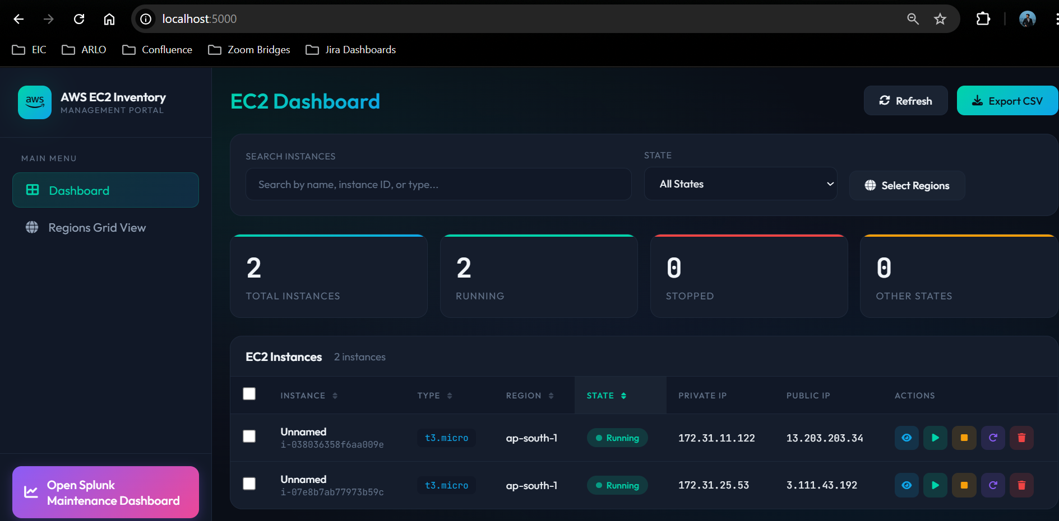
2. AWS Console:
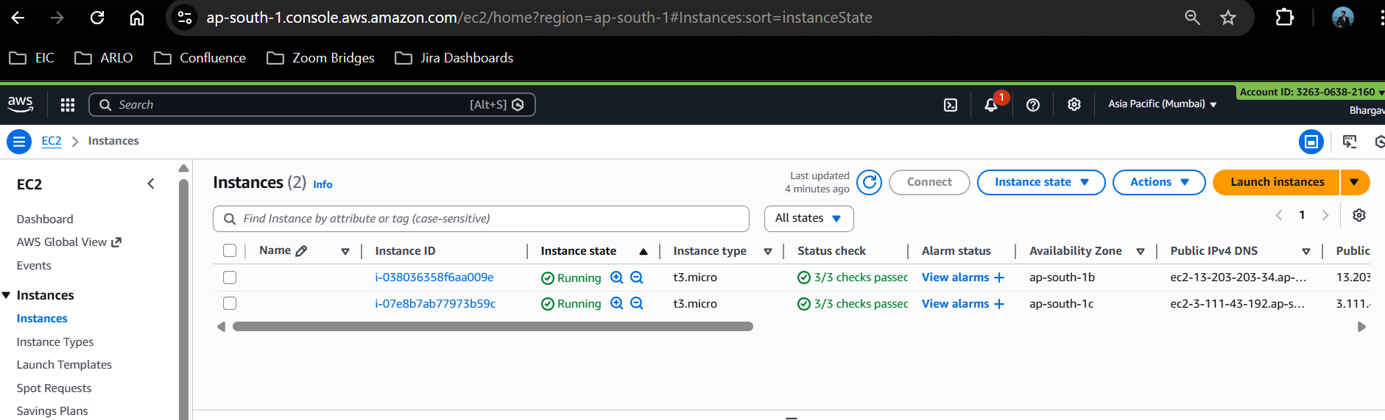

3. Splunk maintenance dashboard:
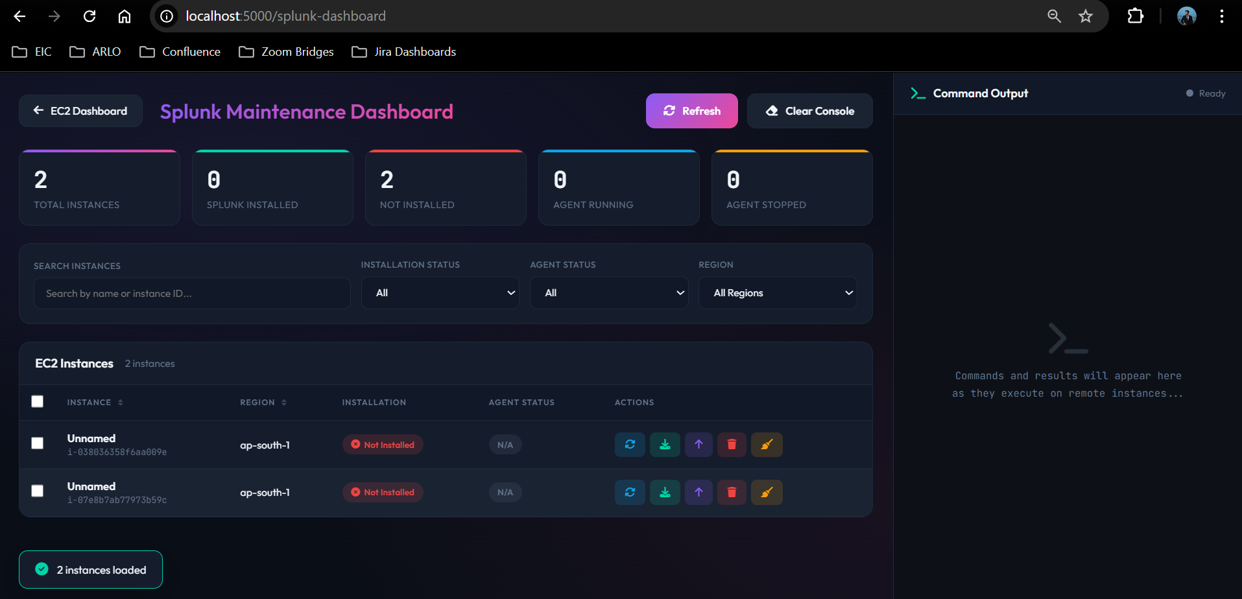
4. Installing Splunk:
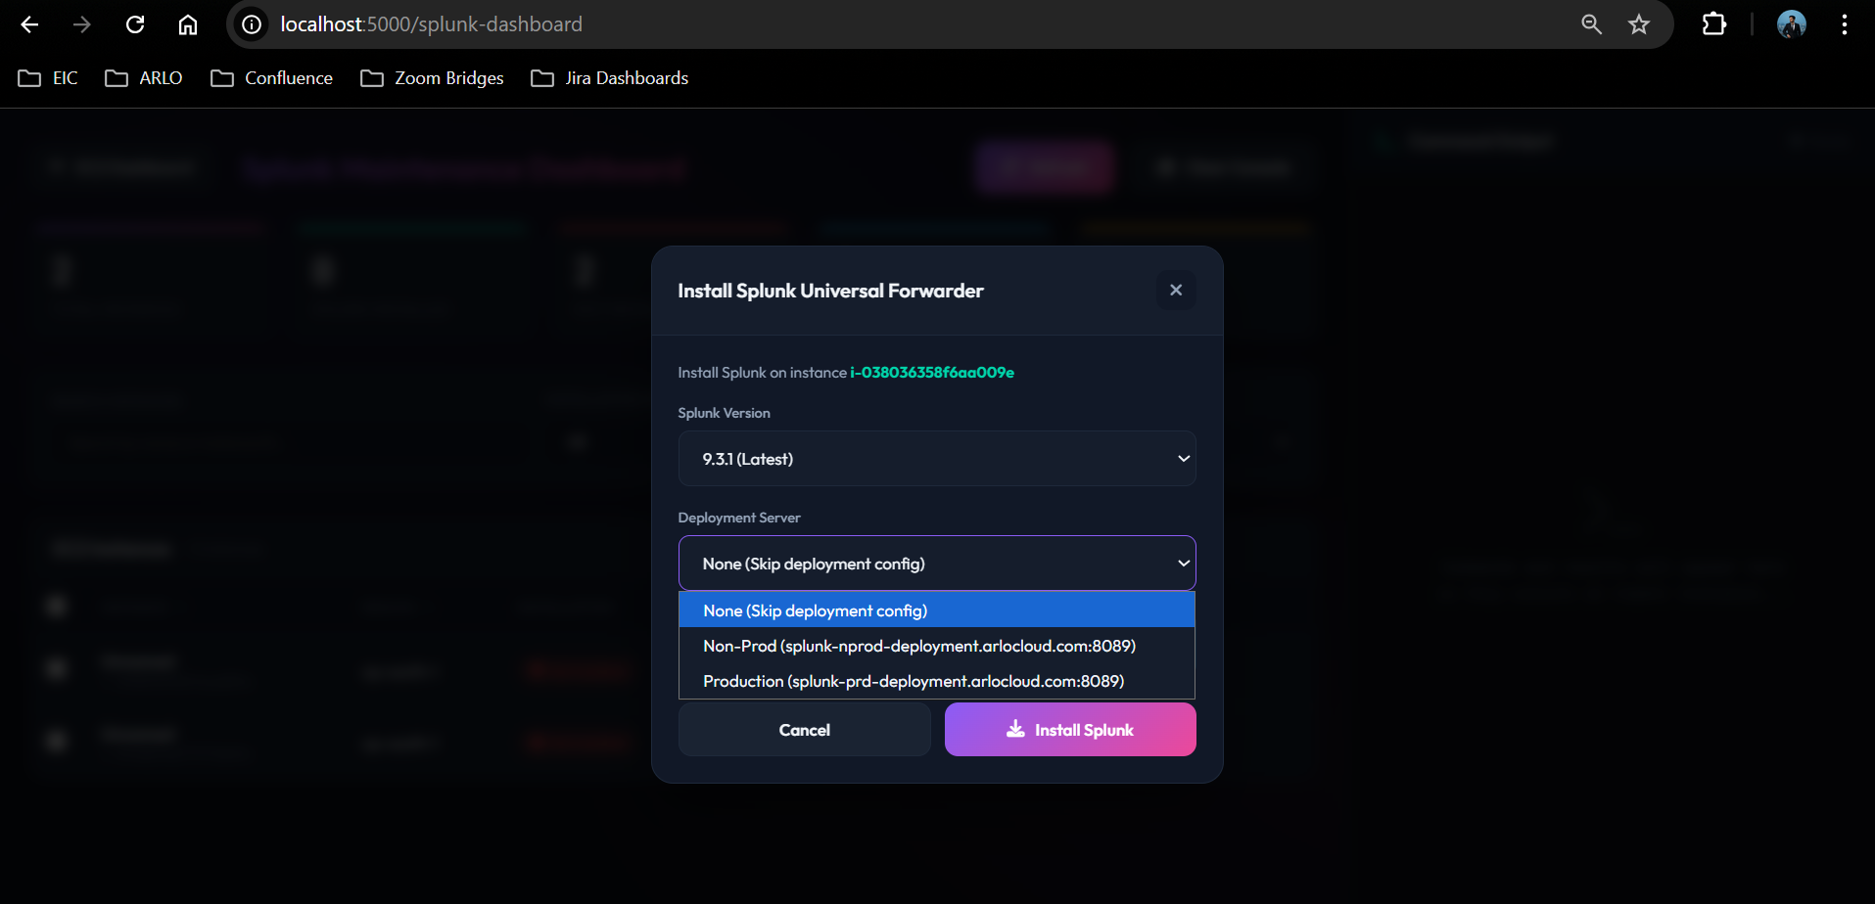

5. Splunk upgrade:
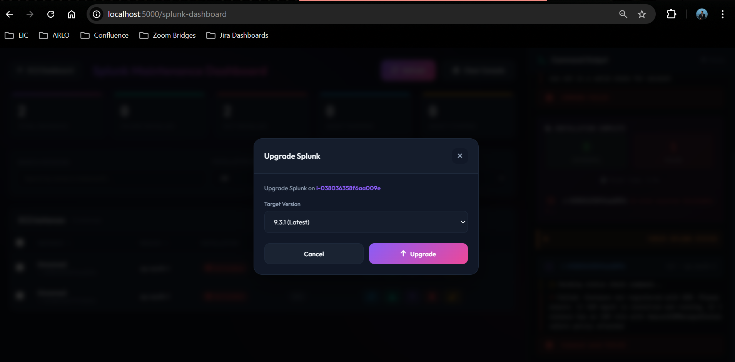
6. The actual integration is under development and will be completed soon.

