Task-2
Task 2: Build a Serverless App Using API Gateway + Lambda + DynamoDB
Goal: Create a simple serverless backend API.
Steps:
- Create a DynamoDB table (e.g., Products).
- Create Lambda functions:
  - Add item
  - Get item
  - List items
- Connect them to routes in API Gateway
  - POST /product
  - GET /product/{id}
- Enable IAM permissions for Lambda → DynamoDB.
- Deploy API and test using any application.

Skills Covered: Lambda, IAM, DynamoDB, API Gateway.

Solution:

- These steps are performed manually by me in my personal AWS account
- The region used here is eu-west-3

Steps:
- Created a Dynamodb table with below configuration:
  - Table name: Products
  - Partition key: id (String)
  - 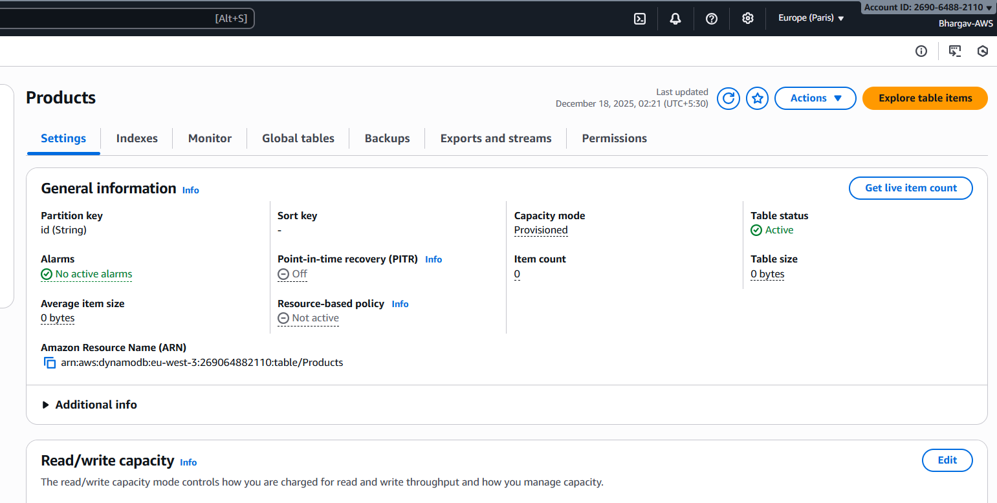
- Created 3 lambda functions as below:
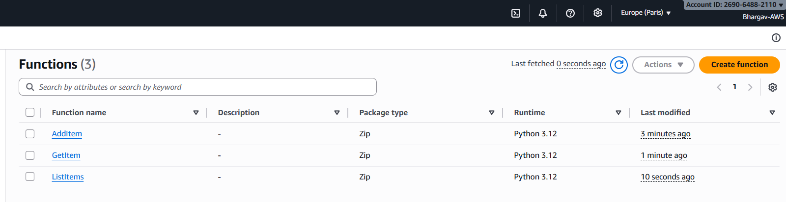
  - Add item:
    - 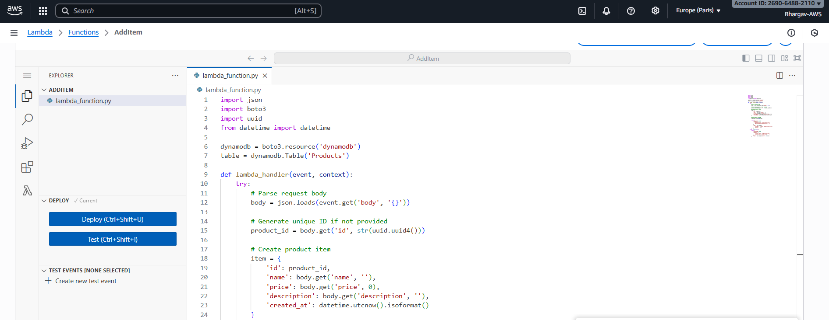
  - Get item:
    - 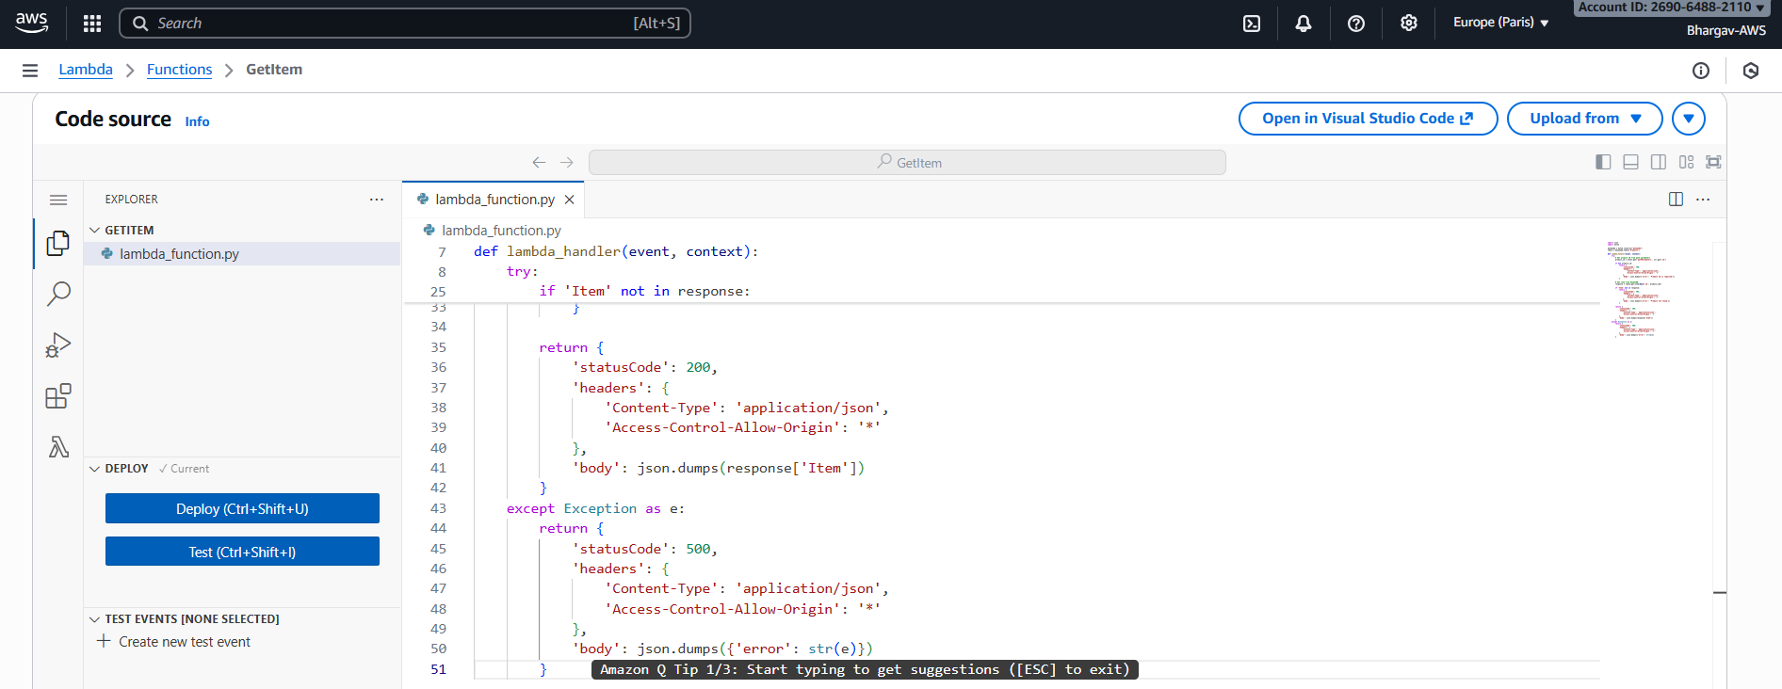
  - List items:
    - 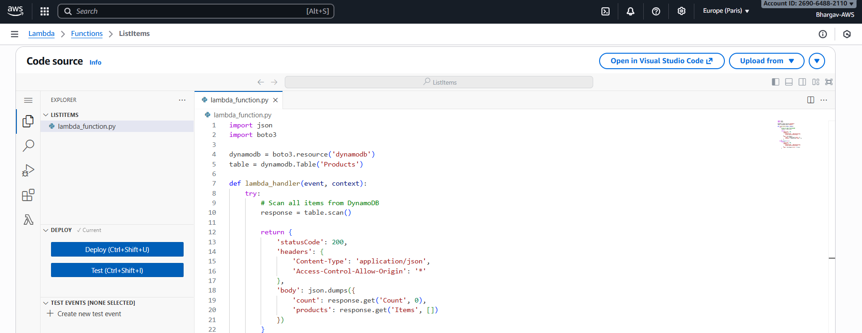

  - Also created and attached below IAM role to these lambdas:
    - AddItem-role-7mjnci1e
    - 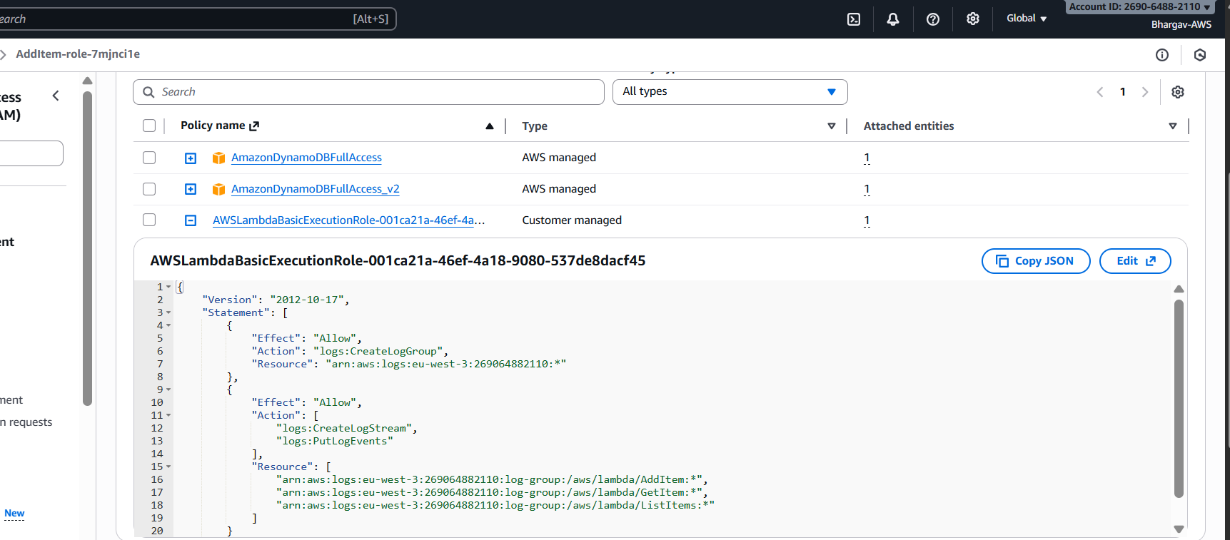

- Connect Lambdas to routes in API Gateway:
  - Name: ProductsAPI (ut92exmf7j) 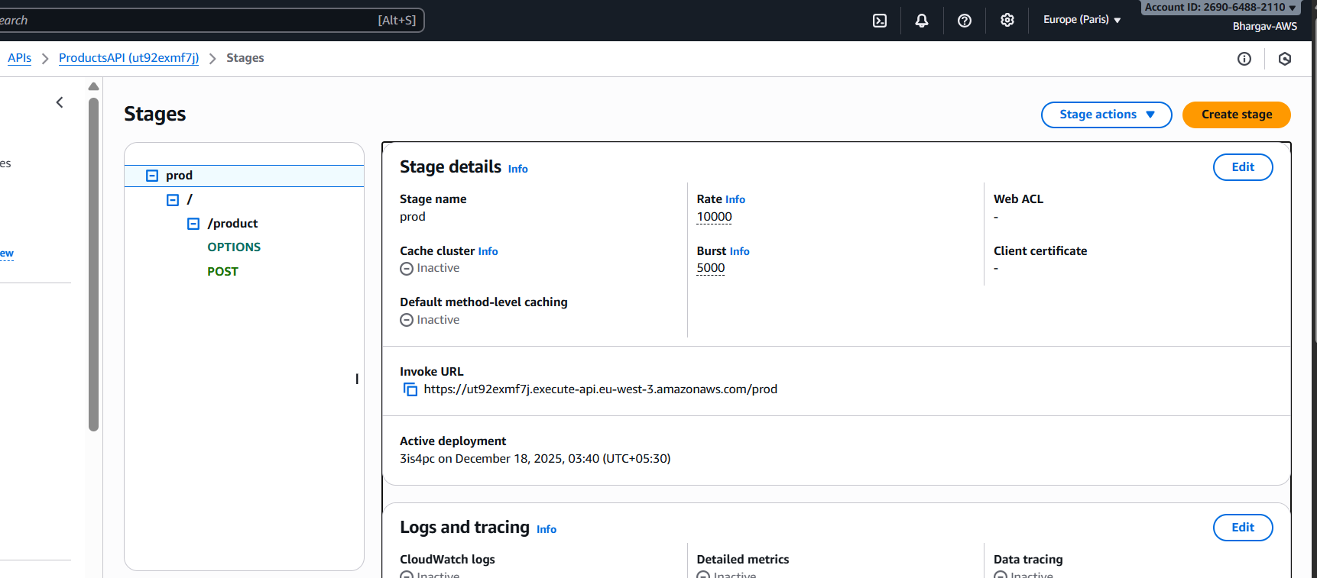
  - Created: POST /product Route:
  - 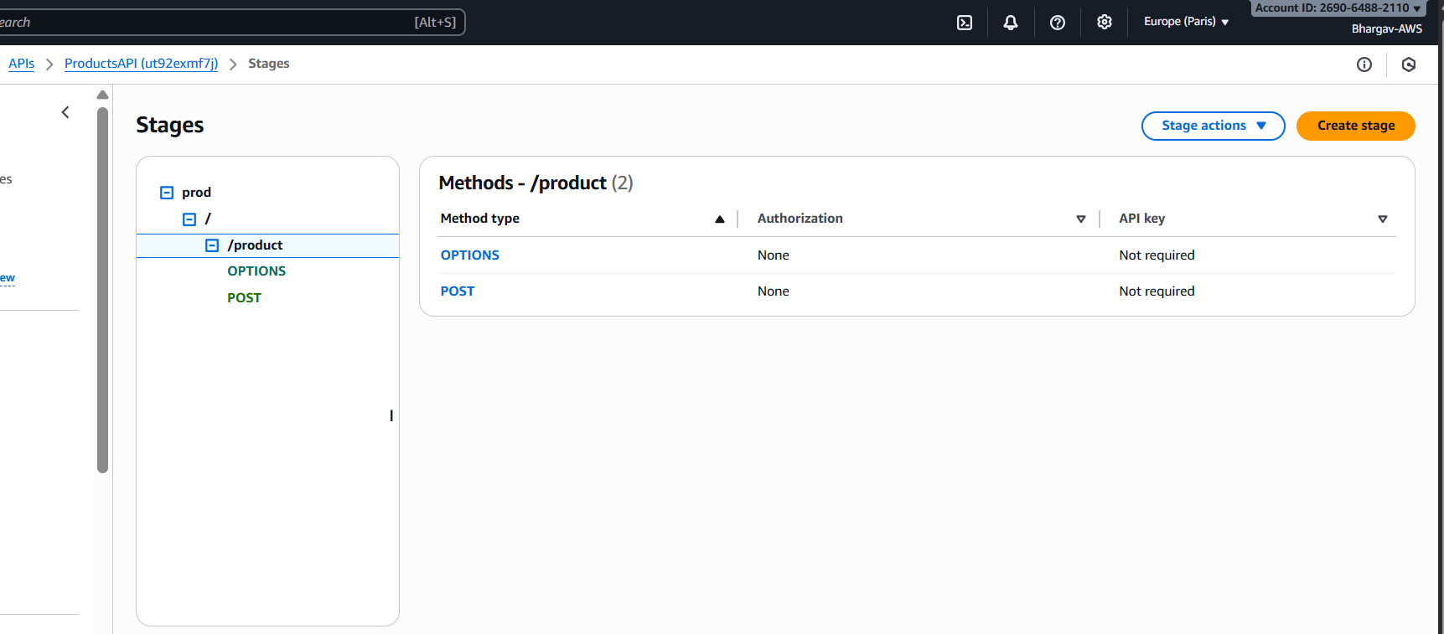
  - 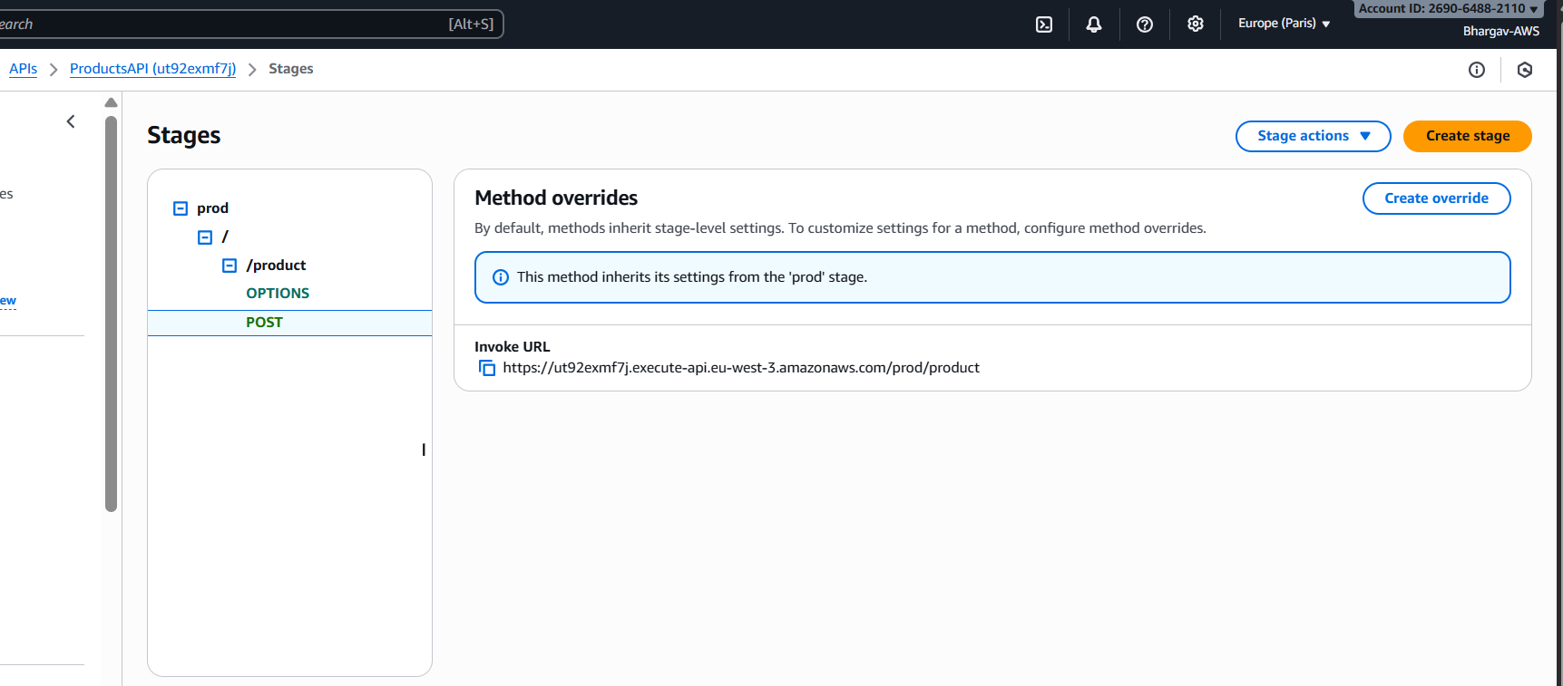

  - Created: GET /product/{id} Route:
  - 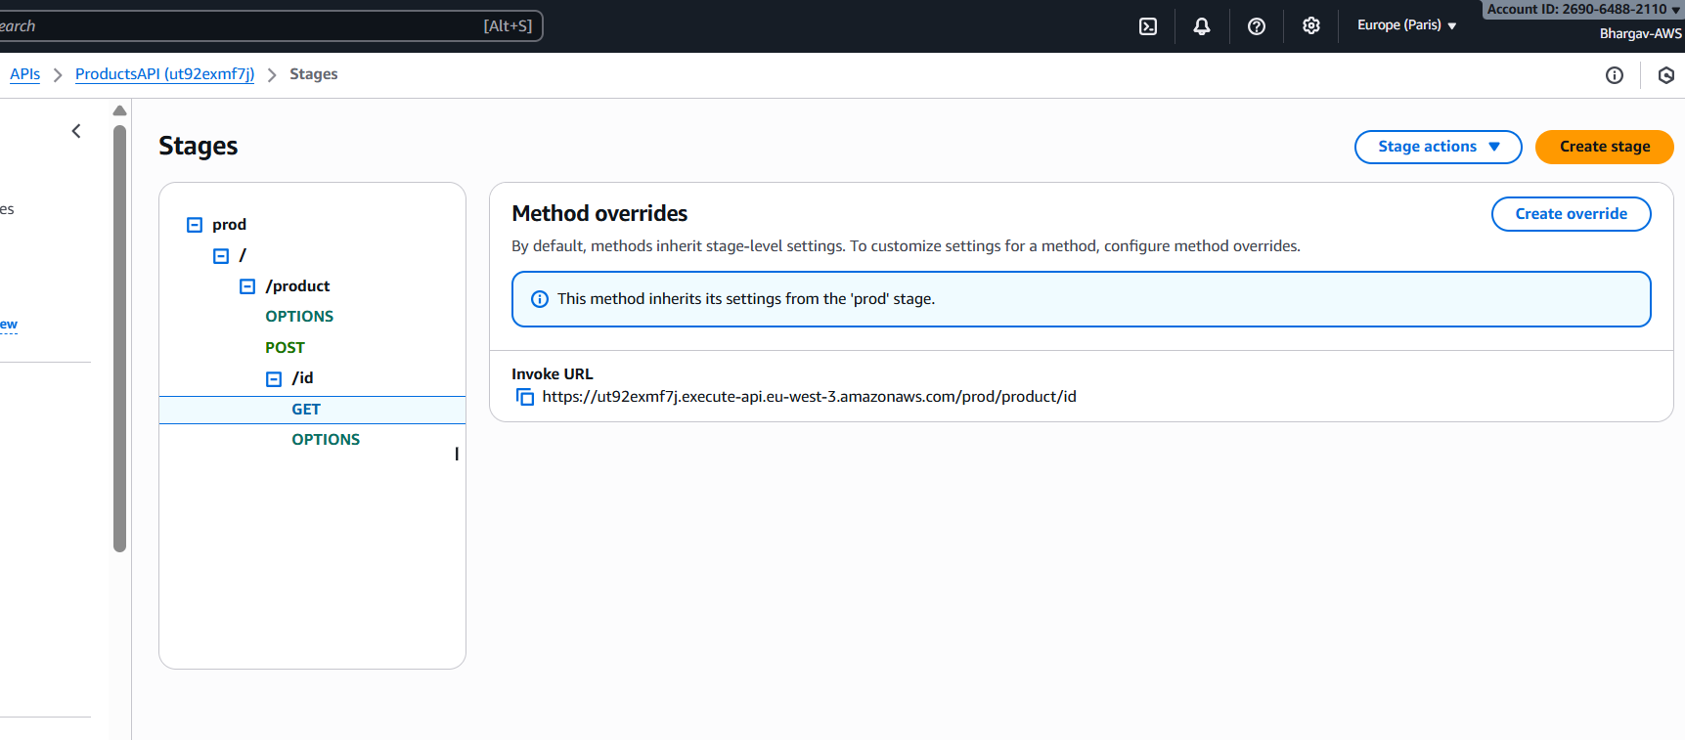
  - Created: GET /product Route (List All)
  - 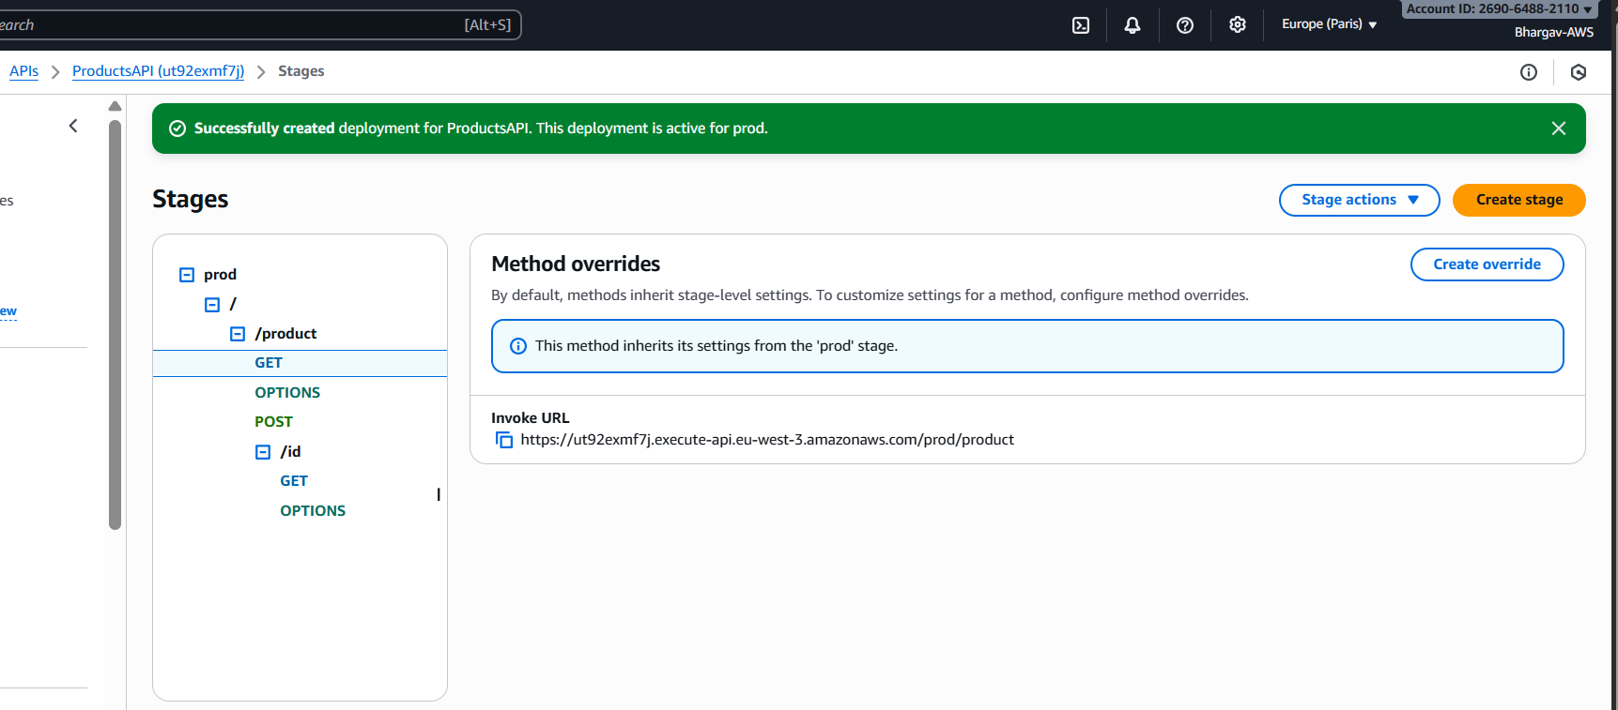

  - Enabled CORS for the above
- Enable IAM permissions for Lambda → DynamoDB
  - Already given
- Deploy API and test using any application:
  - Deployed the API:
    - 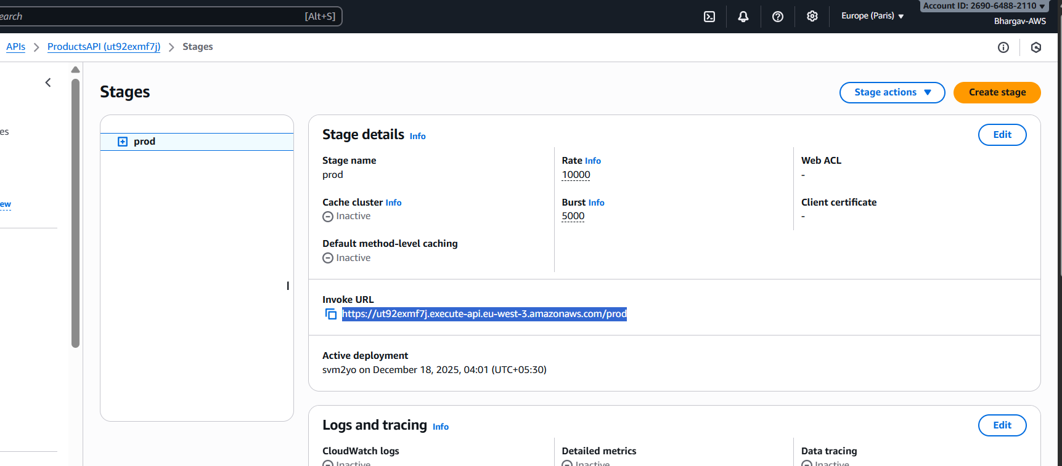
  - Testing from POST from AWS console: (AddItem)
    - 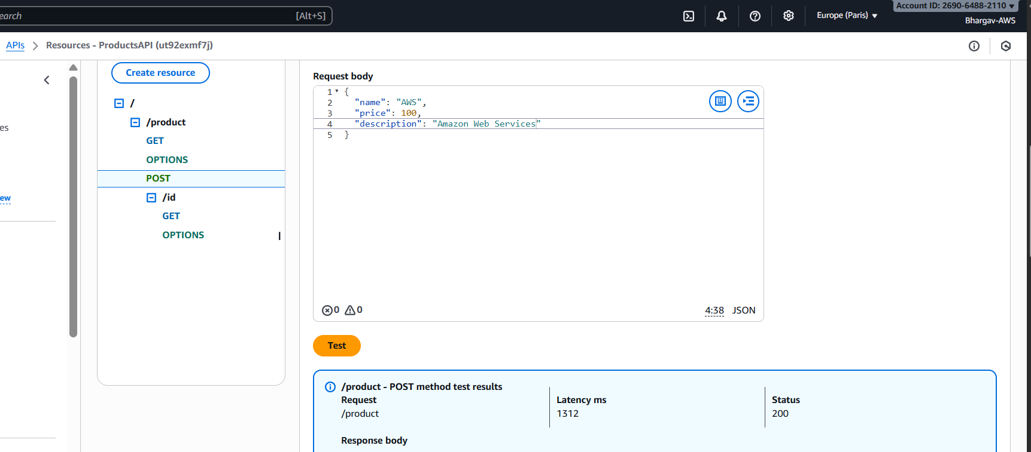
    - 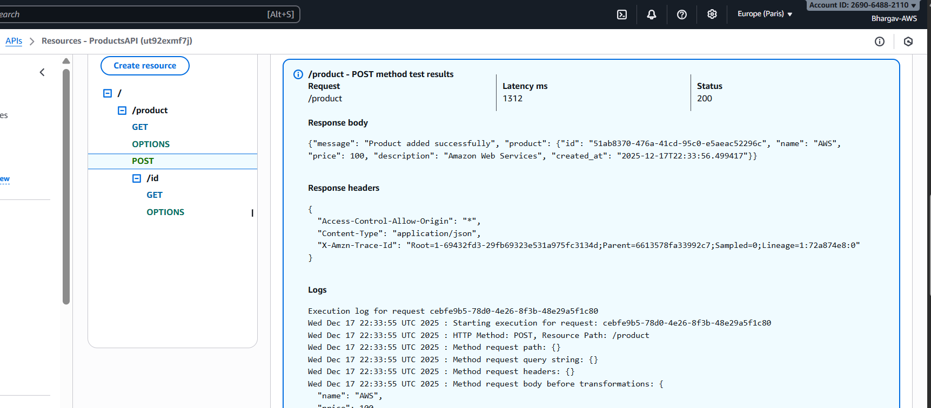

  - Testing from GET from AWS console: (GetItem)
    - 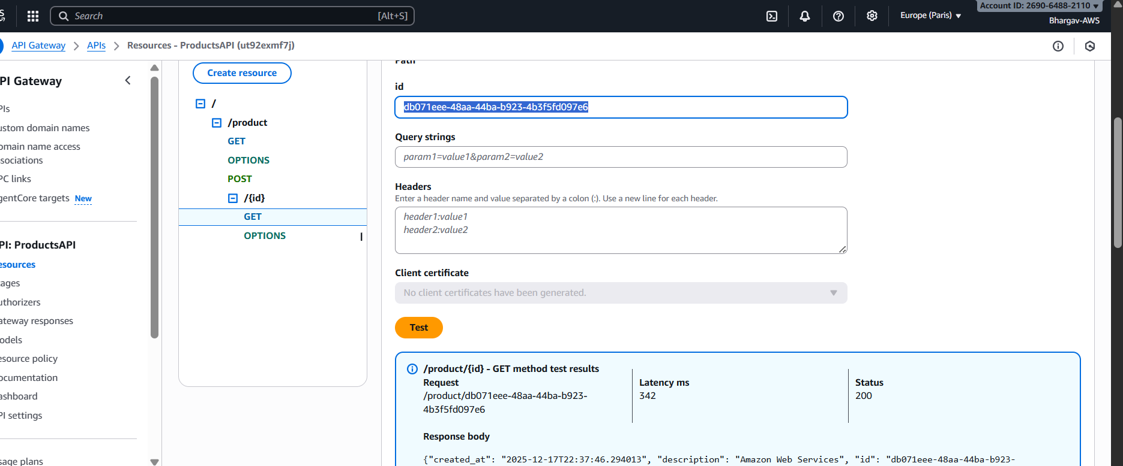

  - Testing from GET from AWS console: (ListItems)
    - 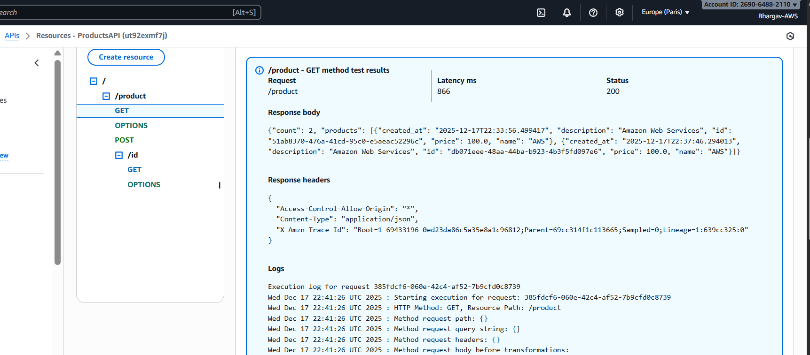
  - DDB table:
    - 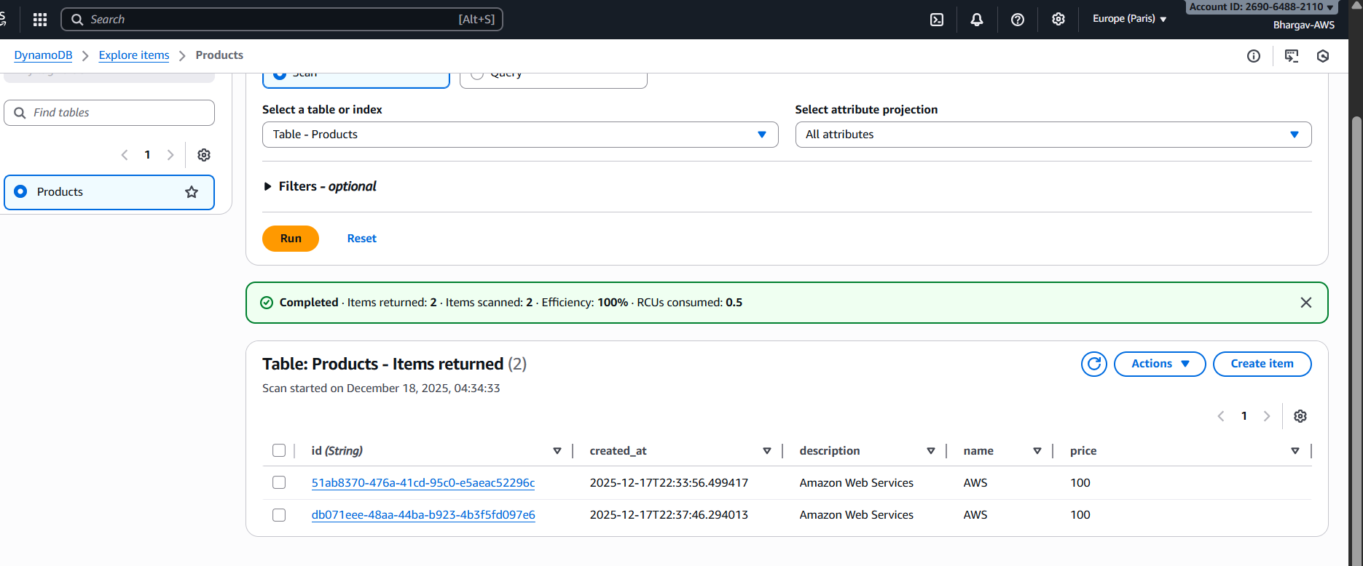

Summary:
- Lambda:
  - Created three functions (AddItem, GetItem, ListItems) using Python.
  - Used event structures (body, pathParameters) and returned proper HTTP responses.
- DynamoDB:
  - Designed a Products table with primary key id.
  - Used PutItem, GetItem, and Scan via boto3.
- IAM:
  - Located Lambda execution roles.
  - Attached AmazonDynamoDBFullAccess so Lambda can access DynamoDB.
- API Gateway:
  - Built a REST API with resources /product and /product/{id}.
  - Connected methods to Lambda through Lambda proxy integration.
  - Deployed the API and used the test console and external clients to validate.

