PROJECT BASED LAB REPORT
On
INSURENCE MANAGEMENT SYSTEM
Submitted in partial fulfillment of the
Requirements for the award of the Degree of
Bachelor of Technology
In
Computer Science and Engineering
By
T.BHARGAV (150030928)
B.PAVAN VARMA (150030107)


DEPARTMENT OF COMPUTER SCIENCE AND ENGINEERING
(CSE)

K L University
Green Fields, Vaddeswaram, Guntur District-522 502
2016-2017

K L University

DEPARTMENT OF COMPUTER SCIENCE AND ENGINEERING

CERTIFICATE

This is to certify that this project based lab report entitled “ INSURANCE MANAGEMENT SYSTEM ”is a bonafide work done by T. Bhargav(150030928),B. Pavan Varma(150030107) in partial fulfillment of the requirement for the award of degree in BACHELOR OF TECHNOLOGY in Computer Science and Engineering during the academic year 2016-2017.

Faculty In Charge Head of the Department
K L University

DEPARTMENT OF COMPUTER SCIENCE AND ENGINEERING

DECLARATION

We hereby declare that this project based lab report entitled “INSURANCE MANAGEMENT SYSTEM” has been prepared by us in partial fulfillment of the requirement for the award of degree “BACHELOR OF TECHNOLOGY in Computer Science and Engineering” during the academic year 2016-2017.
I also declare that this project based lab report is of our own effort and it has not been submitted to any other university for the award of any degree.

Date: T.BHARGAV(150030928)
Place: B.PAVAN VARMA(150030107)

ACKNOWLEDGEMENTS

My sincere thanks to Dr. Vijay in the Lab for their outstanding support throughout the project for the successful completion of the work
We express our gratitude to Dr.V.Srikanth, Head of the Department for Computer Science and Engineering for providing us with adequate facilities, ways and means by which we are able to complete this term paper work.
We would like to place on record the deep sense of gratitude to the honorable Vice Chancellor, K L University for providing the necessary facilities to carry the concluded term paper work.
Last but not the least, we thank all Teaching and Non-Teaching Staff of our department and especially my classmates and my friends for their support in the completion of our term paper work.

_{T.BHARGAV(150030928)}
_{B.PAVAN VARMA(150030107)}

CONTENTS
- Abstract ………………….. 6

- Introduction ………………….. 7

- Modules description …………………. 9
3.1.1 .Registration
3.1.2 .Customer
3.1.3 .Admin
3.1.3 .Display

- Source code ………………….. 11

- Snap shots of the output …………………. 15

- Conclusion ………………….. 18

- References ………………….. 18

1. Abstract
ABSTRACT

This project aims to build an Insurance Management System, that will allow to view the details of policy holders and premium payments. The insurance company provides Group of polices to clients that were registered with it. A group policy is one, which an employer provides to its clients. An agent is responsible for getting the client information and establishing a relation with the insurance company. According to his\her need, the policyholder can choose from various premium policies available. The insurance company needs to keep track of details of its target clients, agents, policyholders, their premium payments and the various products that are available with it. Hence it is under tremendous pressure maintaining their day-to-day activities, which is currently being done manually. Entire records have to be updated timely; even a slight mistake could complicate things. It is very difficult to handle bulk data since human memory is weaker than electronic counterpart. It is time consuming to summarize these details to produce the reports. Hence there is need for an automated system, which can efficiently manage the company’s records, provides instant access and one that improves the productivity. As a result of this automated system, the activities of the company are performed with in the stipulated time and the reliable and efficient service is ensured to its users.
Modules Description
The modules of the Insurance Management System are of following
MODULE 1: The Registration
In this the total database (which consists of not only agent details but also the package details, premium pack etc. are maintained) is confessed in this part only, he manages the details of the agent and establish a relation between a client and the agent. And he keeps tracking the payment lack details and informs the agent when it is due.

MODULE 2: The Customer
In this the total details of the client are maintained (client policy number expiry, payment details etc etc.) Now after the due he will send a notice to clinet about the due. And all these records were managed and make up-to-date by the agent. Agent is controlled by the Employer.And type of the package selected by the whether it is annual or life time package.

MODULE 3: The Display
In this we only get the output of the details of the customers who were taking part of this company and also his details which were enquired during the time of registration.

2. INTRODUCTION
This project deals with Insurance in online. This tool taking care of the policy in online using tracking the details of the customer and the company.If the user enter into the website it will show the details about insurance and other schemes of the policy through this online registration form It helps the customer to view their own insurance status system analysis focuses on the application is require to do. The system allows to see the logical elements from the physical components it uses (computer, terminals and storage system)
The existing system is the manual system. The manual system is prone to error. It is time consuming it is very difficult to produce the report for any person and there is chance for changing the scheme report by doing malpractice. Usage of paper in the payment process leads to less efficiency, less accuracy and less productivity. Proposed system is to eliminate the drawbacks of the existing system. It is designed in order to provide a permanent solution of the problem.
Online insurance services in the middle ages policy agents and policy holders have used the paper to take money from the insurance transaction but know the technology is fully developed everything is being converted to computerized. Now a day’s everyone is using the internet in this fast race the business and money making people are also using. No country, no company and no individual want to fall back in this fast generation everyone wants to the lead the group.

Platform Requirements:
Hardware/Software | Hardware / Software element | Specification /version
Hardware | Processor | Intel i3
Hardware | RAM | 4 GB
Hardware | Hard Disk | 1 TB
Software | OS | Windows 8

Functionalities used in source code are:

- Packages
- Inheritance
- Exception handling
- Constructors
- Static variables
- Interface
- Data structures

3. Module Description
AIM: - To write the JAVA code for the following program

- Registration
- Customer
- Admin
- Display

3.1. DESCRIPTION OF MODULES

3.1.1. MODULE 1:
Here we will be creating an account through registration with details like Username and Password. Here each and every record has to be entered manually through keyboard, where it asks the user to save how many customer details he need to enter. After entering those details through proper format those details which user gives can be saved. In this module we will be able to enter into the next phase when password is correct. The next phase is to enter the specifications required by the admin should be filled by the user.

3.1.2. MODULE 2:

Here we will be creating information with details like name of the Customer, age, address and city. Here each and every record has to be entered manually through keyboard, where it asks the user to save how many Customer details he need to enter. After entering those details through proper format those details which user gives can be saved. In this module we will be able to check whether the person is eligible for Insurance or not.
3.1.3. MODULE 3:
Here we will be displaying the menu of packages by verifying Insurence. Here we display the name of the policy and their specification that represent the policy. In this module we calculate the number of Customers involved upto now for Insurence.

3.1.4. MODULE 4:

Here we will be displaying the details of the customer and his package name etc. This is the module where we got the Result of the entire task we have done and the result is stored in a 2-D-String.

4. SOURCE CODE
Package A (Registration)
package a;
import java.util.Scanner;
public class Registration{
Scanner in=new Scanner(System.in);

String[][] s1=new String[10][10];

public String[][] registrationmethod(int x)
{
int i;
String p,a="a";
i=x;
System.out.print("\nEnter your name: ");
s1[i][1]=in.next();
System.out.print("\nEnter your phonenum: ");
s1[i][2]=in.next();
System.out.print("\nEnter your city:");
s1[i][3]=in.next();

System.out.println("THNAKYOU FOR REGISTERING\nPLEASE SELECT THE PACKAGE");

System.out.println("a.Annual package\nb.life package");
p=in.next();
if(p.equals(a))
{
s1[i][4]="Annual package";
System.out.println("You should pay monthly Rs:5000/-.\n70% of money will be given for accidents");
}
else
{
s1[i][4]="life package";
System.out.println("You should pay monthly Rs:3000/-.\nTotal money will be given after your death by adding 10% of total money to it.");
}
return s1;
}
}
Package A (Customer Search):
package a;
import java.util.*;
public class Customersearch extends Registration {
String k;
int j=1;
Scanner in=new Scanner(System.in);
public void display(String x[][],int y){
if(y==0)
{
System.out.println("NO CUSTOMER HAD REGISTERED YET");
}
else
{

System.out.print("Enter the name:");
k=in.next();
for(j=1;j<=y;j++)
{
if(x[j][1].equals(k))
{

System.out.println("name:"+x[j][1]+"\tphone:"+x[j][2]+"\tcity:"+x[j][3]+"\tPakage:"+x[j][4]);

}}
}

}
}

Package A Continuition(Customer List)
package a;
public class Customerlist extends Customersearch{

public void list(String x[][],int y)
{
if(y==0)
{
System.out.println("NO CUSTOMER HAD REGISTERED YET");
}
else
{

for(int h=1;h<=y;h++)
{
System.out.println("name:"+x[h][1]+"\tphone:"+x[h][2]+"\tcity:"+x[h][3]+"\tPakage:"+x[h][4]);
}}
}}
Package A (Main Function):
import a.*;
import java.util.*;
class Insurence{

static{
System.out.println("--------------------*---------------------");
System.out.println("WELCOME TO INSURENCE MANAGMENT SYSTEM");
System.out.println("--------------------*---------------------");
}

public static void main(String[] args){
a.Registration reg=new a.Registration();
a.Customersearch cus=new a.Customersearch();
a.Customerlist cus1=new a.Customerlist();
String[][] s=new String[10][10];

int choice=0;
final int limit=1;
try{
int i=0;
int count=0;
String username="oops";
String password="project";
String username1,password1;
}
catch(InputMismatchException e){
System.out.println("Inputmismatch exception");
}
while(choice!=5){
System.out.print("Enter Username: ");
Scanner in=new Scanner(System.in);
username1=in.next();
System.out.print("Enter Password:");
password1=in.next();
while(count<limit)
{

if(password.equals(password1))
{
System.out.println("\n\n1.New Registration.\n2.Customer Search.\n3.Customers List\n4.Service Details\n5.Exit");
System.out.print("Enter your choice: ");
choice=in.nextInt();
switch(choice)
{
case 1:
{
++i;
s=reg.registrationmethod(i);
break;

}
case 2:
{
cus.display(s,i);
break;
}
case 3:
{
cus1.list(s,i);
break;
}
case 4:
{
System.out.println("WE WELCOME TO OUR CUSTOMER SERVICE");
System.out.println("OUR CUSTOMERCARE NUMBER IS 180075106");
break;

}
case 5:
{
System.out.println("Quit");
System.exit(0);
}
default:
{
System.out.println("Wrong Choice!!!");
}
}
}
else{
System.out.println("Incorrect entry---Try Again");
count++;
}
}
System.out.println("BURSTED!!!!");
System.exit(0);

}
}
}

OUTPUT:
THE FOLLOWING IS THE OUTPUT

- SCREENSHOTS

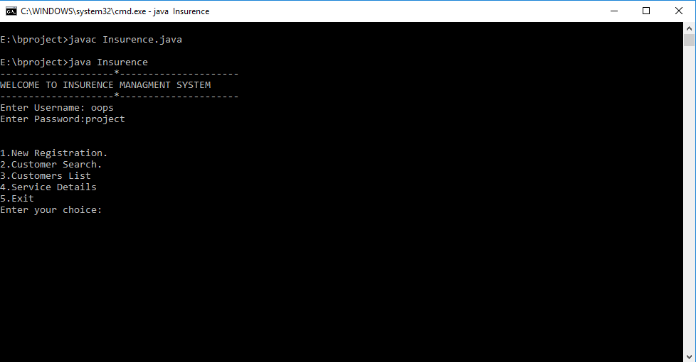

FIGURE 5.1DESCRIPTION:

This is the screenshot shows that the agent usename and password are necessary for login.

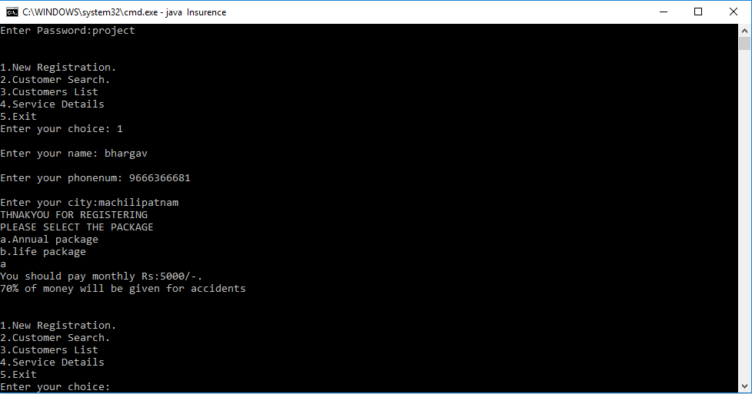
FIGURE 5.2

DESCRIPTION:
This Screenshot displays the correct explanation of mini project where we can select number of customers and can fill the details correctly and we can able to know each ones policy, The total Displayed members are the only customers of the Insurance System.

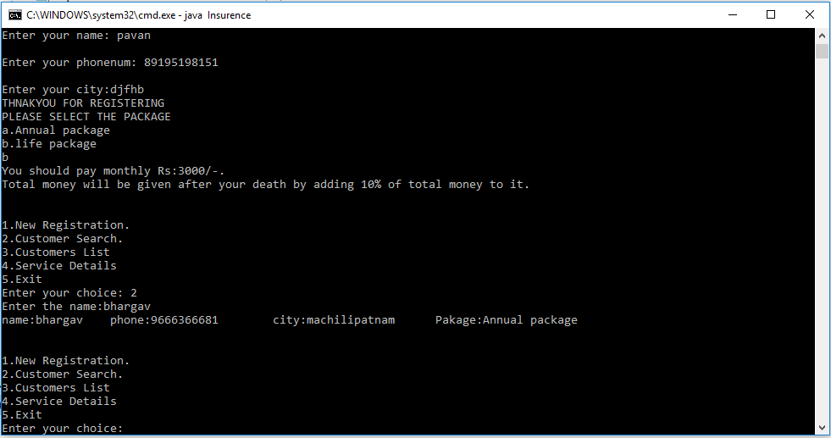
FIGURE 5.3

DESCRIPTION:

This screen shot tells about the customer searching .

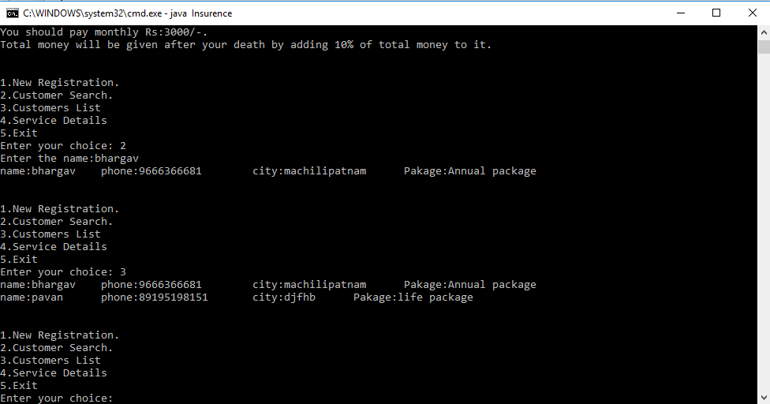

FIGURE 5.4:

DESCRIPTION:

This Screenshot displays the customers list and their data.

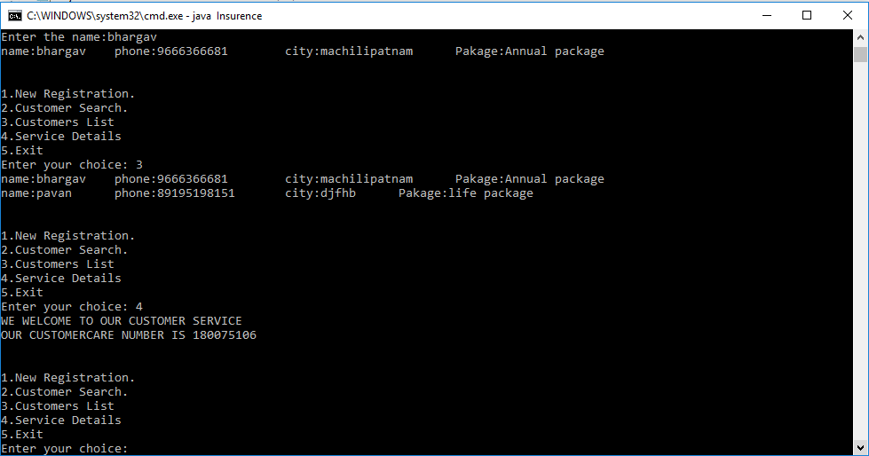
FIGURE 5.5:

DESCRIPTION:

This output shows the service and customer care number.

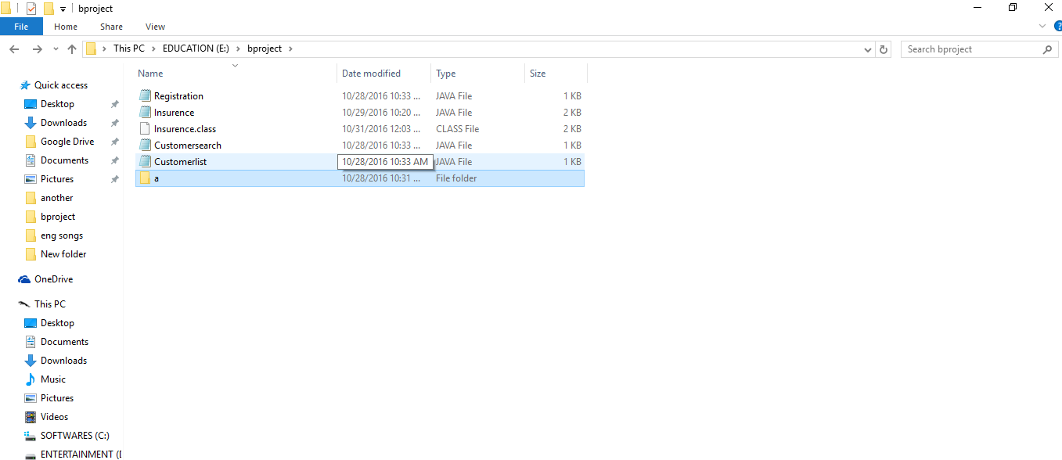

Figure 5.6:

DESCRIPTION:

This output displays the creation of the package.

- Conclusion:

Effectiveness, efficiency, and reliability are the key aspects that make this web-based vehicle insurance management system very useful for vehicle showroom business. The proposed project is very flexible to handle new modules and features as per user requirements in future. It can also be integrated with other systems such as vehicle tracking system, vehicle information management system

References:
- http://www.freestudentprojects.com/studentprojectreport/projectreport/insurance-management-system/
- http://1000projects.org/education-loan-management-system-project-with-source-code.html
- http://www.codingparks.com/loan-management-system-final-year-project/
- http://1000projects.org/education-loan-management-system-project-with-source-code.html

