*To create one image containing various features installed like automatically start the Jenkins, Load the system which can automatically select an interpreter for the above task. We have to manually create one Dockerfile to launch the container with our own image.*

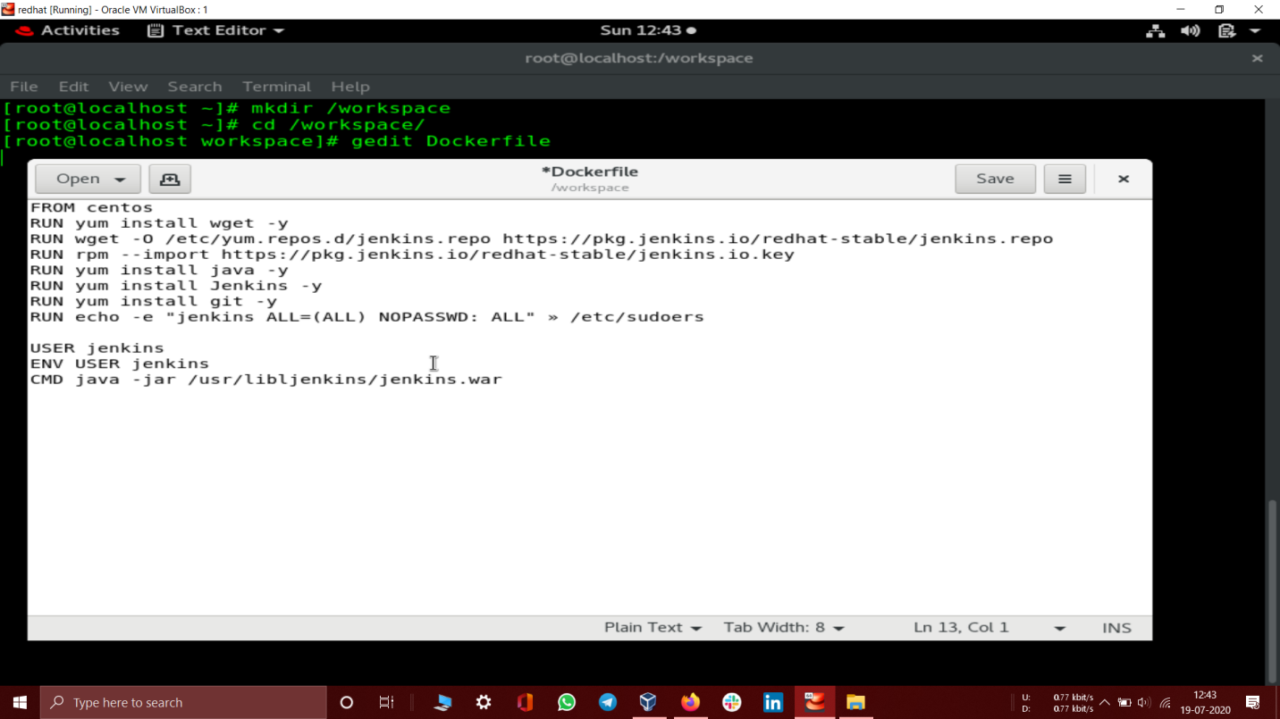

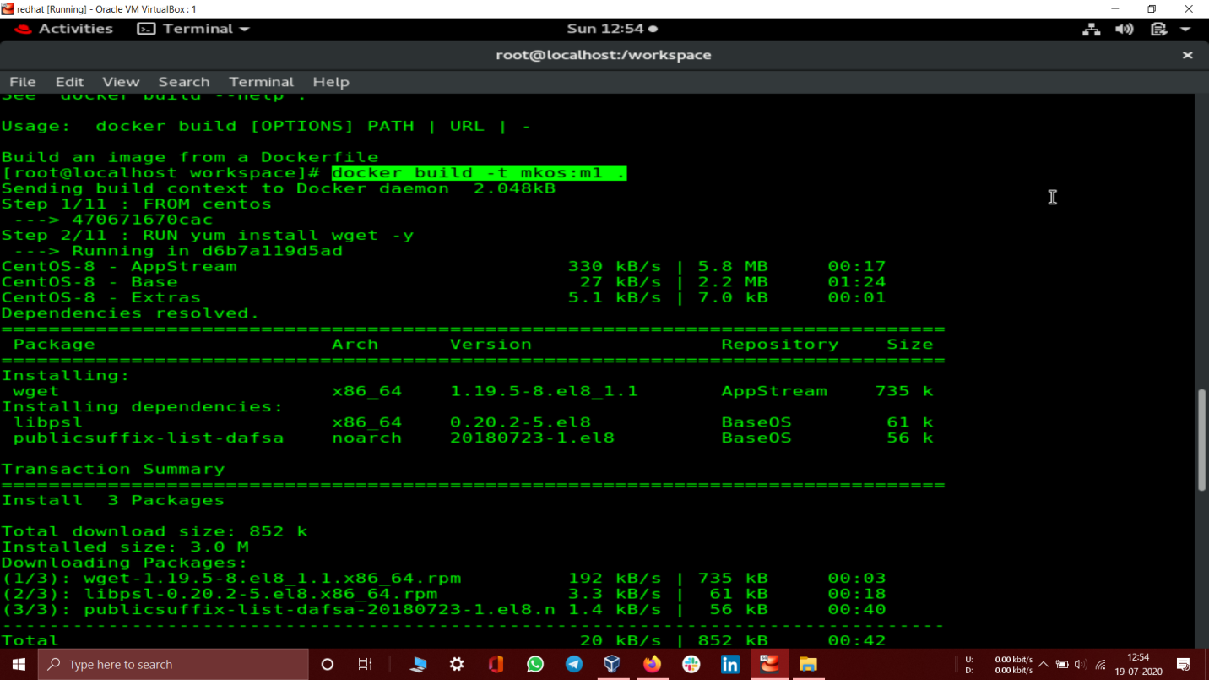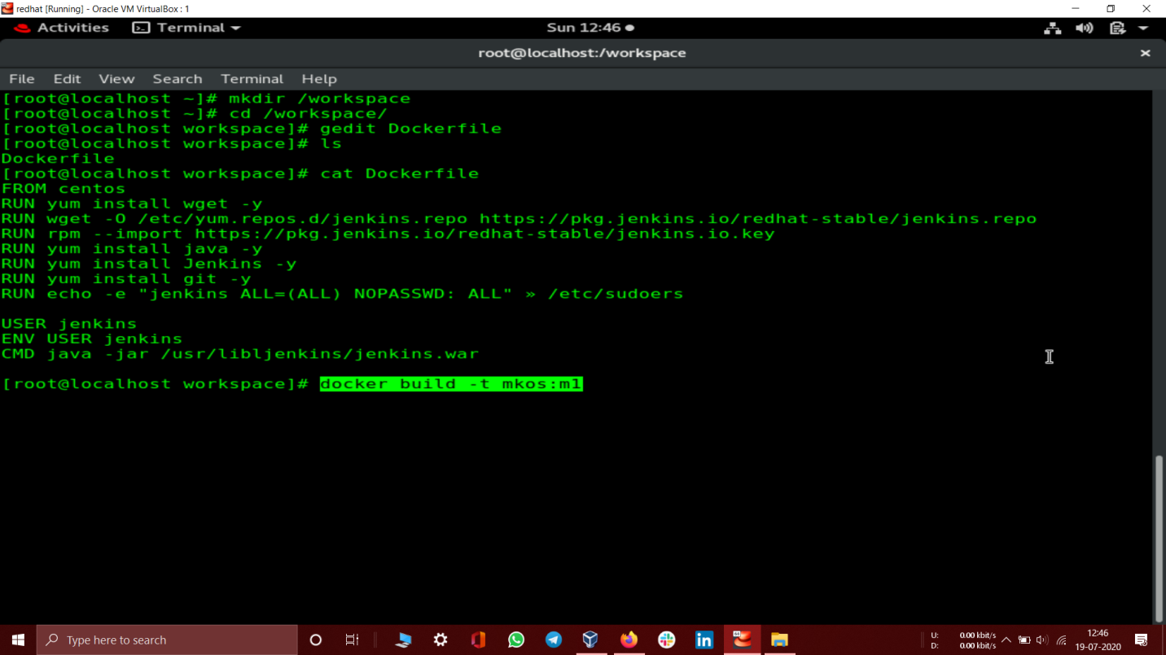

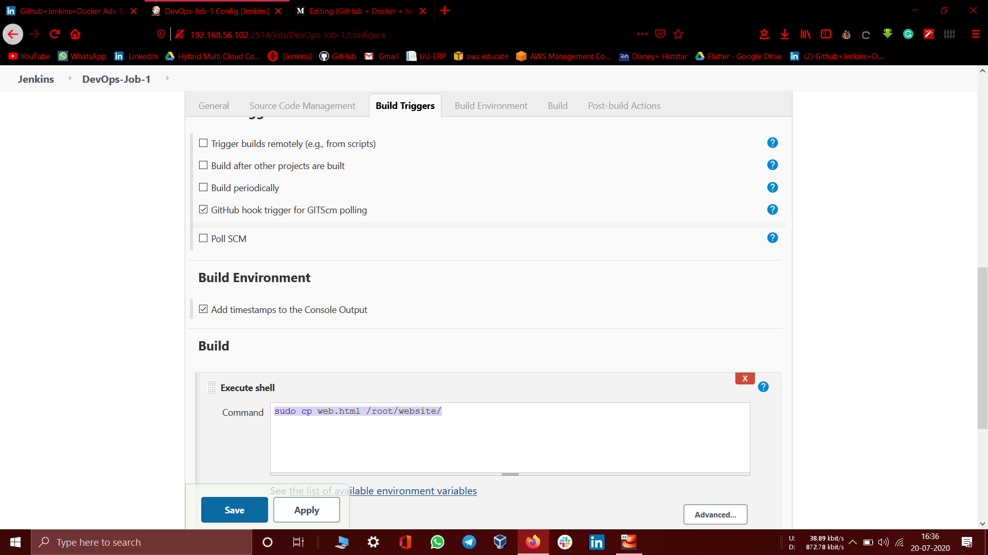

Job1:

After doing the successful setup of Jenkins in your local host now create a new item to start our task, In the task as mentioned at the start, We have to build the first Job which can automatically pull repo from your GitHub Repo just by giving some triggers

**Job2:**

*Let’s move towards the Job2 and which is the tough part of this task. Here you have to use some logic part because this job should automatically detect your code and launch the respective code interpreter and launch the container for the same.*

*In my case, I’m using an HTML file so it should start httpd image container to run HTML file on the web server. We will use here httpd image here which is officially available online.*

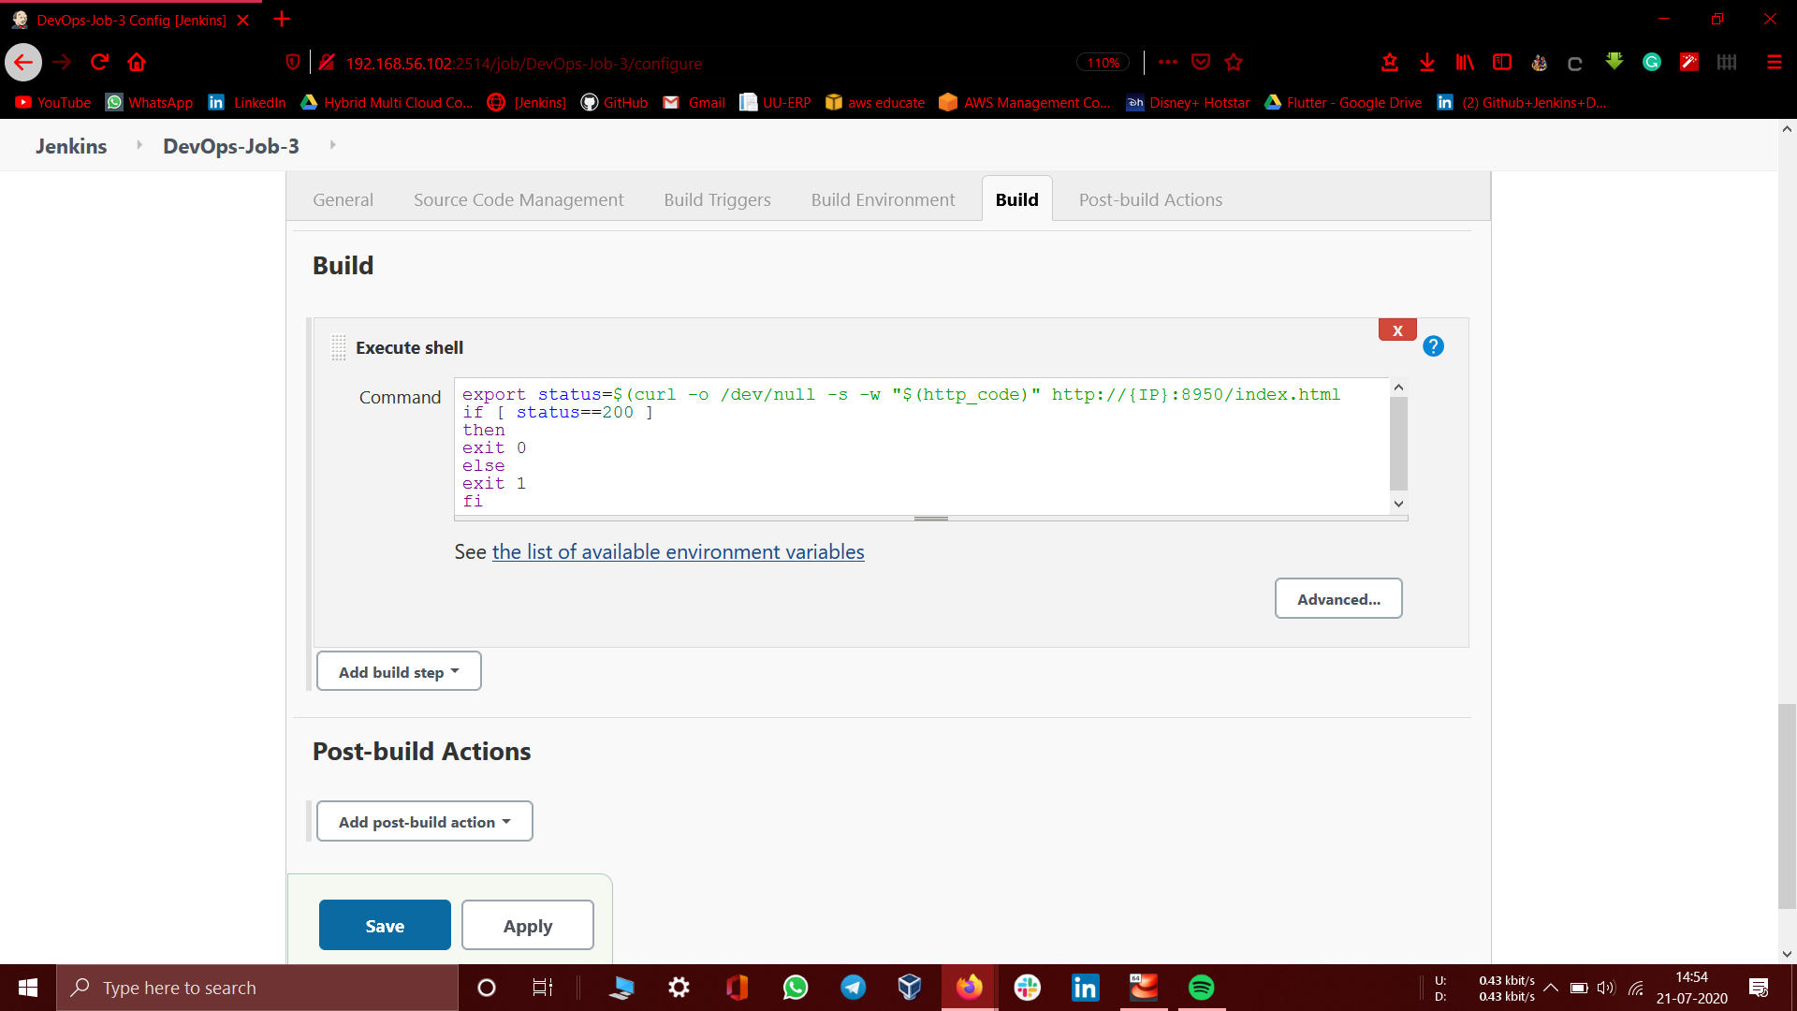

**Job3:**

*Here come one more important part and interesting one in our task, That when you test the jobs running in the system and if build failure occurs than How developer will get to know about this situation?*

*For this, There should be some notification system for the automation task we made.*

*We will add some commands which will be used for launching a new container after a system failure.*

**Here comes the full setup :**

*Now, Lets Build pipeline for monitoring the jobs, Configure and set the first job as DevOps-Job-1 which is my job1 for this task.*

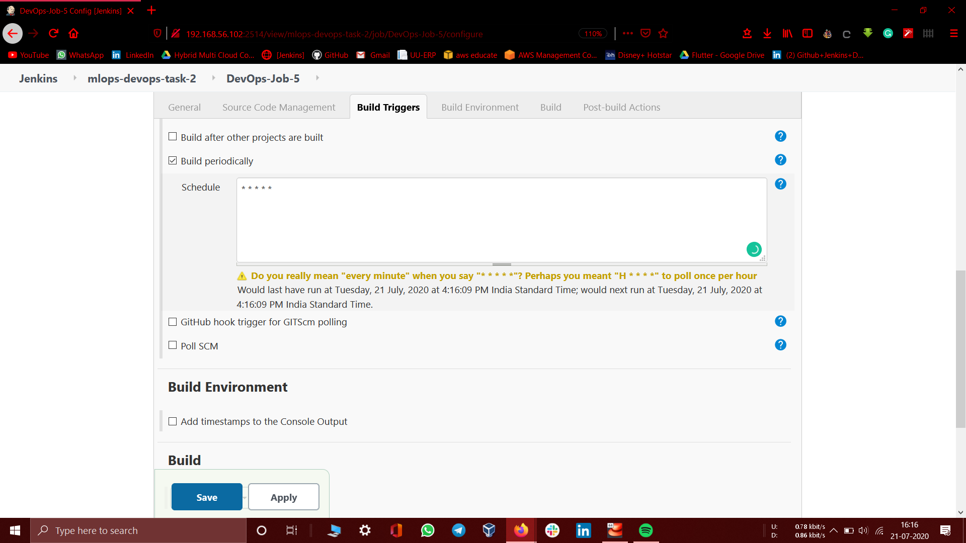

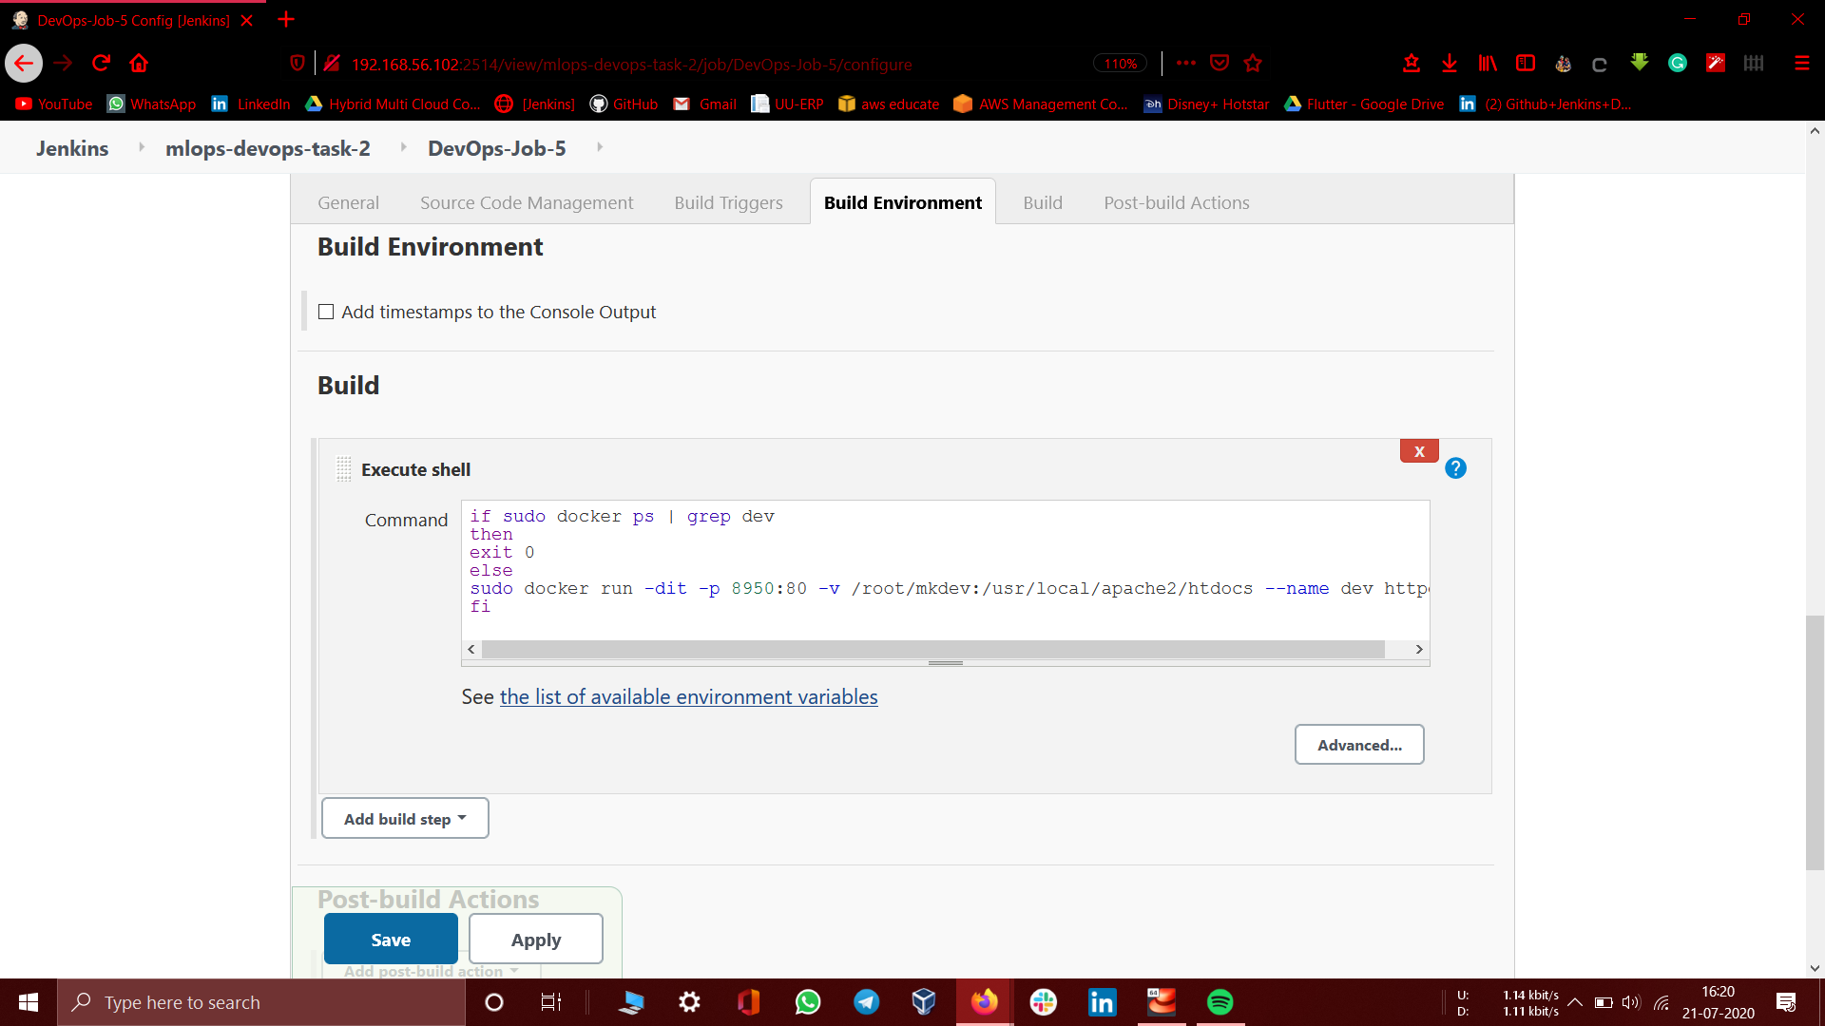

JJOB4:

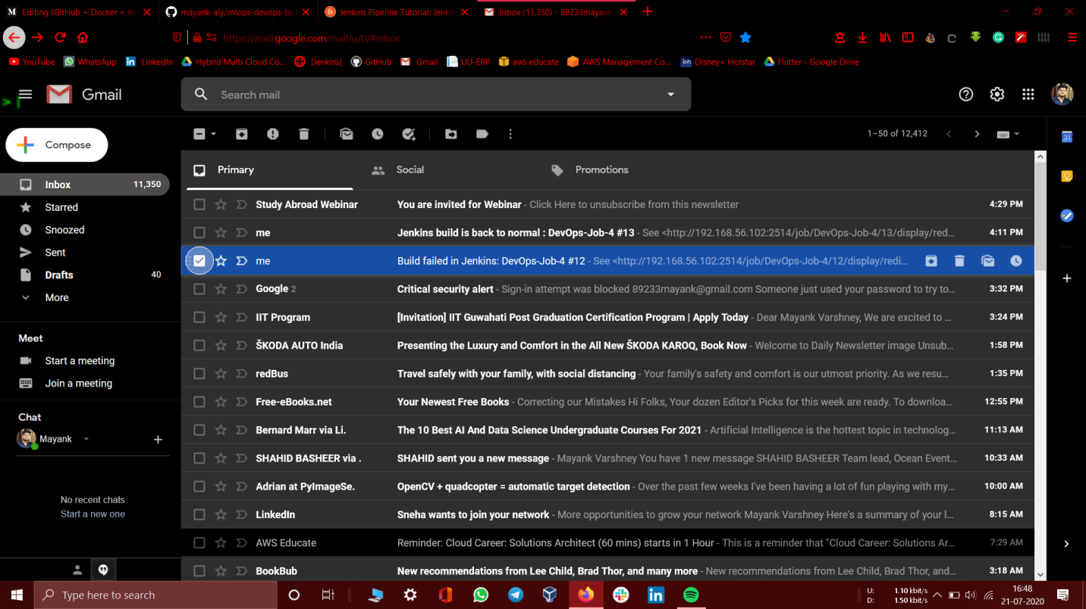

*Here come one more important part and interesting one in our task, That when you test the jobs running in the system and if build failure occurs than How developer will get to know about this situation?*

*For this, There should be some notification system for the automation task we made.*

*JOB5:*

This job will work in monitor the system, Like if the system fails then it will automatically start a new container to don’t make a failure in the project.

We will use SCM polling for this, * here represents 1min.

