- -

A Project Report On

E-commerce Website

Submitted in partial fulfillment of the requirement for the award of the degree

Bachelor of Computer Application (BCA)

Academic Year 2025 – 26

Jeel Kakadiya Bhargav Timbadiya Dhruvik Gondaliya
92300527132 92300527040 92300527135

Internal Guide
(prof. Sushma Kumari)



Rajkot-Morbi Road, At & PO : Gauridad, Rajkot 360 003. Gujarat. India.

Faculty of Computer Applications (FOCA)



This is to certify that the project work entitled

E-commerce Website

submitted in partial fulfillment of the requirement for

the award of the degree of

Bachelor of Computer Application

of the

Marwadi University

is a result of the bonafide work carried out by

Jeel Kakadiya (92300527132)

Bhargav Timbadiya (92300527040)

Dhruvik Gondaliya (92300527135)

during the academic year 2025-26

Jignesh Hirpara Sunil Bajeja R. shreedharan
Faculty Guide |  | HOD |  | Dean

DECLARATION

I/We hereby declare that this project work entitled E-commerce Website is a record done by me.

I also declare that the matter embodied in this project is genuine work done by me and has not been submitted whether to this University or to any other University / Institute for the fulfillment of the requirement of any course of study.

Place : Rajkot
Date : 29-08-25

Jeel Kakadiya (92300527132) Signature :
Bhargav Timbadiya (92300527040) Signature :
Dhruvik Gondaliya (92300527135) Signature :

ACKNOWLEDGEMENT

It is indeed a great pleasure to express our thanks and gratitude to all those who helped us. No serious and lasting achievement or success one can ever achieve without the help of friendly guidance and co-operation of so many people involved in the work.

We are very thankful to our guide Sushma Kumari, the person who makes us to follow the right steps during our project work. We express our deep sense of gratitude to for his /her guidance, suggestions and expertise at every stage. A part from that his/her valuable and expertise suggestion during documentation of our report indeed help us a lot.

Thanks to our friend and colleague who have been a source of inspiration and motivation that helped to us during our project work.

We are heartily thankful to the Dean of our department Dr. R. Sridaran sir and HoD Dr. Sunil Bajeja sir for giving us an opportunity to work over this project and for their end-less and great support to all other people who directly or indirectly supported and help us to fulfil our task.

Jeel Kakadiya (92300527132) Signature:___________
Bhargav Timbadiya (92300527040) Signature:___________
Dhruvik Gondaliya (92300527135) Signature:___________

CONTENTS

Chapters | Particulars | Page No.
1 | SYNOPSIS | 6
2  2.1  2.2 | PREAMBLE  General Introduction  Module description | 7
3 | REVIEW OF LITERATURE | 8
4  4.1  4.2 | TECHNICAL DESCRIPTION  Hardware Requirement  Software Requirement | 9
5  5.1  5.2  5.3  5.4 | SYSTEM DESIGN AND DEVELOPMENT  Dynamic Modeling  - Use Case Diagram  - Sequence Diagram  - Activity Diagram  - Screen Design | 10-13
6 | CONCLUSION | 14
7 | LEARNING DURING PROJECT WORK | 15
8  8.1  8.2 | BIBLIOGRAPHY  Online References  Offline References | 16

SYNOPSIS

This project is an E-Commerce Website developed to provide a simple online shopping experience. The main aim of the project is to design a system where customers can browse different product categories, add items to their cart, and proceed with billing and payment. The system also includes an admin section where store managers can add, update, and track products.

The website has been created using Python , HTML and CSS for the front-end design, while the back-end (if connected) can be extended using databases for storing product and order details. The project focuses on creating a user-friendly interface that works on both desktop and mobile screens.

Key features :

- Homepage with product categories such as Grocery, Fruits & Vegetables, Snacks, Personal Care, and more.

- Shopping cart system where users can view and manage selected items

- Billing and checkout process with payment options like cash or card.

- Customer review section for feedback.

- Login to manage sales and profits.

PREAMBLE

- General Introduction:

The project “E-Commerce Website” is designed to provide an easy and effective online shopping platform. In today’s digital world, people prefer buying products online rather than visiting physical stores. This project is a basic model of an online store where users can browse products, add them to their cart, and proceed with payment.

The system is user-friendly, mobile responsive, and provides essential e-commerce features like product categories, billing, discount options, and invoice generation. An admin panel is also included to manage products and keep track of sales and profit.

The main objective of this project is to understand the working of an online shopping system and to provide a simple platform that demonstrates how e-commerce websites function in real life.

- Module description:

- Homepage Module:
  - Displays the website introduction and main product categories.
  - Provides navigation links to other sections of the website.
- Product Module:
  - Shows different products under categories like Grocery, Fruits & Vegetables, Snacks, Personal Care, etc.
  - Allows customers to view product details and prices.
- Cart Module:
  - Customers can add products to the shopping cart.
  - Allows updating or removing items before checkout.
- Customer Review Module:
  - Customers can give feedback about products and services.
  - Helps in improving the system based on reviews.
- Admin Module:
  - Provides login access for the store administrator.
  - Allows adding, updating, and deleting products.
  - Keeps track of sales, revenue, and profit.

REVIEW OF LITERATURE

E-commerce is one of the fastest-growing sectors in the field of information technology. Many researchers and developers have worked on online shopping systems to improve customer experience and simplify business operations.

- Previous Studies: Earlier e-commerce systems mainly focused on product listing and basic cart features. These systems were limited in design and not mobile-friendly. Customers often faced difficulties in navigation and secure payment.

- Recent Developments: Modern e-commerce platforms now include features like user-friendly interfaces, responsive web design, multiple payment gateways, personalized recommendations, and secure transactions. They also focus on customer reviews, discount systems, and admin dashboards for better management.

- Practical Importance: Literature shows that e-commerce websites help businesses expand their reach beyond physical boundaries, reduce operational costs, and provide convenience to customers. Many successful platforms such as Amazon, Flipkart, and Shopify have set examples for how e-commerce can transform traditional shopping.

- Learning for this Project: By studying existing systems and their limitations, this project has been designed with simple but essential modules like cart management, billing, payment options, and admin control. The main idea taken from the literature is to keep the design simple, user-friendly, and responsive so that it can be used as a base model for more advanced systems.

TECHNICAL DESCRIPTION

- Hardware Requirement:

To run this Python-based E-Commerce project, only a basic computer system is required. A laptop or desktop with at least a dual-core processor and 4GB RAM is sufficient for smooth execution. A minimum of 250GB hard disk space is recommended to store Python libraries, database files, and project-related resources.

The project does not need high-end hardware and can easily run on normal student-level systems. An internet connection may be required for installing Python packages and testing online features, but the project can also be executed offline once all dependencies are installed.

- Software Requirement:

The software requirements for this project are simple and open-source. The project is developed using Python programming language, so Python 3.x must be installed on the system. For database management, SQLite3 is used, which comes pre-installed with Python. If the project uses a web framework, Flask is required for handling the backend logic.

A suitable code editor like Visual Studio Code or PyCharm can be used for development. In case of design, For testing the web version, a modern browser like Google Chrome or Firefox is needed. The operating system can be Windows, Linux, or macOS, as Python is platform-independent.

Sequential Diagram

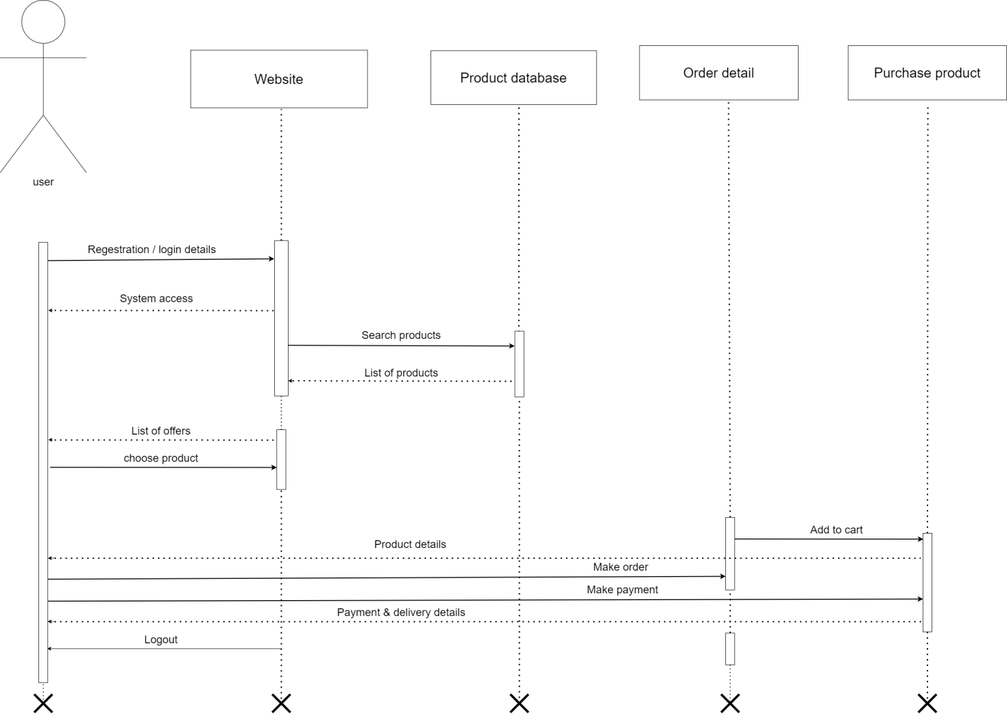

Activity Diagram

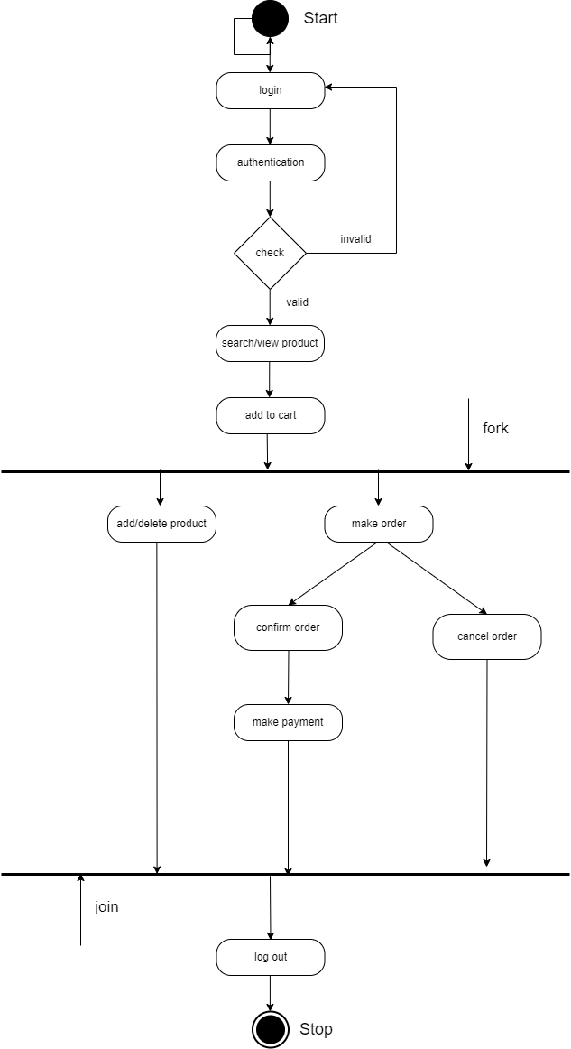

Home Page

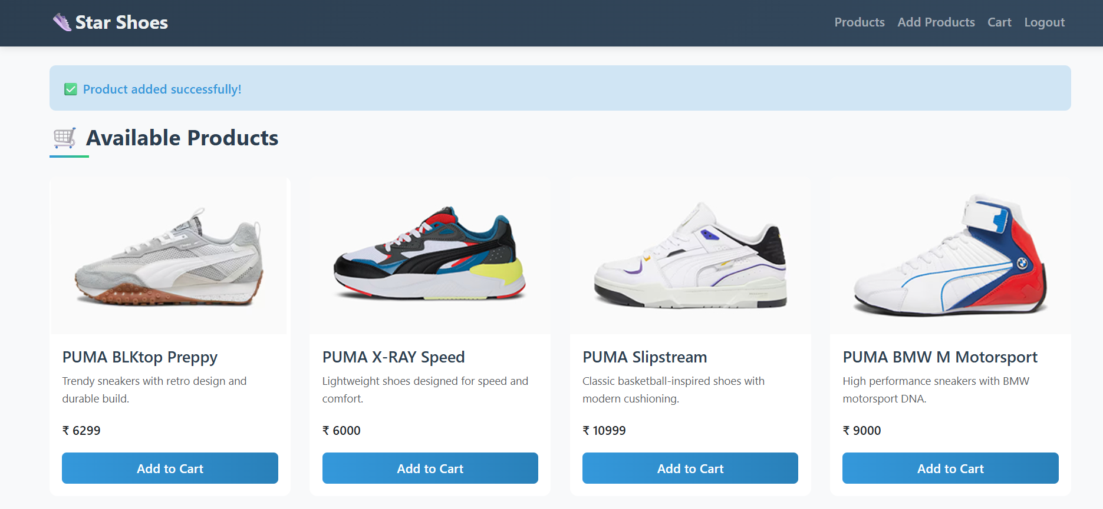

Login Page

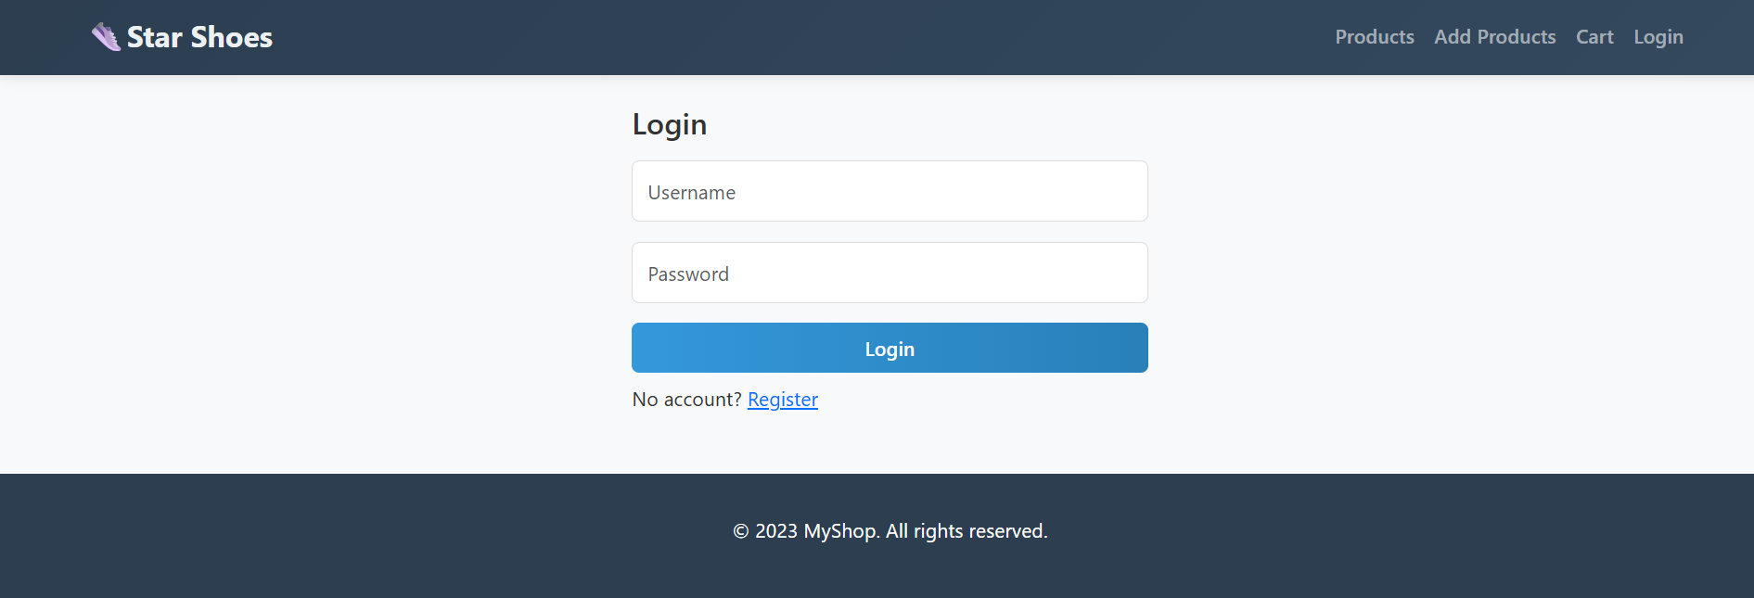

Cart Page

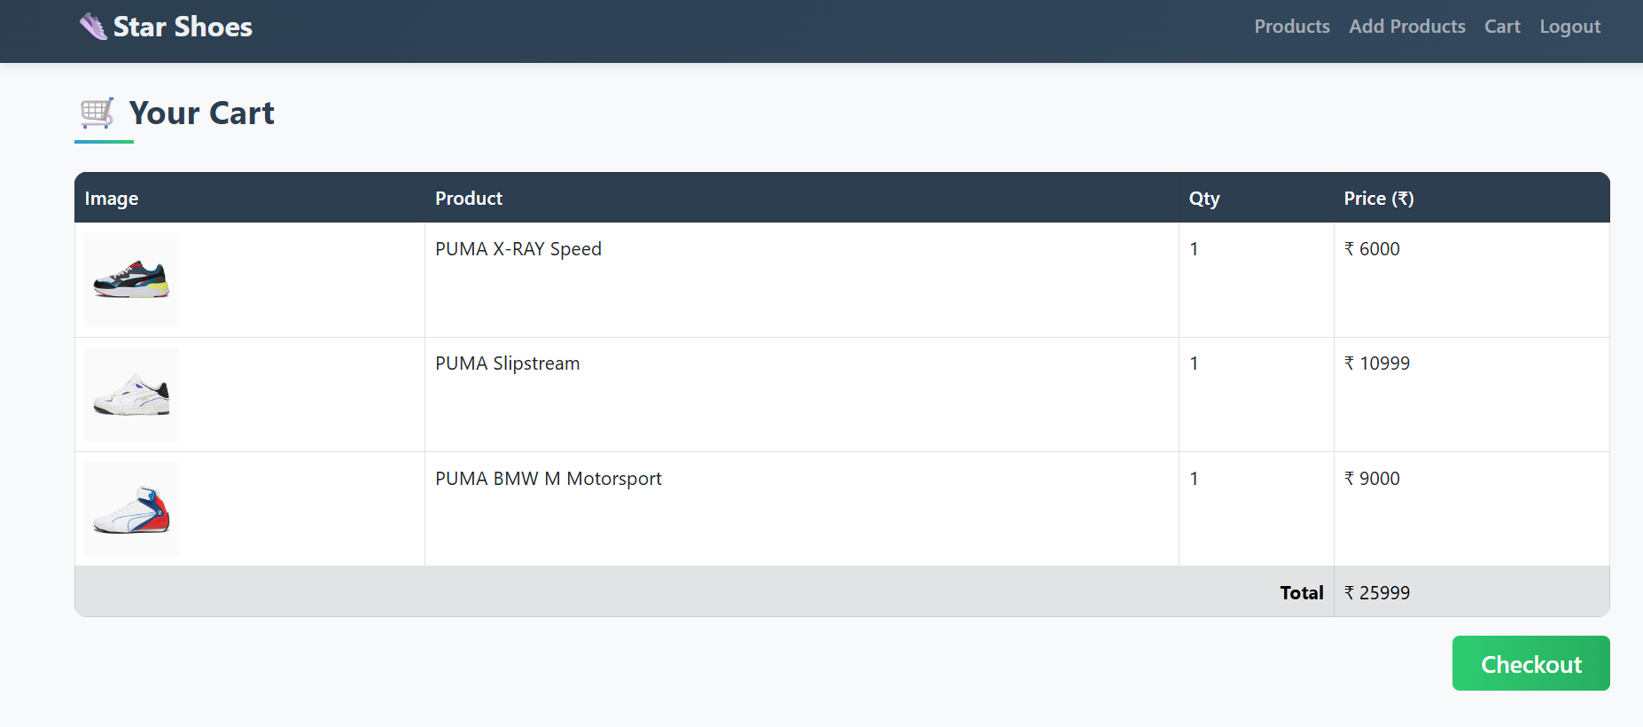

Order Page

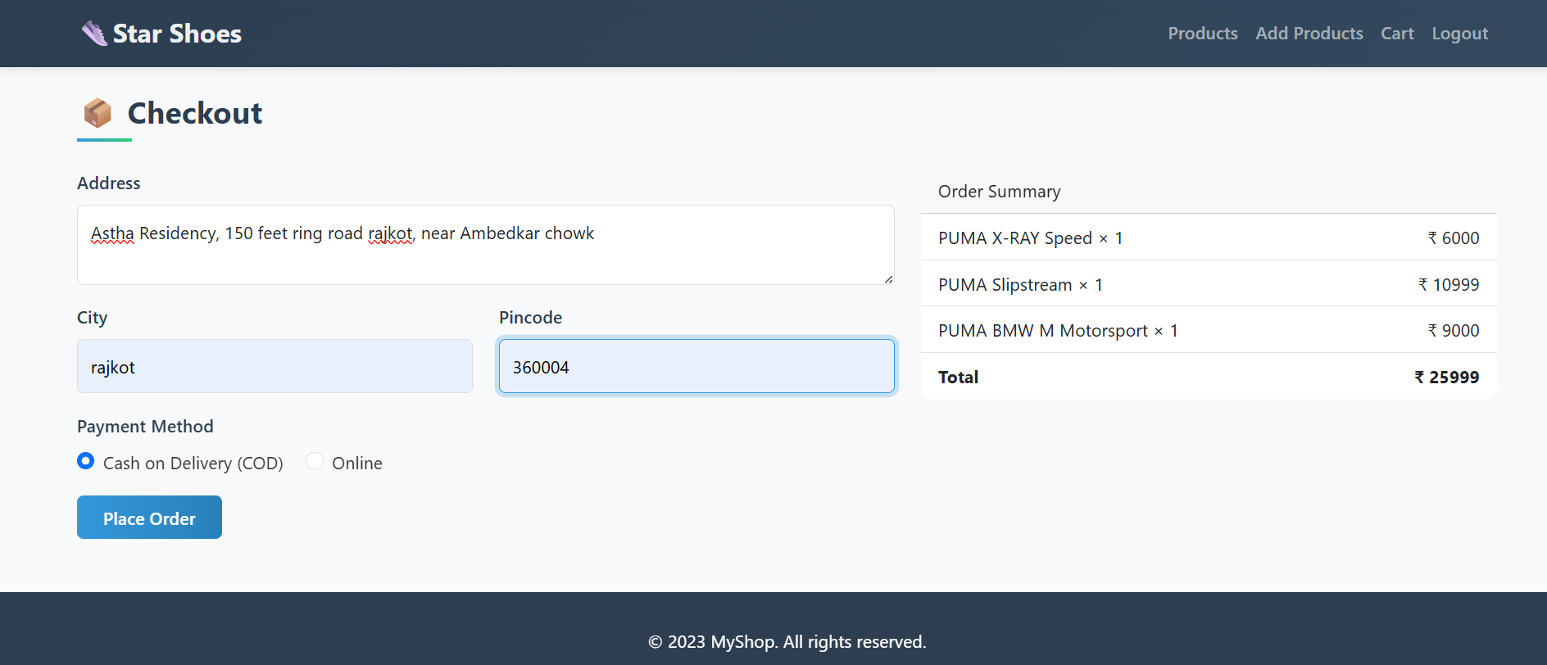

Conclusion

The E-Commerce project developed using Python provides a simple and effective platform for online shopping. It demonstrates the basic working of an e-commerce system, including product management, cart handling and customer interaction. The project also includes an admin module which helps in managing products and tracking sales.

This project shows how Python, along with SQLite and Flask, can be used to design a user-friendly and practical application. It highlights the importance of digital shopping platforms in today’s world, where convenience and accessibility play a major role. Although this is a basic model, it can be further improved by adding advanced features such as secure payment gateways, user authentication, and real-time order tracking.

Learning Objectives

1.To understand the working of an online shopping system through a practical project.
2.To learn how to design and implement modules like product display, cart, billing, and admin control.
3.To apply Python programming concepts in real-life application development.
4.To gain knowledge of database management using SQLite with Python.
5.To develop skills in creating user-friendly interfaces using Flask.
6.To improve problem-solving ability by integrating multiple features into a single system.

Bibliography

- Online References:

1.Python Official Documentation – https://docs.python.org/3/

2.SQLite Documentation – https://www.sqlite.org/docs.html

3.Flask Documentation – https://flask.palletsprojects.com/

4.W3Schools – https://www.w3schools.com/python/

5.GeeksforGeeks – https://www.geeksforgeeks.org
python-programming-language/

- Offline References:

- Programming in Python by Dr. Reema Thareja – Oxford University Press.

- Learning Python by Mark Lutz – O’Reilly Media.

- Class notes and lecture materials provided by faculty.

- Practical lab manuals related to Python and Database Management.

