Program: | GDP1
Course: | INFO6045 “Animation”
Professors: | Michael Feeney
Project # 1: | Basic skinned mesh animation
Weight: | Evenly distributed across your 60% “project” mark portion of the course
Due Date: | Sunday, March 18th at 11:59 PM
Note: This project can be done alone or in pairs.
(Possible groups are listed at the end of the document – you must indicate if you are working within the group or alone before submitting)
Description and Purpose

Create a Win32 (Windows 7/8/10) + OpenGL 4.x application that demonstrates the use of a skinned mesh model and animation.

Details

“Engine”/code requirements:

- You are not to complete this using a game engine (Unity, Unreal, etc.) or existing animation framework (Granny, Ogre, etc.).
- You may use the code provided in class (uses assimp to load the FBX models, then code based on the “Skeletal Animation With Assimp” example (http://ogldev.atspace.co.uk/www/tutorial38/tutorial38.html), or your own custom code, provided you can demonstrate that you created it yourself, and it was created during this term.
- While you are welcome (encouraged, actually) to use the code from class, you will have had to make “sufficient” changes/alterations/additions to the code, specifically in functionality. The gauge for this is how long it would take me (or someone else competent) to make the changes you have implemented – so if you just submit the code from class, more or less “as is”, then you may get a mark of zero (because you “haven’t actually done anything”).
  - Keep in mind that in previous years, students were expected to have implemented that entire assimp/Doom 3 MD5 animation load and display themselves, individually. You simply handing my code back to me doesn’t prove you can do anything.
  - The change this year is that I want you to have more to show at the end, beyond simply loading and displaying an animation.

Requirements:
- Show two skinned mesh animated characters. They can be the same, but there is a bonus mark if they are different characters entirely).
- Use the keyboard/controller to select each character. The unselected character should stop moving and enter their “idle” animation.
- Use the WASD keys/controller to move the characters around.
  - The character must face in the direction of travel.
  - Moving characters have to enter some kind of “walk” (or swim, or movement) animation.
  - An additional key/controller transition into a “run” (or move faster) animation and the character has to move faster in the world.
  - Bonus: There character can “strafe” (this must involve a “strafe”/”walk sideways” animation). Note that the player must normally face the direction of travel to get this bonus.
- There has to be at least five (5) animations present AND operate at the appropriate time (note that I’m not referring to the specific “RPG Character” animation files, but the “animation” in general – i.e. you can use any “idle” animation you’d like, provided that it “makes sense”; your character isn’t going to constantly jump while “idle” for instance, but they could shuffle, look around, check their gun, tap their foot impatiently, etc.).
  - “Idle”: when the character is just standing there, doing nothing
  - “Walk”: when the character is under user control, being moved from one place to another
  - “Run”: There is a “run”, that is different from the walk. For example, moving forward and pressing shift/trigger could change the animation to “run” (AND the character has to move faster)
  - “Jump”: when commanded to jump.
    - If stopped, they simply have to jump in place (i.e. if they are moving, they would stop, then jump “on the spot”).
    - If the character is already moving when a “Jump” animation happens (i.e. the player is currently holding the ‘walk’ button), they move forward in space while jumping.
    - If the character is “running”, then jump would have them jump further (than a “walk jump”).
  - “Action”: some kind of specific action – this could be “fight”, “punch”, “shoot”, “pick up flowers”, whatever.
  - Bonuses: While “strafing”, then can do an alternative animation, like “roll” (or equivalent)
- Interactions with the “scene” the characters are in:
  - The character has to move around the scene in a physically sensible way, like (more or less) not penetrating the floor, passing through walls, etc. Keep this in mind when you design you scene: walking on complex, curved surfaces, stairs, non-axes aligned walls, etc. are much more difficult to handle. Note that you can lose marks for this (see marking scheme), so keep that in mind. I’m not looking for “The Most Perfect Physical Collision Detection”, just that you have something good enough – even in AAA games, there’s the odd part of a character that penetrates here and there.
  - The scene has to “make sense” (it can be “fantastic” and/or “ridiculous”, but has to be recognizable, etc. - more details later in the document).

Additional requirements:
- While you may freely “borrow” mine (or anyone other) code but your code should be “sufficiently” different from mine. See the "plagiarism" test, later in this document, for more details.
- Further, you cannot simply use an existing game engine (or part of a game engine), even if it's a "from source" engine (i.e. you have the entire source) to complete this assignment; it should be either completely new of significantly modified. This includes, but is not limited to: Unity, Unreal, Cry, Anarchy, XNA, Cocos, Ogre, the framework from the OpenGL text, etc. In other words, you are expected to have made the vast majority (essentially all) of the engine in this term by yourselves, from "scratch" - i.e. starting from something a rudimentary as the "OpenGL Book" code or the GLFW starter code (we started with that in class).

- You also cannot simply use an existing game engine (or part of a game engine, Ogre3D for instance) to complete this assignment; it should be either completely new of significantly modified.

Grading Scheme

- Normally a grade of zero will be assigned to any assignment that is submitted late. However, certain rare exceptions apply according to the Infotech Policy on Missed Evaluations and Evaluation Deadlines.
- If you code does not even compile, I will not mark it. Period.
- If you code does not build (i.e. linker error) and run (i.e. no crazy run-time crash that is unexpected), I may investigate this further, but only if there is some simple problem and/or slight configuration error.
Two skinned mesh characters shown | 10
(BONUS: Characters are different) | 10
Ability to select the character | 5
Unselected character enters "idle" animation | 5
WASD/Controller moves selected character appropriately | 30
Character faces in direction of travel | 30
(BONUS: Character can strafe, too) | 15
Animations:
- Idle | 5
- Walk | 5
- Jump | 5
- Action | 5
- Run (alternative mode to walk, character moves faster) | 10
* If walking "jump" moves them forward in space | 10
* The distance of a jump is longer when they are "running" | 10
(BONUS: If "strafing", they can also "roll" in that direction) | 10
Physical scene interaction is correct (-50 to +10) | 10
 | 140

Note: Keep in mind the following:

- These are the maximum marks possible for each section
- There are some minimum requirements that must be present before you will receive any marks. For example: a scene with one static object and one light will not receive any marks; you will only receive partial marks for things like: having two lights instead of four, or loading one model instead of four, etc.
70/12-year old “squinty eye” plagiarism test:
- While you may freely “borrow” mine (or anyone other) code but your code should be “sufficiently” different from mine.
- You should also give credit for where you found the code, if you’ve used a significant portion of it.
- In other words, you cannot simply use an existing game engine (or part of a game engine) to complete this assignment; it should be either completely new of significantly modified.
- How will I determine this?

If I showed your application and/or your source code to either my very pragmatic 70-year-old mother, or a typical 12-year-old, and they looked at it, tilted their heads, squinted their eyes, and said, “you know, they look the same,” then they are the same.
In other words, I’m not going to be drawn into a giant debate over how “different” your code is from mine or anyone else’s, if a complete stranger, say a randomly stopped in the hallways, would conclude that the code and/or output is pretty much the same thing, then it’s “the same.”
- The bunnies in the back skip rope.
- The other bunnies bounce in their chairs
- There's a robot "waiter" on the right (there were lights moving around, but I didn't capture it at the right moment). Note: the "waiter" is actually a combination of other models, including a "Utah Teapot" for a head! Neat!!
- You can move the waiter around
- There are three separate lights
- It’s DirectX 10 (summer 2011)
- This is "ridiculous", but it is "sensible" as it "makes (some) sense" - if you showed this to a little child, they would be 100% OK with it.
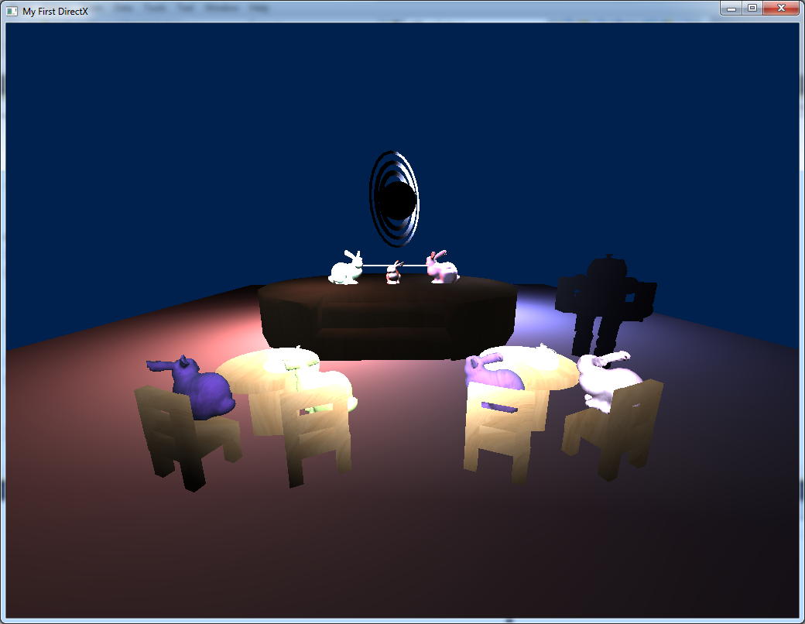
Project Corrections
If any corrections or changes are necessary they will be posted to the course web site and you will be notified of any changes in class. It is your responsibility to check the site periodically for changes to the project. Additional resources relating to the project may also be posted.

