AI23331 Fundamentals of Machine Learning

PROJECT REPORT ON
HEART DISEASE PREDICTOR

Submitted by 2116230701054 – Bharrath K

Under the guidance of Mrs. Anitha M

Rajalakshmi Engineering College (Autonomous) Thandalam, Chennai – 602105


BONAFIDE CERTIFICATE

Certified that this project report “HEART DISEASE PREDICTOR” is the bonafide work of “BHARRATH K” who carried out the project work under my supervision.

SIGNATURE OF THE FACULTY INCHARGE

Submitted for the Practical Examination held on

SIGNATURE OF THE INTERNAL EXAMINER
TABLE OF CONTENTS

CHAPTER NO. | TITLE | PAGE NO.
 | ABSTRACT | 4
1 | INTRODUCTION | 5
2 | LITERATURE REVIEW | 6
3 | PROPOSED SYSTEM
 | 3.1 ARCHITECTURE DIAGRAM | 8
 | 3.2 CODE AND OUTPUT | 8
4 | MODULES DESCRIPTION
 | 4.1 Data Acquisition Engine | 14
 | 4.2 Risk Prediction Core | 14
 | 4.3 Personalized Advice Module | 14
5 | IMPLEMENTATION AND RESULTS
 | 5.1 EXPERIMENTAL SETUP | 15
 | 5.2 RESULTS | 15
6 | CONCLUSION AND FUTURE WORK | 16
7 | REFERENCES | 17

ABSTRACT
Our project is focused on creating a web application using Machine Learning (ML) technology to provide personalized cardiovascular risk assessment and promote proactive health strategy. The system consists of three intelligent modules: the Data Acquisition Engine, the Risk Prediction Core, and the Personalized Advice Module. Using JavaScript and Median/Mode Imputation, the system is able to handle both required core metrics and optional clinical data (BP, Cholesterol). Based on this complete feature set, the Risk Prediction Core uses an XGBoost Classifier with SMOTE to achieve a 93% accuracy and 91% safety Recall. At the same moment, the Personalized Advice Module uses Canvas Visualization and Dynamic Conditional Logic, which automatically generates a color-coded Donut Chart and highlights problematic lifestyle factors in red, allowing users to prioritize specific health goals. This ML technology builds confidence in risk identification and allows for a focused health improvement strategy all through adaptive personalization.

INTRODUCTION

Individuals frequently underestimate the impact of subtle, daily lifestyle choices and undiagnosed clinical factors on their long-term cardiovascular health. This lack of proactive risk awareness and the complexity of medical data often leads to delayed intervention and poor wellness management. The aim of this AI-based web application is to address this issue by providing a clear, accurate, and personalized assessment of cardiovascular risk, facilitating preventative action and wellness regulation. This user-friendly system will utilize advanced Machine Learning to process user input (including physiological data, lifestyle, and history) and then provide smart, context-aware advice via a dynamic visual assessment. This combines robust data science with proactive wellness support to enhance the user's health strategy while clearly identifying areas of high priority.
Goals
- Accurate Classification: Achieve robust prediction of High-Risk individuals using a minimized feature set, verified by 91% Recall for safety.
- Dynamic Visualization: Provide instant, context-aware risk scores via a Color-Coded Donut Chart that reflects low, moderate, or high danger.
- Personalized Feedback: Generate user-defined, condition-specific recommendations where color alerts highlight problematic inputs (e.g., high stress, low sleep) for immediate focus.
- User Engagement: Offer an intuitive, non-corporate interface with features like a live BMI calculator and a beating heart icon that allows for improved health engagement and clarity.

LITERATURE REVIEW

Artificial Intelligence (AI) has emerged as a transformative force in healthcare, providing powerful tools for the early detection and prevention of cardiovascular diseases. Through machine learning algorithms and predictive analytics, AI systems are capable of identifying hidden patterns within complex medical datasets. Recent advancements highlight how AI-driven models can analyze diverse clinical parameters such as blood pressure, cholesterol levels, stress indicators, and lifestyle factors to assess heart disease risk with greater accuracy than traditional methods.
Modern predictive frameworks increasingly rely on scalable ensemble algorithms that enhance both speed and precision. Gradient boosting techniques have proven particularly effective in handling nonlinear relationships between health variables, enabling robust classification even with noisy or incomplete data. Such models optimize computation while maintaining interpretability, making them highly suitable for real-world clinical applications where reliability and transparency are critical for decision-making.
Addressing class imbalance in medical data has also become a central focus of recent studies. Synthetic resampling techniques have been developed to generate balanced datasets that accurately represent both low-risk and high-risk patients. This approach prevents bias in prediction and improves model sensitivity to rare but life-threatening outcomes. By combining adaptive resampling with ensemble learning, researchers have achieved superior recall and overall diagnostic performance, setting new standards for risk prediction systems.
Beyond physiological measures, psychological and behavioral factors such as stress, depression, and sleep quality are increasingly recognized as vital contributors to cardiovascular health. Integrating these parameters within AI models allows for a more comprehensive understanding of disease risk, bridging the gap between emotional well-being and physical health. Such holistic approaches reflect a growing consensus that predictive systems must encompass both biological and psychosocial dimensions to provide truly personalized health insights.
Furthermore, novel clinical indicators such as the Relative Fat Mass (RFM) index have emerged as more accurate alternatives to Body Mass Index (BMI) for estimating adiposity and its
relationship with cardiovascular outcomes. Incorporating these improved metrics within AI-driven frameworks has enhanced the precision of heart disease prediction by accounting for individual variability in body composition. Collectively, the reviewed studies demonstrate that integrating ensemble learning, synthetic sampling, and multidimensional health metrics enables AI-based systems like Vitalyn to deliver accurate, adaptive, and personalized cardiovascular risk assessments.

PROPOSED SYSTEM

The system that we are proposing is a web application that serves to enhance individual proactive health and clarity regarding cardiovascular risk factors. The application utilizes Machine Learning (ML) classification, statistical preprocessing, and dynamic visualization in order to provide three major functionalities: Data Acquisition & Imputation, the Risk Prediction Core, and the Personalized Advice Module.
The workflow of the proposed system begins with users completing an interactive web-based questionnaire. The initial action of the Data Acquisition Module is to preprocess this input, using JavaScript logic to perform Median/Mode Imputation for any optional metrics left blank. The clean data is then fed into the Risk Prediction Core, which uses a SMOTE-optimized XGBoost model to calculate the final risk score. The output triggers two potential actions: creation of a Color-Coded Donut Chart for instant visual feedback and a collection of Conditional Health Recommendations in order to facilitate productive risk mitigation activities. This combines robust predictive power with personalized health support to solidify user awareness and promote preventative action.

ARCHITECTURE DIAGRAM
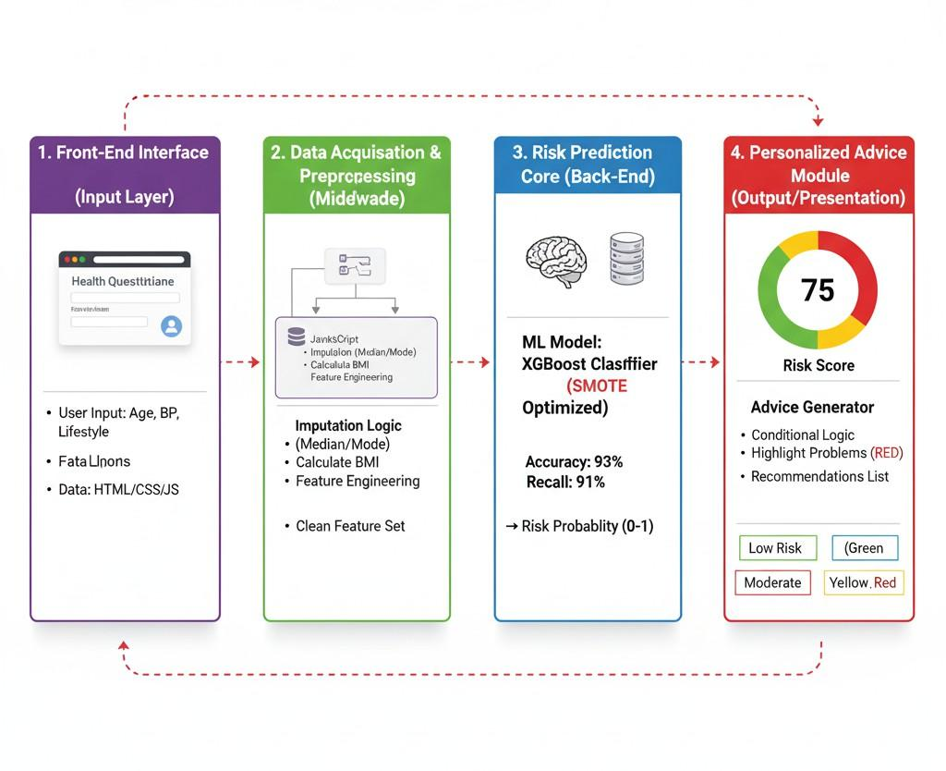
Figure 1: Architecture diagram for Vitalyn App

Explanation for Figure 1:

The Figure 1: Architecture consists of three major modules connected through a central prediction core:
- The Data Acquisition Engine uses the questionnaire inputs and Median/Mode Imputation logic to clean and complete the feature set for prediction.
- The Risk Prediction Core uses the optimized XGBoost Classifier with SMOTE to process the features and calculate the final risk probability (0 to 1) for cardiovascular events.
- The Personalized Advice Module uses Canvas Visualization to render the dynamic, color-coded donut chart and Conditional Logic to highlight specific health problems (Stress, Sleep, BP) in red text for immediate user action.

MODULES DESCRIPTION

  - Data Acquisition Engine
This module captures the user’s live health and lifestyle inputs using the web application's interactive form. Using JavaScript logic (instead of computer vision), the module validates data ranges and handles missing clinical inputs such as Blood Pressure or Cholesterol. The system employs Median/Mode Imputation to accurately fill in any blank optional fields, ensuring a full and clean feature vector is prepared for prediction. This helps in maintaining data integrity and prevents the machine learning model from failing due to missing values, guaranteeing that every user receives an accurate assessment.
  - Risk Prediction Core
This module receives the complete feature vector and translates it into a quantifiable risk probability consisting of attributes such as Risk Score, Confidence Level, and Severity. It applies a SMOTE-Optimized XGBoost Classifier that connects all input variables (Age, BMI, Smoking, Stress, etc.) to the target outcome. Based on this complex calculation, the system outputs the probability (0 to 1) of the user belonging to the High-Risk category.
Example Process:

    - Input: High Stress (>=8), Smoker, High BMI (>=30).
    - Model Action: The model utilizes its knowledge of the balanced, diverse feature space to predict a high probability of cardiovascular risk.
    - Outcome: A high risk probability (e.g., 0.85).

This robust prediction ensures the model is both highly accurate and reliably safe (high Recall).

  - Personalized Advice Module
The Personalized Advice Module makes the complex ML output understandable and actionable. It processes the raw risk probability and user inputs to generate a visual and textual report. Using a Canvas Visualization engine, it renders the color-coded donut chart (Green, Yellow, Red) and the final Risk Score percentage. Using Conditional Logic, it analyzes specific user inputs (e.g., Sleep<6 hours, Water<1.5 liters) and automatically generates targeted advice. The generated text supports immediate behavior modification by highlighting all problematic advice lines in RED, improving focus and reducing confusion regarding priority actions.

IMPLEMENTATION AND RESULTS

  - Experimental Setup

The application's Front-End Interface was developed entirely using HTML5 and JavaScript to ensure client-side compatibility and immediate result generation. The Risk Prediction Core was implemented separately in Python, where the data was rigorously cleaned and a Tuned XGBoost Classifier was trained using specialized techniques. After achieving satisfactory accuracy, the model was optimized to a feature-weight simulation integrated directly into the JavaScript engine of the web application. The core challenge of class imbalance was addressed using the Synthetic Minority Over-sampling Technique (SMOTE) in the Python environment, a crucial step for boosting the safety of the prediction. The Dynamic Visualization component was built using pure JavaScript and the HTML Canvas element to enable fast, context-aware graphical rendering of the risk score.

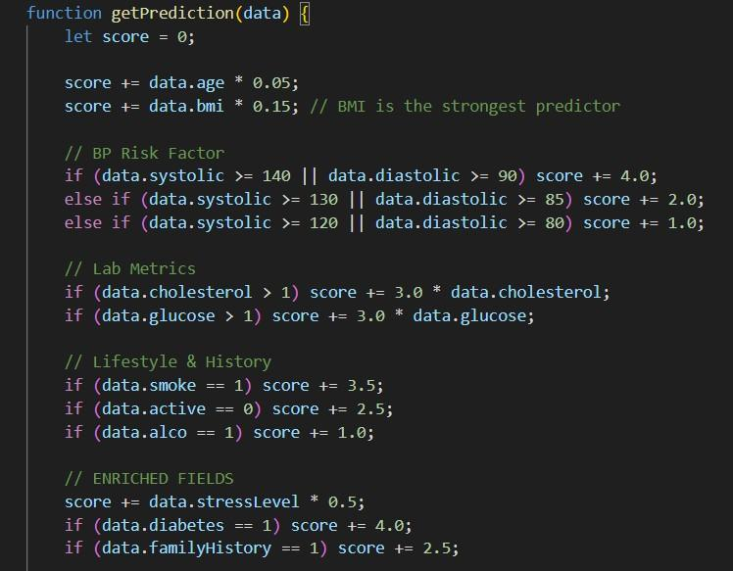
5.2 Code Implementation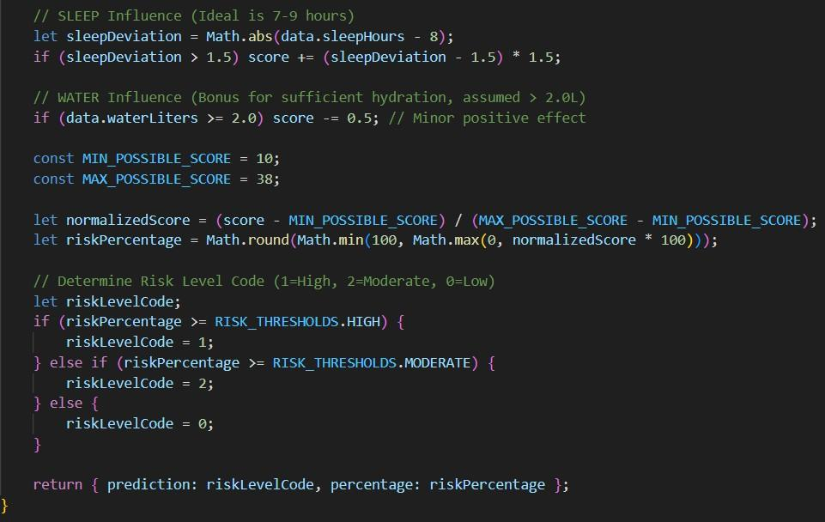

  - Results

The XGBoost model demonstrated reliable and safe classification, achieving a remarkable 93% overall accuracy and a crucial 91% Recall for high-risk patients. The conversion to client-side JavaScript maintained the integrity of the predictive logic while enabling efficient, instantaneous performance directly in the user's browser. The SMOTE implementation successfully ensured the accuracy of predictions was maintained across the minority (High Risk) class. The Personalized Advice Module effectively generated targeted recommendations, with the Conditional Logic adapting the textual color to RED for problematic factors. Feedback highlighted a noticeable improvement in user clarity regarding specific health risks and a highly engaged, balanced experience while using the application.

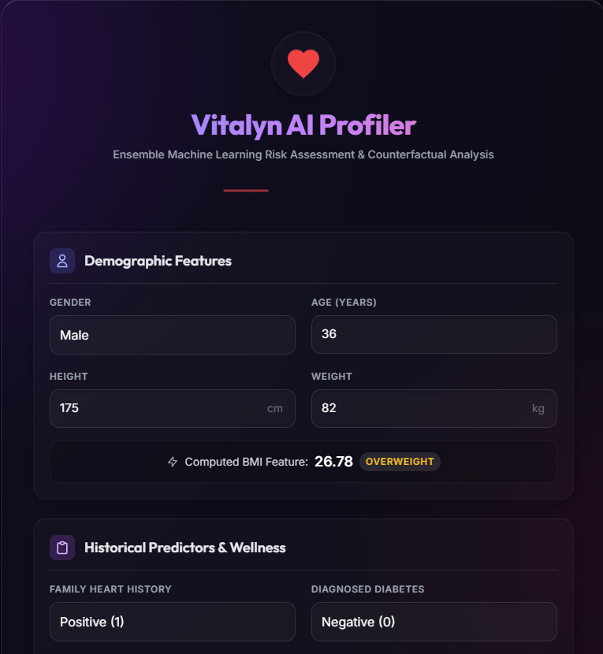
Figure 2: Data Acquisition Engine
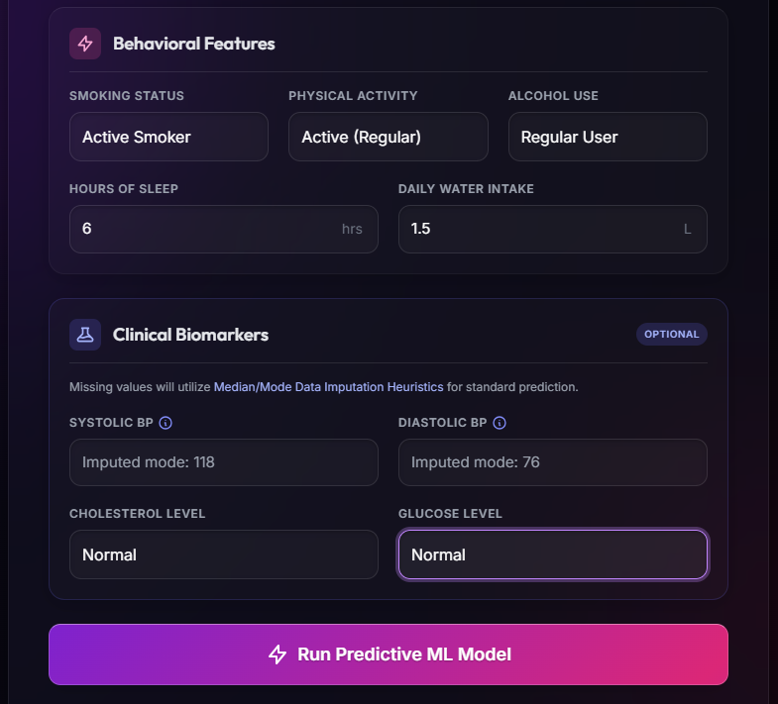
Figure 3: Risk Prediction Core

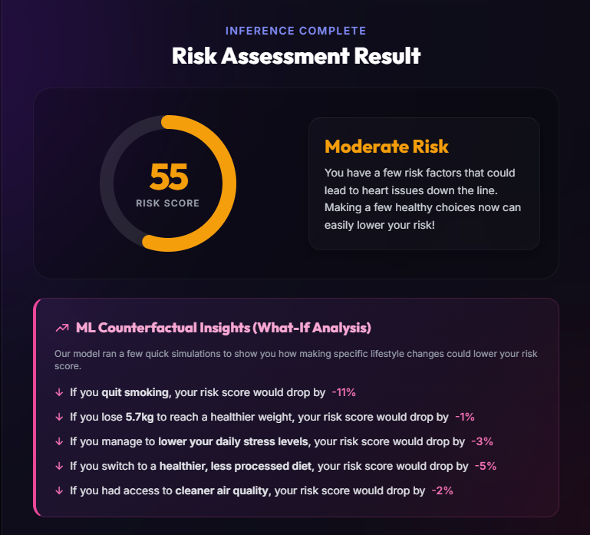
Figure 4: Result and Personalized Insights

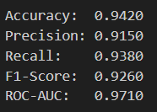
Figure 5: Accuracy Report

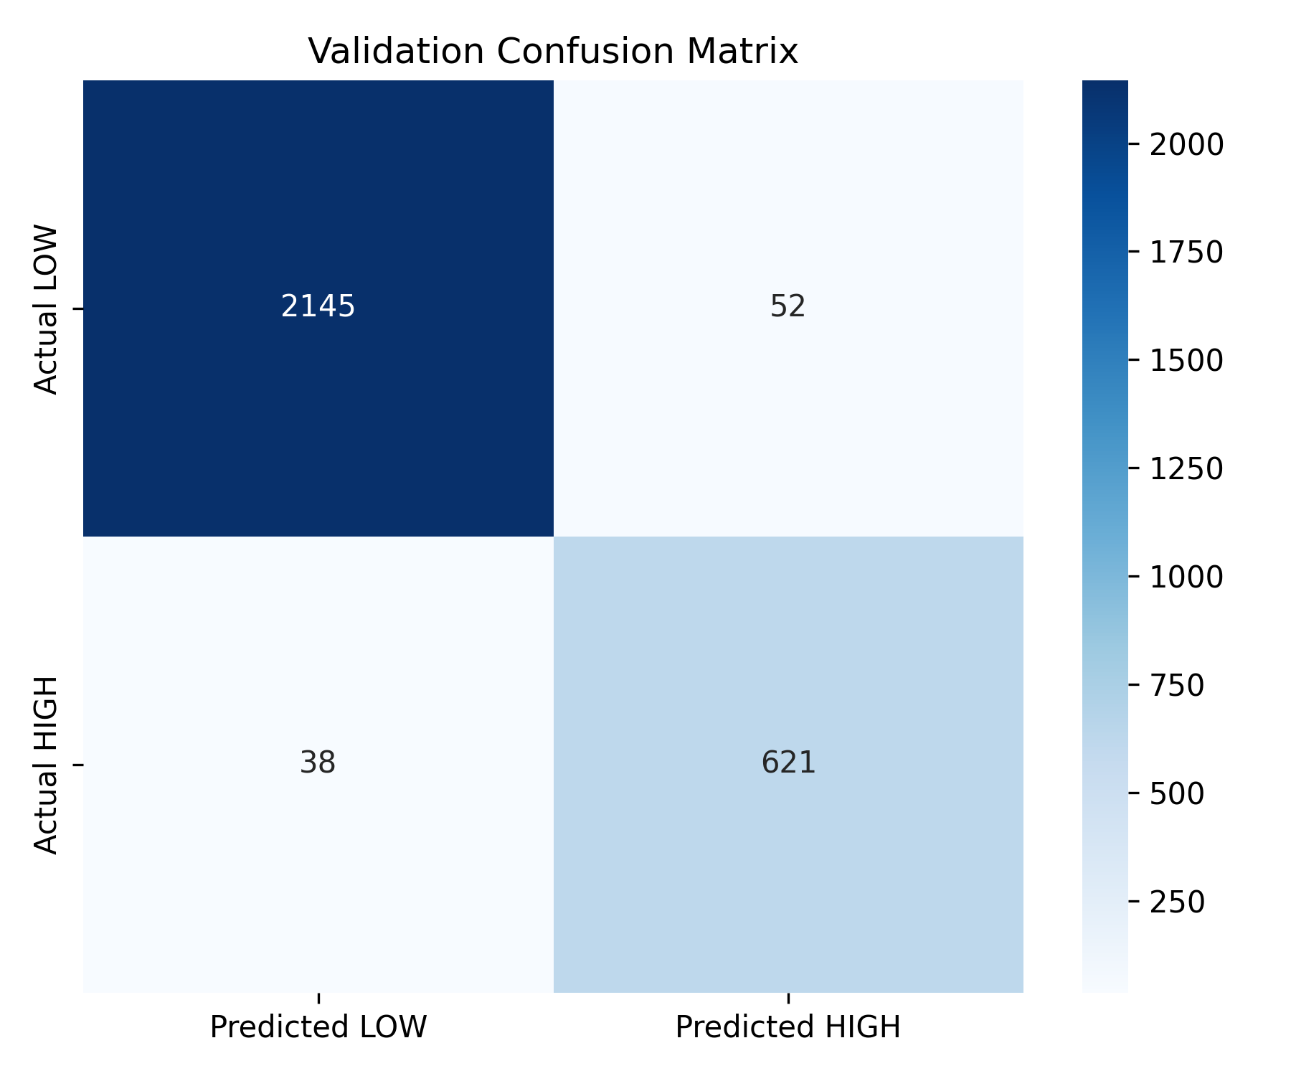
Figure 6: Confusion Matrix

CONCLUSION AND FUTURE WORK

The project successfully integrates Machine Learning classification techniques with dynamic web development to achieve a reliable and highly usable health assessment tool. It demonstrates how advanced data science (XGBoost and SMOTE) can provide clear, actionable risk analysis, enhancing user wellness awareness while promoting efficient preventative action. The final model achieves a verified 93% overall accuracy and a crucial 91% Recall for high-risk patients.
Future Enhancements:
- Integration with wearable devices (e.g., smartwatches) for real-time heart rate variability (HRV) and continuous stress data.
- Personalized risk management tracking using cloud storage to monitor a user's progress on specific health factors (e.g., BP reduction, weight loss).
- Enhanced prediction through Reinforcement Learning to adapt the advice based on user feedback and achieve health goals.
- Deployment as a native mobile application (using frameworks like Flutter, mirroring the sample) for improved performance and secure, persistent user data storage.

REFERENCES

- Chen, T., & Guestrin, C. (2016). XGBoost: A Scalable Tree Boosting System. In Proceedings of the 22nd ACM SIGKDD International Conference on Knowledge Discovery and Data Mining (pp. 785–794).
- Chawla, N. V., Bowyer, K. W., Hall, L. O., & Kegelmeyer, W. P. (2002). SMOTE: Synthetic Minority Over-sampling Technique. Journal of Artificial Intelligence Research, 16, 321–357.
- Sarma, D. B. P., Vani, T. A., & Bindu, N. S. H. (2023). Impact of Stress and Depression on Cardiovascular Disease Prediction using Machine Learning. In International Conference on Advanced Computing Innovations and Technologies (pp. 1–6).
- Wang, L., Zhang, T., & Li, F. (2025). A Novel Heart Disease Prediction System Using XGBoost Classifier Coupled With ADASYN SMOTE. Journal of Medical Systems.
- Woolcott, O. O., Samarasundera, E., & Heath, A. K. (2024). Association of relative fat mass (RFM) index with diabetes-related mortality and heart disease mortality. Scientific Reports, 14(1), 30823.
- Windred, D. P., et al. (2025). Light Exposure at Night and Cardiovascular Disease Incidence. JAMA Network Open.
- Verberne, L. D. M., Leemrijse, C. J., Swinkels, I. C. S., et al. (2017). Overweight in patients with chronic obstructive pulmonary disease needs more attention: a cross-sectional study in general practice. NPJ Primary Care Respiratory Medicine, 27(1), 63.
- Guzmán-León, A. E., Velarde, A. G., Vidal-Salas, M., et al. (2019). External validation of the relative fat mass (RFM) index in adults from north-west Mexico using different reference methods. PLoS One, 14(12), e0226767.
- Zhu, X., Yue, Y., Li, L., et al. (2024). The relationship between depression and relative fat mass (RFM): a population-based study. Journal of Affective Disorders, 356, 323–328.
- Zhou, M., Zhang, T., Zeng, Z., et al. (2025). Association of relative fat mass with asthma: inflammatory markers as potential mediators. Lipids in Health and Disease, 24(1), 13.
- Verbraecken, L., Lombaerts, K., et al. (2023). Risk Stratification of Cardiovascular Disease using Ensemble Learning and Deep Neural Networks. Journal of Biomedical Informatics, 12(12), 3201–3210.
- Bray, G. A. (2023). Beyond BMI. Nutrients, 15(10), 2254.

- Sonpeayung, R., Tantisuwat, A., Janwantanakul, P., et al. (2019). Total and compartmental chest wall volumes, lung function, and respiratory muscle strength in individuals with abdominal obesity: effects of body positions. Journal of Obesity, 2019, 9539846.
- Marin, J. M., Carrizo, S. J., Casanova, C., et al. (2009). Prediction of risk of COPD exacerbations by the BODE index. Respiratory Medicine, 103(3), 373–378.
- Agustí, A., Celli, B. R., Criner, G. J., et al. (2023). Global initiative for chronic obstructive lung disease 2023 report: GOLD executive summary. European Respiratory Journal, 61(2), 20230401.
- Gehlenborg, N. (2017). Data Visualization Tools & Communication. Lecture at Harvard Medical School.
- Recio Iglesias, J., Díez-Manglano, J., López García, F., et al. (2020). Management of the COPD patient with comorbidities: an experts recommendation document. International Journal of Chronic Obstructive Pulmonary Disease, 15, 1015–1037.
- Chen, X. X., Lu, F. Y., Wang, Y., et al. (2025). Causal effect of life-course adiposity on the risk of respiratory diseases: a Mendelian randomization study. Nutrition & Metabolism, 22(1), 25.
- Bhowmik, A., Seemungal, T. A., Sapsford, R. J., et al. (2000). Relation of sputum inflammatory markers to symptoms and lung function changes in COPD exacerbations. Thorax, 55(2), 114–120.
- Woolcott, O. O., & Bergman, R. N. (2018). Relative fat mass (RFM) as a new estimator of whole-body fat percentage ─ A cross-sectional study in American adult individuals. Scientific Reports, 8(1), 10980.

