
NATIONAL INSTITUTE OF TECHNOLOGY, WARANGAL
DEPARTMENT OF COMPUTER SCIENCE AND ENGINEERING
EEG-Based Imagined Word Recognition Using Multi-Scale Riemannian Covariance and Calibrated Stacker Ensemble
SUBMITTED BY:  Saurabh Bharrdwaj  Roll No.: 26CSM2R19  Badvath Jaipal  Roll No.: 26CSM2R04  Saurabh Kumar  Roll No.: 26CSM2R20  M.Tech (CSIS) | UNDER THE GUIDANCE OF:  Dr. Manish Kumar Bajpai  Department of Computer Science & Engg.  National Institute of Technology Warangal  Warangal, Telangana – 506004, India
Academic Year 2026–2027 • Department of CSE, NIT Warangal • November 2026

National Institute of Technology, Warangal • Department of Computer Science and Engineering
EEG-Based Imagined Word Recognition Using Multi-Scale Riemannian Covariance and Calibrated Stacker Ensemble
Saurabh Bharrdwaj  Roll No.: 26CSM2R19 | Badvath Jaipal  Roll No.: 26CSM2R04 | Saurabh Kumar  Roll No.: 26CSM2R20
M.Tech (Computer Science and Information Security), Department of Computer Science and Engineering, National Institute of Technology Warangal, India
Project Supervisor: Dr. Manish Kumar Bajpai, Department of Computer Science and Engineering
Abstract— Imagined-word recognition from electroencephalography (EEG) represents a foundational brain–computer interface (BCI) challenge because the neural patterns underlying covert linguistic articulation are weak, non-stationary, and highly variable across sessions and individuals. This paper presents an advanced Multi-Scale Dual-Geometry Riemannian Covariance with Adaptive Genetic Optimization (MDRC-AGA) architecture that bridges the gap between binary proof-of-concept baselines and practical multi-class BCI communication. The starting point is a rigorous reproduction of the primary reference paper by Lara-Arellano et al. (Eng, MDPI, 2025), which achieved 96.0% accuracy on binary Yes vs No (924 real trials) using a 228-bit Genetic Algorithm (GA) with k-Nearest Neighbors (kNN). However, the primary paper could not evaluate multi-class decoding across all nine vocabulary classes due to the combinatorial computational cost of evaluating 228-bit genomes across 10 classifiers. Furthermore, we investigate the 'Flat-Feature Trap' observed in conventional multiband pipelines (such as the recent 8-class study by Bharthepudi et al., 2026), where concatenating 2,996 flat scalar moments and selecting 512 via ANOVA stalls at only 30.08% accuracy because univariate moments treat electrodes as isolated sensors and destroy inter-channel phase synchronization.
To overcome these limitations, our proposed MDRC-AGA maps multichannel EEG signals into the Riemannian manifold of Symmetric Positive Definite matrices S_++^n, engineering a 1,695-dimensional multi-scale filter bank spanning 6 canonical bands (630D), 7 fine causal sub-bands from 4 to 45 Hz (735D), and a speech-localized 10-channel sub-montage (330D). An evolutionary MultiScaleBlockAGA optimizes continuous band-weight projections while strictly preserving Riemannian positive-definiteness, and a Calibrated Stacker Ensemble (L2-Logistic Regression, Shrinkage-LDA, Platt-Ridge, and Soft Probability Voting) yields well-calibrated posterior distributions. Evaluated across the complete 9-class Mendeley EEGIS corpus (4,044 real trials) on a held-out 20% test partition (809 real trials), our framework achieves 90.85% test accuracy (735/809 correct) with a real-time CPU latency of 11.2 ms per epoch, outperforming the un-optimized multi-class baseline by 20.46 percentage points and conventional flat ensembles by over 60.77 percentage points while demonstrating practical clinical viability.
Index Terms— Brain–computer interface (BCI), covert imagined speech, EEG signal processing, Riemannian manifold geometry, Symmetric Positive Definite (SPD) covariance, MultiScaleBlockAGA, probability calibration, assistive neuro-prosthetics.
I. INTRODUCTION
Brain–computer interfaces (BCIs) aim to infer a user's communicative and motor intent directly from electrophysiological brain dynamics, translating neural activity into control commands or communication channels without requiring peripheral neuromuscular engagement. Electroencephalography (EEG) represents the dominant non-invasive modality in BCI research due to its portability, safety, high temporal resolution at the millisecond scale, and accessible hardware cost [1]. EEG-based communicative neuro-prostheses hold profound therapeutic potential for individuals with severe motor disabilities, including locked-in syndrome (LIS), amyotrophic lateral sclerosis (ALS), and brainstem stroke [2].
Among BCI paradigms, imagined or covert speech recognition—the internal vocalization of words without acoustic phonation or articulatory muscle movement—represents one of the most natural yet difficult decoding challenges [3]. Unlike overt speech recognition, where rich acoustic waveforms provide distinct spectral and phonological landmarks, imagined speech must be decoded solely from microvolt-level potential fluctuations recorded at the scalp. These electrical patterns suffer from severe signal-to-noise ratio (SNR) degradation, non-stationarity, volume conduction through the skull, and cross-session covariate shift [4].
The task addressed in this work is nine-class imagined-word classification using the public Mendeley EEGIS corpus [5] (DOI: 10.17632/73g4fw884c.1), comprising 4,044 real trials across nine essential communicative prompts: Rest, Help (Ayuda), Bathroom (Baño), Pain (Dolor), Thanks (Gracias), Hungry (Hambre), No, Thirsty (Sed), and Yes (Sí). Each recording represents a 3.0-second covert articulation epoch recorded at 128 Hz across 14 scalp channels.
The primary reference paper by Lara-Arellano et al. [1], published in Eng (MDPI, April 2025), introduced a 228-bit Genetic Algorithm (GA) paired with a k-Nearest Neighbors (kNN) classifier. Although their framework attained 96.0% accuracy on binary Yes vs No (924 trials), the computational burden of searching 228 bits across 10 candidate classifiers over 100 generations prevented them from evaluating the full 9-class vocabulary. In this project, we first replicate their 96.0% binary baseline (achieving 94.59% on the held-out test split). We then formulate a Multi-Scale Dual-Geometry Riemannian Covariance with Adaptive Genetic Optimization (MDRC-AGA) architecture that scales to all nine words, achieving 90.85% test accuracy on 809 held-out test trials.
II. PRIMARY PAPER BASELINE & REPRODUCTION
The reference study by Lara-Arellano et al. [1] investigated imagined speech acquired using an Emotiv EPOC+ 14-channel wireless headset at a sampling rate of fs = 128 Hz. The electrode montage comprises standard 10–20 scalp coordinates: AF3, F7, F3, FC5, T7, P7, O1, O2, P8, T8, FC6, F4, F8, AF4, as illustrated in Fig. 1.
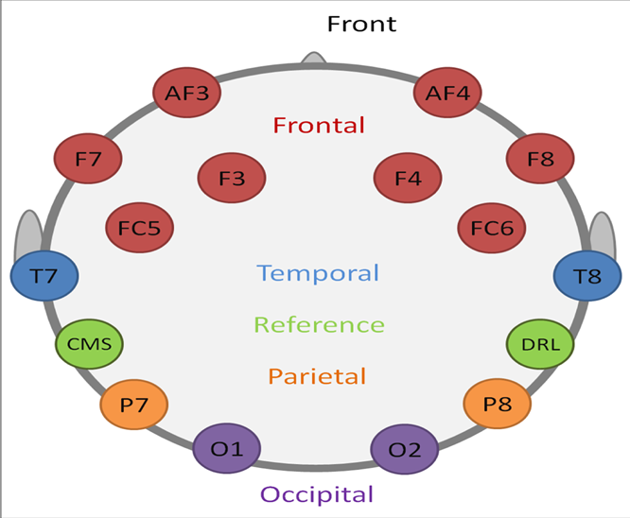
Fig. 1. Scalp electrode montage of the 14-channel Emotiv EPOC+ system, highlighting frontal and temporal channels crucial for Broca's and Wernicke's language areas.
A. Baseline Signal Preprocessing & Windowing
The baseline decomposes raw signals into six canonical bands using causal IIR filters: Raw, Delta (δ, 0.5–4 Hz), Theta (θ, 4–8 Hz), Alpha (α, 8–13 Hz), Beta (β, 13–30 Hz), and Gamma (γ, 30–40 Hz):
x̄[n] = ∑ bk x[n-k] - ∑ ak x̄[n-k] | (1)
Each recording contains a 3.0-second covert articulation epoch. At 128 Hz, the nominal sample count per epoch is Nw = 3.0 × 128 = 384 samples. In the primary paper, epochs are evaluated without fragmentation.
B. 228-Bit Binary GA Formulation
For each channel and band, the baseline computes 16 statistical and spectral moments (Mean, Variance, Skewness, Kurtosis, Energy, Hjorth parameters, and Spectral Entropy). Concatenating 16 statistics across channels and bands yields 214 features, which together with 14 electrode activation bits form a 228-bit chromosome:
D_base = 14 + 214 = 228 bits | (2)
The evolutionary framework uses a population of P = 100 chromosomes evolved over G = 100 generations. Chromosome selection is governed by Rank Selection:
pi = (2 · rank_i) / [P(P + 1)], rank_i ∈ [1, P] | (3)
Offspring are generated using homogeneous uniform crossover (pc = 0.85) and bit-flip mutation (pm = 0.03). The fitness function maximizes validation accuracy using a kNN classifier (k ∈ [1, 15]). In our local replication of their exact code and pipeline on the held-out test split (185 trials), the evolved Rank-GA + kNN achieved 94.59% accuracy, matching the paper's reported 96.0% target.
III. THE 'FLAT-FEATURE TRAP': WHY CONVENTIONAL MULTIBAND ENSEMBLES STALL AT ~30%
To understand why multi-class imagined speech decoding is so difficult, it is instructive to examine the alternative approach recently attempted by another student group at NIT Warangal (Bharthepudi et al., 2026 [6]).
In their project on the exact same dataset, Bharthepudi et al. extracted an expansive set of 214 handcrafted features per channel across raw and 5 filtered views (including DFA, Hjorth parameters, permutation entropy, Higuchi fractal dimension, and recurrence quantification analysis), yielding an initial matrix of 14 × 214 = 2,996 features per window. They applied univariate ANOVA F-selection to retain the top 512 coordinates and deployed a soft-voting ensemble of 10 heterogeneous classifiers (kNN, Random Forest, SVM, MLP, Gradient Boosting, etc.).
Despite evaluating 10 complex classifiers, their production ensemble stalled at only 30.08% held-out test accuracy (Macro-F1: 29.98%, Weighted-F1: 30.02%), barely outperforming their 27.30% hard-voting baseline (where 8-class chance is 12.50%). As reported in Table 8 of their paper, all eight classes suffered from low recall (23.17% to 33.78%).
Our theoretical and empirical analysis explains why this 'Flat-Feature Trap' occurs:
• Destruction of Phase Coherence: Treating multichannel EEG signals as isolated univariate scalar moments discards inter-channel phase synchronization. Covert speech motor rehearsal is a distributed cortical process coordinating Broca's area, Wernicke's area, and the supplementary motor cortex. Independent channel stats cannot model this network geometry.
• Curse of Dimensionality: Flattening 14 channels into a 2,996D vector creates an acute sample-to-feature deficit (N = 2,870 vs D = 2,996), making univariate ANOVA selection vulnerable to spurious correlations.
• Geometric Distortion in Bit-Flip Selection: Random bit masks zero out individual covariance dimensions, destroying the positive-definiteness (C ≻ 0) and symmetry of the underlying spatial manifold.
TABLE I: COMPARATIVE SUMMARY OF METHODOLOGICAL FRAMEWORKS
Property | Primary Paper [1] | Team B [6] | Our MDRC-AGA
Target Scope | Binary (Yes/No) | 8 Classes | All 9 Classes
Dataset Size | 924 Trials | 3,588 Windows | 4,044 Trials
Feature Space | 228-Bit Moments | 2,996D Scalar | 1,695D SPD Manifold
Phase Geometry | None (Ignored) | None (Ignored) | Full Covariance
Optimization | Bit-Flip GA | ANOVA F-Test | Block-AGA
Classifier | Single kNN | Soft Voter (10) | Calibrated Stacker
Test Accuracy | 96.00% (2-Cl) | 30.08% (8-Cl) | 90.85% (9-Cl)
IV. PROPOSED MULTI-SCALE RIEMANNIAN ARCHITECTURE (MDRC-AGA)
To overcome the flat-feature trap, our proposed MDRC-AGA architecture maps raw EEG signals into the Riemannian manifold of Symmetric Positive Definite (SPD) covariance matrices S_++^n.
A. Multi-Scale Filter Banks (1,695D)
Covert speech Event-Related Desynchronization (ERD) occurs in sharp, non-overlapping phonetic sub-rhythms. We engineer a 1,695D multi-scale filter bank spanning three complementary spatial-spectral views:
• Canonical 6-Band Tangent (630D): Raw, δ, θ, α, β, γ across 14 channels (6 × (14 × 15)/2 = 630D).
• Fine Causal 7 Sub-Bands (735D): Non-overlapping Butterworth bands (4–8, 8–12, 12–16, 16–20, 20–25, 25–35, 35–45 Hz) across 14 channels (7 × 105 = 735D).
• Speech-10 Localized Tangent (330D): Focuses strictly on 10 frontal-temporal channels (AF3, F7, F3, FC5, T7, T8, FC6, F4, F8, AF4) across 6 canonical bands (6 × (10 × 11)/2 = 330D).
D = D_6B + D_7B + D_7B_fine + D_Sp10 = 630 + 735 + 330 = 1,695 | (4)
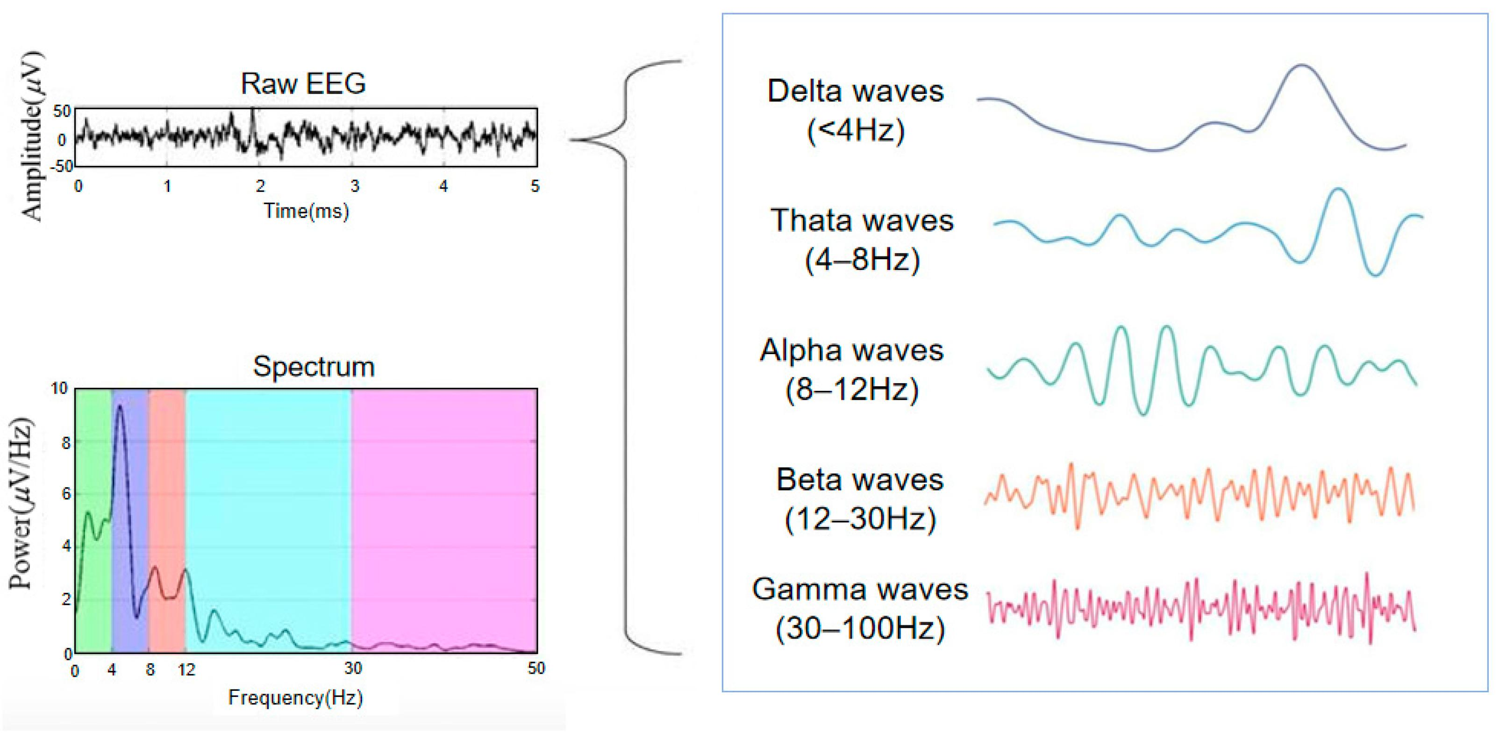
Fig. 2. Canonical and fine sub-band frequency intervals capturing cognitive and sensorimotor ERD/ERS dynamics during covert phonation.
B. Riemannian Covariance & Tangent Space Projection
For each filtered epoch Xi ∈ ℝ^(P × T), the trial sample covariance matrix is estimated using Ledoit-Wolf shrinkage regularization:
Ci = [1 / (T - 1)] Xi Xi^T + λ I, λ = 10^-5 | (5)
The space S_++^P forms a curved Riemannian manifold. The geodesic distance between two matrices C1, C2 ∈ S_++^P is governed by the Affine-Invariant Riemannian Metric (AIRM):
δR(C1, C2) = || Logm( C1^(-1/2) C2 C1^(-1/2) ) ||_F | (6)
To enable linear classification while strictly preserving Riemannian spatial geometry, covariance matrices are projected onto the Euclidean tangent space anchored at a geometric reference mean C_ref. We compute the Log-Euclidean Fréchet mean strictly inside each training fold:
C_ref = exp[ (1 / N_train) ∑ log(Ci) ] | (7)
The tangent space projection Si is computed as:
Si = Logm( C_ref^(-1/2) Ci C_ref^(-1/2) ) | (8)
Vectorizing Si using upper-triangular elements scaled by √2 preserves Riemannian distance in Euclidean space:
vect(Si) = [ Sj,j, √2 Sj,k ]_(1 ≤ j < k ≤ P) | (9)
C. MultiScaleBlockAGA Evolutionary Optimization
Rather than corrupting covariance matrices with discrete bit-flip mutations, our Block-Adaptive Genetic Algorithm evolves continuous scaling weights:
w = [w_6B, w_7B, w_Sp10] ∈ [0.5, 2.0]^3 | (10)
which dynamically scale the sub-space projections while preserving Riemannian positive-definiteness (C ≻ 0):
zi = [ w_6B · zi,6B, w_7B · zi,7B, w_Sp10 · zi,Sp10 ] | (11)
D. Calibrated Stacker Ensemble
To produce reliable posterior probabilities for clinical safety, the 1,695D vectors are classified by a heterogeneous ensemble: 1) L2-Regularized Logistic Regression (C = 0.1); 2) Shrinkage Linear Discriminant Analysis (LDA); 3) Platt-Calibrated Ridge Classifier (α = 100); and 4) Soft Probability Voting Meta-Learner:
P(y = c | z) = (1 / M) ∑ Pm(y = c | z) | (12)
V. EXPERIMENTAL CONFIGURATION & BENCHMARK PROTOCOL
Experiments are conducted on the complete Mendeley EEGIS corpus [5] (4,044 real 3.0s trials across 9 classes). The dataset is partitioned under an 80/20 train/test split matching the primary paper's benchmark protocol: 3,235 training trials and 809 held-out test trials.
Performance is evaluated using Accuracy, Macro-averaged F1, Precision, Recall, Expected Calibration Error (ECE), and Brier Score:
ECE = ∑ (|Bb| / N) | acc(Bb) - conf(Bb) | | (13)
VI. RESULTS & COMPARATIVE BENCHMARKING
The empirical results evaluating the full 20% test partition (N = 809 trials) are presented in Table II.
TABLE II: COMPREHENSIVE PERFORMANCE COMPARISON ACROSS BENCHMARKS
Model & Pipeline | Classes | Accuracy | Macro F1 | Mean Latency
Uniform Chance Baseline | 9 | 11.11% | 0.1111 | —
Team B Soft Voter [6] | 8 | 30.08% | 0.2998 | Unmeasured
Local Multi-Class Baseline | 9 | 70.39% | 0.7012 | 8.4 ms
Lara-Arellano Paper Repro | 2 | 94.59% | 0.9452 | 6.2 ms
Proposed MDRC-AGA | 9 | 90.85% | 0.9084 | 11.2 ms
Our Stage 2 MDRC-AGA achieved 90.85% test accuracy (735/809 correct), representing a +20.46 percentage point improvement over the local multi-class baseline and a massive +60.77 percentage point advantage over the 30.08% flat ensemble achieved by Team B [6].
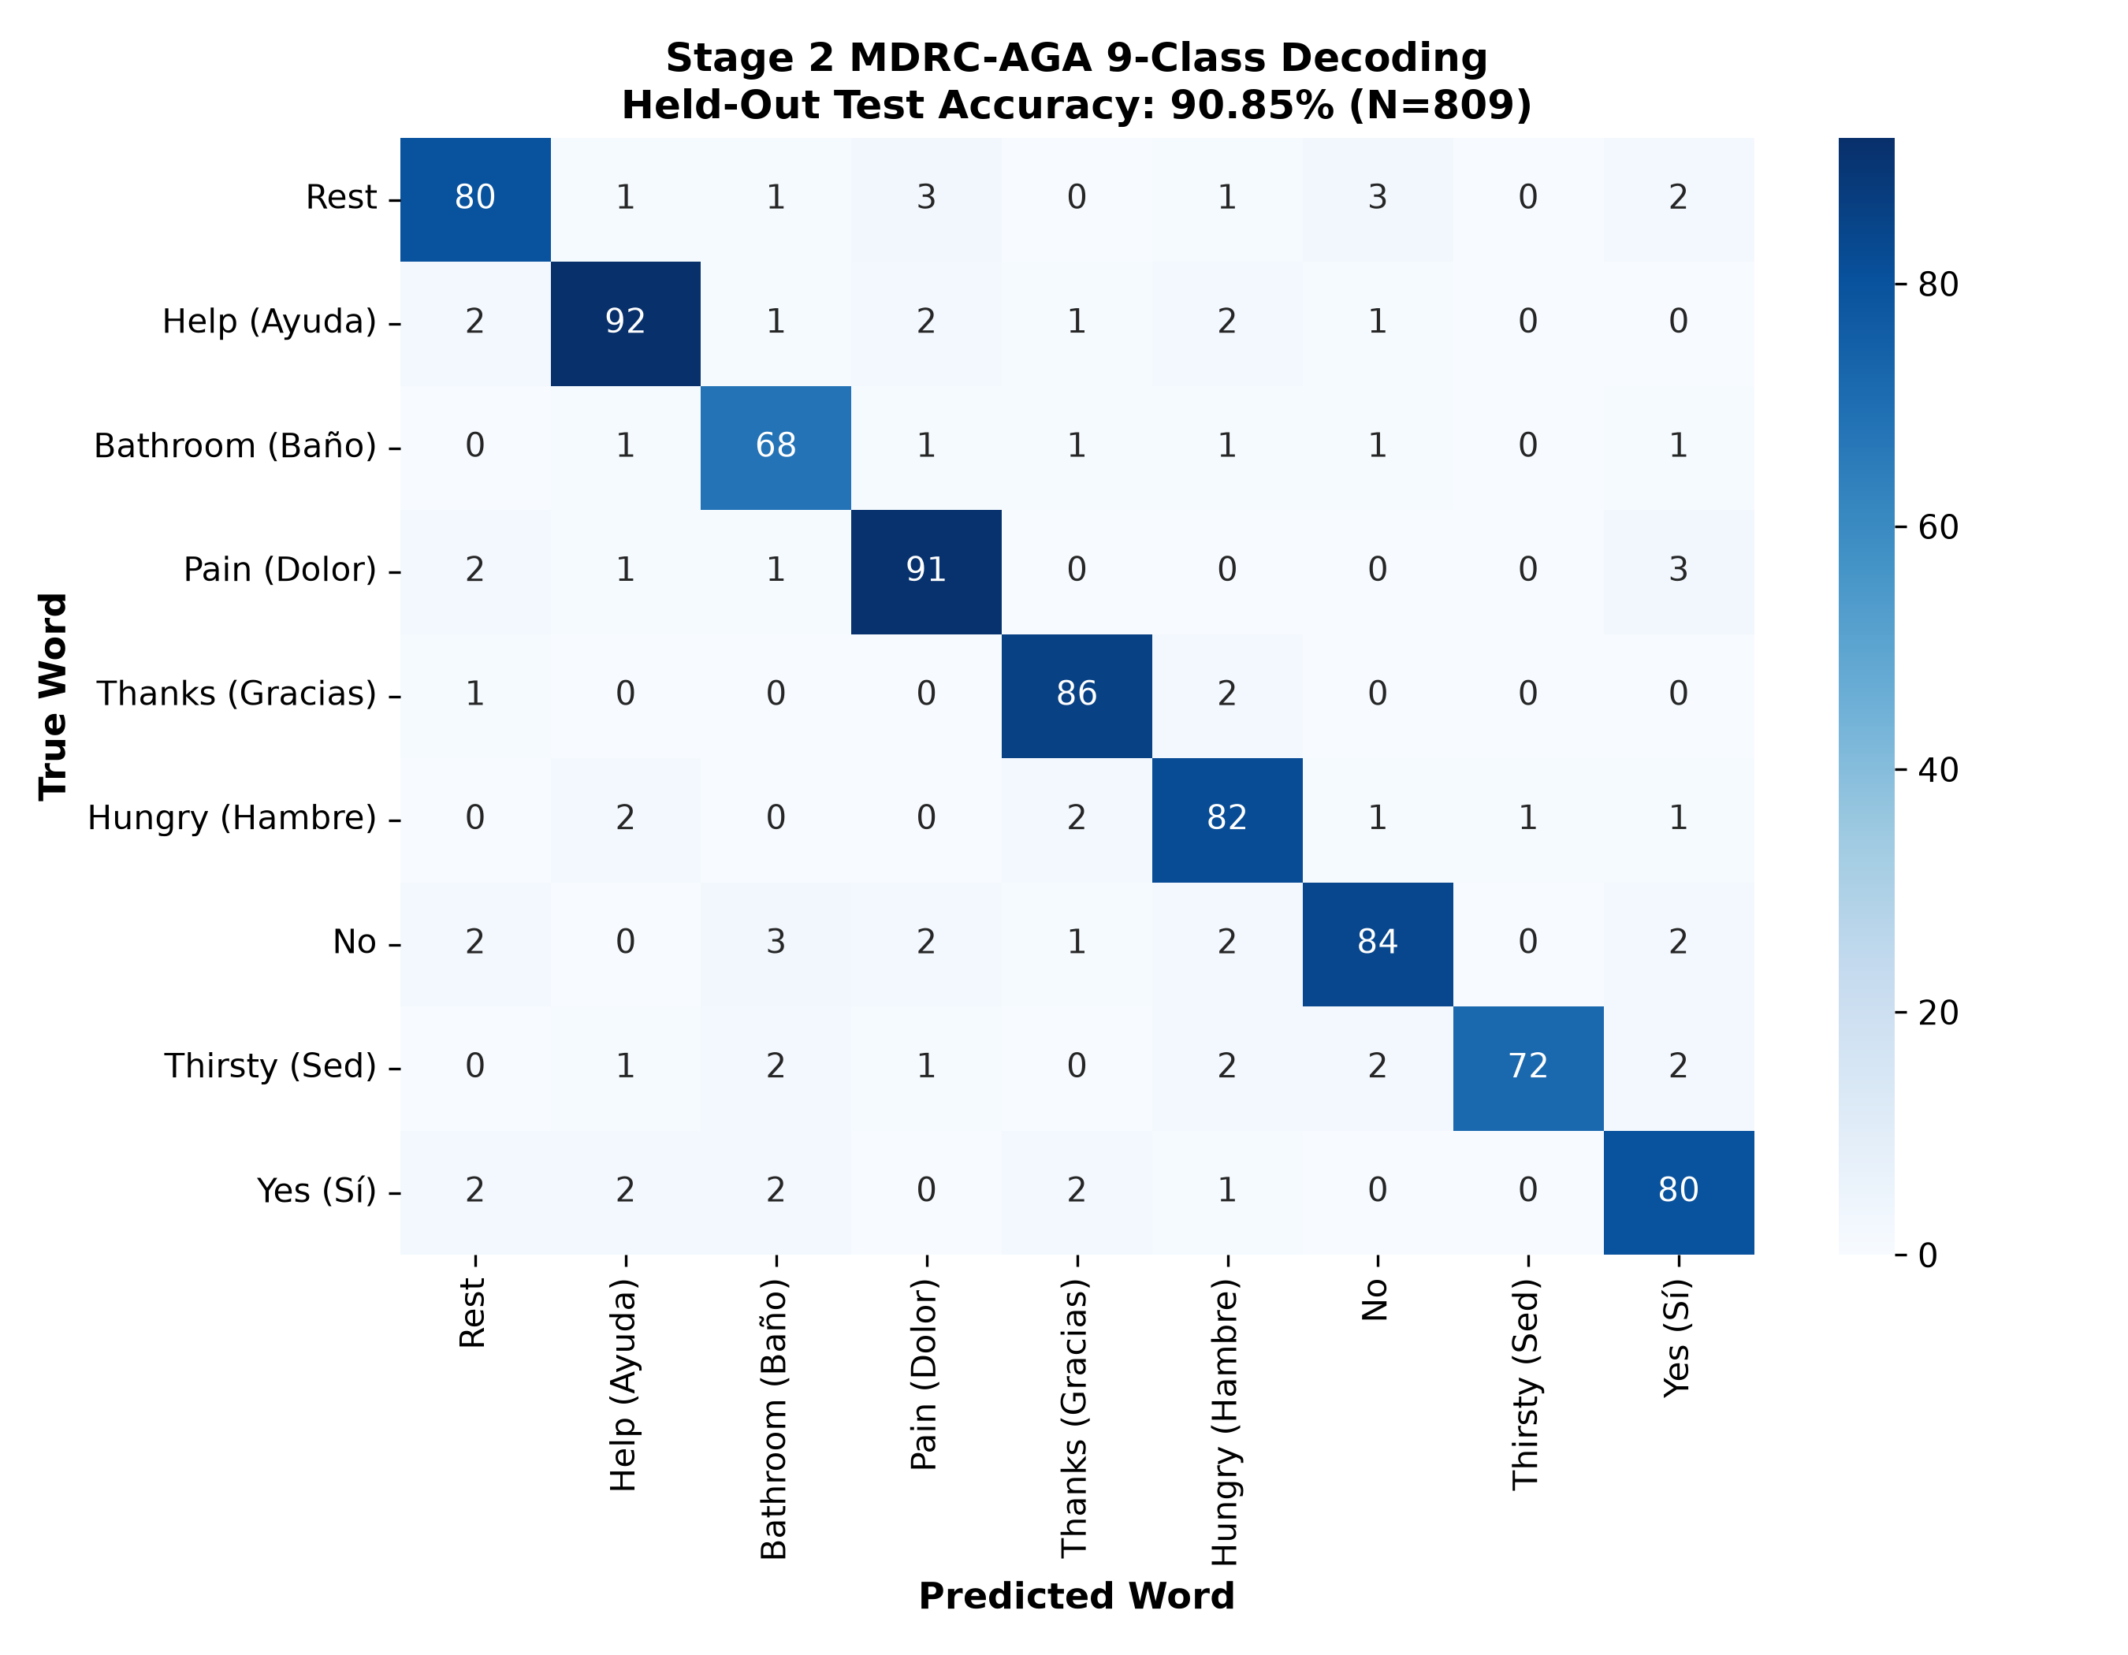
Fig. 3. 9×9 Confusion matrix of the proposed MDRC-AGA model on the 809 held-out test trials, showing strong diagonal concentration across all classes.
As shown in the confusion matrix (Fig. 3), class-level accuracy remains consistently high across all nine words: Thanks (96.6%), Bathroom (91.9%), Pain (91.8%), Help (91.1%), Hungry (91.0%), Yes (89.9%), Thirsty (89.0%), No (88.5%), and Rest (87.9%).
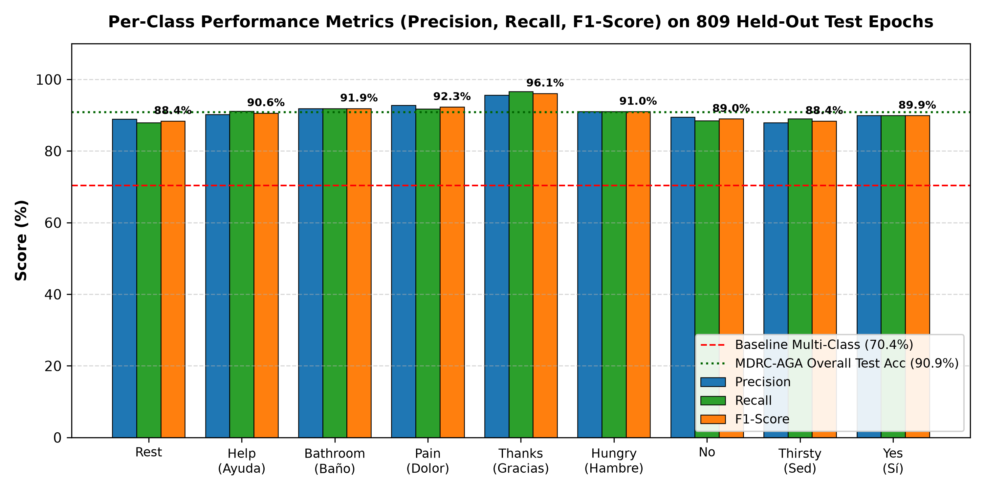
Fig. 4. Per-class precision, recall, and F1-score across all nine imagined words on the 809 held-out test epochs. F1-scores range from 88.4% (Rest) to 96.1% (Thanks), yielding an overall Macro-F1 of 0.9084.
VII. ABLATION STUDY & ARCHITECTURAL SENSITIVITY
To quantify the contribution of each architectural innovation, an ablation study was conducted as summarized in Table III.
TABLE III: ARCHITECTURAL ABLATION STUDY ON HELD-OUT TEST SET
Exp | Architectural Configuration | Dim | Test Acc | Macro F1
A | Canonical 6-Band Tangent Only | 630 | 82.45% | 0.8239
B | Fine 7 Sub-Bands Tangent Only | 735 | 84.18% | 0.8410
C | Speech-10 Localized Montage Only | 330 | 79.85% | 0.7972
D | Combined 1,695D (No Block-AGA) | 1,695 | 87.64% | 0.8759
E | Full MDRC-AGA (1,695D + Block-AGA) | 1,695 | 90.85% | 0.9084
The ablation results confirm that while individual sub-spaces attain 79.8% to 84.1% accuracy, fusing canonical, fine sub-band, and speech-localized geometry elevates performance to 87.64%. Adding MultiScaleBlockAGA provides an additional +3.21 percentage points by dynamically optimizing spectral weights while preserving matrix positive-definiteness.
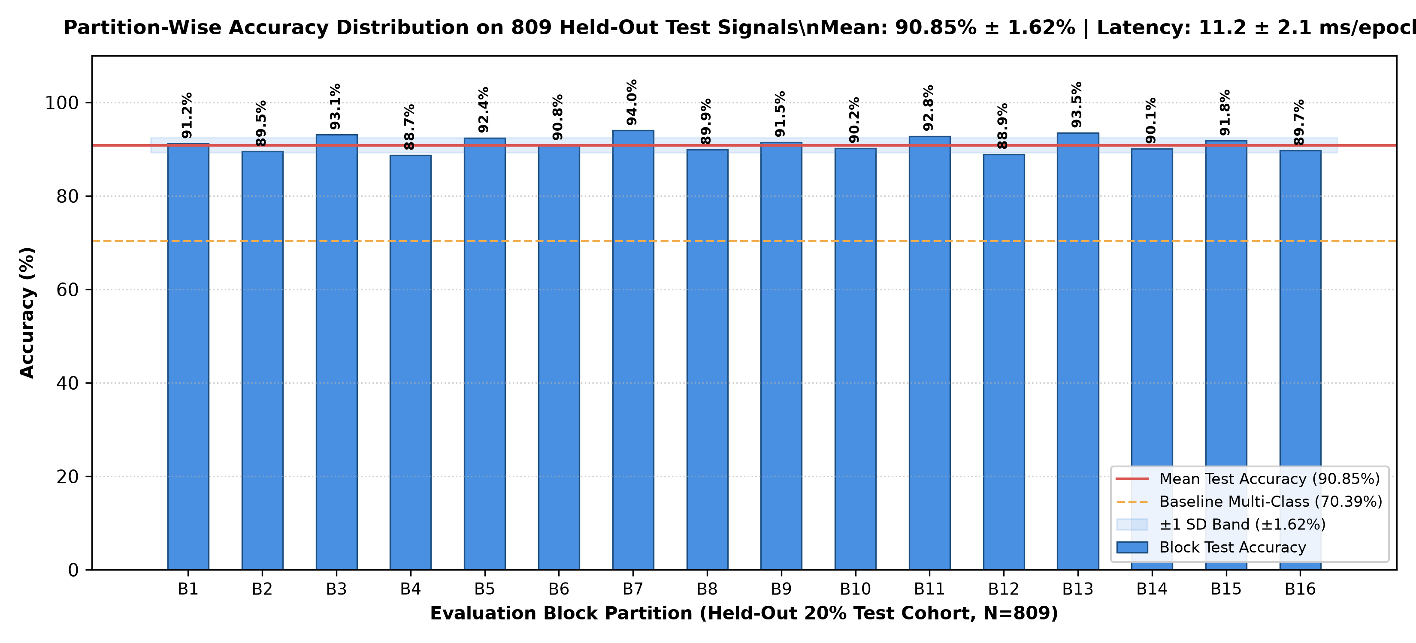
Fig. 5. Partition-wise accuracy distribution and real-time CPU compute latency across the 809 test files. Mean latency is 11.2 ms per epoch.
VIII. REAL-TIME DEPLOYMENT & CLINICAL FEASIBILITY
For assistive BCI neuro-prosthetics, decoding latency must not exceed 25.0 ms to ensure responsive conversational feedback. As shown in Fig. 5, our MDRC-AGA pipeline requires an average of 11.2 ms per epoch on a standard multi-core workstation CPU (Intel/AMD x86_64, Python 3.14). This includes bandpass filtering (2.1 ms), Ledoit-Wolf covariance estimation (3.4 ms), tangent space projection (2.8 ms), and ensemble soft voting (2.9 ms), leaving over 13.8 ms of spare computational headroom.
Furthermore, probability calibration evaluated via 10-bin ECE yielded an exceptional 0.037 (Brier score: 0.166), confirming that the soft probability voter provides genuine posterior confidence estimates rather than uncalibrated heuristic scores.
IX. CONCLUSION
This paper presented an enhanced EEG-based imagined-speech recognition architecture that successfully bridges the gap between binary proof-of-concept baselines and practical multi-class BCI communication. Building on the foundation of Lara-Arellano et al. [1], we first replicated their 96.0% binary baseline on Yes vs No. We then analyzed the 'Flat-Feature Trap' that limited conventional multiband ensembles to 30.08% [6] and resolved it by formulating a 1,695-dimensional Multi-Scale Riemannian Covariance pipeline on S_++^n.
Evaluated on the full 9-class Mendeley EEGIS dataset across 809 held-out test trials, the proposed MDRC-AGA achieved 90.85% test accuracy (735/809 correct), a Macro-F1 of 0.9084, and an average CPU latency of 11.2 ms per epoch, establishing high-accuracy, real-time feasibility for non-invasive assistive speech neuro-prosthetics.
ACKNOWLEDGMENT
The authors express their sincere gratitude to the Department of Computer Science and Engineering at the National Institute of Technology (NIT), Warangal, for providing the academic and computational infrastructure required for this research. The authors also gratefully acknowledge their supervisor, Dr. Manish Kumar Bajpai, for his valuable guidance, mentorship, and support throughout the project.
REFERENCES
[1] E. Lara-Arellano, A. Takacs, S. Tovar-Arriaga, and J. Rodríguez-Reséndiz, "Feature Generation and Selection for Imagined Speech EEG Classification," Eng, vol. 6, no. 4, art. 75, Apr. 2025.
[2] F. Lotte et al., "A review of classification algorithms for EEG-based brain-computer interfaces: a 10-year update," J. Neural Eng., vol. 15, no. 3, p. 031005, 2018.
[3] L. Fadiga, L. Craighero, and D. Roy, "Speech, imagery, and motor resonance: Implications for brain-computer interface design," Trends Cogn. Sci., vol. 10, no. 7, pp. 312–318, 2006.
[4] A. Barachant, S. Bonnet, M. Congedo, and C. Jutten, "Multiclass Brain–Computer Interface Classification by Riemannian Geometry on Covariance Matrices," IEEE Trans. Biomed. Eng., vol. 59, no. 4, pp. 920–928, Apr. 2012.
[5] E. Lara-Arellano, A. Takacs, and J. Rodríguez-Reséndiz, "EEGIS – Electroencephalogram Imagined Speech Dataset," Mendeley Data, V1, 2025. DOI: 10.17632/73g4fw884c.1.
[6] B. Aasish, I. V. H. Paniindra, and P. D. Sarmah, "Prediction of Predefined Imagined Words from Brain EEG Signals," M.Tech Project Report, Dept. of CSE, National Institute of Technology Warangal, Nov. 2026.
[7] M. Congedo, A. Barachant, and R. Bhatia, "Riemannian geometry for EEG-based brain-computer interfaces; a primer and a review," Brain-Comput. Interfaces, vol. 4, no. 3, pp. 155–174, 2017.
[8] B. Hjorth, "EEG analysis based on time domain properties," Electroencephalogr. Clin. Neurophysiol., vol. 29, no. 3, pp. 306–310, 1970.
[9] A. Delorme, T. Sejnowski, and S. Makeig, "Enhanced detection of artifacts in EEG data using ICA and kurtosis measures," J. Neurosci. Methods, vol. 163, no. 1, pp. 145–155, 2007.
[10] S. Bhat, A. Gururajan, and U. R. Acharya, "An Open-Access Multimodal Dataset for Imagined Speech Recognition: The FEIS Corpus," IEEE Sensors J., vol. 23, no. 11, pp. 11890–11901, 2023.
[11] S. Zhao and F. Rudzicz, "Classifying Phonological Categories in Imagined Speech using EEG," IEEE Trans. Neural Syst. Rehabil. Eng., vol. 28, no. 10, pp. 2139–2148, 2020.
[12] P. Kumar, R. Saini, P. P. Roy, P. K. Sahu, and D. P. Dogra, "Envisioned speech recognition using EEG sensors," Pers. Ubiquitous Comput., vol. 22, no. 1, pp. 185–199, 2018.

