1.What are the two values of the Boolean data type? How do you write them?

Ans: The two values of the Boolean data type are “TRUE” and “FALSE”. We can write them as True and False.

2. What are the three different types of Boolean operators?

Ans: AND, OR, NOT

3. Make a list of each Boolean operator's truth tables (i.e., every possible combination of Boolean values for the operator and what it evaluates.)

**OR**

**NOT**

**AND**

|  |  |  |
| --- | --- | --- |
| A | B | OUTPUT |
| True | False | **False** |
| False | True | **False** |
| False | False | **False** |
| True | True | **True** |

|  |  |  |
| --- | --- | --- |
| A | B | OUTPUT |
| True | False | **True** |
| False | True | **True** |
| False | False | **False** |
| True | True | **True** |

|  |  |
| --- | --- |
| INPUT | OUTPUT |
| True | **False** |
| False | **True** |

4. What are the values of the following expressions?

(i) (5 > 4) and (3 == 5)

(ii) not (5 > 4)

(iii) (5 > 4) or (3 == 5)

(iv) not ((5 > 4) or (3 == 5))

(v) (True and True) and (True == False)

(vi) (not False) or (not True)

Ans: (i) False (ii) False (iii) True (iv) False (v) False (vi) True

5. What are the six comparison operators?

Ans: (i) < (ii) > (iii) == (iv) != (v) >= (vi) <=

6. How do you tell the difference between the equal to and assignment operators? Describe a condition and when you would use one.

Ans: equal to (==) operator is used for comparison between two values or variable that values are equal or not whereas assignment operator (=) is use to assign the value in a variable.

If I have to compare the values, we have to use equal to operator (==) and if I have to assign the value in a variable then we have to use assignment operator (=)

7. Identify the three blocks in this code:

spam = 0

if spam == 10:

print('eggs')

if spam > 5:

print('bacon')

else:

print('ham')

print('spam')

print('spam')

**Ans:**

spam = 0

if spam == 10:

print('eggs')

if spam > 5:

print('bacon')

else:

print('ham')

print('spam')

print('spam')

8. Write code that prints Hello if 1 is stored in spam, prints Howdy if 2 is stored in spam, and prints Greetings! if anything else is stored in spam.

spam = int (input ("enter the number "))

if spam == 1:

print("Hello")

elif spam == 2:

print("Howdy")

else:

print("greetings")

9.If your programme is stuck in an endless loop, what keys you’ll press?

Ans: ctrl + c

10. How can you tell the difference between break and continue?

Ans: The break keyword is used to break out a for loop, or a while loop.

Whereas the continue keyword is used to end the current iteration in a for loop (or a while loop), and continues to the next iteration.

11. In a for loop, what is the difference between range (10), range (0, 10), and range (0, 10, 1)?

range(10) gives the output up to 10 excluding 10

range(0, 10) gives the output 0 to 10 excluding 10

range(0, 10,1) the range between 0 and 10 with steps of 1.

12. Write a short program that prints the numbers 1 to 10 using a for loop. Then write an equivalent program that prints the numbers 1 to 10 using a while loop.

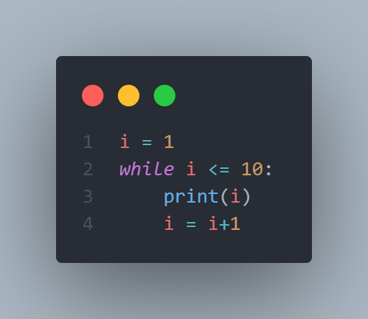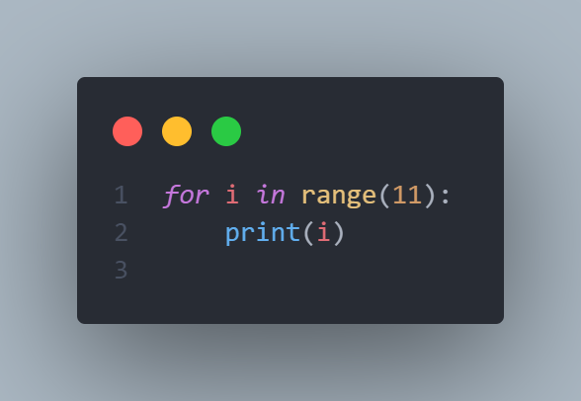

13. If you had a function named bacon() inside a module named spam, how would you call it after importing spam?

Ans: import spam  
 spam.bacon()