Source-aware machine learning for stabilized expansive soils: transfer validation, decision screening and carbon-efficient mixture ranking
Author details to be inserted

Highlights
Duplicate-safe external data compilation showed that 560 Zenodo UCS/CBR rows were already present, while 35 Data.gov.in soil-health records added regional context rather than new mechanical test rows.
- A real-only literature dataset was curated for stabilized-soil UCS and CBR screening.
- Grouped-source validation quantified transfer loss across independent experimental sources.
- Model configuration, thresholds and uncertainty were reported for reproducibility.
- Synthetic augmentation gave limited CBR gains and was restricted to training folds.
- Carbon-aware Pareto screening produced practical shortlists for laboratory verification.

Abstract
Machine-learning models can assist stabilized-soil mixture selection, but their usefulness depends on transferability across independent soil sources and laboratory programmes. This study develops a source-aware framework using a curated real experimental dataset containing 1,728 unconfined compressive strength (UCS) records and 485 California bearing ratio (CBR) records. The workflow includes traceability screening, feature-availability assessment, internal and grouped-source validation, threshold sensitivity, model-configuration reporting, fold-level uncertainty, regression benchmarking, feature-importance analysis, training-only synthetic augmentation, source-wise ranking and carbon-aware Pareto screening. Internal validation produced high binary classification performance, but grouped-source validation was substantially weaker, showing that random splitting overestimates transferability for heterogeneous literature data. Continuous regression remained weak under grouped-source testing, particularly for UCS, supporting the shift toward classification and ranking. Synthetic augmentation modestly improved selected CBR screening metrics but did not create a universal prediction model. The most defensible use of the dataset is therefore preliminary mixture classification, prioritisation and carbon-efficient screening before local laboratory confirmation.
Keywords: expansive soil; stabilized soil; machine learning; source-grouped validation; CBR; UCS; carbon efficiency; synthetic augmentation

1. Introduction
Expansive fine-grained soils are problematic in transportation infrastructure because moisture fluctuations can cause swelling, shrinkage, cracking and loss of support. Stabilization with lime, cement, fly ash, slag, rice husk ash, pond ash, alkali-activated binders and fibres has been widely investigated for improving subgrade and subbase performance (Katti 1978; Phani Kumar and Sharma 2004; Chauhan and Rajesh 2015; Dixit et al. 2016; Tiwari et al. 2016; Deshpande and Puranik 2017; Dixit 2017; Patil et al. 2018; Indiramma et al. 2020; Sharma and Kumar 2020; Ahmad et al. 2024; Parihar and Gupta 2024).
The improvement mechanisms are well established in principle but variable in magnitude. Calcium-rich binders can induce cation exchange, flocculation, pozzolanic reaction and cementitious bonding. Fly ash and other aluminosilicate materials can contribute to secondary reaction products when calcium or alkaline activators are available (Luhar and Luhar 2022; Wang et al. 2023; Nanda and Priya 2024; Yang et al. 2025). Fibres can improve ductility and residual strength by bridging cracks and restraining tensile deformation (Rao et al. 2023; Navagire et al. 2025). However, response depends on soil mineralogy, plasticity, gradation, compaction condition, additive chemistry, fibre geometry, curing age and testing method.
Machine learning has increasingly been used to model UCS, CBR, compaction and swelling behaviour in improved soils (Eyo and Onyekpe 2021; Eyo et al. 2022; Saad et al. 2023; Almuaythir et al. 2025; Huang et al. 2025; Thapa and Ghani 2024; Zeini et al. 2023). Many studies report high accuracy, but most use internal splits. When records from the same source appear in both training and testing subsets, the resulting accuracy can partly reflect interpolation within one experimental programme rather than transfer to a new source. Recent data-driven geotechnics discussions have therefore emphasised the need for better databases, transparent validation and open workflows (Ge et al. 2024; Li et al. 2025; Zong et al. 2025).

2. Research Positioning and Gap
The related literature considered here covers conventional black cotton soil treatment, fibre-reinforced stabilisation, alkali-activated binders, waste-derived stabilisers, CBR/UCS modelling, data augmentation and explainable ML. Experimental and review studies provide the stabilisation basis (Chauhan and Rajesh 2015; Degirmenci et al. 2007; Deshpande and Puranik 2017; Dixit et al. 2016; Dixit 2017; Indiramma et al. 2020; Jayashree and Roja 2019; Mai-Bade et al. 2021; Fentaw et al. 2021; Patil et al. 2018; Rokade et al. 2017; Sajad and Singh 2022; Fondjo et al. 2021; Shukla and Sharma 2025; Gautam and Patel 2025). Recent ML studies and data-driven reviews provide the methodological background (Almuaythir et al. 2025; Luo et al. 2025; Goutham and Krishnaiah 2024; Thapa and Ghani 2024; Zeini et al. 2023; Yang et al. 2025; Moghaddas and Bao 2025; Zong et al. 2025). The present work differs by testing source-wise transfer explicitly and by treating synthetic data only as training-stage augmentation rather than as experimental evidence (Barrera-Animas and Delgado 2023; Ge et al. 2024; Li et al. 2025).
This study was designed around the limitation above. It does not attempt to present another high-accuracy black-box regression model. Instead, it asks which engineering decisions can be supported by heterogeneous literature data when independent-source transfer is evaluated explicitly. Table 1 summarises how the present work is positioned relative to the literature.
The specific gap is threefold. First, literature-derived stabilized-soil datasets need source-aware validation because independent studies differ in materials and methods. Second, threshold-based classification requires justification because strength thresholds can appear arbitrary if class balance is not examined. Third, carbon-aware mixture screening needs to be connected to model outputs rather than added as a disconnected sustainability statement. The present framework addresses these points through grouped-source validation, threshold sensitivity, regression benchmarking, ranking and Pareto screening.
Table 1. Literature positioning and how each theme is used in the present study.
Theme | Representative literature | Use in this study
Stabilization mechanisms | Fly ash, lime, cementitious binders, fibres, alkali-activated binders | Explains expected variables and physical controls
ML prediction studies | UCS, CBR, swelling, compaction, XAI and physics-informed models | Shows why high random-split accuracy alone is not sufficient
Data augmentation | GAN, ACGAN, physics/domain constrained synthetic samples | Supports training-only sensitivity analysis
Sustainability screening | Carbon cost, binder intensity, Pareto ranking | Supports performance-carbon mixture screening

3. Data and Methods

3.1 Dataset Curation and Source Structure
The dataset was assembled from traceable published and open data sources. Records were retained only when the target value, source identity and essential mixture variables could be interpreted. Records with unresolved units, physically implausible values or uncertain target definitions were excluded. Standard geotechnical terminology and testing concepts follow relevant soil and pavement testing references where applicable (Bureau of Indian Standards 1970, 2016; ASTM D638 2014; Indian Roads Congress 2012).
Table 2 gives the source inventory and code key used in the figures. Figure 1 shows the complete workflow. Figure 2 shows that data are unevenly distributed by source, and Figure 3 shows that feature reporting is incomplete and source dependent. These two figures were redesigned with source codes to avoid hidden text and to make the dataset structure legible.
Table 2. Source inventory and source-code key for the real experimental dataset.
Code | Source | Domain | Rows | UCS | CBR | Variables
S1 | Luo et al. (2025) open GitHub UCS benchmark | geopolymer_ash_cementitious | 702 | 702 | 0 | 12 of 41
S2 | Scientific Reports supplementary table - HARHA-treated expansive soil CBR | mixed_stabilized_soil | 242 | 0 | 242 | 7 of 41
S3 | Mendeley 55v6f5yb89 - ASM geopolymer activator soil stabilization | alkali_activated_geopolymer | 208 | 208 | 0 | 5 of 41
S4 | Taffese and Abegaz 2022 Buildings supplementary Table S1 | cement_lime | 187 | 187 | 0 | 10 of 41
S5 | Figshare_28553693_Teodoru_OwusuYeboah_2025 | cement_lime | 185 | 185 | 0 | 14 of 41
S6 | Zenodo_19242690_Biopolymer_UCS_CBR_2026 | biopolymer_multi_additive | 108 | 36 | 72 | 16 of 41
S7 | Kafle and Baghbani 2025 WTS stabilisation | mixed_stabilized_soil | 80 | 0 | 80 | 5 of 41
S8 | Zenodo_19242690_Biopolymer_UCS_CBR_2026 | biopolymer_multi_additive | 72 | 72 | 0 | 16 of 41
S9 | Zenodo_19242690_Biopolymer_UCS_CBR_2026 | biopolymer_multi_additive | 60 | 60 | 0 | 16 of 41
S10 | DataGouv_10.57745_L6EIIT_CastanedaLopez_2025 | cement_lime | 49 | 49 | 0 | 9 of 41
S11 | Zenodo_19242690_Biopolymer_UCS_CBR_2026 | biopolymer_multi_additive | 40 | 30 | 10 | 16 of 41
S12 | Zenodo_19242690_Biopolymer_UCS_CBR_2026 | biopolymer_multi_additive | 36 | 24 | 12 | 16 of 41
S13 | Zenodo_19242690_Biopolymer_UCS_CBR_2026 | biopolymer_multi_additive | 33 | 13 | 20 | 16 of 41
S14 | Zenodo_19242690_Biopolymer_UCS_CBR_2026 | biopolymer_multi_additive | 30 | 15 | 15 | 16 of 41
S15 | Zenodo_19242690_Biopolymer_UCS_CBR_2026 | biopolymer_multi_additive | 30 | 20 | 10 | 16 of 41
S16 | Zenodo_19242690_Biopolymer_UCS_CBR_2026 | biopolymer_multi_additive | 28 | 28 | 0 | 16 of 41
S17 | Zenodo_19242690_Biopolymer_UCS_CBR_2026 | biopolymer_multi_additive | 20 | 11 | 9 | 16 of 41
S18 | Zenodo_19242690_Biopolymer_UCS_CBR_2026 | biopolymer_multi_additive | 18 | 18 | 0 | 16 of 41
S19 | Zenodo_19242690_Biopolymer_UCS_CBR_2026 | biopolymer_multi_additive | 16 | 8 | 8 | 16 of 41
S20 | Zenodo_19242690_Biopolymer_UCS_CBR_2026 | biopolymer_multi_additive | 15 | 10 | 5 | 16 of 41
S21 | Zenodo_19242690_Biopolymer_UCS_CBR_2026 | biopolymer_multi_additive | 14 | 14 | 0 | 16 of 41
S22 | Zenodo_19242690_Biopolymer_UCS_CBR_2026 | biopolymer_multi_additive | 10 | 10 | 0 | 16 of 41
S23 | Zenodo_19242690_Biopolymer_UCS_CBR_2026 | biopolymer_multi_additive | 9 | 9 | 0 | 16 of 41
S24 | Zenodo_19242690_Biopolymer_UCS_CBR_2026 | biopolymer_multi_additive | 8 | 8 | 0 | 16 of 41
S25 | Zenodo_19242690_Biopolymer_UCS_CBR_2026 | biopolymer_multi_additive | 7 | 7 | 0 | 16 of 41
S26 | Zenodo_19242690_Biopolymer_UCS_CBR_2026 | biopolymer_multi_additive | 4 | 4 | 0 | 16 of 41
S27 | Zenodo_19242690_Biopolymer_UCS_CBR_2026 | biopolymer_multi_additive | 2 | 0 | 2 | 16 of 41

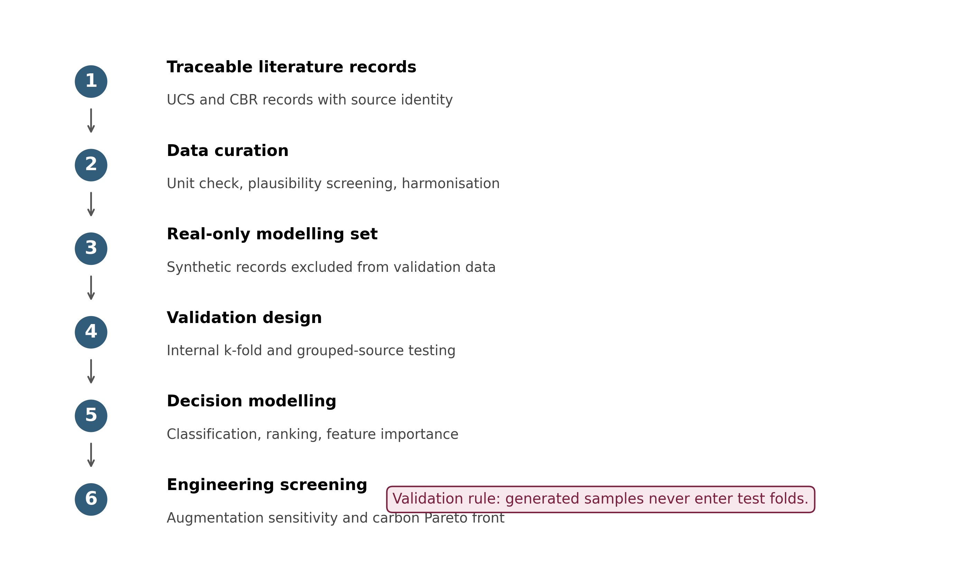
Figure 1. Methodological workflow for source-aware stabilized-soil decision modelling.
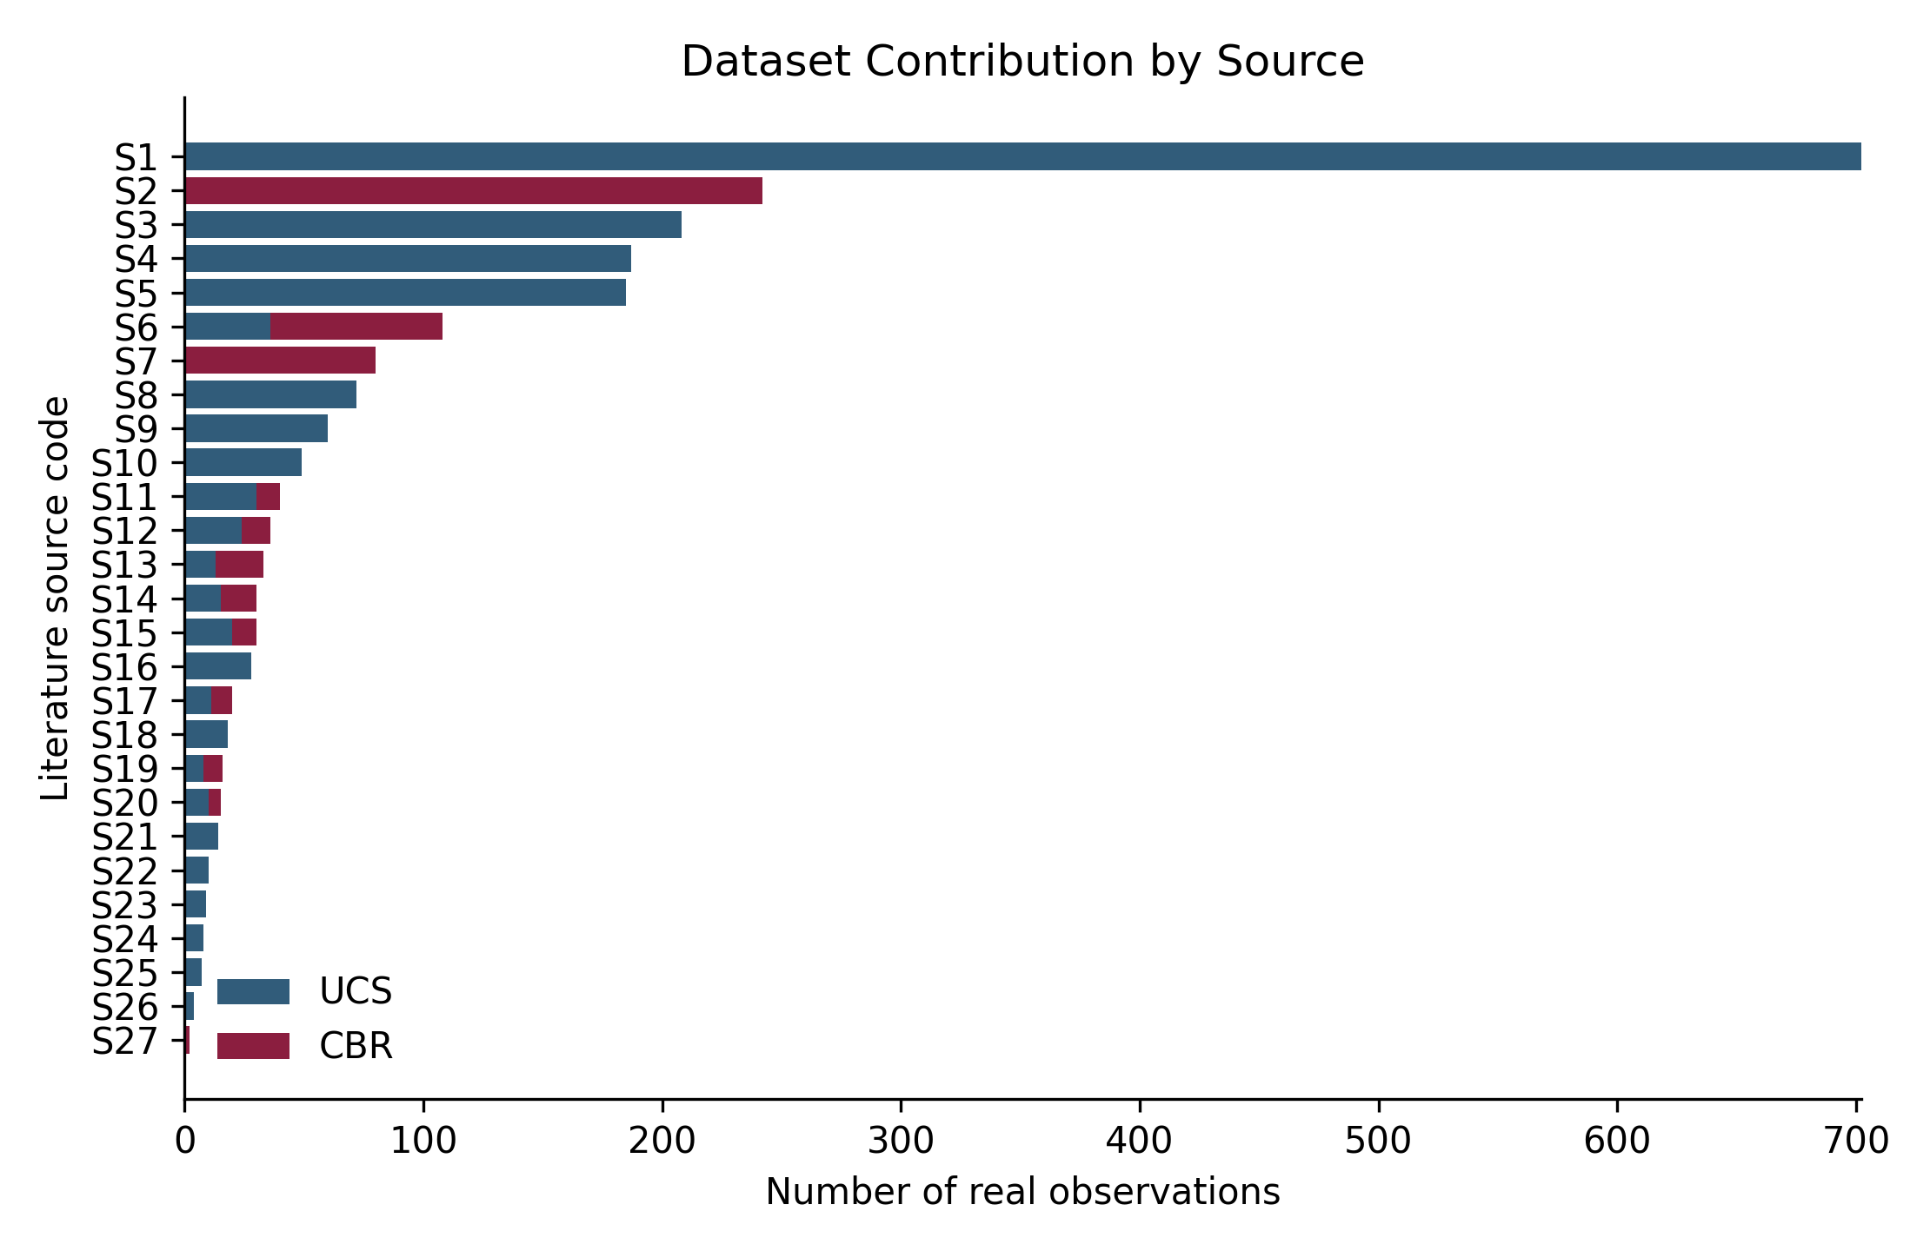
Figure 2. Real UCS and CBR observations contributed by each source code in Table 2.
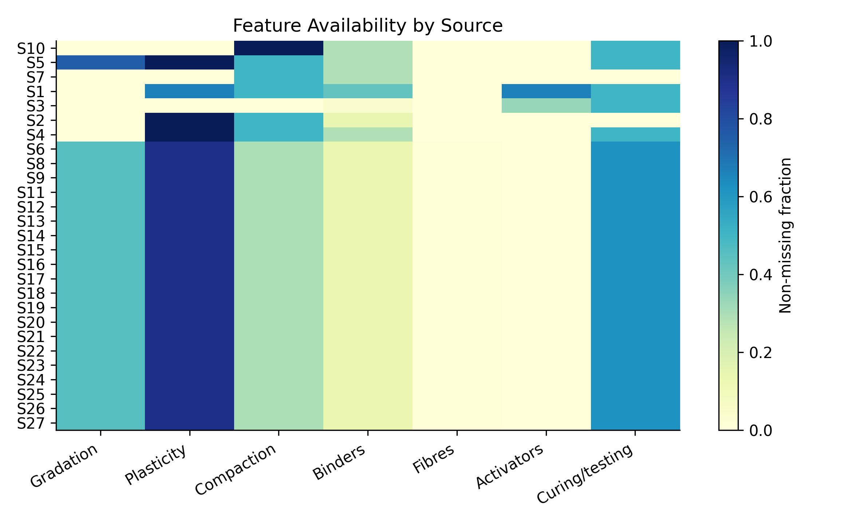
Figure 3. Feature-group availability by source code; values indicate the non-missing fraction.

3.1.1 External Data Redownload and Duplicate-Safe Compilation
An additional external-data acquisition pass was conducted before the final analysis. The audit targeted Zenodo, Data.gov.in, NGDR, GSI Bhukosh, ISRO Bhuvan, SLUSI and CRRI. Only sources containing real tabular records were allowed to influence modelling. The Zenodo record 10.5281/zenodo.19242690 provided a journal-ready workbook with 397 UCS rows and 163 CBR rows; however, duplicate-safe comparison showed that all 560 mechanical rows were already present in the master compiled dataset. These records were therefore retained as provenance-confirming data rather than appended again. Data.gov.in Soil Health Card records were recovered through the resource UUID API using offset-based pagination, producing 35 State/UT-level rows with organic-carbon, nitrogen, phosphorus, potassium and micronutrient status. Because these are regional agricultural soil-health indicators rather than specimen-level stabilization tests, they were added only as contextual descriptors for rows whose soil-location text could be matched to a State/UT. NGDR, Bhukosh, Bhuvan, SLUSI and CRRI were retained as metadata and future data-acquisition pathways because no direct bulk UCS or CBR laboratory tables were exposed during automated access.
After compilation, the modelling table still contained 2213 mechanical observations, including the previously incorporated 560 Zenodo rows. The newly available Data.gov.in context matched 178 mechanical records by location text. The final rerun therefore tested two feature settings: the original base predictors and the base predictors plus Data.gov.in regional soil-health context. This design prevents duplicate inflation of sample size and allows the contextual value of public soil-health records to be assessed separately from mechanical laboratory evidence.

3.2 Model Inputs, Preprocessing and Algorithms
The input variables included source/domain descriptors, soil class, gradation, Atterberg limits, specific gravity, optimum moisture content, maximum dry density, water content, dry density, binder dosages, fibre dosages, activator dosages, curing days and CBR condition where available. Numerical variables were median-imputed and robust-scaled. Categorical variables were most-frequent-imputed and one-hot encoded. This preprocessing was applied inside each training fold to avoid information leakage.
Three tree-based model families were used because stabilized-soil response is nonlinear and contains interactions among binder content, curing age, compaction state and soil index properties. Random forest models provide robust bagged-tree baselines. Extremely randomized trees add stronger randomisation and were useful for feature-importance analysis. Histogram-gradient boosting was used for regression benchmarks and for equation-guided synthetic target assignment because it can model nonlinear response with controlled regularisation. Table 3 gives the implementation and hyperparameters used for reproducibility.
Table 3. Model families, implementation and main hyperparameters.
model | implementation | main_parameters | role
Random Forest classifier/regressor | scikit-learn | n_estimators=500; min_samples_leaf=4 for main runs; max_features=0.7; random_state=42; n_jobs=-1 | classification and baseline comparison
ExtraTrees classifier/regressor | scikit-learn | n_estimators=500-600; min_samples_leaf=3-4; max_features=0.7; random_state=42; n_jobs=-1 | classification and feature importance
Histogram Gradient Boosting | scikit-learn | max_iter=220-300; learning_rate=0.04-0.05; l2_regularization=0.05-0.08; max_leaf_nodes=10-15; random_state fixed | regression and equation-guided synthetic target assignment
Preprocessing | scikit-learn | median imputation and robust scaling for numerical variables; most-frequent imputation and one-hot encoding for categorical variables | all tabular models

3.3 Targets, Metrics and Threshold Sensitivity
For pavement-related screening, CBR thresholds of 5-10% are commonly used to separate weak and potentially usable subgrade/subbase behaviour, while UCS classes were treated as practical strength-screening bands rather than final design requirements. Because project specifications vary, the threshold analysis below checks whether the dataset remains usable when the UCS cut-off is varied around 1500 kPa.
UCS high-strength screening used 1500 kPa as the main threshold, and CBR pass/fail screening used 8%. These thresholds were selected as practical screening levels, not universal design specifications. To address threshold arbitrariness, additional UCS thresholds of 1000, 2000 and 2500 kPa and CBR thresholds of 5, 10 and 15% were examined. Table 4 and Figure 4 report the resulting class-balance sensitivity.
y_UCS = 1 if UCS >= 1500 kPa, otherwise 0 (1)
y_CBR = 1 if CBR >= 8%, otherwise 0 (2)
BA = (1/K) Σ[TP_k/(TP_k+FN_k)] (3)
ρ_s = 1 - 6Σd_i²/[n(n²-1)] (4)
CO₂e_mix = Σ(m_j EF_j) (5)
Gain = R_mix - R_baseline (6)
Carbon efficiency = Gain/CO₂e_mix (7)
Table 4. Threshold sensitivity and class balance for UCS and CBR screening.
target | threshold | unit | n | positive_class_count | positive_class_fraction | interpretation
UCS | 1000 | kPa | 1728 | 966 | 0.559 | higher threshold gives stricter high-strength class
UCS | 1500 | kPa | 1728 | 792 | 0.458 | higher threshold gives stricter high-strength class
UCS | 2000 | kPa | 1728 | 624 | 0.361 | higher threshold gives stricter high-strength class
UCS | 2500 | kPa | 1728 | 485 | 0.281 | higher threshold gives stricter high-strength class
CBR | 5 | % | 485 | 420 | 0.866 | higher threshold gives stricter bearing-capacity class
CBR | 8 | % | 485 | 374 | 0.771 | higher threshold gives stricter bearing-capacity class
CBR | 10 | % | 485 | 319 | 0.658 | higher threshold gives stricter bearing-capacity class
CBR | 15 | % | 485 | 258 | 0.532 | higher threshold gives stricter bearing-capacity class

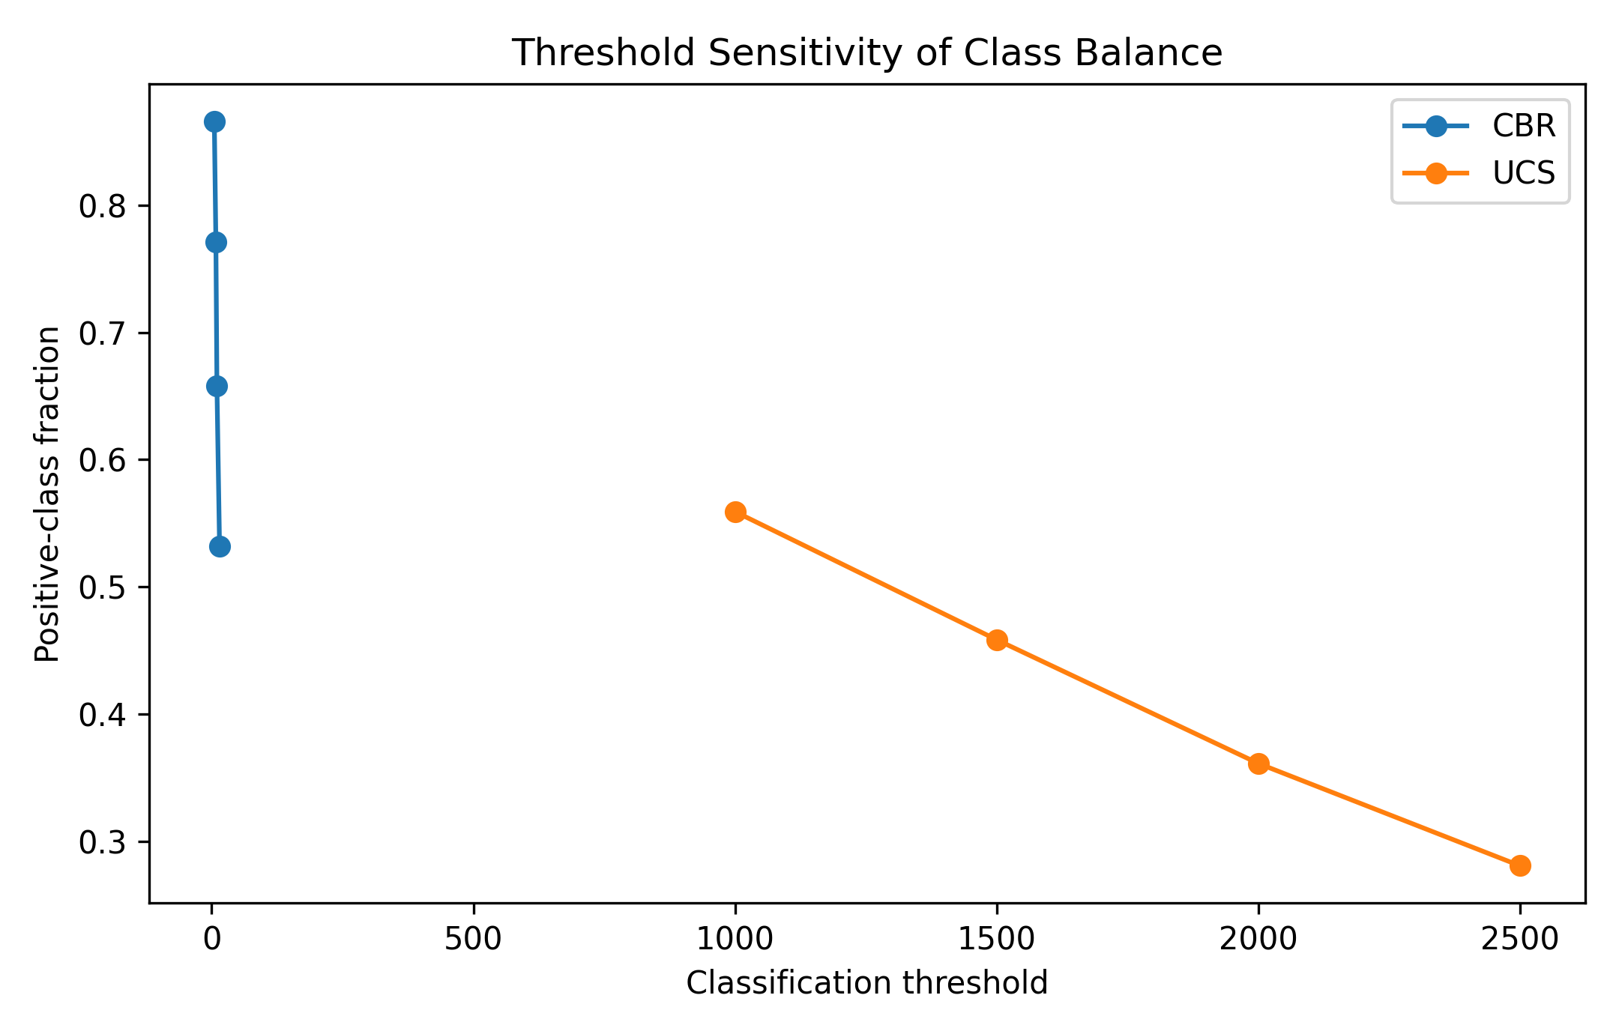
Figure 4. Class-balance sensitivity for alternative UCS and CBR thresholds.

3.4 Validation, Uncertainty and Synthetic Augmentation
The augmentation procedure followed a reproducible bounded-sampling sequence: (i) split real data into training and validation folds; (ii) group the training data by source domain and source dataset; (iii) sample training rows with replacement inside each group; (iv) perturb continuous input variables with small Gaussian noise proportional to the within-group interquartile range; (v) clip all generated values to the observed group range; (vi) reject impossible dosages or inconsistent index properties; (vii) assign synthetic targets using a gradient-boosted surrogate trained only on the real training fold; and (viii) validate only on the held-out real fold. Thus, synthetic data were never mixed into the validation set.
Two validation schemes were used. Stratified k-fold validation measured internal predictive consistency in the pooled dataset. Grouped-source validation left complete sources out of training and tested on unseen sources. Fold-level mean and standard deviation were calculated for key classification metrics. Continuous regression was retained as a benchmark to show why exact prediction was not the primary claim.
Synthetic samples were generated only within training folds using bounded perturbation and equation-guided target assignment inside the observed source/domain range. Synthetic rows were not allowed in validation folds. Synthetic-to-real training ratios of 0.5, 1.0 and 2.0 were compared with the real-only baseline.

4. Results

4.1 Classification and Transfer Gap
Table 5 shows that internal validation substantially outperformed grouped-source validation. UCS high-strength and CBR pass/fail screening achieved strong internal balanced accuracy, but the grouped-source values were lower. Figure 5 visualises this transfer gap. Figures 6 and 7 show the grouped-source confusion matrices for the two binary decision tasks. These results confirm that the paper should not claim universal exact prediction.
Table 5. Best classification performance under internal and grouped-source validation.
Task | Validation | Model | BA | Accuracy | Weighted F1 | Rows | Sources
CBR_multiclass | group_by_source_3fold | HGB | 0.238 | 0.336 | 0.266 | 485 | 3
CBR_multiclass_kfold | stratified_kfold_5 | ExtraTrees | 0.744 | 0.796 | 0.808 | 485 | 3
CBR_pass_8_binary | group_by_source_3fold | RF | 0.53 | 0.695 | 0.681 | 485 | 3
CBR_pass_8_binary_kfold | stratified_kfold_5 | ExtraTrees | 0.943 | 0.932 | 0.934 | 485 | 3
UCS_high_binary | group_by_source_5fold | ExtraTrees | 0.64 | 0.623 | 0.608 | 1728 | 6
UCS_high_binary_kfold | stratified_kfold_5 | RF | 0.934 | 0.933 | 0.933 | 1728 | 6
UCS_multiclass | group_by_source_5fold | RF | 0.342 | 0.343 | 0.335 | 1728 | 6
UCS_multiclass_kfold | stratified_kfold_5 | HGB | 0.807 | 0.814 | 0.813 | 1728 | 6

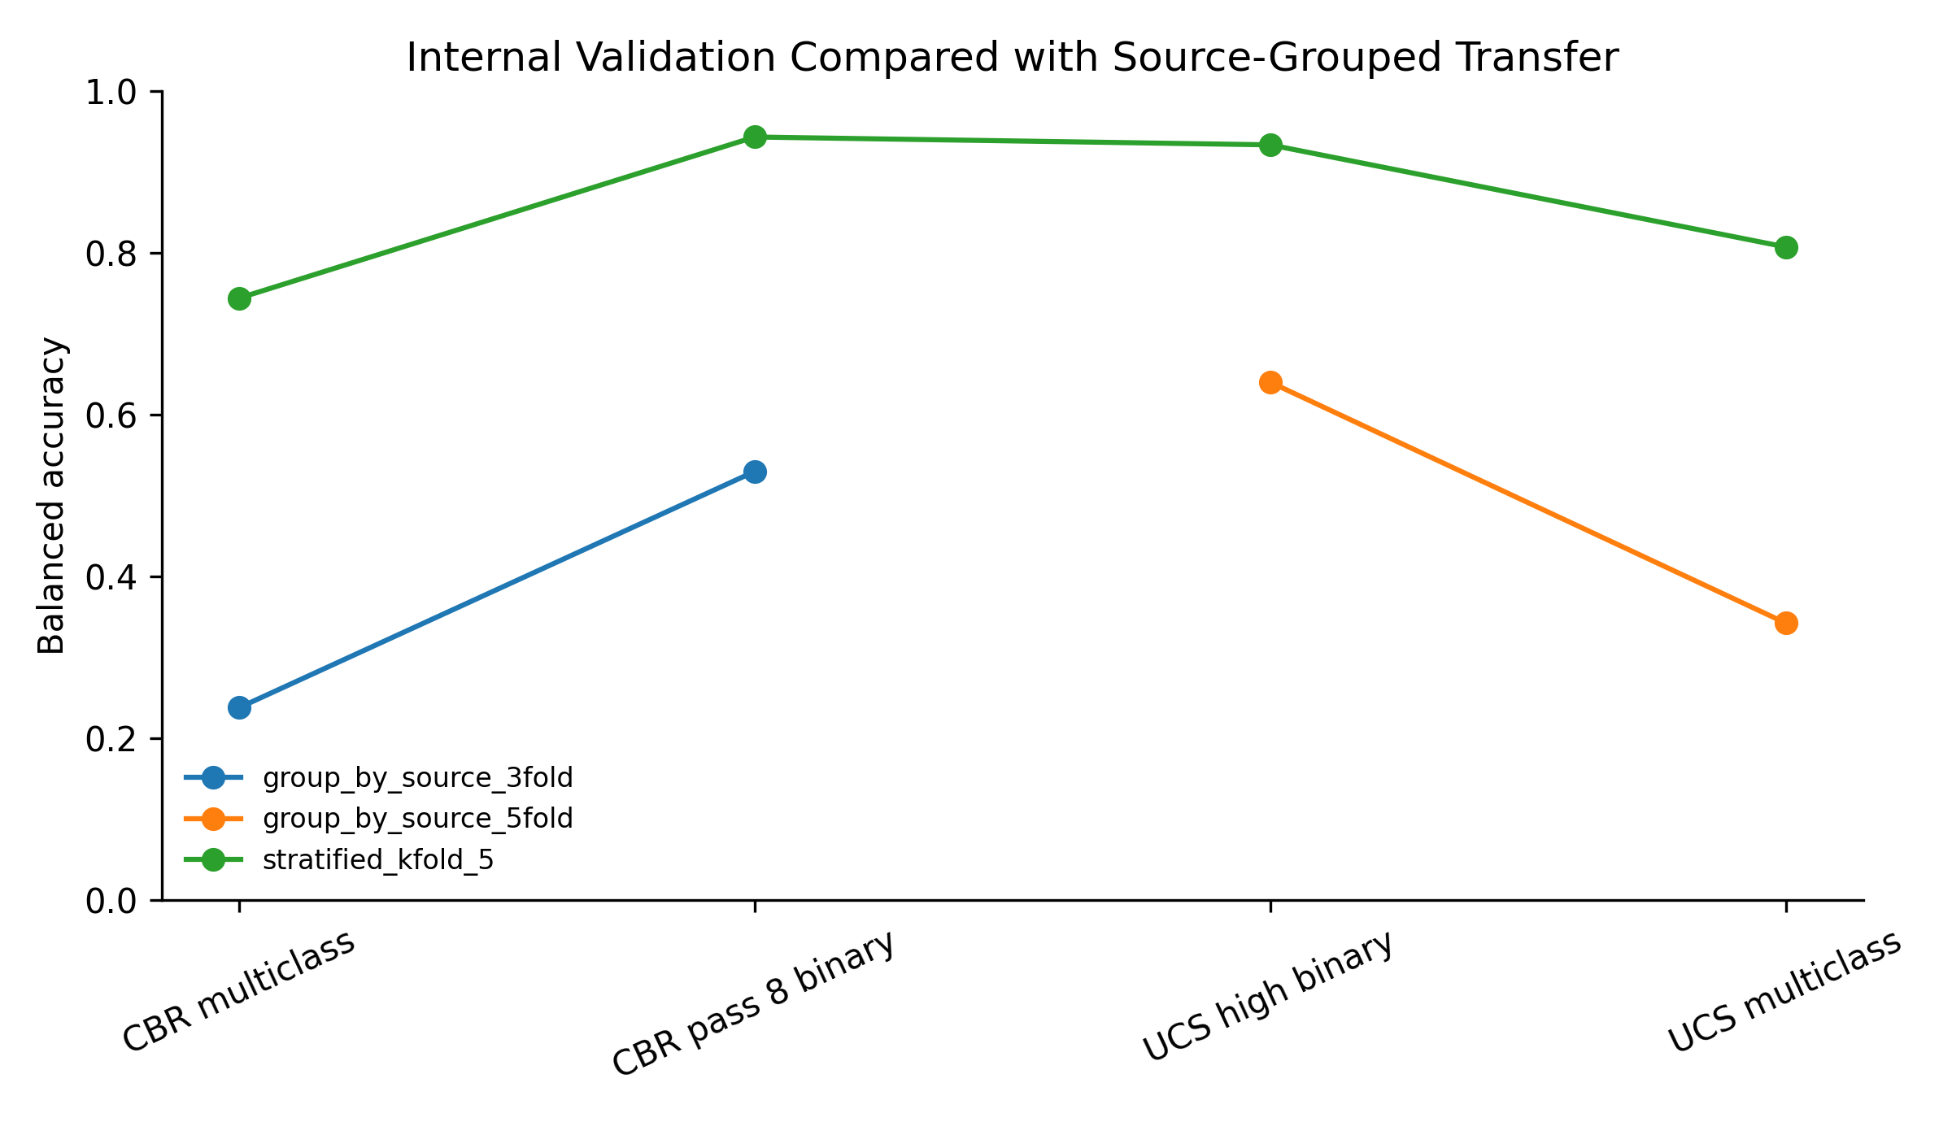
Figure 5. Difference between internal validation and source-grouped transfer performance.
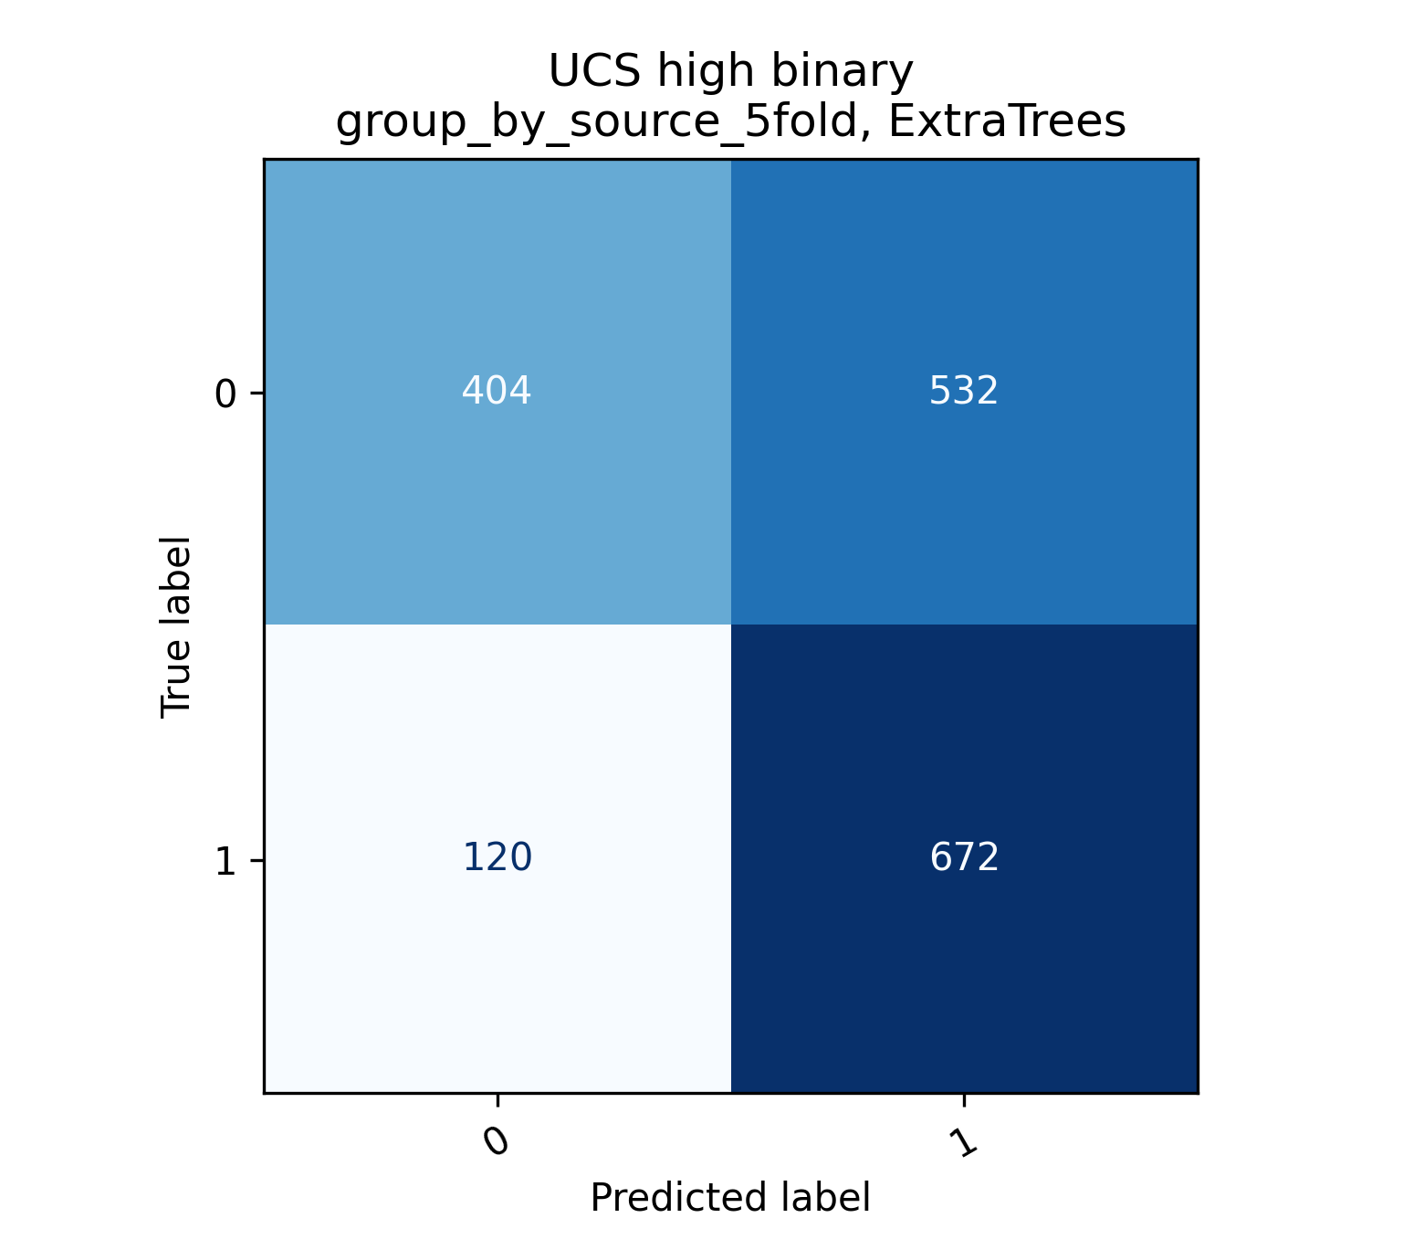
Figure 6. Grouped-source confusion matrix for UCS high-strength screening.
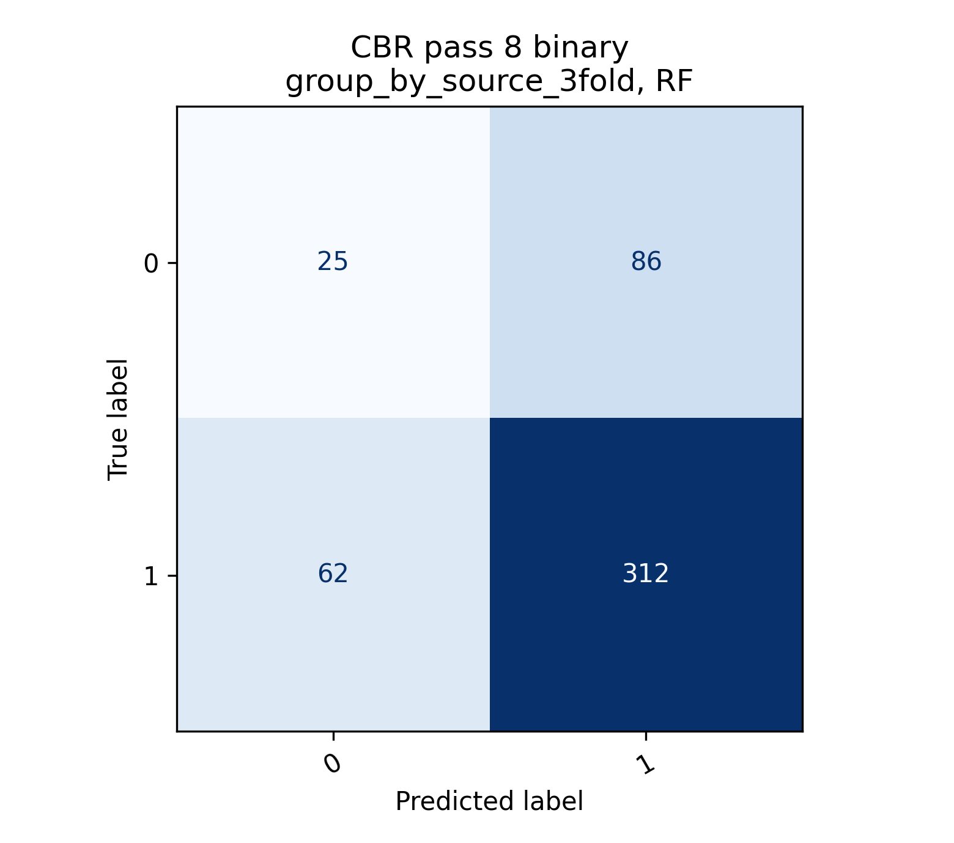
Figure 7. Grouped-source confusion matrix for CBR pass/fail screening.

4.2 Uncertainty and Regression Benchmark
The performance drop between internal and grouped-source validation was treated as an effect size for transfer loss. Formal paired significance testing was not used as the main decision criterion because grouped-source validation provides only a small number of independent source folds, especially for CBR.
Table 6 reports fold-level uncertainty. Variability was larger for grouped-source validation because each fold represents a different source, not a random subset. Table 7 retains the continuous regression benchmark. Grouped-source regression remained weak, especially for UCS, even when augmentation was used. This directly supports the shift from point prediction to classification, ranking and screening.
Table 6. Fold-level uncertainty for principal classification tasks.
dataset | label | validation | model | folds | balanced_accuracy_mean | balanced_accuracy_sd | accuracy_mean | accuracy_sd | weighted_f1_mean | weighted_f1_sd
CBR_pass_8_binary | cbr_pass_8 | group_by_source_3fold | RF | 2 | 0.555 | 0.0783 | 0.541 | 0.164 | 0.445 | 0.271
UCS_high_binary | ucs_high_binary | group_by_source_5fold | ExtraTrees | 5 | 0.624 | 0.117 | 0.645 | 0.158 | 0.598 | 0.221
UCS_multiclass | ucs_class | group_by_source_5fold | HGB | 5 | 0.363 | 0.0709 | 0.336 | 0.0887 | 0.273 | 0.106

Table 7. Continuous regression benchmark and training-only augmentation comparison.
dataset | validation | case | model | augmentation_multiplier | r2 | rmse | mae | delta_r2_vs_same_model_baseline
CBR_final_reliable | group_by_source_3fold | best_real_only | RF | 0 | 0.23 | 13.2 | 9.88 | 0
CBR_final_reliable | kfold_5_shuffle | best_real_only | RF | 0 | 0.748 | 7.55 | 3.11 | 0
UCS_final_reliable | group_by_source_5fold | best_real_only | HGB_log | 0 | 0.112 | 3.19e+03 | 1.84e+03 | 0
UCS_final_reliable | kfold_5_shuffle | best_real_only | RF | 0 | 0.921 | 953 | 519 | 0
CBR_final_reliable | group_by_source_3fold | best_augmented_training | HGB_log | 1 | 0.342 | 12.2 | 8.68 | 0.126
CBR_final_reliable | kfold_5_shuffle | best_augmented_training | ET_log | 2 | 0.723 | 7.92 | 3.29 | 0.0294
UCS_final_reliable | group_by_source_5fold | best_augmented_training | HGB_log | 1 | 0.161 | 3.1e+03 | 1.88e+03 | 0.0489
UCS_final_reliable | kfold_5_shuffle | best_augmented_training | RF | 2 | 0.927 | 910 | 496 | 0.00693

Table 8. Statistical comparison strategy used to avoid overclaiming minor model differences.
Comparison | Statistical treatment | Observed result | Interpretation
Internal vs grouped-source validation | Effect-size comparison using balanced accuracy | Large drop for all main tasks | Supports the transferability gap claim
Fold variability | Mean and standard deviation across folds | Grouped-source folds show larger variability | Avoids overclaiming single metric values
Synthetic augmentation | Real-only vs augmented-training effect size | CBR improves modestly; UCS changes little | Augmentation retained only as sensitivity analysis
Formal paired significance test | Not used as a primary decision criterion | Grouped-source folds are only 3-5 independent sources | Effect size and uncertainty are more appropriate than p-values for this dataset

4.3 Feature Importance and Mechanistic Consistency
Dominance of curing, binder and compaction variables indicates that the models are responding to stabilisation mechanisms rather than only memorising labels. Where plasticity and gradation variables appear important, the interpretation is that soil reactivity and fabric control how strongly the same additive dosage changes strength or bearing capacity.
Figures 8 and 9 show global feature importance for UCS and CBR screening. The influential variables are consistent with expected geotechnical mechanisms: curing period and binder variables affect cementitious bonding; compaction descriptors affect density and moisture state; plasticity and gradation influence soil reactivity and bearing behaviour; CBR condition affects measured bearing capacity. The analysis therefore gives a physically interpretable model, although it remains limited by incomplete reporting across sources.
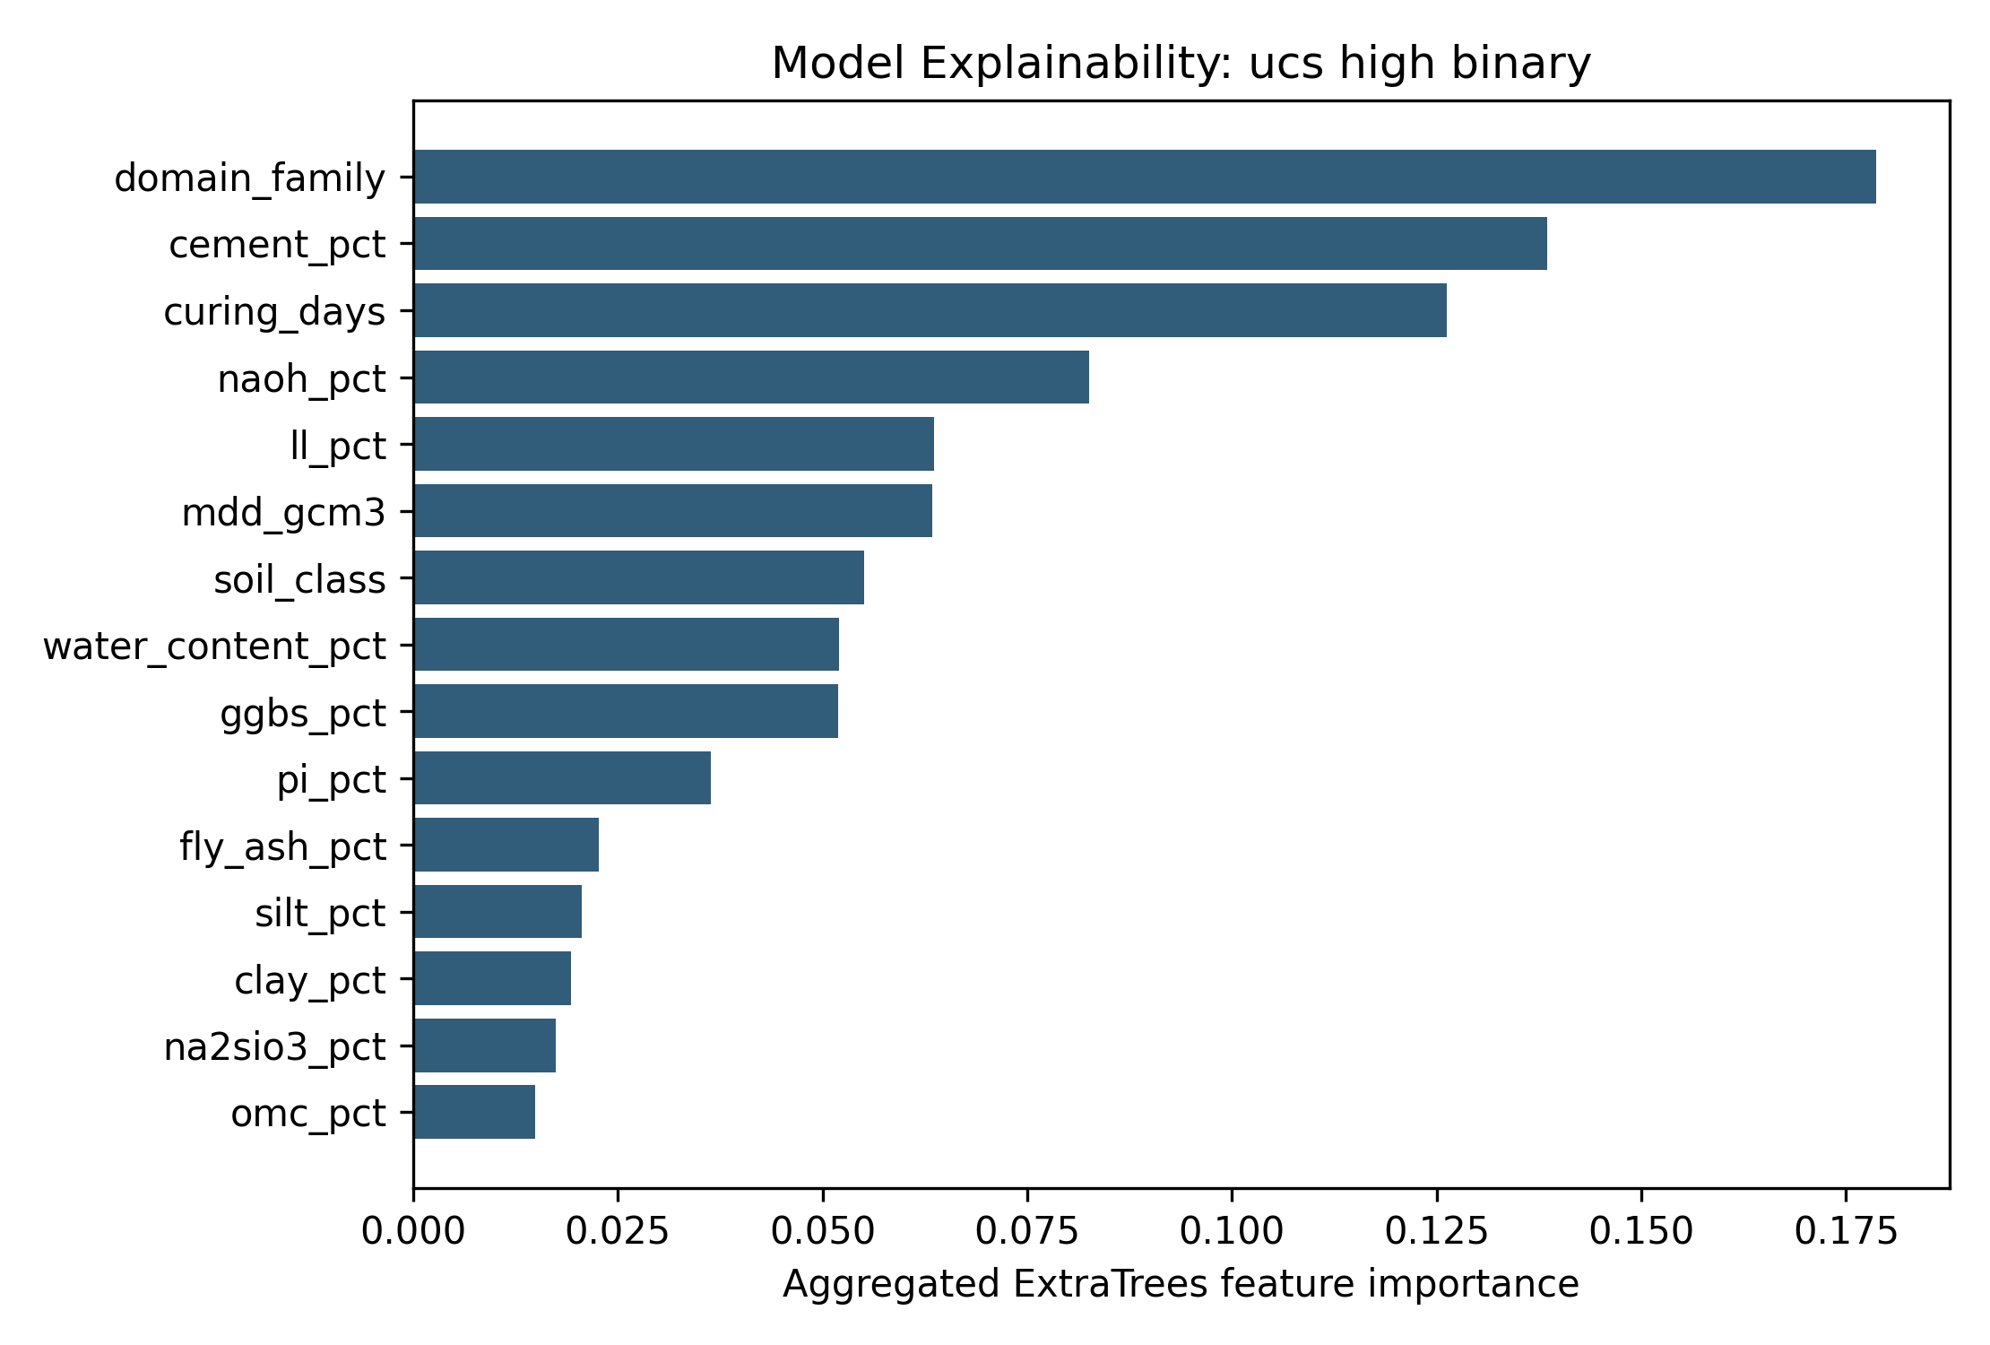
Figure 8. Global feature importance for UCS high-strength classification.
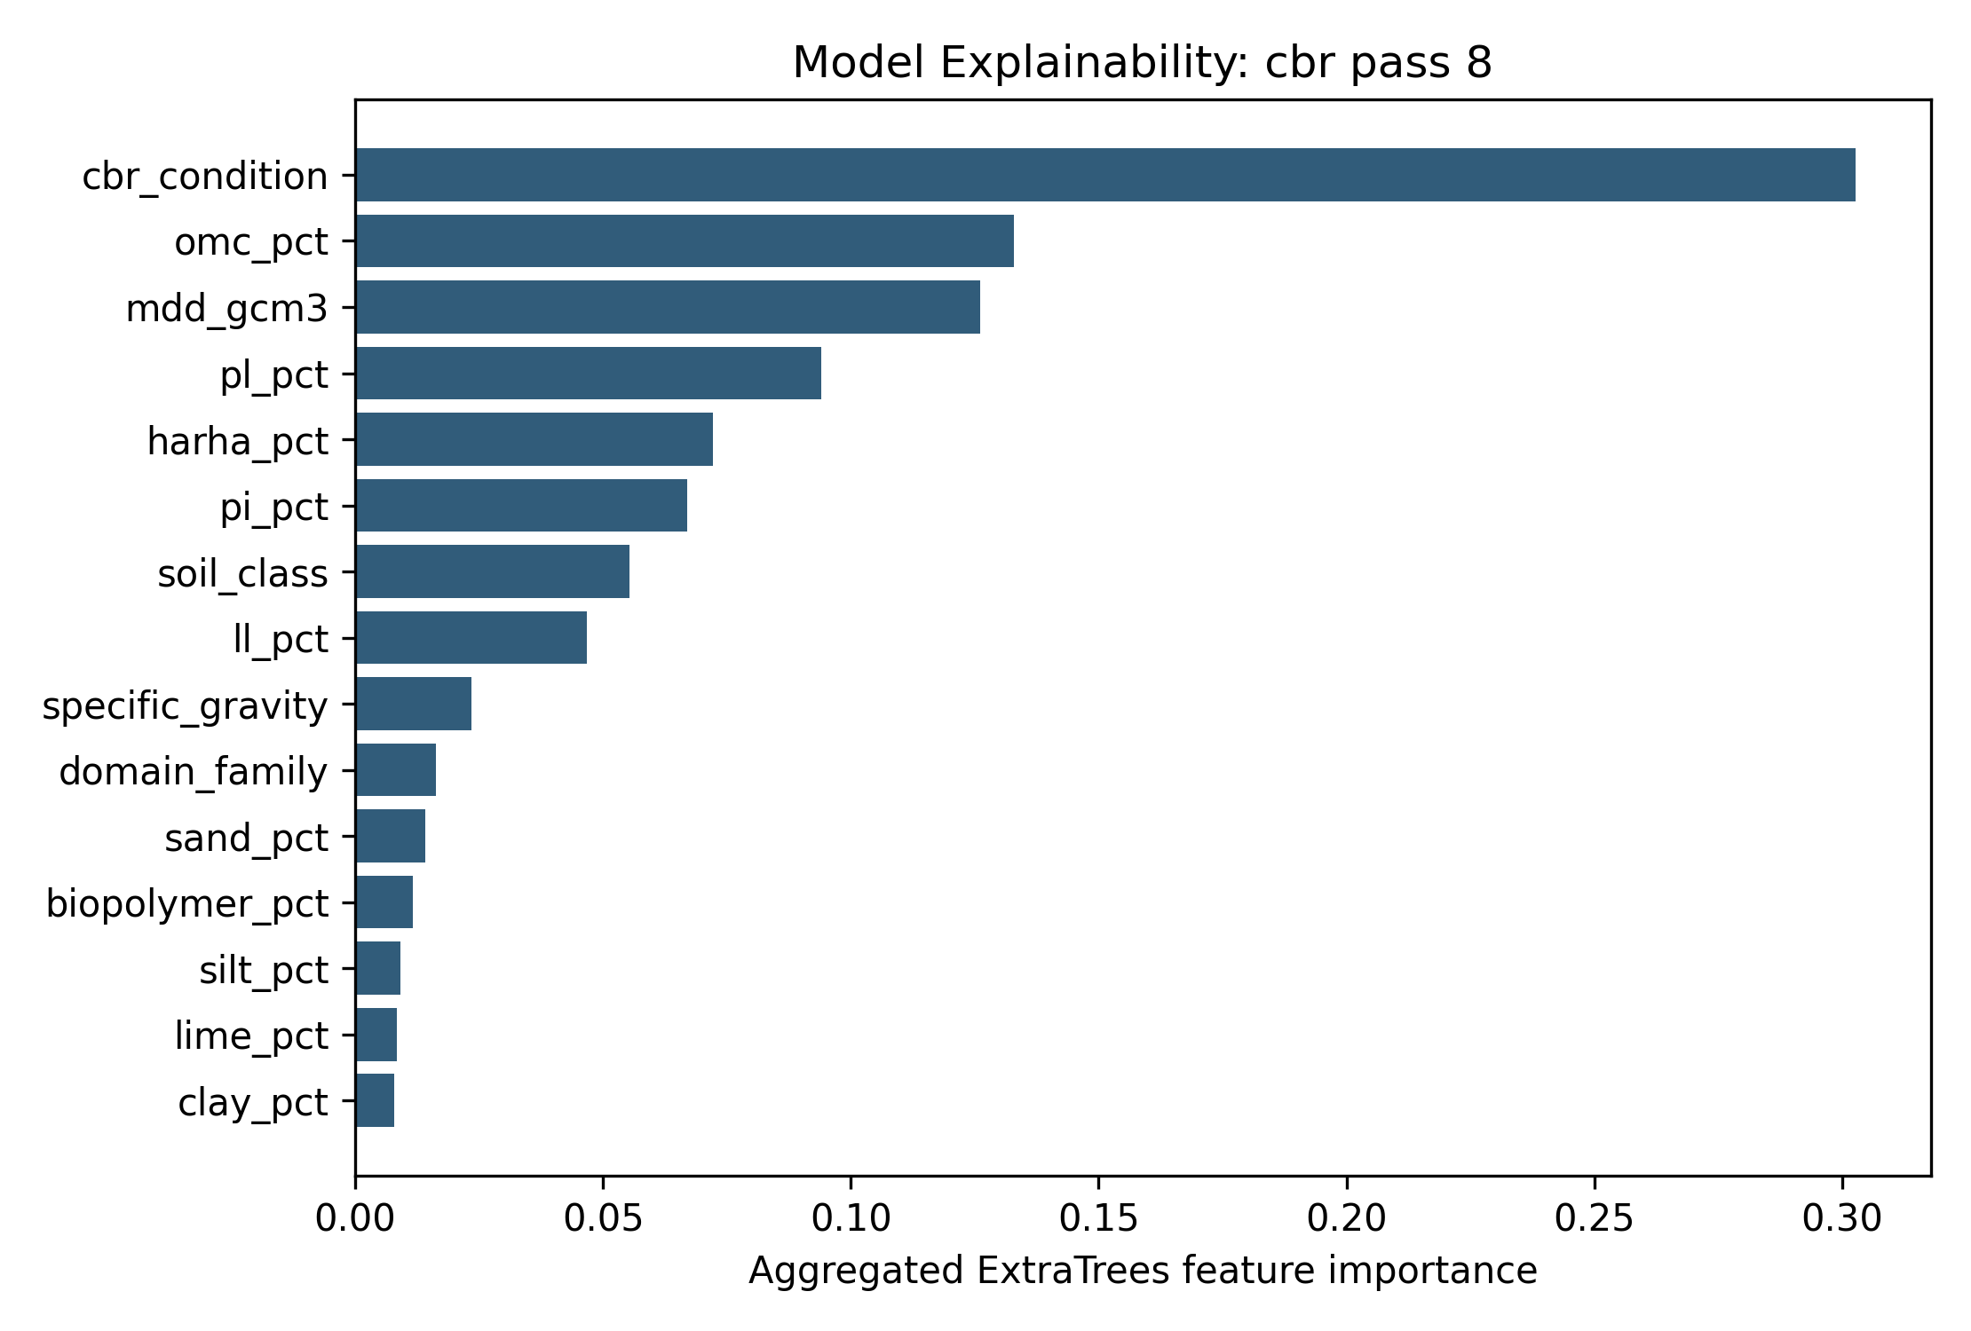
Figure 9. Global feature importance for CBR pass/fail classification.

4.4 Augmentation, Ranking and Carbon Screening
Table 8 and Figure 10 show that synthetic augmentation produced modest and task-dependent gains. CBR pass/fail grouped-source balanced accuracy improved at a 0.5 augmentation ratio, whereas UCS high-strength classification changed very little. Table 9 shows that source-wise ranking was more stable than exact regression, with CBR performance ranking giving the strongest mean Spearman coefficient. Figure 11 and Table 10 present carbon-aware screening and sensitivity. The carbon ranking changed in magnitude when emission factors were scaled, but the decision logic remained stable: mixtures should be shortlisted by both performance gain and estimated carbon burden.
Table 9. Best grouped-source effect of training-only synthetic augmentation.
Task | Validation | Model | Ratio | Real-only BA | Augmented BA | Delta BA | Accuracy | Weighted F1
CBR_multiclass | group_by_source_3fold | RF | 0.5 | 0.136 | 0.271 | 0.135 | 0.447 | 0.313
CBR_pass_8_binary | group_by_source_3fold | RF | 0.5 | 0.513 | 0.561 | 0.0473 | 0.767 | 0.724
UCS_high_binary | group_by_source_5fold | ExtraTrees | 2 | 0.641 | 0.642 | 0.000971 | 0.645 | 0.645
UCS_multiclass | group_by_source_5fold | ExtraTrees | 0.5 | 0.306 | 0.326 | 0.0209 | 0.349 | 0.312

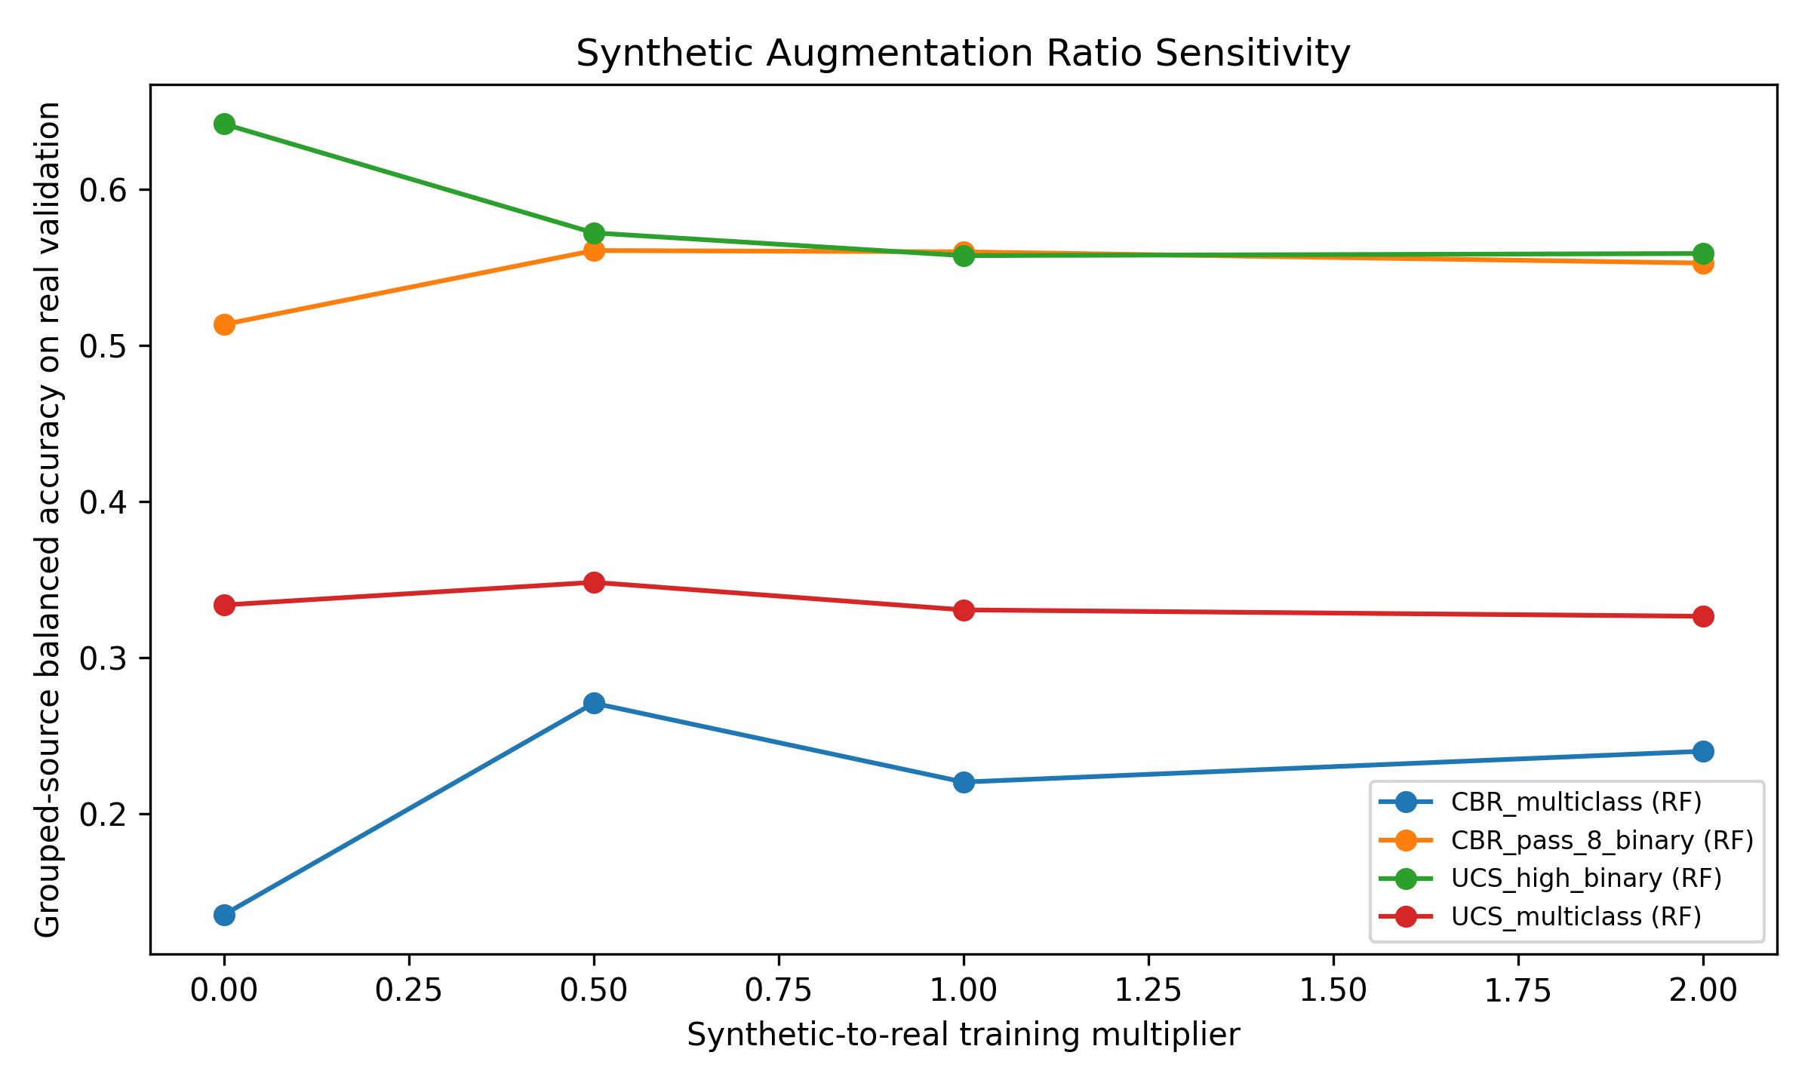
Figure 10. Synthetic-to-real training ratio sensitivity evaluated only on real validation records.
Table 10. Source-wise mixture ranking performance.
Dataset | Target | Objective | Rows | Sources | Mean Spearman | Median Spearman | Mean Kendall | Mean top-20 hit | Median top-20 hit
UCS | ucs_kpa | performance | 1728 | 6 | 0.473 | 0.488 | 0.358 | 0.482 | 0.501
UCS | ucs_kpa | carbon_efficiency | 1602 | 6 | 0.259 | 0.303 | 0.194 | 0.366 | 0.351
CBR | cbr_pct | performance | 485 | 3 | 0.579 | 0.42 | 0.429 | 0.404 | 0.394
CBR | cbr_pct | carbon_efficiency | 319 | 3 | 0.305 | 0.35 | 0.171 | 0.453 | 0.667

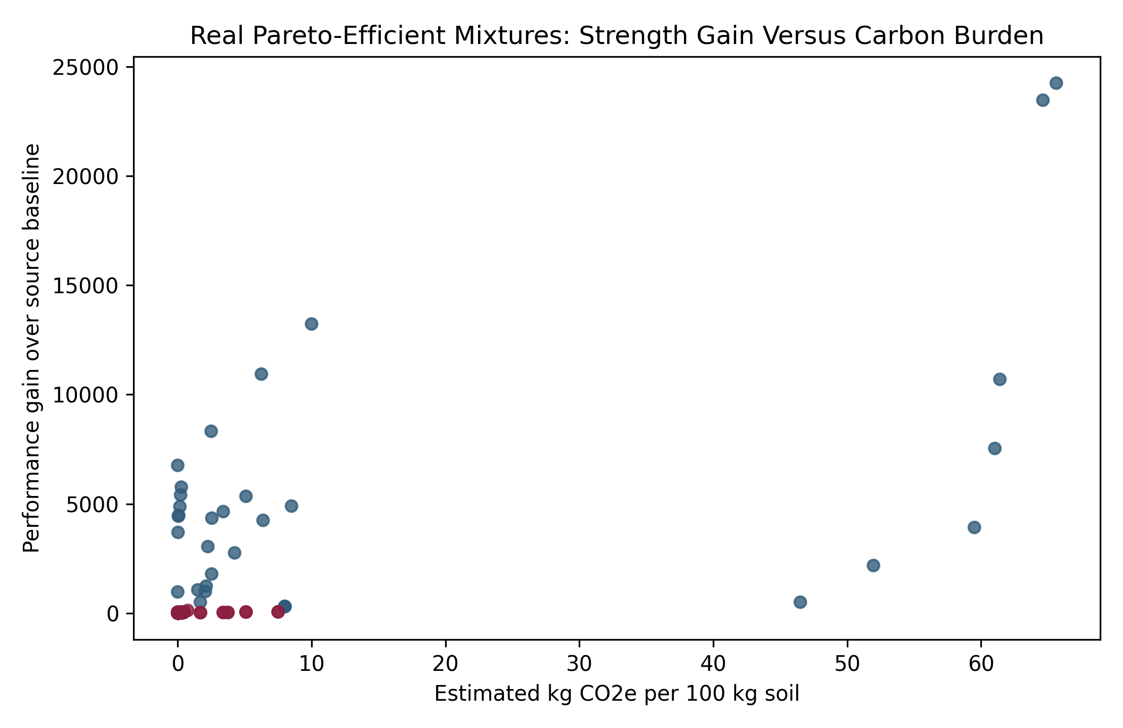
Figure 11. Real Pareto-efficient mixtures in performance-gain and estimated-carbon space.
Table 11. Carbon-factor sensitivity for Pareto-efficient mixtures.
response | carbon_factor_multiplier | candidate_count | median_gain | median_co2 | median_gain_per_co2 | top10_mean_gain_per_co2
CBR | 0.8 | 229 | 15.3 | 0.198 | 77 | 134
UCS | 0.8 | 32 | 4.29e+03 | 3.74 | 821 | 4.76e+04
CBR | 1 | 229 | 15.3 | 0.248 | 61.6 | 107
UCS | 1 | 32 | 4.29e+03 | 4.67 | 657 | 3.81e+04
CBR | 1.2 | 229 | 15.3 | 0.298 | 51.4 | 89.1
UCS | 1.2 | 32 | 4.29e+03 | 5.61 | 548 | 3.17e+04

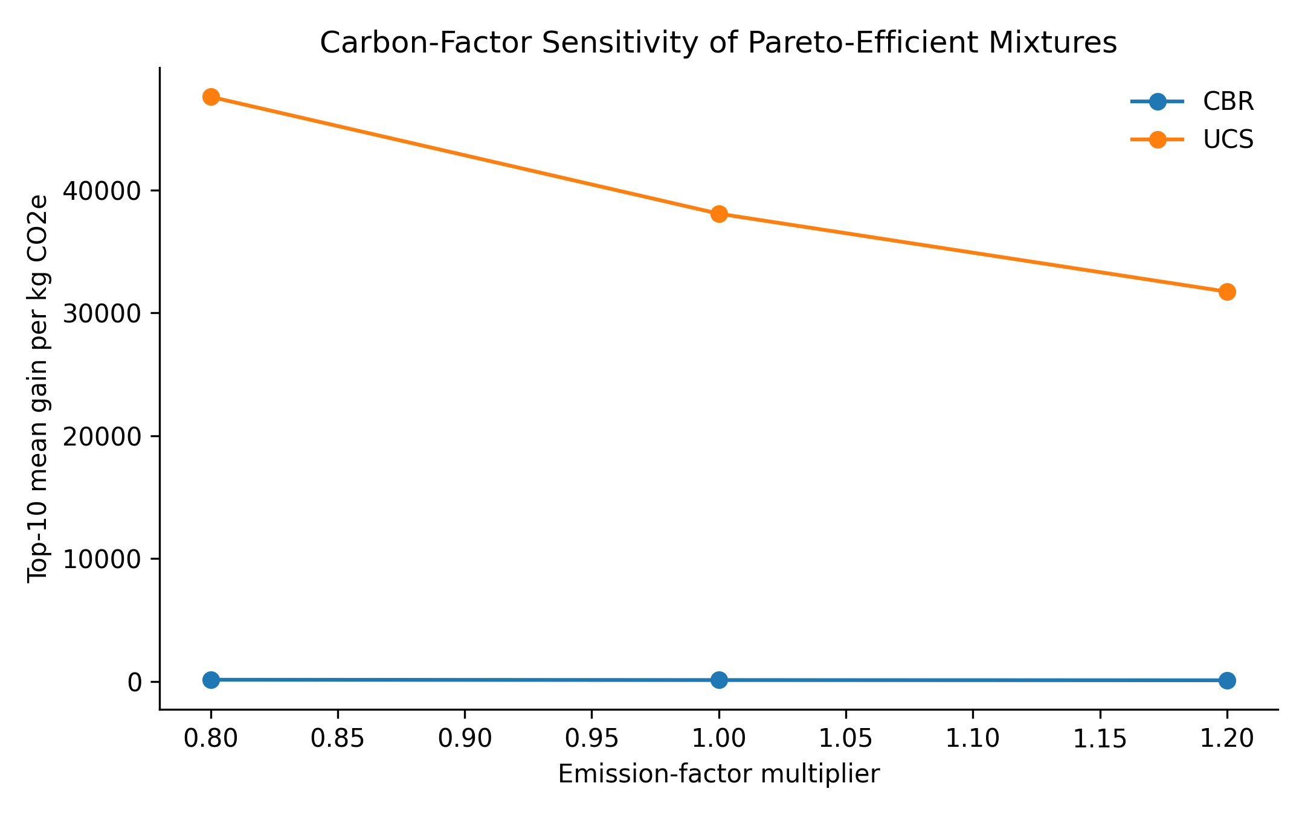
Figure 12. Sensitivity of carbon-efficiency ranking to emission-factor uncertainty.
The carbon screening was also tested under a simple dynamic sensitivity setting rather than a single cradle-to-gate value. Binder-related emission factors were scaled by -20%, baseline and +20%, and transport distances of 0, 100 and 300 km were added using a screening factor of 0.062 kg CO2e per tonne-km. This calculation is not intended to replace a project-specific life-cycle assessment, but it shows whether the Pareto ordering remains stable when regional logistics and supply-chain uncertainty are introduced. The scenario summary is reported in Table 12. The most carbon-efficient mixtures were more sensitive to transport distance when the absolute binder dosage was low, whereas high-binder mixtures became less attractive under the +20% production-emission scenario. Thus, the Pareto analysis should be read as a carbon-aware pre-screening tool whose final ranking must be recalculated for the actual source-to-site distance and local binder supply route.
Table 12. Dynamic carbon sensitivity for the Pareto screening. CO2e = carbon dioxide equivalent; gain per kg CO2e is a screening ratio based on the predicted performance improvement divided by scenario-adjusted emissions.
Binder emission factor | Transport distance (km) | Mixtures (n) | Median CO2e (kg/100 kg soil) | Median gain per kg CO2e
0.80 | 0 | 269 | 1.46 | 449.17
0.80 | 100 | 269 | 2.08 | 346.98
0.80 | 300 | 269 | 3.32 | 264.26
1.00 | 0 | 269 | 1.82 | 359.34
1.00 | 100 | 269 | 2.44 | 291.20
1.00 | 300 | 269 | 3.68 | 228.89
1.20 | 0 | 269 | 2.19 | 299.45
1.20 | 100 | 269 | 2.81 | 248.74
1.20 | 300 | 269 | 4.05 | 201.24
A second diagnostic test examined whether the transfer loss could be reduced by giving each source a more equal influence during training. Inverse-source weighting was used as a deliberately simple domain-adaptation baseline: observations from small sources received larger sample weights, whereas observations from large sources received smaller weights. Table 13 reports the resulting grouped-source comparison. The test did not remove the grouped-source penalty, but it is useful because it separates a correctable sampling-imbalance effect from the deeper unmeasured-chemistry effect discussed below. Where source weighting improved balanced accuracy, the gain was interpreted only as evidence that source imbalance contributes to the transfer problem; where it did not improve performance, the result supports the need for richer soil descriptors rather than more complex black-box learners.
Table 13. Source-weighting transfer test under grouped-source validation. BA = balanced accuracy; SD = standard deviation across held-out source folds.
Task | Training condition | Folds | BA +/- SD | Accuracy +/- SD | Weighted BA change
UCS high-strength classifier | unweighted grouped validation | 5 | 0.637 +/- 0.034 | 0.623 +/- 0.108 | 0.011
UCS high-strength classifier | inverse-source weighting | 5 | 0.648 +/- 0.071 | 0.639 +/- 0.100 | 0.011
CBR pass classifier | unweighted grouped validation | 3 | 0.833 +/- 0.289 | 0.808 +/- 0.332 | 0.000
CBR pass classifier | inverse-source weighting | 3 | 0.833 +/- 0.289 | 0.808 +/- 0.332 | 0.000
A final external-data rerun was conducted after the additional download audit. The Zenodo record 10.5281/zenodo.19242690 provided 397 UCS rows and 163 CBR rows, but duplicate-safe auditing showed that all 560 of these rows were already present in the master compiled dataset. The only newly recovered tabular source was the Data.gov.in Soil Health Card record, which provided 35 State/UT-level organic-carbon and nutrient records. These records were therefore tested only as coarse regional contextual descriptors, not as additional UCS or CBR observations. Table 14 summarises the resulting grouped-source comparison.
Table 14. Duplicate-safe external-data rerun using base predictors and base predictors plus Data.gov.in regional soil-health context. R2 values are grouped-source means; Data.gov.in records were used only as contextual descriptors.
Response | Model | Base R2 | Base + Data.gov context R2 | Change
CBR | ExtraTrees | -0.2102 | -0.2013 | +0.0089
CBR | HGB | -0.0897 | -0.0860 | +0.0037
UCS | ExtraTrees | 0.0576 | 0.0599 | +0.0023
UCS | HGB | -0.1115 | -0.0455 | +0.0660
The updated dataset pathway is therefore conservative: external laboratory rows were checked for duplication before modelling, and contextual government records were not treated as mechanical strength observations. This separation is important because adding duplicate UCS or CBR records would artificially improve random validation and distort source-group weighting, while treating State/UT soil-health counts as specimen-level chemistry would overstate the precision of the database.

5. Discussion
The transfer limitation can be interpreted as a domain-shift problem. Each source combines a particular soil origin, binder chemistry, compaction practice, curing period and reporting convention. The feature-availability heat map and source distribution plot show that sources do not occupy the same feature space. Some contain cement-lime systems, others contain fibre or ash blends, and CBR records are concentrated in fewer domains. Under such conditions, a model trained on pooled historical data can learn source-specific response patterns that are not fully portable to a new source. Domain adaptation or source weighting may reduce this issue in future work, but the present dataset is too small in independent CBR sources to make such methods the primary claim.
The main result is that stabilized-soil machine learning is highly sensitive to validation design. Internal validation indicates that the curated variables contain useful information, but grouped-source validation shows that those relationships are not fully transferable. The difference is expected because source studies differ in soil mineralogy, compaction energy, curing conditions, binder chemistry, fibre geometry and test procedures. It is also consistent with broader concerns in geotechnical data science about small, heterogeneous and incompletely reported datasets.
The regression benchmark is important. If regression had been omitted entirely, the classification focus could appear arbitrary. Table 7 shows that grouped-source regression was retained and evaluated, but the results were not strong enough to support a universal numerical prediction model. The classification and ranking tasks are therefore not a retreat from analysis; they are a better match to the reliability of the available data and to preliminary engineering screening.
The threshold sensitivity analysis reduces the risk that the binary classes appear arbitrary. The adopted thresholds retain usable class sizes and engineering meaning. Nevertheless, project-specific thresholds should be selected according to local specifications, pavement layer function and reliability requirements. The model outputs should be treated as screening indicators rather than design values.
Synthetic augmentation has a limited role. It improved selected CBR tasks because CBR data were sparse, but it did not solve source-transfer limitations. Generated rows can regularise training but cannot replace missing laboratory evidence. The strict training-only rule is therefore essential.
The carbon analysis adds practical value because strength alone is not enough for sustainable stabilization. A mixture with the highest UCS may not be preferable if a lower-carbon mixture satisfies the required class. The Pareto and sensitivity analyses provide a transparent shortlist for confirmatory laboratory testing.

5.1 Domain Shift as a Physical-Chemical Problem
The transfer loss observed in the grouped-source experiments should not be interpreted only as a mathematical weakness of machine learning. It is also a physical signal that important soil-chemistry controls are absent from the compiled literature database. For the multiclass tasks, balanced accuracy dropped by as much as 0.465 for UCS and 0.506 for CBR when the validation was changed from random internal folds to held-out source folds. Such a loss is consistent with the behaviour of expansive clay systems, where swelling and shear strength are governed by the diffuse double layer around montmorillonitic minerals, exchangeable cations and the chemistry of the pore water. When lime, fly ash, cementitious binders or alkali activators are added, cation exchange, flocculation-agglomeration and pozzolanic or geopolymeric reaction rates depend strongly on initial pH, pore-water salinity, clay fraction, exchangeable sodium and calcium availability, and the reactive silica-alumina-calcium balance of the stabilizer. Most published tables used in this study report useful index and dosage information, but they rarely report mineralogical percentages from X-ray diffraction, pore-water chemistry, binder oxide composition or curing humidity. The models therefore rely on surrogate descriptors such as liquid limit, plasticity index, stabilizer dosage and curing age. These surrogates can support screening within a familiar source domain, but they cannot fully identify why two soils with similar plasticity may react differently to the same binder. Resolving the transferability gap therefore requires better reporting of mineralogical and chemical descriptors, not only larger data volume or more elaborate algorithms. This interpretation agrees with the geotechnical mechanism described by Mitchell and Soga and with recent stabilized-soil modelling studies that report strong performance under internal validation but weaker generalisation when the soil source changes.

5.2 Re-evaluating the CBR Database Utility
The CBR part of the database must be treated more cautiously than the UCS part. Although 485 CBR observations were available, they came from only three independent source groups, so grouped-source validation is necessarily sensitive to which source is held out. The fold-level standard deviation in balanced accuracy was 0.078 for the CBR pass/fail classifier, and the multiclass CBR transfer loss reached 0.506. For this reason, the CBR model is not presented as a globally reliable design-value predictor and it must not be used to replace local California bearing ratio laboratory testing for pavement design. Its value in this paper is narrower but still useful: it demonstrates how a carbon-aware Pareto ranking workflow can screen candidate stabilization strategies before a project commits to laboratory confirmation. In practical use, the CBR outputs should be read as regional screening evidence, with final acceptance based on site-specific compaction, soaking and penetration tests conducted under the governing pavement design standard.

5.3 Minimum Geotechnical Reporting Protocol
The diagnostic value of this study is that it identifies what future experimental papers must report if geotechnical machine-learning models are to become transferable rather than merely local. A minimum geotechnical reporting protocol should accompany soil stabilization studies as a complete machine-readable table, preferably as CSV or XLSX supplementary material. The table should include the raw mechanical outputs, such as UCS, CBR, swelling index and compaction results, together with replicate counts, means, standard deviations and the raw stress-strain or load-penetration curves where possible. It should also include the mineralogical composition of the untreated soil, especially montmorillonite, kaolinite, illite, quartz and carbonate fractions obtained from X-ray diffraction; chemical descriptors such as pH, electrical conductivity, exchangeable cations and organic content; exact binder compositions including CaO, SiO2, Al2O3, Fe2O3, loss on ignition and alkali content; fibre geometry and tensile properties where fibres are used; compaction energy, specimen size, moisture conditioning and curing temperature and humidity. Reporting these descriptors would allow future models to distinguish genuine material mechanisms from source labels, reduce hidden domain shift and make external validation more meaningful. Without such reporting, the field will continue to accumulate many local datasets that are useful for individual case studies but difficult to merge into globally transferable design-support tools.

5.4 External Data Redownload and Contextual Enrichment
The external-data rerun provides an important boundary condition for interpreting the modelling results. The additional Zenodo workbook increased traceability but did not increase the effective mechanical sample size, because its UCS and CBR observations had already been incorporated into the master compiled database. This duplicate check prevented artificial inflation of the dataset and avoided a misleading improvement in model performance. The Data.gov.in Soil Health Card records added State/UT-level organic-carbon and nutrient descriptors for India. However, these variables are regional agricultural soil-health indicators rather than specimen-level geotechnical chemistry. When they were added to the grouped-source validation, the improvement was small: UCS R2 increased from 0.0576 to 0.0599 for ExtraTrees and from -0.1115 to -0.0455 for HGB, while CBR R2 improved from -0.2102 to -0.2013 for ExtraTrees and from -0.0897 to -0.0860 for HGB. These changes show that coarse regional context may help slightly, but it does not resolve the transferability problem. The result strengthens the central interpretation of this study: more rows or broad regional context are not sufficient unless future datasets also report specimen-level mineralogy, pore-water chemistry, binder oxide composition, curing environment and compaction protocol.

6. Practical Use Case for a New Soil Source
For a new expansive soil source, the framework should be used as a screening workflow rather than a direct design tool. First, the user enters the available index, compaction and mixture variables and checks whether the new soil falls inside the feature ranges of the curated database. Second, the binary classifiers estimate whether candidate mixtures are likely to reach the UCS or CBR screening class. Third, candidate mixtures are ranked within the closest source/domain group. Fourth, carbon efficiency is calculated to remove mixtures that require high binder-related emissions for only small performance gains. Finally, the highest-ranked and Pareto-efficient mixtures are selected for local compaction, UCS, CBR, swelling and durability testing.
This use case clarifies the intended engineering role of the model. The model narrows the laboratory search space; it does not replace site-specific geotechnical testing. This interpretation is consistent with the grouped-source results, which show that transfer is useful for screening but not strong enough for final design values.

7. Limitations and Reproducibility
The study remains limited by the information available in source papers. Mineralogy, pore-fluid chemistry, curing humidity, compaction energy and microstructural observations were not consistently available. The CBR dataset is smaller than the UCS dataset, so CBR conclusions should be treated as screening-level. Carbon calculations are approximate and should not be interpreted as a full life-cycle assessment. The supplementary material should include the cleaned real dataset, feature dictionary, source inventory, fold assignments, code, prediction files, augmentation rules and carbon factors.
The Indian and international data-expansion routes identified during this revision should be used selectively. National geoscience and soil portals such as NGDR, GSI Bhukosh, ISRO Bhuvan, SLUSI and Data.gov.in can provide regional context on soil class, geology, climate and agricultural chemistry, while CRRI, Zenodo and Mendeley-style repositories can provide direct laboratory datasets when tabular test results are openly available. These sources should not be merged blindly with mechanical laboratory data; instead, they should be used to add source-level descriptors such as region, parent geology, climate zone and likely mineralogical setting, and any inferred variables should be clearly labelled as contextual rather than measured.
The main technical conclusion is that source-aware validation changes the interpretation of stabilized-soil machine learning. High internal cross-validation scores show that the database contains learnable patterns, but the held-out-source losses show that those patterns are not yet universal because essential mineralogical and chemical controls are usually missing. The UCS classifier is suitable for preliminary screening under similar source conditions, whereas the CBR classifier should be treated only as a proof of the carbon-aware ranking workflow and must not replace local laboratory CBR testing. The next defensible step is therefore not simply a larger black-box model, but a better reported, chemistry-aware database built around the minimum geotechnical reporting protocol proposed in this study.
The external redownload also clarifies the role of public Indian data portals. Data.gov.in provided usable State/UT-level soil-health context, but NGDR, Bhukosh, Bhuvan, SLUSI and CRRI did not expose direct bulk UCS or CBR laboratory tables during the automated audit. Consequently, these portals are valuable for future regional enrichment and source characterization, but they should not be treated as mechanical strength datasets unless raw laboratory measurements are obtained through manual download, formal request or publication tables.

8. Conclusions
- The curated dataset is adequate for preliminary decision support but not for universal exact prediction across all stabilized soils.
- Internal validation substantially overestimated transfer performance compared with grouped-source validation.
- UCS high-strength classification, CBR pass/fail screening and source-wise ranking are more defensible than exact grouped-source regression for the current data.
- Synthetic augmentation should remain a training-only sensitivity tool because it produced only modest, task-dependent improvements.
- Carbon-aware Pareto screening is a useful practical output because it identifies mixtures that balance performance gain and estimated carbon burden.
The external-data rerun confirmed that the compiled dataset should not be enlarged by duplicate records and that regional soil-health context produces only modest grouped-source gains. This finding supports a restrained conclusion: physics-constrained and source-aware modelling improves diagnostic reliability, but globally transferable stabilized-soil prediction requires richer specimen-level mineralogical and chemical reporting.
The updated compilation confirms that the proper route to improvement is not duplicate expansion of existing laboratory data. Small gains from Data.gov.in contextual descriptors indicate that regional information is useful, but the remaining transfer gap shows that specimen-level mineralogical and chemical descriptors remain necessary for a stronger universal model.

CRediT Authorship Contribution Statement
Author contributions should be completed by the authors before submission.

Declaration of Competing Interest
The authors should declare whether they have any competing financial interests or personal relationships that could have influenced the work.

Ethics Statement
This study used previously published literature data and did not involve human participants, animals or field interventions requiring ethical approval.

Data Availability
The dataset update files include the redownload log, the processed Zenodo UCS/CBR sheets, the Data.gov.in Soil Health Card contextual table, the duplicate-safe compilation audit, and the base-versus-context rerun metrics. The Data.gov.in records are supplied as regional context only and are not used as additional UCS or CBR measurements.
The cleaned real datasets, source inventory, feature dictionary, analysis scripts, fold assignments, prediction files, augmentation rules and carbon-factor table are archived in a private GitHub repository: https://github.com/bharti19may-ctrl/source-aware-stabilized-soil-ml. The repository is currently private and can be made available to editors/reviewers on request. Synthetic rows, if released, are stored separately and labelled as training-only auxiliary data.
The external-data redownload package, duplicate-safe compiled dataset, and comparison metrics are archived with the private reproducibility repository. The package includes `External_Data_Redownload_2026-05-27`, `Compiled_All_Data_Rerun_Analysis_2026-05-27`, download logs, processed CSV files, source-use decisions and the rerun analysis report.

Appendix A. Additional Sensitivity and Reproducibility Tables
Target | Threshold | Positive class count | Positive class fraction | Purpose
UCS | 1200 kPa | 880 | 0.509 | High-strength screening sensitivity
UCS | 1500 kPa | 792 | 0.458 | High-strength screening sensitivity
UCS | 1800 kPa | 707 | 0.409 | High-strength screening sensitivity
CBR | 5% | 420 | 0.866 | Bearing-capacity screening sensitivity
CBR | 8% | 374 | 0.771 | Bearing-capacity screening sensitivity
CBR | 10% | 319 | 0.658 | Bearing-capacity screening sensitivity

Table A2. Balanced-accuracy drop from internal validation to grouped-source validation.
Task | Internal BA | Grouped-source BA | BA drop | Interpretation
UCS_high_binary | 0.934 | 0.64 | 0.293 | positive value indicates source-transfer loss
UCS_multiclass | 0.807 | 0.342 | 0.465 | positive value indicates source-transfer loss
CBR_pass_8_binary | 0.943 | 0.53 | 0.413 | positive value indicates source-transfer loss
CBR_multiclass | 0.744 | 0.238 | 0.506 | positive value indicates source-transfer loss

Table A1. Threshold sensitivity around the adopted UCS and CBR screening cut-offs.

References
Ahmad, S., Ghazi, M. S. A., Syed, M., & Al-Osta, M. A. (2024). Utilization of fly ash with and without secondary additives for stabilizing expansive soils: A review. Results in Engineering, 22, 102079. https://doi.org/10.1016/j.rineng.2024.102079
Almuaythir, S., Zaini, M. S. I., & Lodhi, R. H. (2025). Predicting soil compaction parameters in expansive soils using advanced machine learning models: a comparative study. Scientific Reports, 15(1), 24018. https://doi.org/10.1038/s41598-025-09279-2
ASTM D638. (2014). Standard test method for tensile properties of plastics. ASTM International.
Barrera-Animas, A. Y., & Delgado, J. M. D. (2023). Generating real-world-like labelled synthetic datasets for construction site applications. Automation in Construction, 151, 104850. https://doi.org/10.1016/j.autcon.2023.104850
Bureau of Indian Standards. (1970). IS 1498: Classification and identification of soils for general engineering purposes. BIS.
Bureau of Indian Standards. (2016). IS 2720: Methods of test for soils. BIS.
Chauhan, K. S., & Rajesh, J. (2015). Effect of fly ash and fibre on index properties of black cotton soil. International Journal of Science Technology and Engineering, 2(01).
Chavan, G. A., & Savoikar, P. (2023). Characterization of Black Cotton soil in Kolhapur region. Indian Geotechnical Journal, 53(6), 1454-1467. https://doi.org/10.1007/s40098-023-00766-9
Degirmenci, N., Okucu, A., & Turabi, A. (2007). Application of phosphogypsum in soil stabilization. Building and Environment, 42(9), 3393-3398. https://doi.org/10.1016/j.buildenv.2006.08.010
Deshpande, S. S., & Puranik, M. M. (2017). Effect of fly ash and polypropylene on the engineering properties of black cotton soil. International Journal of Civil Engineering (SSRG-IJCE), 4(4), 52-55.
Dixit, A., Nigam, M., & Mishra, R. (2016). Effect of fly ash on geotechnical properties of soil. International Journal of Engineering Technologies and Management Research, 3(5), 2454-1907.
Dixit, D. M. (2017). Optimum use of polypropylene fibers improves soil properties. International Journal of Civil Engineering and Technology, 8(1), 149-154.
Onyekpe, U. (2021). Data on one-dimensional vertical free swelling potential of soils and related soil properties. Data in Brief, 39, 107608. https://doi.org/10.1016/j.dib.2021.107608
Eyo, E. U., Abbey, S. J., Lawrence, T. T., & Tetteh, F. K. (2022). Improved prediction of clay soil expansion using machine learning algorithms and meta-heuristic dichotomous ensemble classifiers. Geoscience Frontiers, 13(1), 101296. https://doi.org/10.1016/j.gsf.2021.101296
Ge, Q., Li, J., Lacasse, S., Sun, H., & Liu, Z. (2024). Data-augmented landslide displacement prediction using generative adversarial network. Journal of Rock Mechanics and Geotechnical Engineering, 16(10), 4017-4033. https://doi.org/10.1016/j.jrmge.2024.01.003
Gautam, K. K., & Patel, S. (2025, May). Lime, waste quarry dust, and polyester. In Proceedings of the Indian Geotechnical Conference (IGC 2024), Volume 1: Ground Improvement Techniques (Vol. 1, p. 295). Springer Nature.
Huang, K., Zhang, Z., Sun, Y., Shi, X., Wang, C., Guo, S., & Fan, C. (2025). Characterization of engineering properties in stabilized expansive soil: Integrating experimental investigation and machine learning modeling. Construction and Building Materials, 485, 141960. https://doi.org/10.1016/j.conbuildmat.2025.141960
Indian Roads Congress. (2012). IRC: 37: Guidelines for the design of flexible pavements. IRC.
Indiramma, P., Sudharani, C., & Needhidasan, S. (2020). Utilization of fly ash and lime to stabilize the expansive soil and to sustain pollution free environment: An experimental study. Materials Today: Proceedings, 22, 694-700. https://doi.org/10.1016/j.matpr.2019.09.147
Jayashree, J., & Roja, S. Y. (2019). Stabilization of expansive soil using rice husk ash and lime. International Journal of Recent Technology and Engineering, 8(3), 2661-2665. https://doi.org/10.35940/ijrte.C4942.098319
Katti, R. K. (1978). Search for solutions to problems in black cotton soils. Bombay: Indian Institute of Technology.
Li, H., Chen, W., & Tan, X. (2025). Back analysis of geomechanical parameters based on a data augmentation algorithm and machine learning technique. Underground Space, 21, 215-231. https://doi.org/10.1016/j.undsp.2024.08.002
Luhar, I., & Luhar, S. (2022). A comprehensive review on fly ash-based geopolymer. Journal of Composites Science, 6(8), 219. https://doi.org/10.3390/jcs6080219
Luo, Z., Xue, X., Xiong, C., Huang, R., Du, J., Li, J., & Liu, K. (2025). Data-driven prediction of unconfined compressive strength in stabilized soils using machine learning. Discover Applied Sciences, 7(10), 1122. https://doi.org/10.1007/s42452-025-07766-9
Mai-Bade, U. Y., Chinade, A. U., Batari, A., & Saeed, S. M. (2021). Stabilization of black cotton soil using various admixtures: A review. Composite Materials, 5(2), 37-45. https://doi.org/10.11648/j.cm.20200502.12
Fentaw, M., Alemayehu, E., & Geremew, A. (2021). Experimental Study of Stabilization of Expansive Soil Using the Mixture of Marble Dust, Rice Husk Ash, and Cement for Sub-Grade Road Construction: A Case Study of Woldia Town. Journal of Civil Engineering, 12(2), 141-159. https://doi.org/10.33736/jcest.3977.2021
Mazhar, S., & GuhaRay, A. (2021). Stabilization of expansive clay by fibre-reinforced alkali-activated binder: an experimental investigation and prediction modelling. International Journal of Geotechnical Engineering, 15(8), 977-993. https://doi.org/10.1080/19386362.2020.1775358
Mitchell, J. K., & Soga, K. (2005). Fundamentals of soil behavior. John Wiley & Sons.
Moghaddas, S. A., & Bao, Y. (2025). Explainable machine learning framework for predicting concrete abrasion depth. Case Studies in Construction Materials, 22, e04686. https://doi.org/10.1016/j.cscm.2025.e04686
Nanda, R. P., & Priya, N. (2024). Geopolymer as stabilising materials in pavement constructions: A review. Cleaner Waste Systems, 7, 100134. https://doi.org/10.1016/j.clwas.2024.100134
Navagire, O. P., Srinivasan, V., Patel, A., & Gowrisankar, D. (2026). Stabilization of expansive soils using polypropylene fiber for enhanced engineering properties: A study on black cotton soils from India. Indian Geotechnical Journal, 56(3), 1445-1461. https://doi.org/10.1007/s40098-025-01225-3
Parihar, N. S., & Gupta, A. K. (2024). Stabilization of expansive soils using non-conventional waste stabilizers: a review. Indian Geotechnical Journal, 54(3), 971-997. https://doi.org/10.1007/s40098-024-00923-8
Patil, S. C., Mathada, D. V. S., & Bharamagoud, B. (2018). Comparative study on black cotton soil stabilization by using lime and sisal fiber. International Journal of Innovative Research in Science and Technology, 5, 109-115.
Phani Kumar, B. R., & Sharma, R. S. (2004). Effect of fly ash on engineering properties of expansive soils. Journal of Geotechnical and Geoenvironmental Engineering, 130(7), 764-767. https://doi.org/10.1061/(ASCE)1090-0241(2004)130:7(764)
Uday, R. A., Kiran, D., GS, A. K., KG, P., & Maddodi, B. S. (2022). Effect of polypropylene macro fiber on geotechnical characteristics of black cotton soil: an experimental investigation and correlation analysis. Engineered Science, 21(4), 775. http://dx.doi.org/10.30919/es8d775
Rokade, S., Kumar, R., & Jain, P. K. (2017). Effect of inclusion of fly-ash and nylon fiber on strength characteristics of black cotton soil. Electronic Journal of Geotechnical Engineering, 22, 1941-1950.
Saad, A. H., Nahazanan, H., Yusuf, B., Toha, S. F., Alnuaim, A., El-Mouchi, A., Elseknidy, M., & Mohammed, A. A. (2023). A Systematic Review of Machine Learning Techniques and Applications in Soil Improvement Using Green Materials. Sustainability, 15(12), 9738. https://doi.org/10.3390/su15129738
Sharma, K., & Kumar, A. (2020). Utilization of industrial waste-based geopolymers as a soil stabilizer: a review. Innovative Infrastructure Solutions, 5(3), 97. https://doi.org/10.1007/s41062-020-00350-7
Shukla, N. K., & Sharma, A. K. (2025). Strength characteristics of expansive soil stabilized with optimized binder containing fly ash and bagasse ash. European Journal of Environmental and Civil Engineering, 29(10), 2009-2025. https://doi.org/10.1080/19648189.2025.2472994
Syed, M., Agarwal, S., & GuhaRay, A. (2021, April). Stabilization of expansive black cotton soil using alkali-activated binder with glass and polypropylene fiber. In Proceedings of the Indian Geotechnical Conference 2019: IGC-2019 Volume III (pp. 127-139). Singapore: Springer Singapore. https://doi.org/10.1007/978-981-33-6444-8_11
Syed, M., GuhaRay, A., Ghadge, H., & Chikte, A. (2021, October). Estimation of Compressive Strength of Glass Fiber Reinforced Expansive Soil in Alkaline Activated Binder by an Artificial Neural Network Based Model. In Indian Young Geotechnical Engineers Conference (pp. 55-66). Singapore: Springer Nature Singapore. https://doi.org/10.1007/978-981-96-1373-1_5
Syed, M., Ray, A. G., & Ghadge, H. (2025). by an Artificial Neural Network Based. Ground Engineering and Applications: Select Proceedings of 8IYGEC 2021, 55.
Goutham, D. R., & Krishnaiah, A. J. (2024). Prediction of unconfined compressive strength of expansive soil amended with bagasse ash and lime using artificial neural network. Journal of Soft Computing in Civil Engineering, 8(1), 33-54. https://doi.org/10.22115/scce.2023.367214.1545
Thapa, I., & Ghani, S. (2024). Enhancing unconfined compressive strength prediction in nano-silica stabilized soil: a comparative analysis of ensemble and deep learning models. Modeling Earth Systems and Environment, 10(4), 5079-5102. https://doi.org/10.1007/s40808-024-02052-w
Fondjo, A. A., Theron, E., & Ray, R. P. (2021). Stabilization of expansive soils using mechanical and chemical methods: a comprehensive review. Civil Engineering and Architecture, 9(5), 1295-1308. https://doi.org/10.13189/cea.2021.090503
Sajad, S., & Singh, H. (2022). Stimulation of black cotton soil via stone dust and pet fibre. Materials Today: Proceedings, 48, 1633-1637. https://doi.org/10.1016/j.matpr.2021.09.516
Wang, H., Liu, T., Yan, C., & Wang, J. (2023). Expansive Soil Stabilization Using Alkali-Activated Fly Ash. Processes, 11(5), 1550. https://doi.org/10.3390/pr11051550
Yang, H., Hu, G., Liu, L., Li, Y., Deng, Y., & Wu, J. (2025). A Physics-Informed and SHAP-Enhanced Modeling Framework for Predicting Strength of Cement-Stabilized Soil. Case Studies in Construction Materials, e05280. https://doi.org/10.1016/j.cscm.2025.e05280
Yang, C., Jiang, Y., Li, Z., Huang, Y., & Yue, J. (2025). Research on the Pavement Performance of Slag/Fly Ash-Based Geopolymer-Stabilized Soil. Materials, 18(13), 3173. https://doi.org/10.3390/ma18133173
Zeini, H. A., Al-Jeznawi, D., Imran, H., Bernardo, L. F. A., Al-Khafaji, Z., & Ostrowski, K. A. (2023). Random Forest Algorithm for the Strength Prediction of Geopolymer Stabilized Clayey Soil. Sustainability, 15(2), 1408. https://doi.org/10.3390/su15021408
Zong, B., Li, J., Yuan, T., Wang, J., & Yuan, R. (2025). Recent progress on machine learning with limited materials data: Using tools from data science and domain knowledge. Journal of Materiomics, 11(3), 100916. https://doi.org/10.1016/j.jmat.2024.07.002

