Solution Design Document

EReq and QAD Integration

**Process Name**: EReq and QAD Integration

**Prepared by**: Novigo Solutions

**Date Prepared**: 30-09-2019

**Last Updated**: 30-09-2019

**Version**: 1.0

TABLE OF CONTENTS

1 DOCUMENT HISTORY 3

2 DEVELOPERS 3

3 GLOSSARY OF TERMS 3

4 Field Mapping 3

5 DATABASE 4

6 SQL QUERIES 6

7 DETAILED PROCESS FLOW 8

8 FLOW CHART 10

9 EXCEPTIONS 11

10 PROCESS CONFIGURATION 11

# DOCUMENT HISTORY

|  |  |  |  |
| --- | --- | --- | --- |
| **Version** | **Description** | **Date** | **Author** |
| 1.0 | Initial Draft | 30-09-2019 | Shishir |

# DEVELOPERS

|  |  |
| --- | --- |
| **Name** | **Package Version** |
| Shishir |  |

# GLOSSARY OF TERMS

The following table includes definitions for any abbreviations or notations that are used in the document:

|  |  |
| --- | --- |
| **Term** | **Definition** |
| RPA | Robotic Process Automation |

# 4 Field Mapping

The below Table shows the mapping between RPA Database field , QAD Field and SharePoint field

|  |  |  |
| --- | --- | --- |
| **QAD Field** | **RPA Database Field** | **SharePoint Field** |
| Supplier | EReq_SupplierCode | Supplier |
| ShipTo | EReq_PlantName | PlantName |
| OrderDate | EReq_EreqCreated | EreqCreated |
| DueDate | EReq_DueDate | DueDate |
| Buyer | EReq_BuyerCode | Buyer |
| Site | EReq_Site | Site |
| Project | EReq_ProjectCode | Project |
| CreditTerms | EReq_CreditTerms | Supplier:CreditTerms |
| Req | EReq_Req | Title |
| ItemNumber | EReq_PartNumber | PartNumber(0-9) |
| Qty Ordered | EReq_Quantity | Quantity(0-9) |
| UM | EReq_UnitOfMeasure | UnitOfMeasure |
| Purchase Cos | EReq_UnitPrice | UnitPrice |
| Description | EReq_PREQDescription | PREQDescription |
| Pur Acc | EReq_Account | Account |
| Cost | EReq_CostCenter | CostCenter |
| FOB | EReq_FOB | FOB |
| Shipvia | EReq_ShipVia | ShipVia |

# 5 DATABASE

Three tables are created in the Database:-

1. EReq_Master

FIELDS:

* EReq_ID(primary Key)
* EReq_SupplierCode
* EReq_PlantName
* EReq_EreqCreated
* EReq_DueDate
* EReq_BuyerCode
* EReq_Site
* EReq_ProjectCode
* EReq_CreditTerms
* EReq_Req
* EReq_PREQDescription
* EReq_Account
* EReq_CostCenter
* EReq_FOB
* EReq_ShipVia
* EReq_Status
* EReq_Exception
* EReq_PONumber
* EReq_PODate

1. EReq_MasterDetails

FIELDS:

* EReq_DetailID(primary key)
* EReq_ID
* EReq_Quantity
* EReq_UnitOfMeasure
* EReq_UnitPrice
* EReq_Status
* EReq_Exception

1. EReq_Master_Error_Table

FIELDS:

* EReq_ID
* EReq_SupplierCode
* EReq_PlantName
* EReq_EreqCreated
* EReq_DueDate
* EReq_BuyerCode
* EReq_Site
* EReq_ProjectCode
* EReq_CreditTerms
* EReq_Req
* EReq_PREQDescription
* EReq_Account
* EReq_CostCenter
* EReq_FOB
* EReq_ShipVia
* EReq_Status
* EReq_Exception
* EReq_PONumber
* EReq_PODate

# 6 SQL QUERIES

* **RPA Database**

1) SELECT query is used to extract the EReq ID from EReq_Master

**“**select EReq_ID from EReq_Master where EReq_Req='"+row("Req").ToString+"'**”**

2) Update query is used to set the EReq_Status in EReq_Master as ‘Error’ after error occurred when entering the master record

**“**update EReq_Master SET EReq_Status = 'Error',EReq_Exception ='"+ErrorReason+"' WHERE EReq_Req = '"+in_RequisitonID+"'**”**

3) Update query is used to set the EReq_Status in EReq_MasterDetails as ‘Error’ after error occurred when entering the part details

**“**update EReq_MasterDetails set Ereq_status='Error',EReq_Exception='"+ErrorReason+"' where Ereq_ID in(select EReq_ID from EReq_Master where EReq_Req='"+in_RequisitonID+"') and EReq_PartNumber='"+in_PartNumber+"'**”**

4) SELECT query is used to extract the required data from EReq_Master

**“**select EReq_Req as RequisitonID ,EReq_Exception  as ErrorReason  from EReq_Master where EReq_Exception<>'One or more parts failed'**”**

5) SELECT query is used to extract the required data from EReq_MasterDetails

**“**select E.EReq_Req as RequisitonID,D.EReq_PartNumber as PartNumber,D.EReq_Exception as ErrorReason   From  EReq_MasterDetails   as D

INNER JOIN EReq_Master   as E

ON D.EReq_ID = E.EReq_ID    where E.EReq_Exception='One or more parts failed' and D.EReq_Status='Error'**”**

6) INSERT query is used to copy the records from EReq_Master to EReq_Master_Error_Table

**“**insert into EReq_Master_Error_Table select * from EReq_Master where EReq_Status='Error'**”**

7) DELETE query is used to delete the required data from EReq_Master

**“**delete from EReq_Master where EReq_Status='Error'**”**

# 7 DETAILED PROCESS FLOW

Step 1 – Robot will login to QAD system,RPA Database and Sharepoint application with valid credentials.

Step 2 – Robot reads the SharePoint List “ApprovedEreqPO ” and extracts the required data.

Step 3 – Data from the Sharepoint List is inserted into RPA Database.

Step 4 – Robot will visit the menu option 5.7 and insert the records.

Step 5 – Robot will update the following QAD Fields,

|  |  |  |
| --- | --- | --- |
| **Screen 1** | **Screen 2** | **Screen 3** |
| * Purchase Order * Supplier * Ship To * Order Date * Due Date * Buyer * Site * Project | * Ln * Req * Item Number * Qty Ordered * UM * Purchase Cos * Description * Account * CostCenter | * FOB * ShipVia |

Step 6 – Robot will start with Screen1 and following takes place,

* If there is an error, it will skip that record and proceed with the next record
* If there is no error,it will proceed with the next screen.

Step 7 – Once Screen 1 is successfully executed, Robot will proceed with Screen 2. Part Details are inserted and If there is an error, it will skip that part detail and proceed with the next part detail and continue until all the part details are processed.

Step 8 – Once the Screen 2 is completed,Status of all the parts is compared and only if all the parts has “Success” Status, Robot will proceed with Screen 3, else will discard that record and proceed with the next record

Step 9 – Robot will enter the details in Screen 3 and following takes place,

* If there is an error, it will skip that record and proceed with the next record
* If there is no error,PO Number will be generated successfully and Update the “ApprovedEreqPO” Sharepoint list using “Update List Items

Step 10 – Same steps are repeated for all the records.

Step 11 – After completion of the process, Robot will disconnect from the QAD system,RPA Database and Sharepoint application and notify the user via mail with log file

# 8 FLOW CHART

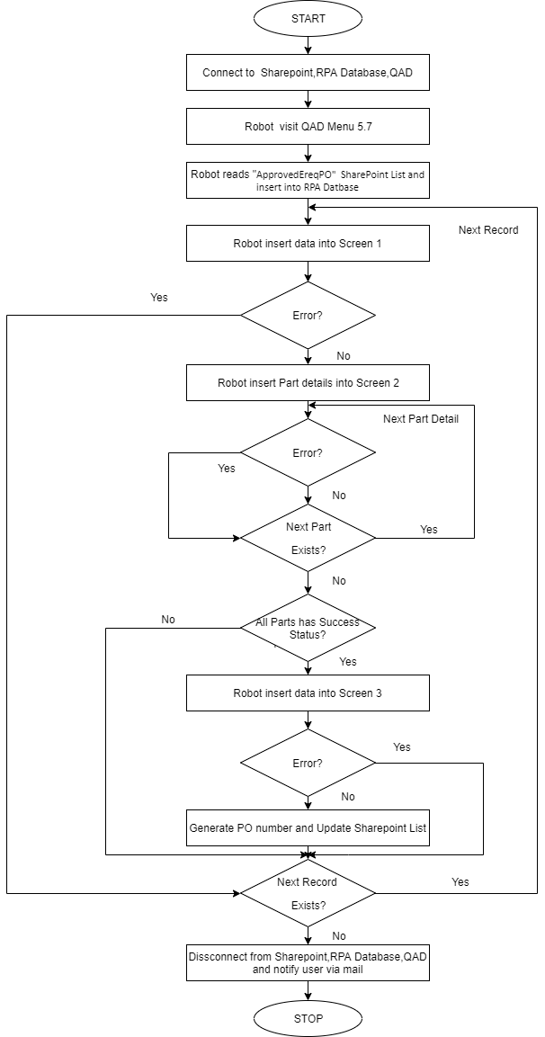

# 9 EXCEPTIONS

1. **Application Exception**

|  |  |  |
| --- | --- | --- |
| **SL NO** | **EXCEPTION** |  |
| 1 | Database connectivity issues | Connection has to be stable |
| 2 | QAD connectivity issues | Connection has to be stable |
| 3 | SharePoint connectivity issues | Connection has to be stable |

1. **Business Exception**

|  |  |  |
| --- | --- | --- |
| **SL NO** | **FIELD** | **EXCEPTION** |
| 1 | Supplier | Not a valid Supplier |
| 2 | Ship To | Ship To does not exist |
| 3 | Order Date/Due Date(invalid month) | Month of a date should be from 1 to 12 |
| 4 | Order Date/Due Date(Invalid day) | Day in a month is invalid |
| 5 | Order Date/Due Date(Invalid year) | Invalid period/year |
| 6 | Buyer | Value must exist in generalized codes |
| 7 | Site | Invalid Site |
| 8 | Project | Invalid Project |
| 9 | Currency | Invalid Currency Code |
| 10 | UM | Value must exist in generalized codes |
| 11 | Pur Account | Invalid account code |
| 12 | FOB | Value must exist in generalized codes |
| 13 | ShipVia | Value must exist in generalized codes |

# 10 PROCESS CONFIGURATION

1 - “Config.xlsx” Contains all the Config data like Menu Option, Sharepoint List Name etc. used in the Process.