

Netlink Tag linerev

World HQ: 999 Tech Row, Madison Heights, MI 48071, USA.

**E-Req and QAD Integration**

**Business Requirements Document**

July 2019

|  |  |  |  |  |
| --- | --- | --- | --- | --- |
| Date | Created by | Date | Reviewed By | Remarks |
| 05/07/19 | Kranti Batchala | 10/07/19 | Amit Sharma |  |
|  |  |  |  |  |
|  |  |  |  |  |
|  |  |  |  |  |

Contents

1. Executive Summary 3

2. Background 4

3. Objectives 4

4. Business Requirements 5

4.1. Application Integration 5

4.2. Master Data synchronization 5

4.2.1. Account Master 5

4.2.2. Cost Center 6

4.2.3. Project Code 7

4.2.4. Supplier Master 7

4.2.5. Ship Via 10

4.2.6. Buyer Code 11

4.2.7. FOB Point 11

4.2.8. Field Specifications 12

4.3. PO Creation 12

4.4. TAM (TRA Approval Matrix) 15

4.5. Non-Functional Requirements 15

4.5.1. Licensing 15

5. Changes to SharePoint 15

6. Assumptions 16

7. Timeline 16

8. Next Steps 16

9. Sign-Off 17

10. Annexure-1: Field Mapping 18

11. Annexure-2: TAM Module Business Requirements 21

11.1. Scope 21

11.2. Process Flow 21

11.2.1. High Level Business Flow Diagram 21

11.3. Business Requirements 22

11.3.1. Application / User Authorization 22

11.3.2. Admin Console 22

11.3.3. Admin Simulator 26

11.3.4. eReq and CEA Integration 28

11.3.5. Requestor Mapping 28

11.3.6. Notifications 29

11.4. Assumptions 29

# Executive Summary

In efforts to optimize the human efforts and help automate Canada’s business processes, Netlink proposes to integrate e-Req system with QAD, so that approved requisitions from e-Req system are automatically converted as Purchase Orders in QAD. This proposal also intends to keep e-Req system’s master data in sync with QAD’s master data. Additionally, for regulatory compliance and improved segregation of duties both e-Req and CEA are being integrated with a newly built TAM module.

An attended Bot will be made accessible to the business users to run this process as and when required.

# Background

Currently e-Req system captures indirect material requisitions. After a successful approval process, these systems generate PO Requisition. However, this PO requisition is manually entered into QAD. This leaves scope for delays in PO process and data inaccuracy. Also, updating of PO details in e-Req system fails many a times because of the Master data inconsistency.

# Objectives

* To provide an integration solution between e-Req system and QAD by synchronizing the below master data:
  + Account Master
  + Cost Center
  + Project Code
  + Supplier code
  + Ship Via
  + Fob Point
  + Buyer code
* To automating the PO creation process in QAD and update the e-Req system accordingly.
* To provide access to attended Bot to all business users involved with this process.

# Business Requirements

Business requirements are classified into 4 modules, namely:-

* Application Integration
* Master Data Synchronization
* PO creation
* PO update

## Application Integration

Below table describes the non-functional requirements to establish connectivity between e-Req system and QAD. Annexure-A defines the field mapping.

|  |  |
| --- | --- |
| Module | Requirement Description |
| QAD to e-Req | * Integration solution will read the master data/ PO data from QAD menus/ reports. |
| * This data will be transmitted and updated to e-Req system via SharePoint API services. |
| E-Req to QAD | * SharePoint APIs will read approved PO data in e-Req system. |
| * Using this data, POs will be created in QAD via QAD menus. |
| TAM | * E-Req system will have integration with TAM (TRA Approval Matrix) * CEA system will have integration with TAM (TRA Approval Matrix) |

## Master Data synchronization

### Account Master

New account codes created in QAD will be updated in e-Req system. This data is populated in Account drop down with active account code with description. Account code field to have defaulted value from Supplier master Purchase account. Account code can be changed by selecting a different one from the drop down list, if the user wish to change.

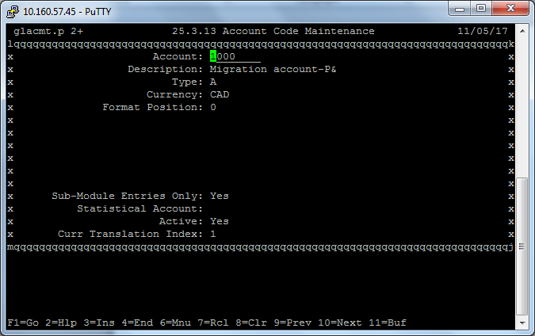

### Cost Center

New cost center codes created in QAD will be updated in e-Req system. Only active Cost Centers to be shown in the e-Req system.

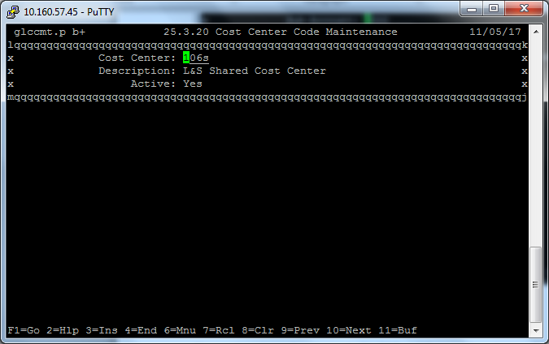

### Project Code

New project codes created in QAD will be updated in e-Req system. Only active Project codes to be shown in the e-Req system.

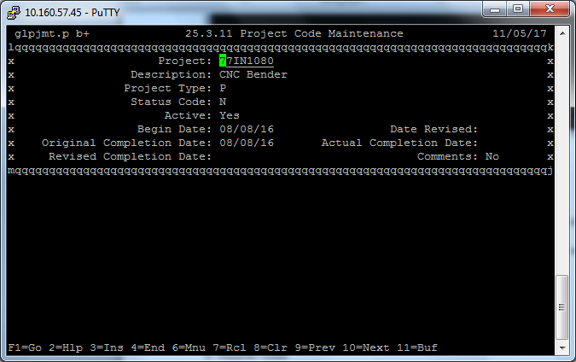

### Supplier Master

Supplier master is another critical information that needs to be in sync as and when a new Supplier is created and any update happens in QAD.

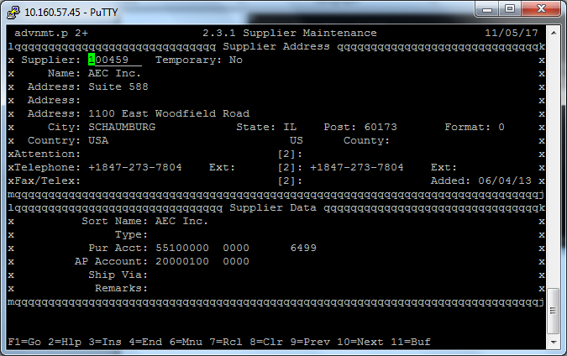

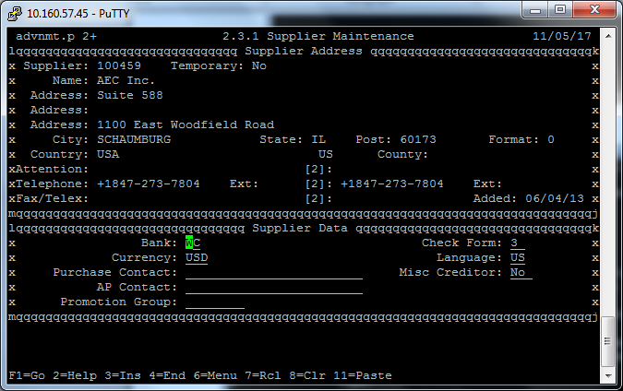

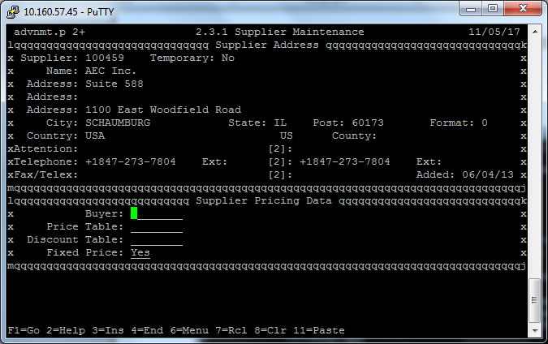

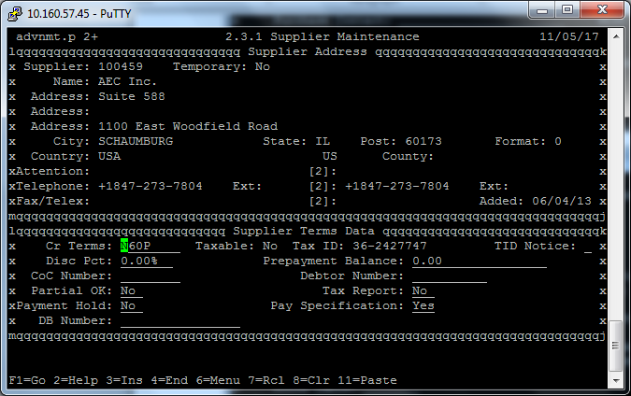

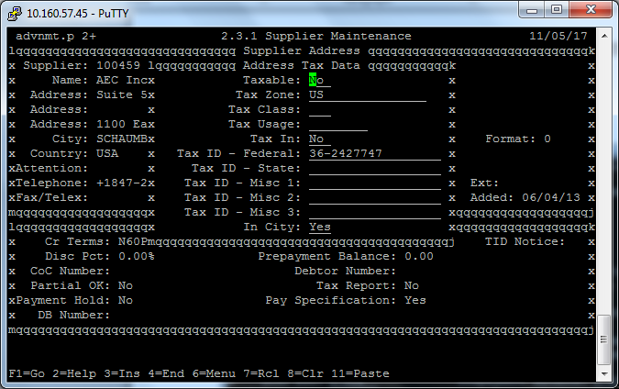

### Ship Via

New Ship Via codes created in QAD will be updated in e-Req system. Only active Ship Via options to be shown in the e-Req system.

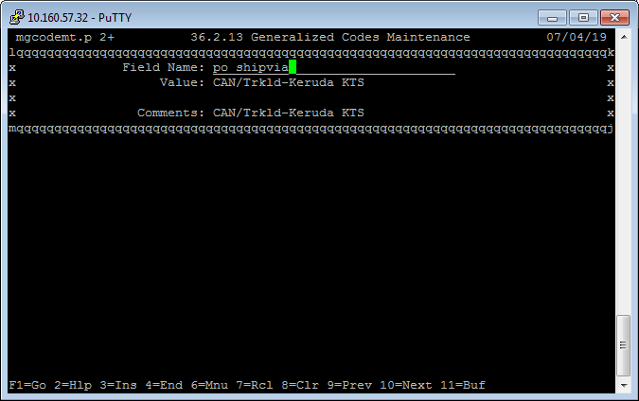

### Buyer Code

New Buyer codes created in QAD will be updated in e-Req system. Only active Buyer codes to be shown in the e-Req system.

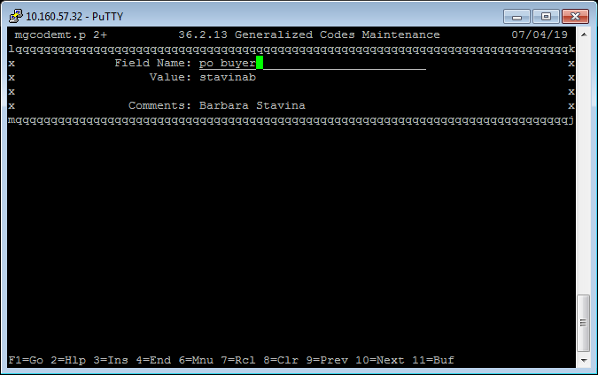

### FOB Point

FOB Point is mandatory for creating POs in QAD. Hence, this field needs to be created in e-Req system and keep this in sync with QAD FOB point.

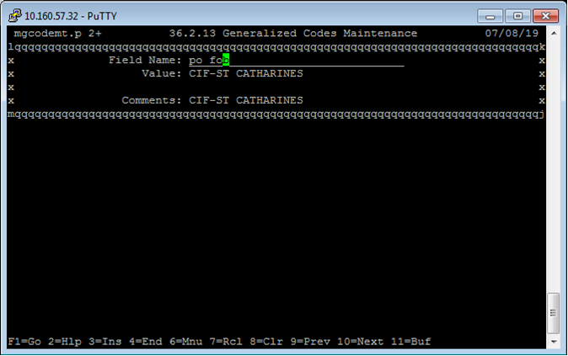

### Field Specifications

Attached as Annexure-A

## PO Creation

A Purchase Order needs to be created in QAD based on the requisition details entered in e-Req system. Only approved requisitions ( will be done via TAM) are considered for creating new POs.

* PO creation in QAD is done by RPA.
* Use a set prefix for PO number as below:-
  + Requisition number from St. Catharines Plant 1 should be “E”
  + Requisition number from St. Catharines Plant 2 should be “F”
  + Requisition number from Tillsonburg Plant 3 should be “G”

Below QAD menus will illustrate the PO creation process in QAD.

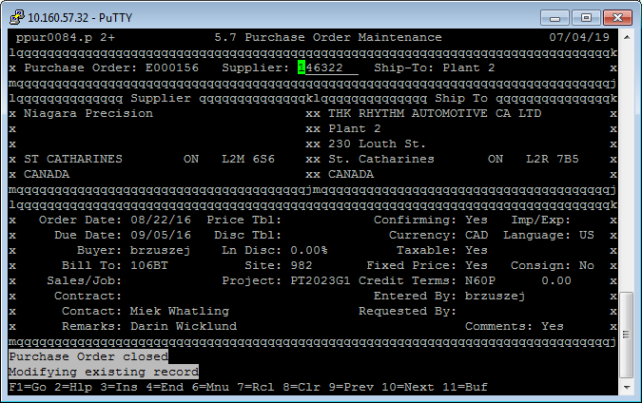

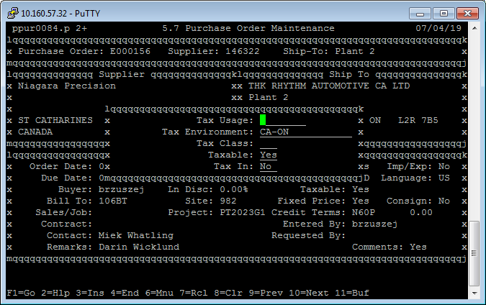

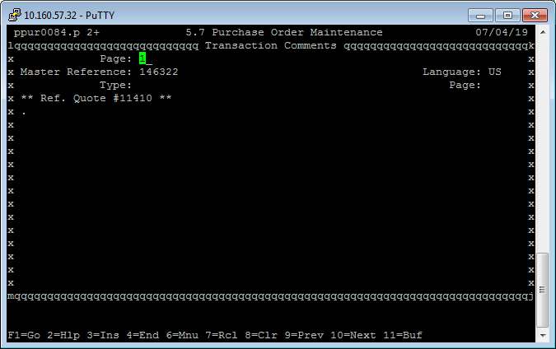

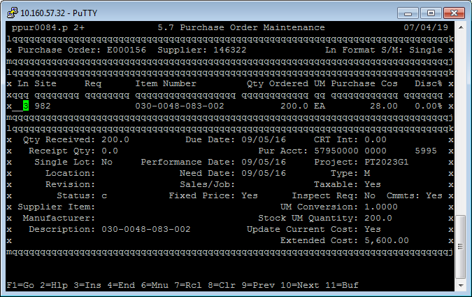

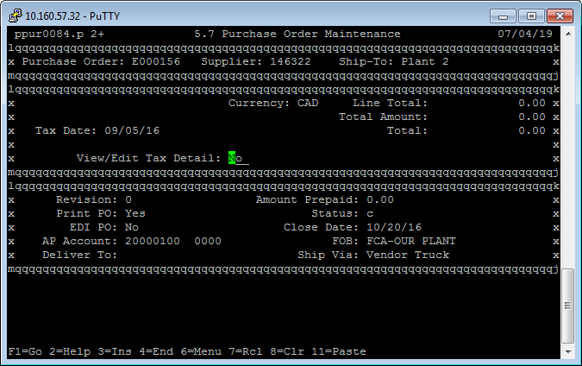

## TAM (TRA Approval Matrix)

Detailed Business requirements for TAM module is at Annexure-1

## Non-Functional Requirements

### Licensing

* Each attended Bot will need to be licensed.

# Changes to SharePoint

* Account Master – No Changes
* Cost Center – No Changes
* Project Code - Active/ Inactive to be added
* Supplier Master – Purchase Account, Credit Terms, taxable to be added
* Ship Via – Create a master list (Ship Via, Active/ Inactive)
* Fob Point – Create a master list
* Buyer code – Need to Active/ Inactive, Buyer code
* Output from E-Req should be Requisition number (Stop generating the PO number)

# Assumptions

* Business users will run this process using an attended Bot.

# Timeline

* This project is estimated to be delivered tentatively in 04 weeks from the date of start.
* Netlink will communicate the progress status on a weekly basis.

# Next Steps

|  |  |  |  |
| --- | --- | --- | --- |
| SNo | Action | Responsibility | EDC |
| 1 | Sign-off on BRD Document | THK Business / THK IT |  |
| 2 | Project Implementations | Netlink |  |
| 3 | Final UAT Testing and Sign-off | THK Business / THK IT |  |
| 4 | Production Launch | THK Business / THK IT / Netlink |  |

# Sign-Off

Use this section of the BRD for sign-offs on the requirements. Sign-offs should include the sponsor and representatives of the solution provider.

|  |  |  |  |  |
| --- | --- | --- | --- | --- |
| SNo | Document | Signed By | Date | Remarks |
| 1 | Sign-off |  |  |  |
|  |  |  |  |  |
|  |  |  |  |  |
|  |  |  |  |  |

# Annexure-1: Field Mapping

| **SNo** | **Label Name** | **Type** | **e-Req Field** | **QAD Menu** | **QAD Field** |
| --- | --- | --- | --- | --- | --- |
| 1 | PREQ Description |  |  |  |  |
| 2 | Site | list | Site |  |  |
| 3 | Ship to Address | list | Ship to Address |  |  |
| 4 | Requester |  |  |  |  |
| 5 | Requester Phone Number |  |  |  |  |
| 6 | Requester Email Address |  |  |  |  |
| 7 | Buyer | list | BuyerName | 3.2.13 | Comments |
| 8 | Buyer Code |  | BuyerCode | 3.2.13 | Value |
| 9 | Buyer Phone Number |  |  |  |  |
| 10 | Buyer Email Address |  |  |  |  |
| 11 | Supplier Name | list | SupplierName | 2.3.1 | Name |
| 12 | Supplier Code | List | SupplierCode | 2.3.1 | Supplier |
| 13 | Address Line 1 | list | Address1 | 2.3.1 | Address |
| 14 | Address Line 2 | list | Address2 | 2.3.1 | Address |
| 15 | Taxable | list | Taxable | 2.3.1 | Taxable |
| 16 | Currency |  | Currency | 2.3.1 | Currency |
| 17 | City |  |  |  |  |
| 18 | Zip |  |  |  |  |
| 19 | Country |  |  |  |  |
| 20 | Supplier Contact Name |  |  |  |  |
| 21 | Supplier Contact Phone Number |  |  |  |  |
| 22 | Supplier Contact Fax Number |  |  |  |  |
| 23 | Ship Via | list | ShipVia | 36.2.13 | Value |
| 24 | Credit Terms |  | CreditTerms | 2.3.1 | Cr Terms |
| 25 | Date Ordered |  |  |  |  |
| 26 | Due Date |  |  |  |  |
| 27 | Purchase Account | list | PurchaseAccount | 2.3.1 | Pur Acct |
| 28 | Cost Center/Dept | list | CostCenter | 25.3.20 | Cost Center |
| 29 | Comments to Buyer |  |  |  |  |
| 30 | Project Code | list | ProjectCode | 25.3.11 | Project |
| 31 | List Item Due Date |  |  |  |  |
| 32 | Line Items Type |  |  |  |  |
| 33 | Quantity |  |  |  |  |
| 34 | Unit of Measure |  |  |  |  |
| 35 | Unit Price |  |  |  |  |
| 36 | Grand Total |  |  |  |  |
| 37 | Account | list | Account | 25.3.13 | Account |
| 38 | Description |  |  |  |  |
| 39 | Reason for Supplier Selection |  |  |  |  |
| 40 | Approver Name |  |  |  |  |
| 41 | Approver2 Name |  |  |  |  |
| 42 | Approver3 Name |  |  |  |  |
| 43 | Approver4 Name |  |  |  |  |
| 44 | Approver5 Name |  |  |  |  |
| 45 | Approver6 Name |  |  |  |  |
| 46 | Approver7 Name |  |  |  |  |
| 47 | Approver8 Name |  |  |  |  |
| 48 | Approver Email Address |  |  |  |  |
| 49 | Approver2 Email Address |  |  |  |  |
| 50 | Approver3 Email Address |  |  |  |  |
| 51 | Approver4 Email Address |  |  |  |  |
| 52 | Approver5 Email Address |  |  |  |  |
| 53 | Approver6 Email Address |  |  |  |  |
| 54 | Approver7 Email Address |  |  |  |  |
| 55 | Approver8 Email Address |  |  |  |  |
| 56 | FOB | List | FOB | 36.2.13 | Value |

# Annexure-2: TAM Module Business Requirements

## Scope

Below table explains the scope of this business requirements document:

|  |  |
| --- | --- |
| Module | Requirement Description |
| TAM – Admin Console | * Admin will be able to configure custom approver levels based on cost center, plant/area of responsibility, amount limits |
| * Admin will be able to configure custom approval dimensions (Department wise, Plant wise etc.) |
| TAM – Simulator | * This module will help admin to simulate the approval matrix |
| Integrations | * eReq Integration |
| * CEA Integration |

## Process Flow

### High Level Business Flow Diagram

The below diagram represents the high level business flow

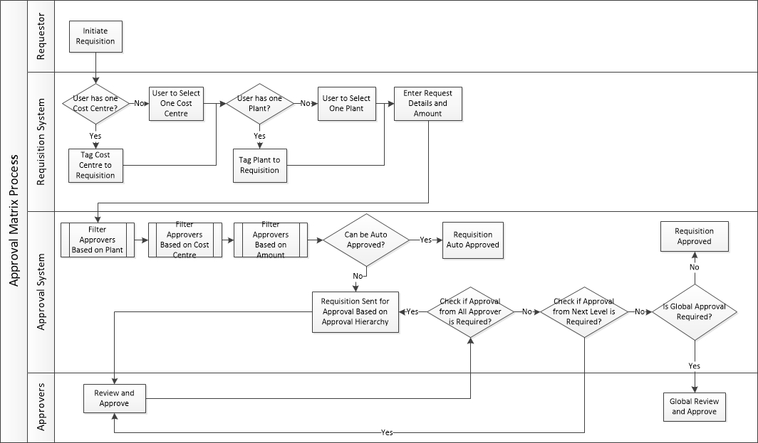

## Business Requirements

* Application Authorization
* Admin Console
* Admin Simulator
* eReq and CEA Integration
* Requestor Mapping
* Notifications

### Application / User Authorization

Authorization functions for eReq and CEA application will be updated to allow access to TAM admin users

|  |  |
| --- | --- |
| Module | Requirement Description |
| Application Authorization | * TAM admin user will get the access to Admin Console and Admin Simulator modules |

### Admin Console

|  |  |
| --- | --- |
| Module | Requirement Description |
| Admin Console | * Admin will be able to configure custom approval rules based on cost center / department, plant/area of responsibility, amount limits |
| * Admin will be able to configure custom approval dimensions (Department level, Finance level etc.) and should be able to edit or disable |
| * Admin will be able to change the level of approval dimensions, and accordingly the approval matrix rules will be updated and applied |
| * Admin will be able to configure the pending action reminder |
| * Admin will be able to configure auto approval rules based on cost center / department, plant/area of responsibility, amount limits |
| * Admin will be able to edit or disable the existing approval rule |
| * Admin will be asked if the new approval rule (after edit/disable) should be applied to existing requisition pending for the approval and If admin choose “Yes” all the pending requisition impacted by the updated rule should be updated with new approval matrix * In case of a new approval rule is added, it will be applied to the new requisitions created not on the existing requisitions |
| * Plant and Area matrix will be defined to be used in Approval matrix for Area of responsibility |

Admin Console Screens

Below is the Admin Console Screen for the Approval Matrix. Admin user have below functions:

* Add new approval rule
* Edit/Disable existing approval rule
* Add new approval dimension
* Edit/Disable existing approval dimension
* Change the approval dimension level and approval rules corresponding to that approval dimension
* View disabled approval dimensions and View disabled approval rules
  + User will be able to re-enable approval dimensions and approval rules
* Simulate approval matrix

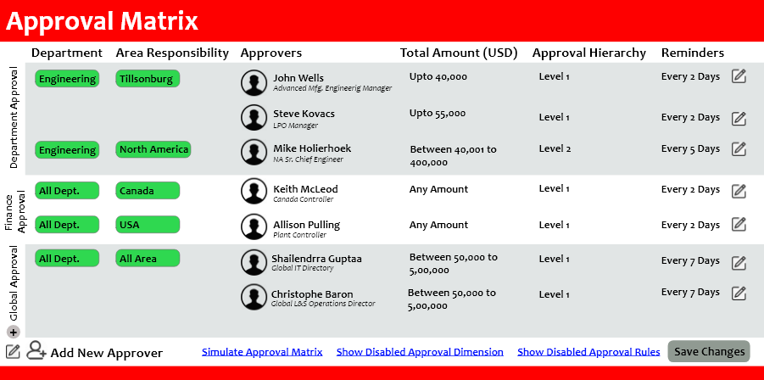

Admin – Add Approval Dimension Screen

Admin user should be able to add approval level

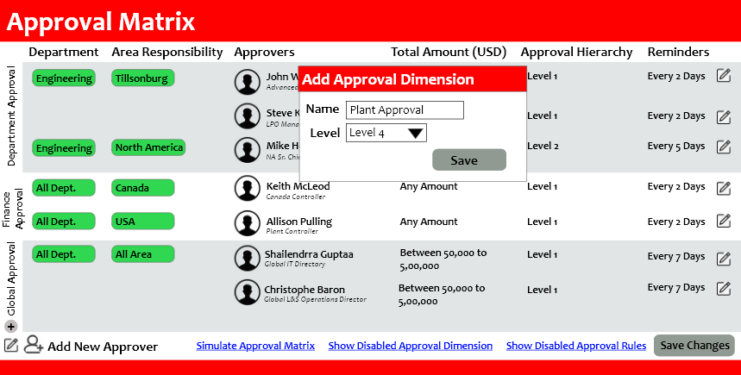

Admin – Edit / Disable Approval Dimension Screen

Admin user should be able to Edit / Disable approval dimension

* User will be able to edit Approval dimension name
  + No two approval dimensions can have same name
* User will be able to edit approval dimension level
  + No two approval dimension can be at same level
* To disable any approval dimension, all the underlying approval rules have to be disabled
* Once an approval dimension is re-enabled, user have to re-enable approval rules (they will not be automatically enabled)

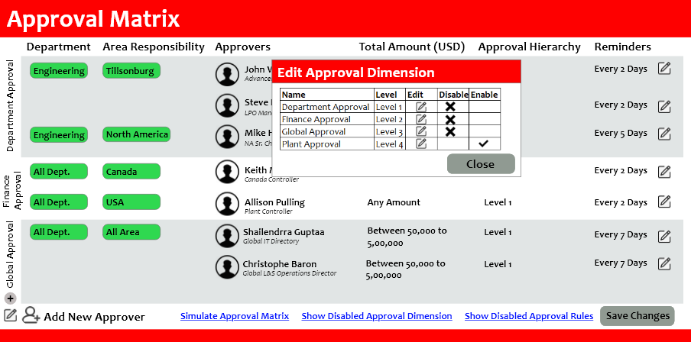

Admin – Add Approver Screen

Admin user should be able to add approval rules in any approval dimension

* For approval rule as auto approve, Approver field will be disabled

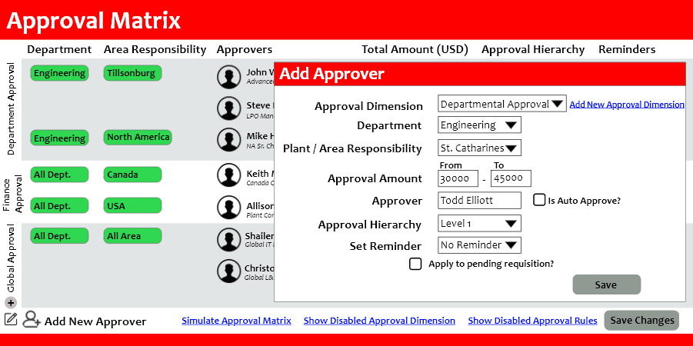

Admin – Edit / Disable Approver Screen

Admin user should be able to Edit / Disable approval rules in any approval dimension

* While editing / disabling approval rules, user can select “Apply to pending requisition” to update the pending requisition with new approval matrix

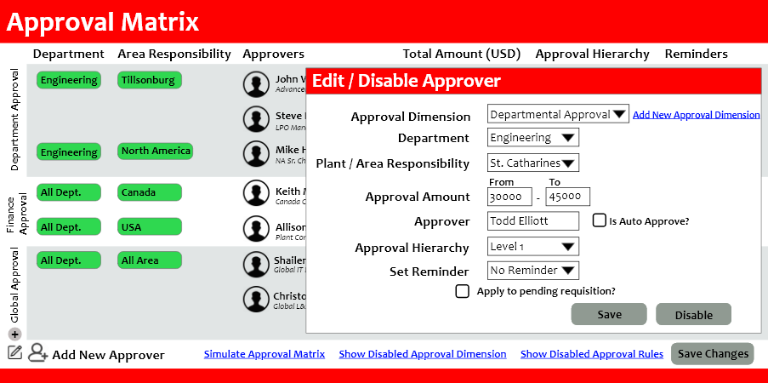

### Admin Simulator

|  |  |
| --- | --- |
| Module | Requirement Description |
| Admin Simulator | * TAM admin will be able to simulate the approval matrix |
| * Any approval matrix once configured will be in a draft mode for an admin to verify, as the verification is complete final approval matrix can be applied for business operations (user will be asked to apply approval matrix when user will click on Save Changes) |

Admin Simulator Screen

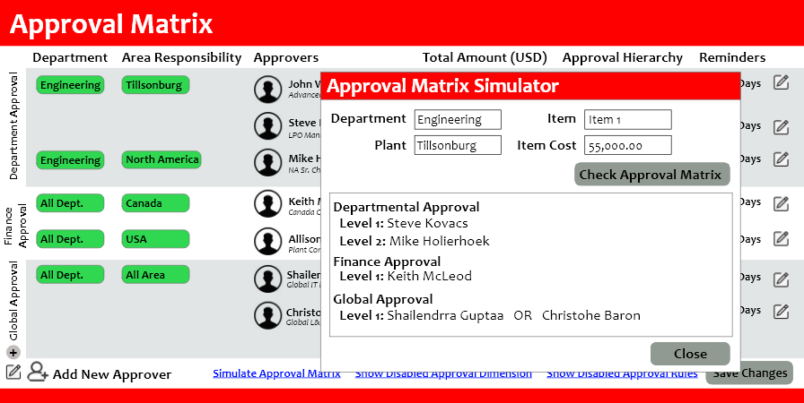

### eReq and CEA Integration

|  |  |
| --- | --- |
| Module | Requirement Description |
| eReq and CEA Integration | * TAM will be tightly integrated with eReq and CEA (with required updates in eReq and CEA) so that requester initiating any requisition will have visibility of the approval matrix |
| * If the approval matrix is updated, pending requisition approvers will not change until the TAM admin select the option to update pending requisitions with updated approval matrix or the approver selects option to update pending requisition while delegating approval responsibilities |
| * If approval matrix is not defined against a requisition, TAM will not allow the requisition to complete and a notification will be sent to TAM admin/concerned plant head for further necessary action |
| * Audit trails to be captured for all the requisitions at every approval/rejections, reminders sent and other necessary details |

### Requestor Mapping

|  |  |
| --- | --- |
| Module | Requirement Description |
| Requestor Mapping | * All the requestors will be mapped to cost centres and plant |
| * One time feed will be provided by TRA, and updates will be done via support requests as and when required |
| * Requestors with no available mapping will be shown with all the cost centres and plants, user can choose appropriate value at the time of requisition initiation |

### 

### Notifications

* Existing SharePoint notifications will continue as is
* Notifications for reminders will be setup
* Required Notifications for the TAM administrator will be setup

## Assumptions

* If any one of the approver approves from the same level then requisition will go-to next approval level or application approval dimension
* In this phase TAM will be integrated with eReq and CEA applications
* Approval delegation feature is not in the scope of current phase