# UiPath - Proof of Concept (POC)

This document serves as a guide for organizations preparing to conduct a UiPath POC. Included in this guide is a list of Frequently Asked Questions (FAQs) as well as a POC checklist to complete in advance of the POC start date.

**UiPath – POC FAQs**

## Q. What is a Robotic Process Automation (RPA) POC?

**A**. POC stands for Proof of Concept, in which either a UiPath developer or a Certified UiPath Partner Developer will

automate a process to showcase UiPath’s RPA capabilities.

## Note: A POC is not a commitment or agreement to automate a process for deployment in Pilot/Production.

**Q. Why is a POC done?**

**A**. A POC is done to showcase the UiPath platform’s capability to automate a process in the customer’s environment. In addition, the POC will demonstrate the RPA development process with UiPath Studio for pre-identified business use cases that include:

* Integration with underlying sub-systems
* Coverage over key technology and operations
* Integration with existing security architecture

## Q. What is not a POC?

**A**. A POC is NOT an engagement entailing:

|  |  |
| --- | --- |
| * An IT architecture review | * Process re-engineering assessment |
| * Client enterprise modeling | * A replacement for a production pilot   ▪ |

## Q. How long does a POC last?

**A**. As a guideline, UiPath are performed over 5-6 days. Through joint discussions, the client lead and pre-sales consultant along with the customer will determine the scope of the processes to be automated. Once this is determined, the RPA developer responsible for delivering the automations will sign-off on the final POC scope and deliverables.

## Q. What kind of processes are strong candidates for a POC?

**A**. Any manual, higher volume, repetitive, rules-based processes that require a human to interact with multiple systems while processing a transaction is ideal.

Note: Even if an entire critical process may not be able to be fully automated in 5-6 days, it should still be considered knowing key success criteria for the POC is experiencing the power and ease of use of UiPath’s automation capabilities interacting with multiple customer systems in context to a high-value business process.

## Q. How can a POC be delivered?

**A**. Remotely **–** Via secure access to the prospective customer’s systems.

## Q. What needs to be completed prior to the POC?

**A**. A POC Checklist on the next page details the steps needed to be completed prior to the POC. These items will be discussed on a pre-POC call that is conducted **at least 5 days before** the POC start date. The pre-POC call will enable all customer and UiPath participants sufficient time to complete any prerequisite work prior to the POC commencing.

# Proof of Concept Checklist

You will find some steps below that need to be taken prior to the Pre-POC call. The RPA Developer will check these requirements during the call, and if any are not met, your Proof of Concept may be delayed.

**Process Document** – This is a check that a Process Document detailing the steps of the automation process has been created and sent to the developer PRIOR to the Pre-POC call.

* The Process Document contains detailed steps and screenshots (sensitive data can be masked) that explain to the developer exactly how the process functions correctly.
* The process must be detailed very simply, such that someone looking at the process for the first time could understand the instructions.
* For example: Open Application in Internet Explorer. Click on Username field. Enter Username. Click on Password field. Enter Password. Click on “Login” button. Maximize window.
* The developer will analyze the scope of the given process to be automated and determine if it is feasible to complete within the allotted days of the POC. If it is not feasible to complete automation of the entire process within the allotted days, it is up to you and the developer to agree on a lesser scope.

**Remote Server Connection** -- Via secure access to the prospective customer’s systems.

**UiPath Studio Installation** – This is a check that UiPath Studio is installed on the machine to be used, has the correct licenses to run, and can interact with the applications involved in the process to be automated.

* Check that the latest version of UiPath Studio is installed on the machine.
* (optional) Check that trial licensing has been obtained from the UiPath Sales Rep or the UiPath website.
* Launch UiPath Studio and click on Blank Project. Name this project anything you want.
* Look for the Activities panel on the left side of the screen and search for the Message Box activity. Click and drag that message box activity into the middle of the screen.

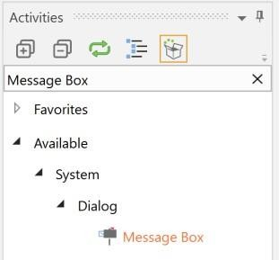 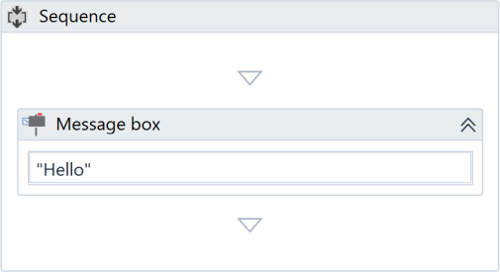

* Type “Hello” (including the quotation marks) into that message box activity.
* 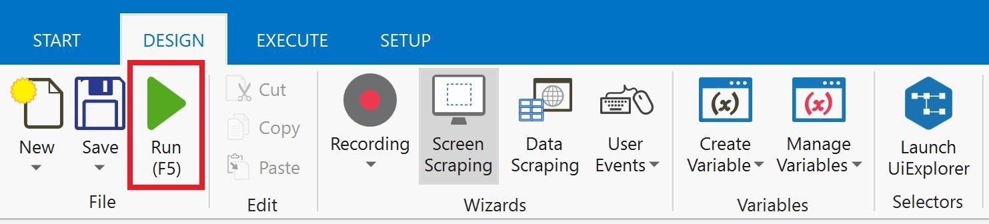Hit Run, which looks like a green Play button, at the top of the screen.
* If a message box containing the text “Hello” appears on the screen, then you are good to go!

**Environment Access Check** – This is a check that the developer has access to the systems and applications involved in the automation process, and that UiPath has access to the system and application selectors.

* Check that the developer has access to all systems and applications related to the automation process.
* Check that the developer has the necessary credentials to access these systems and applications.
* Check that UiPath selectors can interact with your systems and applications by following the instructions below:
* 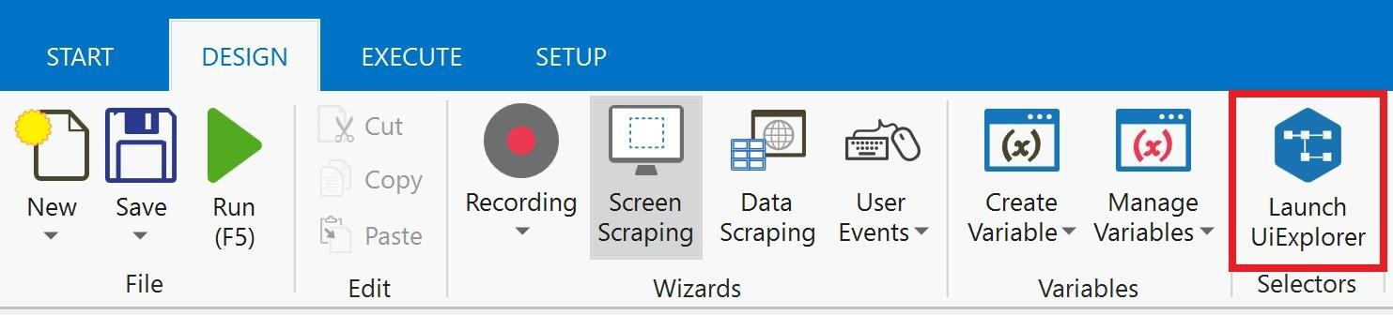Click on “Launch UiExplorer” at the very right of the menu at the top of the page.
* Click on the white cursor on the top left corner of the UiExplorer window that pops up.

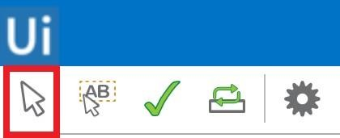

* Move your mouse around your application and check that blue boxes appear around the elements of your systems and applications. If your application isn’t on the screen after clicking the white cursor, simply press F2. You have 3 seconds to get your application on the screen before the UiExplorer activates again.
* If no blue boxes appear, this is okay. However, this will need to be communicated to the developer.
* Click on something that has a blue box around it and check that some code-like text appears in UiExplorer.
* Repeat the above steps for each application that will be used for the automation process.

**Subject Matter Expert Availability** – This is a check that a Subject Matter Expert will be available to be in the room with the developer for the duration of the POC. This is a legal issue – at no point should the developer be left alone with access to your system.

* A Subject Matter Expert of the process to be automated will be in the room with the developer for the duration of the POC.