**Process Name**

**Process Definition Document (PDD)**

Table of Contents

1. Document control 2

1.1 Version Control 2

1.2 Document Review and Sign-Off 2

2. General Process Description 2

2.1 Process summary 2

2.2 Data flow & applications 2

2.3 Process flow – AS-IS 3

2.4 Process flow – TO-BE 3

2.5 Business rules 4

3. Handling Events – Known, Unknown, and Other 4

3.1 Known Exceptions 4

3.2 Unknown Exceptions (Errors) 5

3.3 Other Events 5

4. Step-by-step process documentation 5

4.1 DESCRIPTION OF STEP 6

4.2 DESCRIPTION OF STEP 6

4.3 DESCRIPTION OF STEP 6

5. Additional Details 7

6. Additional Process considerations 8

7. APPENDIX – SAMPLE PROCESS DIAGRAMS 9

7.1 High Level Process 9

7.2 Detailed Process Flow 9

7.1 Detailed Process Flow – Cross-Functional 10

7.1 Value Stream Mapping 10

# Document control

## Version Control

|  |  |  |  |
| --- | --- | --- | --- |
| **Version** | **Date** | **Description** | **Author** |
| 1.0 |  |  |  |
|  |  |  |  |
|  |  |  |  |
|  |  |  |  |

*\*\* Only document version checkpoint when document shared with a primary stakeholder. \*\**

## Document Review and Sign-Off

|  |  |  |  |
| --- | --- | --- | --- |
| **Name** | **Business Role** | **Action** | **Date Reviewed** |
|  | Ex. Process SME | Ex. Signoff |  |

# General Process Description

## Process summary

Provide brief description of the business process.

## Data flow & applications

### Applications interacted with

|  |  |  |  |
| --- | --- | --- | --- |
| Application | Interface | Req Key / Operation / URL | Comment |
| *Ex. System A* | *Website? Hosted Citrix? Microsoft Application? Web Service API?* | *https://...* |  |
|  |  |  |  |
|  |  |  |  |
|  |  |  |  |

## Process flow – AS-IS

*\*\* Make sure to number steps corresponding with recording \*\**

*Include one or more of the following diagrams.*

1. *Process Flow*
2. *Process Flow (cross-functional) – “swim-lane” diagram*
3. *Value stream mapping, with timings (cycle time / duration)*

*In the diagrams, consider how to clearly highlight what process steps are manual (human execution), vs. automated.*

*What type of diagram should we use, and at what level of the process?*

* *Consider the objective of documenting the as-is process – to clearly describe what is happening today, and identify opportunities for improvement/automation. Choose diagrams that clearly highlight where automation could occur, and what potential work could be eliminated/improved through automation.*

*Example: (See Appendix for additional samples)*

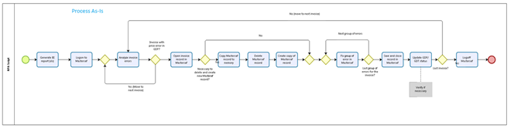

## Process flow – TO-BE

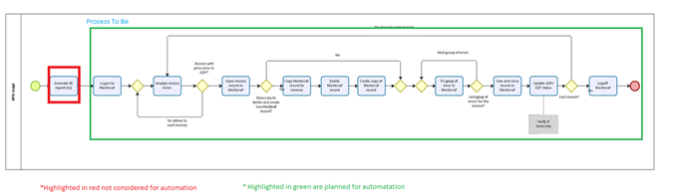

## Business rules

*\*\* Business rules should be captured and related to the screen recording steps to which they pertain \*\**

# Handling Events – Known, Unknown, and Other

There are (3) different types of ‘Events’ that could occur within the processing, that the Bot may need to handle.

1. **Known Exceptions** - expected behaviors or validations that fail as part of the normal process work flow. (E.g. login into one of the core applications failed, navigation to a specific page within the core application failed or timed-out).
2. **Unknown Exceptions** **(ie. Errors)** - refer to exceptions that are not expected and can occur due to multiple reasons (E.g. network outage, core application crash, etc.). These are captured in ‘Error Handling’ commands.
3. **Other Events** - Other events that could provide additional process insight.

## Known Exceptions

The following table contains process exceptions that this process may encounter.

|  |  |  |
| --- | --- | --- |
| **Event Code** | **Description** | **Action** |
| Ex. EXCEPTION_001 | ID value is invalid. | Log the exception.  Notify abc@company.com |
| EXCEPTION_002 | System ABC is not available | Log the exception.  Notify abc@company.com |
| EXCEPTION_003 |  |  |
| EXCEPTION_004 |  |  |

## Unknown Exceptions (Errors)

‘Unknown Exceptions’ are exceptions that might occur during processing, that were expected and therefore not identified previously. These codes will be identified by ERROR_XYZ, and will be documented in the Technical Design Document (TDD).

## Other Events

|  |  |  |
| --- | --- | --- |
| **Event Code** | **Description** | **Action** |
| EVENT_001 |  |  |
| EVENT_002 |  |  |
| EVENT_003 |  |  |
| EVENT_004 |  |  |

# Step-by-step process documentation

*\*\* Include the step by step screen shots or PSR recording here. With each step the following should be considered and documented as applicable:*

1. *Number each step and substep so that they appear in the table of contents (at least to the first substep level, further if it makes sense)*
2. *Document the business rules, key data elements and relevant data validations associated with each step*
3. *Make special note if citrix or terminal emulation is involved in a step. If citrix, is it a published application or part of a published desktop?*
4. *Exceptions and other information of potential interest. There should be consideration for a default action if an unexpected/unknown error occurs.*

## DESCRIPTION OF STEP

*Ex. Consider using Windows ‘Step Recorder” application to include the specific execution steps with screenshots.*

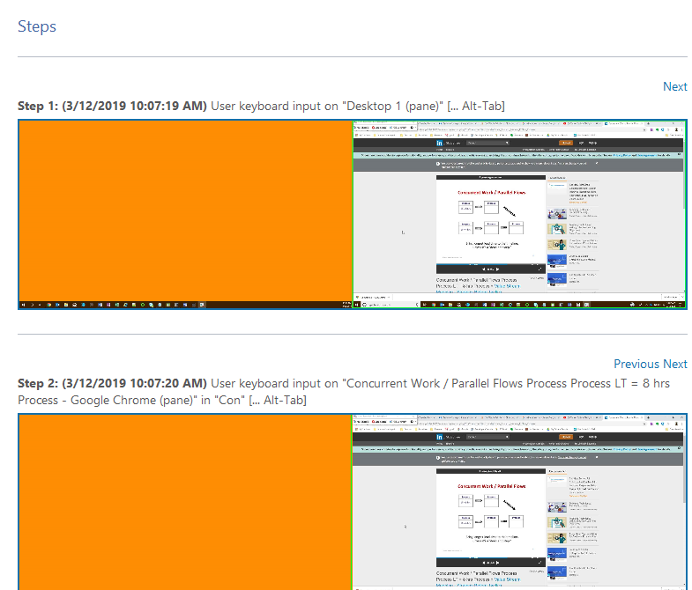

## DESCRIPTION OF STEP

## DESCRIPTION OF STEP

# Additional Details

*Ex. Include “Additional Details’ from Windows ‘Step Recorder” application.*

The following section contains the additional details that were recorded.

These details help accurately identify the programs and UI you used in this recording.

This section may contain text that is internal to programs that only very advanced users or programmers may understand.

Please review these details to ensure that they do not contain any information that you would not like others to see.

*Recording Session…*

# Additional Process considerations

Process Questionnaire:

|  |  |
| --- | --- |
| Question | Answer |
| What is current Schedule of execution? | Frequency: x times / month  Start Time: |
| What is the average volume of Transactions for given frequency? |  |
| How long does it take to go through one Transaction/Cycle? | Avg x mins. |
| How many Persons execute process concurrently currently? | X people |
| Can multiple instances of process execute concurrently? Do the Systems/Apps support that? |  |
| Is there a Service Level Agreement (SLA) in place? If yes, describe the key terms. |  |
| Does process involve Personally Identifiable Information (PII)? |  |
| What are the main goals/targets? | Faster execution  Error Reduction/High Accuracy  Higher up time/Multiple executions  Timely completion |
| Is this process event triggered, time/day triggered, or as needed? |  |
| Would more frequent execution of this process yield any incremental value? |  |
| What is the measure of successful execution of this process? |  |
| What are the failure points for this process, and how is each handled? |  |

# Appendix – Sample Process Diagrams

*Which diagram(s) should I use? Consider factors such as the following:*

* Is the work done by a single role/function, or multiple (cross-functional)
* Is the work linear, or are there parallel activities?
* Does all work follow the same path, or are there multiple paths / exceptions?
  + If multiple, what % of the work follows each path?
* If seeking reduced cycle time, how long do process steps take? Which are manual, vs. currently automated?
* What type of diagram will most clearly highlight the opportunities for improvement from RPA automation?

## High Level Process

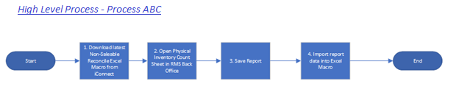

## Detailed Process Flow

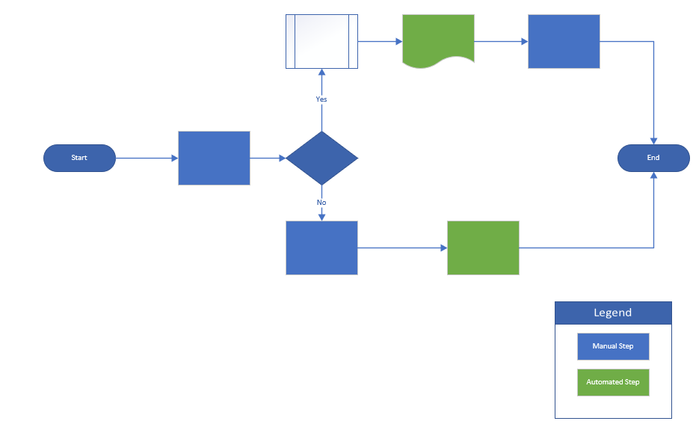

## Detailed Process Flow – Cross-Functional

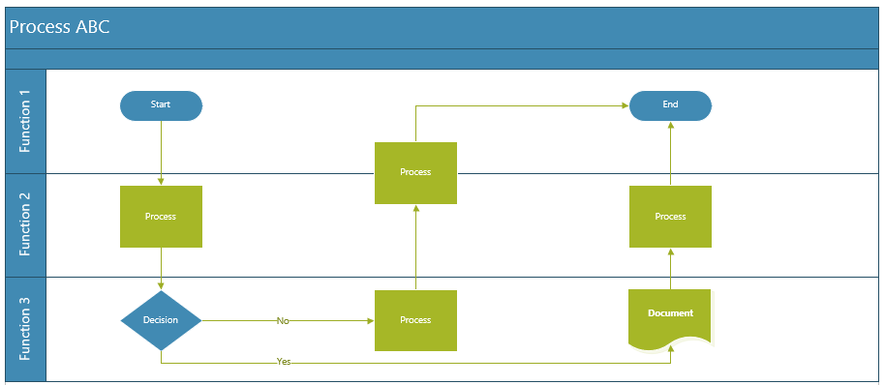

## Value Stream Mapping

