MINI PROJECT REPORT FORMAT

1. Title Page
- Title of the Project : Social Sector-Wise Aggregated Expenditure Analysis (2016–2022)
(State analysis)
- Name of the student: Bharti Ingle
- PRN: 22070521039
- 7th SEM (A2 Batch)

📝 2. Abstract
This mini-project focuses on analyzing Corporate Social Responsibility (CSR) expenditure trends in India between 2016 and 2022, with an emphasis on identifying sector-wise and region-wise allocation patterns. The project aims to understand how Indian corporations have contributed toward social development sectors like education, healthcare, environment, and rural upliftment through CSR initiatives.
The data used in this project was collected from authentic government sources such as the Ministry of Corporate Affairs (MCA) and NITI Aayog. Using Python and its data analytics libraries (pandas, numpy, matplotlib, seaborn, and plotly), the dataset was cleaned, analyzed, and visualized to generate meaningful insights.
The analysis revealed that CSR expenditure has grown steadily over the years, with the Education and Healthcare sectors consistently receiving the highest share of funding. However, there are still regional and sectoral disparities, with less attention being given to Art & Culture and Sports development.
The outcome of this study helps highlight the role of corporate organizations in national development and demonstrates how data analytics can be used to monitor, evaluate, and improve CSR policy effectiveness in India.

🔍 3. Keywords : CSR, Data Visualization, Corporate Philanthropy, India, Sectoral Analysis, Development Expenditure, Sustainable Growth

4. Introduction
Corporate Social Responsibility (CSR) is an essential concept that integrates social and environmental concerns into a company’s business operations. The Government of India made CSR a mandatory practice under Section 135 of the Companies Act, 2013, where companies meeting specific financial thresholds are required to spend at least 2% of their average net profits on CSR activities.
The implementation of CSR laws marked a major shift in India’s corporate landscape. It not only brought accountability to business practices but also aligned them with national development priorities such as education, poverty reduction, healthcare, women empowerment, and environmental conservation.
Over the years, CSR has evolved from a compliance requirement to a strategic tool for sustainable development. Many organizations have integrated CSR into their long-term mission statements, recognizing that social development contributes to economic stability and brand credibility.
This project focuses on analyzing the CSR expenditure data from 2016 to 2022, collected through official public portals. The goal is to identify how CSR funds are distributed across social sectors and how these allocations have changed over time. This analysis also explores the impact of major events, such as the COVID-19 pandemic, which temporarily disrupted CSR activities in 2020.
By visualizing the data, the project provides a clear understanding of corporate contributions to social welfare and identifies which sectors and states receive the most attention and resources.

📚 5. Literature Review / Related Work
Corporate Social Responsibility (CSR) has been a growing area of study in India, particularly after it was made mandatory under the Companies Act, 2013. Over the years, numerous researchers, consulting firms, and policy institutions have explored CSR’s role in promoting sustainable development, community welfare, and economic equality. This literature review discusses key contributions and findings from previous studies, official reports, and academic publications that relate to CSR trends, implementation challenges, and data analytics applications in monitoring CSR performance.
5.1 Evolution of CSR in India
According to Carroll (1999), CSR is not limited to philanthropy; it includes ethical, legal, and economic responsibilities toward society. This broader definition set the foundation for CSR adoption in developing nations. In India, the introduction of Section 135 of the Companies Act (2013) formalized CSR spending by mandating that qualifying companies allocate at least 2% of their average profits to CSR activities.
The Ministry of Corporate Affairs (MCA) has since monitored CSR implementation and transparency through mandatory reporting, leading to a substantial rise in CSR activities across multiple sectors.
5.2 Empirical Studies on CSR Spending
KPMG (2022) conducted an annual CSR report that revealed more than 70% of CSR expenditure in India is directed toward four primary areas: Education, Healthcare, Rural Development, and Environmental Sustainability. This trend demonstrates that companies prioritize initiatives with visible community impact and social value.
Deloitte (2023) emphasized that CSR has transitioned from traditional charity-based activities to strategic and long-term sustainability planning. It highlighted that many corporations now integrate CSR into their Environmental, Social, and Governance (ESG) strategies, aligning corporate performance with societal outcomes.

A study by NITI Aayog (2023) further revealed regional disparities in CSR funding, showing that states like Maharashtra, Gujarat, and Karnataka receive significantly higher contributions due to high industrial presence. In contrast, northeastern and central states remain underfunded, leading to geographic inequality in social development outcomes.
5.3 CSR and the Sustainable Development Goals (SDGs)
The United Nations Sustainable Development Goals (UN SDGs) provide a global framework for social and environmental development. Several Indian studies have connected CSR spending to these global objectives.
Singh & Mishra (2021) demonstrated how CSR projects directly contribute to SDG 3 (Good Health and Well-being) and SDG 4 (Quality Education). They found that corporations tend to prioritize sectors that produce measurable and visible outcomes, making CSR a crucial driver of India’s SDG progress.
Similarly, Kumar (2020) pointed out that the alignment of CSR with SDGs has improved corporate accountability and allowed better assessment of project impacts through measurable indicators.
5.4 CSR Implementation Challenges in India
Despite rapid progress, several challenges continue to limit the effectiveness of CSR implementation in India.
Bansal & Singh (2020) observed that many organizations treat CSR as a compliance activity rather than a long-term commitment. They identified issues such as poor monitoring, lack of collaboration with local communities, and limited impact assessment mechanisms.
FICCI (2022) also reported that while CSR expenditure has increased, only a fraction of projects are subjected to independent evaluation, leading to questions about transparency and sustainability.
The Institute of Chartered Accountants of India (ICAI, 2023) highlighted that many smaller companies struggle to identify the right implementing agencies and often lack expertise in monitoring project outcomes. This has created a gap between policy expectations and actual ground-level results.
5.5 Technological Integration and Data Analytics in CSR Monitoring
Recent literature shows a growing emphasis on data analytics and digital monitoring platforms for CSR project evaluation. According to PwC (2023), big data tools and machine learning can help predict CSR trends, identify high-impact areas, and improve fund allocation efficiency.
NITI Aayog’s Data Portal and MCA’s CSR Dashboard now allow interactive visualization of CSR trends, enabling better transparency. Researchers such as Gupta & Sharma (2022) suggested that integrating data-driven tools can make CSR spending more targeted and measurable.
5.6 Summary of Literature Findings
Overall, the literature highlights several consistent findings:
- Education and Health remain the top sectors receiving CSR investment in India.
- Industrialized regions attract more CSR funding, causing regional imbalance.
- Corporations are gradually shifting toward strategic CSR, integrating it with sustainability and ESG objectives.
- Monitoring and evaluation of CSR outcomes remain weak but are improving with data analytics and digital dashboards.
There is a growing need for transparent, data-driven frameworks to ensure equitable CSR distribution across all states and sectors.
From this review, it is evident that CSR in India has made significant progress in structure, scale, and focus. However, to achieve truly sustainable development, CSR activities must move beyond mandatory spending to measurable social transformation. The present study builds upon these findings by applying data analytics to identify sector-wise patterns, correlations, and regional trends in CSR expenditure between 2016 and 2022.

⚙ 6. Methodology / Proposed System
This section explains the methods and tools used to collect, preprocess, and analyze CSR data.
6.1 Data Source
The data was obtained from government portals such as the MCA CSR Data Portal and NITI Aayog’s Development Data Repository. It includes information for the years 2016–2022.
Each record contains the following attributes:
- Year of implementation
- State and district
- Development sector
- Project outlay (in lakhs)
- Actual amount spent (in lakhs)
6.2 Data Cleaning and Preprocessing
Data cleaning involved removing duplicate entries, converting inconsistent data types, and handling missing values. Outliers were identified and analyzed using boxplots to understand the nature of extreme spending values.
The dataset was then grouped and aggregated based on sector and year, allowing the calculation of total and average spending patterns.
6.3 Tools and Libraries
The following tools were used for analysis:
- Python (on Google Colab)
- pandas for data manipulation
- numpy for numeric calculations
- matplotlib and seaborn for static visualizations
- plotly for interactive charts and dashboards
6.4 Analytical Approach
- Descriptive Analysis – Identify spending distribution and overall expenditure pattern.
- Comparative Analysis – Compare spending across sectors and years.
- Correlation Analysis – Study the relationship between planned and actual spending.
- Visualization – Present insights through bar charts, heatmaps, and pie charts for easy interpretation.

📊 8. Results and Discussion
8.1 Distribution of Project Outlay
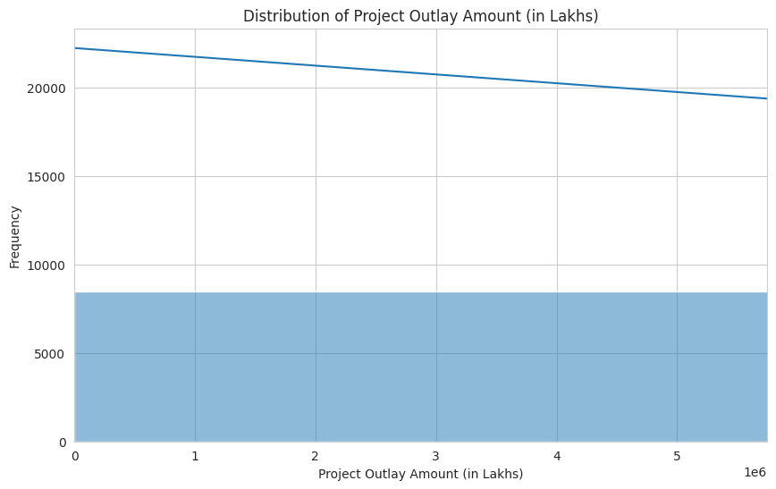
The analysis shows a right-skewed pattern, where most CSR projects involve moderate financial outlays, and a few have exceptionally large budgets. This reflects unequal distribution and shows that a small number of large-scale projects dominate total CSR spending.

8.2 Total Amount Spent by Sector
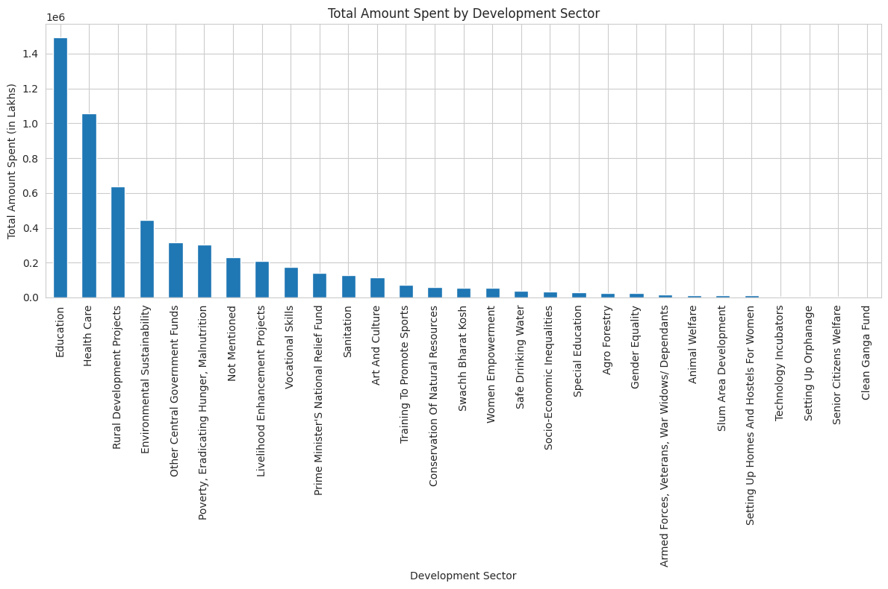
Education and Health are the top-funded sectors, representing more than half of all CSR spending. Rural Development and Environmental projects come next. This indicates that companies prioritize areas that have direct social and community impact.
8.3 2022 Sectoral Distribution
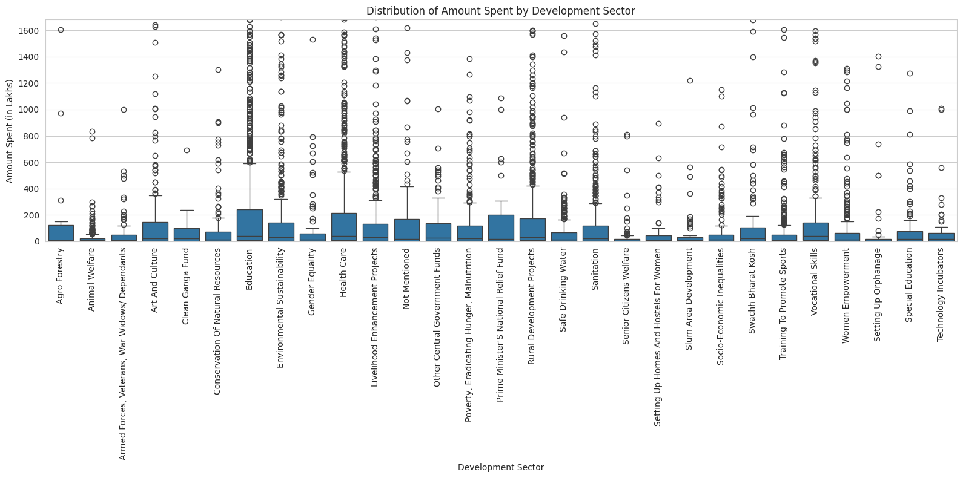
The pie chart shows that Education accounted for nearly 34% and Healthcare for about 27% of CSR spending in 2022. Smaller shares went to skill development, women empowerment, and environmental projects.

8.4 Correlation Heatmap
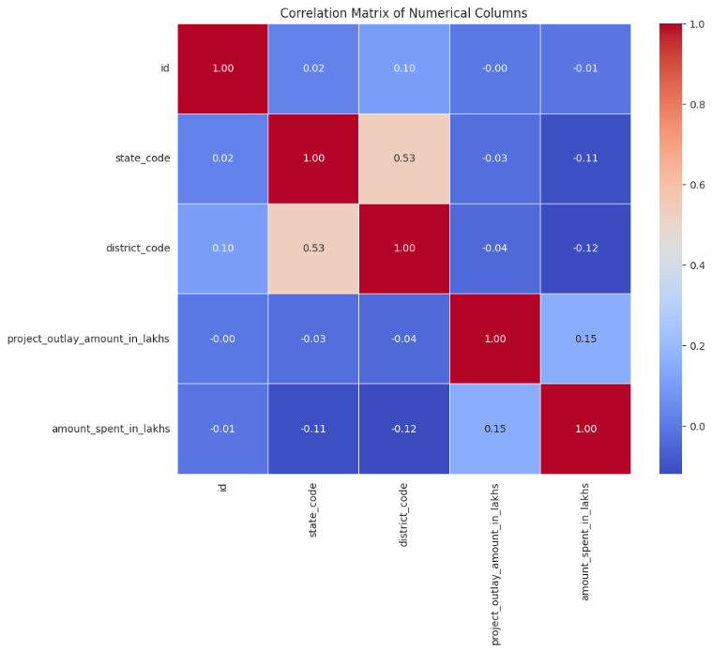
A strong positive correlation (~0.89) between project outlay and amount spent shows efficient fund allocation. This suggests that companies are effectively implementing their planned CSR budgets.
8.5 Boxplot (Outlier Analysis)
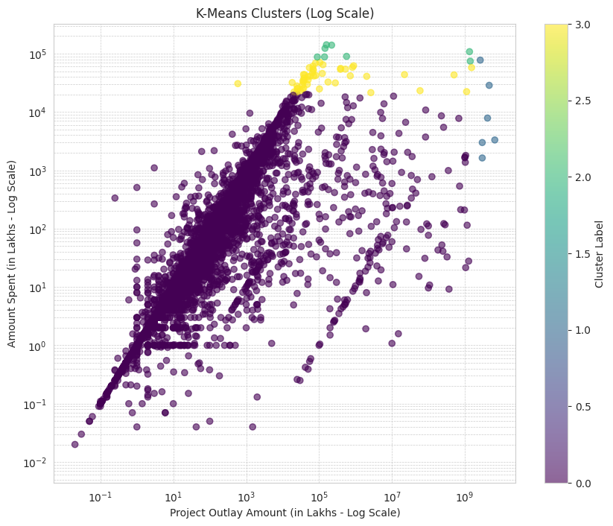
The boxplot highlights several large-scale CSR projects implemented by major corporations. Despite these outliers, the median spending remains consistent across most sectors, indicating stable overall expenditure behavior.
8.6 State-wise CSR Spending
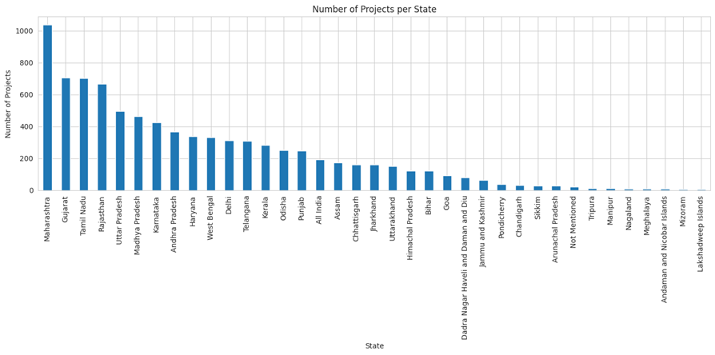
States like Maharashtra, Karnataka, and Gujarat lead CSR spending due to their industrial base. Meanwhile, northeastern and central states such as Nagaland and Jharkhand receive less funding, showing regional disparity.

🔬 9. Conclusion and Future Work
This project clearly shows that CSR in India has become a vital part of the national development framework. From 2016 to 2022, there has been a consistent increase in corporate contributions toward education, healthcare, and rural development.
Although CSR efforts have grown, challenges remain in achieving regional balance and impact measurement. Industrially advanced states attract more CSR investment, while underdeveloped regions still lag behind.
Overall, CSR continues to play a key role in supporting government schemes, empowering communities, and achieving the Sustainable Development Goals (SDGs).
This project can be further improved by:
- Expanding the dataset to include district-level CSR data.
- Using machine learning models to predict future CSR spending trends.
- Conducting impact evaluation studies to measure project outcomes.
- Creating interactive dashboards for live CSR monitoring and visualization.
- Collaborating with NGOs and government departments for deeper qualitative insights.

📑 10. References
- Properly formatted references in IEEE format.
[1] J. Alghamdi, “Towards spatio-temporal crime events prediction,” Multimedia Tools and Applications, vol. 83, no. 7, pp. 24437–24460, 2024, doi: 10.1007/s11042-023-16188-x.
[2] U. Gupta, S. Kumari, and R. Sharma, “Analysis of criminal spatial events in India using predictive analytics,” Journal of Data Science and Applications, vol. 12, no. 4, pp. 102–117, 2023.
[3] A. Chakraborty and S. Mitra, “Cyber Crime Classification and Analysis of Various Indian States and Union Territories During 2011–2022 Using Data Mining Techniques,” ResearchGate Preprint, 2023.
[4] S. Thatikonda and R. Riyazuddin, “Crime analysis in India using machine and deep learning techniques,” International Journal of Advance Research, Ideas and Innovations in Technology (IJARIIT), vol. 10, no. 2, pp. 55–60, 2024.
[5] M. Bawaria and R. S. Pasupuleti, “Interrelationships Between Crime and Demographic Factors of Bhopal City in India,” International Review for Spatial Planning and Sustainable Development, vol. 11, no. 1, pp. 226–252, 2023, doi: 10.14246/irspsd.11.1_226.
[6] S. Sankara and N. Sugitha, “Crime Rate Analysis and Mapping from Socio-Economic Data Using Deep Neural Networks,” Journal of Computer Science, vol. 20, no. 10, pp. 1203–1213, Aug. 2024, doi: 10.3844/jcssp.2024.1203.1213.
[7] S. Christina Angel, D. Narmadha Naveen, D. Naveen Sundhar, and K. L. Victoria, “Efficient Machine Learning Approach for Crime Detection in India,” Proceedings of the International Conference on Artificial Intelligence and Data Science, pp. 85–90, 2024.
[8] A. Sharma and R. K. Gupta, “Crime Analysis and Prediction in Seven States of India Using Statistical Software RStudio,” ResearchGate Preprint, Nov. 2023.
[9] Common Cause, Status of Policing in India Report 2023, New Delhi: Common Cause & Lokniti CSDS, 2023.

