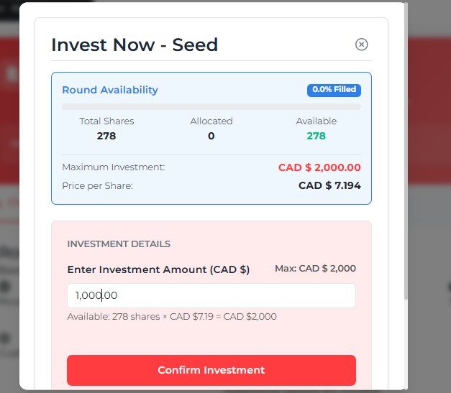
Investor:
When an investor is about to invest in a round, a popup will appear showing how many shares are left in that round and how much they can invest.
Note for capavate

For a Canadian-incorporated company raising a funding round in USD, the exchange rate to use for cap table purposes should be the rate on the transaction (closing) date of the investment, not the date you receive or later convert the funds. All amounts on Canadian corporate records, including your cap table and share issuances, must be reported in Canadian dollars, so the USD investment amount gets converted at the official exchange rate on the transaction day—the day shares are issued to the investor.
This rate can be sourced from the Bank of Canada’s official daily rate, and it's important that you document which rate and date were used in your records for transparency and consistency. If the closing happens over several days or in tranches, you use the exchange rate for each specific closing or tranche date.

Query:
For a Canadian-incorporated company:
(How will we know it is a Canadian company? Because we will convert the money from USD to CAD.)
Suppose a company chooses USD as the currency for a particular funding round. In that case, we can convert that round’s amount from USD to CAD, but for a Canadian-incorporated company, explain or suggest something for this.

We will ALWAYS display the currency in which the company is raising that round. For example, if a Canadian company is raising the round in USD, then the currency in the pop-up should also be in USD. This is because when the investor wires in the funds, it will have to be in USD. They will deal with the final exchange rate at their bank.

Question for our internal discussion: should we include a ‘approximate’ local currency for reference purposes to the investor? For example, if the investor is based in England (we should know this via his registration), then we may present (in small letters), the approximate amount in Pounds at the bottom of the field?

Query: How will the money be funded to the company?
We can only display whole (integer) numbers.
From our side, everything is set so that the amount will be converted based on the exchange rate of the day the investment is completed, according to the Bank of Canada.
But how will this happen?
- The investor enters the amount and signs off on the terms sheet, subscription document, amount entered. (we will need a paragraph that the investor accepts before signing).
- The company wiring instructions will be displayed on the next screen, along with confirmation email of the term sheet, subscription document and the digital signature sent to the investor email address.
- The investor wires the funds (offline).
- Once the funds are received and confirmed by the company, the signatory will log in to the system and ‘confirm’ the investment from the investor.
- This action by the signatory will update the cap table accordingly. (we need to discuss whether the cap table is updated at the time of confirmation OR at the close of the round by the signatory).

Company End:
Investor portal:
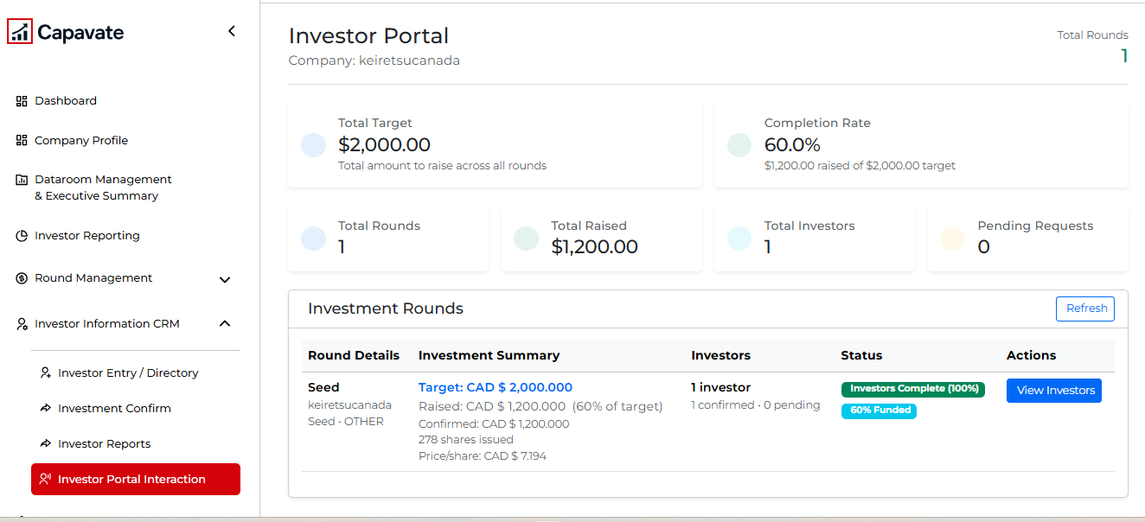

For now, this is a single round. But when there are multiple rounds and each has a different currency, then how should we display the currency in Total Target and Total Raised?
For a single round, we can handle it easily, but when we calculate the total of all rounds together, which currency should be displayed?

We can discuss this in further detail on our call.

