The main company login is done only by the signatory or the owner, because users register on the platform and then log in to create multiple companies. After that, in each company, the user can add only two signatories
CORRECT.
The signatory logs into the company account and adds multiple investors. Then the company/signatory can share multiple rounds or reports with the investors.
CORRECT. Also, only the signatory (this can also be the ‘owner’) can start/edit/adjust/close/confirm investors in a round. No one else can do this.
Important note for implementation:

When a fundraising round is shared with investors, they are invited to review the following materials:
- Executive summary (auto-generated by the system)
- Term sheet (uploaded by the signatory)
- Subscription document (uploaded by the signatory)
- Round details (system data)

Investors can then take one of two actions by signing:

1. **Soft Circle Interest** – The investor indicates an intended investment amount to show interest, but this is not a firm commitment. It signals that they want further discussion with the signatory or company before committing.

2. **Commit to Invest** – The investor confirms a specific investment amount and is granted access to the company’s bank/wire information to send funds offline.

Once the company confirms receipt of the funds (outside the platform), the signatory logs back into the system to “secure” that investor. This action finalizes the investor’s participation and automatically updates the company’s cap table.

Round 0:
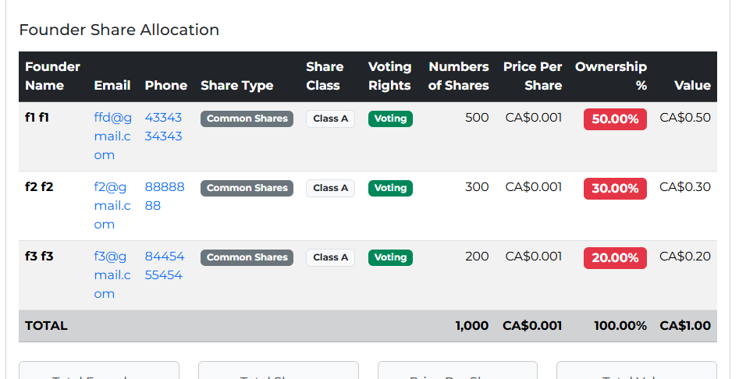

When an investor registers on the platform, they receive a unique link, and upon clicking it, the registration page will be displayed. CORRECT.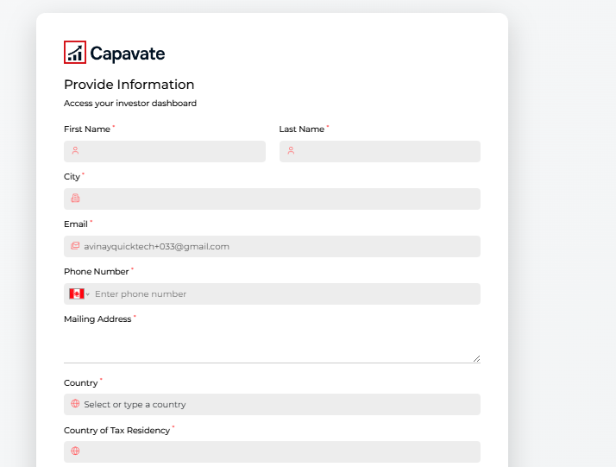
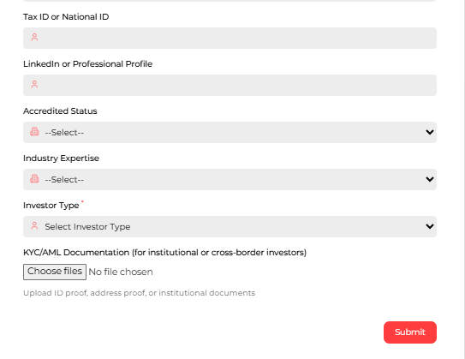

Now, in this form, there is a field for investor types.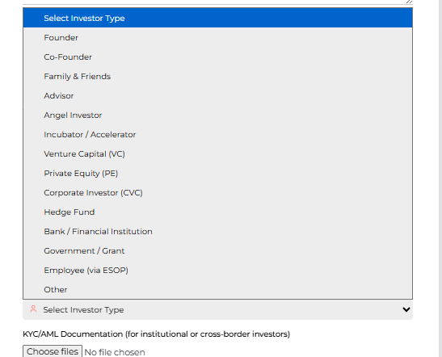
CORRECT.

After the investor logs in, a list will be displayed in the company module showing all the companies that have added that investor
CORRECT. This is where the investors can TRACK their individual investments.

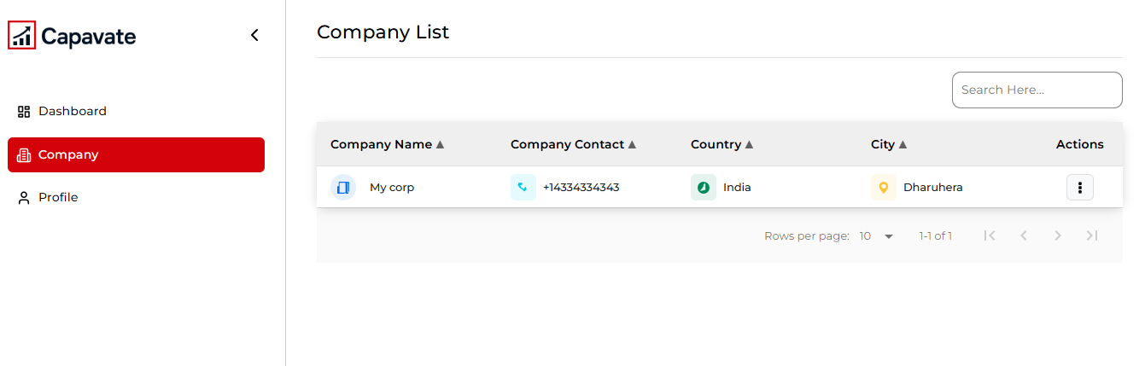
Action: This includes the investor report, data room report, and capital round documents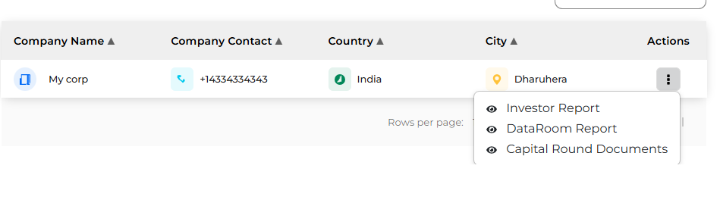

By clicking on the Capital Round Document, a list of rounds will be displayed, and you can view each round
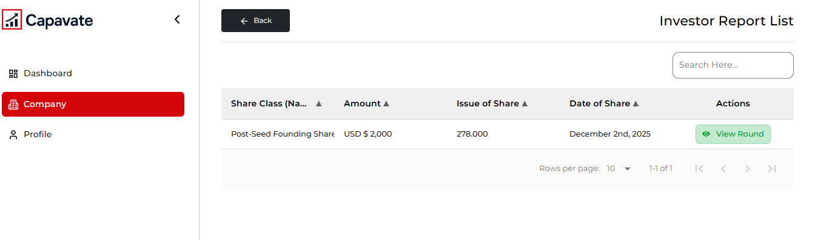
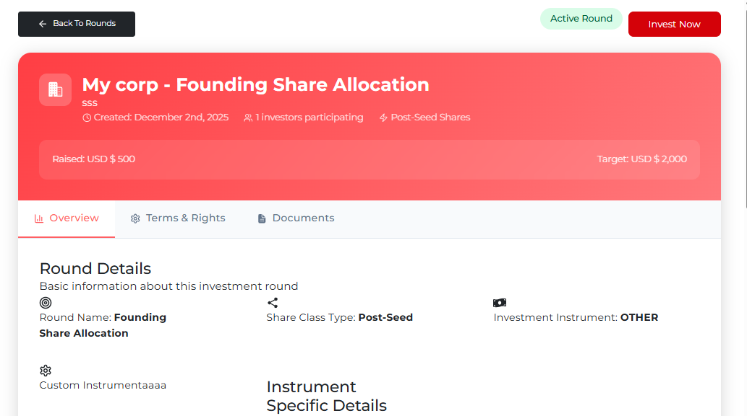

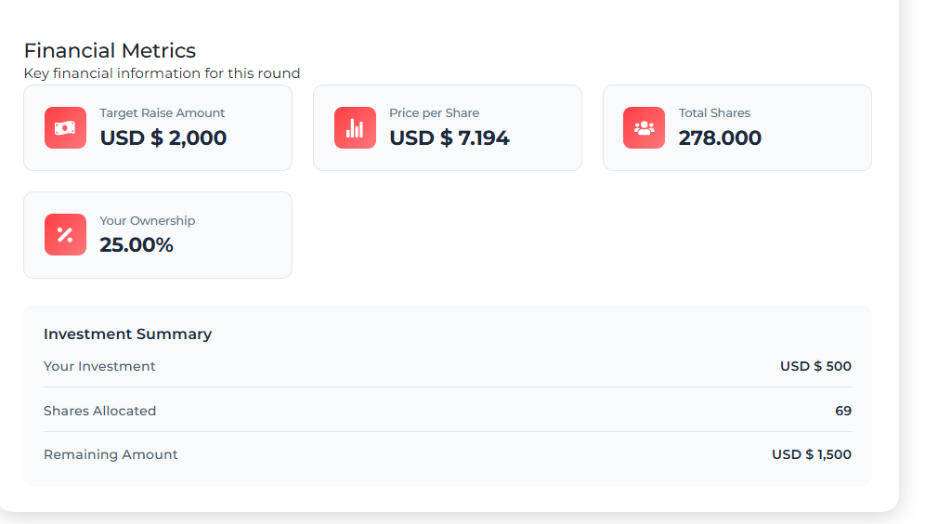
By clicking the ‘Invest Now’ button, the investor makes the investment.
=> If I am an investor and I am not part of the company, meaning I am not a signatory, administrator, or owner, then I cannot see the email and phone number. Instead, asterisks (****) will be displayed.

MAIN QUERY
Will the investor log in to the company
If he logs in, how will he log in (because usually the signatory or owner logs in to the company)? In what capacity? There must be some process...
Please explain this
I’m not sure I follow your query. Maybe we can have a quick chat online to clarify.

...
The company adds a signatory. If any signatory does not have an authorized signatory, they cannot create or edit anything in any module
So then, how will this process work for the investor?"
Investor Login: https://blueprintcatalyst.com/investor/login
Username: avinayquicktech+02@gmail.com
Password: lHO!Y7HH

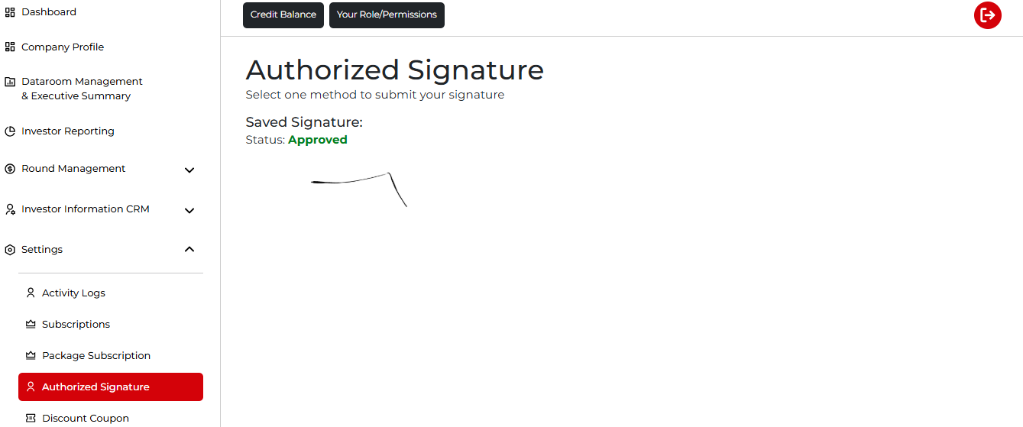

Query For Round:
In the next round (Let’s call it Series A) we will see the Convertible Notes Conversion and Purchased Shares:
In the case of a Series A round, when I check the instrument type, it shows as a Preferred Equity round. It also has an 'Add Warrant,' which I was told to hold. Please explain this.