The current project flow is as follows:
Users create companies, and only two signatories can be added to each company, no more.
However, one signatory can be added to multiple companies.
When a signatory logs into a company, they then create a round, whether it's Round 0 or for investment.
⇨ Q: But Round 0 will only be created once?
Client end:
So what informations are needed for this round zero? Number of shares issued to each
founder. Okay. So let's say founder number one, 500 shares number found founder number
two, 300 shares founder number three, 200 shares in total.
Main Query:
Q: When rounds are created in the company...
⇨ Q: Will individual founders be allocated personal shares in Round 0?
⇨ Q: Or will the company's shares be displayed under the founders' names?
Because when creating a round, there is no option to add founders in the case of Round 0.
Please explain about the founder and the company.
Example/Suggestion ?:
Round 0
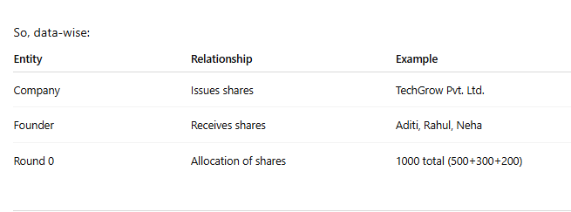
Round 1
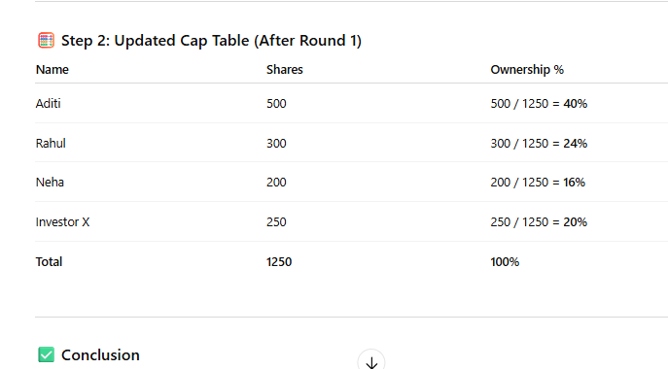
Is this correct or not? Otherwise, please explain it to me so I can continue. There's some confusion.

- ⇨ Is the round active or closed? When will the calculation/ownership update happen? When the round is active or closed? In some cases, it will depend on the instrument type.
- ⇨ When will the cap table be updated? When it's active or when the round is closed?
- ⇨ Will the cap table be updated when the round is closed?
- When will the cap table be updated from the investor's end?

