Company Main login Sirf signatory or owner krta hai..kuki platform main users register hota hai fr User Login krke multiple company create krta hai, Uske baad hr company main, User sirf two signatory add kr skta hai...

Signatory company main login krke multiple investor add krta hai , Fr company/signatory multiple round ya report investor ko share kr skte hai...

Round 0:
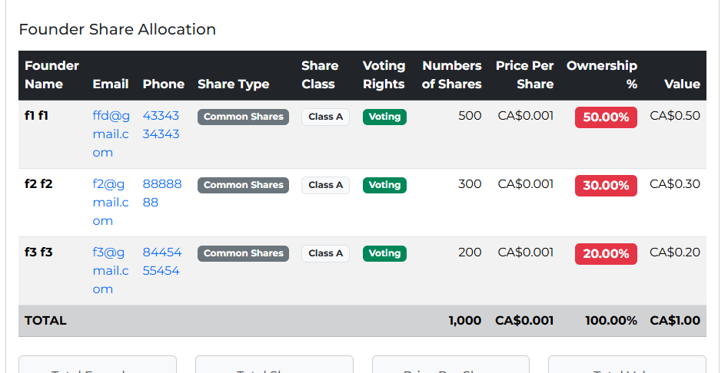

Jb Investor platform main register hota hai tb usko unique link send hota hai or click krke register page display hoga:
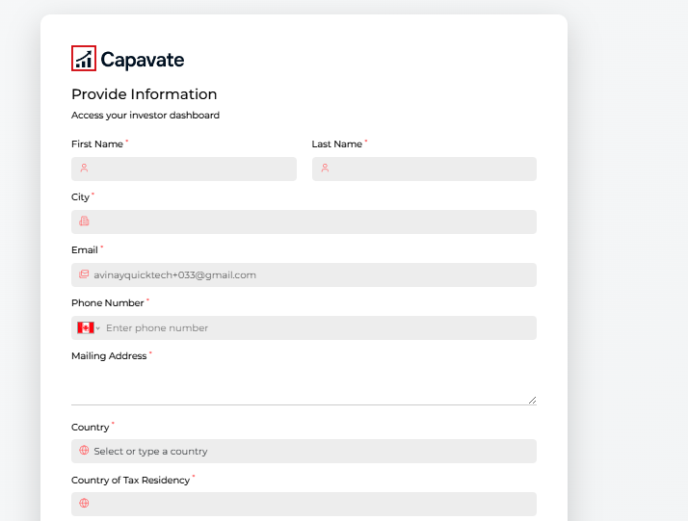
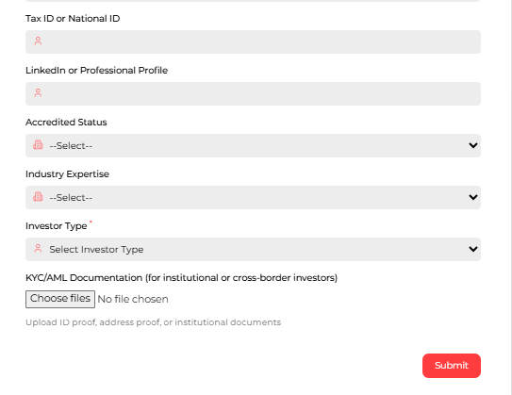

Ab iss form main field investor types hai
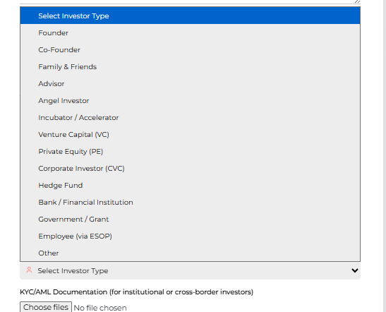
Investor login krne ke baad usko company module main list display hogi jin companies ne uss investor ko add kiya hai unn companies ki...
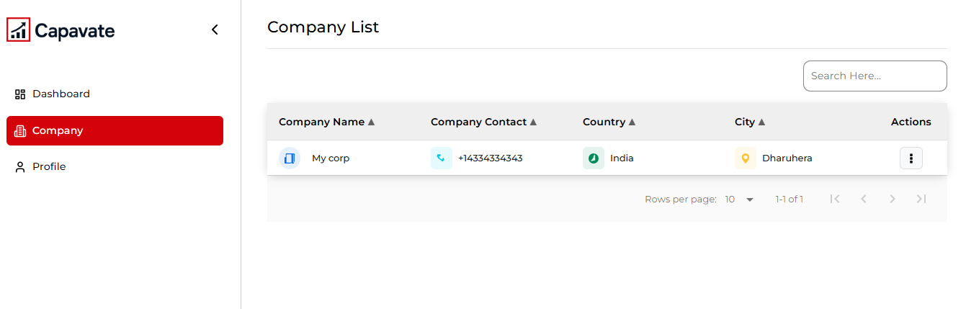
Action: Isme investor Report,Dataroom report, Capital Round document hai
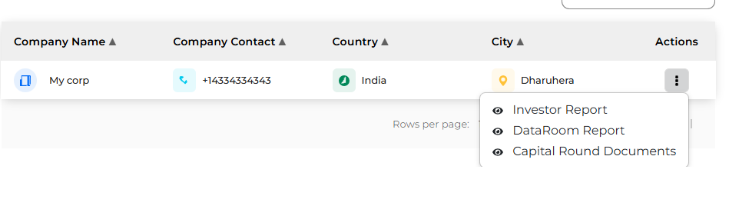

Capital Round Document main click krke,rounds ki list display hogi or View round
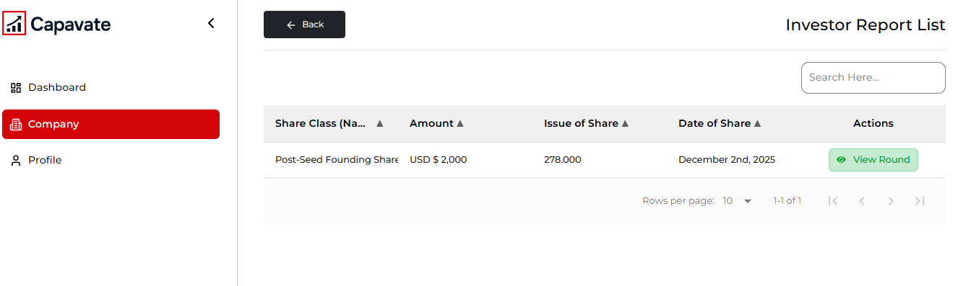
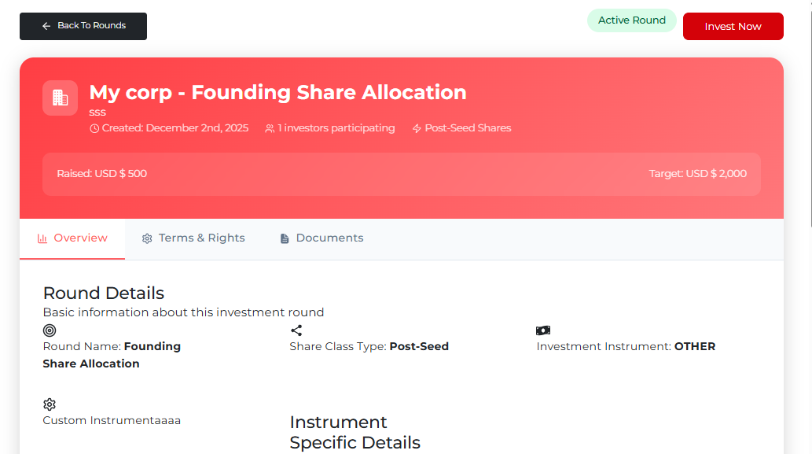

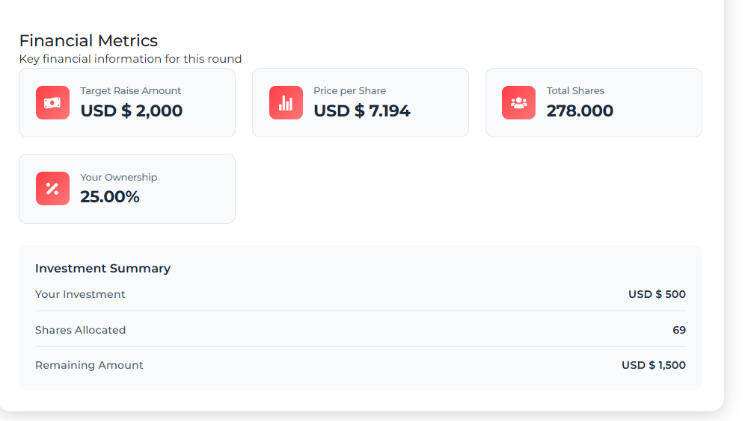
Invest Now button main click krke investor investment krta hai.
=> If I am investor and I am not a part of this company I mean I am not signatory or administrator or ownership
Then I can not see it Email dn Phone number means put star star aastrik signs

Main Query:
Investor company main login krega?
Agr login krta hai bo kaise login hoga(kuki company main signatory or owner login hota hai),, kis behave main, koi to process hoga....
Iske ley explain kre.....

...
Signatory ko company add krti hai agr kisi b signatory ke pas authorize signator na ho tb bo kisi b module main create/edit/ nhi kr skta.
Fr y process investor ke ley kaise hogi....
Investor Login: https://blueprintcatalyst.com/investor/login
Username: avinayquicktech+02@gmail.com
Password: lHO!Y7HH

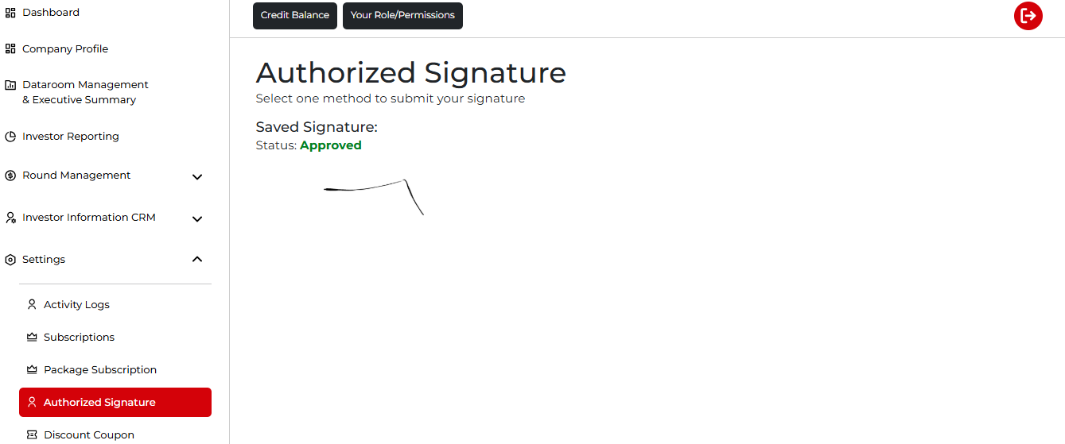

Query For Round:
In the next round (Let’s call it Series A) we will see the Convertible Notes Conversion and Purchased Shares:
Series A round case main jb main instrument type ko check krta hut b mujy iss round ke ley Preferred Equity round lgta hai or isme Add Warrant hai jisko apne Hold krne ko bola hai, iske ley explain kre
