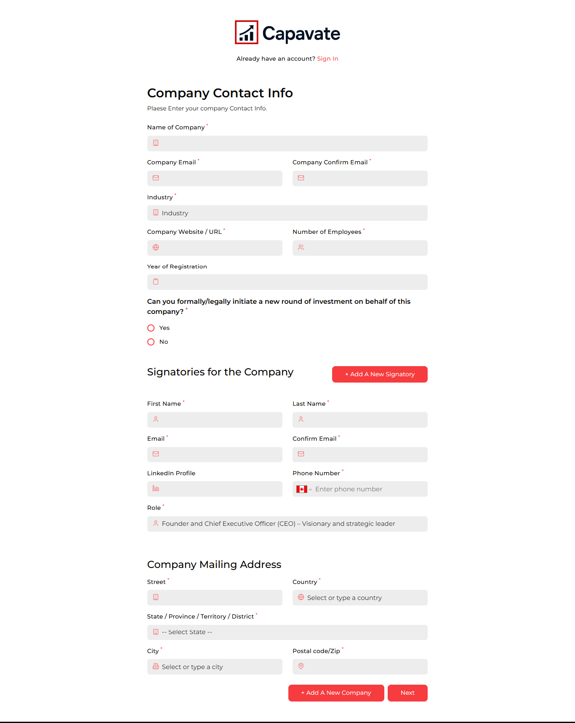
Company registration page hai, Agr user Add A New Company main click krega same page open hoga other company information fill ke ley

Signatories for the Company
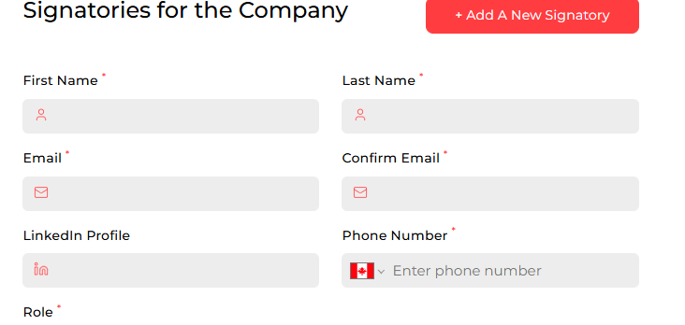
Company Main login iss form se hogi?
Login main confusion hai,.
Login kon kr rha hai, Signatories ?

Agr koi user multiple company add kr rha hai fr usko apni multiple companies kaise view hongi ,
Ek user multiple company or un company main Signatories multiple add to kr lega but user ko apni multiple account kaise access honge
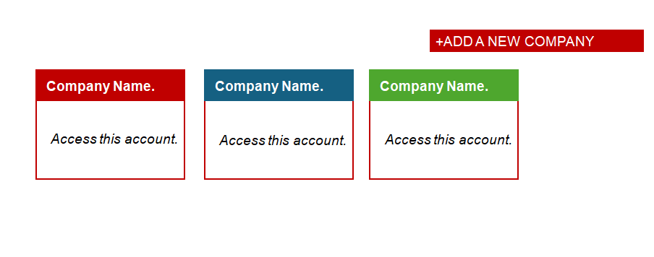
Agr same user Multiple account create krta hai tb bo sbi account kaise access krega,
Please ek baar Registration, Login ,Roles, subscription process explain kre ki inka flow kya hoga
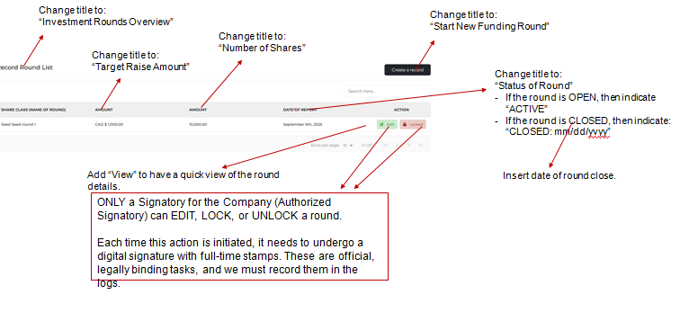

Iss screenshot se lg rha hai ki signatory login hoga platform main

Same company main multiple signatory login honge?

Subscription kaise work kregi( DataRoom Management + Investor Report ) company ke accrodng ya Signatory ke according,
Explain this page,
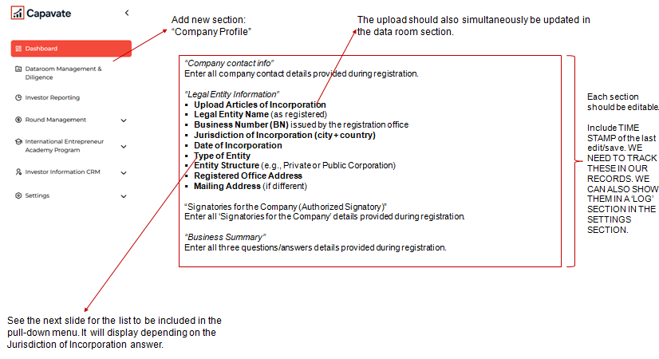
Please un process ko explain kre..

