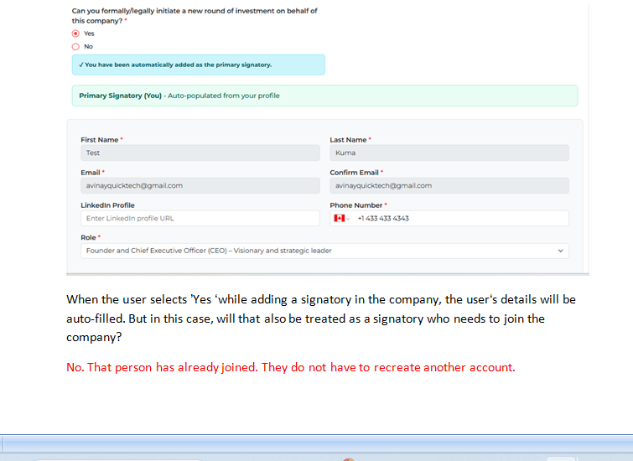
Same signatory multiple company main register ho skta hai?

Jb company register krte hai tb signatory add krte hai or signatory ko hum invitation link send krte jisse bo company ko join kr ske, jisse signatory ka account create hoga uske bad bo login krke company view kr skta hai,

Sir y flow clear krna important hai , kuki pehly client end se y tha ki Signatory sirf ek company ka data view krega or usme work , but jb Yes or no ke case main Owner ka data auto fill ho rha hai or bo already joiined hai tb , Signatory login or Owner company view kaise krega.

Owned user ki company Access dashboard page se hogi,
Jb owned user access button pr click krega tb usi company ke dashboard page main redirect ho jaega
