Module:
Setting Ko chord kr sbi dynamic hai...
Dashboard:
Isme or bi kuch add kr skte hai data track ke ley.
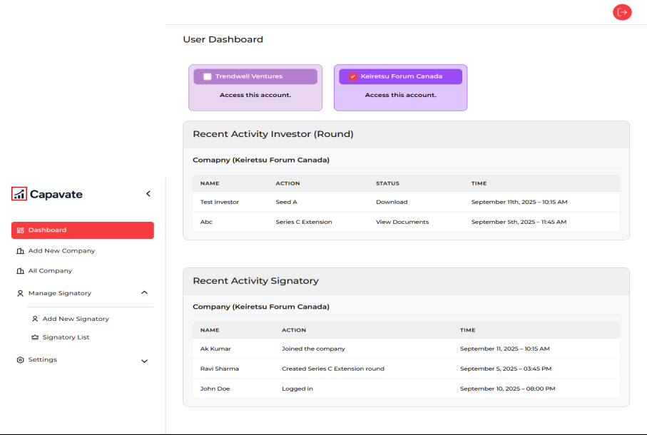
All Company/ Add New Company
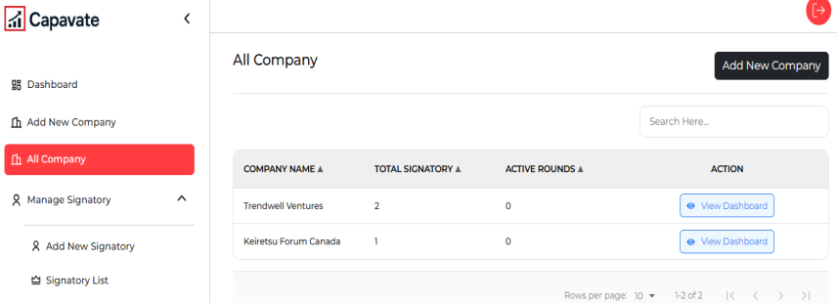
Jb koi user company add krega or usme signatory add krega tb signatory ko Invitation email send hogi..

Y sb dynamic kiya hua hai..
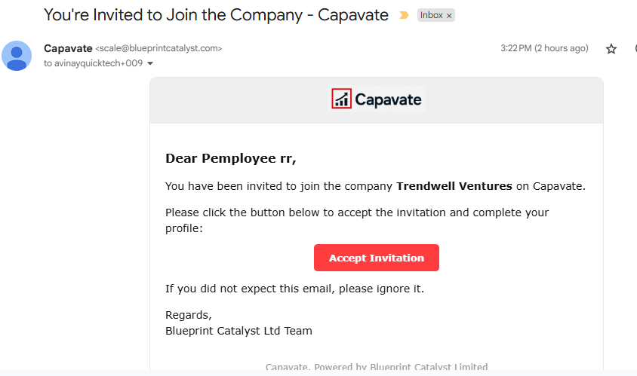
Signatory isme password create krke company dashboard page main redirect ho jaega.
Manage Signatory:
User company main or bi signatory add kr skte hai. With invitation link send
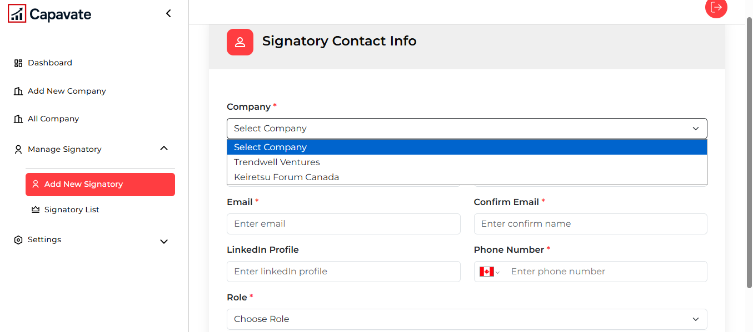
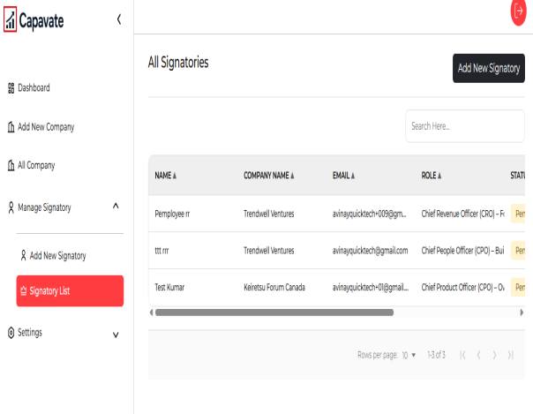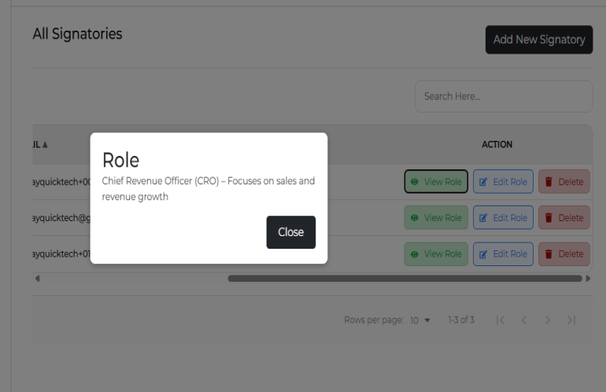
User Signatory ke role view krega or usko edit b kr skta hai.
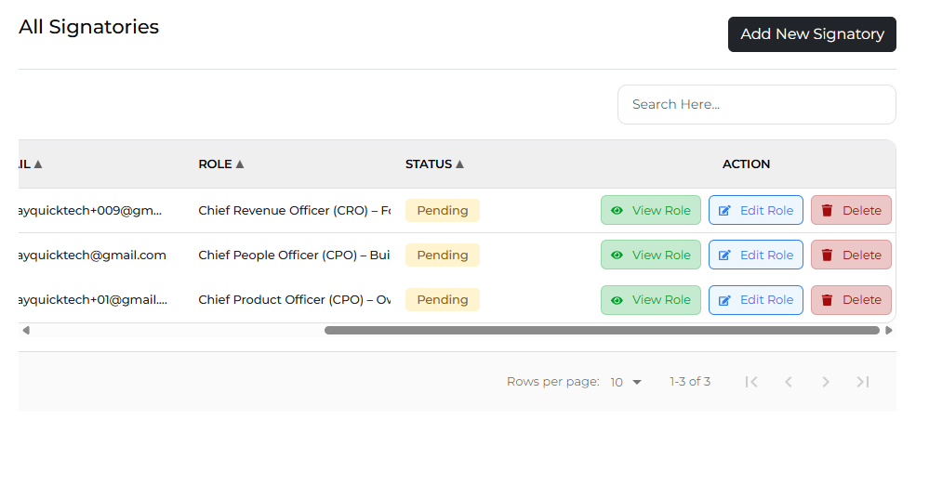
Work continue for company dashboard page..

