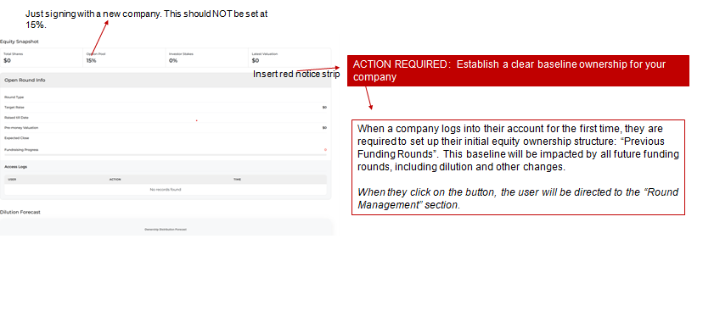
Please explain: Agr company kisi investor ko report round share krte hai, mean multiple investor ko tb , investor funding or shares kaise krega jisse company ke investor stokes get honge?
Regarding iske (Previous Funding Rounds).
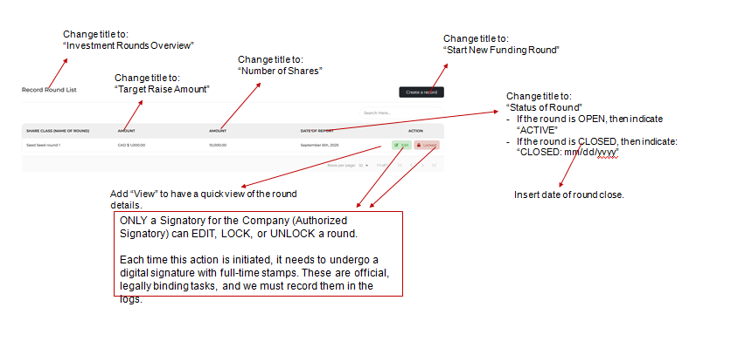
Authorized Signature: Agr signatory authorized signature krta hai tbi usko Add, edit, Lock Unlock etc ki permission hogi ..Digital Signature ki bina signatory kuch Add edit ni kr skta?.

Jb user company add kr rha hai or Signatory invite kr rha hai tb Role ka kya work hoga
Platform main signatory login ke baad, kis module main kya condition hogi role ke according
