Q1.
Solution:
select d.dept_name, e.emp_name, e.salary
from employee e
join department d
on e.dept_id=d.dept_id
where salary>
(
select
avg(salary)
from employee e1
where e1.dept_id=e.dept_id
having count(e1.emp_name)>=3
)
;
Output:
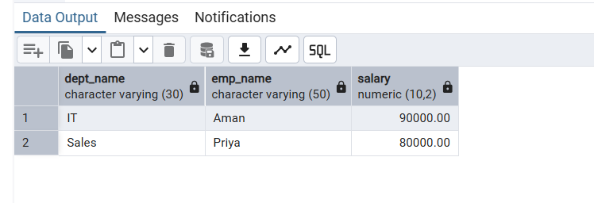
Q2.
Solution:
create or replace function tg_audit_changes()
returns trigger
language plpgsql
as
$$
begin
if tg_op ='Insert' then
insert into customer_audit values(new.customer_id, new.customer_name, 'ADDED',time, new())
return new
else if tg_op='Delete'
insert into customer_audit values(old.customer_id, old_customer_name, 'REMOVED',time, old())
return old

end;
$$

