Metabolic zonation of the bovine liver lobule: a cross-species re-analysis of Stereo-seq spatial transcriptomics
Bharti Mittal
November 2026
Code and results: github.com/bhartimittal2976/bovine-liver-zonation

Abstract
Background. Liver function is divided along the lobule, from the portal tract where blood enters to the central vein where it leaves. Lobular zonation has been mapped in detail in mouse and, more recently, in human, but not in ruminants. In ruminants most glucose is made in the liver from rumen-derived propionate. A recent Stereo-seq dataset of adult Holstein liver (GSE315416) was released as a technical resource, without quantitative zonation analysis.
Methods. I built a two-landmark lobular coordinate (η) from the spatial data alone. Central veins were defined by GLUL⁺ pericentral domains and portal tracts by biliary-positive foci. Genome-wide zonation was modelled on 25 × 25 µm bins with a block-adjusted quasi-Poisson model that controls for regional differences in sequencing depth. I then tested 18 curated metabolic pathways and compared bovine zonation with published zonation tables from independent cows, pigs, humans and mice using one-to-one orthologs. I followed up candidate ruminant-specific features gene by gene, with per-animal controls, and measured lobule geometry.
Results. Of 5,524 genes tested, 315 were zonated (FDR < 0.05, ≥ 1.4-fold), and 98.7% of them replicated in direction across two halves of the section that differ in depth. Bovine zonation calls agreed in direction with independent cows (8/8 genes), human (25/27), mouse (14/15 Visium, 16/18 scRNA-seq) and pig (5/6). Raw periportal gradients of gluconeogenesis and the urea cycle were shallow. After normalising for each dataset's dynamic range, however, they were as periportal as in other species, and propionate-entry enzymes, β-oxidation and OXPHOS were unzonated in all species. The P450 steps of bile-acid synthesis (CYP27A1, CYP8B1, CYP7A1) were more pericentral in both cow sources than in any control species (nominal p = 0.007–0.05). A pericentral shift of de novo lipogenesis was not supported. The central-vein to portal-tract distance was about 500–650 µm, and lobules were about 0.9 mm across and roughly hexagonal.
Conclusions. Lobular zonation in the bovine liver is largely conserved and resembles human more than mouse. The expected ruminant adaptation, a flattened or relocated gluconeogenic zone, is not visible at the transcript level. A sharper central confinement of bile-acid synthesis is a candidate bovine feature that needs more animals to confirm.
Keywords: liver zonation; spatial transcriptomics; Stereo-seq; cattle; ruminant metabolism; comparative genomics; bile acids

1. Introduction
Hepatocytes are not functionally uniform. Oxygen, hormones and morphogens such as Wnt form gradients along the porto-central axis of each lobule, and metabolic tasks are distributed along it. In rodents, gluconeogenesis, the urea cycle and β-oxidation are periportal, while glutamine synthesis, xenobiotic metabolism, bile-acid synthesis and lipogenesis are pericentral [1, 2, 3]. Single-cell reconstruction showed that about half of expressed mouse liver genes are zonated [4]. Spatial atlases of live human donors and of pig, cow and mouse liver have since shown that some of these patterns differ between species [5].
Cattle are an important test case. A lactating dairy cow absorbs little glucose from the gut and relies on hepatic gluconeogenesis, mainly from rumen propionate, to meet most of its glucose demand [6]. Hepatic de novo lipogenesis is minimal in ruminants, because adipose tissue takes over that role [7]. Whether these adaptations are reflected in how metabolic genes are arranged within the bovine lobule is unknown.
Akter and Liu recently released a high-resolution Stereo-seq dataset of adult Holstein liver [8]. Their report focused on technical validation (quality control, clustering, reference annotation and maps of marker genes) and left quantitative zonation and ruminant metabolism for future work. This project takes up those questions using the public data.

2. Objectives
- Build a central-vein to portal-tract coordinate for the bovine lobule from the spatial transcriptome alone, and validate it with independent markers.
- Produce a genome-wide, depth-aware map of zonated genes in the bovine liver.
- Place ruminant-relevant metabolic pathways (propionate to glucose, nitrogen handling, fatty-acid oxidation, ketogenesis, lipid export, lipogenesis, bile-acid synthesis) along that axis.
- Compare bovine zonation with pig, human and mouse, and test candidate ruminant-specific features gene by gene.
- Measure lobule geometry: central-vein to portal-tract distance, lobule size and shape.

3. Methods

3.1 Data
Stereo-seq data for sample GSM10044212 (chip B03015G1; GEO GSE315416) were aggregated into bin50 units (50 × 50 DNA nanoballs, about 25 × 25 µm). After bin-level quality control, 125,587 bins and 19,045 genes remained, covering 78 mm² of tissue. Reads had been aligned to ARS-UCD2.0 with SAW v7.0.0 [8, 9]. Central-vein domains were taken from a consensus of GLUL-enrichment calls over nine parameter settings; a bin's consensus frequency (0–9) is the number of settings that place it in a GLUL-enriched domain.

3.2 Lobular coordinate
Central veins (CV) were bins with a GLUL consensus frequency of at least 7 of 9 (65 components). For portal tracts (PT), a score built from biliary genes (KRT19, KRT7, EPCAM, SOX9, SPP1, CFTR) and portal-mesenchyme genes (COL1A1, COL1A2, COL3A1, ACTA2, MYH11, TAGLN, DCN, LUM, VIM) was z-scored on log-normalised counts and smoothed (σ ≈ 75 µm). The top 1.5% of bins formed candidate foci. Foci of at least 5 bins were kept only if biliary genes were at least 2-fold enriched relative to library size, which excludes large hepatic veins (24 of 26 kept). For each bin, η = d_CV / (d_CV + d_PT), so η = 0 at the central vein and 1 at the portal tract. Bins within 50 µm of a landmark, or with a CV–PT span over 1.5 mm, were excluded; 65,637 parenchymal bins (52%) remained.

3.3 Genome-wide zonation model
Counts were summed into pseudobulk cells defined by 2 mm spatial blocks × 8 equal-width η layers (152 cells, 23 blocks). For each gene detected in at least 0.5% of bins with at least 200 UMIs (5,524 genes), I fitted a quasi-Poisson GLM, log E[y] = block + poly3(η) + log(library size), and tested the η terms with an F-test (Benjamini–Hochberg FDR [10]). The block fixed effect absorbs regional differences in depth and RNA quality, so a gene must vary along η within blocks to count as zonated. The effect size is the fitted log2 ratio between the portal-most and central-most layers. Genes were called robust when FDR < 0.05, |log2FC| ≥ 0.5, and the direction was the same in the top and bottom halves of the section, which differ in depth. Robust genes were further split into parenchymal gradients (also significant within η 0.125–0.875 and not enriched in portal-tract bins) and boundary-restricted genes. Sensitivity was assessed across six alternative landmark definitions.

3.4 Pathway zonation
Eighteen pathway gene sets were curated, each annotated with its rodent zonation pattern from the literature [1, 2, 4]. Pathway counts were pooled and fitted with the same model. A pathway was called zonated when the pooled FDR was below 0.05 and at least two member genes were significant in the same direction, with none in the opposite direction.

3.5 Cross-species comparison
Reference zonation tables came from Yakubovsky et al. [5]: Visium data for live human donors (n = 5, non-steatotic), cows (n = 2), pigs (3 domestic, 2 wild boar) and mice (n = 6), all processed with one pipeline. Mouse hepatocyte scRNA-seq zonation came from Halpern et al. [4]. Genes were matched through Ensembl one-to-one cattle–human–mouse orthologs [11]. All tables were oriented so that layer 1 is pericentral, which was checked with GLUL/CYP2E1 versus HAL/SDS. Portal bias was defined as the log2 ratio of the two portal-most to the two central-most layers. Because spatial platforms differ in resolution, pathway biases were also divided by each dataset's own xenobiotic-CYP bias.

3.6 Gene-level tests of candidate ruminant features
For bile-acid synthesis and de novo lipogenesis genes, each animal's portal bias was scaled by its own CYP2E1 + CYP1A2 gradient. Animals were excluded if their anchor genes showed a mis-oriented axis (CYP bias > −0.3 or periportal HAL ≤ 0); this removed one cow and one wild boar. Two cow sources (this sample and the remaining Visium cow) were compared with 15 control animals (pig, human and mouse) using exact one-sided permutation tests. This sample's uncertainty was estimated with a 500-fold spatial-block bootstrap. I also ran leave-one-gene-out analyses for the pooled sets.

3.7 Lobule morphometry
Two landmark sets were used. The first was the marker landmarks above, with CV fragments within 100 µm merged (44 CVs, 23 PTs). The second was the peaks of a detrended zonation signature built from the 72 pericentral and 62 periportal parenchymal genes (94 CV and 118 PT candidates). I measured nearest-neighbour centroid distances, built CV-centred Voronoi lobules clipped to tissue (keeping cells that do not touch the tissue edge and lie within 1.5 mm of their CV), and measured equivalent diameter, number of neighbours and circularity. To ask whether the pericentral zone has a fixed width or scales with lobule size, I compared half-maximum positions of a pericentral signature across tertiles of CV–PT span, using a block bootstrap.

3.8 Software
Analyses used Python 3.11 with NumPy, SciPy, pandas, AnnData, scikit-learn, scikit-image and matplotlib [12]. The batched quasi-Poisson fitting was checked against statsmodels (coefficients agree to 10⁻⁶). All code and result tables are in the accompanying repository.

4. Results

4.1 A two-landmark lobular coordinate for the bovine liver
GLUL⁺ central-vein domains and biliary-positive portal foci did not overlap. Portal foci lay a median of about 650 µm from the nearest central vein, which is plausible for a bovine lobule. The resulting coordinate η was supported by genes that were not used to place the landmarks. Of 14 testable markers, 12 had the expected direction: CYP2E1, CYP2A13, CYP1A2, CYP3A76 and RHBG were pericentral, and ASS1, ASL, ARG1, PCK1, HAL, HAMP and ALDOB were periportal (Figure 1). CPS1 and LECT2 were flat. Coverage was incomplete: most of the upper-left part of the section had no detected portal tract.
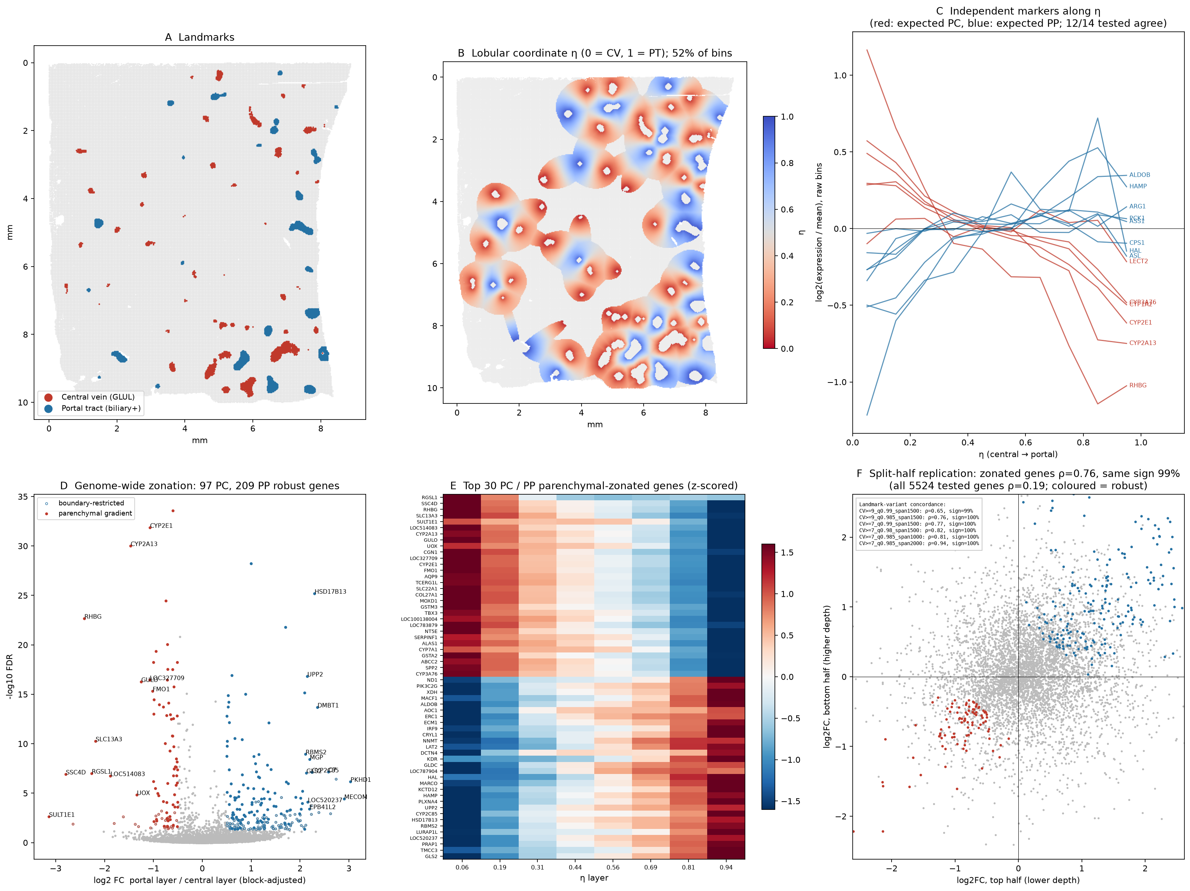
Figure 1. Lobular coordinate and genome-wide zonation. (A) Central-vein (red) and portal-tract (blue) landmarks. (B) Lobular coordinate η. (C) Independent markers along η. (D) Genome-wide zonation. (E) Model profiles of the top pericentral and periportal parenchymal genes. (F) Replication between the top and bottom halves of the section.

4.2 About 6% of tested genes are robustly zonated
Of 5,524 genes, 315 were zonated (FDR < 0.05, ≥ 1.4-fold), and 98.7% had the same direction in both halves of the section. After excluding landmark genes, 306 were robust (209 periportal, 97 pericentral), and 301 kept their direction across all six landmark definitions. Splitting by pattern showed that many periportal hits (PKHD1, MECOM, C7, MGP, DMBT1, CA4) were portal-tract cell signals rather than hepatocyte gradients. The parenchymal gradient set contained 72 pericentral genes (SULT1E1, CYP2A13, CYP2E1, UOX, GULO, FMO1, SLC22A1, GSTM3, TBX3, AQP9, CYP7A1, ALAS1, RHBG, SLC13A3) and 62 periportal genes (HSD17B13, CYP2C85, UPP2, GLS2, HAMP, HAL, GLDC, XDH, ALDOB). Sinusoidal genes such as MARCO (Kupffer cells) and KDR (endothelium) were also zonated. The Wnt targets TBX3, ZNRF3 and SP5 marked the pericentral zone, as in mouse and human.

4.3 Pathway zonation and the ruminant hypothesis
In raw terms, pericentral programmes (ammonia scavenging, xenobiotic CYPs, bile-acid synthesis) were clearly pericentral. Gluconeogenesis and the urea cycle were periportal but shallow (about 1.15–1.4-fold), and propionyl-CoA metabolism, β-oxidation, ketogenesis and OXPHOS were not zonated (Figure 2). Taken alone, this would suggest that the periportal oxidative and gluconeogenic programme is flattened in the ruminant. A check against weaker portal landmarks showed that stricter landmark definitions did not steepen periportal gradients. The cross-species comparison (Section 4.4) showed that this reading is not correct.
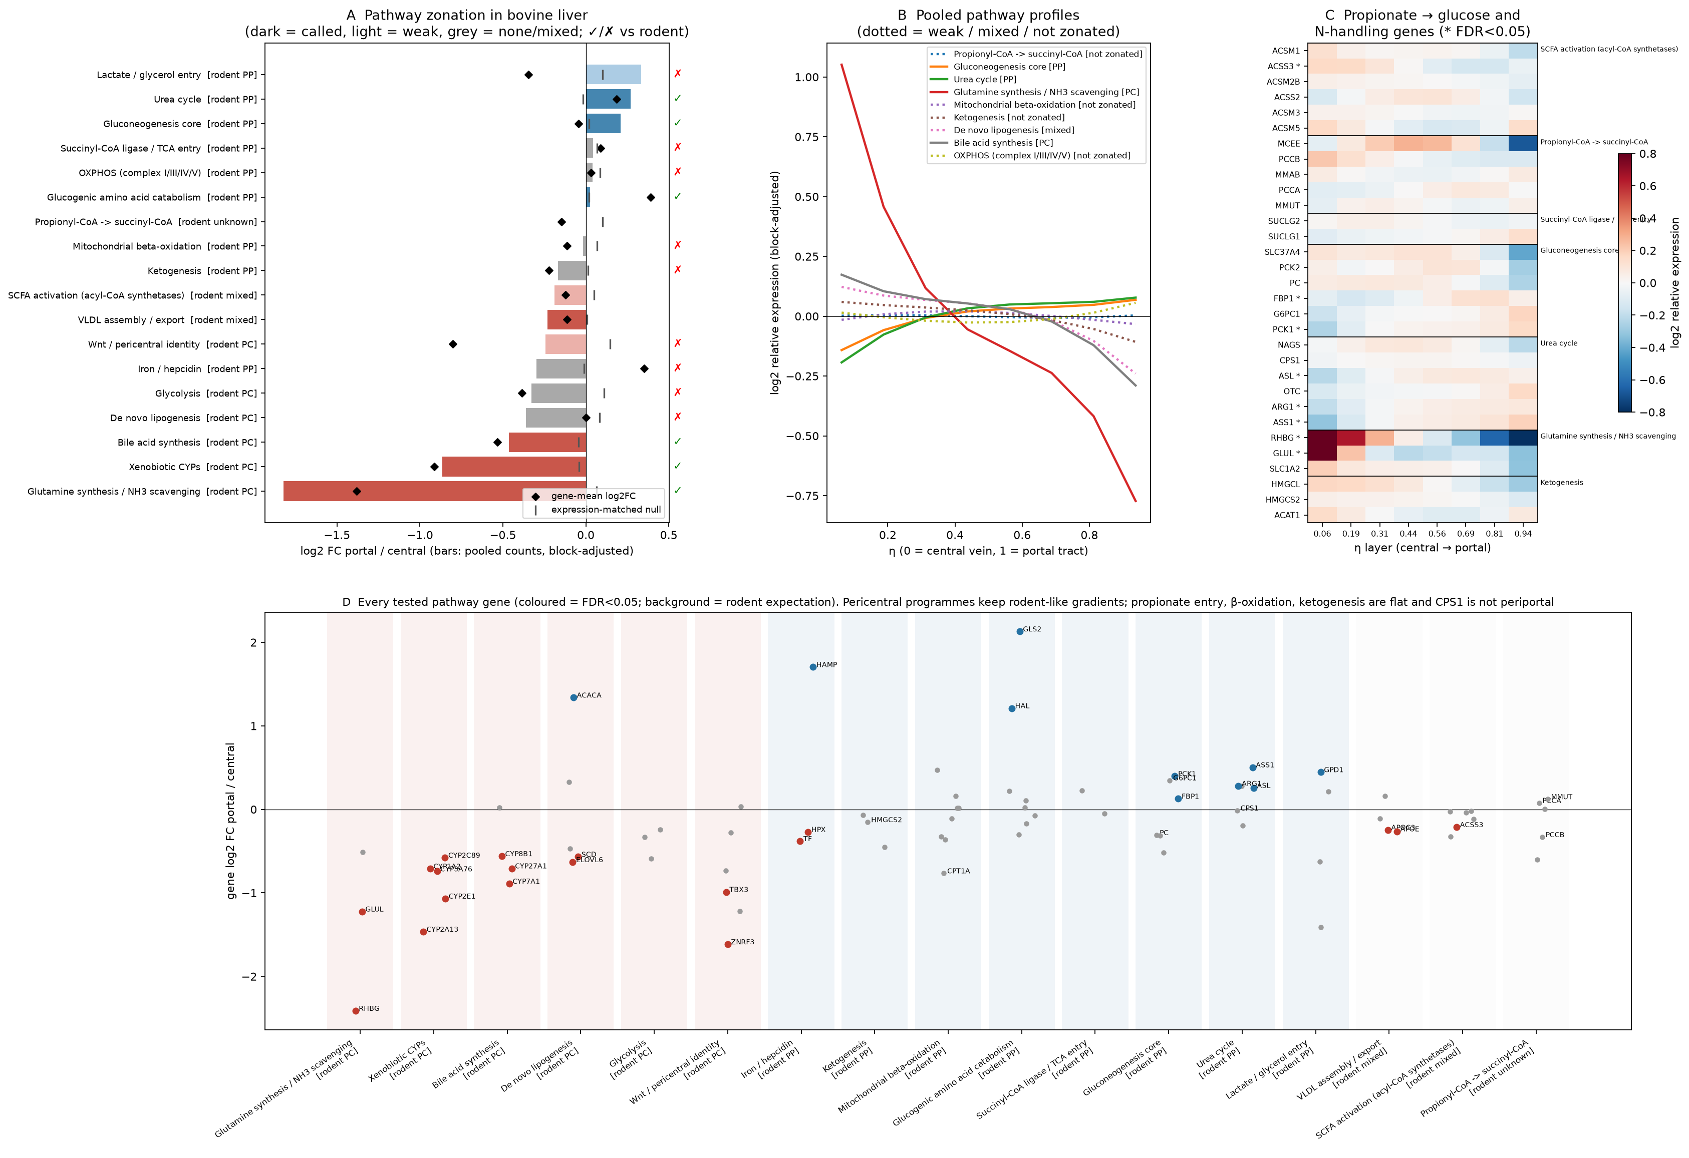
Figure 2. Pathway zonation in bovine liver. (A) Pooled pathway log2 portal/central ratios with the rodent expectation. (B) Pooled pathway profiles along η. (C) Gene-level profiles for propionate-to-glucose and nitrogen-handling genes. (D) All tested pathway genes grouped by rodent expectation.

4.4 Cross-species comparison
Robust bovine genes agreed in direction with every reference wherever the reference gene was clearly zonated (|bias| ≥ 0.5): 100% with independent cows (8/8), 93% with human (25/27), 93% with mouse Visium (14/15), 89% with mouse scRNA-seq (16/18) and 83% with pig (5/6). Genome-wide, bovine zonation was most similar to human (Spearman ρ = 0.48–0.53 for well-expressed genes), then to the independent cows (ρ = 0.21–0.34, close to their own animal-to-animal ceiling), and least similar to mouse (Figure 3). The independent cow Visium data were noisy: the two animals correlated with each other at ρ = 0.03 overall and 0.51 only for highly expressed genes.
Spatial platforms differ greatly in dynamic range. The same mouse urea-cycle gradient is about 2-fold in scRNA-seq but almost flat in Visium. When each dataset was scaled by its own CYP gradient, bovine gluconeogenesis (+0.24) and urea-cycle (+0.30) zonation matched or exceeded pig, mouse and human (Table 1). Propionate-entry enzymes, β-oxidation and OXPHOS were unzonated in every species, and CPS1 was also flat in human. The shallow raw bovine gradients therefore reflect resolution, not ruminant biology.
Table 1. Pathway portal bias scaled by each dataset's xenobiotic-CYP bias (negative = pericentral). *Lipogenic enzymes are below detection in the cow Visium data, so this value is unreliable.
Pathway | Cow (this study) | Cow Visium | Pig | Human | Mouse Visium | Mouse scRNA
Glutamine synthesis / NH₃ scavenging | −2.02 | −1.02 | −1.13 | −0.95 | −1.27 | −1.25
Bile-acid synthesis | −0.51 | −0.37 | −0.07 | −0.26 | −0.15 | −0.06
De novo lipogenesis | −0.41 | −0.31* | +0.08 | −0.17 | +0.24 | +0.04
β-oxidation | −0.03 | −0.15 | +0.01 | −0.10 | −0.10 | −0.02
Propionyl-CoA → succinyl-CoA | −0.01 | −0.34 | +0.03 | −0.09 | −0.06 | −0.01
OXPHOS | +0.04 | −0.05 | −0.05 | −0.05 | −0.02 | +0.01
Gluconeogenesis | +0.24 | +0.11 | +0.16 | −0.01 | +0.20 | +0.16
Urea cycle | +0.30 | +0.27 | +0.18 | +0.04 | +0.20 | +0.18

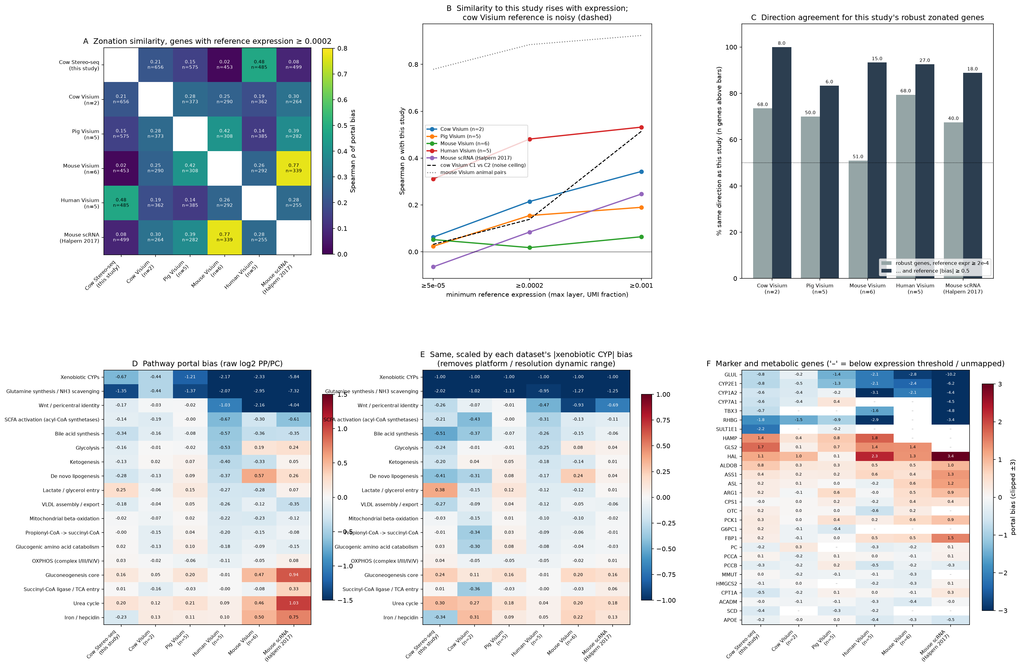
Figure 3. Cross-species zonation. (A) Similarity of portal bias between datasets. (B) Similarity to this study by expression level, with the cow animal-to-animal ceiling. (C) Direction agreement for robust bovine genes. (D, E) Pathway portal bias, raw and scaled by CYP. (F) Marker and metabolic genes.

4.5 Candidate ruminant features: bile-acid synthesis, not lipogenesis
Two patterns were shared by both cow sources but not by other species: a stronger pericentral bias of bile-acid synthesis and of lipogenesis. Gene-level testing with per-animal controls (Figure 4, Table 2) supported the first only in part. The P450 steps of the classic pathway were more pericentral in both cow sources than in any control species: CYP27A1 (p = 0.007), CYP8B1 (p = 0.013) and CYP7A1 (p = 0.051), together with HSD17B4 (p = 0.022). None passed correction for the 18 genes tested (lowest q = 0.12). The peroxisomal side-chain steps (SLC27A5, ACOX2, AMACR, SCP2) were not shifted, and the pooled pathway was not significant (p = 0.09). A post-hoc observation was that the bile-acid sensor FXR (NR1H4, p = 0.007) and the uptake transporter NTCP (SLC10A1, p = 0.015) leaned periportal in cow, whereas they were flat or slightly pericentral in controls.
The lipogenesis signal was driven entirely by SCD (p = 0.38 without it), and SCD is also pericentral in pig and human. ACACA was periportal in this sample. The independent cows barely express lipogenic enzymes, which is consistent with low hepatic lipogenesis in ruminants [7], so this feature could not be replicated.
Table 2. Scaled portal bias of bile-acid synthesis genes, cow versus controls (negative = pericentral). †Driven by SCD; p = 0.38 when SCD is removed. n.d., not detected.
Gene | This study (95% CI) | Cow Visium | Pig / human / mouse | p | q
CYP27A1 | −0.71 (−0.90, −0.52) | −0.61 | −0.15 / −0.35 / −0.43 | 0.007 | 0.12
CYP8B1 | −0.61 (−0.84, −0.34) | −0.70 | n.d. / −0.19 / −0.26 | 0.013 | 0.12
HSD17B4 | −0.40 (−0.74, −0.05) | −0.91 | −0.08 / −0.27 / −0.20 | 0.022 | 0.13
CYP7A1 | −0.92 (−1.25, −0.63) | −0.57 | −0.35 / −0.11 / −0.57 | 0.051 | 0.23
Pooled synthesis enzymes | −0.23 (−0.32, −0.14) | −0.32 | −0.09 / −0.29 / −0.08 | 0.088 | –
Pooled lipogenesis enzymes | −0.33 (−0.50, −0.12) | −0.18 | +0.06 / −0.19 / +0.19 | 0.051† | –

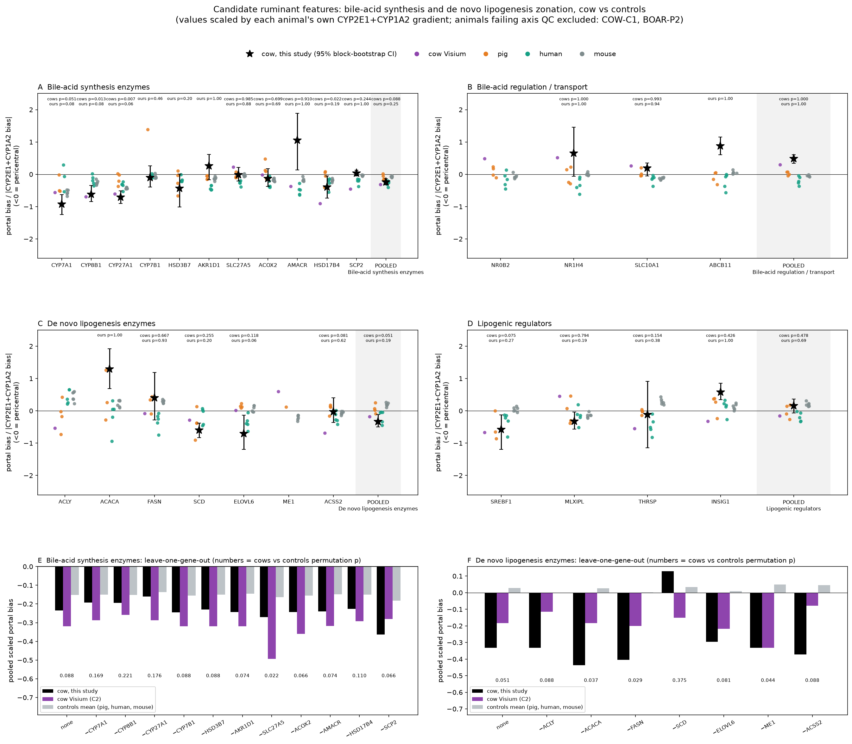
Figure 4. Bile-acid synthesis and lipogenesis genes, cow versus controls. Values are scaled by each animal's CYP2E1 + CYP1A2 gradient. Stars show this study with 95% block-bootstrap CIs. (E, F) Leave-one-gene-out analysis for the pooled enzyme sets.

4.6 Lobule geometry
Marker landmarks are specific but incomplete (GLUL is detected in about 4% of bins), so marker-based distances are upper bounds. The more complete signature landmarks give a lower estimate (Table 3, Figure 5). The central-vein to portal-tract distance was about 500–650 µm, and CV-centred lobules were about 0.9 mm in equivalent diameter (1.3 mm with marker landmarks only). Lobules had a median of 6 Voronoi neighbours, i.e. they were roughly hexagonal. The GLUL⁺ pericentral cuff was about 120 µm across, roughly 2–4 hepatocytes. Whether the pericentral zone has a fixed absolute width or scales with lobule size could not be resolved: marker landmarks favoured a fixed width of about 250 µm, but more complete portal landmarks reversed the result, because long CV–PT spans mostly mark missed portal tracts.
Table 3. Lobule morphometry in one 10 µm section (apparent 2D sizes).
Measure (median, IQR) | Marker landmarks | Signature landmarks
CV → nearest PT | 744 µm (620–1078) | 502 µm (427–599)
PT → nearest CV | 653 µm (557–808) | 520 µm (439–614)
CV–CV nearest neighbour | 739 µm (608–1029) | 476 µm (369–684)
Lobule equivalent diameter | 1336 µm (1244–1525), n = 19 | 875 µm (807–1044), n = 63
Neighbours per lobule | 6 (5–6) | 6 (5–6)

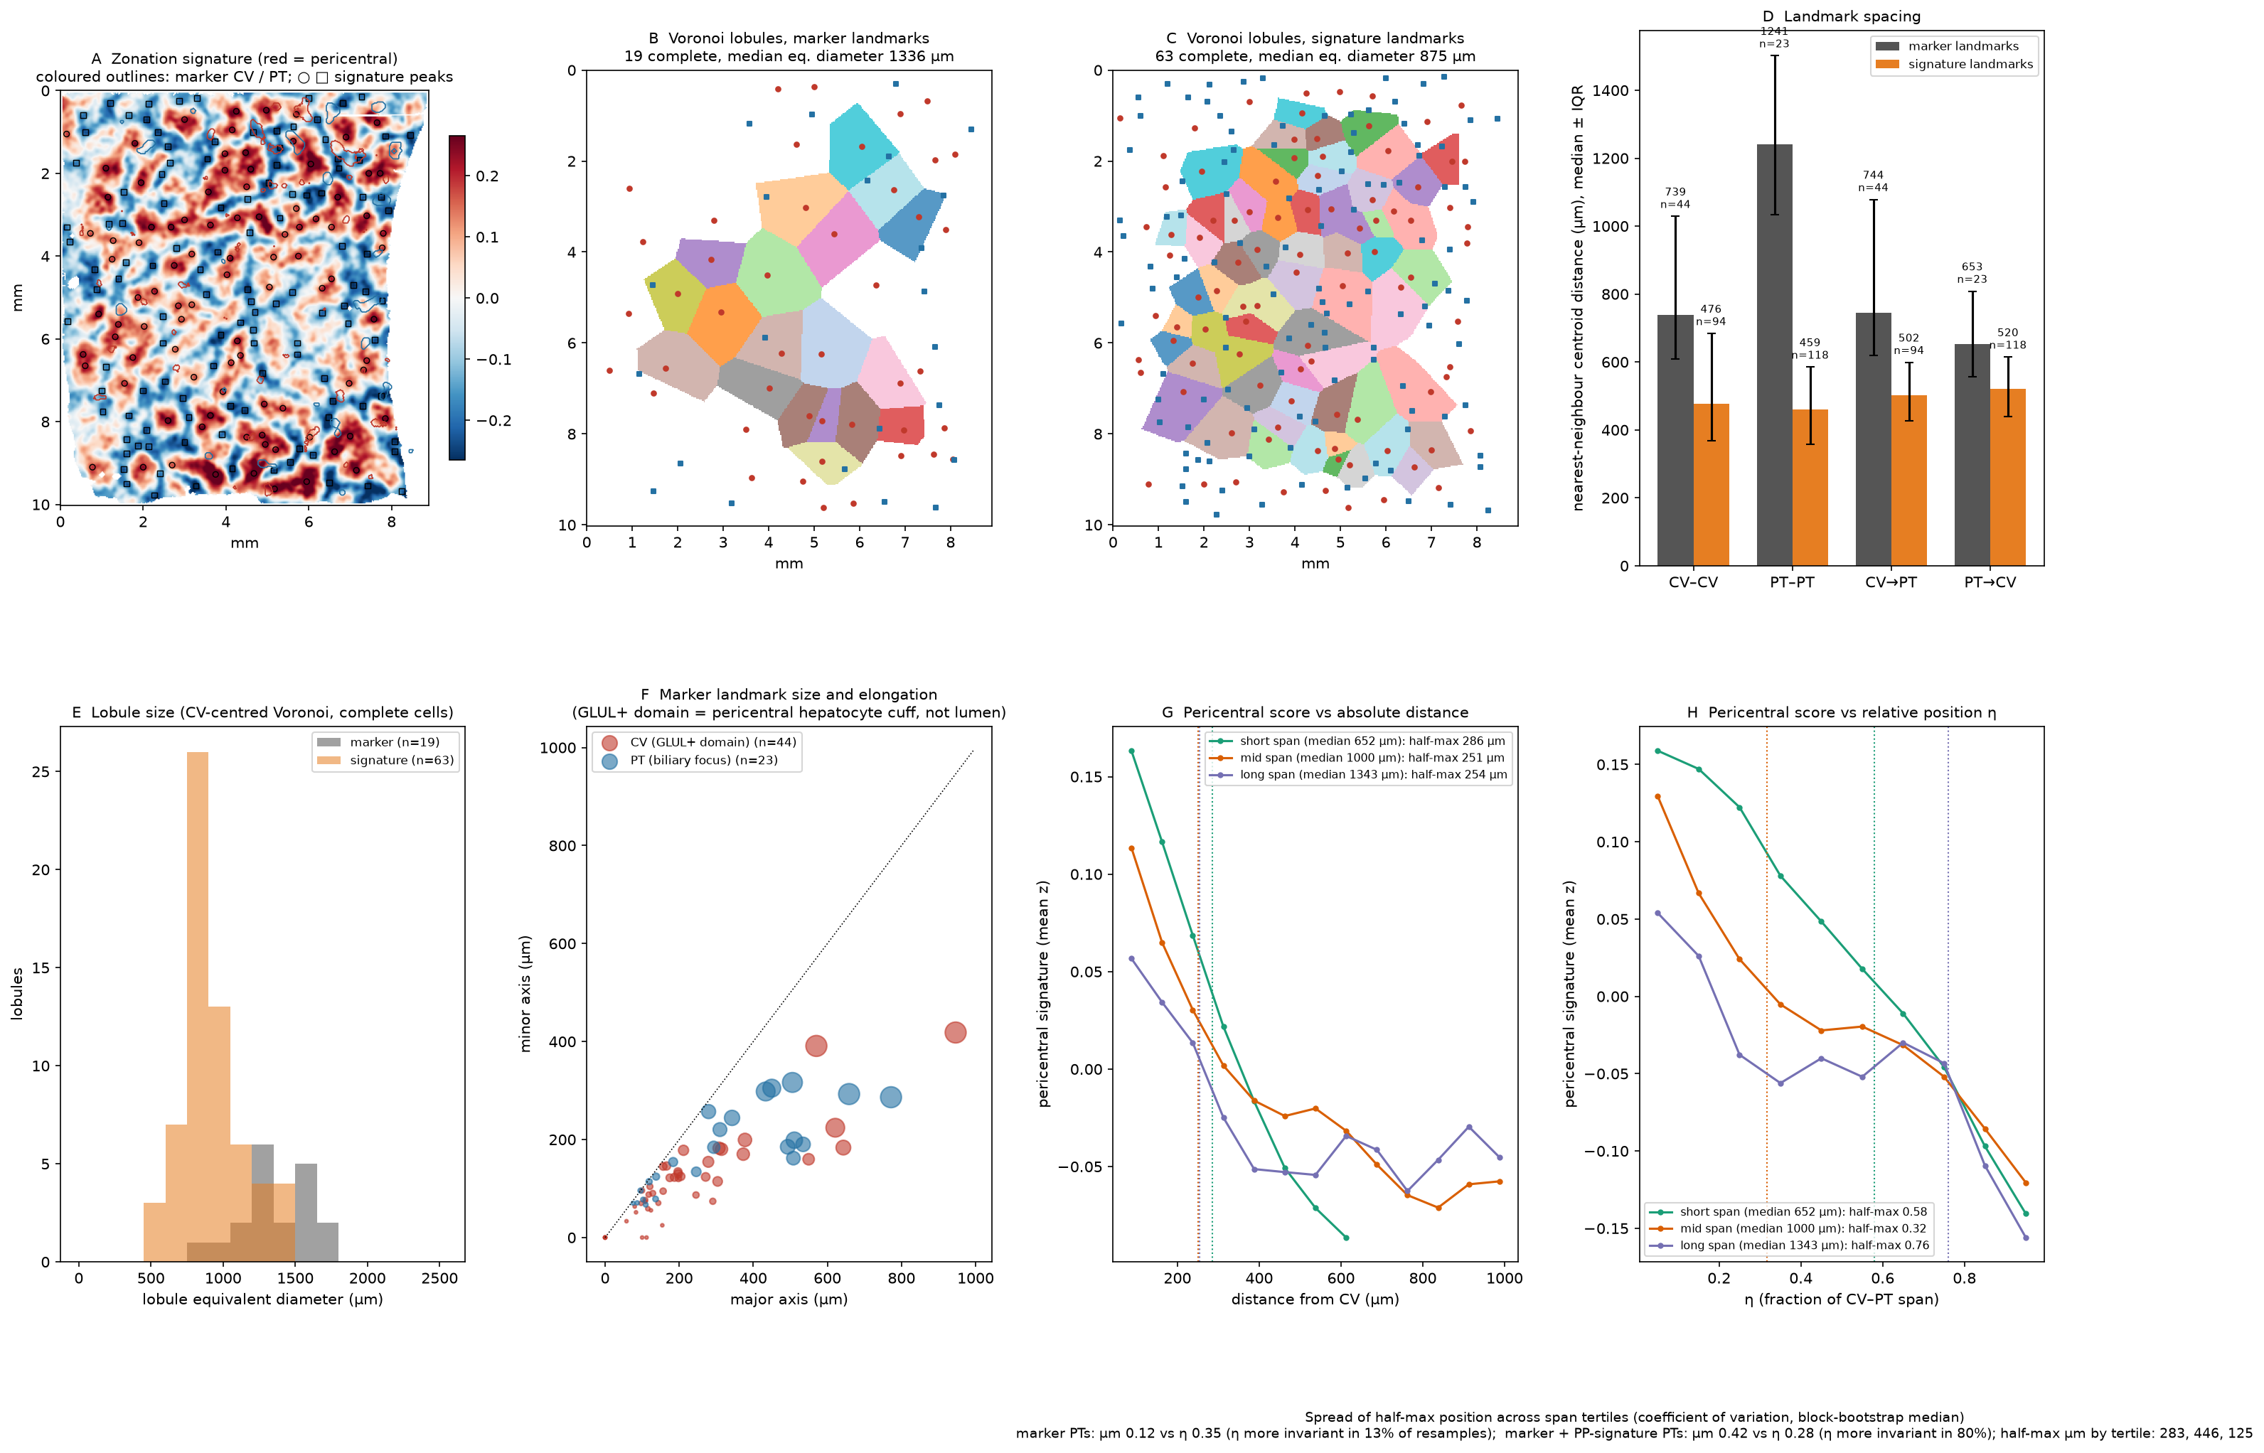
Figure 5. Lobule morphometry. (A) Zonation signature map (red = pericentral) with landmarks. (B, C) CV-centred Voronoi lobules. (D) Landmark spacing. (E) Lobule size. (F) Landmark size and elongation. (G, H) Pericentral signature versus absolute distance and relative position, by CV–PT span tertile.

5. Discussion
This analysis turns a technical spatial resource into a quantitative map of bovine lobular zonation. Three points stand out.
First, bovine zonation is largely conserved. Pericentral glutamine synthesis, xenobiotic metabolism and Wnt targets, and periportal HAL, GLS2, HAMP and urea-cycle genes, followed the mammalian pattern. Genome-wide, the bovine profile was closer to human than to mouse, which fits the larger lobules and slower metabolic rates of large mammals. Mouse may therefore be a weaker model for bovine liver zonation than is usually assumed.
Second, the main ruminant hypothesis was not supported at the transcript level. One might expect a liver that makes glucose continuously from propionate to spread gluconeogenesis across the lobule. The raw bovine gradients did look flat, but the cross-species comparison showed that this was a property of the measurement. Once resolution was accounted for, bovine gluconeogenic and urea-cycle zonation were as periportal as in other species. Propionate-entry enzymes were unzonated in every species, so their uniform distribution is a general mammalian feature rather than a ruminant adaptation. Metabolic flux may still be zonated through substrate supply, oxygen or post-transcriptional control, which transcript maps cannot show. This was the most important correction in the project: without the cross-species normalisation, the single-dataset result would have been over-interpreted.
Third, bile-acid synthesis is a candidate bovine feature. Both cow sources placed the cholesterol-hydroxylating P450 steps more centrally than any control species. The post-hoc periportal lean of FXR and NTCP suggests that cows may separate bile-acid synthesis from bile-acid uptake and sensing more sharply. This would be consistent with the distinct bile-acid pool of ruminants, but the evidence here is nominal and needs confirmation.

Limitations
- One section from one animal. The independent cow reference is shallow, and one of its two animals failed axis QC.
- Bin50 units mix 2–4 hepatocytes with non-parenchymal cells, which compresses effect sizes compared with single-cell data. Only about 6% of genes reached the effect threshold.
- Landmark detection is incomplete, so marker-based distances are upper bounds and the scaling question remains open.
- Cross-platform comparison depends on normalisation. Conclusions are drawn mainly from directions and from CYP-scaled values.
- Transcript gradients do not measure metabolic flux.

Future work
- Repeat the analysis on the second GEO sample (GSM9427230) and on further animals, especially lactating cows.
- Use a complete portal marker (KRT19 or portal-vein staining) to test whether zonation width scales with lobule size.
- Test the bile-acid hypothesis directly: CYP7A1/CYP8B1 immunostaining together with spatial bile-acid measurements.

6. Conclusions
A depth-aware, two-landmark analysis of public Stereo-seq data gives the first genome-wide map of bovine liver zonation. The map is reproducible within the section and agrees with independent cows, humans, mice and pigs. Bovine zonation is mostly conserved and closer to human than to mouse. Apparent flattening of periportal gluconeogenesis is a resolution effect. A sharper central confinement of bile-acid synthesis is the most promising candidate for a bovine-specific feature.

Data and code availability
Raw and processed data: GEO GSE315416. Reference zonation tables: supplementary data of [4] and [5]. Orthologs: Ensembl BioMart. Code, result tables and figures: github.com/bhartimittal2976/bovine-liver-zonation.

References
1. Ben-Moshe S, Shapira Y, Moor AE, et al. Spatial sorting enables comprehensive characterization of liver zonation. Nat Metab. 2019;1(9):899–911. doi:10.1038/s42255-019-0109-9
2. Droin C, Kholtei JE, Bahar Halpern K, et al. Space-time logic of liver gene expression at sub-lobular scale. Nat Metab. 2021;3(1):43–58. doi:10.1038/s42255-020-00323-1
3. Gebhardt R, Matz-Soja M. Liver zonation: novel aspects of its regulation and its impact on homeostasis. World J Gastroenterol. 2014;20(26):8491–8504. doi:10.3748/wjg.v20.i26.8491
4. Halpern KB, Shenhav R, Matcovitch-Natan O, et al. Single-cell spatial reconstruction reveals global division of labour in the mammalian liver. Nature. 2017;542(7641):352–356. doi:10.1038/nature21065
5. Yakubovsky O, Bahar Halpern K, Shir S, et al. A spatial atlas of the healthy human liver from live donors. Nature. 2026;653:1148–1157. doi:10.1038/s41586-026-10377-y
6. Aschenbach JR, Kristensen NB, Donkin SS, Hammon HM, Penner GB. Gluconeogenesis in dairy cows: the secret of making sweet milk from sour dough. IUBMB Life. 2010;62(12):869–877. doi:10.1002/iub.400
7. Hanson RW, Ballard FJ. The relative significance of acetate and glucose as precursors for lipid synthesis in liver and adipose tissue from ruminants. Biochem J. 1967;105(2):529–536. doi:10.1042/bj1050529
8. Akter S, Liu GE. A high-resolution Stereo-seq spatial transcriptomic resource for adult Holstein cattle liver. Int J Mol Sci. 2026;27(17):7844. doi:10.3390/ijms27177844
9. Chen A, Liao S, Cheng M, et al. Spatiotemporal transcriptomic atlas of mouse organogenesis using DNA nanoball-patterned arrays. Cell. 2022;185(10):1777–1792. doi:10.1016/j.cell.2022.04.003
10. Benjamini Y, Hochberg Y. Controlling the false discovery rate: a practical and powerful approach to multiple testing. J R Stat Soc Series B. 1995;57(1):289–300.
11. Martin FJ, Amode MR, Aneja A, et al. Ensembl 2023. Nucleic Acids Res. 2023;51(D1):D933–D941. doi:10.1093/nar/gkac958
12. Virshup I, Rybakov S, Theis FJ, Angerer P, Wolf FA. anndata: access and store annotated data matrices. J Open Source Softw. 2024;9(101):4371. doi:10.21105/joss.04371

