PROBLEM STATEMENT: https://www.hackerrank.com/challenges/sherlock-and-cost/problem

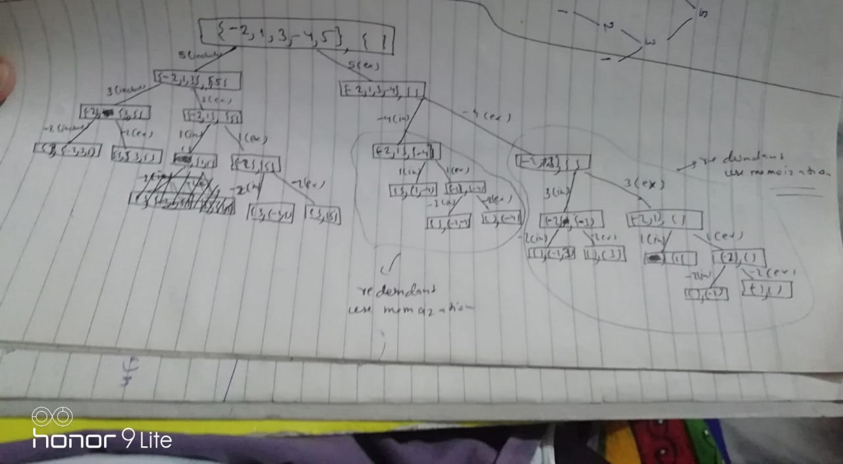

Solution Description:

Let see the problem with the help of an example, suppose given an array of length 5 and numbers are

{-2, 1, 3, -4, 5}. In the solution we start from the last number -5. Because it is dynamic programming

Problem so we take decision at every stage. So, at this stage we take decision either include 5 or not.

If we include 5 in the solution then -4 is automatically excluded as per the problem statement. So, now

We have 3 number and we have to choose which number we have to include in solution. Now it is

turn of number 3 same as previous take decision whether include 3 or not in the solution. If we include

3 then 1 is automatically excluded from the solution. We repeat the same procedure for every other

Stage. Some stage you found that same stage is already been processed. So we have to use

Memorization here to get rid of redundant calls.