Perception Space
Definition and Framework — Mind Machine Learning

1. What is a perception space?
A perception space is defined by the form that data takes on when observing something and how that data is encoded. Every sensor has one. Every combination of sensors has a joint one. The space contains every possible observation the sensor could ever produce, and each actual observation is a single point in that space. The sensor can be physical hardware or virtual (software computing sensory data from a physics simulation). The math is identical because what defines the space is the data format and range, not the substrate.
Adding information to a perception space does not just make it bigger. It adds structure. Consider adding a text description to an image. A CLIP encoder converts that description into a 768-dimensional vector that is semantically meaningful because it was produced by a model trained on human language. The embedding for golden retriever sits near labrador and far from motorcycle because a GPT-like model learned those relationships from how humans use language. When you combine the image space with this embedding space, the joint space inherits that semantic structure. This is a key reason text-to-image models work well: the embedding dimensions are pre-organized by human knowledge.
This principle generalizes. Whenever you add a modality or information source to a perception space, the new dimensions bring their own structure. For our avatar, proprioception dimensions are structured by the physics of the skeleton. Touch dimensions are structured by the body surface geometry. Each modality brings structure inherited from its physical origin.
Over training, the model discovers its own semantic categories from this physical structure. The prediction loss pushes encoded representations of similar-outcome instances toward each other. That cluster IS the category, even though no description was ever provided. This is what gain of function means: each new category is a new discrimination in the functional perception space. And each new discrimination becomes available as input to later transformer blocks. Function begets function. This is how higher perception emerges from lower perception, through training on embodied experience.
A note on terminology: in machine learning, latent space refers to the compressed internal representation learned by a model. In standard usage it is static between training steps. But the patent (US 11,537,850 B2) specifies modulation of model parameters and hyperparameters by pain and pleasure. The encoding function itself is wellness-dependent. A model in pain encodes the world differently than a model at ease, at the representation level. In neuroscience, perceptual space refers to how a human subjectively organizes one sense (color wheel, pitch axis) — low-dimensional, single-modality, static. None of these concepts include the space changing with embodied activity or treat gain of function as expansion of a discriminable region through compositional learning. Perception space as defined here is a new term.

2. Combining modalities
When you combine modalities, the joint perception space grows multiplicatively as the Cartesian product of each modality’s space. A CLIP text embedding adds 768 semantically structured dimensions. The power of additional modalities comes not from the size of the space but from the structure each one brings.
We hypothesize that more dimensions create cleaner and shorter credit-assignment paths to wellness signals. Consider a model with only vision trying to learn that an object is hot. Pain is not visible. You can see a burn mark but not pain itself. A vision-only model must discover that certain pixel patterns predict a sensation with no visual form — cross-modal causation from a single modality, which is information-theoretically impoverished.
Add touch. On first contact, tactile pain fires immediately and unambiguously. The forward model’s cross-modal attention can learn in one trial: this visual pattern co-occurred with this tactile pain. Touch provides a direct credit-assignment path that vision alone would need many trials to approximate. The patent’s digital pain model provides what vision cannot: direct sensory grounding. Touch is closer to thermal pain than vision is. Cleaner paths should mean better signal-to-noise in the wellness gradient (gradient clipping caps magnitude, so it is signal quality that matters, not magnitude). This should compound with modulation: the modality that detected the threat gets its resolution boosted, making future detections sharper. To be validated by the modality ablation experiments in the companion execution document.
Our avatar has six modalities: vision, touch, audio, proprioception, motor commands, and inter-mind signals. The joint space enables perceptions no single modality contains. Heavy requires vision + proprioception + touch together.

3. Perception spaces are dynamic
The patent establishes that sensor resolution and dynamic range are modulated by pain and pleasure. Movement generates touch. Touch stimulates sensors. Stimulated sensors get a resolution boost. Human analogy: after paralysis, an affected limb participates less in the movement-touch-feedback loop. Avatar equivalent: if actuators are disabled, the feedback loop breaks and the effective perception space in those dimensions stops growing.
Modulation extends beyond sensor resolution. The patent specifies modulation of resolution, dynamic range, model parameters (weights), hyperparameters (learning rate), and meta-parameters (algorithm swapping, memory allocation, computation budget). Biology provides a concrete example: myelination. The developing brain changes axon transmission speed by up to about 100x in targeted pathways (Flechsig; eNeuro 2018). Sensory cortex myelinates early; prefrontal cortex completes in the mid-20s (PNAS 2012, PMC 2013). The brain modulates its own meta-parameters on a developmental schedule that gates what computation is possible. This is precisely what the patent describes.
Modulating temperature (softmax peakedness) connects to creativity: moderate increase produces diverse outputs (exploration), low temperature produces repetitive outputs (exploitation). This mirrors the neuroscience of dopamine, which follows an inverted U: moderate levels produce peak creative flexibility, extremes impair it (DeYoung 2013; Chermahini and Hommel 2010; Frontiers in Neurology 2014 on Parkinson’s patients).

4. Space vs. visited region
Standing on toes does not change the touch perception space. It reaches different points within it. The space is defined by sensor architecture and modulation. The visited region is defined by behavior.

5. Four layers
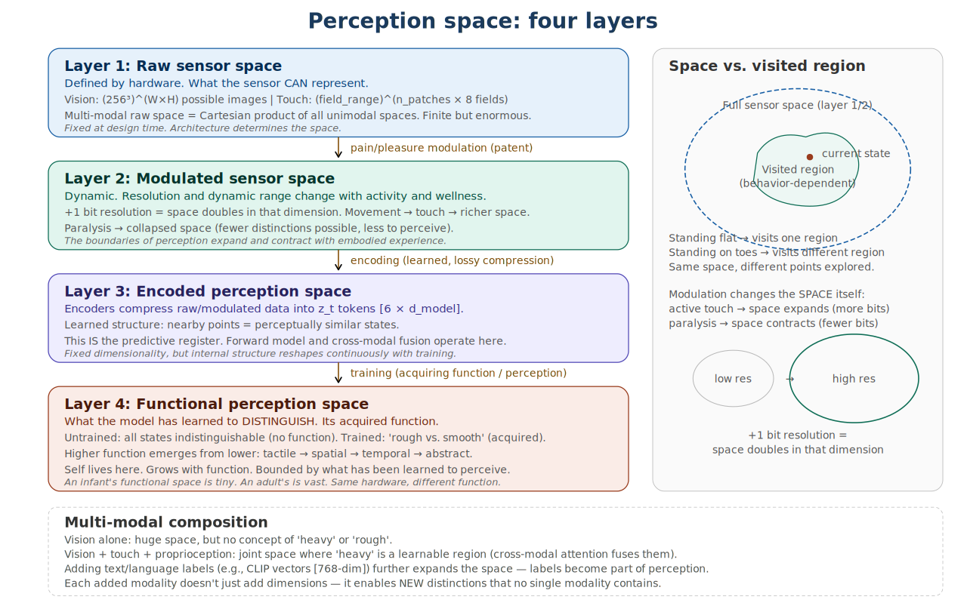
Figure 1: Four layers of perception space.
Layer 1 — Raw sensor space. What the sensor can represent. Our sensors are virtual (TMC patches from mesh collisions, spatial audio from engine, foveal vision from virtual cameras). The math is identical to hardware sensors. The full raw multi-modal space is the Cartesian product of all individual sensor spaces.
Layer 2 — Modulated sensor space. Modulation controls the effective number of distinguishable levels per dimension. Does not expand theoretical bounds. Movement and pleasure increase effective bits. Pain and paralysis decrease them.
Layer 3 — Encoded perception space. Encoders compress to z_t tokens (6 × 768 = 4,608 values per frame). Fixed dimensionality. Training reshapes which raw states map to nearby vs distant encoded points. Two states the encoder couldn’t initially distinguish may, after training, map to very different vectors because distinguishing them improved prediction.
Layer 4 — Functional perception space. What the model has learned to distinguish. Higher function emerges from lower through 8 stacked transformer blocks, each capturing residual prediction error the blocks below left. The exact distribution across blocks is shaped by the prediction loss, the data, and training duration. You cannot learn reaching produces contact without first representing reaching and contact as distinguishable patterns.
Self lives in this layer. Level 1 self (motor-sensory correlation via DifferentiableBodySchema) is implemented and testable. Level 2 (control-correlation over minutes) and Level 3 (abstract-correlation) are specified but not yet implemented. Self is bounded by what the model has learned to perceive.

6. Manifold constraints
Not all mathematically representable sensory states are physically realizable. Physics, body morphology, temporal continuity, and cross-modal agreement constrain the set of valid trajectories. A forward model trained to minimize prediction error on real sensory data is performing manifold learning: it internalizes the constraint surface of realizable state transitions (Bengio, Courville, and Vincent 2013).
We hypothesize that prediction-error-driven learning is more sample-efficient than reward-driven RL for embodied systems because it learns manifold structure, not just which states score well. An RL agent knows where the reward is but not how the world works. Our agent learns how the world works, and wellness tells it where to go within that understood world. The manifold is the foundation on which all function is built. To be validated by the modality ablation and scaling experiments described in the companion execution document.

7. Example: diffusion models
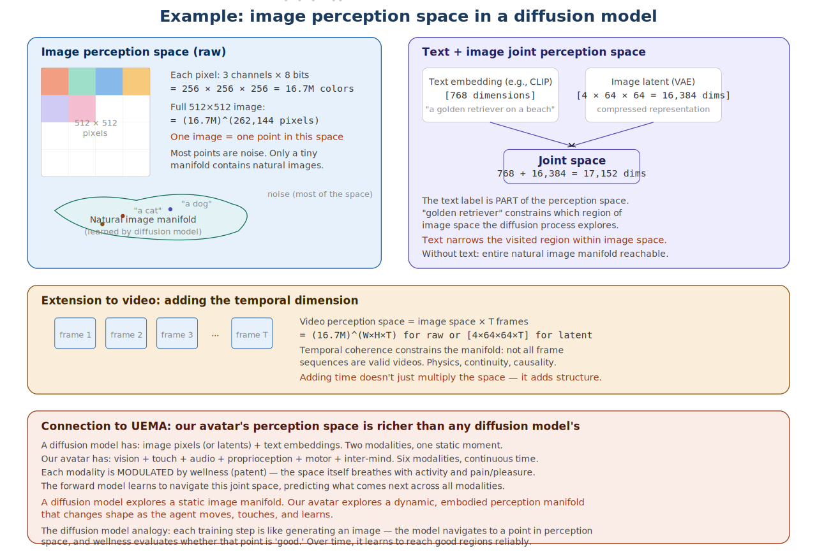
Figure 2: Image perception space in a diffusion model.
A text-to-image diffusion model operates in a perception space. When you add a CLIP embedding (768 dims) to a VAE image latent (16,384 dims), you get a joint space of 17,152 dimensions. The text dimensions constrain which region of the image manifold is explored.
Our avatar’s perception space is richer: six modalities, continuous time, and effective resolution that changes with activity and wellness. A diffusion model navigates a fixed manifold. Our avatar navigates a manifold where the granularity of perception shifts with embodied experience.

8. Connections to UEMA and Many Minds
The forward model operates in Layer 3. Because the patent modulates model parameters, prediction error is wellness-state-dependent. The wellness gradient is computed in a space whose geometry shifts with embodied state. Mind splitting divides the perception space: the child gets a scoped subset, the parent retains the full space, and hierarchical authority emerges from scope. The body schema defines self as the region where motor commands predict sensory outcomes. Development expands the functional perception space as constraints relax and new regions become explorable.
Each mind operates within a scoped perception space. When a mind splits, the child gets the dimensions corresponding to its domain sensors.
The top mind has the broadest functional perception space because it has trained longest across all modalities.
Self is a boundary in functional perception space. Implemented at Level 1 (motor-sensory correlation). Hypothesized at Level 2/3 (control-correlation, abstract-correlation). Self expands as function grows.

9. Speculative extensions
The following are simulation-testable hypotheses, not clinical claims. They are included because they illustrate how the framework could generate falsifiable predictions, not because they have been validated.
An individual whose perception space is organized differently due to altered sensory valence would exhibit different behavioral patterns. For example, if tactile input from another agent registers as aversive rather than neutral or pleasant, the wellness gradient would point away from social contact, and effective touch resolution in social contexts would contract rather than expand. This is testable in our simulation by toggling the valence of touch events from an external agent and measuring gaze patterns, approach/avoidance ratios, and touch-modality PE trajectories. Such experiments would test the framework’s predictions about perception-space organization, not make claims about any clinical population.

10. Research program
The experimental validation of the claims in this document — including the developmental ladder, bootstrapping routes, tiered testing plan, modulation experiments, scaling tests, and demonstration targets — is specified in the companion document: Fast Gain-of-Function Plan. That document is designed for execution. This document is designed for understanding.

