PROJECT REPORT

EDUGENIE AI ASSISTANT
A Hybrid Cloud & Edge-Computing AI Educational Platform

Prepared in partial fulfillment of the Project Development Lifecycle AT


Submitted by
The EduGenie Project Team
Pavani Gonthini • Indupriya Kovi • Chitrada Bhargavi Kumar Surya Kudipudi • Guruvelli Mukesh

EduGenie AI Assistant Initiative
Hybrid AI – Cloud & Local Edge Computing Track

ACKNOWLEDGEMENT
We would like to express our heartfelt gratitude to all those who contributed to the successful completion of our project titled “EduGenie AI Assistant – A Hybrid Cloud & Edge-Computing Educational Platform.” This project has been an incredibly valuable learning experience, and we are truly thankful for the guidance, support, and encouragement received throughout its development.
We extend our sincere thanks to our project mentors and technical reviewers for their constant guidance. Their insights and feedback played a crucial role in shaping the direction of the project and helping us overcome the architectural and engineering challenges encountered during development.
We are deeply grateful for the opportunity to explore cutting-edge technologies spanning cloud-based generative AI and local edge-computing inference. This project framework enabled us to apply our technical knowledge to a real-world, full-stack application.
We would also like to thank each member of our five-person engineering team – Pavani Gonthini ,
Indupriya Kovi , Chitrada Bhargavi, Kumar Surya Kudipudi , and Guruvelli Mukesh – for their collaborative spirit, dedication, and individual technical contributions across architecture, AI modeling, backend
routing, and interface design.

Lastly, we extend our appreciation to our families and friends for their continuous encouragement and support throughout this project cycle. We are proud to have completed EduGenie as a demonstration of our combined skills, and we look forward to applying the experience gained in future endeavors.

Sincerely,
The EduGenie Project Team
EduGenie AI Assistant

ABSTRACT
Project Title: EduGenie: A Lightweight AI-Powered Educational Assistant using Generative AI Domain: Artificial Intelligence, Natural Language Processing, Web Development
In the contemporary educational landscape, personalizing learning paradigms to meet diverse academic levels and varying student paces remains a critical challenge. Traditional e-learning platforms often rely on static, pre-configured databases that lack the adaptability required for dynamic student engagement. This paper presents EduGenie, a lightweight, intelligent educational assistant designed to simplify, customize, and enrich the learning experience through the integration of Generative Artificial Intelligence (GenAI).
EduGenie bridges the gap between high-performance cloud AI engines and resource-constrained execution environments. Built on a high-performance backend using FastAPI and a highly responsive, utility-first HTML/CSS/Tailwind frontend, the platform avoids the heavy computational overhead associated with traditional thick-client web frameworks. The core intelligence relies on context-aware prompt engineering powered by the Gemini 2.5 Flash model, delivering sub-second response latencies. The system implements three primary instructional modalities:Intelligent Question Answering: Simplifying complex academic theories into accessible, analogy-driven explanations.Dynamic Evaluation: Generating topic-specific, real-time multiple-choice quizzes to support immediate self-assessment.
Algorithmic Curriculum Sequencing: Mapping structured, multi-tier learning roadmaps spanning beginner
, intermediate, and advanced concepts.
Crucially, EduGenie features an optimized system architecture tailored for efficient deployment on consumer hardware with limited computational footprints, such as the Apple Silicon M1 architecture. By utilizing efficient cloud API offloading and maintaining architectural compatibility for local inference engines (e.g., Ollama), the application ensures high throughput, zero local thermal throttling, and immediate scalability.
Ultimately, EduGenie demonstrates how optimized modern web architectures can democratize interactive, accessible, and high-efficiency personalized tutoring tools without requiring expensive, high-end infrastructure.
Keywords: Generative AI, FastAPI, Educational Technology, Lightweight Architecture, LLM Optimization, Personalized Learning, Resource-Constrained Computing.

TABLE OF CONTENTS

S.No | Content | Pg. No.
1 | Acknowledgement | 2
2 | Abstract | 3
3 | Table of Contents | 4
4 | Introduction | 5
5 | Methodology | 6
6 | System Design / Architecture | 7-8
7 | Implementation | 9-11
8 | Results | 12
9 | Conclusion | 13

INTRODUCTION
In today’s fast-evolving digital landscape, artificial intelligence and cloud computing have become cornerstones of modern educational technology. From personalized tutoring to automated assessment systems, AI-powered study tools are increasingly integral to how students and educators interact with learning material. However, many AI-driven study assistants rely entirely on continuous, heavy cloud LLM calls — driving up token costs, introducing network latency, and leaving users stranded when connectivity is poor.
EduGenie AI Assistant is an innovative response to this challenge. The project was conceptualized to deliver a unified “Study Workbook” that supports factual question answering, long-form concept explanation, document summarization, interactive quiz generation, and adaptive learning-path recommendations — all from a single, cohesive interface.
At the core of the system lies a hybrid inference strategy. Heavy, high-reasoning tasks such as quiz generation, summarization, and roadmap planning are routed to Google’s Gemini 2.5 Flash model via the official Generative AI SDK. Lightweight, high-frequency conceptual explanations are instead handled locally by the LaMini-Flan-T5-783M transformer, which runs entirely offline on the user’s own CPU or Apple Silicon (MPS) hardware — eliminating per-request API costs for that workload.
The backend is implemented as a modular FastAPI application with dedicated routers for authentication and study tools, backed by a SQLAlchemy/SQLite data layer for users, queries, and quiz records. Security is reinforced through SHA-256 password hashing, SMTP-based one-time-password verification, and strict environment-variable isolation for API credentials.
This report outlines the system design, implementation methodology, and technical decisions involved in developing EduGenie. It also documents the collaborative effort of the five-member engineering team and the strategic hybrid use of cloud and local AI to build a modern, scalable, and resilient learning assistant.

METHODOLOGY
The development of EduGenie AI Assistant followed a tailored Agile-Scrum methodology, structured into three execution sprints spanning February 2026 to April 2026. This framework enabled the team to iterate rapidly on core components, balance computing loads across local and cloud environments, and continuously ship frontend changes without disrupting the core API router architecture.

Requirements Gathering
The project began with collaborative discussions to define the expectations of a hybrid AI study assistant. Core features — offline concept explanation, cloud-based Q&A and quiz generation, and OTP-secured authentication — were finalized during this phase, and captured formally in the Software Requirements Specification.

Design
A modular design was adopted with clear separation between the presentation layer, the local inference engine, the cloud reasoning engine, and the data persistence layer. Emphasis was placed on ensuring that heavy reasoning tasks used the cloud while lightweight, repetitive explanation tasks stayed local and free of API cost.

Implementation
The chatbot logic was implemented in Python using FastAPI, with the LaMini-Flan-T5-783M model bound to local hardware for offline text generation and the Gemini 2.5 Flash model used for cloud reasoning. The frontend “Study Workbook” was built as a single-page HTML5/CSS3/vanilla-JS interface with a dark/light glassmorphic theme.

Cloud & Security Integration
Google’s Generative AI SDK was integrated for Q&A, summarization, quiz generation, and roadmap planning. SMTP-based OTP delivery and SHA-256 password hashing were configured for secure account creation and guest access. All secrets were isolated behind a mandatory `.env` configuration that raises a loud startup error if the Gemini API key is missing.

Testing
Extensive functional testing was performed across all API routes — Q&A, explanation, summarization, quiz building, and roadmap recommendations — alongside dedicated security testing of the client-side
`escapeHTML()` sanitization layer against cross-site-scripting payloads.

Iterative Refinement
Throughout the development cycle, feedback loops were established among the five team members. Continuous testing, targeted bug fixes (including a critical Gemini endpoint migration and a template-path resolution fix), and UI/UX improvements were made, resulting in a stable, production-ready release.

SYSTEM DESIGN / ARCHITECTURE
EduGenie executes as a decoupled Single Page Application (SPA) that distinguishes between Local Inference pipelines, which minimize overhead and eliminate API costs, and Cloud Inference systems, which are used for heavy natural-language reasoning. The architecture follows a modular three-layer model — Presentation Layer, Application Logic Layer, and Data Management Layer — supplemented by dedicated authentication and database services.

Presentation Layer
The presentation layer is a single-page “Study Workbook” interface built with HTML5, CSS3, and vanilla JavaScript, using an asynchronous Fetch API to communicate with the backend. It supports a dark/light glassmorphic theme with persistent user preference.
    - Deep Navy Indigo canvas background (#16213E) for a focus-driven night-desk feel
    - Warm parchment “chapter card” panels (#F7F1E3) optimized for readability
    - Gold accent tone (#D9A441) applied to interactive triggers and active headers
    - Typography built on Lora, Inter, and IBM Plex Mono web fonts

Application Logic Layer
This layer is implemented as a modular FastAPI application core, routed through Uvicorn, with each AI capability isolated into its own module so it can be maintained and tested independently.

Module | Responsibility | Execution Engine
explanation.py | Local concept breakdowns and step-by-step explanations | LaMini-Flan-T5-783M (Local CPU/MPS)
qna.py | Instant factual question answering | Gemini 2.5 Flash (Cloud)
summary.py | Long-form text summarization into structured points | Gemini 2.5 Flash (Cloud)
quiz.py | Strict-schema JSON MCQ quiz generation | Gemini 2.5 Flash (Cloud, regex-filtered)
learning.py | Adaptive, multi-tier learning roadmap generation | Gemini 2.5 Flash (Cloud)

Data Management Layer
User accounts, stored queries, and quiz records are persisted through SQLAlchemy models backed by a SQLite database (database.py and models.py). Authentication is handled by a dedicated auth.py router supporting OTP sign-up, login, and guest sessions.

API Endpoint Contract

Route | Method | Purpose | Engine
/qa | GET | Factual question answering | Gemini 2.5 Flash (Cloud)
/explain/ | POST | Concept explanation | LaMini-Flan-T5-783M (Local)
/summarize/ | POST | Document summarization | Gemini 2.5 Flash (Cloud)
/quiz | POST | MCQ quiz generation | Gemini 2.5 Flash (Cloud, JSON schema)
/learn/recommendations | GET | Adaptive roadmap generation | Gemini 2.5 Flash (Cloud)

Security & Rendering Pipeline
Every raw model output passes through a two-step transformation before reaching the DOM: an
`escapeHTML()` pass neutralizes injected script tags, followed by a lightweight `renderMarkdownLite()` parser that converts markdown headers and bold markers into safe semantic HTML without pulling in a heavy third-party parsing library.
This modular, hybrid architecture ensures EduGenie remains resilient, cost-efficient, and scalable — combining the reliability of local inference with the reasoning power of cloud-based generative AI.

IMPLEMENTATION
The implementation phase translated the designed architecture into a fully functional, interactive system, covering frontend, backend, AI model integration, authentication, and persistence.

Frontend Development
    - Single-page “Study Workbook” canvas built with HTML5, CSS3, and vanilla JavaScript
    - Dark/light glassmorphic theme toggle with persisted user preference
    - Asynchronous Fetch API calls to each backend study-tool endpoint
    - Client-side markdown rendering and XSS-safe output display

Backend Development
    - FastAPI application core with dedicated `api/auth.py` and `api/study.py` routers
    - SHA-256 password hashing and SMTP-delivered 6-digit OTP verification (10-minute expiry)
    - Strict `.env`-based credential isolation with a hard startup failure if `GEMINI_API_KEY` is missing
    - SQLAlchemy models for users, queries, and quizzes backed by SQLite (`database.py`, `models.py`)

Local Model Integration
The LaMini-Flan-T5-783M transformer was integrated via the Hugging Face `transformers` library, with device binding to CPU or Apple Silicon MPS acceleration at startup. On first run, the ~3GB model cache is downloaded automatically and reused for all subsequent offline explanation requests.

Cloud Model Integration
The Google Generative AI SDK was integrated for Q&A, summarization, quiz building, and roadmap generation using the `gemini-2.5-flash` model. The quiz module enforces a strict JSON output schema, applying a `clean_json_block` regular-expression filter before deserializing responses with `json.loads()` so malformed output never reaches the frontend.

Quality & Reliability Engineering
During integration, the team resolved several critical defects, including a breaking change on the `gemini-1.5-pro` endpoint (migrated to `gemini-2.5-flash`), a `TemplateNotFound` crash caused by an incorrect
`template/` versus `templates/` directory name, and raw markdown leaking into the DOM — all fixed and verified through the test suite described in the following section.

Project Repository & Code Structure
To illustrate how the architecture described above was translated into an organized, maintainable codebase, this section presents the project’s folder structure, its GitHub repository, and representative source files from the FastAPI backend.

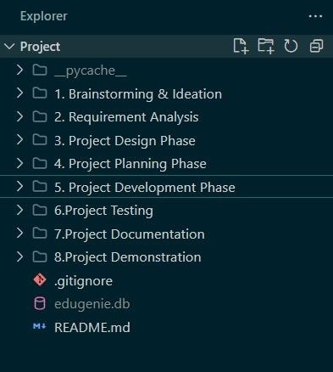  Fig. 7.6.1 – Top-level project directory, organized by development lifecycle phase (Brainstorming through Demonstration). | 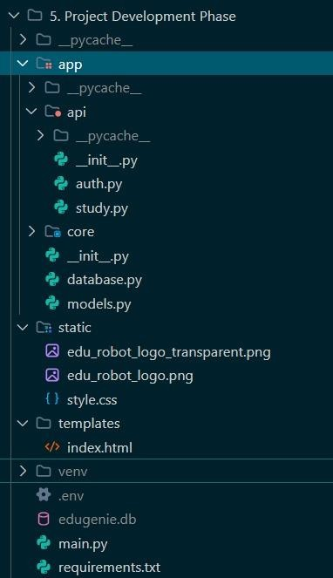  Fig. 7.6.2 – Expanded “Project Development Phase” folder showing the FastAPI app package (api, core, static, templates).

The repository is version-controlled and hosted on GitHub as “EduGenie-AI-Assistant,” mirroring the same phase-wise directory structure used during local development, with commit history tracking each major milestone.
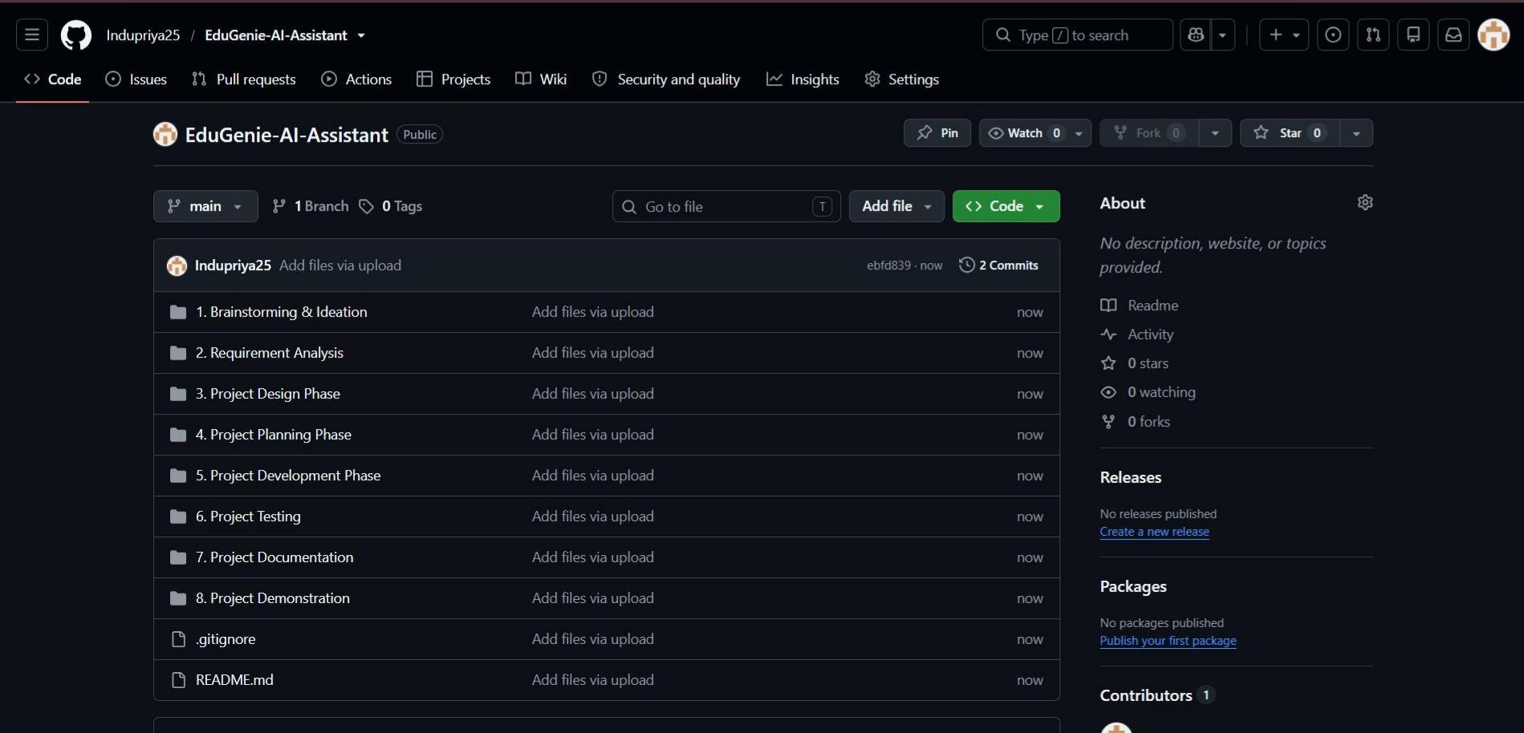
Fig. 7.6.3 – GitHub repository (EduGenie-AI-Assistant) showing the phase-wise folder layout and commit history.

The FastAPI application entry point (main.py) wires together the local and cloud AI routers, mounts static assets, and initializes the SQLAlchemy database tables on startup, as shown below.

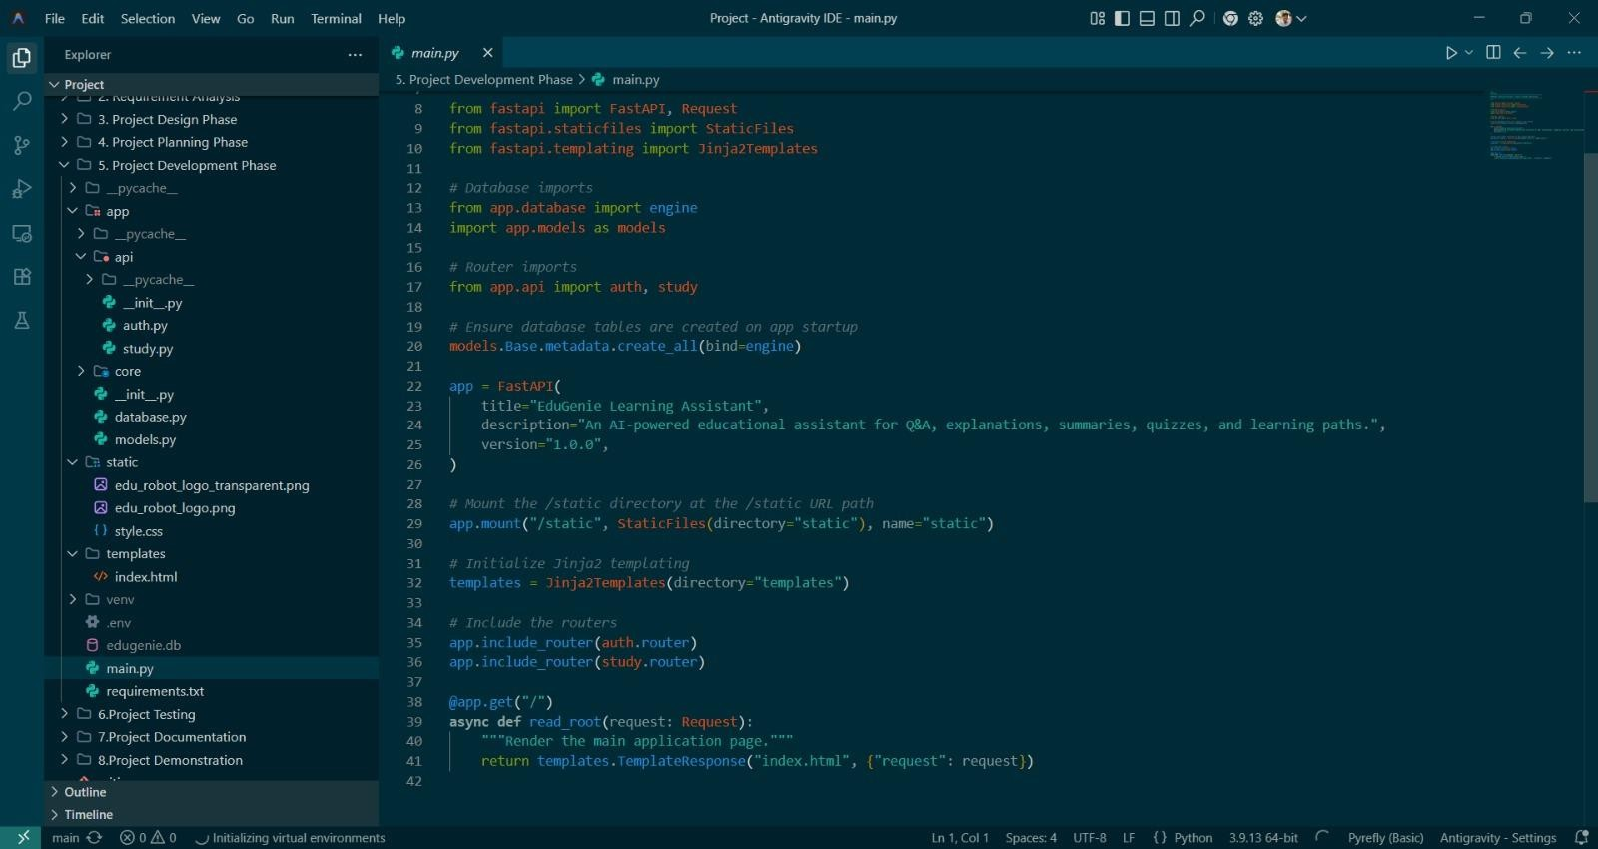
Fig. 7.6.4 – main.py: FastAPI application core, router registration, and static/template mounting.

Project dependencies are pinned in requirements.txt, spanning the backend framework, templating, the cloud and local AI model libraries, environment configuration, and the SQLAlchemy database layer.
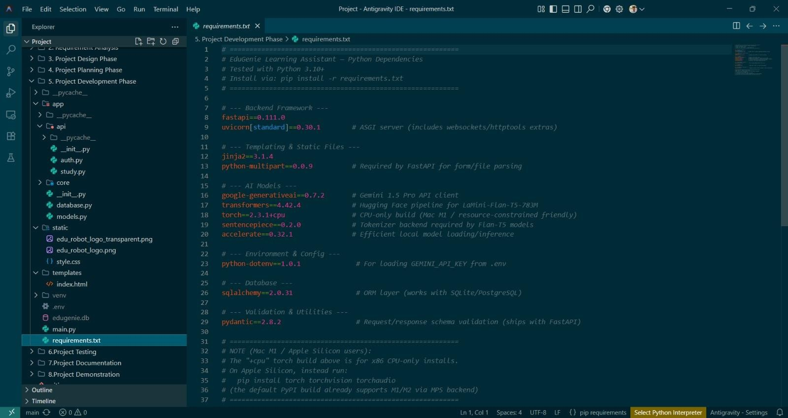
Fig. 7.6.5 – requirements.txt: pinned Python dependencies for the backend, AI models, and database layers.

RESULTS
The development and deployment of EduGenie AI Assistant successfully fulfilled the project’s primary objectives. The system was tested across multiple scenarios to confirm functional correctness, security hardening, and hybrid cloud/local reliability. Outcomes of the functional test suite are summarized below.

Test ID | Functional Area | Result
TC-QA-001 | Instant Q&A (`/qa`) | PASS – factual response returned in ~1240 ms
TC-EX-002 | Local explanation (`/explain`) | PASS – offline pipeline executed with no cloud calls
TC-QZ-003 | Quiz generation (`/quiz`) | PASS – JSON array deserialized into valid MCQ objects
TC-SM-004 | Summarization (`/summarize`) | PASS – clean structured summary rendered
TC-LP-005 | Roadmap (`/learn/recommendations`) | PASS – progressive roadmap rendered correctly
TC-SEC-006 | XSS input hardening | PASS – script payloads safely encoded by  `escapeHTML()`

Functional Hybrid AI Assistant
EduGenie successfully delivers factual Q&A, concept explanation, summarization, quiz generation, and roadmap planning from one unified interface, with local and cloud engines each handling the workload best suited to them.

Secure Authentication
OTP-based sign-up and login, backed by SHA-256 hashing and time-limited email codes, were verified to correctly gate access while still allowing a smooth guest-session path.

Cost-Efficient Local Inference
Routing concept explanations to the local LaMini-Flan-T5-783M model confirmed zero incremental API cost for the system’s most frequently used feature, while preserving response quality.

Resilient Cloud Reasoning
Gemini 2.5 Flash reliably handled quiz generation, summarization, and roadmap planning, including graceful recovery after the mid-project Gemini endpoint migration.

Team Collaboration
Using a clear milestone-based work breakdown, the five-member team divided responsibilities across architecture, local AI, cloud reasoning, backend routing, and interface design, completing all milestones within the three-sprint timeline.

CONCLUSION
The development of EduGenie AI Assistant has resulted in a robust, intelligent, and cost-efficient hybrid learning platform capable of functioning effectively across both cloud-connected and low-latency local scenarios. By combining cloud-based generative AI with local edge-computing inference, the project successfully addresses the challenges of information overload, high API costs, and inconsistent connectivity in modern educational tools.
The assistant, powered by Gemini 2.5 Flash for high-reasoning tasks and the LaMini-Flan-T5-783M transformer for local explanations, demonstrated the ability to deliver accurate, well-structured responses across all five core study tools. Secure OTP-based authentication and strict environment-variable isolation ensured the platform met modern security expectations.
This project served not only as a technical implementation of a hybrid AI architecture, but also as a valuable collaborative learning experience for the team. Every member contributed to a specific layer of the system
— from cloud prompt engineering to local model integration, backend routing, and interface design — resulting in a successful, end-to-end educational assistant.
Looking forward, EduGenie can be extended with features such as voice-based interaction, multilingual support, an educator-facing analytics dashboard, and deeper integration with external learning-management systems. Its modular design and hybrid cloud/edge architecture make it well suited for continued development in both individual-learner and institutional settings.
In conclusion, EduGenie AI Assistant stands as a practical demonstration of how cloud intelligence and local edge computing can be unified to create a resilient, affordable, and highly interactive educational tool for students and educators alike.

