TERRAFORM-02
2). Execute all the templates shown in the video.
Using two providers in a same configuration file
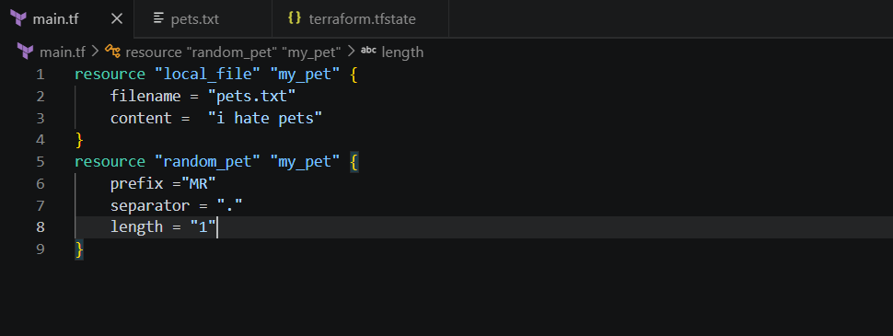
Initializing backend : terraform init
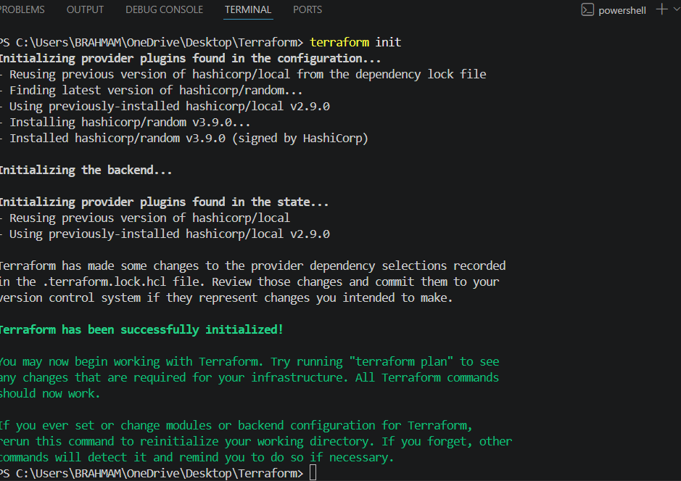
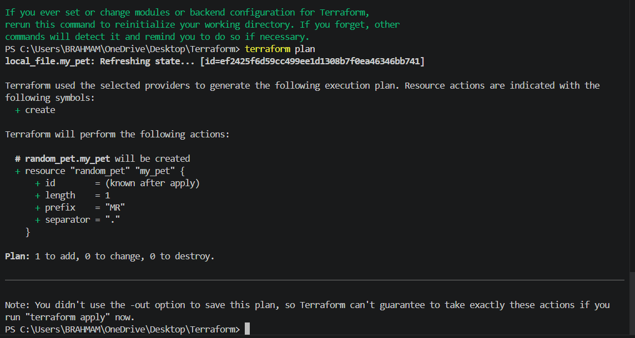
I can ihate pets to we love pets
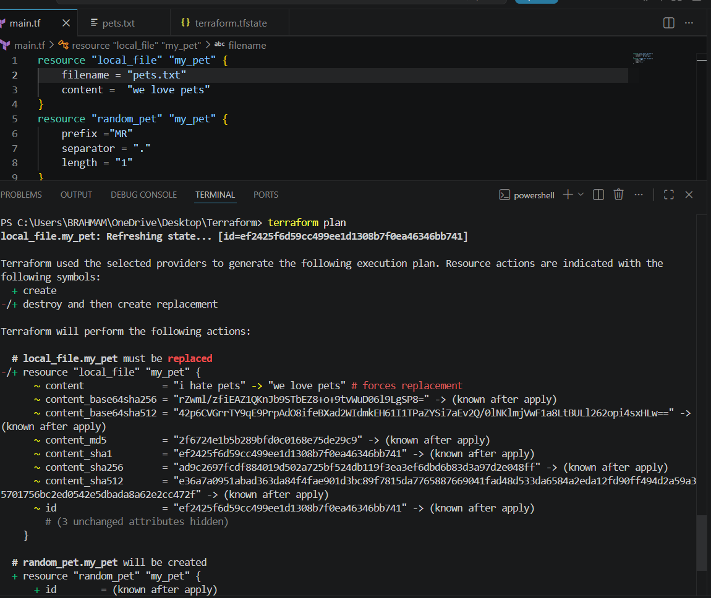
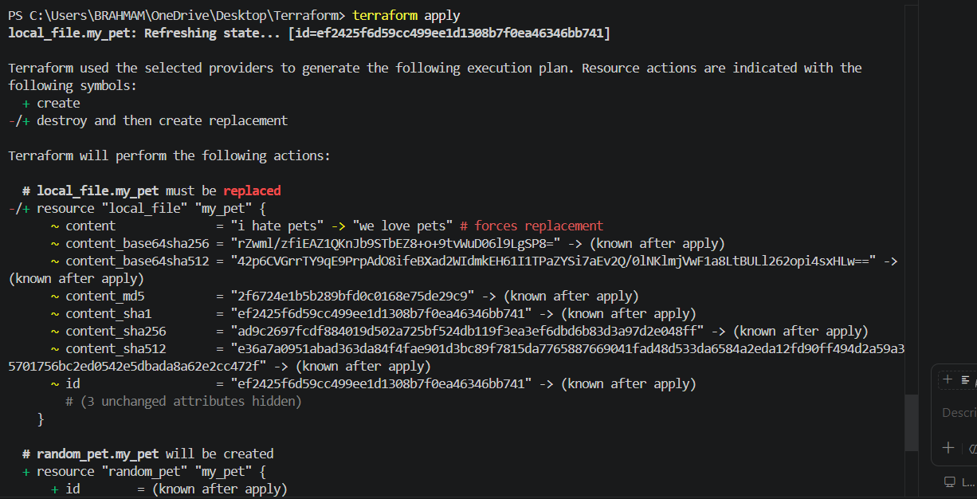
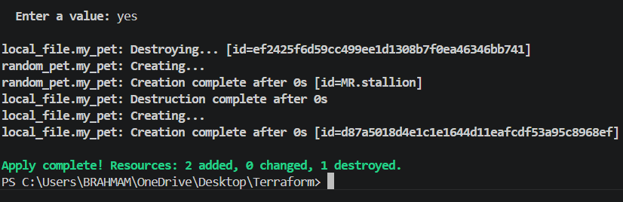
We can see
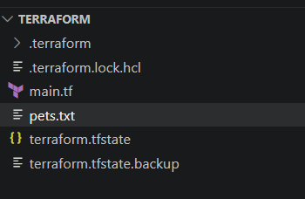
Pets.txt has been created and content inside is we love pets
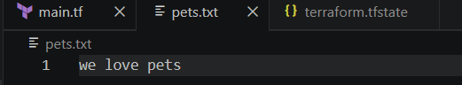
Lets work with the variables
Lets create a variables.tf file
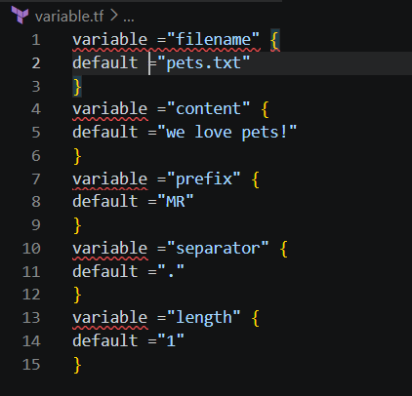
We have created a variables.tf file so instead of hardcoding the values inside our main
configuration file we will be referring to this variable.tf file inside main.tf file
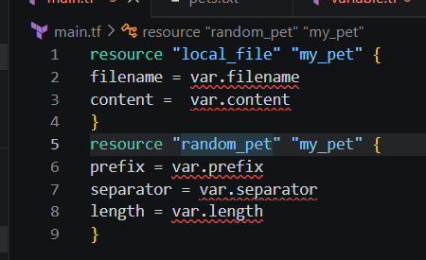
This is our main.tf now
Here we are using the variables var.filename , var.content etc from the variables.tf file
Lets now apply the changes
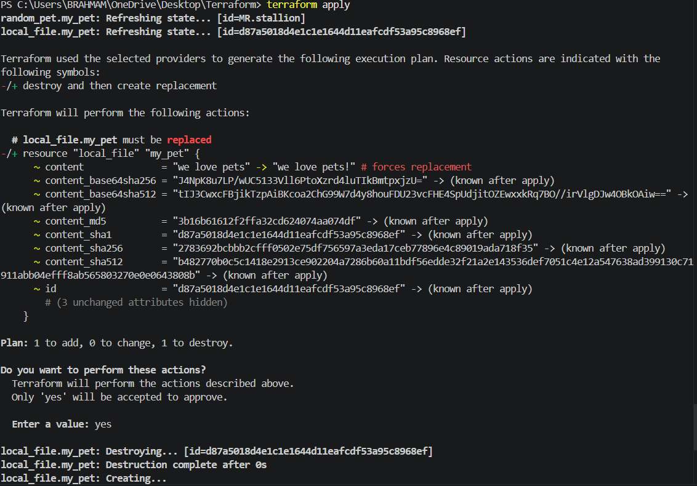
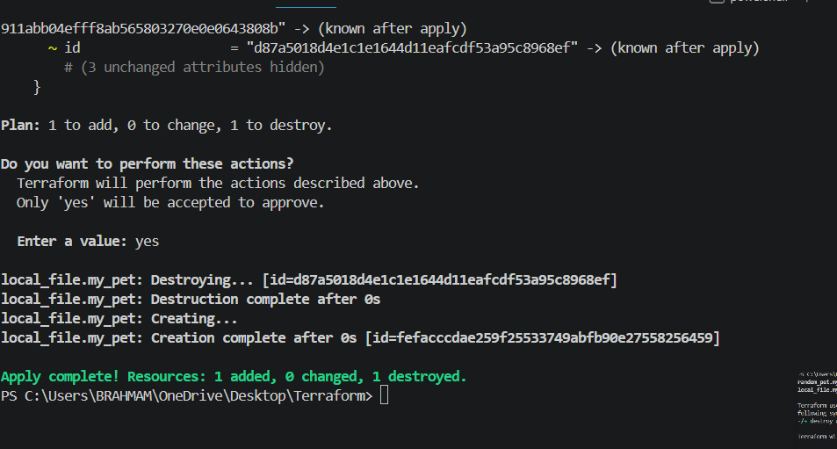
Here we can see replaced the word

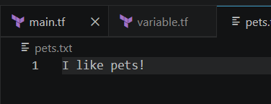

3. Integrate Terraform in Jenkins using the Terraform plugin.
Lets install terraform plugin in Jenkins.
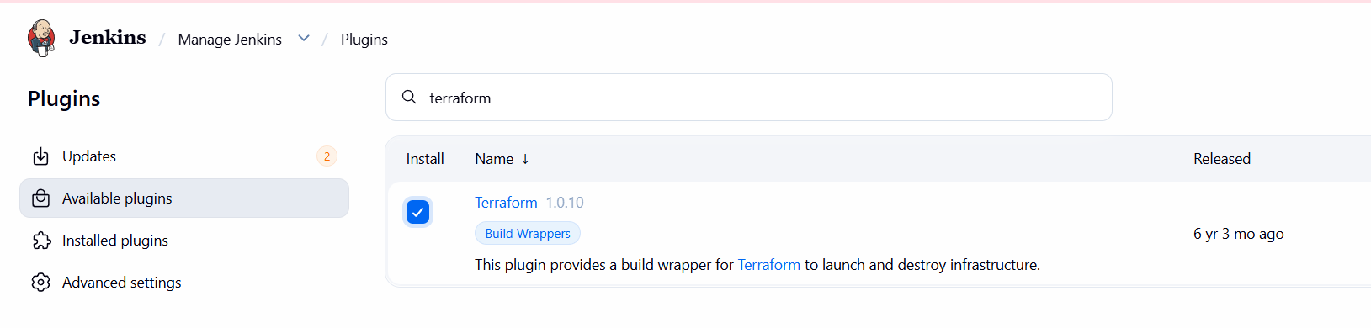
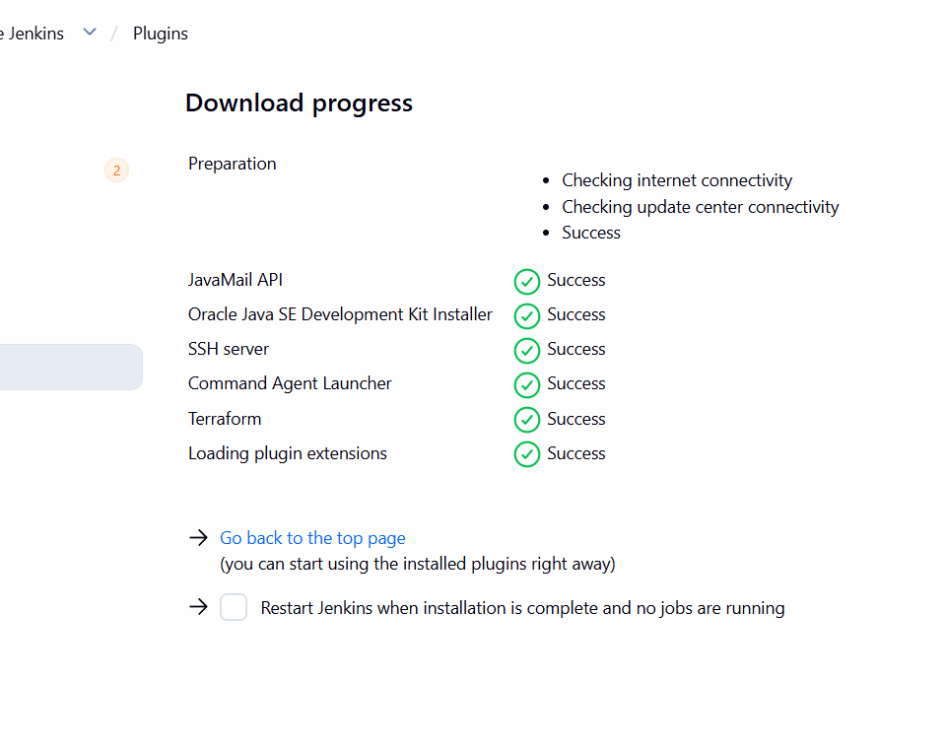
Configure terraform
Tools terraform installation give name save
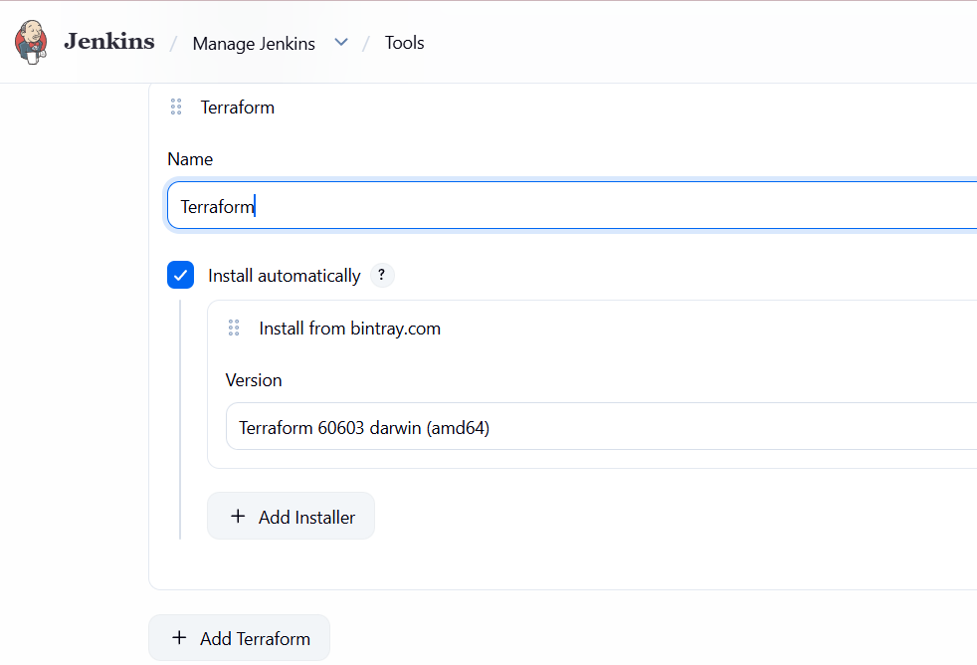
Lets create a main.tf file
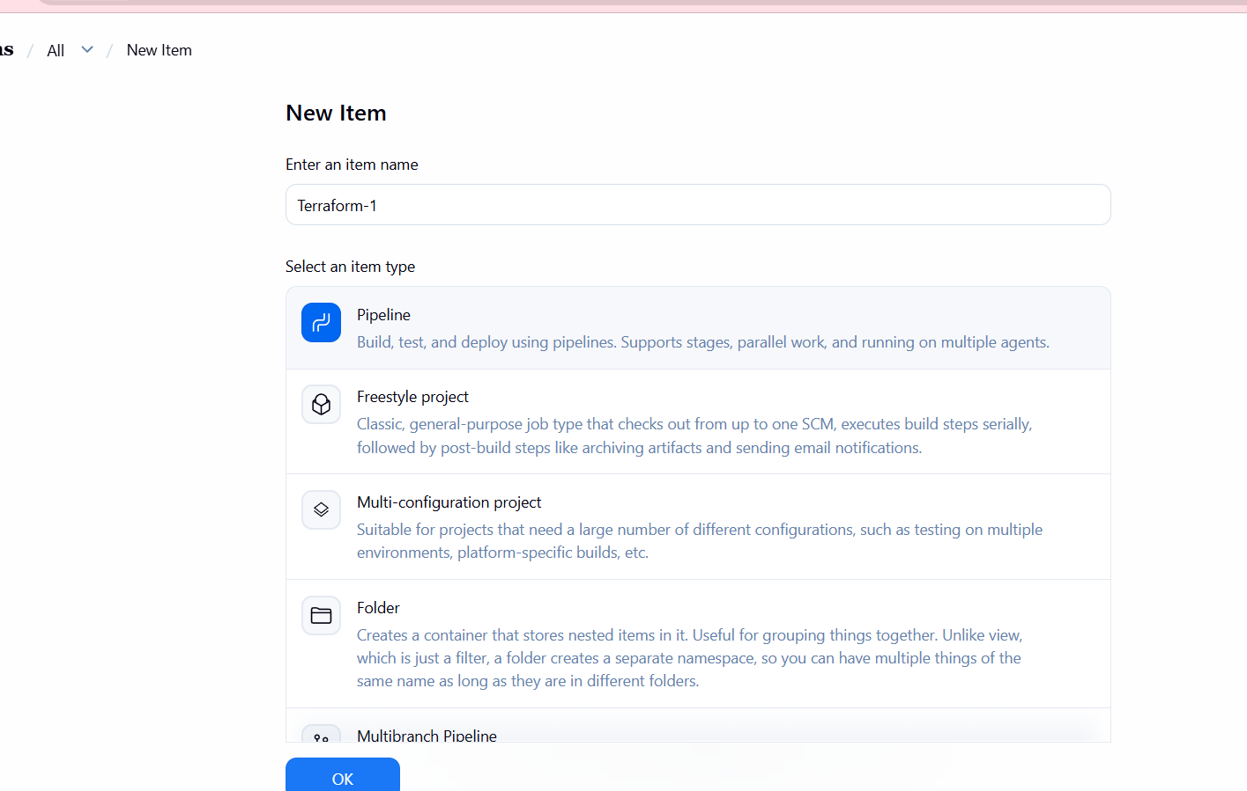
after job creating we can go to ec2 instance change directory with the job name change directory to this and vi main.tfgiven below the script enter
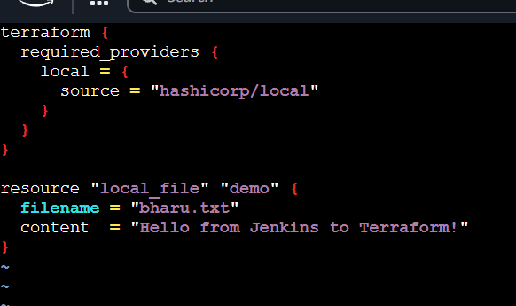
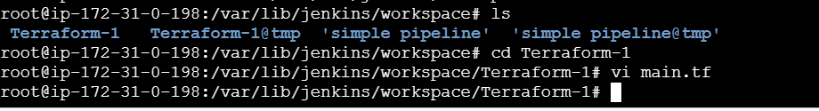
Now lets create a pipeline job
pipeline {
agent any
tools {
terraform 'Terraform'
}
stages {
stage('Terraform Init') {
steps {
sh 'terraform init'
}
}
stage('Terraform Plan') {
steps {
sh 'terraform plan'
}
}
stage('Terraform Apply') {
steps {
sh 'terraform apply -auto-approve'
}
}
}
}
