TERRAFORM-06
1). Watch the Terraform-06 video.
2). Execute the script shown in the video.
Terraform Module
A Terraform module is a reusable package of Terraform code that groups resources together
and can be used multiple times.
Lets create a directory first called aws_instance
In directory lets create two files
1. main.tf
2. variables.tf
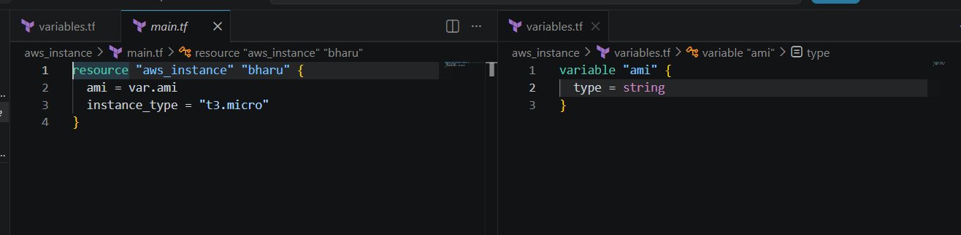
Now lets create another directory called development
In this lets create another main.tf
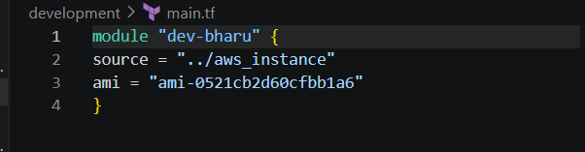
Lets change the directory go to aws_instance doirectory and lets perform terraform init
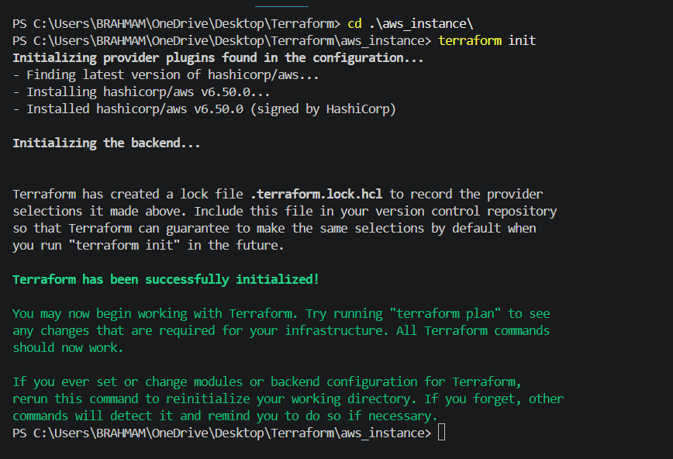
Now lets execute terraform apply
After terraform apply I got error because of my vpc dooesnot have subnetfirst I have go to vpc in aws and copy that subnet and paste in aws_instance file
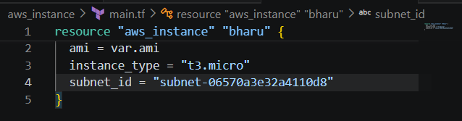
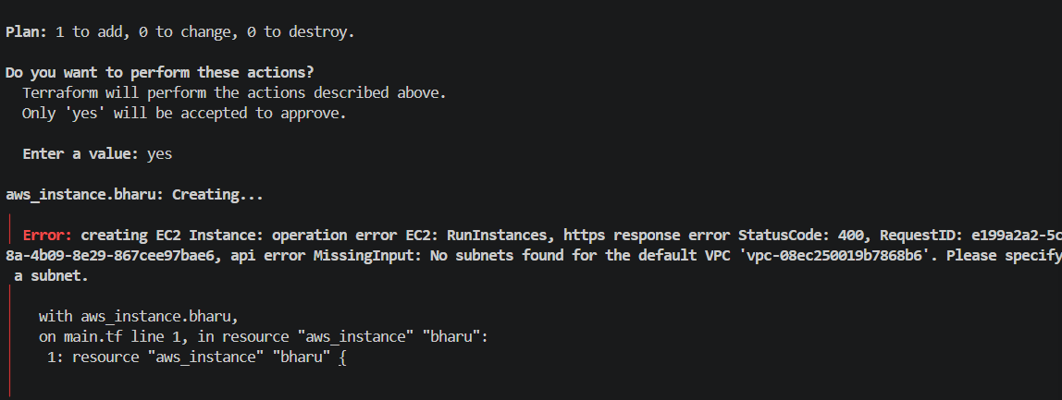
After putting subnet id terraform apply
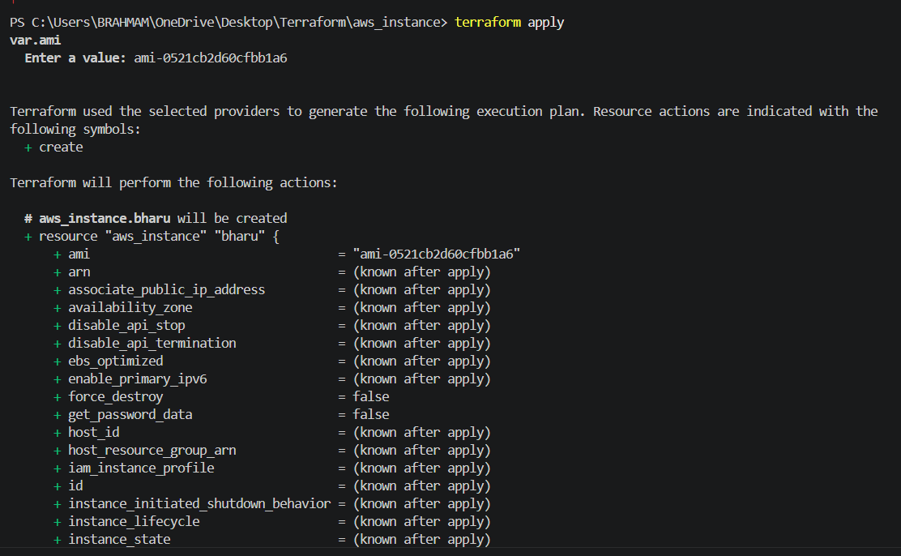
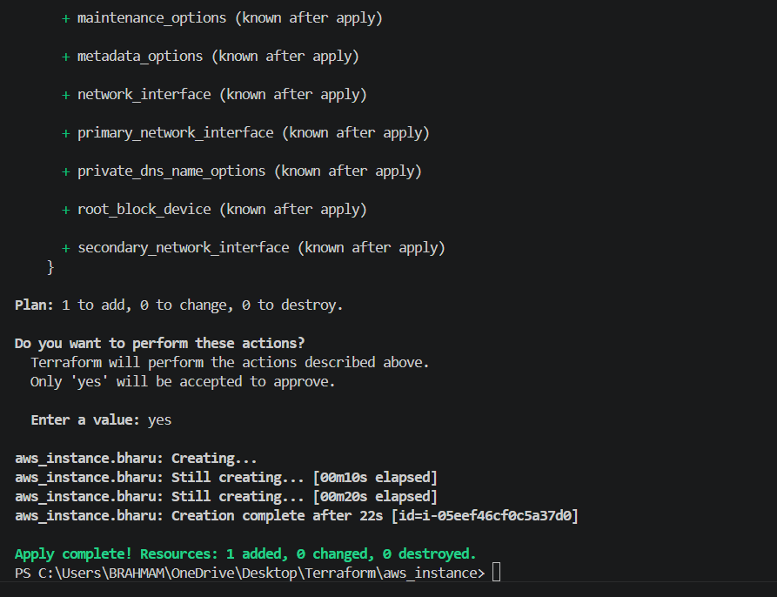
Now we can see terraform.tf file has been created in Development Directory
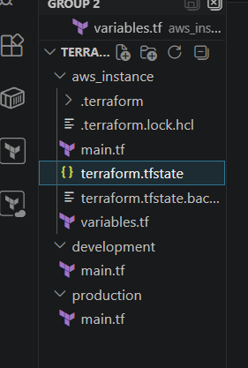
Terraform Workspace
Workspace can be used if we have multiple projects/environments using the same configuration.
Lets create main.tf and variables.tf files.
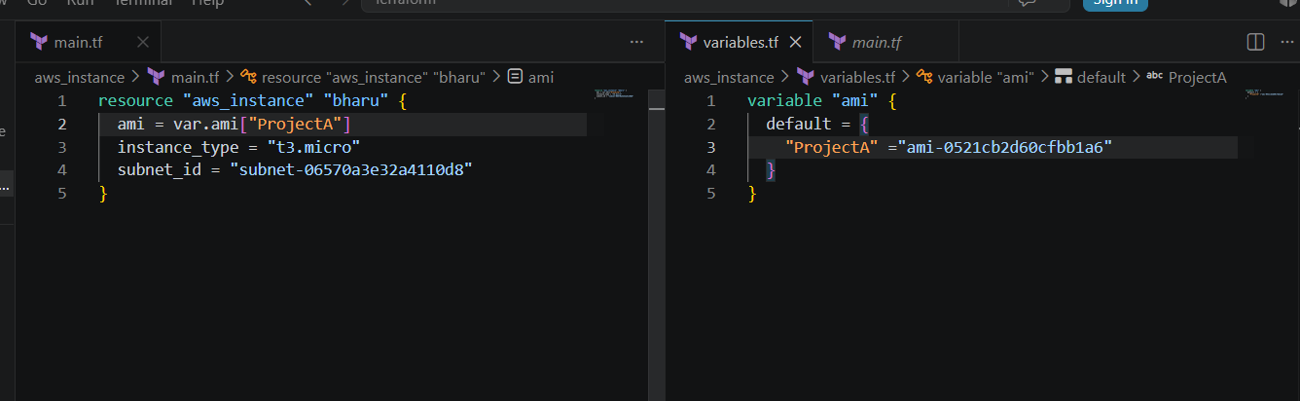
For creating workspace
terraform workspace new projectA ⇒ for creating a new workspace
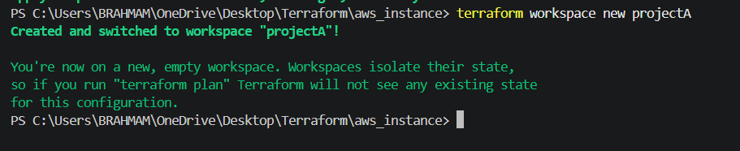
We can see the new workspace created in terraform.tfstate.d
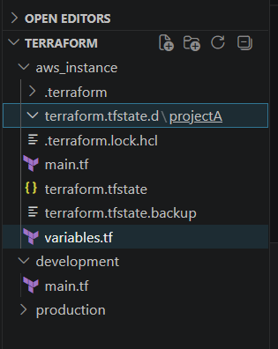
terraform workspace list ⇒ for getting list of workspace
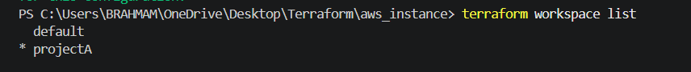
terraform workspace selecr projectA to swtich to specific workspace
Lets check if the folder called ProjectA
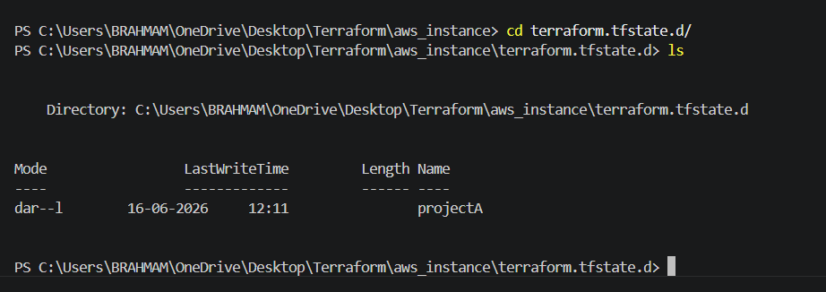
Lets do terraform init nowterraform apply
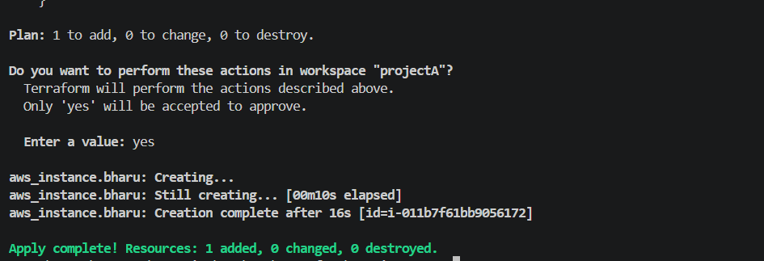
Lets check in aws ec2 if the instance has been created or not
3). Provision EC2, S3, and VPC using Terraform modules.
So let's create a directory called aws_instance →main.tf
Lets create a sub directory called Modules → inside modules create 3 folders each and 3
files inside each folder with names VPC→main.tf, S3→main.tf, ec2→main.tf
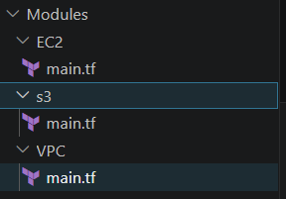
aws_instance →main.tf
provider “aws”{
Region = “us-east-1”
}
module "vpc" {
source = "./modules/vpc"
}
module "s3" {
source = "./modules/s3"
}
module "ec2" {
source = "./modules/ec2"
}
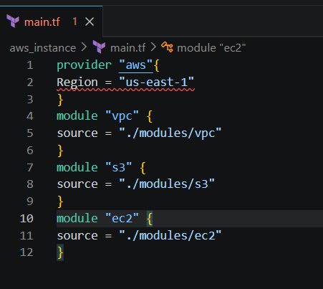
Modules
VPC →main.tf
resource "aws_vpc" "my_vpc" {
cidr_block = "10.0.0.0/16"
tags = {
Name = "terraform-vpc"
}
}
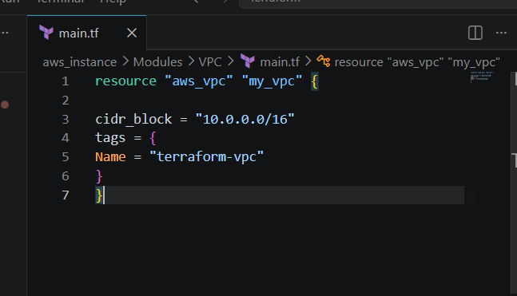
S3 →main.tf
resource "aws_s3_bucket" "my_bucket" {
bucket = "bharu-terraform-module-demo-12345"
tags = {
Name = "terraform-s3"
}
}
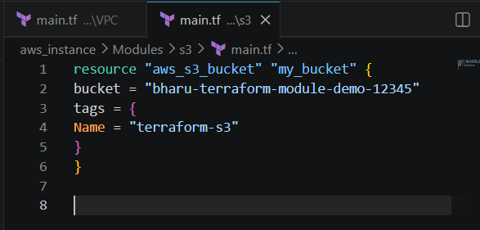
EC2 →main.tf
resource "aws_instance" "my_ec2" {
ami = "ami-0b6d9d3d33ba97d99"
instance_type = "t3.micro"
Subnet_id = “subnet-06570a3e32a4110d8”
Associate_public_ip_address = true
tags = {
Name = "terraform-ec2"
}
}
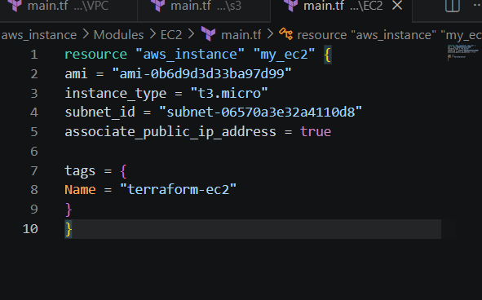
Now lets intialize terraform now
terraform init
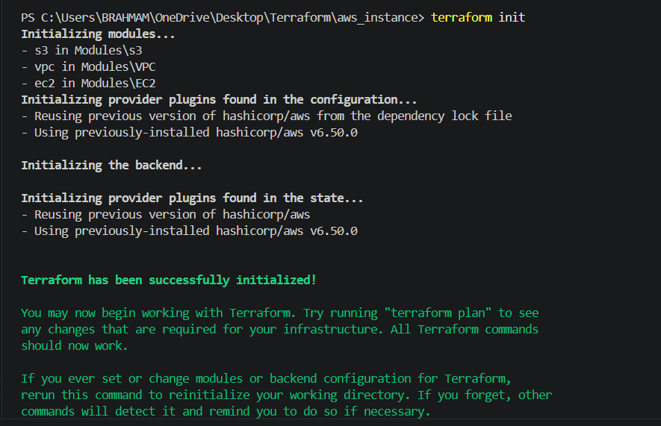
Terraform plandry run
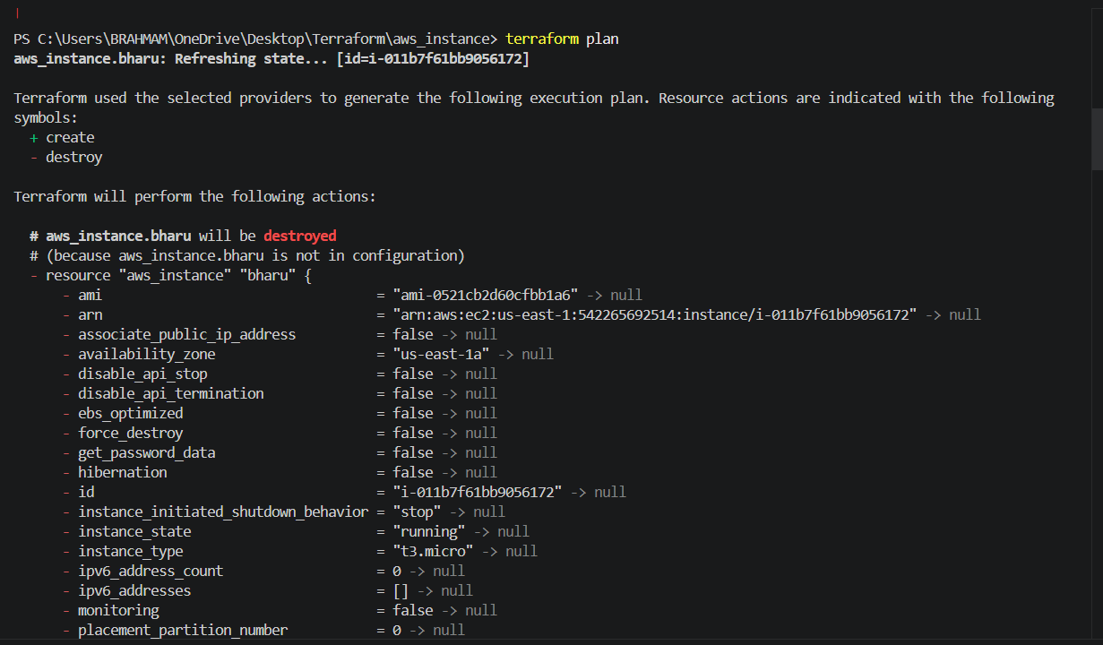
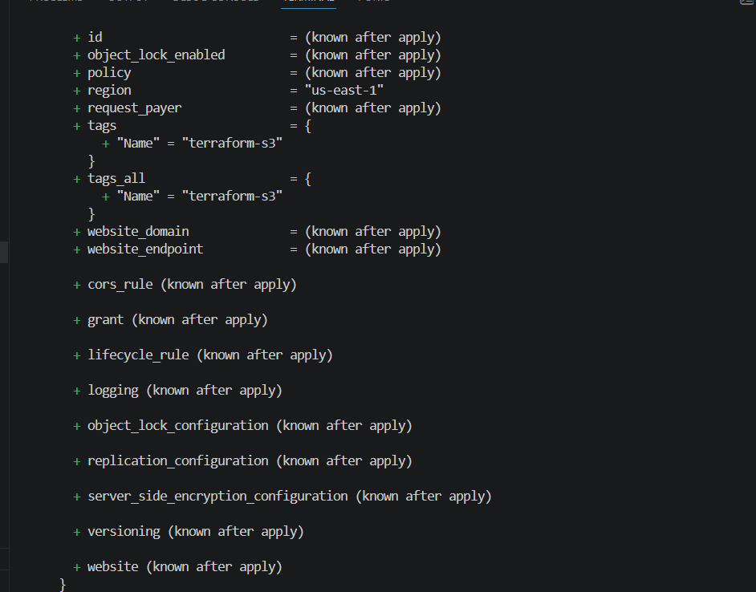
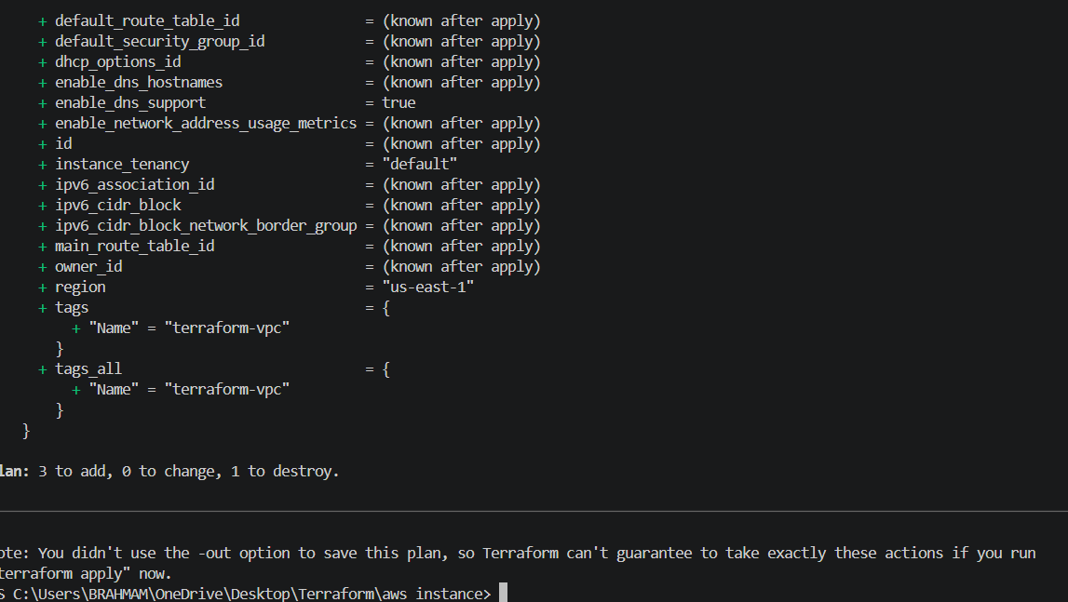
Terraform apply
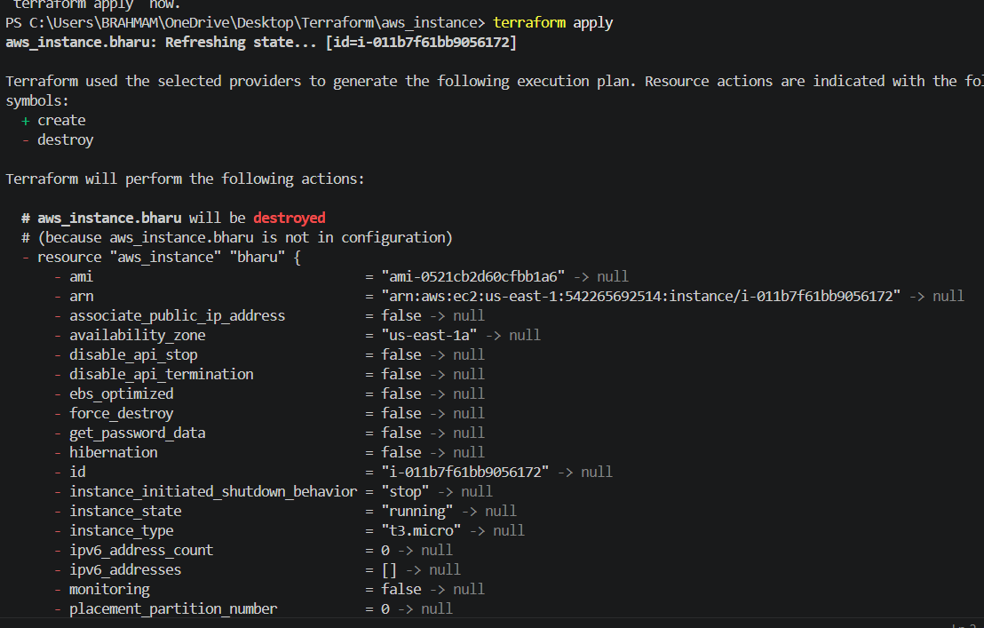
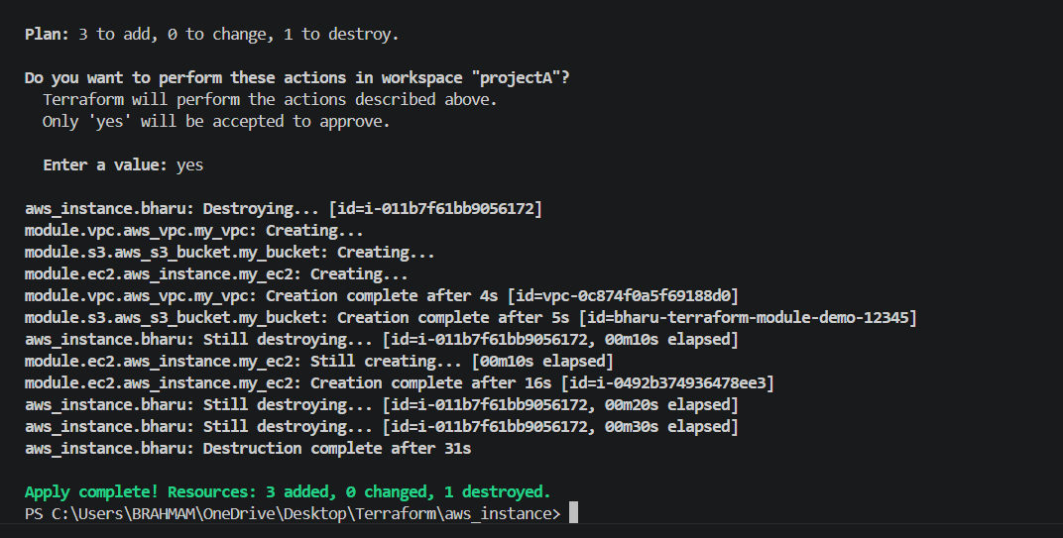
Lets check in AWS EC2 → if the instance has been created
4)Provision EC2 for 3 different environments (Dev, Staging, and Prod) using Terraform workspaces.
First let's create a directory called terraform-workspace.
Now lets add a file called main.tf
provider "aws" {
region = "us-east-1"
}
resource "aws_instance" "workspace_ec2" {
ami = "ami-0b6d9d3d33ba97d99"
associate_public_ip_address = "true"
subnet_id = "subnet-06570a3e32a4110d8"
instance_type = lookup(
{
dev ="t3.micro"
staging ="t3.small"
prod ="c7i-flex.large"

},
terraform.workspace
)
tags ={
Name =terraform.workspace
}
}
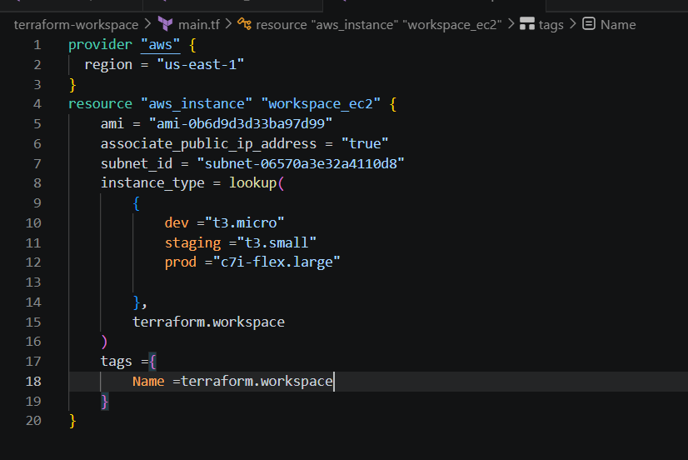
Lets do terraform initlscd terraform-workspaceterraform workspace list
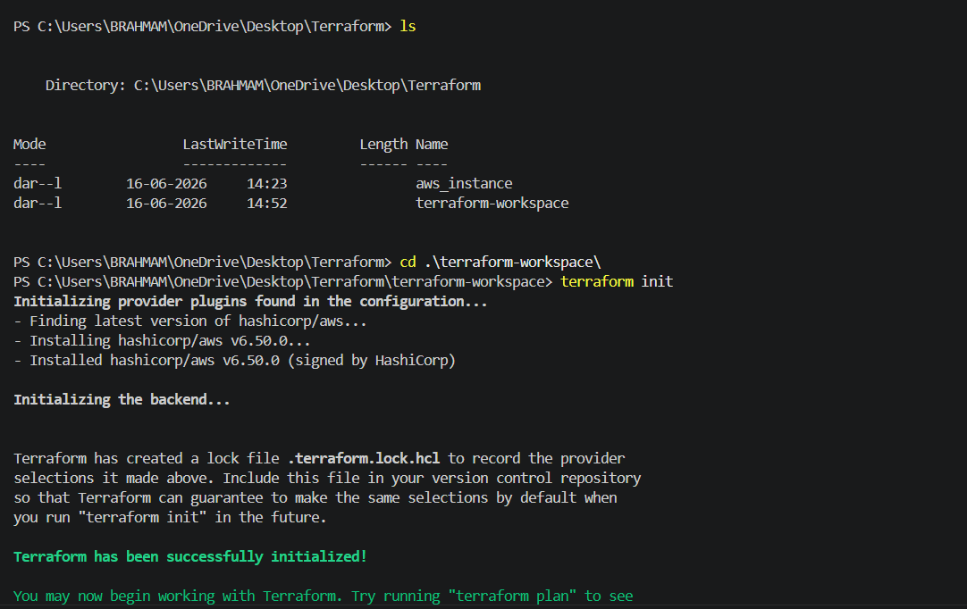
Terraform workspace new dev Terraform workspace new staging Terraform workspace new prod
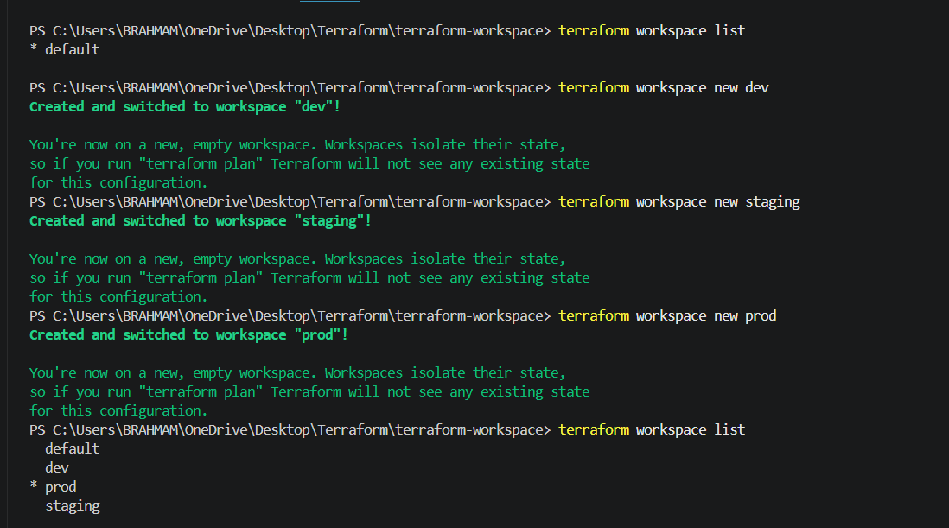
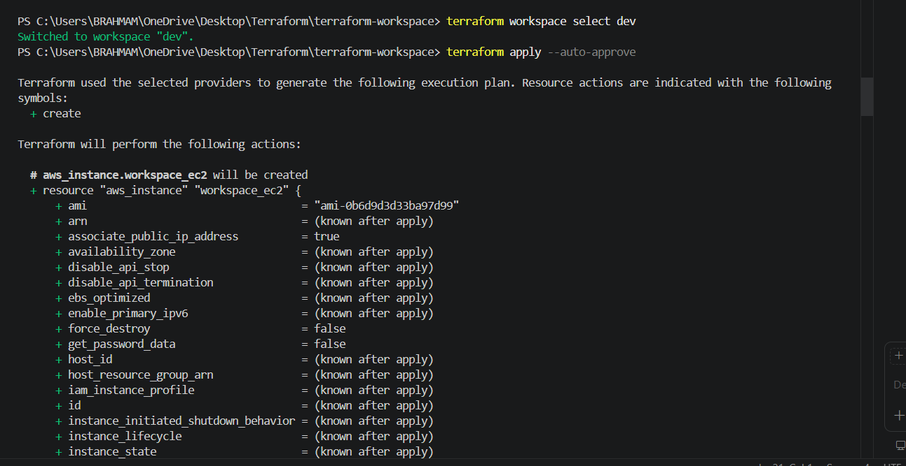
Terraform workspace select devterraform apply –auto-approveterraform workspace select staging terraform apply –auto-approve terraform workspace select prod terraform apply –auto-approve
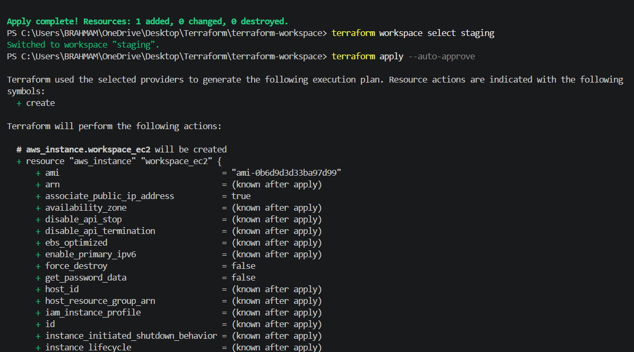
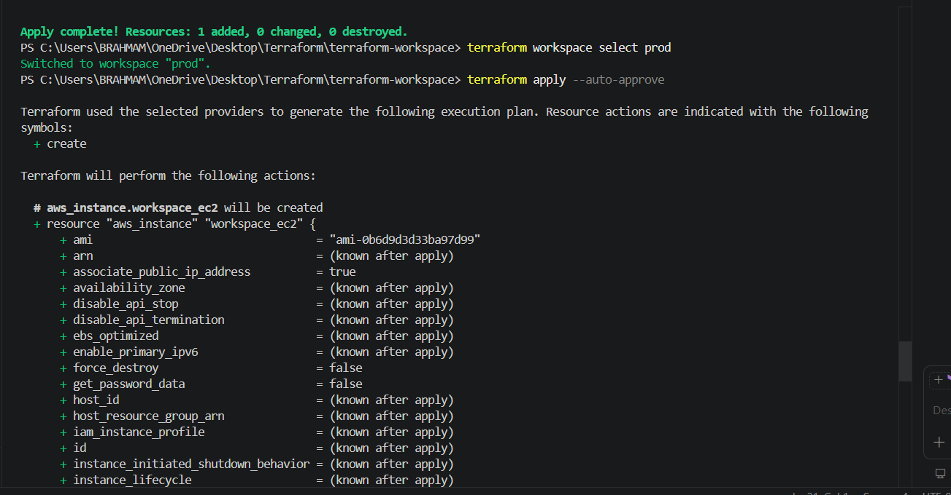
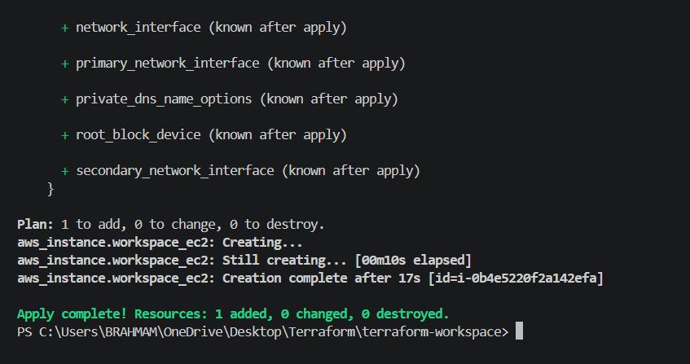
- Lets check in AWS EC2 if the instances have been created
